Assignment 1

Introduction

The purpose of this assignment is to develop my skills in relation to measurement and data analysis. Throughout the report I will details my findings and evidence providing screenshots and detailed explanations, this will draw on my learning throughout the duration of this course. The report will rely on numerous sources, all of which are referenced, and credibility has been checked to ensure that only credible referencing is referred to.

Below is a report on my findings.

The work I carried out was created through Proteus, I was tasked with the building of two different circuits, firstly I created these by downloading and then installing the proteus software.
I then created the circuits and examples of these can be seen below. [Figure 2-6]
To produce these different types of circuits and the attached graphs I first worked out the following calculation $f_{res}=\frac{1}{2π\sqrt{LC}}$for my circuit frequency prior to creating on proteus using the working attached below. [Figure 1]

Figure 1

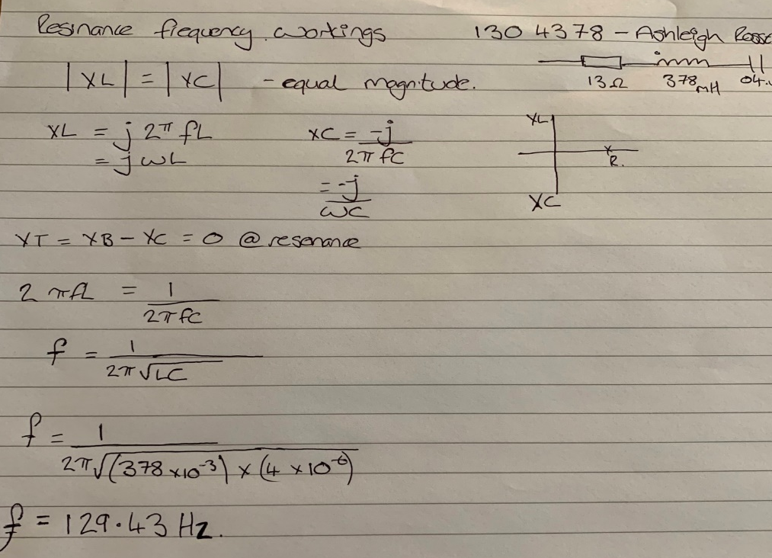

Above is my workings and the frequency generated for my student number,129.43Hz

There are two types of circuit created, a series RLC Circuit and a Parallel RLC Circuit, these circuits consist of a resistor inductor and capacitor, the components are then connected across a voltage supply.
The parallel RLC circuit is exactly opposite to the series RLC circuit. In the parallel RLC circuit, all the components are connected in parallel, the voltage across each element is same. In a series RLC circuit all these components are connected in series, the current in each element remains the same.

The use of these RLC circuits are used to tune the frequencies of AM/FM radios,and televisions and is commonly used as a damper circuit in analogue applications. It can be used as a bandpass and bandstop filter. the circuit forms an oscillator circuit or a tuned circuit. They have the ability to provide a resonant frequency signal.

Difference between Series RLC Circuit and Parallel RLC Circuit
 | RLC SERIES CIRCUIT | RLC PARALLEL CIRCUIT
1 | Resistor, inductor and capacitor are connected in series | Resistor, inductor and capacitor are connected in parallel
2 | Current is same in each element | Current is different in all elements and the total current is equal to vector sum of each branch of current i.e I_{s}² = I_{R}² + (I_{C} – I_{L})²
3 | Voltage across all the elements is different and the total voltage is equal to the vector sum of voltages across each component i.e V_{s}² = V_{R}² + (V_{L} – V_{C})² | Voltage across each element remains the same
4 | For drawing phasor diagram, current is taken as reference vector | For drawing phasor diagram, voltage is taken as reference vector
5 | Voltage across each element is given by : V_{R}= IR, V_{L} = I X_{L}, V_{C} = I X_{C} | Current in each element is given by:  I_{R} = V / R , I_{C} = V / X_{C} , I_{L} = V / X_{L}
6 | Its more convenient to use impedance for calculations | Its more convenient to use admittance for calculations
7 | At resonance , when X_{L} = X_{C}, the circuit has minimum impedance | At resonance, when X_{L} = X_{C}, the circuit has maximum impedance
Equation of RLC Circuit
An RLC circuit having resistor R, inductor L, and capacitor C connected in series and are driven by a voltage source V. Let Q be the charge on the capacitor and the current flowing in the circuit is I. Apply Kirchhoff’s voltage law[2]this is the principle I will be using for my experiment.

For the rest of this report, I will give an overview of my results in the form of graphs created from proteus and excel calculations and also using excel software to create and plot graphs generated using this software.

Series RLC Circuit

Below is a series RLC Circuit as per diagram given and attached screen shot of the proteus generated circuit with my student number substituted into the values. There is also a screenshot of my frequency response graph generated by simulating the circuit and measuring the voltage across the resistor,capacitor inductor.

1304378, R = 13Ω, C = 04 µF, and L = 378 mH

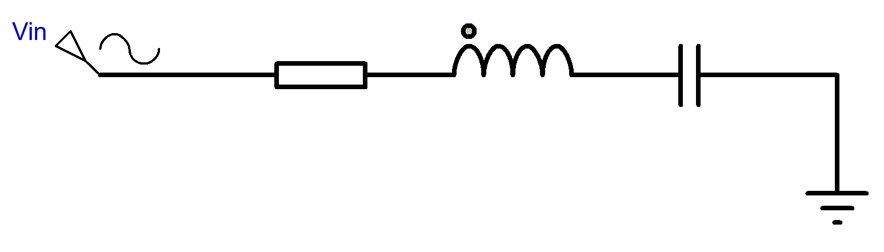

Figure 2

Figure 3

Figure 4

As the current travels through the inductor it generates a magnetic field, this charges the inductor and it creates a magnetic field, this then charges the capacitor, the transfer of magnetic to electric energy hence creates resistance. we can see from the graph that as per my workings previously the resonance is at 129.43Hz

B Parallel RLC Circuit

A parallel RLC Circuit as per Diagram below and attached screen shot of the proteus generated circuit with my student number substituted into the values. There is also a screenshot of my frequency response graph generated by simulating the circuit and measuring the voltage across the resistor,capacitor inductor.
1304378, R = 13Ω, C = 04 µF, and L = 378 mH

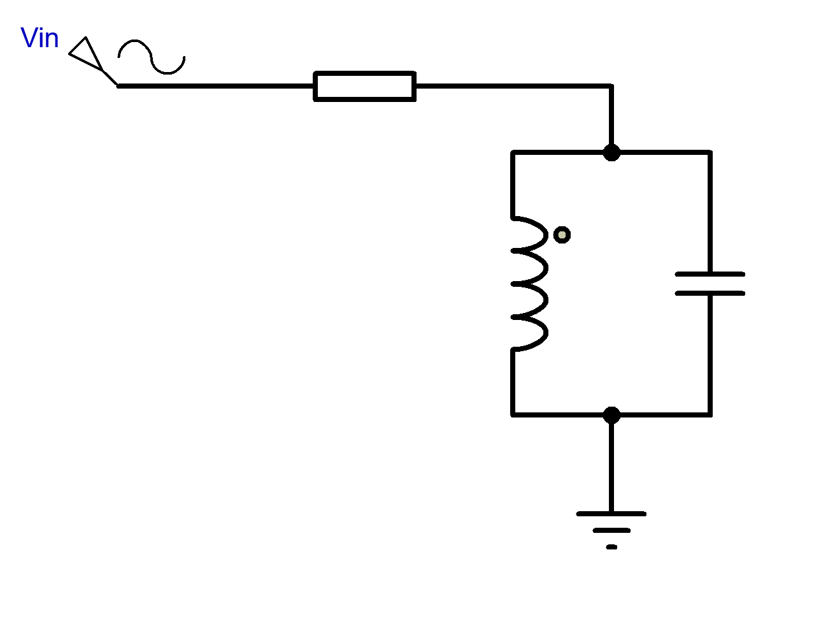

Figure 5

Figure 6

1

From the graph we can see the voltage magnification which only happens in frequency graphs seen below.

Series RLC Circuits

Figure 7

Figure 8

Figure 9

Figure 10

Parallel RLC circuit

Figure 11

Figure 12

Figure 13

Figure 14

Figure 15

Resonant frequency basic theory

Resonance occurs in a series circuit when the supply frequency causes the voltages across L and C to be equal and opposite in phase. In a series RLC circuit there becomes a frequency point where the inductive reactance of the inductor becomes equal in value to the capacitive reactance of the capacitor. In other words, X_{L} = X_{C}. The point at which this occurs is called the Resonant Frequency point, ( ƒ_{r} ) of the circuit, and as we are analysing a series RLC circuit this resonance frequency produces a Series Resonance.
Series Resonance circuits are one of the most important circuits used electrical and electronic circuits. They can be found in various forms such as in AC mains filters, noise filters and also in radio and television tuning circuits producing a very selective tuning circuit for the receiving of the different frequency channels. Consider the simple series.
A parallel circuit containing a resistance, R, an inductance, L and a capacitance, C will produce a parallel resonance (also called anti-resonance) circuit when the resultant current through the parallel combination is in phase with the supply voltage. At resonance there will be a large circulating current between the inductor and the capacitor due to the energy of the oscillations, then parallel circuits produce current resonance.
A parallel resonant circuit stores the circuit energy in the magnetic field of the inductor and the electric field of the capacitor. This energy is constantly being transferred back and forth between the inductor and the capacitor which results in zero current and energy being drawn from the supply.[3]

‘’Q” basic theory

The quality factor or Q factor is a measure of the performance of a coil, capacitor inductor in terms of its losses and resonator bandwidth. Simple formulas can relate the variables. The quality factor or 'Q' of an inductor or tuned circuit is often used to give an indication of its performance in a resonator circuit.
The quality factor relates the maximum or peak energy stored in the circuit (the reactance) to the energy dissipated (the resistance) during each cycle of oscillation meaning that it is a ratio of resonant frequency to bandwidth and the higher the circuit Q, the smaller the bandwidth, Q = ƒ_{r} /BW.[4]

I created both a Series and Parallel RLC circuits using proteus.I choose and selected my components from the part and component menu, the components were placed into the circuit and joined with wires to create my circuits. I then were created component values and these were changed inline with my student number, I ran the circuit simulation software to check my circuits and corrected any mistakes made, when I was happy with the circuits. Inline voltage and current readings were then taken in various places across the resistor, inductor and capacitor at designed frequencies from 100HZ to 20kHz . I graphed these result using the built in operations of proteus.

The response of a circuit containing both inductors and capacitors in series or in parallel depends on the frequency of the voltage or current.
From my graphs I can see that in a series RLC circuit the frequency increases sharply over the increase of the voltage, the capacitor and inductor graph traces pass through each other at the resonant frequency of my working out, 129.43 this is also inline with the resistor peak but at a lower amplitude of the trace q factor.

In my experiment from the Parallel RLC circuit I can see that when the capacitor and resistor are connected in parallel the resistor blocks the flow of current while the charge is applied to the capacitor, the capacitor charges then while the voltage across the resistor drops off, this can be simulated by the wave form in the graphs. At my frequency of 129.43 the voltage across the resistor is lowest while across the capacitor is at its highest peak. This resonance creates a circuit at its maximum value and equal to the resistance, creating a circuit of of high resistance and low current, the circuit will be ‘’in phase’’.

References
https://moodle.uwtsd.ac.uk
https://hwb.uwtsd.ac.uk/
https://googlescholar.com [1]
https://www.electrical4u.com/rlc-circuit [2]
https://www.electronics-tutorials. [3] [4]

