Student name: Jay Parmar
Student id: 2423112
Course name: International Business Concept
Course id: LCMB7034

Table of Contents
1. Introduction 4
2. Benefits and Challenges of International Operations 4
a. Why Samsung Can Be Designated an MNC/TNC 4
b. The Nature of Samsung’s Global Operations Across the Value Chain 5
c. Entry Modes Used by Samsung in International Markets 7
d. Benefits Obtained from Samsung’s International Operations 8
3. OLI Analysis: How Ownership, Location and Internalisation Factors Shaped Samsung’s Market Entry into India 10
a. Samsung’s Competitive Strengths Driving FDI into India 11
b. Location Advantages (L): Why India Became a Strategic Expansion Destination 12
c. Internalisation Advantages (I): Why Samsung Prefers Ownership Control in India 13
d. How OLI Factors Influence Samsung’s Leading Mode of Entry in India 14
4. Cultural Differences and Their Impact on Samsung’s Market Entry Strategy and Success in India 15
a. Power Distance and Hierarchical Structures 15
b. Individualism vs Collectivism 15
c. Uncertainty Avoidance 16
d. Long-Term Orientation 17
e. Masculinity and Competition Orientation 17
f. Communication Style: High Context vs Multi-context Culture 18
g. Impact on Workforce Management and Expatriate Leadership 18
h. Overall Impact on Samsung’s Success in India 18
5. SOP Adjustments for Samsung’s Success in India 19
Adjustment 1: Localised Product Development and Market Responsiveness SOP 19
Adjustment 2: Cross-Cultural Workforce Management and Leadership SOP 21
Adjustment 3: Localised Supply Chain, Manufacturing, and Vendor Partnership SOP 23
6. Conclusion 25
Reference list 26

List of figures:
Figure 1World map showing Samsung’s global presence 10
Figure 2OLI Model Diagram 11
Figure 3Bar graph comparing Hofstede scores (Power Distance, Individualism, Masculinity, etc.) 19
Figure 4Cross-Cultural Workforce Management 21
Figure 5Localised Supply Chain, Manufacturing, and Vendor Partnership SOP 23

1. Introduction
This​‍​‌‍​‍‌​‍​‌‍​‍‌ international business consultancy report is a comprehensive investigation of Samsung Electronics' global operations and strategic internationalisation approach, which is one of the top few MNCs worldwide. Headquartered in South Korea and with operations in more than 80 countries, including several emerging markets, Samsung manifests a wide global footprint across its technology, electronics, and digital solutions value chains (Gamal and Mostafa, 2023).
The main objective of this report is to analyse the advantages and disadvantages of international activities carried out by Samsung and evaluate whether the expansion strategies of the company are in line with theoretical international business frameworks. The report will examine how the entry modes, market presence, and competitive strategies of Samsung are influenced by OLI factors. The report will examine the cultural differences between South Korea and India and find out how they affect Samsung's achievement and viability in the long run.

2. Benefits and Challenges of International Operations

a. Why Samsung Can Be Designated an MNC/TNC
Samsung​‍​‌‍​‍‌​‍​‌‍​‍‌ Electronics is generally known as a major multinational corporation (MNC) and in certain respects, a transnational corporation (TNC) because of its worldwide presence, decentralised operations, and integrated international value chains. The firm is active in more than 80 countries across Asia, Europe, the Americas, Africa, and the Middle East.
​‍​‌‍​‍‌​Samsung​‍​‌‍​‍‌​‍​‌‍​‍‌ is a typical MNC/TNC that exhibits the core features of such an organization, for example:
• It has several foreign subsidiaries that operate independently like Samsung India Electronics, Samsung Vietnam, Samsung Electronics America.
• There is integration of value chains that cross borders, which entails research labs that are globally spread, production hubs that are present in multiple countries, and sales channels.
• The company uses decentralised strategic decision-making, which gives subsidiaries the freedom to modify products and marketing strategies so that they fit local environments (Cho, Atukeren and Yim, 2023).
• It has made large-scale foreign direct investments (FDI) in manufacturing facilities, R&D centres, and supply chains all over the world.
• The company has a diverse global workforce that consists of more than 260,000 employees from over 100 different nationalities (Samsung Newsroom, 2025).

b. The Nature of Samsung’s Global Operations Across the Value Chain
Samsung’s​‍​‌‍​‍‌​‍​‌‍​‍‌ worldwide activities are a reflection of a sophisticated and vertically integrated value chain that grasps how to extend the company’s market competitiveness, control, and innovation. The international value chain of the company can be portrayed through its primary operational components:
1. Research and Development (R&D)
Innovation is the main source of Samsung’s competitive advantage. The R&D strategy of the company is global and locally independent:
• South Korea (HQ): R&D centre of excellence for semiconductors, mobile innovation, AI, quantum computing, and chip production technologies.
• United States: Research emphasis was put on software, telecommunications standards (5G/6G), semiconductors, and digital ecosystems.
• India: Samsung’s major R&D centre outside Korea, with locations in Bengaluru, Noida, and Delhi, devoted to AI, camera optimisation, UX, 5G software development, and regional product adaptation.
• Europe & Israel: Research in cybersecurity, semiconductor design, connectivity, and machine learning.
2.​‍​‌‍​‍‌​‍​‌‍​‍‌ Sourcing and Supply Chain
Samsung has the supply chain that is one of the most complicated and at the same time most stable in the world:
• The sources of the components are spread over several countries, such as South Korea, China, Taiwan, Japan, Vietnam, India, Germany, and Mexico.
• The strategic control of Samsung is maintained over the most vital components, for instance, semiconductors, memory chips, OLED displays, batteries, and camera sensors.
• The company has diversified its suppliers to lessen the risk of political conflicts, particularly after the U.S.–China tensions.
• Samsung, through backward integration, can produce some of its essential components, thus the company is less dependent on external suppliers.
3. Production and Manufacturing
Samsung’s​‍​‌‍​‍‌​‍​‌‍​‍‌ production model is heavily reliant on large-scale global manufacturing hubs:
• About 50% of Samsung phones are produced in Vietnam.
• South Korea is dedicated to the production of high-tech semiconductors and display technologies.
• India (Noida) is home to one of the largest mobile manufacturing facilities in the world.
• Brazil, Indonesia, and Turkey are factories that serve regional manufacturing needs.
• Poland and Hungary focus on consumer electronics and home appliances.
4. Global Sales and Marketing
Samsung’s​‍​‌‍​‍‌​‍​‌‍​‍‌ global sales system is made up of:
• Different sales models supported by subsidiaries, enabling the local adjustment of prices, culture, and competition.
• Marketing strategies at the regional level, mainly in developing countries, with changes in product features and advertising campaigns.
• Omnichannel distribution covering the network of retail stores, e-commerce platforms, partner outlets, and authorised dealers.
• Significant brand localising, particularly in India, where Samsung changes the communication by focusing on aspects like affordability, youth segments, and technological ​‍​‌‍​‍‌​‍​‌‍​‍‌empowerment.
5. Financing and Global Financial Strategy
Samsung's​‍​‌‍​‍‌​‍​‌‍​‍‌ financing strategy is a good fit for borderless operations:
- Uses worldwide treasury centers for cash management and foreign exchange optimization.
- Is present in global capital markets, placing bonds in dollars, euros, and won.
- Is actively involved in deliberate overseas investment (e.g., building a semiconductor plant in the USA, expanding India Manufacturing).
- Has put in place risk-hedging tools to handle currency fluctuations in developing markets.

c. Entry Modes Used by Samsung in International Markets
The main entry modes comprise:
1. Direct Foreign Investment (FDI) – Dominant Entry Mode
Samsung is by far the most significant and influential intervention of a foreign market through direct foreign investment where it establishes a wholly-owned subsidiary.
For instance:
- Manufacturing plants in India, Vietnam, Brazil, and Hungary.
- Semiconductor fabs in South Korea and the USA.
- Display factories in China.
2. Joint Ventures (JVs)
Used​‍​‌‍​‍‌​‍​‌‍​‍‌ strategically when there are regulations in the host country or requirements for sharing technology.
Examples:
• JV with Corning for the production of Gorilla Glass.
• Former JVs in China for display ​‍​‌‍​‍‌​‍​‌‍​‍‌technology.
3.​‍​‌‍​‍‌​‍​‌‍​‍‌ Licensing and Technology Agreements
As a rule, Samsung licenses proprietary technologies or patents that are a part of its portfolio, especially ones in the telecommunications and semiconductor sectors.
4. Exporting
As a general practice, Samsung was launching its plants through local productions. But before that, the company Samsung entered new markets by exports.
Examples:
• The initial presence in Africa and Latin America was based on exports until local production was started.
5. Contract Manufacturing
By the means of Contract Manufacturing, Samsung has a few options to thoroughly expand the business in the regions where they cannot establish full-fledged facilities.
6. Strategic Alliances
Partnership with Google, Microsoft, Intel, and Qualcomm allow Samsung to keep up with the rapid changes in the tech industry and wired deeper technologically ​‍​‌‍​‍‌​‍​‌‍​‍‌worldwide.
Samsung's​‍​‌‍​‍‌​‍​‌‍​‍‌ main strategy is, in most of the markets, to go for a very substantial investment in wholly-owned production and sales subsidiaries. With this method the company can achieve:
• Maintenance of the cutting-edge technology control
• Smoothness of the supply chain integration
• Standard of quality being the same all over the world
• Strong intellectual property (IP) rights enforcement
• Development of customised products tailored to specific regions (e.g., India-focused models)

d. Benefits Obtained from Samsung’s International Operations
Samsung's​‍​‌‍​‍‌​‍​‌‍​‍‌ wide-ranging global expansion offers the company a lot of strategic, financial, and competitive advantages.
1. Economies of Scale
Having many factories in different countries gives Samsung the chance to:
• Cut down its production costs
• Produce big quantities at lower unit prices
• Divide their fixed R&D and marketing costs worldwide
• Be able to keep the lead in terms of cost in different product categories
2. Access to Global Talent and Innovation
Samsung​‍​‌‍​‍‌​‍​‌‍​‍‌ gains the above-mentioned talents from their various parts of the world operations, which are:
• A highly skilled engineering talent (India, the USA, Germany)
• A software development expertise (India, Israel, Poland)
• A leadership in semiconductor (South Korea, Taiwan, USA)
• Design capabilities (UK, Italy)
3. Market Diversification and Revenue Expansion
Samsung​‍​‌‍​‍‌​‍​‌‍​‍‌ lessens the risk by worldwide diversification:
• Most of the revenue i.e. over 70% comes from the markets that are outside the home country.
• The company is financially stable due to the energetic money flow from different areas such as smartphones, semiconductors, TVs, and appliances.
• The company grows in the long run because it is exposed to emerging markets (India, Vietnam, Indonesia, ​‍​‌‍​‍‌​‍​‌‍​‍‌Brazil) (Kurniawan and Khoirur Rizal Luthfi, 2023).
4. Enhanced Competitiveness Through Localisation
Samsung​‍​‌‍​‍‌​‍​‌‍​‍‌ localises its products through its global activities to meet the specific needs of the different regions:
- India: "Make for India" features like S Bike mode, multilingual support, long-battery phones.
- Middle East: products developed for very hot weather conditions.
- Europe: energy-efficient home appliances that comply with EU standards.
5. Strategic Risk Mitigation
Operating​‍​‌‍​‍‌​‍​‌‍​‍‌ in different regions worldwide allows Samsung to reduce the following risks:
- Supply chain disruptions
- Political risk
- Natural disasters
- Trade conflicts (e.g., U.S.–China tech restrictions)
6. Stronger Global Brand Recognition
Samsung​‍​‌‍​‍‌​‍​‌‍​‍‌ has been one of the main factors behind their brand's success through their worldwide activities:
• It has always been ranked as one of the top 10 global brands for several years consecutively (Chang and Huang, 2021).
• The company is promoting its brand through local and global activities such as local sponsorships, global sports partnerships, and marketing specific to the ​‍​‌‍​‍‌​‍​‌‍​‍‌region.
7. Resource Access and Cost Advantages
Samsung​‍​‌‍​‍‌​‍​‌‍​‍‌ enjoys these advantages:
- Reduced labour costs in Vietnam, India, and Indonesia.
- Regulatory benefits for production in India and the USA.
- The availability of sizeable local markets.
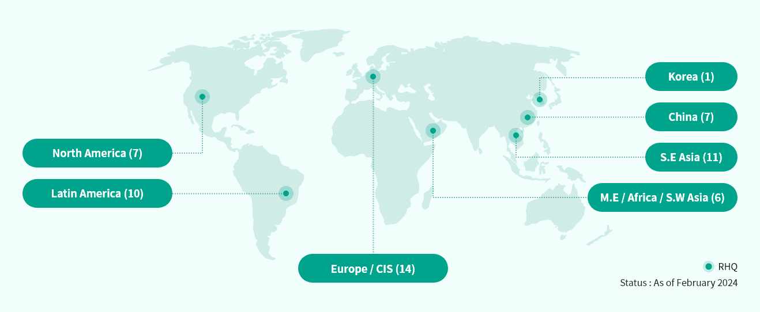
Figure 1World map showing Samsung’s global presence
Source: (Samsung, 2023)

3. OLI Analysis: How Ownership, Location and Internalisation Factors Shaped Samsung’s Market Entry into India
The OLI paradigm, by John Dunning, outlines the various factors that explain foreign direct investment by multinational corporations instead of other ways like exporting or licensing. Samsung decided to penetrate the Indian market, which is a rapidly growing emerging economy, primarily because of its Ownership advantages complemented by Location-specific benefits and Internalisation incentives that persuaded Samsung to choose large-scale FDI and wholly owned subsidiaries as the mode of entry.
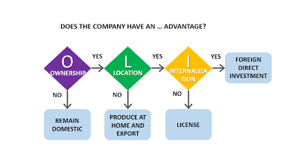
Figure 2OLI Model Diagram
Source: (Bruin, 2024)

a. Samsung’s Competitive Strengths Driving FDI into India
1.​‍​‌‍​‍‌​‍​‌‍​‍‌ Technological Leadership
Samsung is at the forefront restating technology developments, notably it dominates in semiconductor, memory chips, OLED display, and smartphone technologies.
2. Strong Global Brand Equity
Samsung is one of the world top multinational brands characterized by high brand loyalty, being positioned at the top of the market, and global recognition (Tochukwu et al., 2023).
3. Financial Strength and Investment Capability
It was through Samsung’s strong income and reserve that the company was able to inject a large Foreign Direct Investment in India, as a result of the Huge Noida plant.
4. Organisational Capabilities and Vertical Integration
Samsung’s vertical integration is a way to guarantee cost effectiveness and being in control of the supply chain by manufacturing or obtaining almost half of the components internally.
Critical Discussion
Ownership advantages clearly explain why Samsung chose FDI as the way of entering foreign markets and on the other, they could pose the risk of high fixed costs and exposure to host country risks.

b. Location Advantages (L): Why India Became a Strategic Expansion Destination
India is filled with features that position it as one of Samsung's most strategically important emerging markets.
1. Large and Growing Consumer Market
India boasts one of the largest populations globally besides a rapidly growing middle class that is driving the demand for mobile phones, televisions, and digital appliances. The presence of a young, tech-savvy demographic further intensifies the demand for smartphones, which happen to be one of Samsung's major product segments. Samsung's FDI in India will enable it to satisfy local consumer needs directly while standing up to rivals like Xiaomi and Vivo.
2. Government Incentives and Favourable Industrial Policies
The Indian government is always ready to promote the manufacture of electronics through such initiatives as:
• Make in India
• Production Linked Incentive (PLI) Schemes
• Tax incentives for manufacturing and exports
3. Cost-Effective Labour Market
India is endowed with a large pool of skilled but affordable labour, especially in areas like engineering, software development, and electronics assembly. Samsung's R&D programs in Bengaluru and Noida are highly benefited by top-notch technological talent at attractive wage levels giving the company the leverage to accomplish innovation at scale efficiently.
4. Strategic Geographic Position
India geographically is very close to such areas as Southeast Asia, the Middle East, and Africa. Producing in India allows Samsung to cut the shipping duration and save on the logistics costs of exports going to nearby areas.
5. Rising Digital Ecosystem
The rapidly digitalised India of today, which is mostly attributed to more smartphone usage, widening internet access, and government's spending on digital infrastructure, is bound to create long-lasting demand for Samsung's gadgets. This ecosystem is like a good earth on which Samsung can sow the seeds of the firm, incubate the seeds, and get the fruits of the land.
Critical Discussion
Despite India being endowed with attractive location advantages, Samsung is still subject to hurdles like delays in bureaucratic processes, lack of infrastructure, and keen competition from Chinese producers. The market opportunities combined with government support however, overshadow these challenges and therefore, the reason why Samsung decided FDI entry mode first and foremost.

c. Internalisation Advantages (I): Why Samsung Prefers Ownership Control in India
The internalisation aspect deals with a question of why Samsung decided to internalise its operations instead of using external options such as exporting, licensing, or partnerships.
1. Protection of Proprietary Technology
Samsung's essential technologies such as semiconductor designs, display innovations, camera developments, and software algorithms that are the main sources of the company's competitive advantages are the most sensitive ones. If these technologies are licensed in India, there will be the risk of copying or leaking.
2. Quality Assurance and Operational Consistency
The global Samsung quality standard can be maintained only if the company has tight control over production and supply chain processes (Nguyen, 2021). By internalising the production, Samsung is able to check the quality at every level, from component manufacturing to assembly and after-sales service.
3. Supply Chain Integration
Samsung's model of vertical integration is heavily dependent on the efficient and synchronized coordination of various stages of production (Yang and Kim, 2025). The decision to internalise in India has led to efficient supply chain integration, which comprises:
• More sourcing control
• More control of material flows
• Lesser reliance on third-party suppliers
• Quicker reaction to market changes
4. Avoiding Transaction Costs and Opportunism
Samsung's dependence on external partners in India can have a negative impact in terms of:
• Behaviour with opportunistic intentions
• Conflicts over contracts
• Production delays
• Quality that is not consistent
5. Faster Decision-Making and Local Responsiveness
By FDI, Samsung gains the flexibility to operate in a more agile manner thus can easily make changes in product offerings that target the Indian market. The presence of local R&D allows the company to adjust the features of smartphones to suit Indian consumers, thus enabling higher local responsiveness than exporting or licensing.
Critical Discussion
The internalisation advantages provide a valid reason to Samsung for opting wholly owned manufacturing facilities though it also points up the financial risk and operational exposure that comes with the approach.

d. How OLI Factors Influence Samsung’s Leading Mode of Entry in India
The combined effect of Ownership, Location, and Internalisation advantages basically illustrates Samsung’s entry strategy in India.
Reasons Why FDI and Wholly Owned Subsidiaries Are the Most Suitable for Samsung in India
• Ownership: A high level of technological expertise and the strength of a global brand imply the need for a high degree of control.
• Location: India is a place with a large potential market and at the same time the advantages of low costs, which together make it worthwhile to invest for the long-term.
• Internalisation: The best way to protect technology and ensure quality is through full ownership.
Strategic Outcomes
• Extensive manufacturing capabilities
• Large-scale investment in R&D
• The capacity to meet Indian consumers' needs at short notice

4. Cultural Differences and Their Impact on Samsung’s Market Entry Strategy and Success in India
Comprehending cultural differences between South Korea and India is essential to understand the international strategy of Samsung and its long-term viability. The cultural gap influences customer behaviour, leadership expectations, modes of communication, and socializing practices in the organization (Wolfgruber and Einwiller, 2024). Employing Hofstede’s Cultural Dimensions, this part looks at the cultural disparities critically between the two nations and assesses their effects on Samsung’s market entry and operational strategies in India.

a. Power Distance and Hierarchical Structures
South​‍​‌‍​‍‌​‍​‌‍​‍‌ Korea and India are both characterized by a significantly high-Power Distance; however, India displays even more respect for authority and top-down decision-making is more deeply ingrained in the Indian culture.
Effects on the Impact of Samsung
The hierarchical Korean management of Samsung was in line with the Indian expectations; thus, it was helpful for the entry (Lipura, 2021). Indians were fond of directive leadership, as they required clear instructions, however, if the hierarchy is too strong it can slow down problem-solving and limit innovation in R&D.
Samsung has to maintain the hierarchical management style while integrating creative methods to keep up with the competition from rapidly growing companies like Xiaomi and local ​‍​‌‍​‍‌​‍​‌‍​‍‌firms.

b. Individualism vs Collectivism
South Korea is somewhat collectivist, while India shows a blend of collectivism and individualism because of the diversity in regions, generations, and socio-economic status.
Effects on Customer Behaviour
Korean collective culture supports Samsung brand loyalty and long-term relationships, which go well with Samsung’s premium positioning strategy.
In India, collectivism still exists, but being value-conscious dominates a large portion of buying decisions, especially in the mid-range of the smartphone market.
Due to price sensitivity and peer influence Samsung had to go for a double strategy i.e. the urban consumers would be given premium devices while mass markets would get affordable models.
Operational Implications
Indian employees are very diverse in their expectations when it comes to teamwork, rewards, and communication, and this requires the HR department to be more flexible in their approaches (Malik et al., 2022).
Whereas the Korean collectivist society that stresses the importance of group harmony, the Indian employees may opt for pursuing their individual aspirations and thus the management of teams needs to be done by strategies that are adapted to this difference.

c. Uncertainty Avoidance
South Korea has a very high score in Uncertainty Avoidance, and the society with this characteristic normally values structure, detailed planning and stability. India has a moderate score that indicates that it is somewhat tolerant towards ambiguity.
Effects on Samsung’s Strategy
Korean HQ is all for having well-structured processes and everything planned out in detail.
India’s very laid-back and informal way of doing business was a challenge that they had to meet with more flexible and adaptable approaches especially in areas such as distribution and marketing.
Critical Evaluation
This was Samsung's strategy for empowering Indian leadership, so they could be the ones who respond quickly to the changing situation, thus alleviating cultural mismatches and ensuring the company's competitiveness in the market.

d. Long-Term Orientation
South Korea is usually long-term oriented, while India, although moderately long-term oriented, is quite culturally diverse (Chun et al., 2021).
Consequences for Market Success
One of the main reasons for Samsung's investment in India is to cater to the Indian market through the massive factory and R&D centres in Noida, reflecting the company's long-term vision.
Indians are more likely to be loyal to brands that are really committed to them and this is the factor that builds consumer trust and brand legitimacy.
With the rapid changes for products in India, Samsung had to strike a balance between long-term planning and short-term responsiveness to manage this crisis.
Critical Evaluation
The long-term orientation was a great support for the manufacturing sector and the entire ecosystem; however, it still had to be very flexible to accommodate the fast-changing consumer preferences in India.

e. Masculinity and Competition Orientation
South Korea is a typical masculine society, where most attention is given to achievement and performance. India also bears some masculine traits, which are mainly exhibited through aspirational purchases and status symbols.
Market Entry Implications
In India, Samsung used premium devices such as Galaxy S and Fold in the marketing campaign to depict the gadgets as status consumable goods, thus attracting the Indian aspirations.
Among the most essential activities for the adaptations were competitive pricing and "Make for India" features like longer-lasting batteries and regional language support.
Operational Implications
Korean style of performance-driven management can cause the existence of harsh conditions that may put heavy pressure on those teams which are not well-prepared like Indian ones, thus it is a great challenge for cross-cultural HR management to be successful and quite sensitive at the same time to handle this properly.

f. Communication Style: High Context vs Multi-context Culture
Although both countries are high-context cultures, India's linguistic and regional diversity make it more complex.
Implications
Relational Korean managers were able to utilize business tactics, thereby establishing trust, and building long-term relationships.
For marketing and customer service, several languages and cultural identities had to be considered apart from the usual ones.
Regional campaigns, local celebrities, cricket sponsorships, and multilingual content all played a part in deepening the connection with the market.

g. Impact on Workforce Management and Expatriate Leadership
Challenges
The expectation of discipline and long working hours by Korean managers may not be met with Indian workers who would rather go for flexible and relationship-based approaches.
Adaptations Required
Recruiting Indian executives in top positions to close the cultural gaps is one adaptation.
Cross-cultural training for Korean managers.

h. Overall Impact on Samsung’s Success in India
Samsung has been able to sustain its success in India mainly through its adaptability. Localization of technological innovations, marketing specific to regions, local talent investments, flexible distribution channels, and an effectively managed blend of Korean–Indian leadership style are just some of the ways by which Samsung turned India into one of its biggest markets globally, notwithstanding the initial cultural shocks.
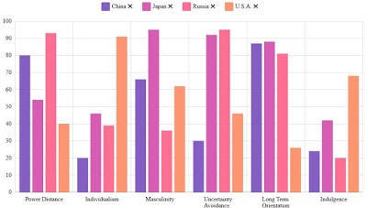
Figure 3Bar graph comparing Hofstede scores (Power Distance, Individualism, Masculinity, etc.)
Source: (Jan, 2025)

5. SOP Adjustments for Samsung’s Success in India
In​‍​‌‍​‍‌​‍​‌‍​‍‌ order to maintain as well as to increase its competitive position in India, Samsung is obliged to make sure that its Standard Operating Procedures (SOPs) are not only in line with the OLI considerations but also with the cultural aspects of the Indian market. The dynamic consumer behaviour of India, its regulatory environment, socio-cultural diversity, and competitive landscape call for tailor-made operational practices which are quite different from those employed in South Korea.

Adjustment 1: Localised Product Development and Market Responsiveness SOP
Samsung's​‍​‌‍​‍‌​‍​‌‍​‍‌ one of the most essential SOP modifications in India is the creation of a neighbourhood-centered product innovation and a quick-response system. India is a highly varied and highly price-sensitive market of the kind where consumer preferences change very quickly, among other things, because of technology trends, competitor pricing, and cultural factors (Gurnani and Gupta, 2024). It is necessary for Samsung to make it a regular practice of operation to have product development be the result of local initiatives rather than a central control from South ​‍​‌‍​‍‌​‍​‌‍​‍‌Korea.
a. Rationale Based on OLI Factors
Ownership​‍​‌‍​‍‌​‍​‌‍​‍‌ Advantages
Samsung, through its technological expertise, is capable of creating products that are different from others in the market (Runge, Schwens and Schulz, 2021). But the previous analyses indicate that just rebranding Korean products doesn't always meet the expectations of Indian consumers - particularly in the middle segments of the market.
Location Advantages
The young population of India, its increasing digital adoption, climate changes, and multilingual environment are the factors that contribute to the creation of the unique preferences.
Internalisation Advantages
Samsung's inclination towards internal control should be evident in product innovation that is specific to India.
b. Cultural Justification
India's​‍​‌‍​‍‌​‍​‌‍​‍‌ rich cultural diversity is a major factor in how products are accepted in the market. For instance:
- High-context communication indicates that consumers are more responsive when features and marketing are culturally relevant.
- Aspirational purchasing is the main reason for the increasing demand of features such as high-quality cameras and large displays.
- Multilingual requirements are the reason why devices that support several Indian languages are highly preferred.
c. Implementation Recommendations
Samsung​‍​‌‍​‍‌​‍​‌‍​‍‌ needs to formalize the below SOP steps as part of its operations:
- India-first feature development: The two R&D centres in Bengaluru and Noida should be given the power to create and test new features exclusively for Indian users.
- Rapid market response cycles: The company should strive to shorten the product adaptation timelines by lessening the requirement for approval from the Korean headquarters (Al-Shamsi, 2022).
- Local climate and usage testing: Part of the SOP should be running heat tests, dust exposure tests, and battery optimisation under Indian conditions.
- Multilingual UI SOP: Making it compulsory to include the regional languages in all mid-range and entry-level smartphones should be the first ​‍​‌‍​‍‌​‍​‌‍​‍‌step.
d. Expected Impact
This​‍​‌‍​‍‌​‍​‌‍​‍‌ change will enable Samsung to compete more effectively with Xiaomi, Vivo, and Realme in the mid- and low-end segments of the market and, at the same time, strengthen brand loyalty by being relevant and responsive.

Adjustment 2: Cross-Cultural Workforce Management and Leadership SOP
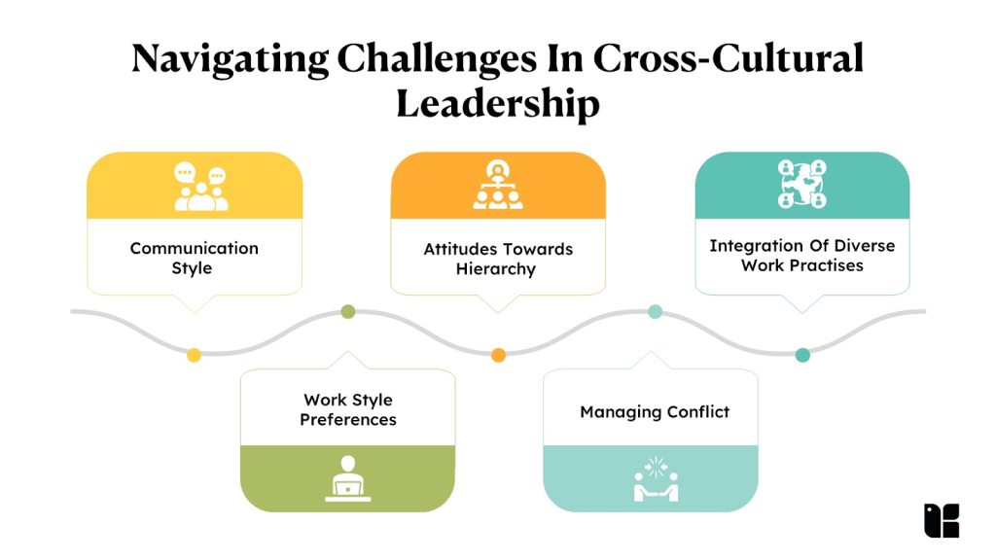
Figure 4Cross-Cultural Workforce Management
Source: (Khandelwal, 2024)
Considering​‍​‌‍​‍‌​‍​‌‍​‍‌ the large cultural gaps between South Korea and India, Samsung has to establish standard operating procedures that will facilitate the implementation of cross-cultural management practices.
a. Rationale Based on OLI Factors
Ownership Advantages
Among the key strengths of Samsung are its organisational capability and the culture of the workforce which is very well disciplined. As a result of indifferent Korean hierarchical and high-pressure work practices being directly merged into India, employee morale may go down and the rate of turnover will increase without a doubt.
Location Advantages
Some of India's locational advantages are a large pool of skilled talent. In the absence of culturally sensitive SOPs, Samsung will be left with a shortage of talents as these will go to companies like Google, Amazon, and startups based in Bengaluru.
Internalisation Advantages
As Samsung is an internalised operation, workforce effectiveness is very important in terms of quality and innovation which have to be under the control of the company. SOPs are supposed to be the tool by which the internal teams assure that they are high-performing and culturally ​‍​‌‍​‍‌​‍​‌‍​‍‌cohesive.
b. Cultural Justification
Differences​‍​‌‍​‍‌​‍​‌‍​‍‌ between Indian and Korean work cultures are as follows:
- Leadership styles: Korean managers opt for a directive style of leadership; Indian employees might look for a collaborative and relationship-based type of leadership (Kim and Shin, 2022).
- Communication patterns: Korean employees rely on indirect communication; Indians might use a combination of directness and context that depends on the region and hierarchy.
- Work–life preferences: The extended work hours tradition typical of Korea is at odds with India's growing trend towards flexibility and well-being​‍​‌‍​‍‌​‍​‌.
c. Implementation Recommendations
Samsung​‍​‌‍​‍‌​‍​‌‍​‍‌ needs to put SOPs in place that cover:
- Expatriate cross-cultural training with a focus on Indian communication styles, negotiation norms, and workplace expectations (Zakaria and Yusuf, 2022).
- Enabling local leadership through a transfer of decision-making power of Indian managers in marketing, HR, and product development.
- Hybrid work and flexibility SOP to be in line with the changing professional culture of India.
- Conflict resolution procedures that reflect both Korean and Indian communication preferences (Lee and Sylvén, 2021).
- Performance management SOP tailored to account for individual achievements besides group performance.
d. Expected Impact
Improved​‍​‌‍​‍‌​‍​‌‍​‍‌ cultural compatibility can:
- Increase productivity
- Enhance talent retention
- Strengthen internal collaboration
- Support Samsung’s long-term operational stability in India

Adjustment 3: Localised Supply Chain, Manufacturing, and Vendor Partnership SOP
The large Indian area, different conditions of the infrastructure, and the complex laws make Samsung have to not only strengthen but also localise its standard operating procedures for supply chain management, vendor partnerships, and manufacturing ​‍​‌‍​‍‌​‍​‌‍​‍‌operations.
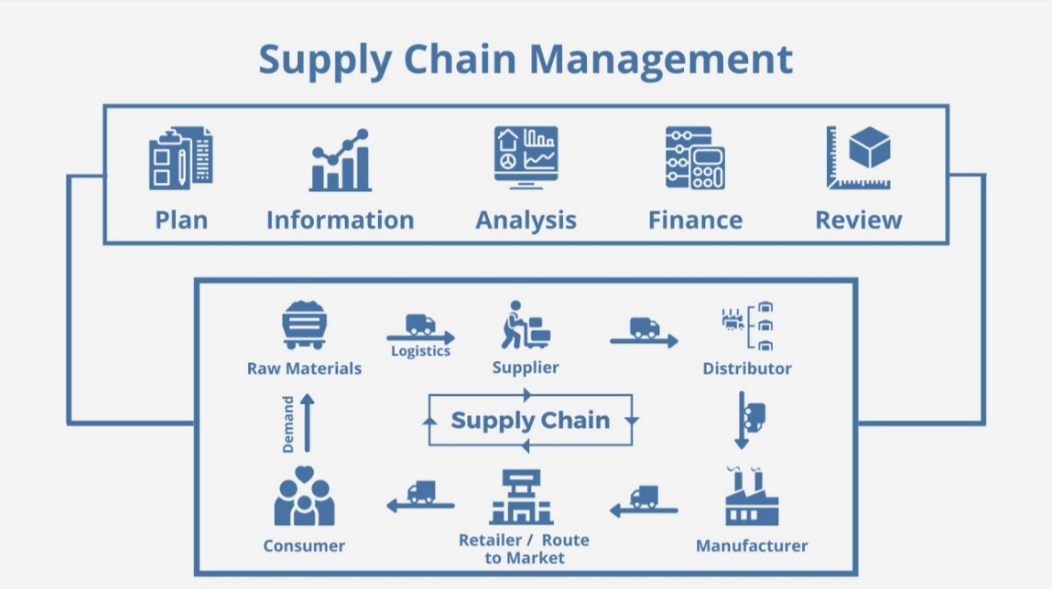
Figure 5Localised Supply Chain, Manufacturing, and Vendor Partnership SOP
Source: (Labs, 2025)
a. Rationale Based on OLI Factors
Ownership​‍​‌‍​‍‌​‍​‌‍​‍‌ Advantages
Samsung’s main strength resulting from its vertical integration is the control of its internal supply chain in a very efficient way (Son and Kim, 2022).
Location Advantages
India is a major source of manufacturing incentives under the PLI scheme and has cheap labour (Vora et al., 2021). In order to harness these advantages to the fullest extent, Samsung will have to modify SOPs so as to be in accordance with Indian regulatory standards, supplier dynamics, and distribution realities.
Internalisation Advantages
While Samsung is obligated to maintain the quality of its products by internalisation, which means that SOPs have to be in support of an easy and smooth coordination with local suppliers, government bodies, and logistics ​‍​‌‍​‍‌​‍​‌‍​‍‌partners.
b. Cultural Justification
Indian​‍​‌‍​‍‌​‍​‌‍​‍‌ business culture is largely dependent on:
- Relationship-based negotiations (Rodolaki, Barakos and Hitch, 2023)
- Trust-building with suppliers
- Flexibility and informal communication
c. Implementation Recommendations
Samsung​‍​‌‍​‍‌​‍​‌‍​‍‌ needs to update its standard operating procedures to have the following:
• Vendor localisation SOP: Use Indian suppliers for the components as a matter of first priority so as to reduce the cost of imports and be able to take advantage of government incentives.
• Flexible logistics SOP: Have the regional infrastructural disparities, seasonal disruptions, and local compliance issues as contingencies for each of which you can draw a plan (Maghsoudi et al., 2025).
• Government compliance SOP: Assign teams to oversee compliance that will also take care of regulatory updates concerning import duties, GST, and manufacturing incentives.
• Relationship-oriented procurement SOP: Add regular engagement meetings, supplier development programmes, and trust-building initiatives with Indian vendors.
• Sustainability and environmental SOP: Ensure that the production process is in line with India’s changing environmental ​‍​‌‍​‍‌​‍​‌‍​‍‌regulations (Zhou et al., 2023).
d. Expected Impact
These​‍​‌‍​‍‌​‍​‌‍​‍‌ modifications will reduce costs, increase supply chain resilience, and raise efficiency levels. They will deepen connections with the government, make the company more competitive, and facilitate exports from India.

6. Conclusion
This​‍​‌‍​‍‌​‍​‌‍​‍‌ report goes beyond the surface to explore Samsung's global operations and their tactical move to the Indian market using the three leading analytical frameworks: global value chain analysis, OLI (Ownership, Location, Internalization) theory, and cross-cultural differences. The assessment reveals that foreign direct investment (FDI) is identified as the best way of entering a market for Samsung out of various market entry alternatives. The driver for this decision is chiefly the company’s possession of strong ownership advantages such as cutting-edge technological capabilities, solid brand equity, and a vertically integrated organizational structure.
Furthermore, the attractive location advantages of India are the reasons for the FDI decision of Samsung to be additionally justified. The nation entails not only a giant and ever-expanding consumer base but also offers a labour force that is highly skilled and has industrial policies favouring local manufacturing and research and development (R&D). Consequently, these create conditions for the company’s hefty investments in the local production of high-tech goods and setting up of innovation laboratories to be both feasible and strategically sound.
Additionally, according to the cross-cultural study, leadership expectations, communication methods, consumer patterns, work culture are some of the areas where South Korea and India differ significantly. These differences impact Samsung’s marketing strategies and operational efficiency at the local level. Therefore, these three key SOP changes are suggested; localizing product development more deeply, managing a culturally diverse workforce more effectively and increasing localization in the supply chain and manufacturing processes to better match the Indian ​‍​‌‍​‍‌​‍​‌‍​‍‌market.

Reference list
Al-Shamsi, M.A.S. (2022). Review of Korean Imitation and Innovation in the Last 60 Years. Sustainability, [online] 14(6), p.3396. Available at: https://www.mdpi.com/2071-1050/14/6/3396.
Bruin, L. de (2024). Eclectic Paradigm/OLI Paradigm EXPLAINED with EXAMPLES | B2U. [online] B2U - Business-to-you.com. Available at: https://www.business-to-you.com/choosing-the-right-entry-mode-strategy/.
Chang, Y.-Y. and Huang, H.-C. (2021). Exploring Patterns of Evolution for Successful Global Brands: A Data-Mining Approach. Sustainability, [online] 13(14), p.7915. Available at: https://www.mdpi.com/2071-1050/13/14/7915.
Cho, W.C., Atukeren, E. and Yim, H.R. (2023). Overseas Market Expansion Strategy of the Global Electronic Components Company Based on the AHP Analysis of Factors in Technology, Organization, and Environment Context: a Case of Samsung Electro-Mechanics. Systems, [online] 11(11), pp.532–532. Available at: https://www.mdpi.com/2079-8954/11/11/532.
Chun, D., Zhang, Z., Cohen, E., Awasthy, R., Botero-R, J., Bastida Dominguez, M., Florea, L., Genc, O.F. and Soares, A.M. (2021). LTO and the Passage of Time: Time to Revisit Hofstede’s Cultural Dimensions? Academy of Management Proceedings, [online] 2020(1), p.11737. Available at: https://www.researchgate.net/profile/Eric-Cohen-3/publication/343371923_LTO_and_the_Passage_of_Time_Time_to_Revisit_Hofstede's_Cultural_Dimensions/links/61f2c37e9a753545e2fe8e9f/LTO-and-the-Passage-of-Time-Time-to-Revisit-Hofstedes-Cultural-Dimensions.pdf.
Gamal, M. and Mostafa (2023). GLOBAL-LOCAL PRODUCTION NETWORKS ORGANIZATION OF SAMSUNG ELECTRONICS CORPORATION: THEORETICAL FRAMEWORK, SPATIAL PATTERNS, DYNAMICS, STRATEGIES, AND CASE STUDY. [online] Available at: https://journals.ekb.eg/article_284296_fd79094c38f3bee7e3df835083d2a66f.pdf.
Gurnani, K. and Gupta, N. (2024). Factors Affecting Consumer Behaviour in Indian Fashion Retail Industry: A Study of Recent Trends and Preferences. IJFMR240218688, [online] 6(2). Available at: https://pdfs.semanticscholar.org/317c/8279e2a4ce429dc238b5e425ea1a7b1189d2.pdf.
Jan, G. (2025). Launching new Hofstede culture comparison tool - Geert Hofstede. [online] Geert Hofstede. Available at: https://geerthofstede.com/launching-new-hofstede-culture-comparison-tool/.
Khandelwal, S. (2024). Cross-Cultural Leadership: Navigating Global Teams And Markets | Kapable Blog. [online] Kapable Blog. Available at: https://kapable.club/blog/leadership/cross-cultural-leadership-navigating-global-teams-and-markets/.
Kim, S. and Shin, M. (2022). Effective Leadership Differs Between Organizations: A Comparative Study of US and German Multinational Corporations in South Korea. SAGE Open, [online] 12(2), p.215824402210978. Available at: https://journals.sagepub.com/doi/pdf/10.1177/21582440221097890.
Kurniawan, A. and Khoirur Rizal Luthfi (2023). Impact of the US-China Trade War on Foreign Trade of Emerging Economies: Brazil, South Africa, and Indonesia. JSP : Jurnal Ilmu Sosial dan Ilmu Politik, [online] 27(2), pp.157–157. Available at: https://pdfs.semanticscholar.org/7035/8ece818bab2ac1496d0b3c06a3be2c697afa.pdf.
Labs, C. (2025). In today’s global and fast-moving business landscape, supply chain efficiency is no longer just about logistics and procurement—it’s about collaboration. Businesses are increasingly relying on multiple vendors and suppliers spread across geographies, each playing a critical role in ensuring the smoo. [online] Linkedin.com. Available at: https://www.linkedin.com/pulse/improving-vendor-collaboration-unified-supply-chain-management-labs-tn4cc.
Lee, J.S. and Sylvén, L.K. (2021). The role of Informal Digital Learning of English in Korean and Swedish EFL learners’ communication behaviour. British Journal of Educational Technology, [online] 52(3), pp.1279–1296. Available at: https://bera-journals.onlinelibrary.wiley.com/doi/pdf/10.1111/bjet.13082.
Lipura, S.J.D. (2021). Deconstructing the periphery: Korean degree-seeking students’ everyday transformations in and through India. Research in Comparative and International Education, [online] 16(3), pp.252–275. Available at: https://journals.sagepub.com/doi/pdf/10.1177/17454999211038769.
Maghsoudi, A., Sigala, I.F., Piotrowicz, W.D. and Allahi, F. (2025). Supply chain disruption and mitigation strategies: insights from humanitarian operations in a complex environment. International Journal of Logistics Research and Applications, [online] pp.1–34. Available at: https://www.tandfonline.com/doi/pdf/10.1080/13675567.2025.2490570.
Malik, A., Budhwar, P., Mohan, H. and N. R., S. (2022). Employee Experience –the Missing Link for Engaging employees: Insights from an MNE’s AI‐based HR Ecosystem. Human Resource Management, [online] 62(1), pp.97–115. Available at: https://onlinelibrary.wiley.com/doi/pdfdirect/10.1002/hrm.22133.
Nguyen, T. (Mae) (2021). Norm Assembly in Global Value Chains. SSRN Electronic Journal. [online] Available at: https://papers.ssrn.com/sol3/Delivery.cfm?abstractid=3878596.
Rodolaki, C., Barakos, G. and Hitch, M. (2023). The Role of Intercultural Differences and Challenges Faced in Negotiating Active Mine sites’rehabilitation Objectives from Africa to Europe. The Extractive Industries and Society, [online] 16, pp.101362–101362. Available at: https://www.sciencedirect.com/science/article/pii/S2214790X2300151X.
Runge, S., Schwens, C. and Schulz, M. (2021). The invention performance implications of coopetition: How technological, geographical, and product market overlaps shape learning and competitive tension in R&D alliances. Strategic Management Journal, [online] 43(2), pp.266–294. Available at: https://sms.onlinelibrary.wiley.com/doi/pdfdirect/10.1002/smj.3334.
Samsung (2023). Logistics-Global Network | Samsung SDS | India. [online] Samsungsds.com. Available at: https://www.samsungsds.com/in/global-networks/global-network.html.
Samsung Newsroom (2025). Fast Facts Samsung Electronics. [online] Samsung.com. Available at: https://news.samsung.com/global/fast-facts.
Son, I. and Kim, S. (2022). Supply Chain Management Strategy and Capital Structure of Global Information and Communications Technology Companies. Sustainability, [online] 14(3), p.1844. Available at: https://www.mdpi.com/2071-1050/14/3/1844.
Tochukwu, I., Uchenna, O., Chidera, K., Olusola, A. and Okwukwe, N. (2023). SAMSUNG, A SMOOTH OR TREACHEROUS JOURNEY OF GLOBALIZATION? JOURNAL OF BUSINESS AND SOCIAL SCIENCES, [online] 2023, p.21. Available at: https://iuojs.intimal.edu.my/index.php/jobss/article/download/424/421.
Vora, A., Gupta, A., Ojha, A., Pandey, P., Sagar Marwaha, M., Kadam, S. and Singh, S. (2021). INDIA’S PHARMA AND MEDICAL DEVICES STRATEGIES: AN ASSESSMENT OF THE PRODUCTION LINKED INCENTIVE (PLI) SCHEME. [online] Available at: http://www.ijirr.com/sites/default/files/issues-pdf/3736.pdf.
Wolfgruber, D. and Einwiller, S. (2024). Culture matters: Cultural variability in corporate codes of conduct as a means to foster organizational legitimacy. Business Ethics, the Environment & Responsibility. [online] Available at: https://onlinelibrary.wiley.com/doi/pdf/10.1111/beer.12733.
Yang, H.J. and Kim, C. (2025). Vertical vs. Horizontal Integration in HBM and Market-Implied Valuation: A Text-Mining Study. Applied Sciences, [online] 15(22), p.12127. Available at: https://www.mdpi.com/2076-3417/15/22/12127.
Zakaria, N. and Yusuf, B.N.M. (2022). Sacrifices from relocation to a foreign land: Multifaceted challenges experienced by self-initiated expatriate female nurses during cross-cultural adjustment. Current Psychology, [online] 1(1). Available at: https://link.springer.com/content/pdf/10.1007/s12144-022-02745-4.pdf.
Zhou, S., Rashid, Md.H.U., Mohd. Zobair, S.A., Sobhani, F.A. and Siddik, A.B. (2023). Does ESG Impact Firms’ Sustainability Performance? The Mediating Effect of Innovation Performance. Sustainability, [online] 15(6), p.5586. Available at: https://www.mdpi.com/2071-1050/15/6/5586.

