Environmental Sustainability in Hospitality Portfolio

BMB7004
Dr Jayne Griffiths Parry
Ffion Cumberpatch 1551691

Contents
1. Guest Experience 3
Essay: The impact of Sustainability on guest experience and customer satisfaction 3
Reference List 6
2. Staff Awareness 7
Reflective Essay: Employee attitudes and raising awareness of sustainability 7
Reference List 9
3. Brand Image 10
Presentation: The importance of brand image in the era of sustainability 10
4. Regulatory Affairs and Fiscal and Economic Incentives 18
Report: What are the Regulatory Affairs, Fiscal and Economic incentives driving sustainability? 18
Executive Summary 18
Introduction 18
Regulatory Affairs 18
Economic Incentives 19
Fiscal Incentives 19
Fiscal Penalties 20
Other Considerations 21
Conclusion 21
Reference List 22
5.Sustainability in the future 23
Reflective Essay: The future of sustainability in the hotel industry 23
Reference List 24

Guest Experience

Essay: The impact of Sustainability on guest experience and customer satisfaction
For decades, hotels have been introducing sustainable practices into their operations (Revilla et al, 2001). Large hotel organisations such as Marriott and Hilton are some of the organisations spearheading sustainability in hospitality. In 2011 Marriott was named the "greenest hotel company" in the UK and in 2013 Hilton exceeded all their sustainability goals they had set out in their 2009 Corporate Social Responsibility plan (Burns-Smith, 2015). However, very little research has been done on the impact of how sustainable practices may influence the customer choice (Millar and Baloglu, 2008). The purpose of this essay is to consider the role sustainability plays in the guest experience and the impact it has on guest satisfaction.
Consumer awareness surrounding environmental issues has grown exponentially over the last thirty years and in response an increased number of hotels have been implementing sustainable practices year on year in order to match guest expectations and improve their public image (Gil-Saura et al, 2021). This is supported by the increase in eco hotels and green hotels around the world. The June 2021 Global Consumer Insights survey found that although all age groups have increased interest in sustainability, Millennials are most likely to take it into consideration when making purchasing decisions (PwC, 2021).
A 2016 Accor study of over 7,000 hotels found that gender impacted the attitude of a guest towards sustainability and found that women are more likely to get involved in sustainable practices. This is supported by Gil-Sura et al, (2021) who also found women to be more eco-responsible. This study by Accor also revealed that 36% of guests take sustainability into account when choosing a hotel. One major finding in the Accor report is that guests would not accept a reduction in comfort or convenience in exchange for more eco responsible policies (Accor, 2015). This corroborates a study by Burns-Smith (2015) that there are more important factors to a guest when choosing a hotel stay than sustainability.
Guests account for over 50% of energy and water usage in an average hotel. This number can increase to 90% of usage and waste in self-contained accommodation. According to the American Hotel and Lodging Association (2019) between 94% and 99% of chains and 83% of independent hotels have implemented a linen and towel reuse programme, many of these introducing incentives for guest participation. Although, it could be argued that these initiatives are implemented to increase the hotels bottom line rather than enhance the guest experience. A study by Bruns-Smith et al, 2015 found that guests are more willing to participate in green operations when the organisation provides incentives, for example loyalty programmes. Hyatt, Marriott and IHG have all introduced loyalty incentives for guests for making greener decisions whilst staying and forgoing housekeeping services, for example IHG provides guests with 500 points per day for guests who opt out of housekeeping. However, these loyalty programmes do allow hoteliers to provide an enhanced guest experience and enable them to add value to their service, through personalisation.
Sustainability is important to the guest experience, however, hoteliers must be careful they do not force restrictive changes on guests which may derail guest satisfaction. In order to truly enhance the guest experience through sustainability they need to ensure there is an element of personalisation. Over the years sustainable amenities have been introduced into guest rooms and have decreased guest satisfaction due to the rigidity, for example windows that do not open, eco-friendly but noisy mini fridges, motion sensor lights and other features that make it difficult for guests to adjust the room to suit their needs.
In order to provide guest satisfaction through sustainability organisations must provide sustainable ways in which a guest can personalise their experience, for example dimmer lights, natural fabrics on the beds, wicker furniture and rugs which are sustainable and can be adjusted for the climate of the location the hotel is in (Jai et al, 2017). Another way to enhance the guest experience through sustainability is by offering a variety of plant based menu items in their restaurants, Walt Disney have been focusing on this for the past year due to the increase in demand for vegan and vegetarian options (Disneyworld, 2021).
During the Covid19 pandemic, when most countries imposed lockdowns, when people were unable to travel or leave home, there was an improvement in the environment, water cleared in Venice and there was a decrease in air pollution in China. This highlighted to the court of public opinion as to what changes needed to be made in order to look after our environment. It has been suggested that the hotel industry is the most harmful to the environment of all the hospitality sectors (Rahman et al, 2021). Prior to the COVID-19 pandemic the 2019 United Nations sustainability report demonstrated that guests were demanding sustainable hotel stays (Global Sustainable Development Report, 2019). A study of 102 global companies in 2020 by Globescan reported that 40% of respondents said that COVID will increase the relevancy and expectations for sustainable business. Over a third of respondents predicted changing and additional expectations for organisations in the future. Despite struggling financially through the pandemic many organisations are doubling down on their sustainability efforts, committing to a safer, greener and healthier future. Meanwhile Governments all over the world are introducing new sustainable targets. In Singapore, for example the Singapore Hotel Association (SHA) and the Singapore Tourism Board (STB) have launched a new sustainability roadmap and the Government has set a target for hotels to reduce their emissions by 2030 (The Business Times, 2021).
However, hoteliers will still need to consider the impact of sustainability on guest experience and customer satisfaction. A study by Burns-Smith et all (2015) found there is a link between sustainable practices and customer satisfaction but it is weak compared to other customer satisfaction drivers such as facilities, the room standard and quality of food and beverage. However, the study did find that sustainability does not decrease guest satisfaction (Bruns-Smith et al, 2015). Koch et al (2020) also conducted a study and found that sustainable practices have a positive impact on customer satisfaction due to improved perception of the organisation. Koch et al (2020) also found that sustainable practices enhance the guests' trust in these organisations, this is consistent with the findings of Balaji et al (2019). However, there is a paucity of research to determine if sustainable practices themselves enhance the guest experience. Koch (2020) also found that if guests have a satisfactory experience the sustainable initiatives of the hotel have a positive impact on their satisfaction, this is supported by a previous study conducted by Merli et al (2019).
Sustainability currently plays a minor role in the guest experience and has loosely been linked to guest satisfaction in hotels. Although it seems sustainability is important to the consumer, it is currently not as important to the guest experience as some hoteliers initially thought, with most guests still inclined to choose price and convenience over sustainability. However, as we move towards a post pandemic world the impact of sustainability on guest experience and customer satisfaction may develop further within the hospitality industry.

Reference List
Assaf, A and Magnini, V (2012) Accounting for customer satisfaction in measuring hotel efficiency: evidence from the US hotel industry. International Journal of Hospitality Management. 31, pp. 642-647

Accor (2016) Guest habits and expectations of hotels in terms of sustainable development: international report. Pp 11 – 26 [Accessed on 22 March 2022]

Balaji, M. S., Jiang, Y., & Jha, S. (2019). Green hotel adoption: A personal choice or social pressure? International Journal of Contemporary Hospitality Management. 31(8), 3287–3305.

Bruns-Smith, A., Choy, v., Chong, H. and Verma, R. (2015) Environmental Sustainability in the Hospitality Industry: Best Practices, Guest Participation and Customer Satisfaction. Cornell Hospitality Report. Vol 15 (3)

Gil-Saura, I. Moise, M. Molina, M. (2021) The importance of green practices for hotel guests: does gender matter?, Economic Research-Ekonomska Istraživanja

Jai, T. Li, X. and Yu, Y. (2017) The impact of green experience on customer satisfaction: evidence from TripAdvisor, International Journal of Contemporary Hospitality Management Vol 29. Pp 1340 - 1361

Merli, R., Preziosi, M., Acampora, A., & Ali, F. (2019). Why should hotels go green? Insights from guests experience in green hotels. International Journal of Hospitality Management, 81, 169–179.

Millar, M., Baloglu, S. (2008) Hotel guests’ preferences for green hotel attributes. Proceedings of the European Council for Hotel, Restaurant, and Institutional Education Conference, Dubai, United Arab Emirates.

Pwc, 2021. The global consumer: changed for good. PwC's June 2021 Global Consumer Insights Pulse Survey. [online] PwC, pp.13 - 16. Available at: <https://www.pwc.com/gx/en/consumer-markets/consumer-insights-survey/2021/gcis-june-2021.pdf> [Accessed 22 March 2022].

Rahman, I., Reynolds, D. and Svaren, S. (2012) How green are North American Hotels? An exploration of low-cost adoptions practices, International Journal of Hospitality Management, Vol. 52, pp. 13-23

Revilla, G. Dodd, T. Hoover, L (2001) Environmental tactics used by hotel companies in Mexico. International Journal of Hospitality & Tourism Administration, 1 (3/4), pp. 111-127

Tzschentkea, N. (2008) Going green: decisional factors in small hospitality operations
International Journal of Hospitality Management, 27 (1) (2008), pp. 126-133

2. Staff Awareness

Reflective Essay: Employee attitudes and raising awareness of sustainability
Ten years ago, when I first started working in the hospitality industry, I was oblivious to the existence of sustainability. I was unaware of any sustainable practices at the hotel or any goals or targets to be achieved. However, I have recently researched on the topic of sustainability back as far as 2012. Sustainability was not a new concept, as it is evident that trends in sustainability such as water purification, alternative energy efficiency and fair-trade food (Hollander, 2012) existed. So why is it that none of the team I worked with knew anything about sustainability? We were not made aware through any campaigns, staff meetings or training. Employee attitudes towards sustainability were limited as many employees were unaware of the concept of sustainability. Employees who think sustainability is important to their hotel’s success wanted to learn more about sustainability (Allen and Craig et al, 2013). Therefore, including information in your recruitment advert or in your induction training is a good start to introducing your new employees to sustainability and why it is important to the organisation. A study by Scerri and James (2010) found that communication is crucial to assist an organisation in implementing sustainability practices, the employees need to know what sustainability is, how it fits with the organisation’s objectives and targets and what part they need to play in reaching those targets when it comes to sustainability. This is cohesive with my earlier experiences in hospitality, owners and managers but communicate clearly with their teams.
According to Allen and Craig (2013) very little is known about how organisations launch sustainability initiatives or how they communicate information about those initiatives to their employees. What Allen and Craig (2013) did find however, is that communicating sustainability practices and initiatives to employees is mostly overlooked. This is congruent with my previous experiences of organisations failing to communicate changes to marketing or operations with frontline employees – sometimes a day before the change takes place. Although, hoteliers must remember that in order to successfully introduce a new initiative, employee engagement is required.
Sustainability is at the forefront of consumer choice when purchasing products and services therefore, we need to ensure all staff are aware of sustainable practices organisations have in place to meet sustainability goals (Deloitte, 2021). Consumer attitudes to sustainability have changed and therefore employee attitudes towards sustainability have also changed – after all, even our employees are consumers outside work hours. There are segments of the workforce now opting only to work for organisations that are sustainable, that share similar beliefs and values. There are employees on our teams that are speaking up and sharing their thoughts and ideas on how our properties can be more sustainable.

Reference List
Allen, M. Craig, C. (2013) Sustainability information sources: employee knowledge, perceptions, and learning. Journal of Communication Management. (17) 4, pp 292 – 307.

Deloitte (2021). Sustainability & Consumer Behaviour 2021. [online] Available at: <https://www2.deloitte.com/uk/en/pages/consumer-business/articles/sustainable-consumer.html> [Accessed 25 March 2022].

Scerri, A. and James, P. (2010), "Communities of citizens and 'indicators' of sustainability", Community Development Journal, Vol. 45 No. 2, pp. 219-236

Staib, R. (2009) Business Management & Environmental Stewardship. Eastbourne: Palgrave Macmillan

Millar, M., Park, SY. (2013) Sustainability in Hospitality Education: The Industry’s Perspective and Implications for Curriculum. Journal of Hospitality and Tourism Education. 25 (2)
North, K (1992) Environmental business management: An introduction. Geneva: International Labour Office Geneva

3. Brand Image

Presentation: The importance of brand image in the era of sustainability
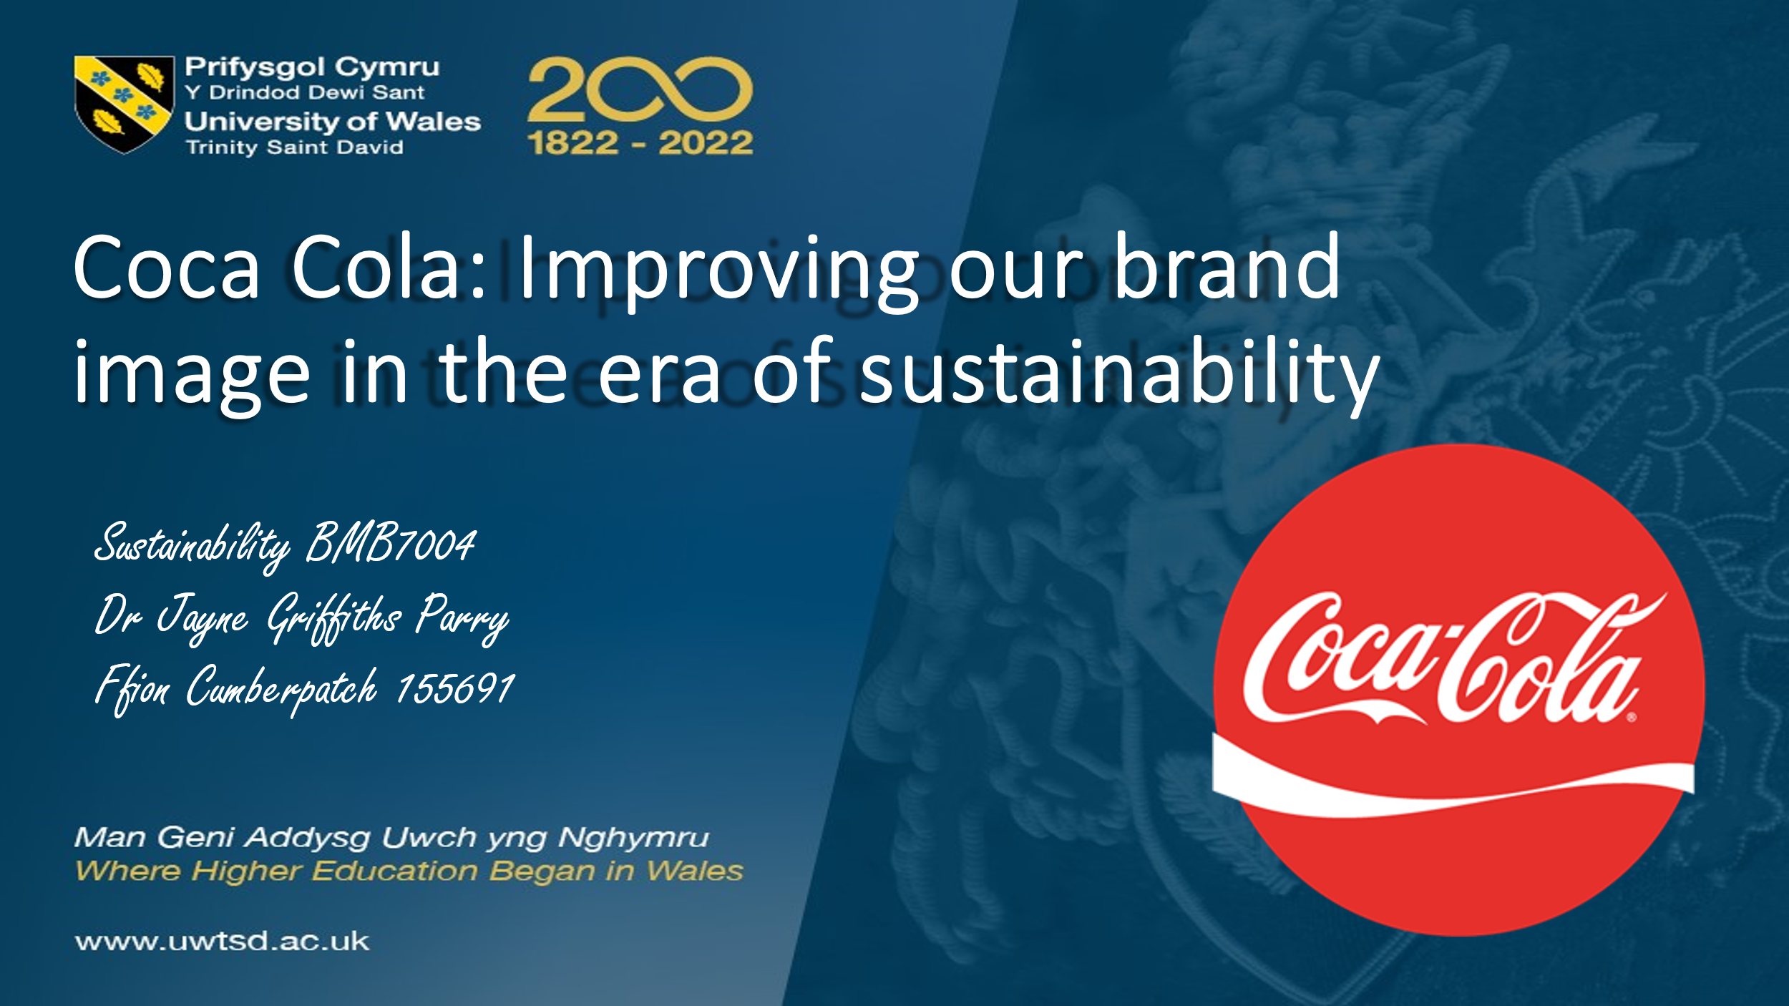
Good afternoon and welcome to a presentation on improving our brand image in the error sustainability. Here at Coca Cola we are very good at doing a lot of things, however, when it comes to sustainability we currently have a negative reputation among our consumers and this is something that we need to rectify.
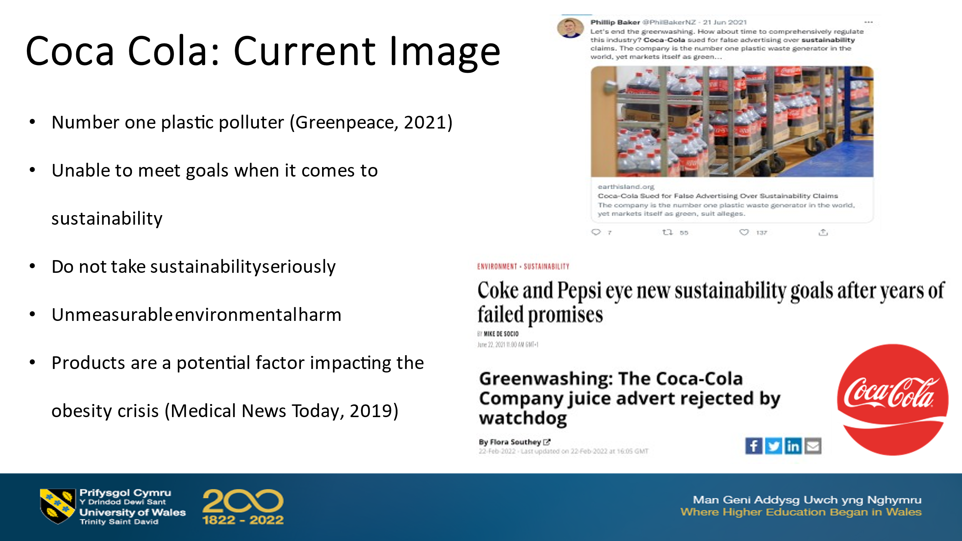
Following research that from the marketing department there is a lot of negative press surrounding Coca Cola and sustainability. According to Greenpeace we are the number one plastic polluter in the world and as we know from recent consumer capaigns, plastic is one of the hot topics at the moment.
Meanwhile we are being seen in the press as unable to meet our goals when it comes to sustainability, some consumers even going as far as to say we do not take sustainability seriously.
According to other sources we do unmeasurable environmental harm and according to several medical journals our products have a major contributor to the obesity crisis.

The definition of sustainable development that you can see here is rather dated, however it still applies today. Here at Coca Cola we need to meet the needs of our present customers without compromising the planet and our communities for our future customers. So that is what we are here to talk word today how can we at Coca Cola take that negative image that we have at the moment when it comes to sustainability and flip it, let’s make Coca Cola known not just for it’s drinks but for it’s sustainable practices.
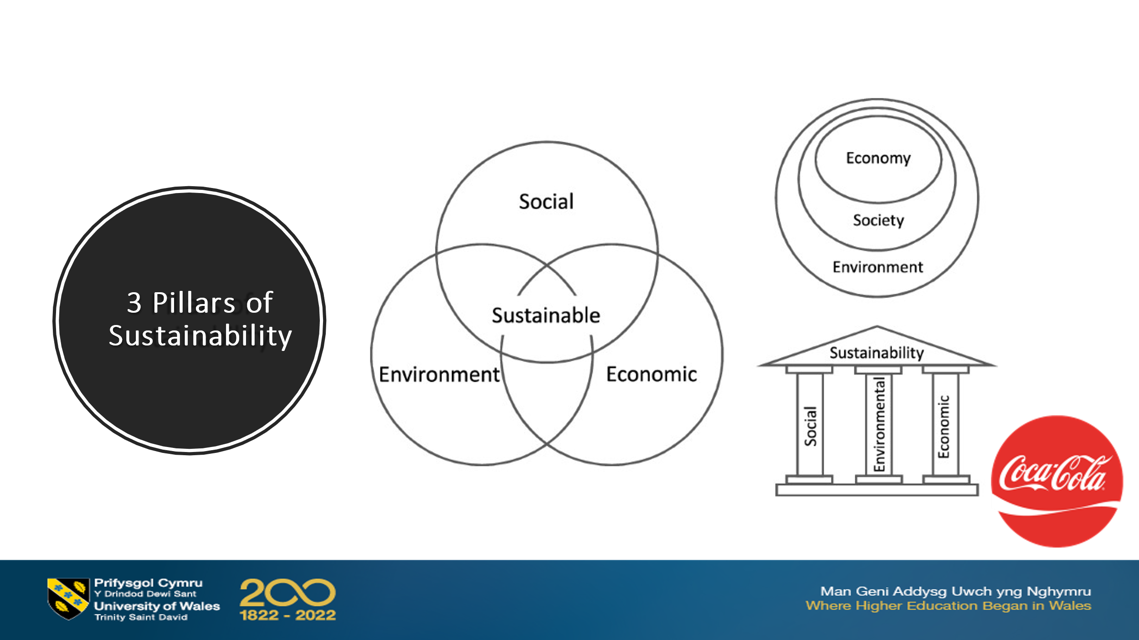
There are three pillars of sustainability we have the social economic and environmental pillars that make up sustainability, now here at Coca Cola we will be focusing our next or our plan on the environmental impact that we have and the social impact that we have.

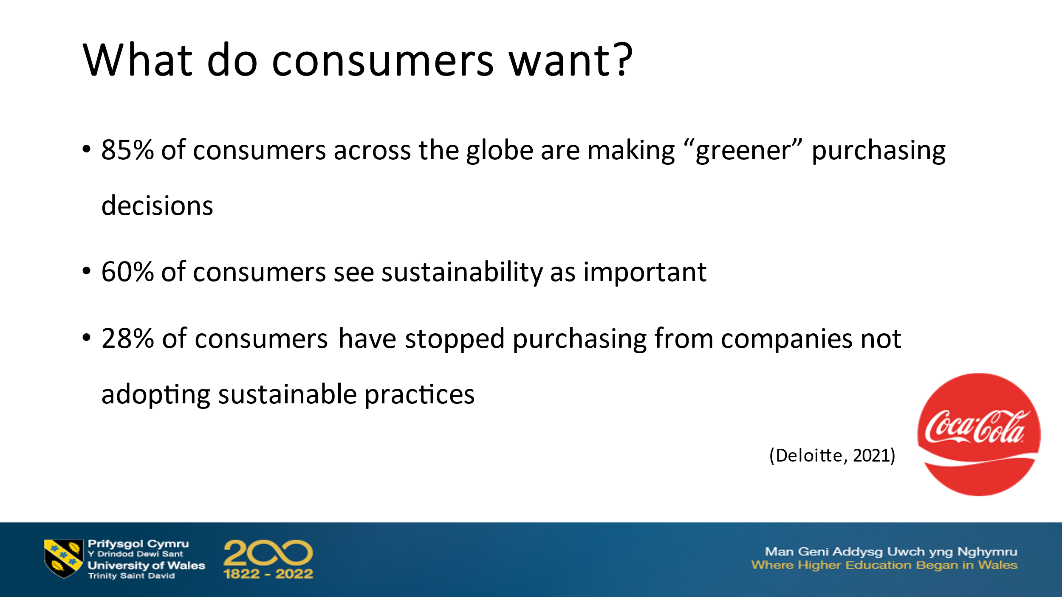
Many studies have been done into consumers and sustainability and here at Coca Cola what we need to do is know exactly what our consumers want. You can see from the statistics here 85% of consumers across the globe and making greener purchasing decisions - 85% that means that here Coca Cola we need to make sure that when our consumers are looking for sustainable products that we have them here and they are marketed effectively. We can also see that 60% of consumers see sustainability as an important factor in a product and 28% of consumers have actually stopped purchasing from companies not adopting sustainable practises - now we do have some sustainable practises in place but it seems from looking at our current image this is not in the forefront of the consumers mind.
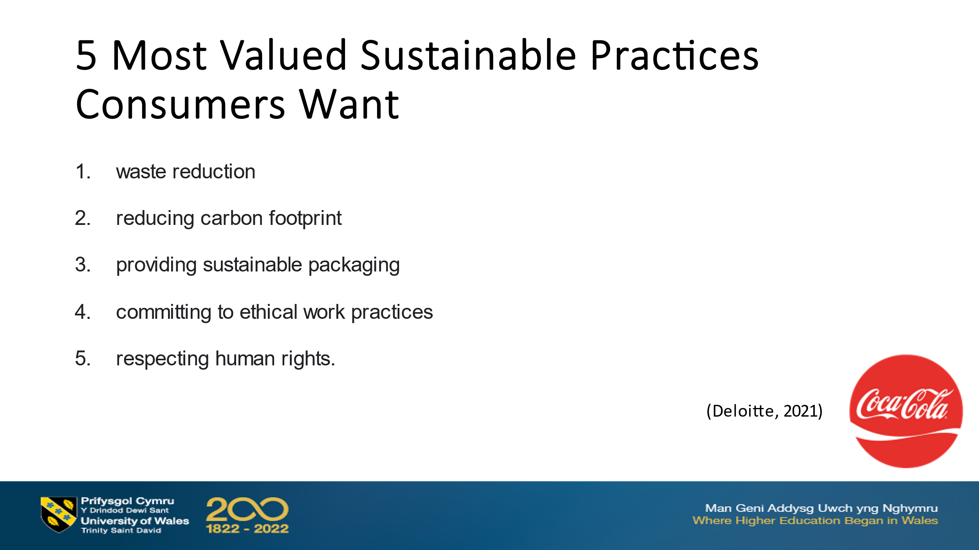
So in order for us to make the changes we need we need to know what sustainable practises our consumers want to see us adopting so here are the five most valued sustainable practises - waste reduction is number one so we need to look at ways in which we can reduce the wastage that we have from creating our Coca Cola products we can also see reducing carbon footprint is incredibly important so one of the things that comes to mind is how we transport our products.
Providing sustainable packaging again another very important factor some places now are considering other methods to package their drinks such as paper. And finally the last two are very much things to focus on in house - committing to an ethical work practise and respecting human rights and so there will be some next steps for human resources.
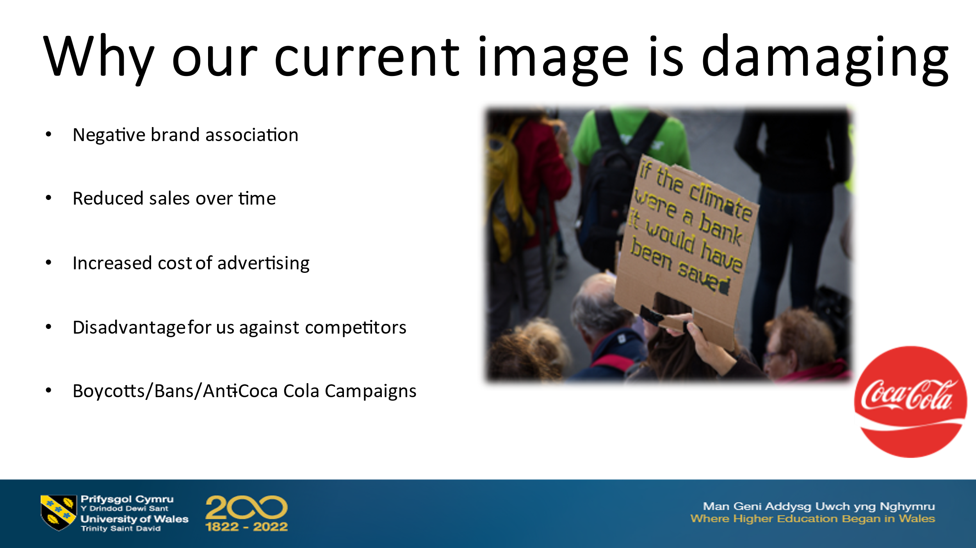
So why is our current image so damaging while when our consumers view us as unsustainable doing damage to the communities the environment and their health then they are they are creating a negative brand association and this can actually reduce our sales overtime which means that there is an increased cost of advertising because we then need to try and change the narrative it's a disadvantage for us against our competitors and it could lead to boycotts bands or anti Coca Cola campaigns.
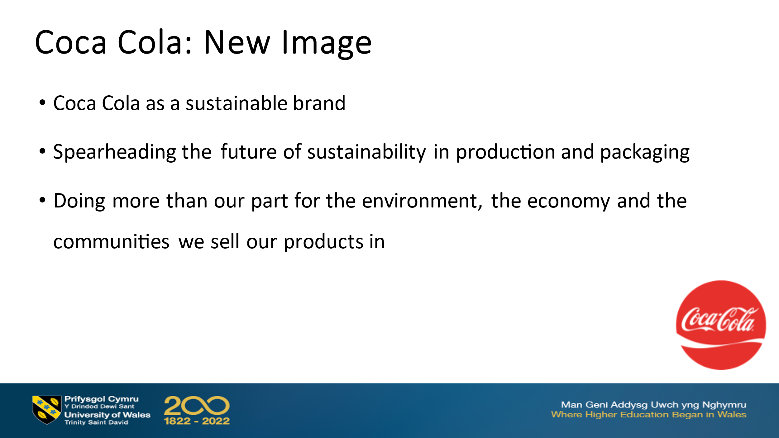
So what is this gnu image that we are trying to sell for Coca Cola well we want to sell Coca Cola as a sustainable brand we want to give the impression that we are spearhead in the future sustainability in production and packaging which will actually get us ahead of our competitors we want to show that we are doing more than our part for the environment the economy and communities that we sell our products in we want to be the benchmark for sustainability in our industry

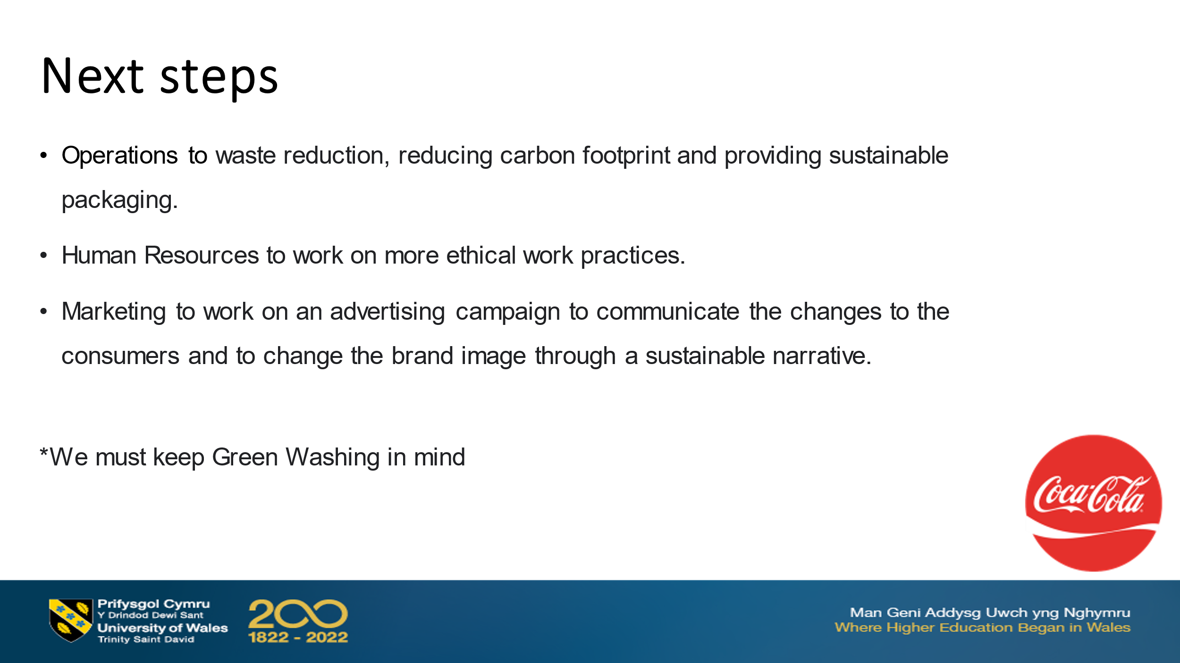
So what are the next steps for us here at Coca Cola well the next steps for us is for our operations team to have a meeting and to discuss ways in which we can reduce our waste our carbon footprint and provide more sustainable packaging.
Next steps for our human resource team is to work on more ethical work practises and finally it'll be up to marketing to work on an advertising campaign to communicate all these changes that we are making to the consumers and to actually change the brand narrative through the brand image through a sustainable narrative
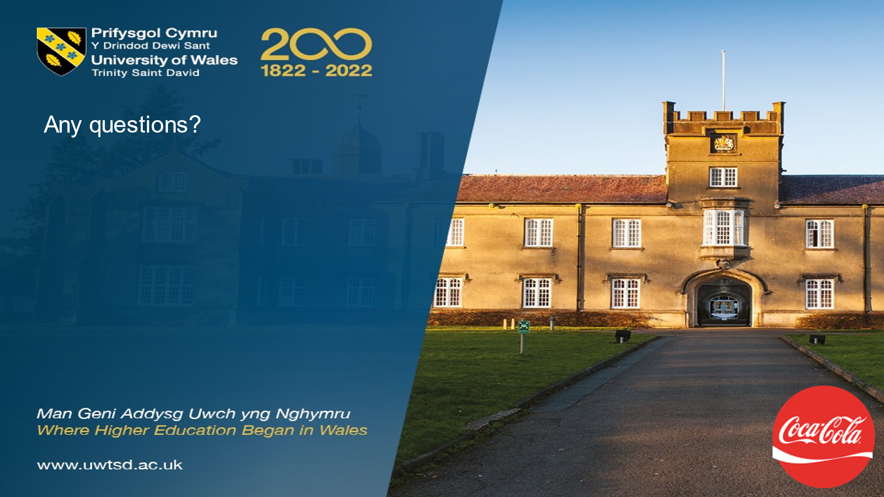

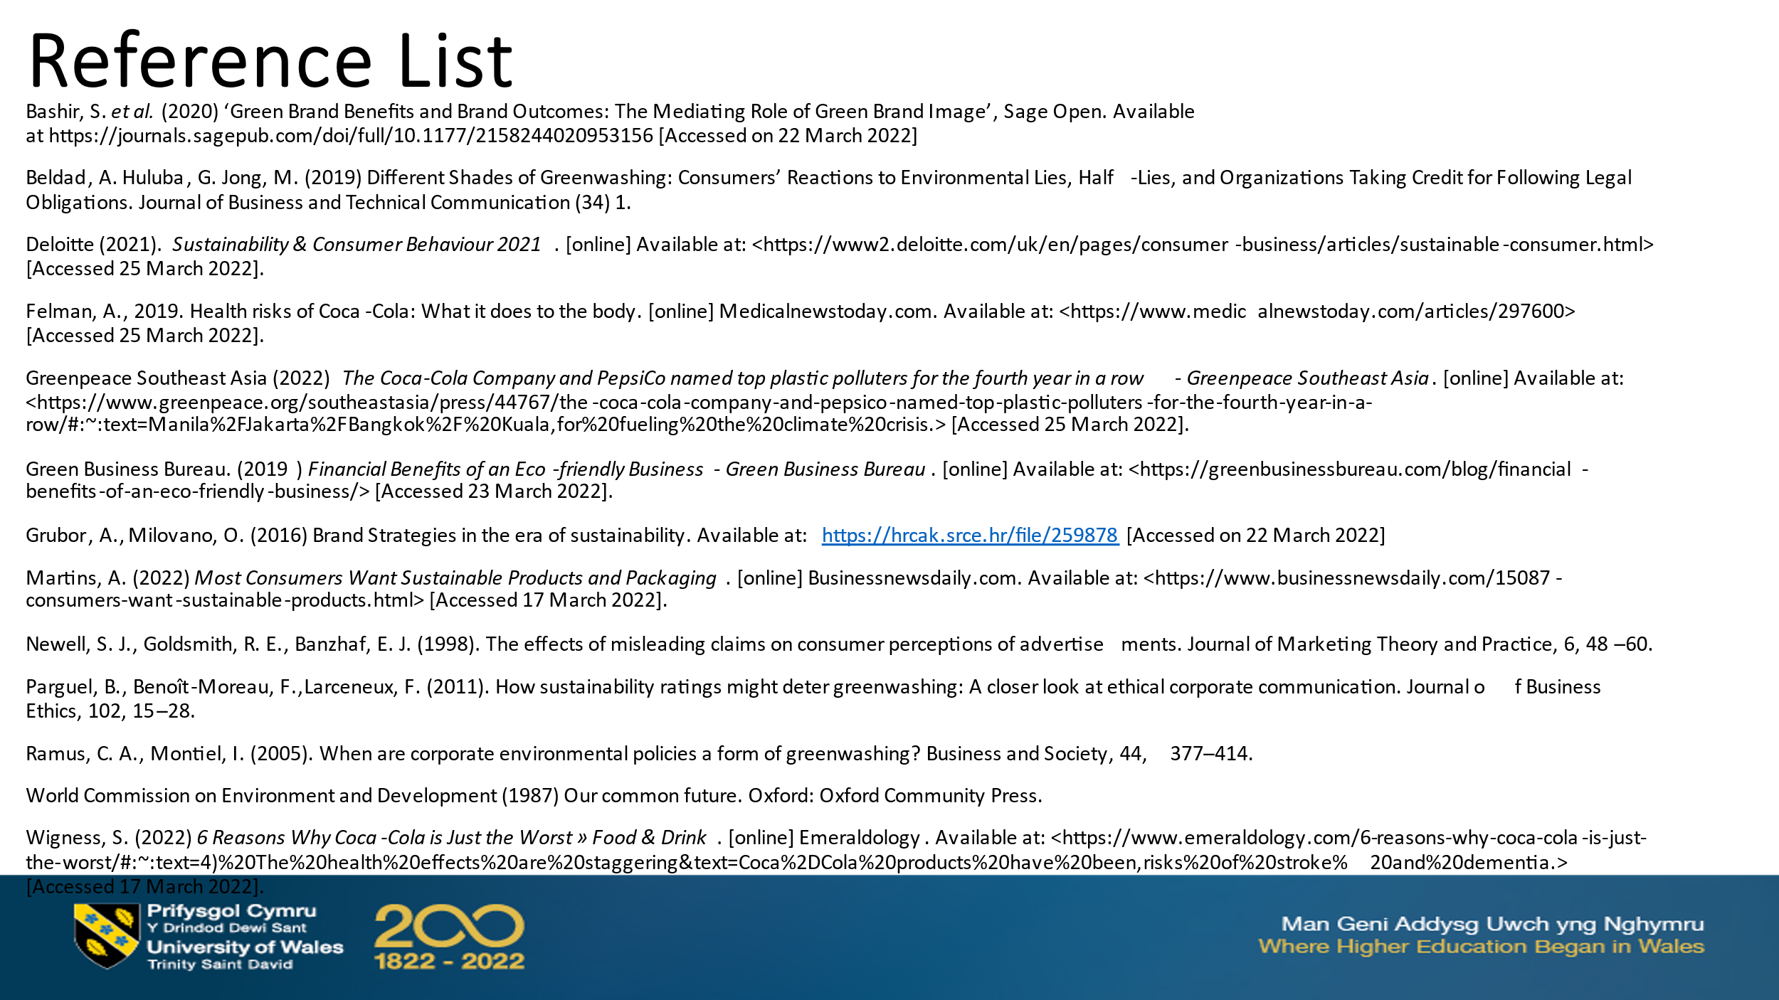

4. Regulatory Affairs and Fiscal and Economic Incentives

Report: What are the Regulatory Affairs, Fiscal and Economic incentives driving sustainability?

Executive Summary
There are many factors currently being used to drive sustainability in the hospitality industry. The purpose of this report is to highlight some of the regulatory affairs and economic incentives currently imposed on hospitality businesses to encourage them to choose sustainable operations. Although there are many incentives and penalties imposed by official organisations and governments, one important factor driving sustainability in most businesses is consumer attitudes and behaviour, after all, consumer led campaigns have been successful in the banning of plastic straws, could consumer led campaigns be the answer to driving sustainability in hotels in future.

Introduction
Policy makers have an important role to play in driving sustainability although opinions are divided. Should there be a focus on imposing bans and penalties or should the focus be fixed on promoting incentives. This report will highlight the regulatory affairs, incentives, penalties as well as fiscal and economic incentives that are currently driving sustainability.

Regulatory Affairs
Legislation is useful when it comes to sustainability as it can assist in regulating the way organisations utilise natural resources, minimise pollution, manage waste, protect ecosystems and human rights (Altenrath, 2021). Since the 1990’s the UK government has introduced many legislation in the name of sustainability.
In November 1990 the Environmental Protection Act was introduced with 164 sections and 9 parts. It covers a wide range of topics including pollution control, waste on land and statutory nuisances. The Environmental Protection Act 1990 has many penalties in place if someone commits an offence. For example there are fixed penalty fines for littering offences, noise pollution and fly tipping. However, it should be argued that these issues are difficult to police and prosecutions are proportionately rare.
In July 2019 the UK Government introduced the Green Finance Strategy (GFS) which aimed to align the private sector with clean, environmentally stable and resilient growth targets to strengthen the competitiveness of the UK financial sector.
Although driving sustainability through legislation is not a new concept it is one not widely advertised to the public. The majority of the legislation exists to encourage businesses to be more sustainable. However, legislation is predominantly used as a last resort which limits it’s effectiveness as a driver for sustainability.
Some examples of legislation being used to drive sustainability is new legislation introduced by Germany which will make it mandatory for the hospitality sector to provide reusable containers instead of single use plastics from 2023 onwards.
Another example is in October 2021, the UK government introduced a ban on supplying single use plastic straws and stirrers. The European Union has also introduced a ban on a series of single use plastics such as cutlery, straws and stirrers. In the USA , some states have followed the example and also started introducing bans on single use plastic.

Economic Incentives
Economic Policy Instruments (EPIs) are incentives that have been created and introduced to create positive behavioural change in organisations to encourage more sustainable practices. EPI's usually include pricing, for example the introduction of water tariffs, environmental taxes and charges, subsidies on products and certain operational practices, permits for disposing of polluted water along with voluntary agreements and risk management schemes.

Fiscal Incentives
Capital allowances on energy efficient items is one fiscal incentive for businesses. This allows companies to claim capital allowances when they purchase any energy efficient, low carbon or zero carbon technology for their business; for example, air source heating pumps or smart light technology. This is a good example of a fiscal incentive as it will reduce the amount of tax an organisation would have to pay (Gov, 2021).
As an incentive for installing HVAC, interior lighting and hot water systems that reduce energy, businesses are able to claim rebates on costs. There are also tax grants of between 10% to 30% for use of alternative energy properties as well as tax credits available for vehicles that meet fuel efficient standards such as hotel cars or minibuses. Furthermore, there is also bonus depreciation for qualified recycling and reuse of equipment (Green Business Bureau, 2019)
It is not only the government offering incentives for businesses choosing to implement sustainable practices. The Small Business Administration (2021) offers financing solutions to businesses supporting green technologies and The Environmental Protection Agency provides grants for environmentally friendly business operations (Gov, 2021).

Fiscal Penalties
The Climate Change Levy (CCL) is one form of regular penalty a organisation may face. If an organisation is using a significant amount of energy, they may need to pay a rate back to the government, although many organisations pass this cost onto the consumer through pricing. However, businesses may apply for a 90% reduction for electricity and a 65% reduction for gas on the CCL rate provided they are an energy intensive business but have signed a climate change agreement with the Environment Energy (Gov, 2021).
All over the world Carbon pricing initiatives are also in place in more than forty-five countries shifting the cost of emissions back to organisations. This initiative allows organisations to decide whether they will alter their operations and lower their emissions or whether to continue emitting and pay for their emissions instead (World Bank Group, 2017. This means that most organisations can choose between the sustainable route or the unsustainable route. It is a matter of choice and conscience for hoteliers to actively choose the sustainable route and make changes when it comes to this initiative.
There is also the Streamlined Energy and Carbon Reporting (SECR) Framework where large organisations such as hotel companies report their energy consumption to the government to encourage the implementation of energy efficient measures that are sustainable for the environment and the economy (Gov, 2022).
SECR builds on, but does not replace, existing requirements that companies may face such as mandatory greenhouse gas (GHG) reporting for quoted companies Energy Saving Opportunity Scheme (ESOS), Climate Change Agreements (CCA) Scheme, and the EU Emissions Trading Scheme (ETS). SECR extends the reporting requirements for quoted companies and mandates new annual disclosures for large unquoted and limited liability partnerships (LLPs) (Carbon Trust, 2019).

Other Considerations
Consumer behaviour and spending power has some control over organisations in relation to sustainability, for example, consumer led campaigns such as the elimination of plastic straws, encouraged businesses as well as industries to consider the impact their practices may have on the environment (Dabrowska et al, 2021). Consumers have a degree of influence and are able to drive change as they expect their feedback to be considered especially in relation to sustainability.

Conclusion
There are many regulatory affairs, fiscal and economic incentives driving sustainability in the hospitality industry. However, there is a lot of responsibility with policy makers to bring in regulations, incentives and bans to drive sustainability further and more rapidly, unfortunately this is difficult as the introduction of regulations and penalties are usually used as a last resort. Therefore, the consumer led campaigns that may be considered as catalysts for more sustainable creativity and innovation within the hospitality industry.

Reference List
Altenrath, F., (2021). Sustainability-driven legislation: setting the right conditions for hospitality?. [online] Hospitality Net. Available at: <https://www.hospitalitynet.org/viewpoint/125000094.html> [Accessed 18 March 2022].

Berger-Walliser, G., Shrivastava, P. & Sulkowski, A. (2016). Using Proactive Legal Strategies for Corporate Environmental Sustainability, Michigan Journal of Environmental & Administrative Law, 6(1), 1-27

Lubowiecki-Vikuk, A., Dąbrowska, A., & Machnik, A. (2021). Responsible consumer and lifestyle: Sustainability insights. Sustainable production and consumption, 25, 91–101.

Legrand, W (2019) Who makes hospitality sustainability happen: Governments, Industry, Consumers? Available at: https://www.hospitalitynet.org/viewpoint/125000024.html [Accessed on 22 March 2022]

GOV.UK. (2022). Environmental taxes, reliefs and schemes for businesses. [online] Available at: <https://www.gov.uk/green-taxes-and-reliefs> [Accessed 23 March 2022].

Green Business Bureau. (2019). Financial Benefits of an Eco-friendly Business - Green Business Bureau. [online] Available at: <https://greenbusinessbureau.com/blog/financial-benefits-of-an-eco-friendly-business/> [Accessed 23 March 2022].
Molthan-Hill, P. (2014) The Business Students Guide to Sustainable Management: Principles and Practice. Sheffield: Greenleaf Publishing Ltd
The Carbon Trust. (2019). SECR explained: Streamlined Energy & Carbon Reporting framework for UK business. [online] Available at: <https://www.carbontrust.com/news-and-events/insights/secr-explained-streamlined-energy-carbon-reporting-framework-for-uk> [Accessed 23 March 2022].

Weybrecht, G. (2014) The Sustainable MBA: A Business Guide to Sustainability. 2 edn. West Sussex: Wiley & Sons

World Bank Group (2017) State and Trends of Carbon Pricing. World Bank. Available at: https://elibrary.worldbank.org/doi/abs/10.1596/28510 [Accessed on 21 March 2022]

5.Sustainability in the future

Reflective Essay: The future of sustainability in the hotel industry
We are currently in the era of sustainability, now more than ever consumer behaviour and attitudes towards sustainability are making organisations make greener choices when it comes to their products or services (Iqbal, 2018). As a hospitality professional for the majority of my early career and now subsequently lecturing on the topic of hospitality I have noticed first hand the increase in eco and green hotels such as The Rockway Hotel in Queens, Azumi Setoda in Japan and Xigera Safari Lodge in Botswana. These are properties focusing on not just the environmental pillar or sustainability but also the social pillar of sustainability (Purvis, 2018). Brands focusing on more than just environmental sustainability will have an advantage.
In the future we can expect to see consumers choosing the most sustainable brands for their products and services, after all we have already seen this begin to happen in recent surveys (Deloitte, 2021). Consumers are choosing sustainable hotels over unsustainable hotels, however, in my experience even consumers staying in unsustainable hotels are disappointed when coming face to face with unsustainable practices and often mention it in their reviews or on their comment cards. They are disappointed to see single use plastics being used or bins overflowing with no recycling options. Based on previous research and experience, the hotels with a green brand image and matching sustainable practices will be the ones consumers spend their income on.
Guest experience must be a consideration in future when hoteliers consider implementing new and innovative sustainable amenities. Sustainable amenities that negatively impact the guest experience through restriction will not be welcome, even if it is for the good of the environment. Guests do not want to compromise comfort and convenience for more sustainable amenities. Therefore hoteliers need to seek sustainable amenities that enhance the guest experience but at a smaller cost to the environment. In my experience with guests “sustainability” is not a satisfactory reason for uncomfortable temperatures, a lack of lighting or a good water pressure. In future sustainability will be an expectation rather than a commodity.
There is legislation, economic and fiscal incentives already in place to drive sustainability into the future, however, as discussed in a previous part of this portfolio legislation is usually the last resort. As hoteliers I believe that we should not do the bare minimum when it comes to sustainability and we should not wait for legislation to come into place before we take action. We must listen to our consumers, take their feedback on board, look at our competitors and what they are doing along with the most sustainable hotels in our industry and ask the question: What more can we do?
In a world where consumers are seeking greener products and services many hotels are already focusing on being more sustainable. However, we must now look to the future of sustainability and create a plan for being more sustainable for the environment, for the economy and for the communities we have hotels in.

Reference List
Cetron, M.J., Davies, O., DeMicco, F. and Song, M. (2020), "Shaping the future of hospitality and travel: trends in energy, environmental, and labor force and work", International Hospitality Review, 34 (2), pp. 129-152.
Globetrender. (2016) 2060 forecast: 14 innovations for the hotel of the future. [online] Available at: <https://globetrender.com/2016/12/14/hotel-of-the-future/#:~:text=Many%20hotels%20already%20focus%20on%20being%20eco-friendly%20but,geothermal%20technology%20and%20have%20a%20carbon%20neutral%20footprint.> [Accessed 25 March 2022].
Iqbal, Q. (2018) The Era of Environmental Sustainability: Ensuring That Sustainability Stands on Human Resource Management. Global Business Review.
Karpagram, M., Jaikumar, G. (2010) Green Management: Theory & Applications. New Delhi: Ane Books
Levy, E. Parra, D. (2021) Environmental approach in the hotel industry: riding the wave of change. Sustainable Futures. 3.
Martínez-Martínez, A., Cegarra-Navarro, JG., Cobo, MJ., Valon, T. (2022) Impacts and Implications for Advancing in Environmental Knowledge in Hospitality Industry in COVID Society: a Bibliometric Analysis. Journal of Knowledge Economy.
Melissen, F. Cavagnaro, E., Damen, M., Dueke, A. (2015) ‘Is the hotel industry prepared to face the challenge of sustainable development? Journal of Vacation Marketing, 22(3), pp. 227–238.

Midgett, C., Deale, C. Crawford, A., Weber, M., Bendickson, J. (2020) ‘A cross-case analysis of barriers to sustainability in small tourism accommodation enterprises in Dare County, North Carolina’, Tourism and Hospitality Research, 20(2), pp. 144–156.
Pollack, S (1995) Improving Environmental Performance. London: Routledge
Purvis, B., Mao, Y. and Robinson, D. (2018) Three pillars of sustainability: in search of conceptual origins. Sustainability Science

