  Assignment 2  Learning in the Digital Era | Abstract  Module Name: Learning in the Digital Era  Module Code: ACCA 4025  Student Name: Damian Szast  Student ID: 253630  Group: 3  Lecturer’s Name:  UNIVERITY OF WALES TRINITY SAINT DAVID  LONDON CAMPUS

Table of Contents
Introduction 2
Cover page 2
Conclusion 8
References 8

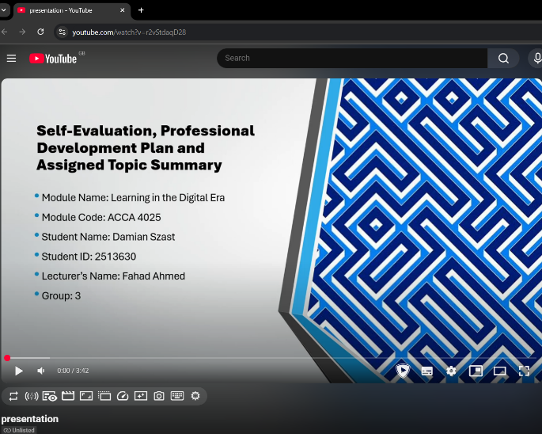

Introduction
This report is mostly about self-evaluation and professional development. I used reflective practice to identify strengths and things to improve. It was supported by a Professional Development Plan (PDP) with SMART goals. The report also summarises key learning concepts from Unit 4, emphasising the importance of reflection and continuous improvement.

Cover page
This report presents a self-evaluation and professional development plan based on reflective practice.
Video Link: https://www.youtube.com/watch?v=r2vStdaqD28

Presentation link: A presentation on Self-Evaluation, Professional Development Plan and Topic Summary.pptx
Slide 1 COVER PAGE
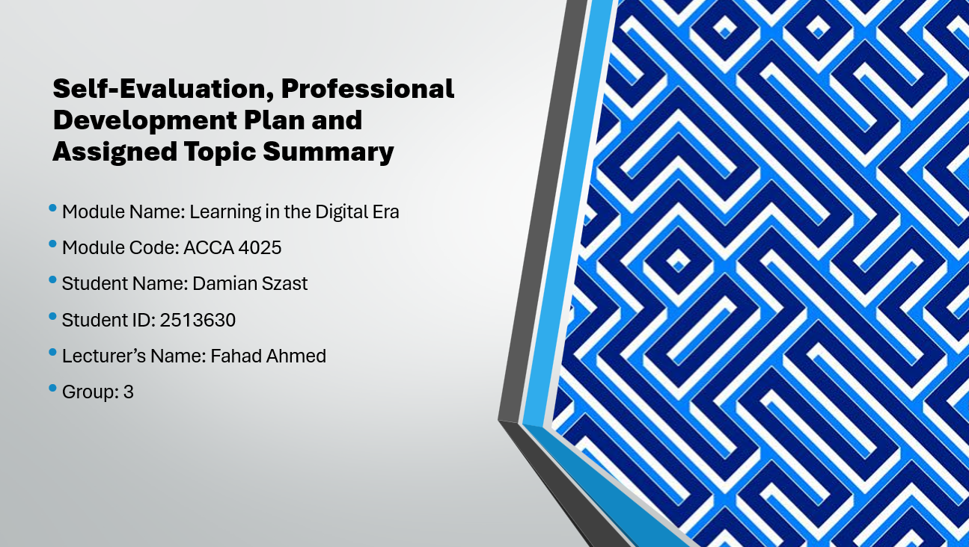
Slide 2 CONTENTS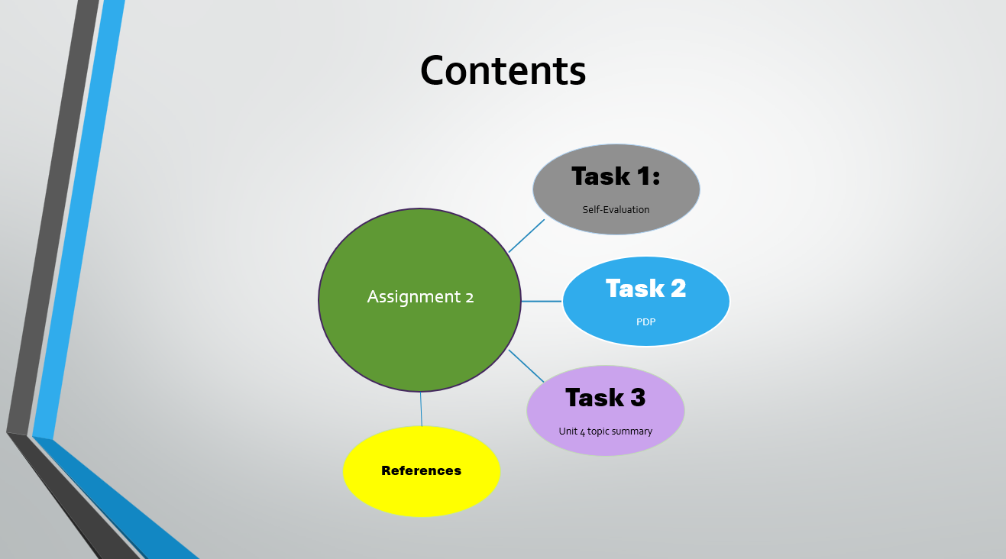
Slide 3 INTRODUCTION


Slide 4 GIBB’s REFLECTIVE MODEL
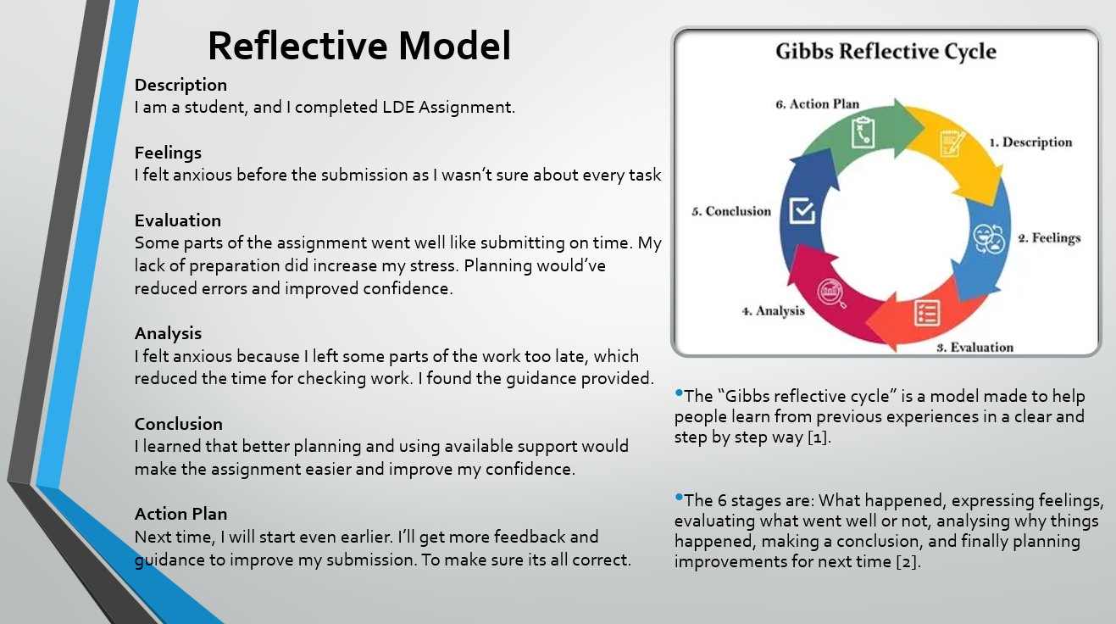
Brief explanation: Gibbs Reflective Cycle is a tool that helps one think about what happened by going through six steps: description, feelings, evaluation, analysis, conclusion and the action plan [1]. In my work for this task, my model told me to think about what I learned. Also, how feelings like fear made me do worse, and how I can do better. I looked at what made me anxious and saw that making more time and preparing helped me explain what I learned and what I still need to learn [2]. I will use this thinking in my next assignment so I can plan and keep doing better work.
Slide 5 TASK 1: SELF EVALUATION
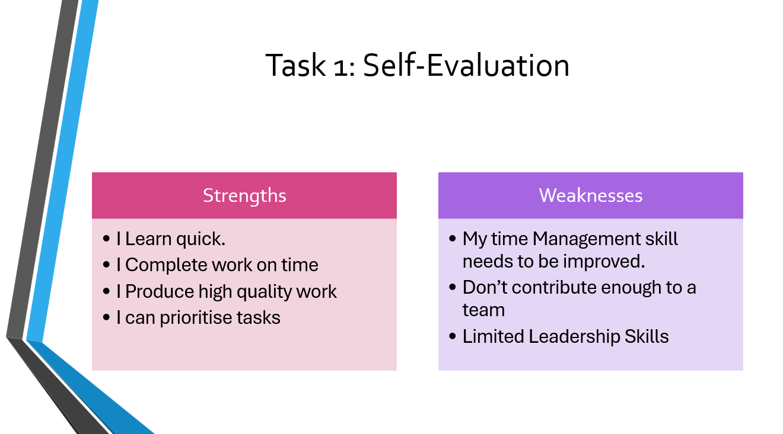
Brief explanation: The self-evaluation using SWOT analysis, helped find key strengths such as completing work on time and producing high-quality work. It also helped find weaknesses including time management, teamwork contribution and leadership skills. Recognising these areas gives a good foundation to improve and help with professional development.

Slide 6 TRAITS GAINED FROM THE SELF EVALUATION
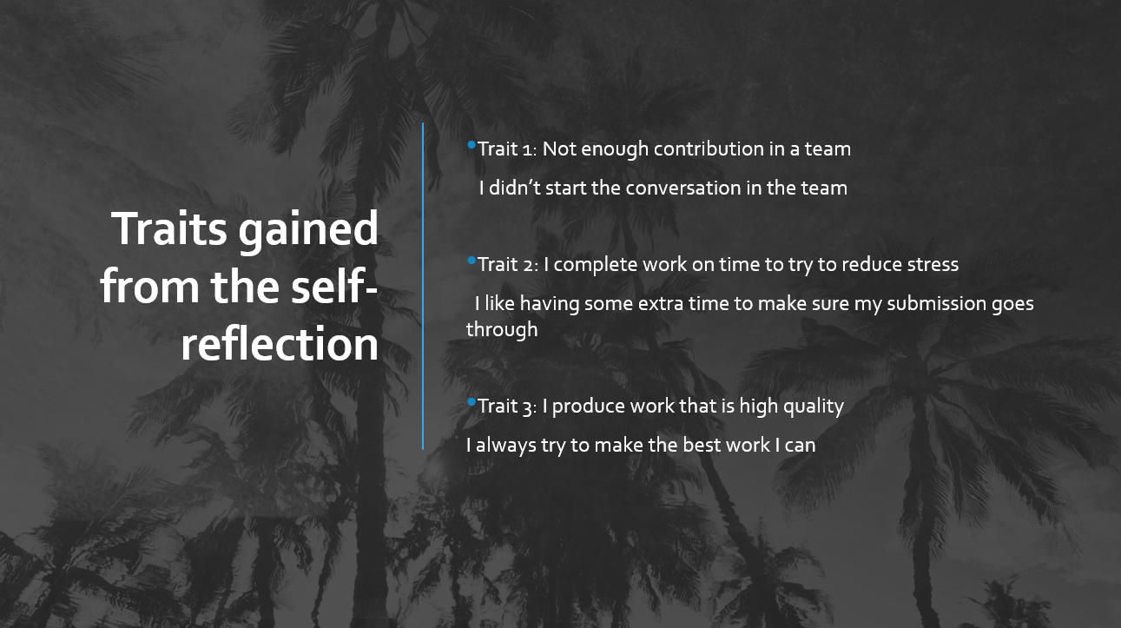
Brief explanation: I found the traits above from self-reflection. The improvement and positive habits such as timely completion and producing high-quality work.

Slide 7 PROFESSIONAL DEVELOPMENT PLAN
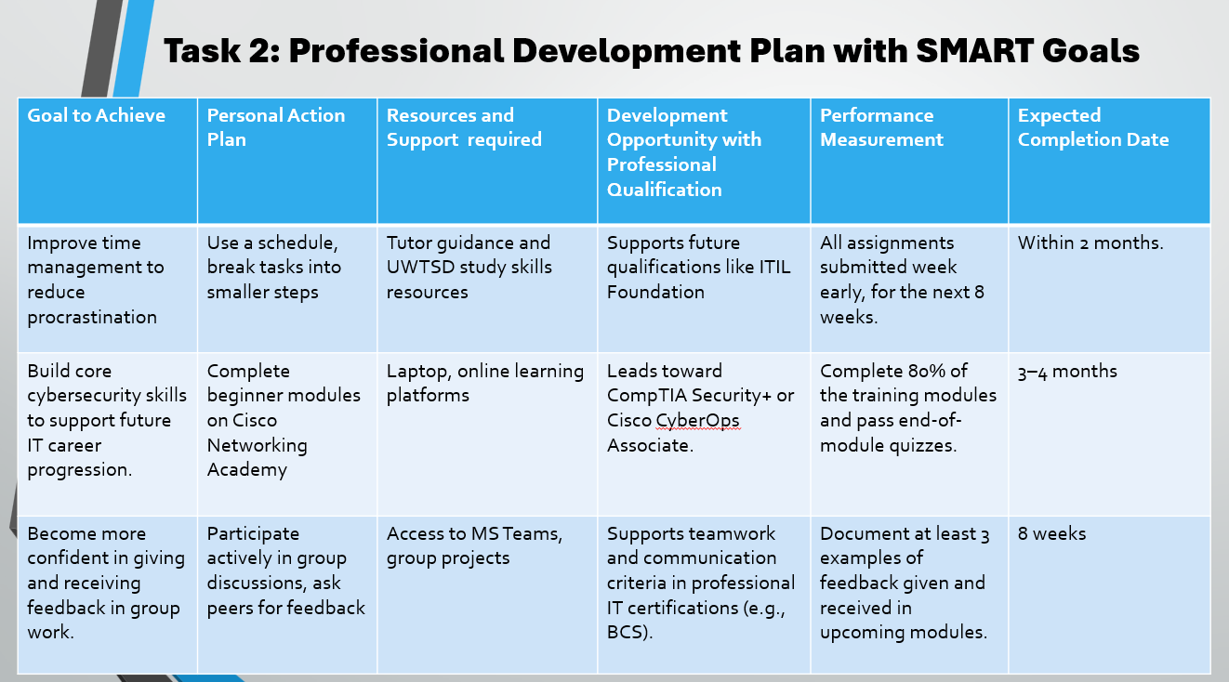
Brief explanation: This plan uses SMART goals to identify “actions” resources and future career progression.

Slide 8 UNIT 4 TOPIC SUMMARY
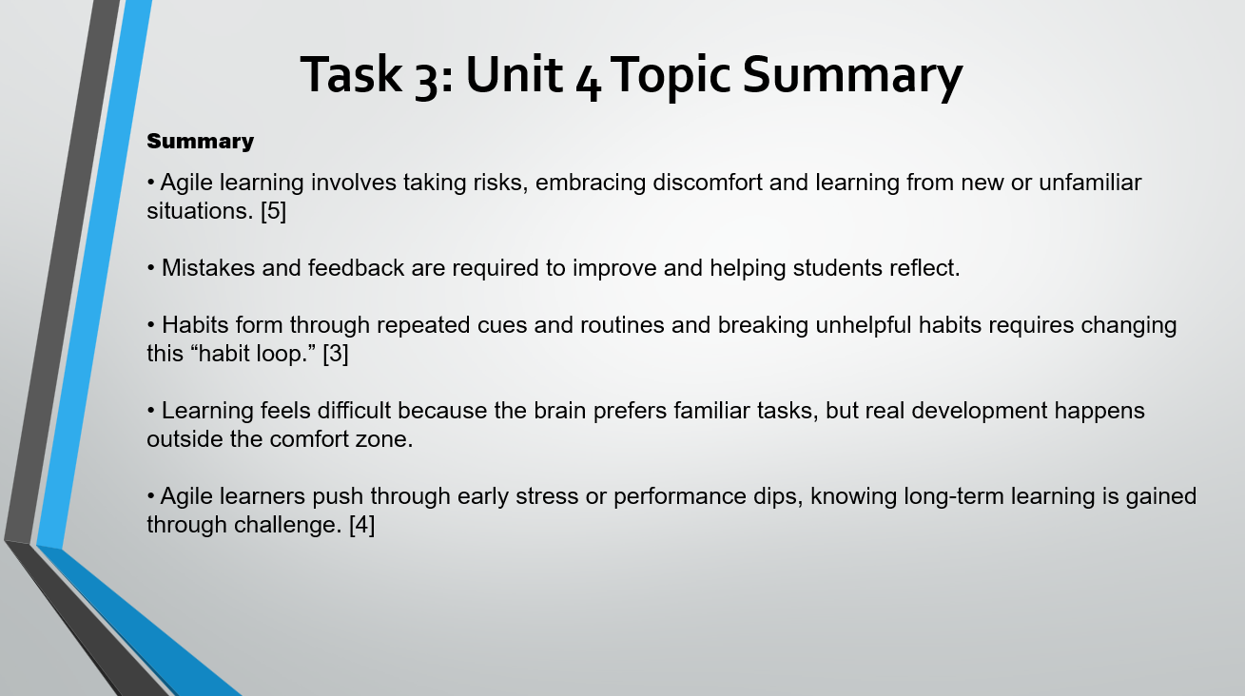
Brief explanation: The main ideas from Unit 4, focusing on agile learning, habits and feedback. Showing how learning often happens when working outside your comfort zone.

Slide 9 CONCLUSION
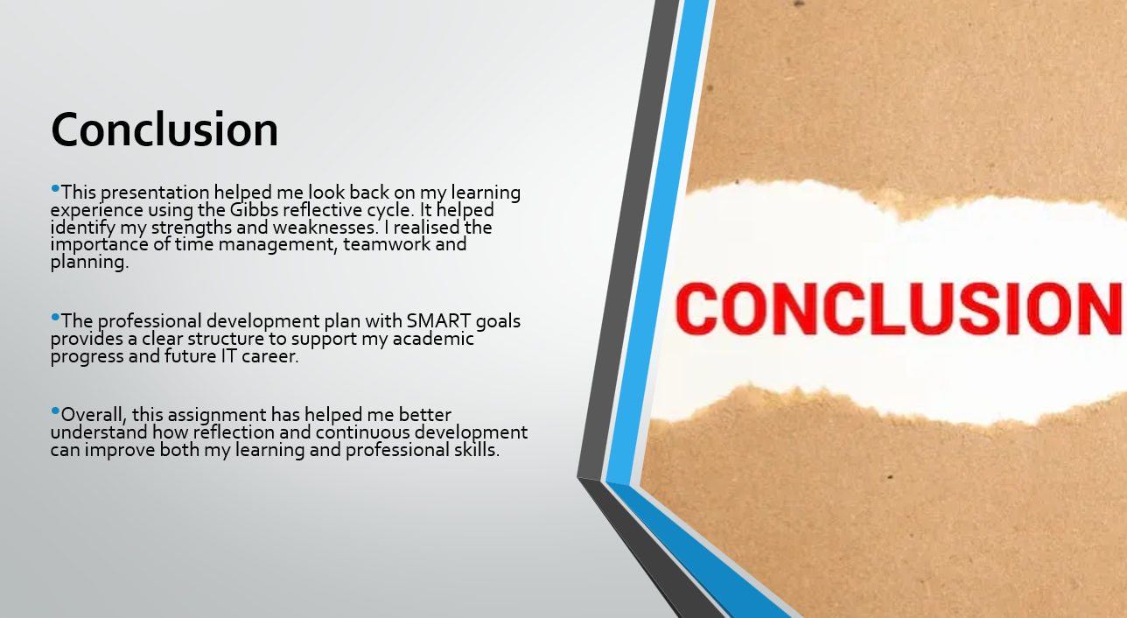
Brief explanation: This conclusion brings together the main ideas/points from the reflection, development plan and topic summary. It shows how the assignment has supported my learning and future development.

Slide 10 - References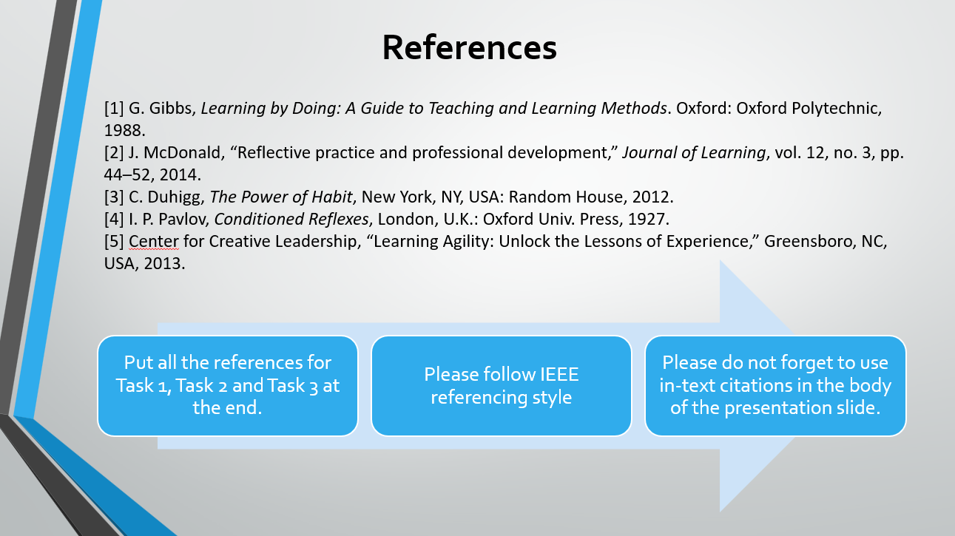

Conclusion
This report has looked at myself and tried to think about self-evaluate, reflective, and professional development to more people to understand more about what i am good at and what can I work on to get better and stronger. Also using reflective practice and setting smart goal, I was able to find clear goals that can support me in my academic success and career in the future. This report is all about why reflection is very important and how doing reflective practice can help you with professional and learning skills.

References
[1] G. Gibbs, Learning by Doing: A Guide to Teaching and Learning Methods. Oxford: Oxford Polytechnic, 1988.
[2] J. McDonald, “Reflective practice and professional development,” Journal of Learning, vol. 12, no. 3, pp. 44–52, 2014.
[3] C. Duhigg, The Power of Habit, New York, NY, USA: Random House, 2012.
[4] I. P. Pavlov, Conditioned Reflexes, London, U.K.: Oxford Univ. Press, 1927.
[5] Center for Creative Leadership, “Learning Agility: Unlock the Lessons of Experience,” Greensboro, NC, USA, 2013.

