Effective Team Working and Communication (BMSW4002_LON)

Lecturer: Toyin Adisa
Student Team Leader: Marian Ursu (1916878)
Student: Ana Merlan (1917636)
Student: Cristian Sturzu (1916726)
Student: Calin Hortolomei (1917705)
Student: Alexandru Bucur (1915902)

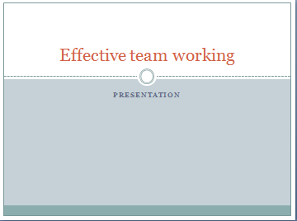

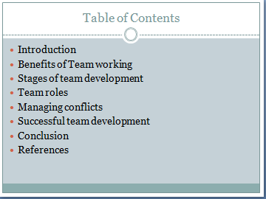

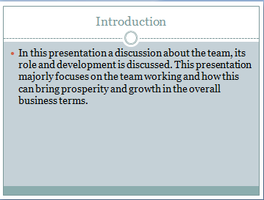

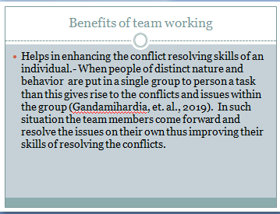
Team working enhances the sense work and culture amongst the individuals. Independent work done by any personnel is necessary but on the other hand when the individuals unite as a team then values of the individuals are added and thus delivering better results and efficiency (Johnson, 2017).

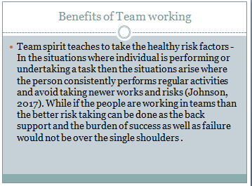

In the situation where the projects are highly uncertain and risky than the team operations are beneficial and highly influential in delivering better results to the situation.

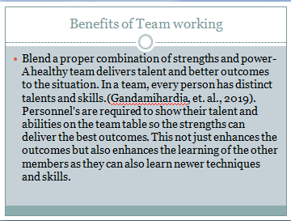

A team can be stronger and prosperous if every individual gives their entire skills and abilities. The back support and the diversified skills of a team can make a team prosper and grow consistently and attain established goals more efficiently (Gandamihardja, et. al., 2019).

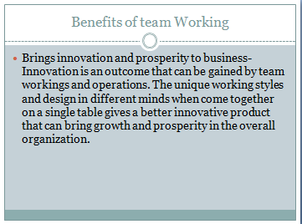

No business can gain innovation if the solo working and constant path of working is followed in the business. When teams are created, people come together with different opinions and thus giving better outcomes with better team spirit and dedication towards the work.

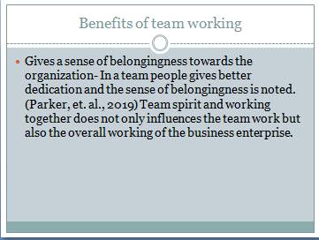

No business can prosper in long run if its employees do not regard the work place as a place of their own. This dedication of a person is gained from the team spirit and strength that they gain by working together as a single unit (Parker, et. al., 2019).
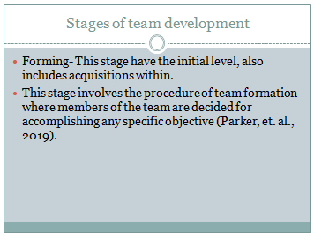

Team development is majorly categorized into major five stages as stated above. To develop a team there are certain major changes that ahs to be undergone by the individuals and by the team as a whole (Black, et. al., 2019). A standard attitude, behavior and ability of the individuals have to be created to bring consistency in the team.

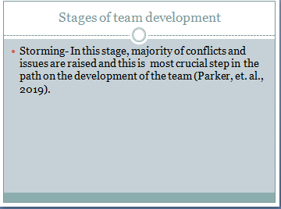

This is a stage of conflict arising. Here, the team members are introduced to one other and the uniqueness in their thinking process and working structure results in the conflicts (Parker, et. al., 2019). This stage has to be performed and dealt with easily and the team is dependent over this stage.

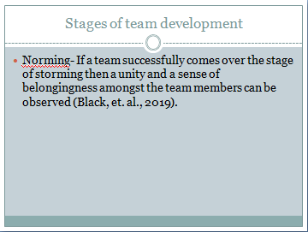

After the conflicts and issues, the team members come forward to resolve them, if resolved successfully then the team members build a good sense of belongingness towards the team, its members as well as the organization for which they are working.

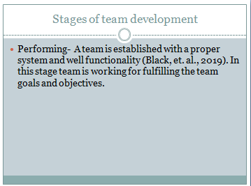

This stage is the stage in which actual working of the organization is seen. In this stage team members come as a single unit and try to accomplish their tasks and work within time so that their overall aim and objective could be fulfilled (Parker, et. al., 2019).
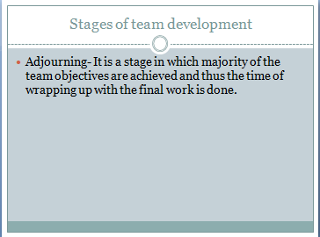
This is the final stage of team development, in this the teams is done with the majority of their work and soon the team is going to end as the tasks given would be accomplished and also the purpose of the team (Gren, et. al., 2020).

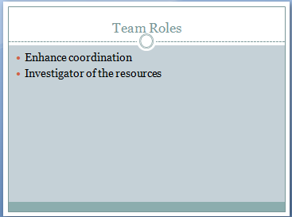

To have a proper balance in the team it is essential that proper roles of the team are given so that the organization can gain better outcomes (Lehmann-Willenbrock, et. al., 2016). Team roles give a proper framework of the team and the obligations that they have over.

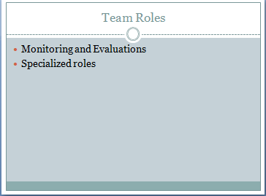
The role of a team is not just specific to one area rather they try to perform and accomplish majority of the areas for attain their ultimate goals.
A proper bifurcation of the team roles and working is done so no chaos occur at the time of final results (Gren, et. al., 2020). A proper authority and responsibility should be delegated with a proper monitoring and evaluation of the operations that are done on both individual as well as on team basis.

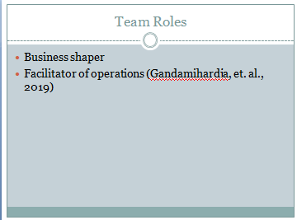
A team is considered as a part that is shaping the business and its operations so the better outcomes from the business can be gained in a proper form (Sapsed, et. al., 2012. ).
A team is the one that facilitates and delegates the operations within that are helpful in making the ultimate goals fulfill and make the organization prosper and grow.

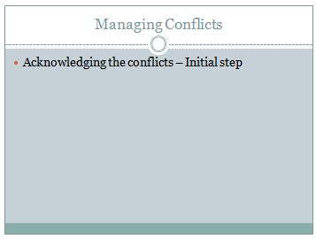
In a team conflicts are observed and noted commonly. There are number of people in a team and conflict in their opinions and thoughts can give rise to the conflicts amongst thee work and the entire team (Khamkhong and Tayco, 2018). The organization shall train the employees with proper cooperation, communication skills and other better practices to reduce the number of conflicts.

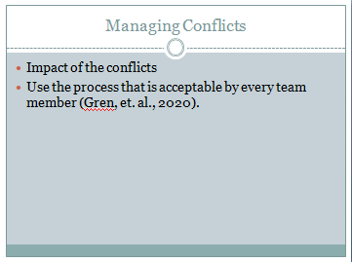
In these stages, the effect that the conflict can have over the business is identified. It is necessary to understand the effect that these conflicts can have so that the conflicts with severe impact can be dealt early as compared to the other conflicts (Gren, et. al., 2020). To resolve the issue the idea and the chosen techniques should be in accordance that is highly acceptable and taken up by the people of the team. If the issue is not resolved with a common idea or technique that t may result in major impact of the conflicts.

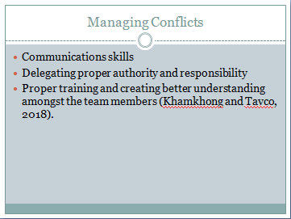
To have a better resolution of the conflicts an efficient and effective communication skills have to be performed so that the thing can be made understandable to every member of the team and thus inspiring them to move on a common path (Gandamihardja, et. al., 2019). Chosen communication skills and the form plays a crucial role in managing the issues more efficiently. The conflicts arise because of unclear authority and responsibility distribution and thus making them clear can also eliminate some of the issues.
The business house can also go for having a situation where the team can have a good and improved understanding of the situation and also make the things better (Lehmann-Willenbrock, et. al., 2016).

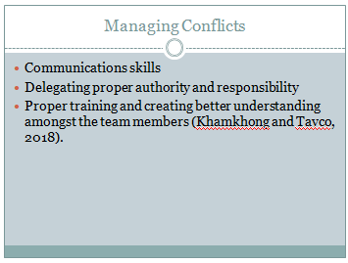
To have a better resolution of the conflicts an efficient and effective communication skills have to be performed so that the thing can be made understandable to every member of the team and thus inspiring them to move on a common path (Gandamihardja, et. al., 2019). Chosen communication skills and the form plays a crucial role in managing the issues more efficiently. The conflicts arise because of unclear authority and responsibility distribution and thus making them clear can also eliminate some of the issues.
The business house can also go for having a situation where the team can have a good and improved understanding of the situation and also make the things better (Lehmann-Willenbrock, et. al., 2016).

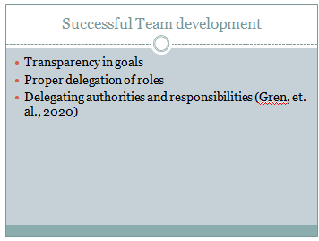
The work and the outcomes of the team can be proper and reliable only if a proper team and its proper development is observed. To have a successful team development the organization has to take all the team members on a same board (SHARMA, 2019). Growth of the team as well as of the organization can only be seen if the proper development in the team is observed (SHARMA, 2019).

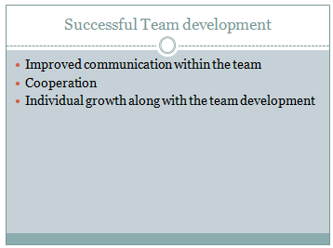
The development of the team increases with improvement in the communication skills among the team members. Cooperation among the team members plays an important role in the development of team and also results in effective and efficient work (Gren, et. al., 2020). The cooperation and coordination amongst the team members results in development in of the team as well as every individual working in the team. If a team leads to a successful development and proper coordination among the team members, the team can achieve every goal effectively and efficiently.

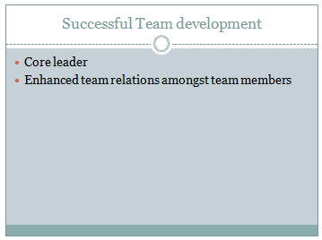
A team can develop only if the leader is effective. A leader plays a crucial role in organizing the team as a whole and can also prosper the team spirit (Sapsed, et. al., 2012). If a team is managed in a successful form than it can also deliver the better working and the unity amongst the team. Unity can bring better results and enhanced outcomes from the team as a whole.



