
Module: Psychological Classifications and Provisions
Module code: BMHP6029
“Understanding Autism Spectrum Disorder: A Critical Analysis of Classification, Treatment, and Rehabilitation”
Student Name: Ioana Popa
Student ID:2313594

Table of Contents
1. Introduction 3
2. Classification and Diagnosis 3
2.1. Classification in ICD-11 3
2.2. Diagnostic Criteria 4
2.3 Critical Analysis 4
3. Treatment and Rehabilitation 5
3.1 Technical Standard Treatment 5
3.2. Rehabilitation Measures 5
3.3 Critical Evaluation 5
4. Historical vs Contemporary Provision 6
5. Present Discussions and New Problems 7
6. Recommendations 7
Conclusion 8
References 10

1. Introduction
Autism Spectrum Disorder (ASD) is a neurodevelopment disorder that is also marked by enduring impairments of social communication, interaction, and the occurrence of limited and repetitive behaviors or interests (Alsbakhi et al., 2025). The condition has a spectrum of occurrence between mild and severe, impaired cognitive functioning, and language skills, thus posing special diagnosing, treating, and supporting challenges. The research on autism in the framework of mental and behavioral disorders is critical because it is associated with cognitive, emotional, and social development, affecting education, healthcare provision, and community reintegration (Ahmed et al., 2025). This report is aimed at critically analysing ASD and paying attention to classification based on ICD-11, diagnosis criteria and treatment plans, and rehabilitative actions. The report will also look into modern controversies and new challenges in autism research, especially in the areas of early detection, computer applications and service accessibility. Through the review of existing literatures and clinical practices, this report will seek to offer a subtle insight on ASD, the strengths, limitations and implications of the practice, policy and future research (Ali, 2025; Luongo et al., 2024). Among the main points, there are classification, diagnosis, treatment, rehabilitation, and critical assessment of interventions.

2. Classification and Diagnosis

2.1. Classification in ICD-11
According to Ahmed et al., (2025), might cause over- or underdiagnosis, especially when the population has a non-characteristic or high-functioning manifestation. Also, there is a possibility that socio-cultural and systemic factors affect diagnostic results, which explains the need to use culturally sensitive assessment plans (Long et al., 2022). Although ICD-11 offers a standardised method that can be used worldwide, it is limited. The high heterogeneity of the presentation poses a challenge of identifying subtle or intricate characteristics of ASD, which may result in differences in diagnosing and receiving treatment (Alsbakhi et al., 2025). The discussed classification methodology based on computational and AI (Ahmed et al., 2025) could assist in overcoming these issues by delivering more objective evaluations of data and minimising subjective bias in clinical appraisal.

2.2. Diagnostic Criteria
ASD is diagnosed based on the lack of social communication as well as the existence of limited and repetitive behaviors (Kalra et al., 2023). Impaired eye contact, lack of ability to engage in a two-way communication and the limitation of interpreting social cues are some of the issues of social communication. Limited behaviors can be in the form of repetitive behaviors, demands to do things in the same way or fascination with interest that is very restricted and highly focused. ICD-11 provides more specifics like intellectual functioning and language development that can inform the planning of the intervention (Long et al., 2022). The age of onset is a significant factor because in most cases, the symptoms are observed in early childhood, but the recognition process may be distorted by the changes in severity, cultural beliefs, or the lack of access to assessment services. The tools that are commonly used as diagnostic include Autism Diagnostic observational schedule-2 (ADOS-2), Autism Diagnostic Interview-Revised (ADI-R) and clinical observation. The majority of the latest literature illustrates that machine learning and AI algorithms could help with the early diagnosis of the conditions with the help of behavioral patterns, genetic data, and movement data, which would increase the accuracy and make interventions in time (Luongo et al., 2024).
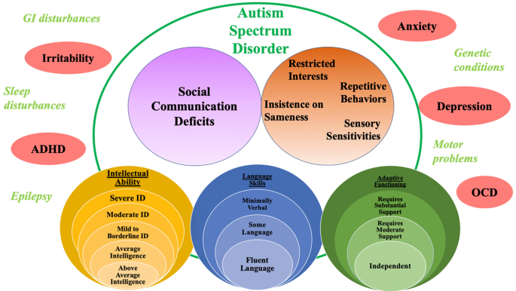
Figure 1: Diagnosis area of Autism
(Source: Long et al., 2022)

2.3 Critical Analysis
ICD-11 classification also offers a clear structure that is also internationally recognised to enhance uniformity in the research and clinical practice (Ahmed et al., 2025). They can be used to implement support and intervention approaches tailored to particular individuals by using severity and functional specifications, and the reliability of the support can be ensured by standardised diagnostic instruments (Kalra et al., 2023). One of the opportunities is the use of computational intelligence methods such as AI-based classification models in early detection and accurate profiling, especially in complex or highly functioning cases (Ali, 2025). However, there are still problems. ASD is spectrum in nature, individual differences can be hidden and diagnosis can be more limited by socio-cultural or economic status, which results in inequity in the provision of care. Although AI-assisted diagnosis is improving, the problem of algorithmic bias and the necessity of high validation is also crucial (Ahmed et al., 2025).

3. Treatment and Rehabilitation

3.1 Technical Standard Treatment
ASD is a multidisciplinary disorder requiring treatment based on behavioral, educational, and medical interventions. Applied Behavior Analysis (ABA) is one of the evidence-based interventions that are popular and aim at skills development and minimisation of challenging behaviors (Mazza et al., 2021). Speech and language therapy is used to address communication impairments, occupational therapy, and sensory integration help to occupational therapy and adaptive functioning, as well as daily living activities. Comorbidity conditions, including anxiety, ADHD, or sleep disorders, are usually treated using pharmacological interventions (Kalra et al., 2023). Acupuncture as a complementary intervention has demonstrated possible effects on the management of symptoms, but there is little evidence and should be interpreted with caution (Wang et al., 2021).
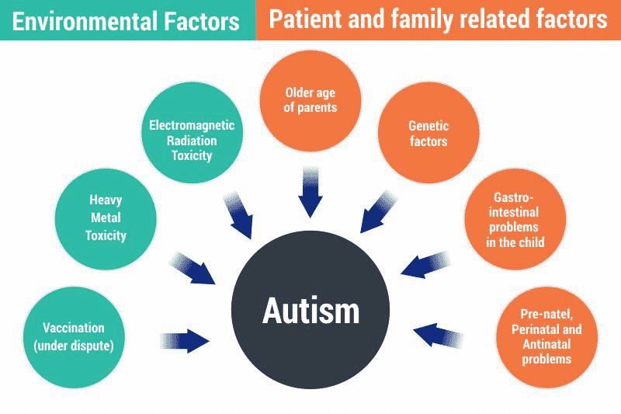
Figure 2: Autism treatment
(Source: Mazza et al., 2021)

3.2. Rehabilitation Measures
Some of these include rehabilitation through educational inclusion, social skills training, vocational support and family-focused programs. The inclusion approaches to mainstream education should promote socialisation and academic activity, and the specialised vocational programs should be used to help adult life (Mazza et al., 2021). Social skills training covers interpersonal related issues, and community support programs offer advice to families going through healthcare, education, and social services (Aarabi et al., 2021).

3.3 Critical Evaluation
The effectiveness of intensive behavioral and educational interventions in the improvement of adaptive functioning and social communication is supported by evidence. The intervention at early stages and individualised treatment are more successful, especially when the families are actively engaged in the treatment. Nevertheless, socio-economic level, geographical area, and availability of healthcare services have an uneven effect on the opportunity to access high-quality treatment and rehabilitation services (Aarabi et al., 2021). Another ethical consideration can be made, namely in the case of intensive interventions, such as ABA, which have been called into doubt due to the likelihood that they disregard autonomy. Other techniques like acupuncture may provide add-ons but require further intensive studies to enable their broader application (Wang et al., 2021). In total, the ASD treatment and rehabilitation processes should be centered on the evidence-based interventions and individual differences, cultural contexts, and ethical issues.The use of computational tools to identify the signs of early and plan personalised care can improve outcomes and decrease disparities (Alsbakhi et al., 2025).

4. Historical vs Contemporary Provision
In the past, the concept of autism had a very poor understanding and conceptualisations concentrated on institutionalisation and segregation of individuals with atypical behaviors. Until the middle of the 20 th century, autistic persons were generally confined in asylum and special institutions due to lack of understanding of developmental conditions and deficit-oriented attitude toward mental and behavioral disorders (Jackman and Zwaigenbaum, 2023). There was a lack of consistency in diagnosis and it was, to a large extent, based on observational descriptions, which tended to conflate autism with intellectual disability or severe psychiatric conditions (Macoun et al., 2024). There were low levels of educational opportunities and social opportunities and support services were disjointed or not there.
The transition to community-based and person-centred practices was a paradigm shift in the provision of autism. The understanding of autism as a neurodevelopmental disorder and not as a mental illness led to the emergence of early intervention programmes, inclusion, and family-based support services (Jackman and Zwaigenbaum, 2023). The increased functional independence and participation into social life were enabled through the introduction of structured behavioral therapies, speech and language interventions, and occupational support (Alsbakhi et al., 2025). The modern provision is more and more moving towards the autistic perspectives, which is also consistent with the values of neurodiversity, paying more attention in order to strengths and abilities of individuals, rather than weaknesses (Green, 2023).
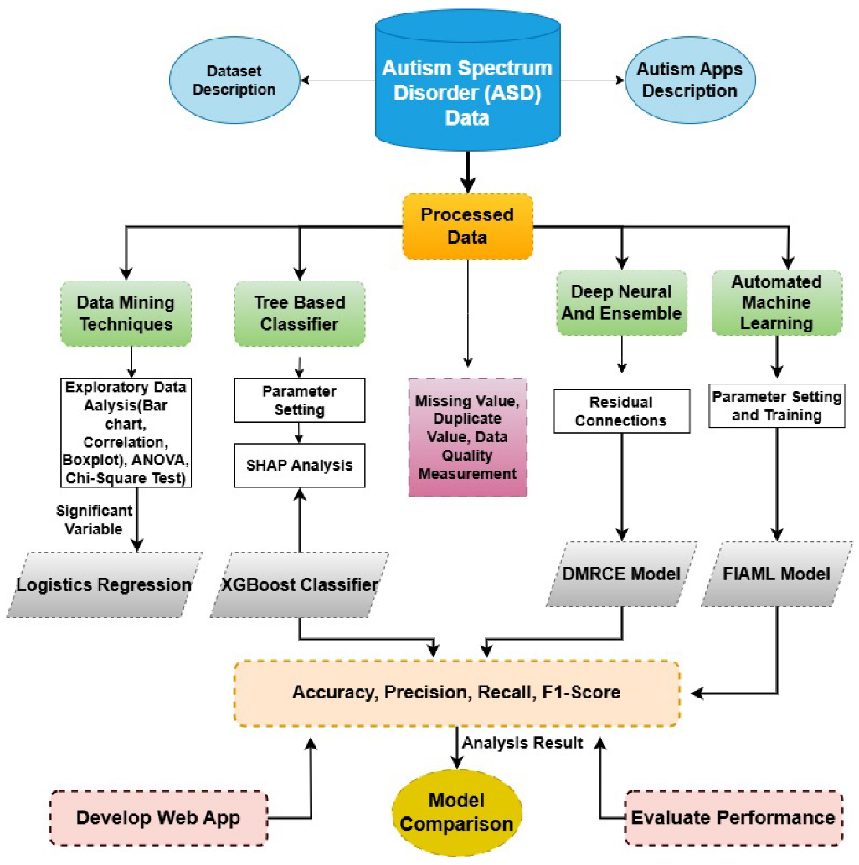
Figure 3: Autism Spectrum disorder
(Source: Mazza et al., 2021)
Contemporary services also include general mainstream education, specialised early interventions, vocational training, technological assistance like e-learning and recommender systems (Accommodated to the needs of autistic individuals) (Rathod et al., 2024). With these advancements, the autistic individuals have been able to enjoy autonomy, living standards, and integration into society. However, inequalities still exist, especially in relation to access to care, cultural literacy, and geographic diversity, and they are still trying to reach a point of equal care provision (Ardissono and Cena, 2022). Most importantly, the change of institutionalisation to inclusive and person-based care has changed lived experiences and promoted an agency and acceptance of neurodivergence as a positive form of human diversity (Lombardo and Mandelli, 2022).

5. Present Discussions and New Problems
The modern considerations in the study and practice of autism revolve around neurodivergence, differentiation, and the moral aspect of the course of intervention. Neurodiversity activists also champion strengths-based paradigms that focus on adaptive potentials, cognitive strengths, and contribution of autistic people as opposed to deficit-based approaches that focus on remedies of behaviors deemed unusual (Lombardo and Mandelli, 2022). The implication of this debate on the areas of healthcare, education, and social policy is vast as traditional conceptions about autism as a disorder to be corrected were challenged. The diagnosis of autism is still disputed. Although ICD-11 does not eliminate the term disorder, other academics suggest defining autism as a condition or difference, which is the functional variation and not the pathology (Lombardo and Mandelli, 2022). New studies are still contributing to the early recognition and management. Genetic research, highly sophisticated computational models, and AI-assisted screening tools can be used to improve precision in diagnosis and prediction of developmental paths (Whitby et al., 2022). Anxiety, depression, and ADHD are the most frequently identified co-occurring mental health conditions, the presence of which is becoming the most critical determinant of prognosis and intervention planning (Whiteley et al., 2021). Engagement, learning skills, and social interaction of autistic individuals are further enhanced by technological advances, such as inclusive recommender system, personalised e-learning systems, and accessible digital support.

6. Recommendations
Raising Diagnostic Accuracy and Early Diagnosis.
Positive intervention requires an early and accurate diagnosis. Clinicians can also use AI-assisted and computational screening tools to diagnose autism earlier in life, which results in better outcomes (Mauro et al., 2022). Diversity in the accuracy of diagnoses may be overcome by standardisation of evidence-based instrument such as ADOS-2 and ADI-R by using these instruments in different health conditions.
Strengths-based and Person-Centred Approaches
The interventions should be less institutional and rather patient-centered in terms of individuals, tastes, and neurodivergent characteristics (Lombardo and Mandelli, 2022). Behavioral therapies, social skills training, inclusion in education and family involvement are the methods to improve adaptive functioning and social participation. Strong based practice emphasises on strengths and not weaknesses, which promotes self-sufficiency and well-being.
Improvements in Policy and Practice.
The policies must encourage inclusion in education, workplace, and equal access to healthcare services and rehabilitation services. Autistic individuals can learn and engage through the use of technological aids, such as personalised e-learning tools or recommender systems (Rathod et al., 2024).
Future Research Directions
It is suggested to use longitudinal studies, culturally sensitive diagnostic practices, and strengths-based interventions assessment. Involvement of autistic individuals in the participatory research process will make sure that the interventions and policies are based on the lived-experiences (Mazza et al., 2021).

Conclusion
Autism Spectrum Disorder is a complicated neurodevelopment disorder that demands delicate knowledge in classification, diagnosis, treatment and rehabilitation. Although ICD-11 offers a standardised structure, the controversies of terminology, spectrum heterogeneity, and neurodivergence point to the necessity of person-centred approaches, which are flexible. The impact of changes in history on institutionalisation to inclusive, community-based care have contributed to enhancing the lived experiences of Autistic individuals through the support of early intervention, educational inclusion and technological innovations. The current practice and policy should focus on the use of strengths-based interventions, equal access to services, and participatory research, where clinical, educational, and social strategies should be provided to empower autistic people and consider neurodiversity.

References
Aarabi, M.A., Abdi, K. and Khanjani, M.S., 2021. Challenges of accessing and using rehabilitation services in people with autism spectrum disorder: A systematic review. Archives of Rehabilitation, 22(3), pp.260-277.
Ahmed, M., Hussain, S., Ali, F., Gárate-Escamilla, A.K., Amaya, I., Ochoa-Ruiz, G. and Ortiz-Bayliss, J.C., 2025. Summarizing recent developments on autism spectrum disorder detection and classification through machine learning and deep learning techniques. Applied Sciences, 15(14), p.8056.
Ali, H., 2025. A meta-review of computational intelligence techniques for early autism disorder diagnosis. International Journal of Theoretical & Applied Computational Intelligence.
Alsbakhi, A., Thabtah, F. and Lu, J., 2025. Autism Data Classification Using AI Algorithms with Rules: Focused Review. Bioengineering, 12(2), p.160.
Balaji, V. and Raja, S., 2022. Recommendation Learning System Model for Children with Autism. Intelligent Automation & Soft Computing, 31(2).
Green, J., 2023. Debate: Neurodiversity, autism and healthcare. Child and Adolescent Mental Health, 28(3), pp.438-442.
Jackman, A. and Zwaigenbaum, L., 2023. The history of autism spectrum disorder. In Neurodevelopmental Pediatrics: Genetic and Environmental Influences (pp. 215-226). Cham: Springer International Publishing.
Kalra, R., Gupta, M. and Sharma, P., 2023. Recent advancement in interventions for autism spectrum disorder: A review. Journal of Neurorestoratology, 11(3), p.100068.
Licea, A.D., 2024. A historical examination of autism spectrum disorder diagnosis: a systematic literature review.
Lombardo, M.V. and Mandelli, V., 2022. Rethinking our concepts and assumptions about autism. Frontiers in psychiatry, 13, p.903489.
Long, D., Yang, T., Chen, J., Dai, Y., Chen, L., Jia, F., Wu, L., Hao, Y., Li, L., Zhang, J. and Ke, X., 2022. Age of Diagnosis and demographic factors associated with autism spectrum disorders in chinese children: a multi-center survey. Neuropsychiatric disease and treatment, pp.3055-3065.
Luongo, M., Simeoli, R., Marocco, D., Milano, N. and Ponticorvo, M., 2024. Enhancing early autism diagnosis through machine learning: Exploring raw motion data for classification. PLoS One, 19(4), p.e0302238.
Macoun, S.J., Bedir, B. and Sheehan, J., 2022. Autism across the Ages: An Abbreviated History. In Handbook of Autism and Pervasive Developmental Disorder: Assessment, Diagnosis, and Treatment (pp. 3-28). Cham: Springer International Publishing.
Mauro, N., Ardissono, L. and Cena, F., 2022. Supporting people with autism spectrum disorders in the exploration of Pois: an inclusive recommender system. Communications of the ACM, 65(2), pp.101-109.
Mazza, M., Pino, M.C., Vagnetti, R., Filocamo, A., Attanasio, M., Calvarese, A. and Valenti, M., 2021. Intensive intervention for adolescents with autism spectrum disorder: Comparison of three rehabilitation treatments. International journal of psychiatry in clinical practice, 25(1), pp.28-36.
Rathod, V.N., Goudar, R.H., Kulkarni, A., GM, D. and Hukkeri, G.S., 2024. A survey on e-learning recommendation systems for autistic people. IEEE Access, 12, pp.11723-11732.
Wang, L., Peng, J.L., Qiao, F.Q., Cheng, W.M., Lin, G.W., Zhang, Y., Gao, T.G., Sun, Y.Y., Tang, W.Z. and Wang, P., 2021. Clinical randomized controlled study of acupuncture treatment on children with autism spectrum disorder (ASD): A systematic review and meta‐analysis. Evidence‐Based Complementary and Alternative Medicine, 2021(1), p.5549849.
Whitby, P.S., Smith, T.E. and Michaud, C., 2022. Historical Overview of Autism Spectrum Disorder. In Autism Spectrum Disorders (pp. 27-43). Routledge.
Whiteley, P., Carr, K. and Shattock, P., 2021. Research, clinical, and sociological aspects of autism. Frontiers in Psychiatry, 12, p.481546.

