Introduction
For my chosen subject, I have chosen the construction and development of the rail connection to the joint town of Fishguard & Goodwick in Pembrokeshire, and the establishment of the Fishguard Harbour. The construction of a railway line to the town in the early 20th century allowed for the Great Western Railway (GWR) to establish a rail link further east towards Carmarthen to attract Irish ferry traffic and break the monopoly of railway lines that the GWR owned throughout Wales. The purpose of this report is to outline the history, construction and potential challenges faced when establishing the railway to Fishguard and Goodwick.
Background History
In 1876, the Narberth Road and Maenchlohog Railway (NR&MR) had connected their slate quarries to the GWR Main Line, though it hadn’t proven to be economically viable and closed in 1882 when they were out-competed in slate traffic (). Plans for The North Pembrokeshire and Fishguard Railway (NP&FR) were made in 1884, with the intention to build a 13 mile and 73 chain line to Fishguard and Goodwick, connecting through the towns of Puncheston and Letterston, starting at Rosebush. A harbour was to be built on Fishguard Bay for a shorter ferry route to Rosslare in Ireland, though the service wouldn’t begin there until 1906 when the harbour station was opened after the GWR failed to establish a trans-atlantic port in New Milford (Neyland). Though development of the project was authorised in 1878, it wouldn’t see completion until 1898, with various financial and technical difficulties resulting in major delay.
There were many stakeholders over the course of the NP&FR project, such as the existing financier of the NR&MR, Edward Cropper, his son Edward Denman Cropper Jr, and his stepson Joseph Macaulay, who was the railways general manager as well as the owner of Rosebush Quarry. Sir Hugh Owen was the head of a consortium that ran the Rosebush and Fishguard Railway, an independent company who were given the right to build the line to Ffishguard and Goodwick. In 1891, they would receive financial benefactor in the form of Colonel Joseph Orkell, a wealthy man from Liverpool, though he would declare bankruptcy in 1893 when the line had only reached Puncheston. The county would receive two more benefactors, both from Birmingham, a solicitor Joseph Rowlands, and a brass-founder James Cartland. They would both float their own company, The Fishguard Bay Railway & Pier Company (FBR&PC), to build a line 74 chains long around the west of Fishguard Bay, as well as a hotel (The Fishguard Bay Hotel) ()

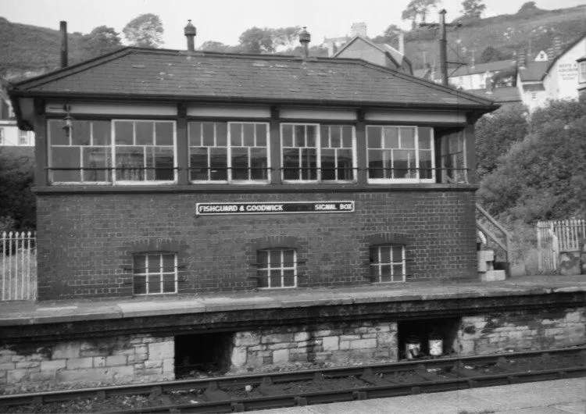()
Fishguard and Goodwick Station signal box, mid 1960s
Engineering and Design
The station signal box had been around before the platform had been built, instead of replacing the box, they built around it, leaving the windows to the locking room level with the platform. The box itself is a GWR Type 7D with a 34-lever frame, though it would be upgraded to a 53-lever frame in May of 1965, sourcing its components from a decommissioned signal box in Port-Talbot. For this photo in particular, the plate would have said “Fishguard & Goodwick Station Signal Box”, though in the mid 1960s the station was closed from passenger use while the Fishguard Harbour station was still operable, so the word “Station” was painted over to avoid the confusion of two active passenger stations at the time.
As newer technologies were being introduced in around 1901, the Ingersoll Sergeant Drilling Company were establishing an air compressing plant to drill rock near The Wyncliffe Hotel (Fishguard Bay Hotel), 15 travelling cranes were employed, with the larger rocks being used for sea defence, the smaller rocks for ballast, and the fine chippings for concrete. Over 250 acres of rock were cleared to make space for the harbour wall, the railway station and the ten sidings to hold the goods wagons, as well as the Marine shop, the Power house, Engineering workshop, Offices, Customs house and refreshment rooms for passengers. Permanent housing for GWR workers and their familes were also built in Harbour Village, with a majority of them having move from Neyland after ferry operations there ceased. In 1905, over 100 contractors and 400 GWR staff were employed at the harbour, with the harbour itself being opened in August 1906. ()
Around the time of the construction of Goodwicks rail connection, it was common practise for temporary workers camps to be constructed in the proximity of a local property close to the work site, these camps would serve the more skilled labourers such as stone masons, brick workers, blacksmiths and carpenters. One family in particular in Jordanston, the Lloyd Family, had their home bought out by a local workers camp that held over 300 workmen, though thankfully they would be built a new home only a few yards away, though it was difficult for a family of 9 to be living in stables during the construction. The line being built from Letterston to Goodwick was only 6 and a half miles long, but it ran through many cuttings and embankments with over 6 overbridges and 7 underbridges, and the line had to minimise curves as much as possible to minimise the impact of the gradient as trains had to carry heavy trains up from sea level. ()
Construction Timeline
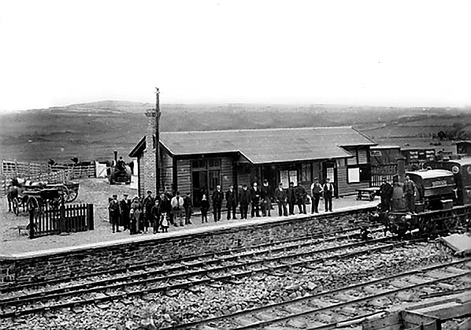()
Goodwick Railway Station on opening day, 1st August 1899. The station only had a singular platform at this point, with the north building of the station yet to be completed.

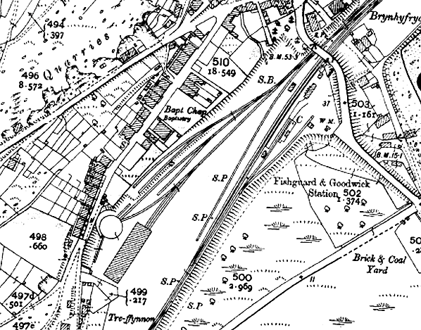
(1:2500) Ordnance Survey of Fishguard and Goodwick Station shortly after the extension to Fishguard Harbour in the year 1908, the signal box is stationed opposite the north end of the station and the engine sheds were completed in 1906. At that point the line was single track. The engine shed stands on the west side of the yard with a small goods yard east of the station with a dock and a 10 ton capacity crane stationed at the dock.

()

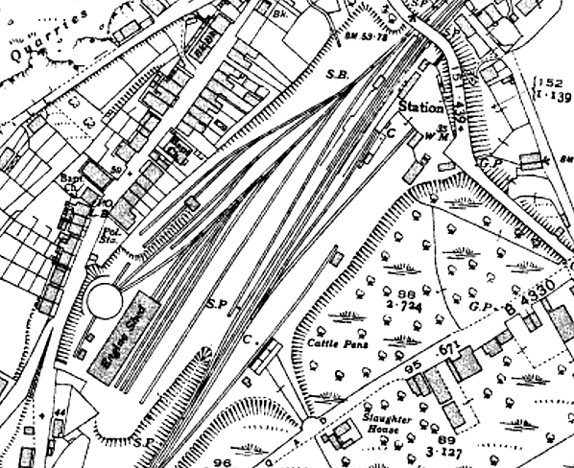
(1:2500) Ordnance Survey of Fishguard and Goodwick Station in the year 1937, the second platform had been completed while being built around the original signal box. A third siding was added to serve as a cattle dock and pens nearby to the slaughter house on Wern Road. The goods dock gains a second crane while more sidings have been added east of the engine shed.

()

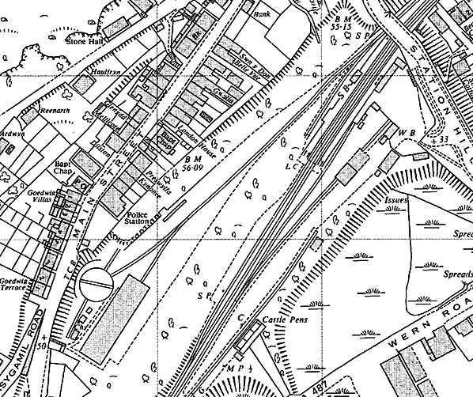
(1:2500) Ordnance Survey of Fishguard and Goodwick Station in the year 1965, the track layout near the engine shed has been heavily simplified with the shed being closed by that year. A good shed has been added to one of the goods sidings. A barrow level crossing has been added to the south end of the platforms to traverse between them. The station building on the up end of the north platform from 1937 has been replaced and is the only building retained in the modern day.

()
Conclusion
To summarise, connecting the GWR to Fishguard and Goodwick was done to streamline Irish ferry traffic by offering a more linear route from Fishguard Bay. Due to certain difficulties, the construction took over 20 years to complete in full, including trouble with stakeholders and finances. The harbour would be made by cutting over 250 acres of stone from the cliff side around The Wyncliffe Hotel, then building a railway line around the west side of Fishguard Bay. The rock cut from the cliff would be utilised for sea defence, railway ballast or chippings for concrete. In 1908, Goodwick Station would have a single platform with an engine shed, coal hopper and a turntable for locomotive services, as well as a small goods yard with a crane. In 1937, the second station platform would be completed, the goods yard would be expanded with a second crane and cattle pens for the neighbouring slaughter-house. By 1965, the engine shed would be closed and the station would stop serving passengers, though the Harbour station still worked passengers. A level crossing would be added at the south end of the station also.
In the modern day, all that’s left of Fishguard and Goodwicks railway line is a single track station leading through Goodwick to the harbour, a shell of what it used to be.

References
- Nick Catford, Disused Stations Site Record (2017), NORTH PEMBROKESHIRE & FISHGUARD RAILWAY - BRIEF HISTORY, Available at: http://www.disused-stations.org.uk/features/north_pembrokeshire_and_fishguard_railway/index.shtml [Accessed: 02/12/2024]
- Nick Catford, Disused Stations Site Record (2017), NORTH PEMBROKESHIRE & FISHGUARD RAILWAY - BRIEF HISTORY, Available at: http://www.disused-stations.org.uk/features/north_pembrokeshire_and_fishguard_railway/index.shtml [Accessed: 06/12/2024]
- John Mann, Disused Stations Site Record (2017), Fishguard & Goodwick Station Gallery 2 Early 1950s - September 1962, Available at: http://www.disused-stations.org.uk/f/fishguard_and_goodwick/index2.shtml [Accessed: 06/12/2024]
- Martin Roberts (with contributions from Ken Thomas, Hendrefach Uchaf ), Fishguard and Goodwick local history (2024), Construction of the railway line to Goodwick Station (1899) and Fishguard Harbour (1906)., Available at: https://www.hanesabergwaun.org.uk/places/goodwick-railway-yard-station/construction-of-the-railway-line-to-goodwick-station-1899-and-fishguard-harbour-1906 [Accessed: 04/12/2024]
- Martin Roberts (with contributions from Ken Thomas, Hendrefach Uchaf ), Fishguard and Goodwick local history (2024), Construction of the railway line to Goodwick Station (1899) and Fishguard Harbour (1906)., Available at: https://www.hanesabergwaun.org.uk/places/goodwick-railway-yard-station/construction-of-the-railway-line-to-goodwick-station-1899-and-fishguard-harbour-1906 [Accessed: 05/12/2024]
- John Mann, Disused Stations Site Record (2017), Fishguard & Goodwick Station Gallery 3: September 1963 - August 1974, Available at: http://www.disused-stations.org.uk/f/fishguard_and_goodwick/index2.shtml [Accessed: 07/12/2024]
- John Mann, Disused Stations Site Record (2017), Fishguard & Goodwick Station Gallery 3: September 1963 - August 1974, Available at: http://www.disused-stations.org.uk/f/fishguard_and_goodwick/index2.shtml [Accessed: 07/12/2024]
- John Mann, Disused Stations Site Record (2017), Fishguard & Goodwick Station Gallery 3: September 1963 - August 1974, Available at: http://www.disused-stations.org.uk/f/fishguard_and_goodwick/index2.shtml [Accessed: 07/12/2024]
- John Mann, Disused Stations Site Record (2017), Fishguard & Goodwick Station Gallery 3: September 1963 - August 1974, Available at: http://www.disused-stations.org.uk/f/fishguard_and_goodwick/index2.shtml [Accessed: 07/12/2024]

http://www.disused-stations.org.uk/features/north_pembrokeshire_and_fishguard_railway/index.shtml
http://www.disused-stations.org.uk/features/north_pembrokeshire_and_fishguard_railway/index.shtml
https://www.hanesabergwaun.org.uk/places/goodwick-railway-yard-station/goodwick-signal-box
https://www.hanesabergwaun.org.uk/places/goodwick-railway-yard-station/construction-of-the-railway-line-to-goodwick-station-1899-and-fishguard-harbour-1906
https://www.hanesabergwaun.org.uk/places/goodwick-railway-yard-station/construction-of-the-railway-line-to-goodwick-station-1899-and-fishguard-harbour-1906
http://www.disused-stations.org.uk/f/fishguard_and_goodwick/index.shtml
http://www.disused-stations.org.uk/f/fishguard_and_goodwick/index.shtml
http://www.disused-stations.org.uk/f/fishguard_and_goodwick/index.shtml
http://www.disused-stations.org.uk/f/fishguard_and_goodwick/index.shtml

