Student Name: Adeshola Sallu

Student ID Number: 2118601

International Meetings Management: BMIH6007

Lecturer: Kathryn Flynn

Link to video recording

https://uowtsd-my.sharepoint.com/:v:/g/personal/2118601_student_uwtsd_ac_uk/EUKkcMOuYgZBiYxjCyPPGTUB4HS5G0ZYXSmngIi3eow2dQ?referrer=Teams.TEAMS-WEB&referrerScenario=MeetingChicletGetLink.view.view

PowerPoint Slides

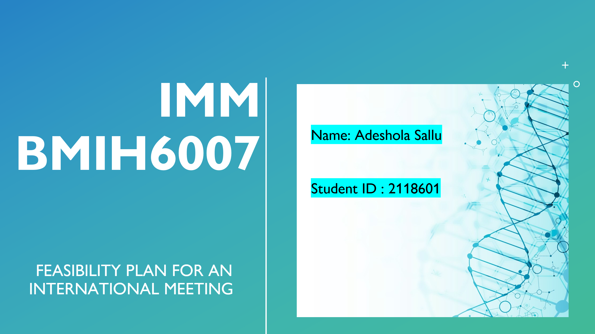

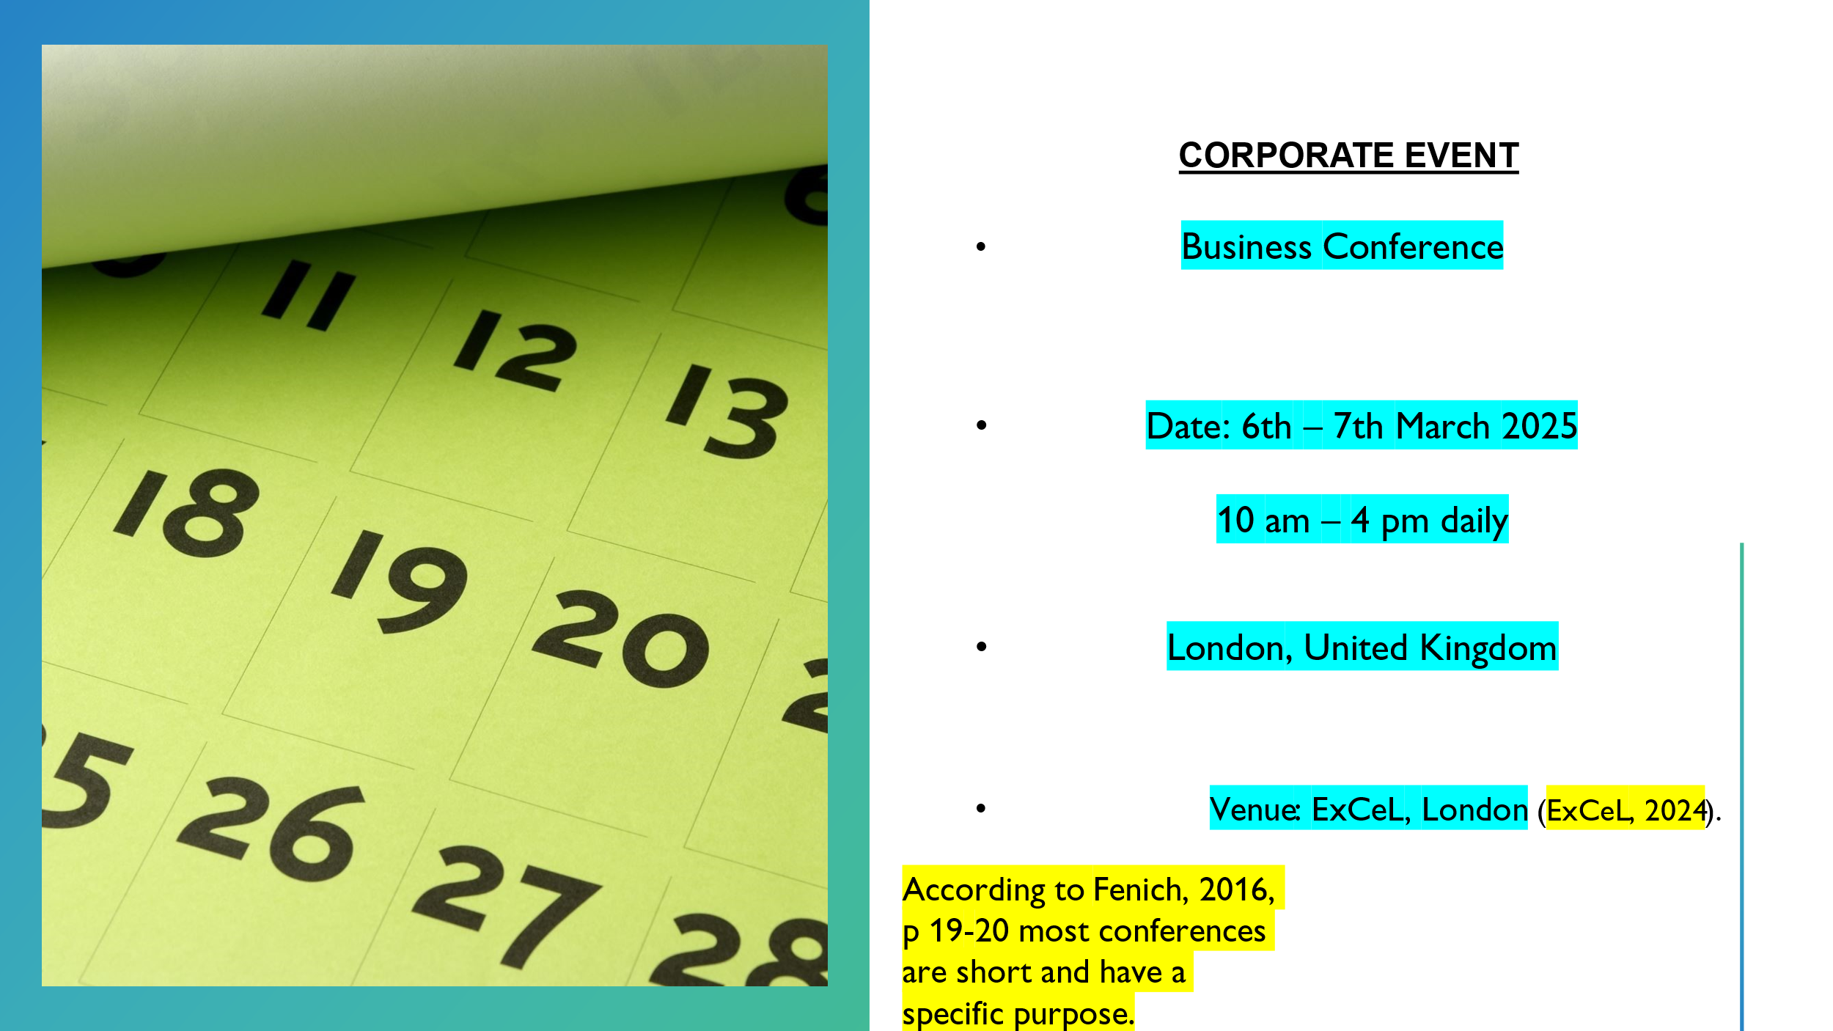

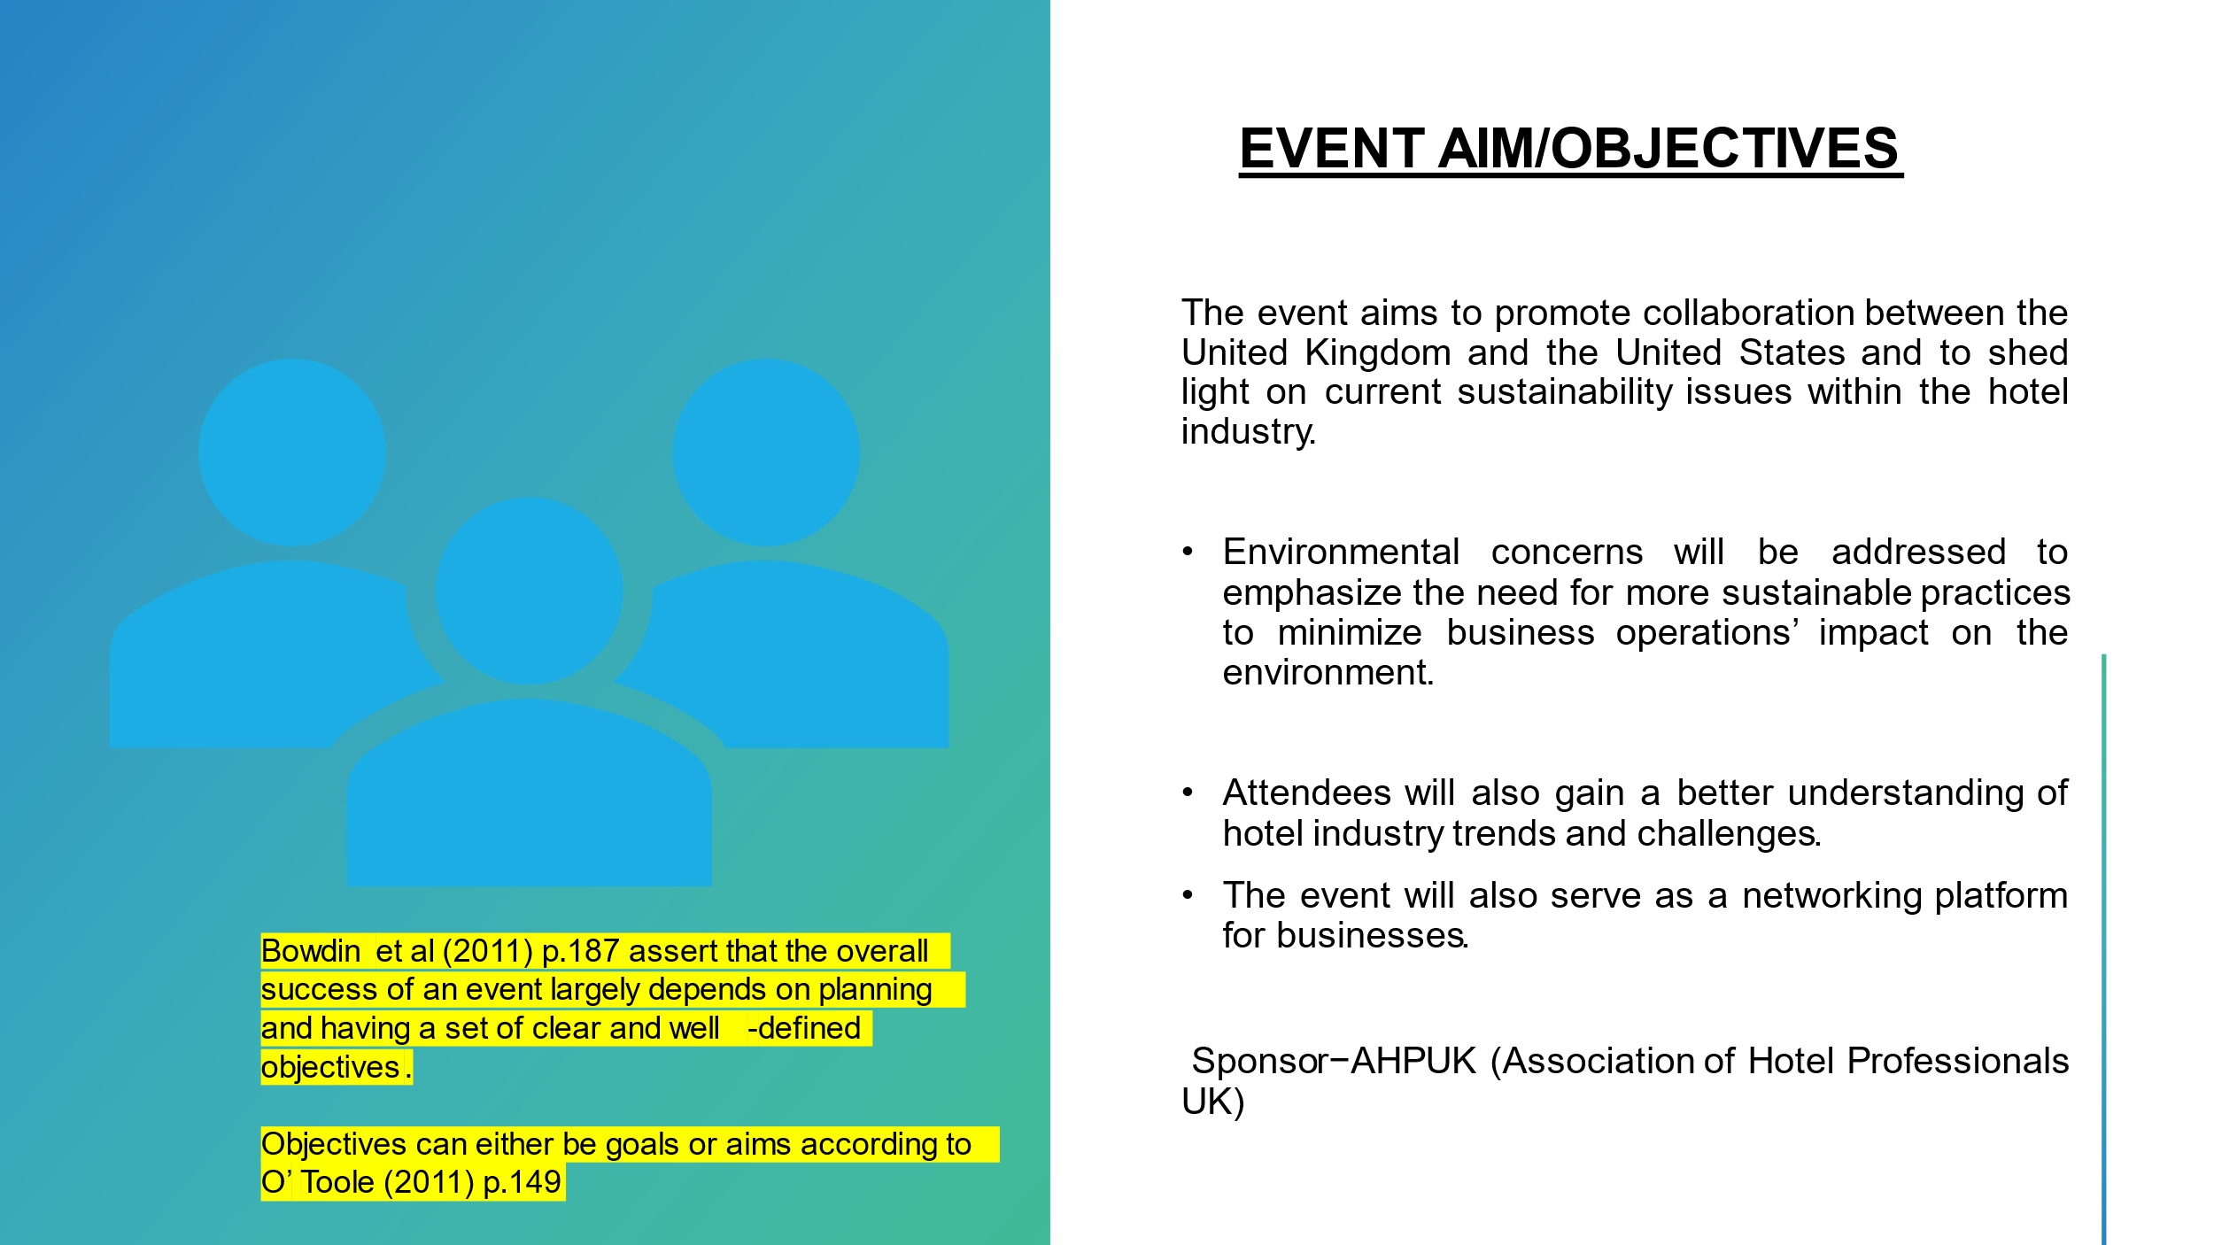

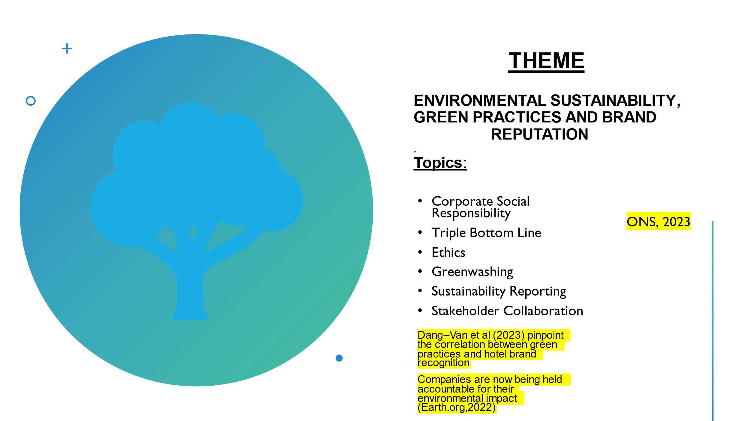

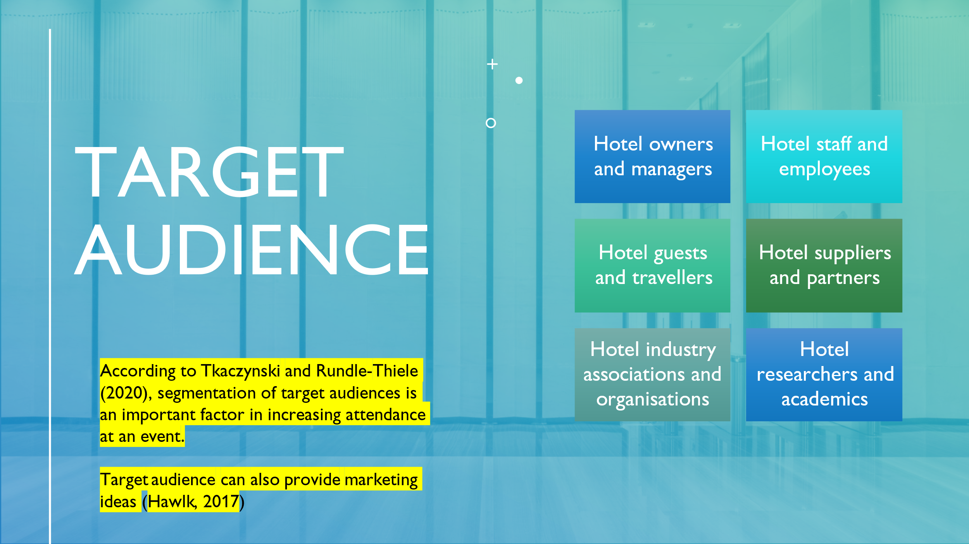

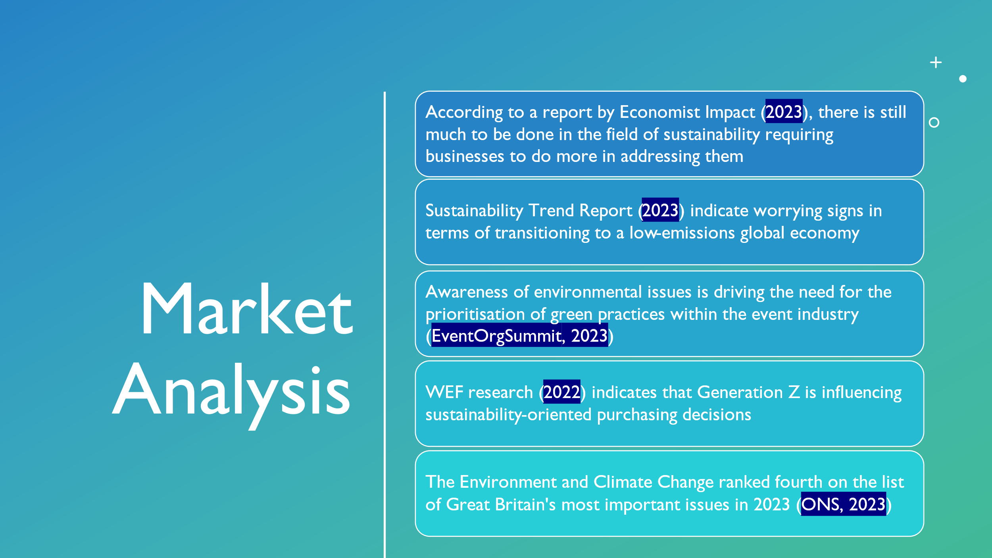

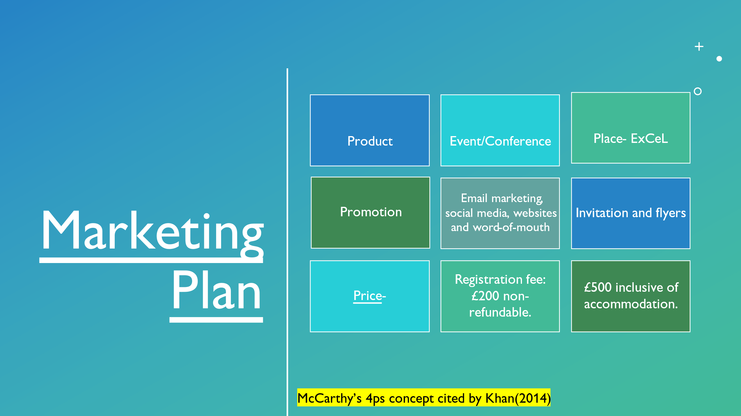

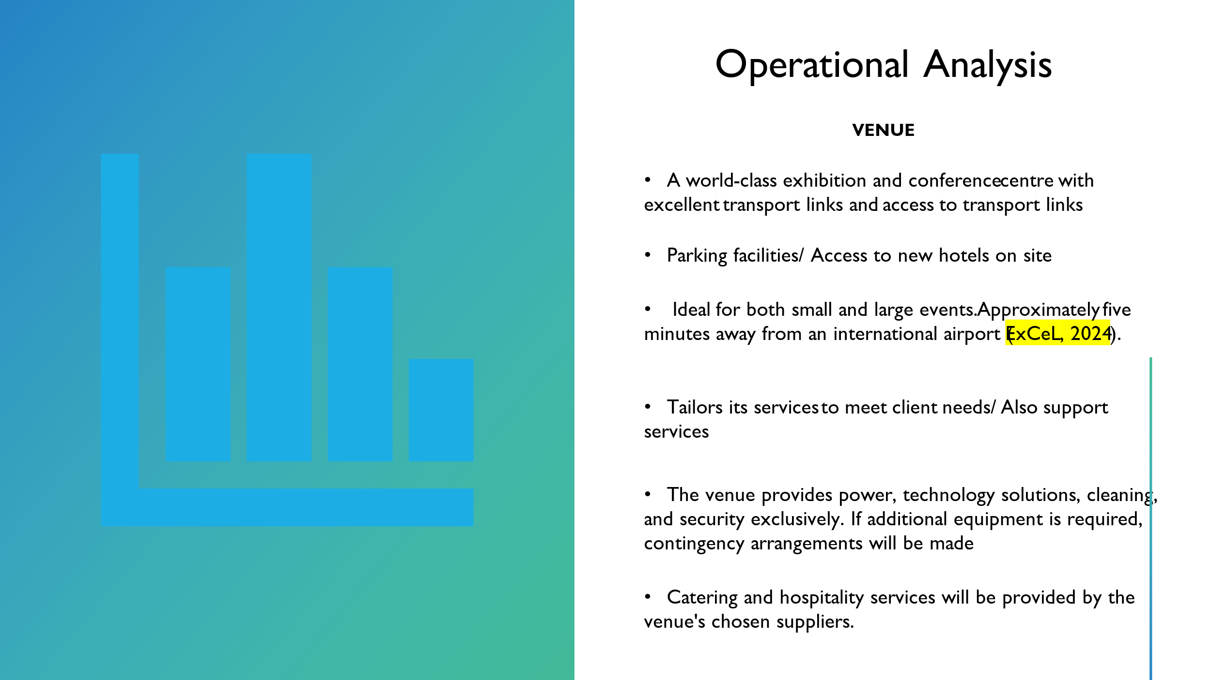

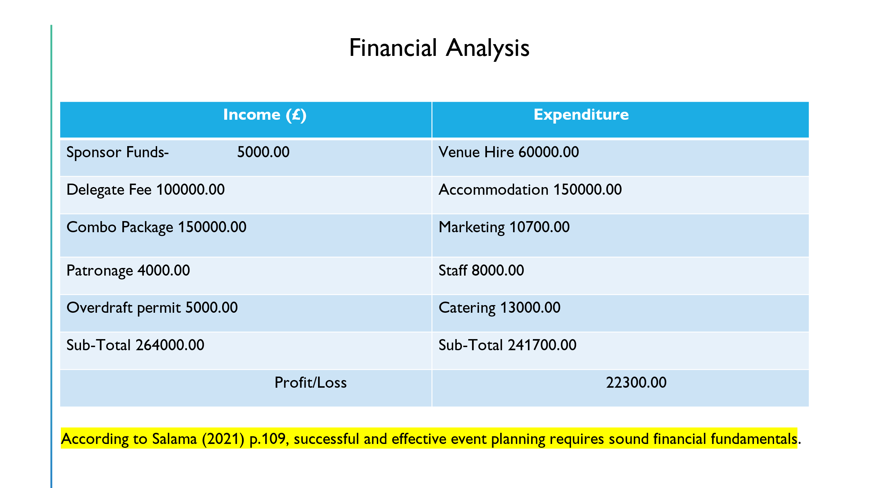

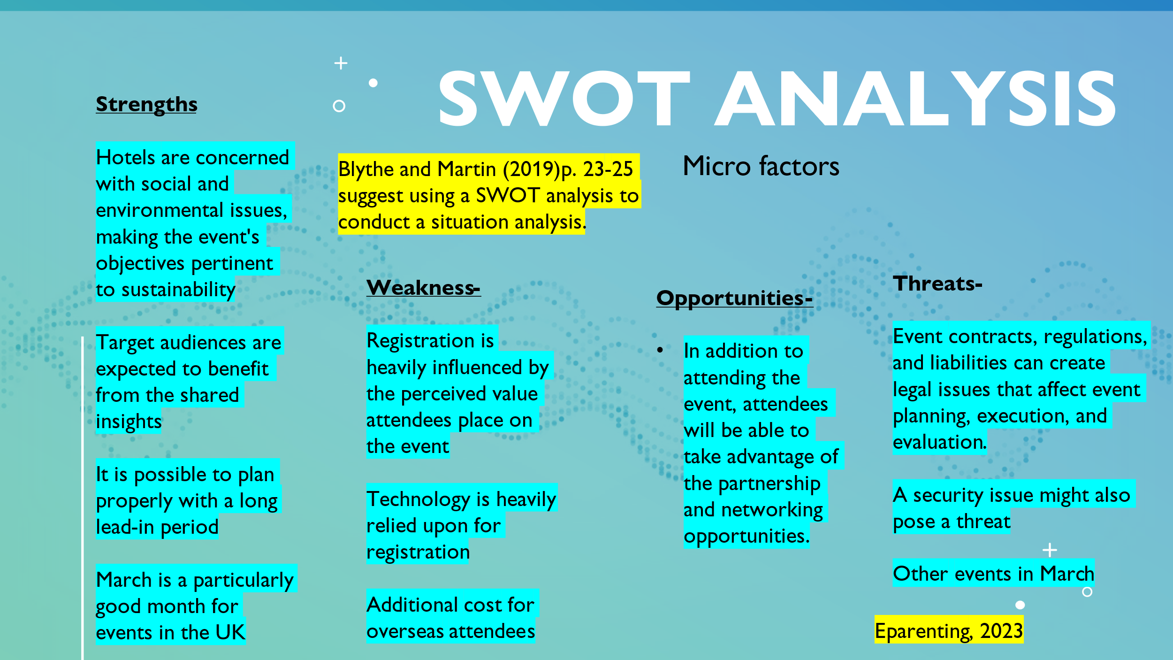

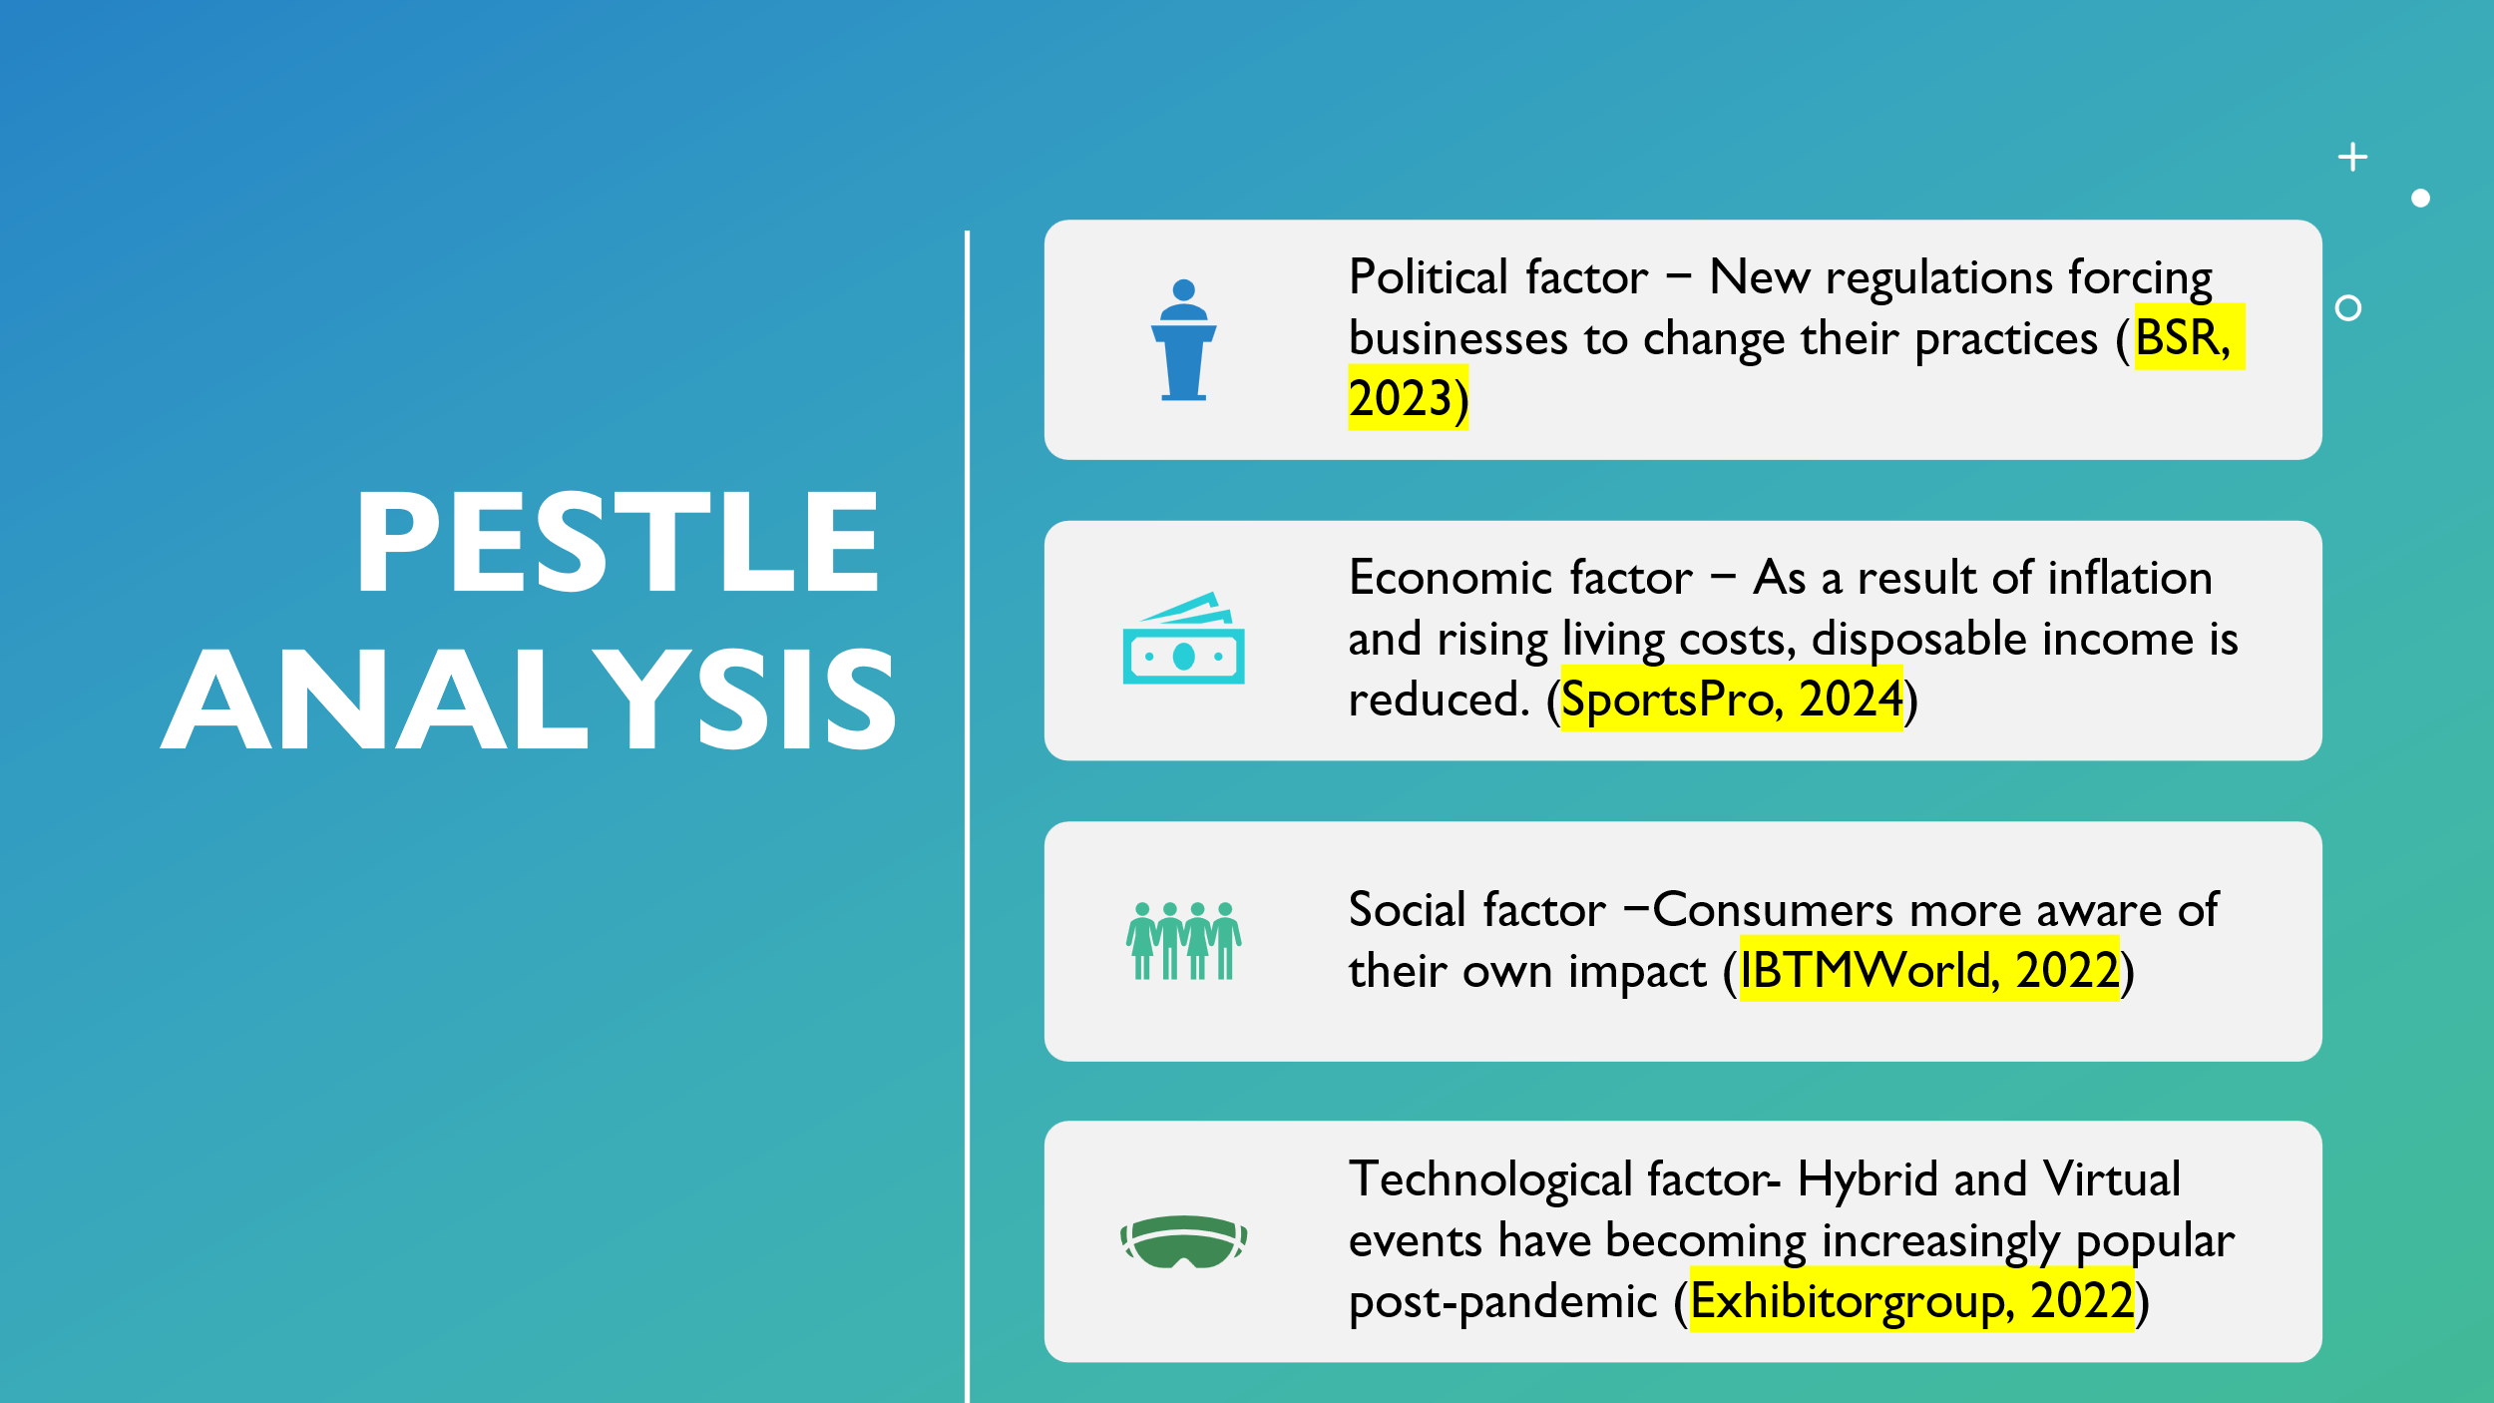

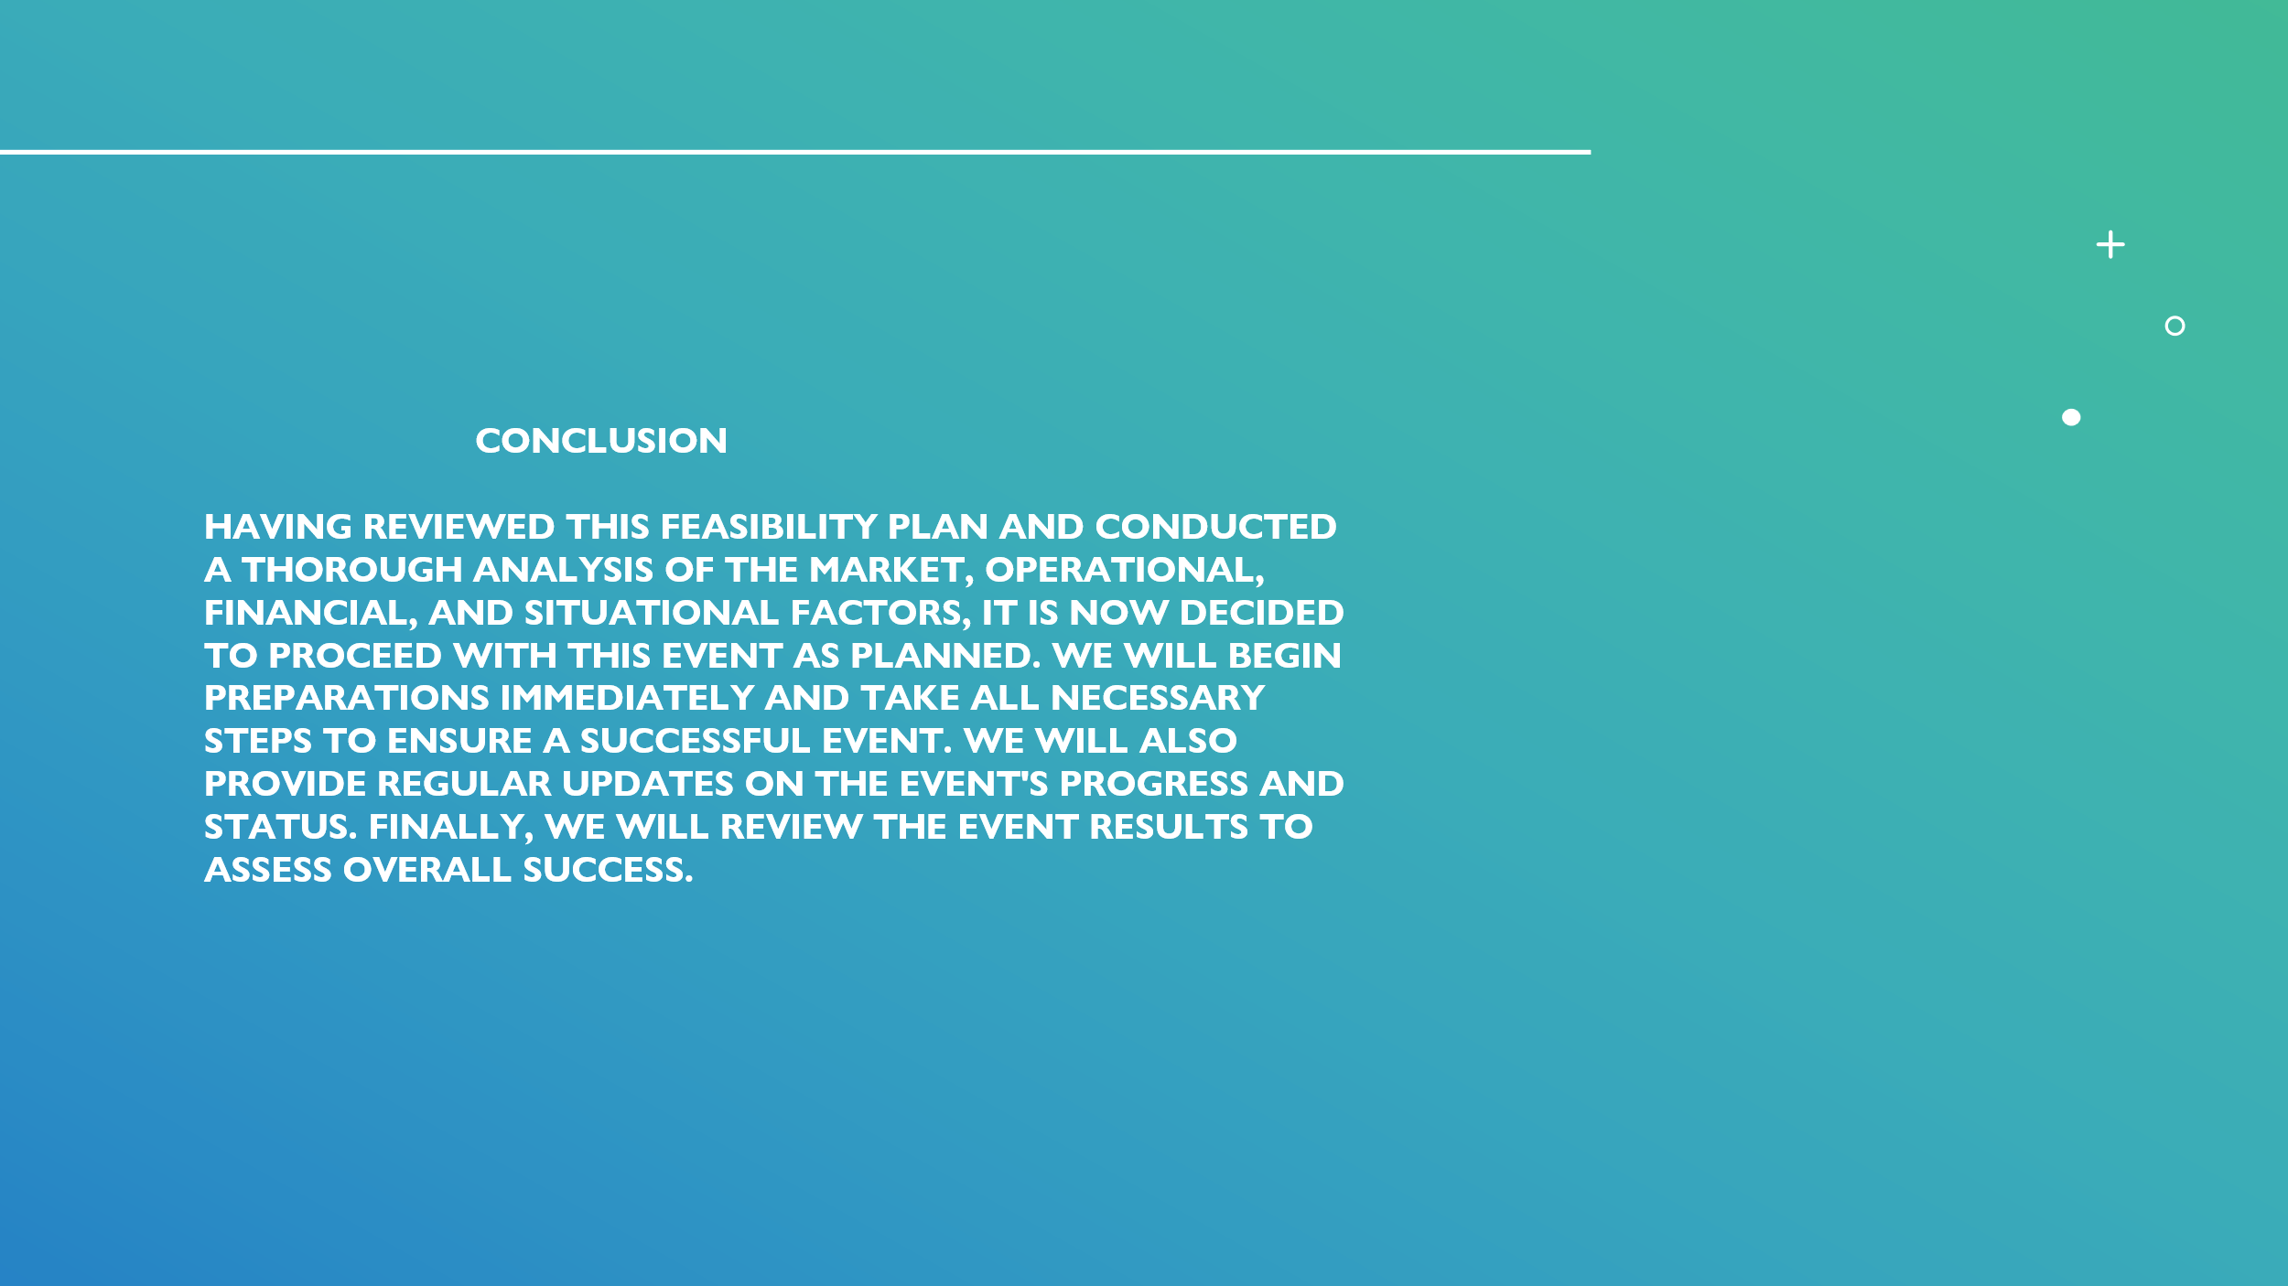

References

Avery and Brown + Small 99 (2022) your sustainability events calendar. Available at: https://sustainabilityevents.co.uk/calendar/ (Accessed on: 31 January 2024)

Blythe J. and Martin J. (2019) Essentials of Marketing. 7th ed. Swansea
Bowdin, G., Allen, J., Harris, R., McDonnell, I., O’Toole, W. (2011) Events Management. Oxford, U.K.: Routledge (Events Management Series). Available at: https://search-ebscohost-com.ezproxy.uwtsd.ac.uk/login.aspx?direct=true&db=nlebk&AN=459613&site=ehost-live (Accessed: 26 January 2024).
BSR (2023) How New Regulations Are a Game-Changer in Just and Sustainable Business. Available at: https://www.bsr.org/en/sustainability-insights/insights-plus/how-new-regulations-are-a-game-changer-in-just-and-sustainable-business (Accessed on 04 February 2024)

Dang‐Van, T., Vo‐Thanh, T., Wang, J., & Nguyen, N. (2023). Luxury hotels’ green practices and consumer brand identification: The roles of perceived green service innovation and perceived values. Business Strategy and the Environment, 32(7), 4568–4583. https://doi.org/10.1002/bse.3381

Earth.Org (2022) 10 Companies Called Out for Greenwashing. Available at: https://earth.org/greenwashing-companies-corporations/ (Accessed on: 31 January 2024)
Economic Impact (2023) What are the top sustainability trends for 2024? Available at: https://impact.economist.com/sustainability/net-zero-and-energy/what-are-the-top-sustainability-trends-for-2024 (Accessed on 30 January 2024)
Eparenting (2023) MARCH 2024 EVENTS CELEBRATION AND SPECIAL DAYS. Available at https://eparenting.co.uk/celebrations/celebrations_and_events_in_march.php (Accessed on: 02 February 2024)
ExCeL (2024) Welcome to ExCeL London. The home of world-leading events. Available at: https://www.excel.london/organiser (Accessed on: 30 January 2024)
ExCeL (2024) Welcome to ExCeL London. The home of world-leading events. Available at: https://www.excel.london/visitor (Accessed on: 31 January 2024)

ExhibitorGroup (2022) Virtual/Hybrid Events Are Changing the Way the World Comes Together for 2022 & Beyond, According to 6Connex Survey. Available at: https://www.exhibitoronline.com/news/article.asp?ID=22292 (Accessed on: 04 February 2024)
Event Organisers Summit (2023) VENUE SUSTAINABILITY: A TRANSFORMATIVE TREND IN UK EVENT MANAGEMENT. Available at: https://eventorganiserssummit.co.uk/venue-sustainability-a-transformative-trend-in-uk-event-management/ (Accessed on 30 January 2024)
Fenich, G.G. (2016) Meetings, expositions, events, and conventions an introduction to the industry. Fourth edition; Global edition. Harlow, United Kingdom: Pearson.
GENERATION (2023) The Sustainability Trends Report 2023. Available at: https://str2023.generationim.com/chapters/introduction?utm_medium=google_ads&utm_source=primary&utm_campaign=google_ad&utm_content=copy1 (Accessed on: 30 January 2024)

Hawlk, K. (2017) "Need Marketing Ideas? Ask Your Target Audience", Journal of Financial Planning, vol. 30, no. 11, pp. 28-29.
IBTM World (2022) 7 Sustainable Trends in the MICE Industry. Available at: https://www.ibtmworld.com/en-gb/blog/event-management/sustainable-trends-mice-industry.html (Accessed on: 05 February 2024)
Khan, M.T. (2014) "The Concept of 'Marketing Mix' and its Elements (A Conceptual Review Paper)", International Journal of Information, Business and Management, vol. 6, no. 2, pp. 95-107.
OFFICE OF NATIONAL STATISTICS (2023) Public opinions and social trends, Great Britain: 15 to 26 November 2023 Available at: https://www.ons.gov.uk/peoplepopulationandcommunity/wellbeing/bulletins/publicopinionsandsocialtrendsgreatbritain/15to26november2023 (Accessed on: 29 January 2024)
O’Toole, W. (2011). Events feasibility and development: from strategy to operations. Butterworth-Heinemann.

Salama, M. (2021). Event project management: principles, technology and innovation (M. Salama, Ed.). Goodfellow Publishers Limited.

SportsPro (2024) 'It's a perfect storm' How the cost-of-living crisis is hitting the UK live events business. Available at: https://www.sportspromedia.com/insights/features/cost-of-living-crisis-live-events-industry-inflation-brexit-covid-the-o2/?zephr_sso_ott=zOOzvK (Accessed on:03 February 2024)

Tkaczynski, A., & Rundle-Thiele, S. (2020). Event Market Segmentation: A Review Update and Research Agenda. Event Management, 24(2), 277–295. https://doi.org/10.3727/152599519X15506259855913

WORLD ECONOMIC FORUM (2022) Gen Z cares about sustainability more than anyone else – and is starting to make others feel the same. Available at: https://www.weforum.org/agenda/2022/03/generation-z-sustainability-lifestyle-buying-decisions/

