
Cyber Security Essentials
Amit Naik, Kwame.
By Elaine Rodovalho 2427102
12/14/12

Zero Trust Security Framework for Vigilant Trust & Asset Management

Abstract
In this report, the researcher will focus on how a Zero Trust security framework can be implemented at Vigilant Trust & Asset Management to ensure that the cybersecurity issue has been managed in the financial sector, which has been increasing in number. The company also extends to security threats such as phishing, ransomware, and the insider threat that may harm the sensitive information and client confidence. The concept of the proposed solution the Zero Trust model presupposes no trust naturally present in the network and implements the principle of constant authentication and authorization of each access request. These risks are mitigated by the report by identifying important technical controls that include multi-factor authentication (MFA), network micro- segmentation, and endpoint protection. Through Zero Trust, Vigilant Trust & Asset Management will greatly improve its security posture, minimize its vulnerabilities, and provide improved compliance with regulatory requirements. This framework will eventually enhance the capacity of the organization to identify, thwart and counter advanced cyber threats to offer a more robust defense against possible breaches.

Table of Contents
Abstract 2
Introduction 4
Identification of Modern Threats 4
Modern Security Policies (Zero Trust) 7
Technical Mitigation Measures 8
Proactive Monitoring & Incident Response 10
Continuous Monitoring and Its Role in Detecting Advanced Threats 10
Incident Response Planning 11
Proactive Monitoring & Incident Response 12
Continuous Monitoring and Its Role in Detecting Advanced Threats 12
Incident Response Planning 12
Conclusion 13
References 14

Introduction
Financial institutions require cybersecurity because of the sensitivity of information they deal with, including the financial records and transaction information of their customers. Data breach may result in huge financial losses, reputation damages, and regulatory fines. The financial industry has the highest data breach average with USD 6.08 million being spent on data breach in 2024 compared to global average (IBM, 2024). Phishing, ransomware, and Ransomware-as-a-Service (RaaS) attacks are among the issues that Vigilant Trust & Asset Management has to deal with, and, according to recent reports, cybercrime against financial institutions has been on the increase (FCA, 2023).
Conventional security paradigms are no longer sufficient since the threat environment has changed and companies have grown increasingly dependent on the cloud and remote access. The Zero Trust security model presents its solution by making no user or device trusted by default, implying that it has to constantly authenticate and authorize all access requests (Rose et al., 2020). This goes a long way in minimizing external and internal intrusions.
In this report, the author examines the potential application of a Zero Trust architecture in solving the cybersecurity issues of Vigilant Trust and Asset Management. It describes the threat identification, security policies, technical mitigation, and a proactive monitoring framework and finally gives suggestions on how to implement Zero Trust.

Identification of Modern Threats
Vigilant Trust and Asset Management is a financial institution that deals with a dynamic threat community that includes external and internal security risks. One of the most common forms of external threats is the phishing attacks, which remain to be the most common method of cybercrime that targets financial institutions. Recent studies reveal that financial entities are the victims of over 50 percent of phishing campaigns in the world (KnowBe4, 2025). Also, ransomware and especially Ransomware-as-a-Service (RaaS) have become a factor of concern, and financial companies have been victimized by attackers. In a recent survey, it was discovered that about 65% of financial institutions indicated that they experienced ransomware in 2024 (InvenioIT, 2024). This is a model that allows less technically proficient criminals to initiate ransomware attacks, and it has given rise to a higher rate of such occurrences and an overall significant attack rate, especially using double-extortion tactics (FCA, 2023).
The problem of insider threats is also a major issue. Insiders with either ill motives or lack thereof may avoid traditional perimeter defenses, using the access privileges to steal information or cause havoc. As a matter of fact, the financial institutions are the most harmed by the credential misuse and privileged-user abuse (IBM, 2024). The threat of AI-based cyberattacks also complicates the matter, and attackers are taking advantage of machine learning to automatize and scale phishing and credential stuffing campaigns (Arxiv, 2025).
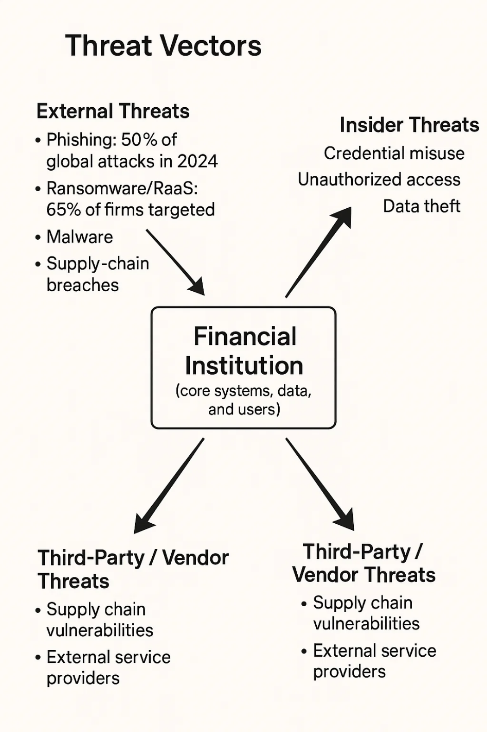
Figure 1: Threat Vector Diagram
Self-Made
Financial institutions need to take a structured approach to risk identification and management to be able to manage these risks. Such frameworks as NIST Cybersecurity Framework (CSF) offer powerful principles of threat identification, risk evaluation, and mitigation actions (NIST, 2018). The ISO/IEC 27001 standard is an addition to these activities that can provide a structured process of addressing information security, including the threat identification, vulnerability, and possible impact on organizational assets (Syteca, 2025).

Modern Security Policies (Zero Trust)
The increased level of advanced cyberattacks requires a radical change in the organizational approach to security. The classical models of security in perimeter are increasingly becoming ineffective in the face of current threats as can be seen through the widespread use of phishing, ransomware, and insider attacks. Zero trust security model, built on the principle of never trust and always verify, is one of the solutions to these challenges by mandating continuous verification and authentication of users and devices, irrespective of their whereabouts (Rose et al., 2020). The requests to have access to resources are treated, in this model, as an external network, thereby minimizing the chances of unauthorized access.
In order to establish Zero Trust at Vigilant Trust & Asset Management, the company should adopt the best practices, as identified by the frameworks like the NIST Cybersecurity Framework (CSF) and ISO/IEC 27001. An example is that, as per the NIST CSF Protect functionality, the institutions should implement robust access controls, implement multi-factor authentication (MFA) on all users, and implement least privilege settings, whereby users are only granted access to what they need to conduct their work (NIST, 2018). Another important aspect of Zero Trust is micro-segmentation of the network that restricts the movement of attackers across the environment in the future (Syteca, 2025).
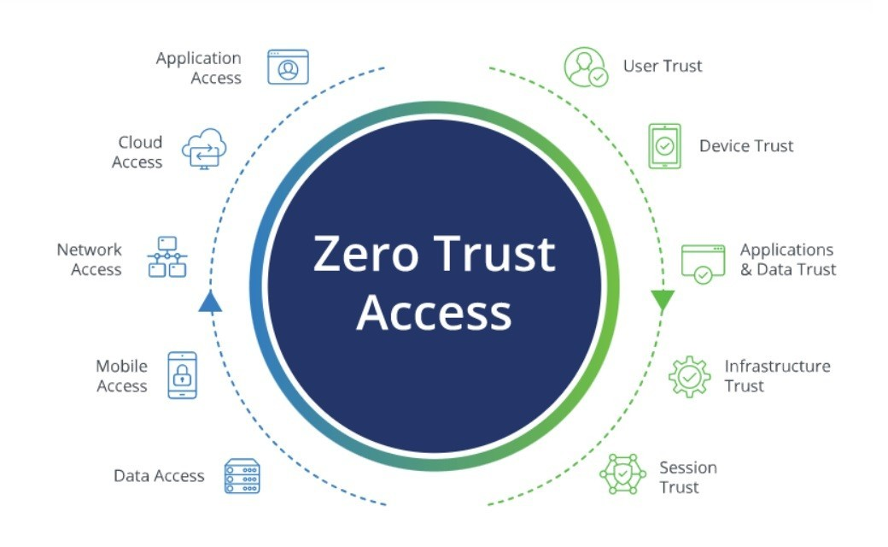
Figure 2: Zero Trust Model for Modern Security Architecture
Source: http://linkedin.com/pulse/zero-trust-model-modern-security-architecture-vintageglobal-ftuae
Constant observation of user activities and network traffic should also be incorporated in the integration of Zero Trust policies. Observing suspicious activities would help organizations identify possible breaches at an early stage mitigating the effects of a compromised system. Also, data security measures like strong encryption at rest and in transit are necessary in protection of sensitive information.

Technical Mitigation Measures
Vigilant Trust & Asset Management is a financial institution that is exposed to a dynamic world of cybersecurity and this necessitates complex technical solutions to fight the growing sophistication of cybercrimes. Identity and Access Management (IAM), multi-factor authentication (MFA), network segmentation, encryption, and constant monitoring should form part of a robust technical defense strategy to develop a complete security posture.
Key Technical Measures & Recommended Tools
Technical Measure | Purpose | Recommended Tools/Techniques
Identity & Access Management (IAM) + MFA | Ensures that only authenticated users gain access to critical resources. Reduces risk of unauthorized access. | Tools such as Okta and Azure Active Directory provide IAM services with MFA integration. Privileged Access Management (PAM) solutions such as CyberArk help with controlling access for high-risk accounts (Rose et al., 2020).
Network Micro-segmentation + Least-Privilege Access | Limits lateral movement within the network and restricts unauthorized access to specific resources. | Cisco ACI or VMware NSX offer segmentation capabilities, while RBAC (Role-Based Access Control) can enforce least-privilege principles across all systems (Syteca, 2025).
Encryption (Data-at-Rest & In-Transit) | Protects sensitive data even if systems are compromised, ensuring confidentiality and integrity. | AES-256 encryption for data at rest and TLS 1.3 for data in transit, as recommended by NIST (NIST, 2018). Vormetric Data Security Platform offers enterprise-grade encryption tools for both storage and communication.
Endpoint Detection & Response (EDR) | Monitors endpoint activity to detect malicious behaviors or anomalies, preventing advanced threats like ransomware. | Solutions like CrowdStrike Falcon and Microsoft Defender provide endpoint protection by analyzing endpoint activities and applying threat intelligence (Suhail et al., 2025).
Security Information & Event Management (SIEM) | Aggregates and analyzes data from various systems for real-time detection and correlation of suspicious activities. | Splunk, IBM QRadar, and Elastic Stack (ELK) are commonly used SIEM platforms to collect logs, monitor network traffic, and detect potential security incidents in real time (Daah et al., 2024).
Integration into Vigilant’s Security Architecture
Vigilant Trust & Asset Management would need to combine these technical controls into a Zero Trust Architecture (ZTA), in which IAM and MFA can be used as the initial line of protection, and authorized users can access only sensitive resources. The micro-segmentation of the network would limit the horizontal flow across the environment whereas encryption will make the intercepted data unreadable. Theensity would be endpoint protection (EDR) to keep a constant check on the user devices and servers regarding any suspicious activity. Lastly, the SIEM system would make the aggregation of logs centralized so that the security teams would be able to correlate the events and identify any suspicious activity among all systems.
The success of such actions depends on the constant patch management and readiness to respond to incidents. Updates to the software and frequent vulnerability scans are necessary to close the possible access points, whereas a carefully organized incident response team will enable a quick recovery in case of an attack (IBM, 2024).

Proactive Monitoring & Incident Response
The threats should be monitored proactively in order to determine them before they will cause much harm. Managed Security Service Providers (MSSP), Security Information and Event Management (SIEM) systems are some of the main elements of this strategy. Precise security logs that are collected in real-time across all sources (network traffic, endpoints, user activity) will enable the security personnel to identify anomalies and react promptly to possible intrusions.

Continuous Monitoring and Its Role in Detecting Advanced Threats
Continuous monitoring refers to the systematic process of observing security data (e.g., logs, network flows, and user activity) to determine if there is malicious behavior or suspicious activity. SIEM system offers a centralized monitoring, matching the events and applying predefined rules and machine learning algorithms to identify abnormal activities. In particular, a strange amount of data out of a system, in particular involving sensitive data, could be a sign of a data exfiltration attempt a frequently used trick in ransomware attacks. The EDR systems are a complement to the SIEM, and they enable in-depth information about endpoint activity, and they can detect malware or unauthorized activity on machines (NIST, 2018).

Incident Response Planning
A successful incident response plan (IRP) is a systematic process which includes: Detection, Containment, Eradication, Recovery, and Post-Incident Review. Detection phase: during the Detection phase, alerts of the security teams are created in real-time by the SIEM and EDR systems, in case of a potential breach. In Containment, systems that have been affected are blocked out in an attempt to restrain the attack. Eradication is aimed at eliminating any malware or unauthorized access and Recovery is aimed at restoring systems using clean backups and implementing patches to counteract vulnerabilities that were used in the attack. Lastly, a Post-Incident Review, assists in the optimization of security policies and enhances future response.
Drills on incident response should be conducted regularly in order to be prepared. Tabletop exercises are aimed at simulating different types of cyberattacks, e.g., the ransomware and phishing attacks, which will assist teams to practice their roles and enhance communication as well as define flaws in the IRP (Suhail et al., 2025).
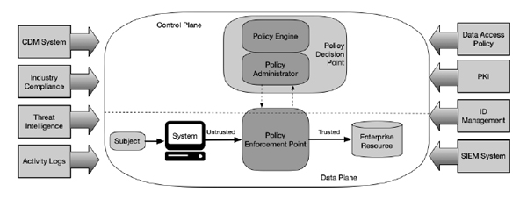
Figure 3: Zero Trust Architecture Core Components
Source: NIST SP 800-207

Proactive Monitoring & Incident Response

Threats should be monitored proactively to prevent inflicting much harm. The security information and event management (SIEM) systems and Managed Security Service Providers (MSSP) play a significant role in this plan. Live gathering of security records of all the sources (network traffic, endpoints, user activity) enables security teams to identify anomalies and take prompt action against possible intrusion.

Continuous Monitoring and Its Role in Detecting Advanced Threats

Continuous monitoring is a systematized process of viewing security data, which may be logs, network flows, and user activities, to detect malicious behavior or suspicious activity. SIEM system offers centralized monitoring where event correlation is done and conditions are checked against pre-defined rules and machine learning algorithms that identify abnormal patterns. As an example, a large amount of data out of a system, particularly sensitive data, can be an indication of data exfiltration attempt - a frequent method in ransomware attacks. The EDR systems are the supplement to the SIEM as they can offer in-depth information about endpoint actions, detect malware or unauthorized activities on devices (NIST, 2018).

Incident Response Planning
A successful incident response plan (IRP) includes systematic steps: Detection, Containment, Eradication, Recovery and Post-Incident Review. The SIEM and EDR systems provide real-time alerts that alert security teams on a possible breach in the Detection phase. In Containment, the isolated systems are used to restrict the spread of the attack. Eradication is the process of eliminating any malware or unauthorized access whereas Recovery is the one that aims at restoring systems based on clean backups and applying patches in response to vulnerabilities that were exploited in the attack. Lastly, Post-Incident Review aids in the optimization of security policies and better response in the future.
Incident response drills should be done regularly and should be conducted to provide preparedness. Tabletop exercises recreate the different types of cyberattacks, including ransomware and phishing attacks, and enable teams to practice their roles, enhance their communication, and detect gaps in the IRP (Suhail et al., 2025).

Conclusion
Zero Trust framework plays an important role in securing Vigilant Trust and Asset Management through the application of continuous validation of users and devices, no matter where these are located. This will reduce the chances of data breach, ransomware attacks and insider threats. With the changes in cyber threats, Vigilant will be forced to make constant adjustments in security posture to remain ahead of the emerging threats. Through Zero Trust, the company will be able to anticipate better security, minimize attack surfaces, and respond to incidents better. The model will eventually promote a solid defense that will guarantee continued safeguarding of sensitive financial information and customer confidence.

References
Arxiv (2025) ‘AI-Driven Cybersecurity Threats: A Review of Attack and Mitigation Techniques’, arXiv. Available at: https://arxiv.org/abs/2503.22710 (Accessed: 9 December 2025).
Daah, C., et al. (2024) ‘Enhancing Zero Trust Models in the Financial Industry’, Electronics, 13(5), p. 865. Available at: https://www.mdpi.com/2079-9292/13/5/865 (Accessed: 9 December 2025).
FCA (2023) Cybersecurity Risks and Challenges in Financial Institutions. Financial Conduct Authority. Available at: https://www.fca.org.uk (Accessed: 9 December 2025).
FCA (2023) Financial Services Cybersecurity Risks and Challenges. Financial Conduct Authority. Available at: https://www.fca.org.uk (Accessed: 9 December 2025).
IBM (2024) Cost of a Data Breach 2024: Financial Services Industry. IBM. Available at: https://www.ibm.com (Accessed: 9 December 2025).
InvenioIT (2024) Ransomware in the Financial Industry: Trends and Impact. InvenioIT. Available at: https://invenioit.com (Accessed: 9 December 2025).
KnowBe4 (2025) ‘2025 Financial Sector Threat Report’. KnowBe4. Available at: https://www.knowbe4.com (Accessed: 9 December 2025).
NIST (2018) Cybersecurity Framework: NIST Special Publication 800-53 Revision 5. National Institute of Standards and Technology. Available at: https://www.nist.gov/cyberframework (Accessed: 9 December 2025).
Rose, S., Borchert, O., Mitchell, S., and Connelly, S. (2020) Zero Trust Architecture. NIST Special Publication 800-207. Available at: https://nvlpubs.nist.gov/nistpubs/specialpublications/NIST.SP.800-207.pdf (Accessed: 9 December 2025).
Suhail, S., et al. (2025) ‘A Framework for Enhancing Cyber Incident Response with Security Monitoring and Intrusion Detection in Financial Institutions’, Journal of Cybersecurity & Information Assurance. Available at: https://www.sciencedirect.com/science/article/pii/S2542660525000605 (Accessed: 9 December 2025).
Syteca (2025) ‘Zero Trust Security: ISO 27001 Integration for Financial Institutions’, Syteca. Available at: https://www.syteca.com (Accessed: 9 December 2025).

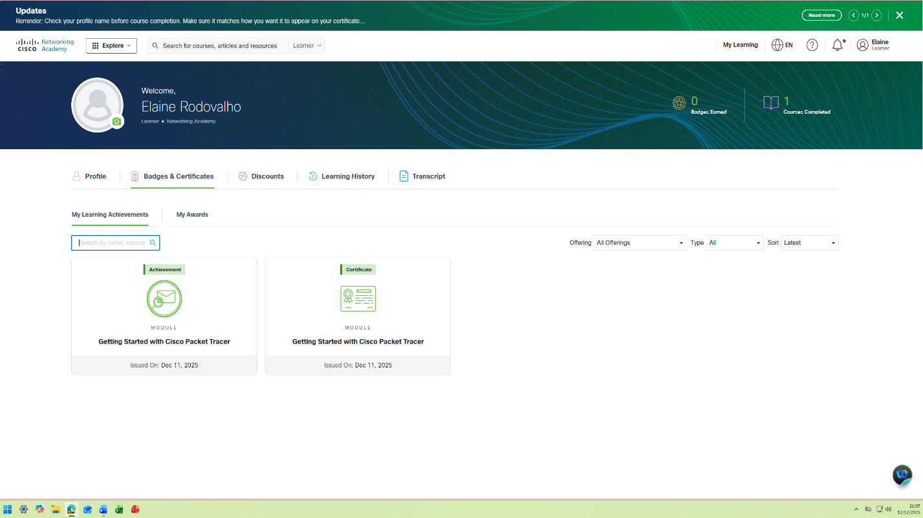

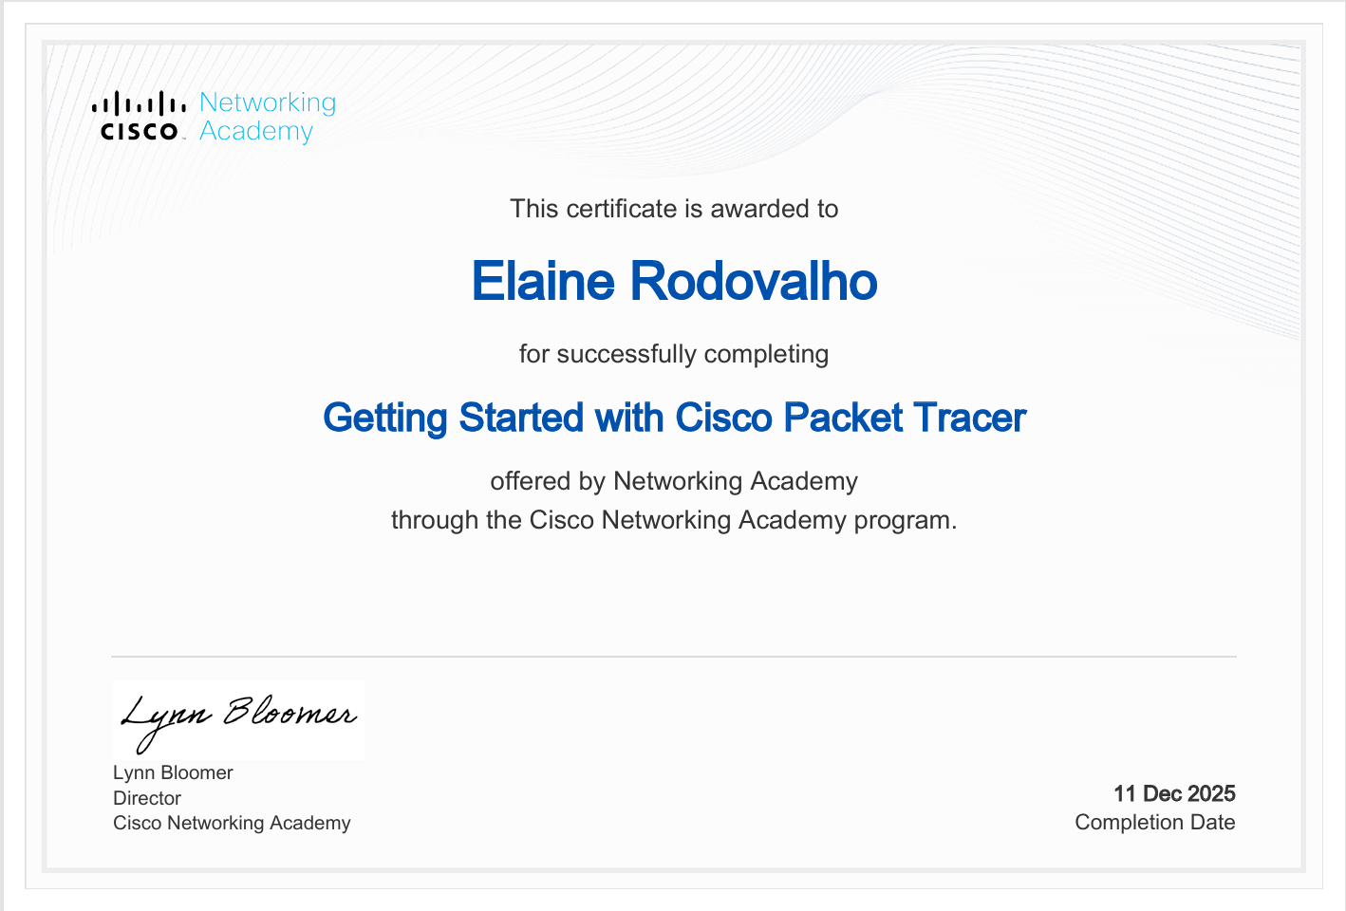

https://1drv.ms/p/c/418c0f925241648c/IQDZJUWE_FueSonlVlNP7HxZAU-isxx4gSVEehNUeoSfwgQ?e=YSZojx
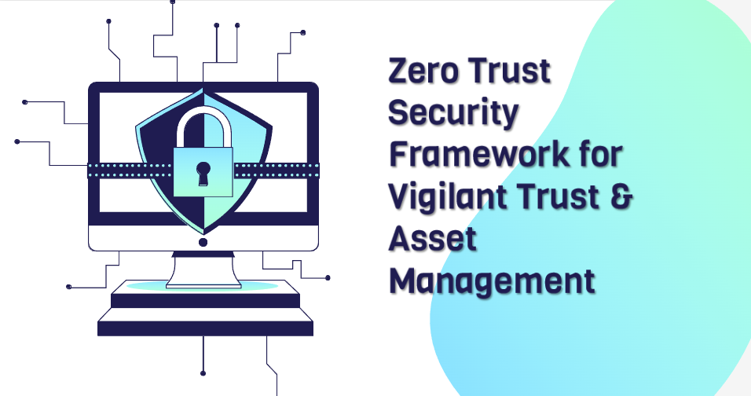
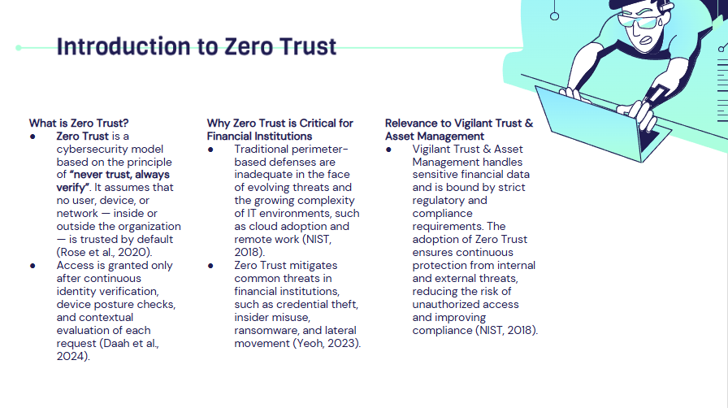
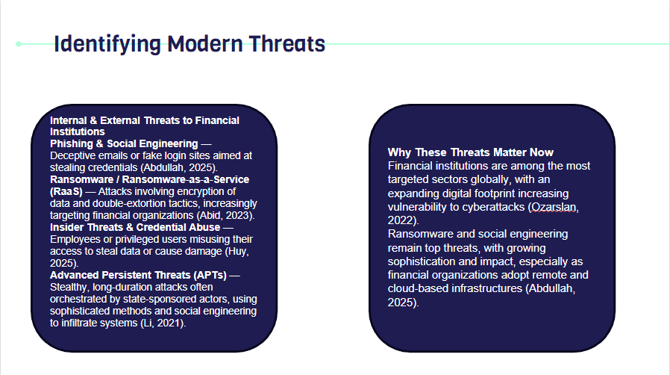

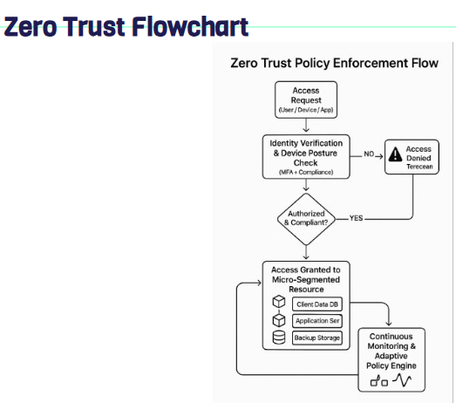

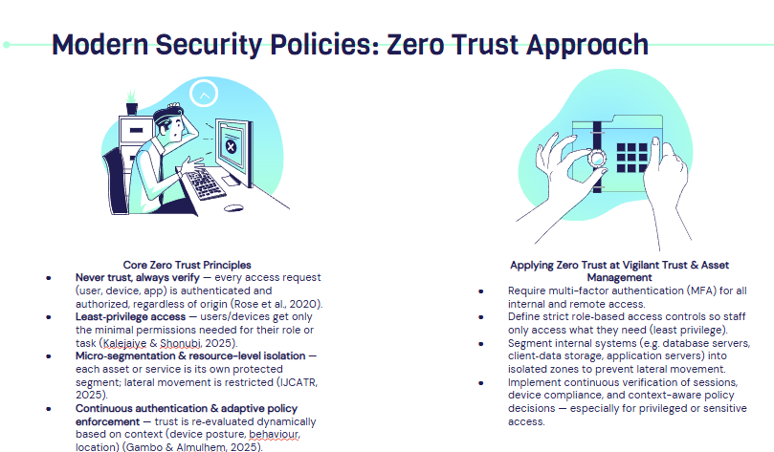

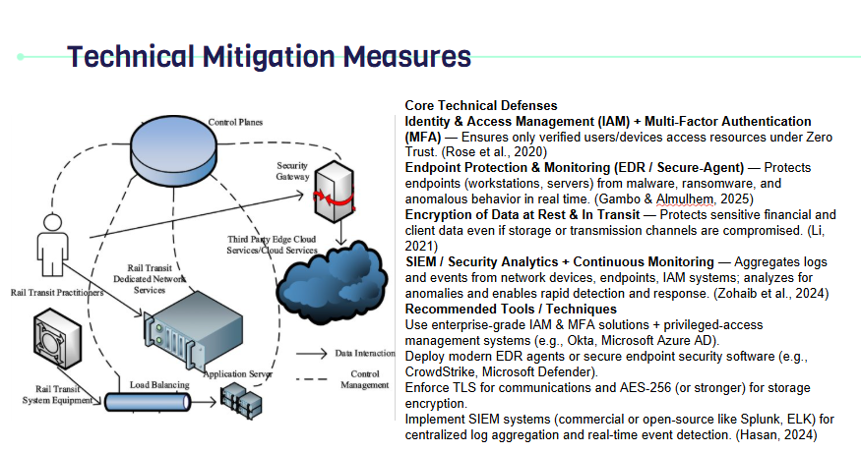

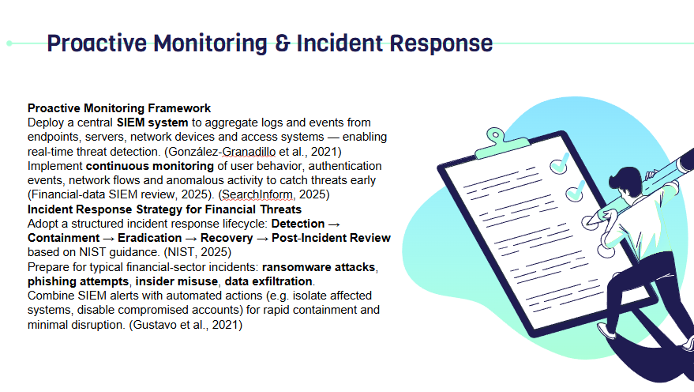

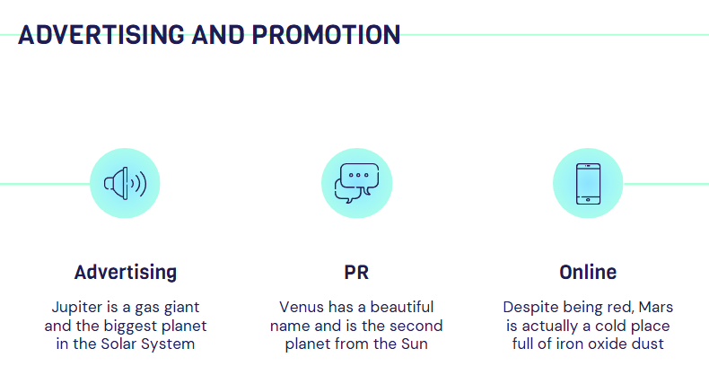

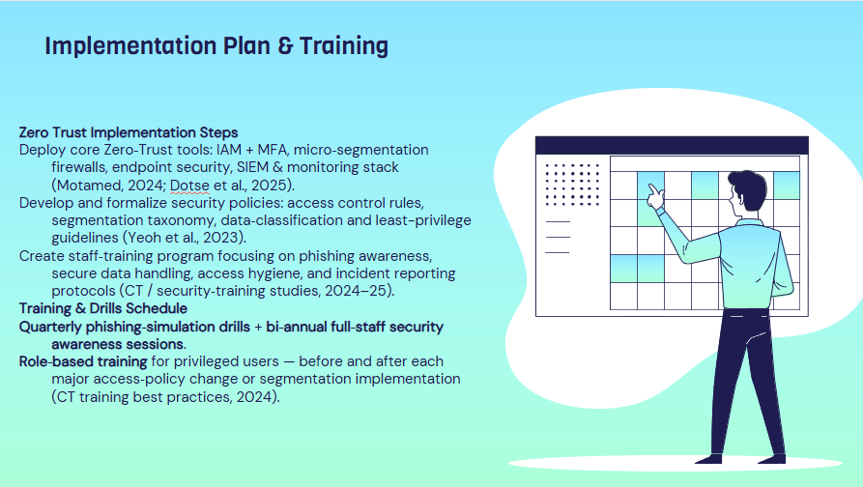

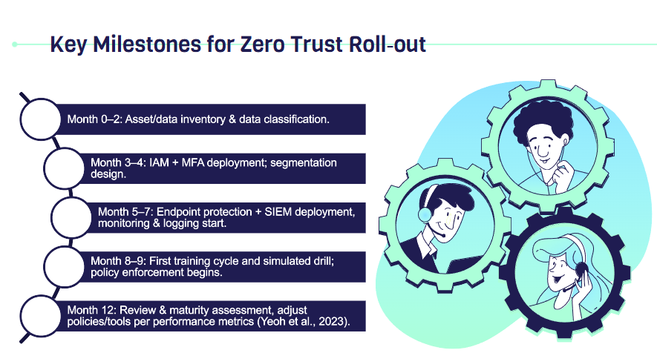

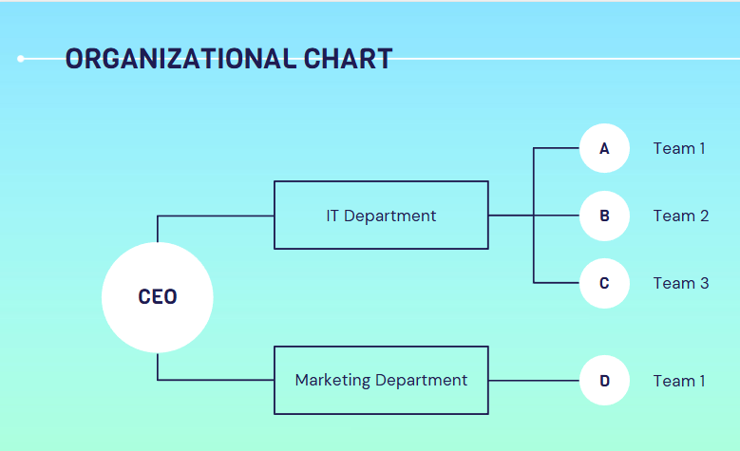

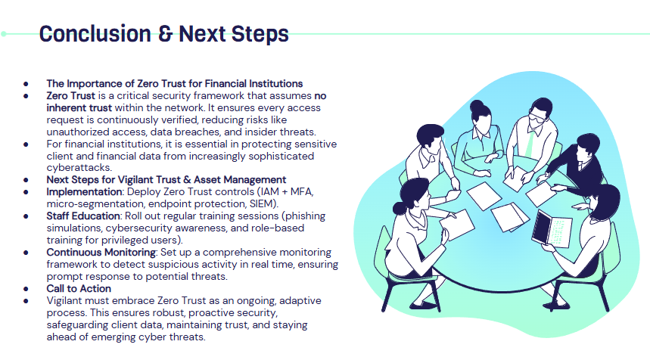

Abdullah, M. I., 2025. Cybersecurity Threats in the Financial Sector: Trends and Mitigation Strategies. Journal of Financial Cybersecurity Studies. Available at: https://www.researchgate.net/publication/391755055_CYBERSECURITY_THREATS_IN_THE_FINANCIAL_SECTOR_TRENDS_AND_MITIGATION_STRATEGIES [Accessed 9 Dec. 2025].
Abid, N., 2023. Ransomware Attacks on Financial Institutions: A Review of Risks and Countermeasures. International Journal of Multidisciplinary Sciences and Arts, 2(2), pp. 95-110. Available at: https://www.researchgate.net/publication/387325370_Ransom_ware_Attacks_on_Financial_Institutions_A_Review_of_the_Literature_on_Cybersecurity_Risks_and_Countermeasures [Accessed 9 Dec. 2025].
CISA / Cybersecurity-training literature, 2024. Why Employee Cybersecurity Awareness Training Is Important — analysing human-error mitigation in financial sectors.
González-Granadillo, G., González-Zarzosa, S. & Diaz, R., 2021. Security Information and Event Management (SIEM): Analysis, Trends, and Usage in Critical Infrastructures. Sensors, 21(14), p. 4759. Available at: https://doi.org/10.3390/s21144759 [Accessed 9 Dec. 2025].
Daah, C., Wonuola, I., Obunadike, C. & Izundu, A. C., 2024. Enhancing Zero Trust Models in the Financial Industry. Electronics, 13(5), p. 865. Available at: https://www.mdpi.com/2079-9292/13/5/865 [Accessed 9 Dec. 2025].
Dotse, S. K., et al., 2025. Zero Trust Architecture Implementation in Enterprise Networks: Evaluating Effectiveness Against Cyber Threats. International Journal of Computer Applications, 187(45).
Gambo, M. L. & Almulhem, A., 2025. Zero Trust Architecture: A Systematic Literature Review. arXiv. Available at: https://arxiv.org/abs/2503.11659 [Accessed 9 Dec. 2025].
Hasan, M., 2024. Enhancing Enterprise Security with Zero Trust Architecture. arXiv. Available at: https://arxiv.org/pdf/2410.18291 [Accessed 9 Dec. 2025].
Huy, S., 2025. Insider Threats in Banking Sector: Detection, Prevention, and Challenges. Journal of Cybersecurity & Risk Analysis, 4(1), pp. 45-62. Available at: https://jcsra.thestap.com/archives/volume-2025-4/6870c93824fbb712166871e9?utm_source=chatgpt.com [Accessed 9 Dec. 2025].
IJCATR, 2025. Zero Trust Enforcement Using Microsegmentation, Identity-Aware Proxies, and Continuous Adaptive Risk Assessment in Multi-Tenant Environments. International Journal of Computer Applications Technology and Research, 14(7), pp. 61-77.
Kalejaiye, A. N. & Shonubi, J. A., 2025. Zero Trust and Micro-Segmentation. The American Journal of Management and Economics Innovations, 56.
Li, Y., 2021. A Comprehensive Review of Cyber-Attacks and Protection Mechanisms. International Journal of Information Security and Cyber-Risk, 10(3), pp. 122-138. Available at: https://www.sciencedirect.com/science/article/pii/S2352484721007289 [Accessed 9 Dec. 2025].
Motamed, A., 2024. The Zero Trust Security Model and Its Application in Organizations. Journal of Resource Management and Decision Engineering, 3(3), pp. 21-32.
NIST, 2018. Cybersecurity Framework: NIST Special Publication 800-53 Revision 5. National Institute of Standards and Technology. Available at: https://www.nist.gov/cyberframework [Accessed 9 Dec. 2025].
NIST, 2025. Incident Response Recommendations and Considerations for Cyber Risk Management. NIST Special Publication 800-61r3.
Ozarslan, S., 2022. Key Threats and Cyber Risks Facing Financial Services and Banking Firms. Financial Security Review, 5(4), pp. 201-215. Available at: https://www.picussecurity.com/key-threats-and-cyber-risks-facing-financial-services-and-banking-firms-in-2022 [Accessed 9 Dec. 2025].
Rose, S., Borchert, O., Mitchell, S. & Connelly, S., 2020. Zero Trust Architecture. NIST Special Publication 800-207. Available at: https://nvlpubs.nist.gov/nistpubs/specialpublications/NIST.SP.800-207.pdf [Accessed 9 Dec. 2025].
SearchInform, 2025. How SIEM Enhances Security in Financial Institutions. SearchInform Cybersecurity Reports.
Sygnia, 2025. Incident Response Process, Plan & Complete Guide. Sygnia Security Reports.
Yeoh, W., 2023. Zero trust cybersecurity: Critical success factors and implementation. Journal of Cybersecurity & Information Assurance. Available at: https://www.sciencedirect.com/science/article/pii/S016740482300322X [Accessed 9 Dec. 2025].
Yeoh, W., et al., 2023. Zero Trust Cybersecurity: Critical Success Factors and a Maturity Assessment Framework. Computers & Security, 133, p. 103412.
Zohaib, S. M., Ahmed, M. & Qureshi, I. A., 2024. Zero Trust VPN (ZT-VPN): A Framework for Secure Remote Access. Information, 15(11), p. 734. Available at: https://www.mdpi.com/2078-2489/15/11/734 [Accessed 9 Dec. 2025].

