Critical Evaluation of Brauns multiplier and wallace tree multiplier using vhdl
Electronics II (ACDA6001) (EES Version)

UWTSD
Louis S (2322688)

Contents
Abstract 4
Introduction 4
Background Research 4
What are multipliers? 4
Different Types 4
Braun 4
Wallace 5
Dadda 5
Booth 5
Array 6
Applications 6
Image and Video Processing 6
Communication Systems 6
Artificial Intelligence 6
Embedded Systems 6
Main Assignment 7
Flow Diagrams 7
Braun 7
Wallace 7
Block Diagrams 7
Braun 8
Wallace 10
Design Process 12
Braun 12
Wallace 12
Wallace Dot Diagram 12
VHDL 13
Braun 13
Wallace 15
Diagrams & Reports 16
Braun Multiplier 17
Wallace 18
RTL Design 20
Schematic 22
FPGA Design 24
Braun 24
Wallace 25
Simulated & Results 25
Simulation 25
Braun 26
Wallace 30
Analysis & Interpretation 34
Complexity 34
Timing 34
Utilisation 34
Power 35
Recommendations 35
Conclusion 35
References 35
Appendix 37
Braun Multiplier Code 37
Wallace Multiplier Code 41

Abstract
The report found that when comparing both the Braun and Wallace multipliers, the Wallace performed better in terms of resource utilisation and power consumption; however, the timing simulations found it was slower than the Braun in this specific situation, which may be attributed to optimisation or routing within Vivado.

Introduction
Multipliers perform one of the most fundamental mathematical operations in existence, acting as the foundation of many applications such as DSP, Embedded Programming, Communications and Graphical Processing.
FPGAs (Field Programmable Gate Arrays) act as a versatile basis to implement varying types of multipliers, each with their own trade-offs in speed, efficiency, complexity and power consumption, among other things. As such, there is a clear need to select suitable multipliers for their intended applications.
This report details the comparison of the performance of Braun & Wallace tree multipliers using VHDL, in addition to the design process, as well as a review of what types and current developments there are in the field of FPGA multipliers.

Background Research

What are multipliers?
In this context of FPGAs, multipliers are circuits that allow multiplication to be performed between two binary numbers, forming the basis of all modern technologies, allowing for complex data processing and calculations.
Made up of Half and Full Adders, which themselves are made up of a combination of XOR, AND & OR gates shown below
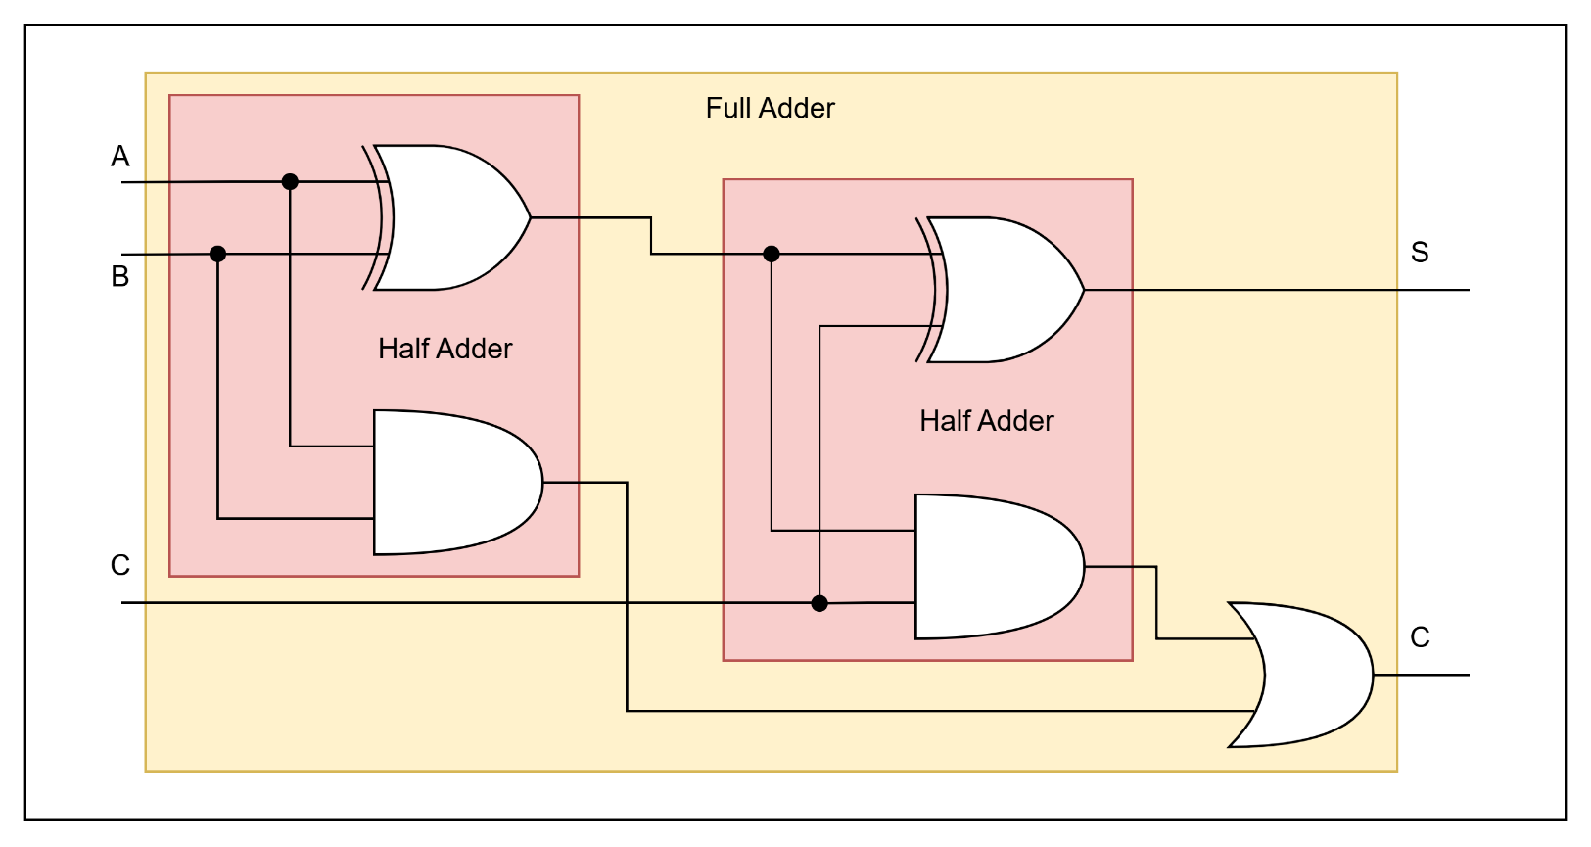

Different Types
There are numerous types of multipliers, each with its own strengths and weaknesses. Some, but not limited to, include:

Braun
A simple type of multiplier, the Braun method is tailored for ease of implementation due to the relative simplicity of its construction, being made up of both half and full adders as well as AND gates in an array structure.
It processes binary numbers simultaneously as opposed to sequentially, as some other multipliers do; this results in a relatively quick process.
Its advantages include:
- Simplicity with ease of hardware implementation
- Quicker speeds for smaller bit widths due to fewer logic gates present
- Propagation delay is uniform, resulting in a predictable delay
Some of its limitations include:
- Higher clock cycles required for larger operations, compared to some other multipliers
- Larger bit widths are slower to process and increase linearly with bit count

Wallace
The Wallace multiplier is a type of binary multiplier that multiplies two different bit integers. Also made up of AND, Half and Full Adders, it is instead designed to reduce the number of partial products until giving a final product.
By using this method, decreased computation time can be achieved due to processing multiple rows simultaneously; however, with a trade-off being that of higher wiring complexity and area usage.
Its advantages include:
- Improved speed, with the simultaneous processing
- Efficiency, for aspects such as power consumption
Some of its limitations include:
- Complexity in both area layout and wiring connections
- Power consumption, compared to other multipliers

Dadda
A Dadda multiplier, like the others, is a binary multiplier and is similar to that of the Wallace, with a key design alteration, in that they reduction in the upper layers, in an attempt to save on gate usage.
Like Wallace, Dadda operates using the same design principle, reducing adders for speed, with the limiting factor also being complexity.
Its advantages include:
- Lower area and hardware complexity due to the reduced number of gates used
- Higher speeds due to parallel product reduction
- Optimised to avoid unnecessary additions
Some of its limitations include:
- Unconventional layout resulting in more difficult routing and layout
- Struggles with scaling to larger bit-widths, due to increasing complexity

Booth
The Booth method lowers computations by not creating a partial product for each 1 bit, but by encoding it in such a way that a partial product is only created when the bit stream changes, similar to that of a falling or rising edge. The premise behind this was to reduce adder usage and the number of partial products.
Its advantages include:
- Higher speeds due to fewer operations being performed
- Fewer adders are utilised for better hardware efficiency
- More suitable for larger bit-widths due to fewer wasted additions
Some of its limitations include:
- More complexity when implementing compared to other simpler multipliers
- May operate more slowly if the bit input is constantly changing state, i.e., 01010101
- Processes a single bit per clock cycle, likely slower than optimised parallel multipliers

Array
One of the simpler designs of a multiplier, the Array method, stores the partial products in an array. As a result of its simplicity, it suffers from high delays and
Its advantages include:
- Very simple to implement and understand
- Regular and predictable layout
- Easy to scale for larger bit-widths
Some limitations include:
- High dynamic power from the number of gates switching
- Large hardware requirement from the number of gates in use
- Large bit-widths cause poorer performance and greater delays in processing
- Larger area required due to the number of gates and AND gates used in the design
[1] [2] [3] [4] [5] [6] [7] [8] [9] [10] [11] [12] [13] [14] [15] [16]

Applications
Due to the fundamental nature of Multipliers in modern systems, there are numerous applications and an exhaustive list can’t be added here, but a few notable selections can include:

Image and Video Processing
Due to the real-time nature of video processing, there can be a lot of information and data requiring processing, especially considering the number of multiplications per frame required. As a result, Image and Video Systems tend to prefer higher throughput and energy efficiency.
Methods such as Wallace and Dadda would likely be more suited to this type of application.

Communication Systems
Similar to that of Image and Video, Communication Systems often require larger amounts of throughput due to the large amounts of data requiring processing during their de/modulation stages and other processes such as error correction.
Wallace and Dadda would also likely be more suited to this type of application due to their ability to support real-time processing.

Artificial Intelligence
Modern AI utilises large amounts of matrix multiplication, especially systems that utilise deep learning or neural networks. As a result, they prefer architecture that provides simultaneous, high-speed and throughput, with another factor requiring as minimal power wastage as possible due to the sheer amount of time required.

Embedded Systems
Embedded Systems often are focused on optimising for space as much as possible, and as a result tend to prefer smaller area and lower power consumption than the application mentioned in the previous use cases.
This results in favouring smaller and simpler systems such as the Braun over larger than the Wallace or Dadda.

Main Assignment
This section of the report details the Design, Implementation, Validation & Analysis of the operation of both a Braun and Wallace Multiplier using Vivado, Microsoft Excel & Draw.io.

Flow Diagrams
Basic flow diagrams were created to illustrate the function of each multiplier at a high level, shown below.

Braun
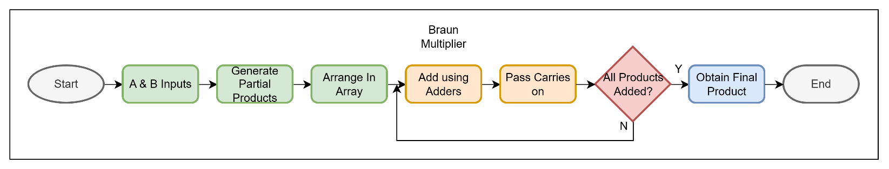

Wallace
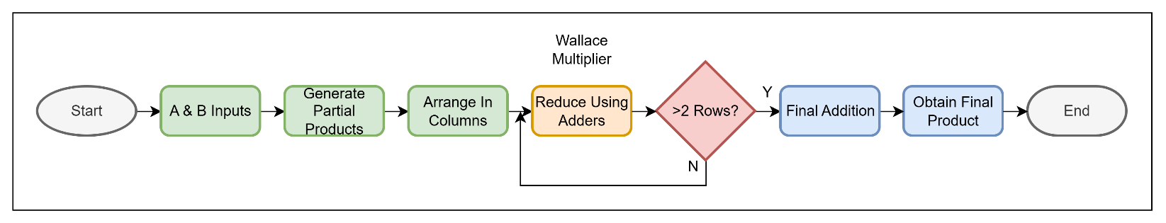

Block Diagrams
Then the block diagrams were created for both the Braun and Wallace multipliers, to illustrate how the inputs, signals and carries connected internally within the system.
The critical path was also shown in another version, which illustrates the longest path data could take, and by extension, the slowest, which is required later in the design portion of the report.

Braun
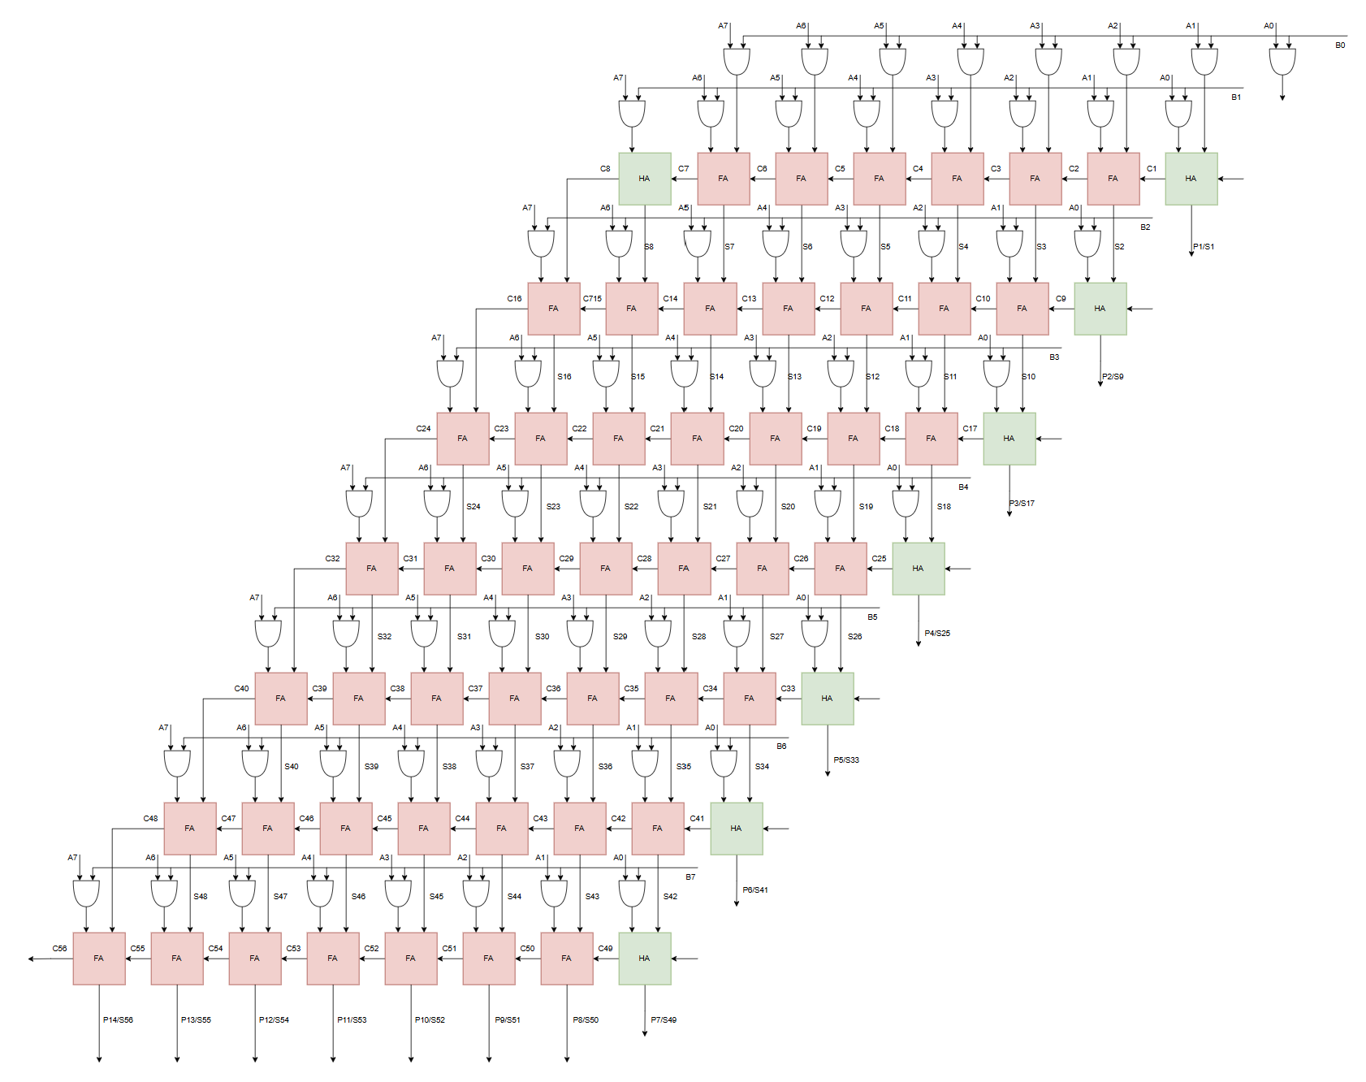
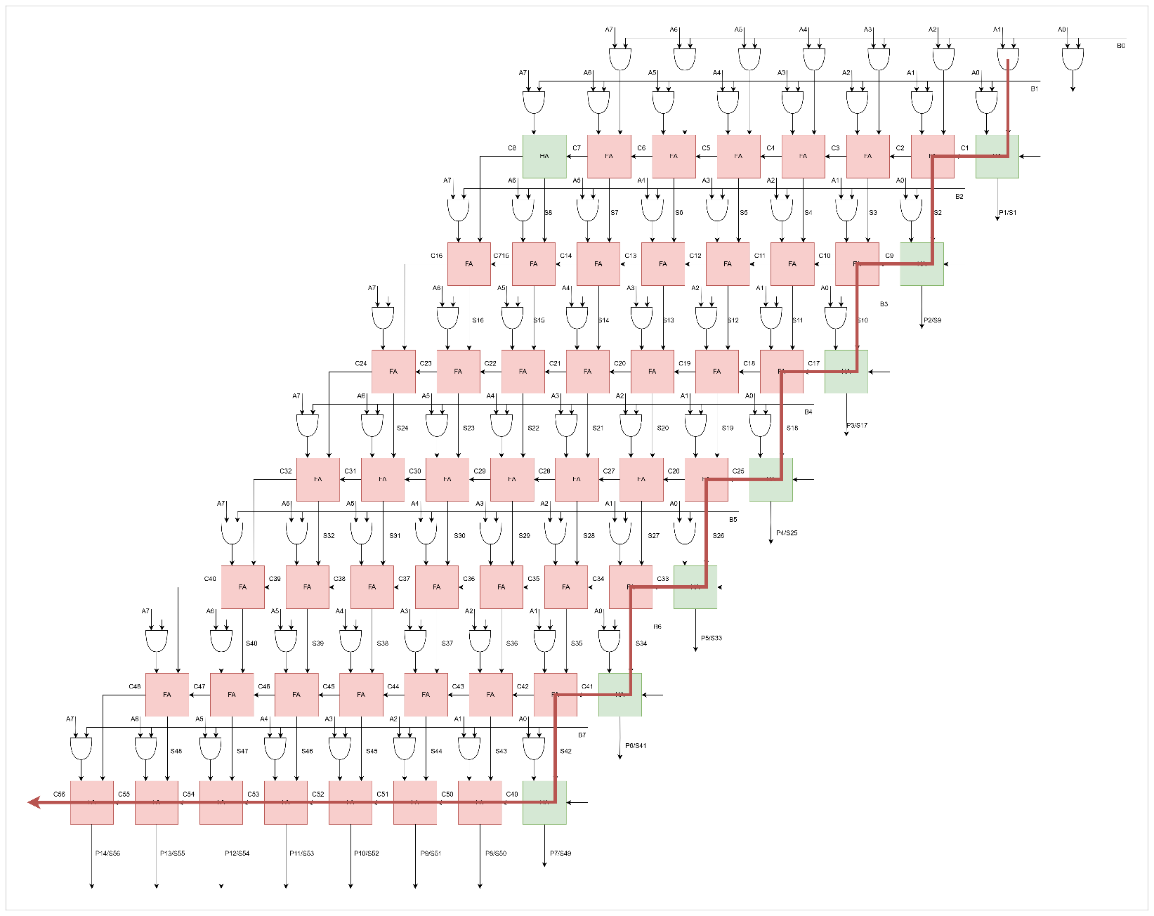

Wallace
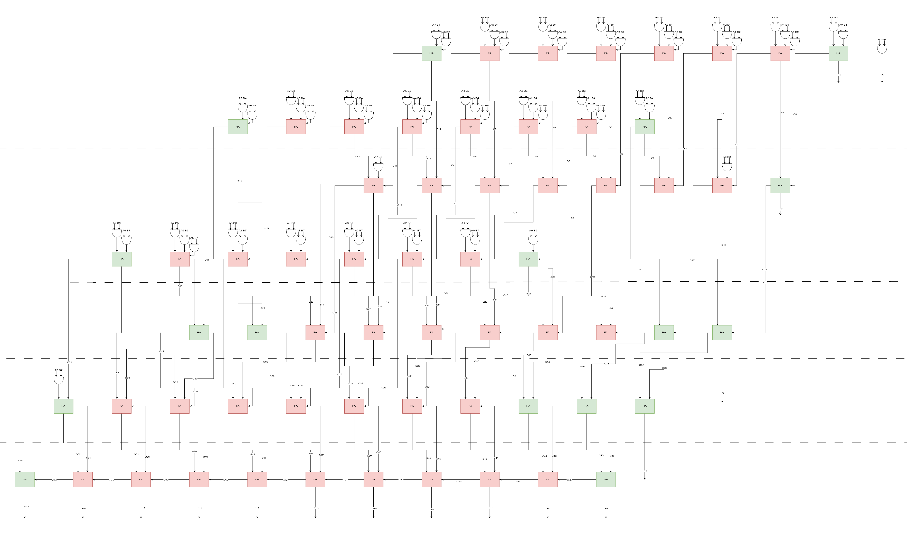
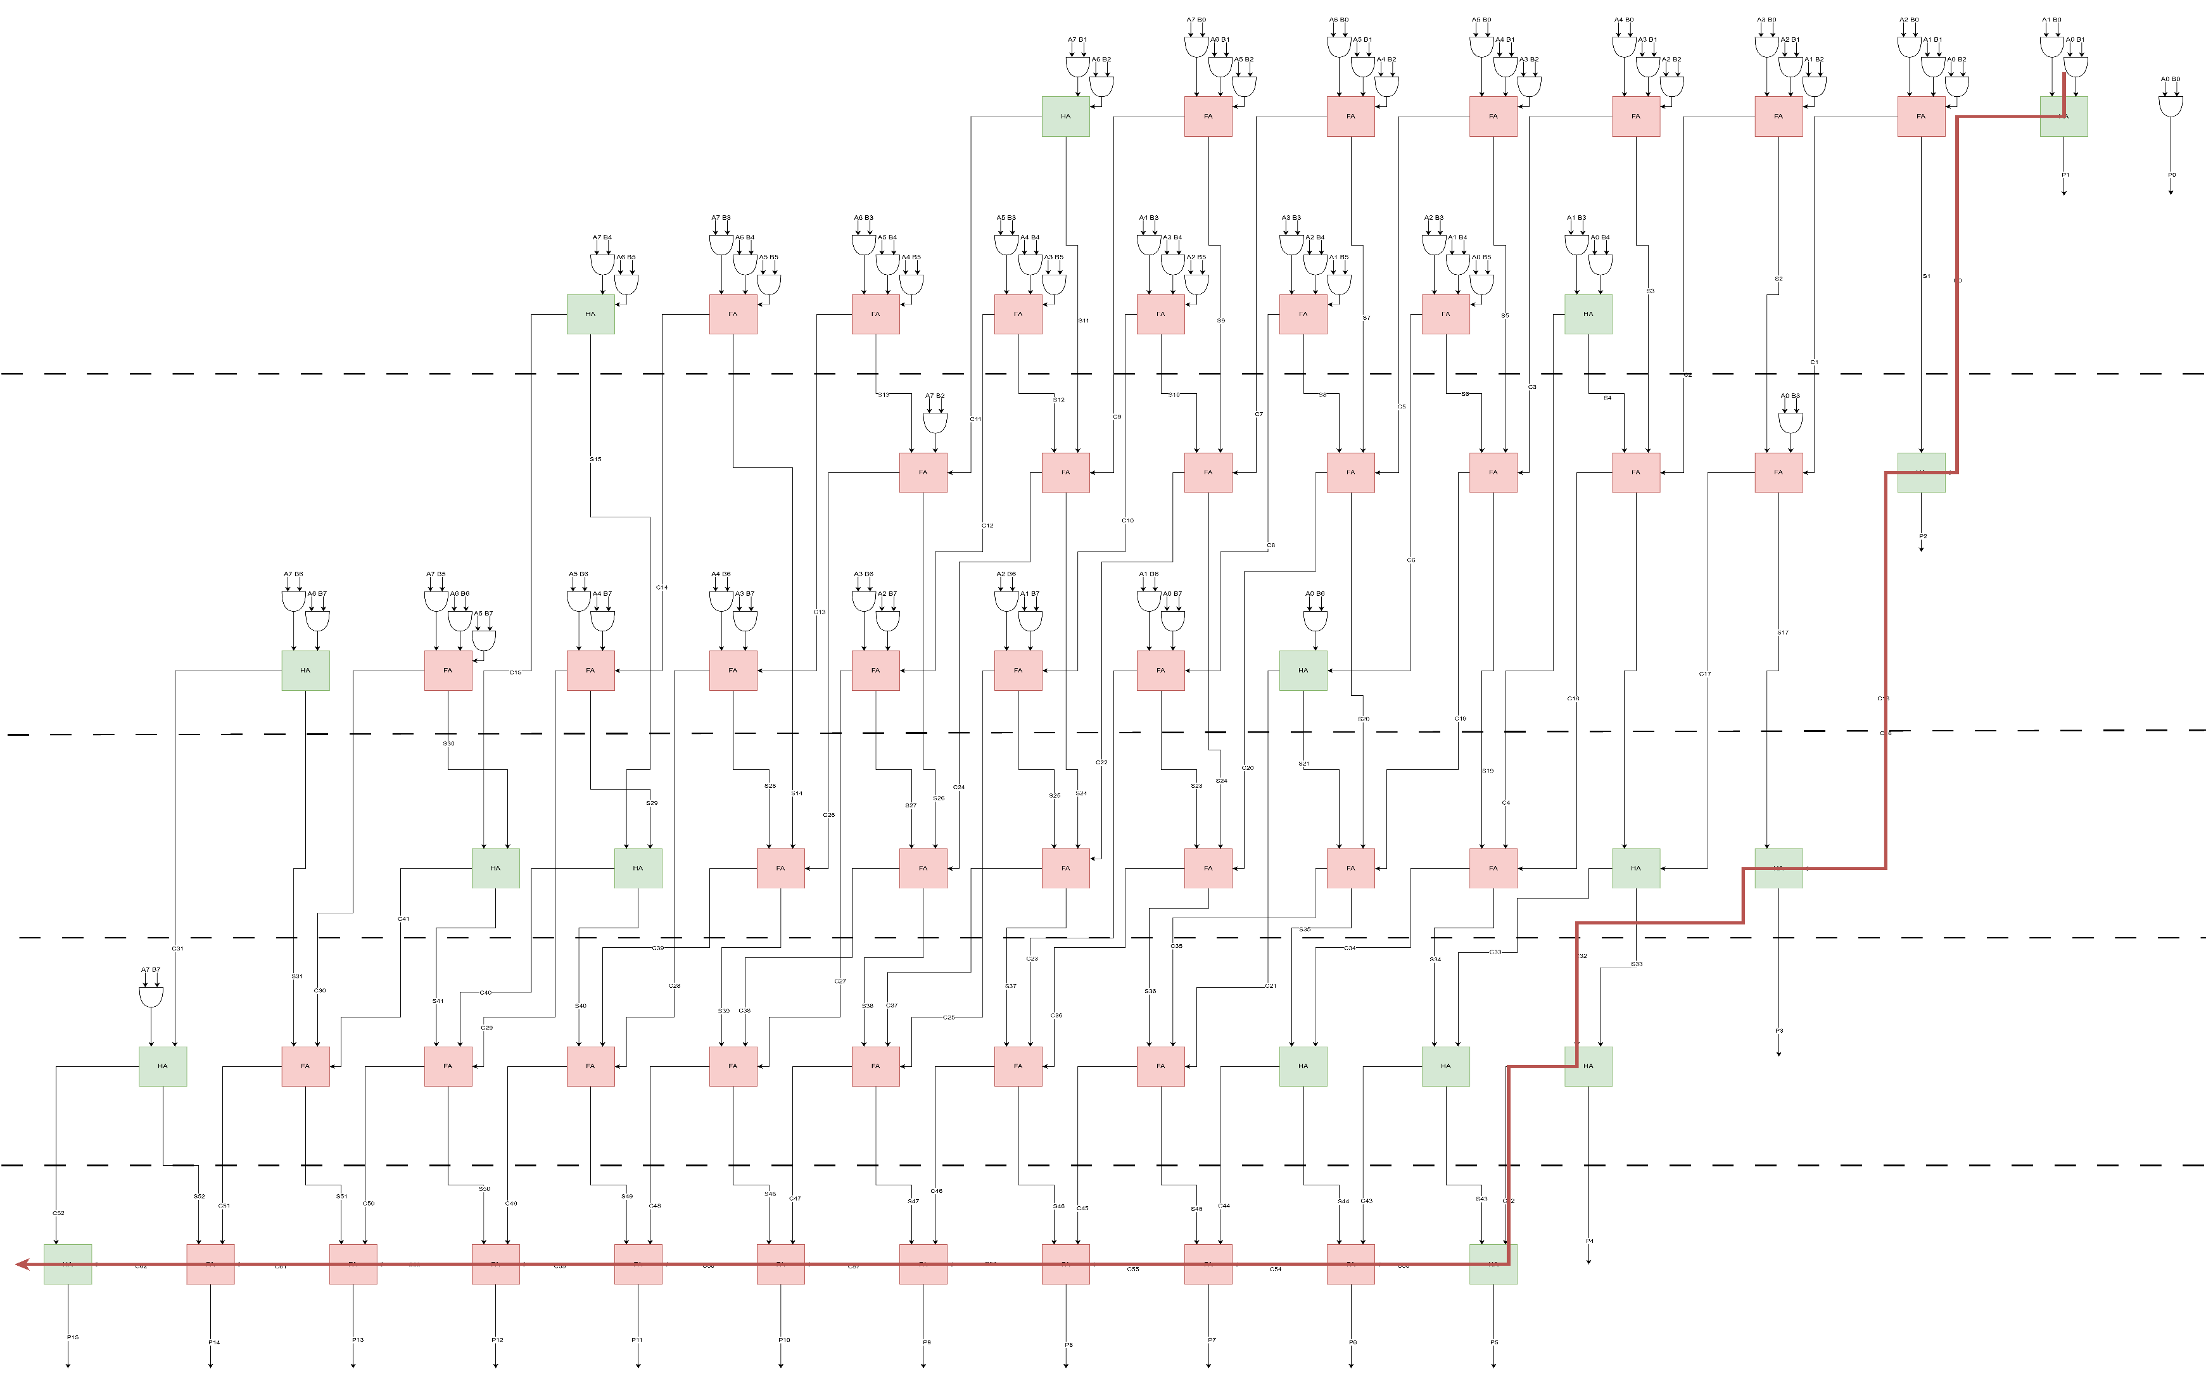

Design Process
This section outlines some of the design process that was applied to simulate and programme both Braun and Wallace multipliers, making use of Excel to represent the complexity of the connections in a way that can be better understood in the event of debugging and error correction.

Braun

Wallace
The Excel spreadsheet was utilised to plan out the programmed connections for the Wallace tree (similar to that of the Braun shown previously), with green and pink denoting the half and full adders, respectively and showing which of the sum and carry outputs are connected to their respective adders to produce the final P outputs.
As well as this, their groupings were also determined, which were later used for the VHDL programming.

Wallace Dot Diagram
The diagram below illustrates the dot diagram for the Wallace Tree, representing the partial products in the multiplier matrix. Reduction occurs column by column, using half and full adders with carry bits moved diagonally to the next column.

VHDL
This section breaks down the function of each part of the VHDL code for each of the multipliers, with the full unadulterated code in the appendix at the end of the report.

Braun
The section of code below declares the Braun hardware interface with 8 bits for each of the A and B inputs.
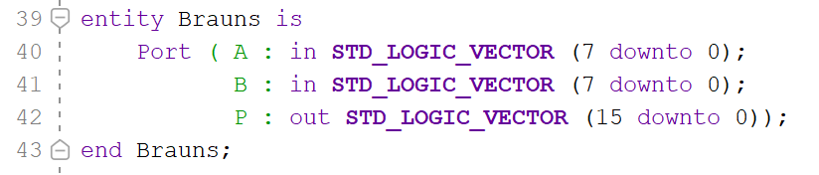
This section represents the grid of the Inputs shown in the Braun Excel spreadsheet.
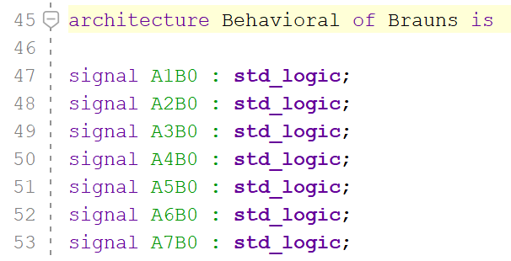
This section defines the carry and sum signals, respectively.
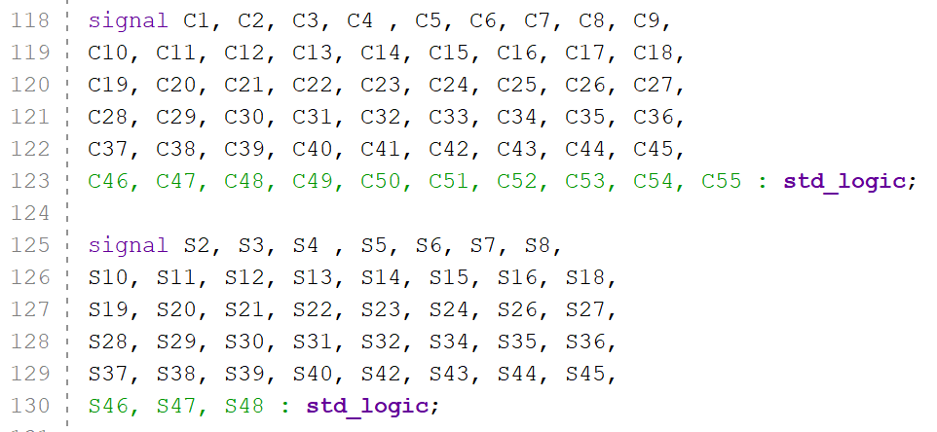
This section defines both the Full adder and the half adder with their inputs and outputs.
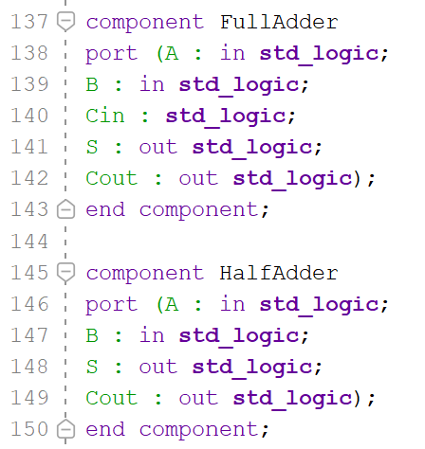
This section defines the AND gates from the initial A and B inputs for each of the combinations.
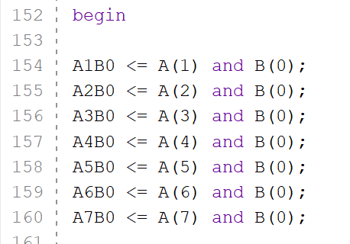
This section outlines how each of the outputs is created from each of its parts.
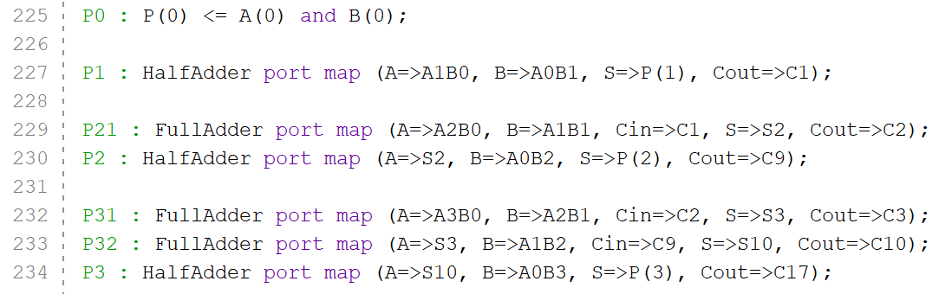

Wallace
Much like the Braun, this section of the Wallace code declares the hardware interface with 8 bits for each of the A and B inputs, as well as the 16-bit outputs.
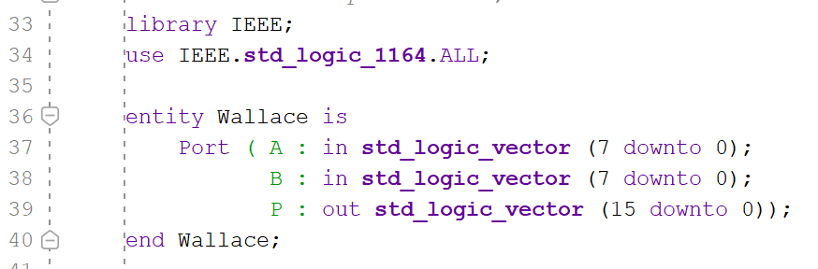
This section also outlines the initial grid of Input combinations.
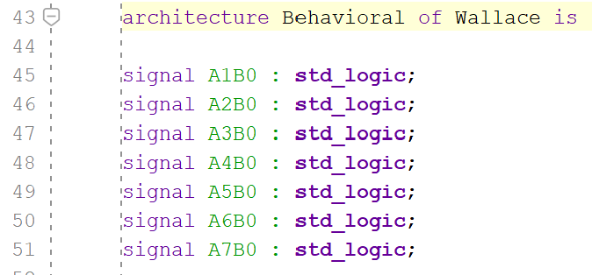
This section defines the carry and sum signals in the same way as Braun does
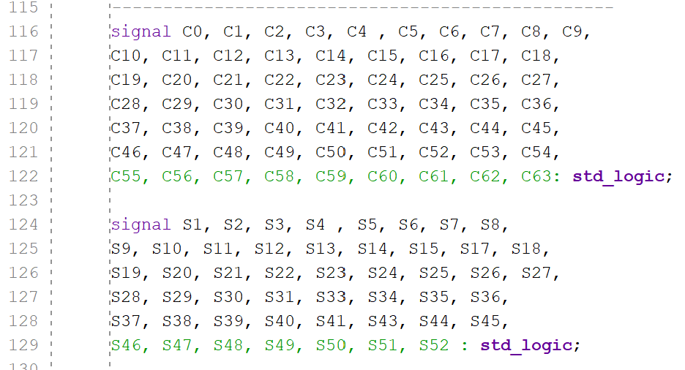
This section defines both the Full adder and the half adder with their inputs and outputs.
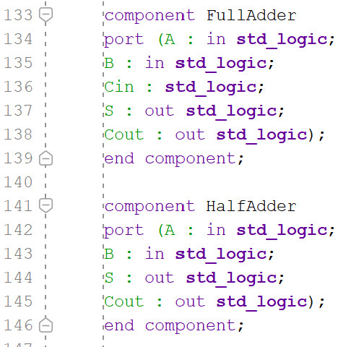
This section defines the AND gates from the initial A and B inputs for each of the combinations.
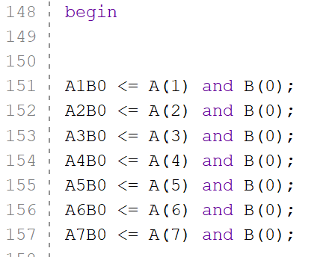
This section outlines how each of the outputs is created from each of its parts.
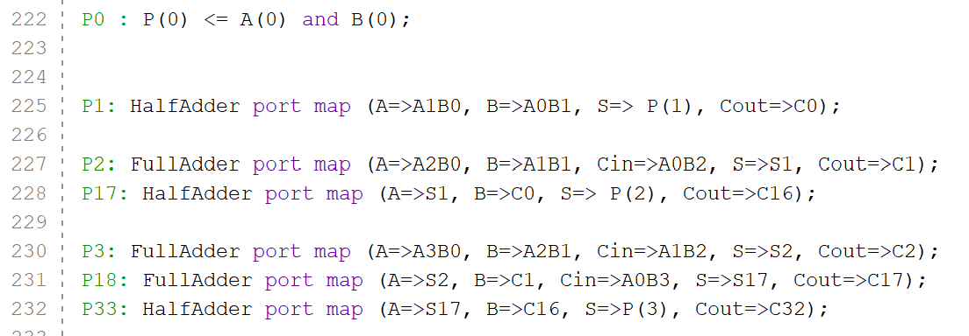

Diagrams & Reports
This section details the diagrams and reports produced by Vivado once the multipliers were constructed and programmed. This includes the project summary, timings, utilisation and power consumption for the simulated device. This allows both the Braun and Wallace multipliers to be compared with the same parameters for a fairer comparison, as detailed in the analysis and interpretation section of the report.
Each sub section of the part of the report outlines different aspects of how the multipliers operate and function.
- Project Summary gives a top-level overview of the device’s performance, giving a brief outline of the other important aspects such as power or timing, whilst maintaining a ‘surface level’ amount of detail for quick reference.
- Timing Report shows if the design can perform at the intended clock frequency, which can be a failure point in hardware should there be a discrepancy in timings. As well as presenting things such as WNS to determine if there is a design, it also helps to report on critical paths and worst negative slack, which is the duration of the slowest data path.
- Utilisation Report does as the name suggests and demonstrates how much of the system resources are being utilised for slice LUTs & Registers, the amount of LUTs used for Logic and Bonded IOBs (Input/Output Blocks).
- Power Report demonstrates the consumption of power by the implementation with the ‘used’, ‘excess’ and power margin between them, as well as the temperature of the device when operating.

Braun Multiplier

Project Summary
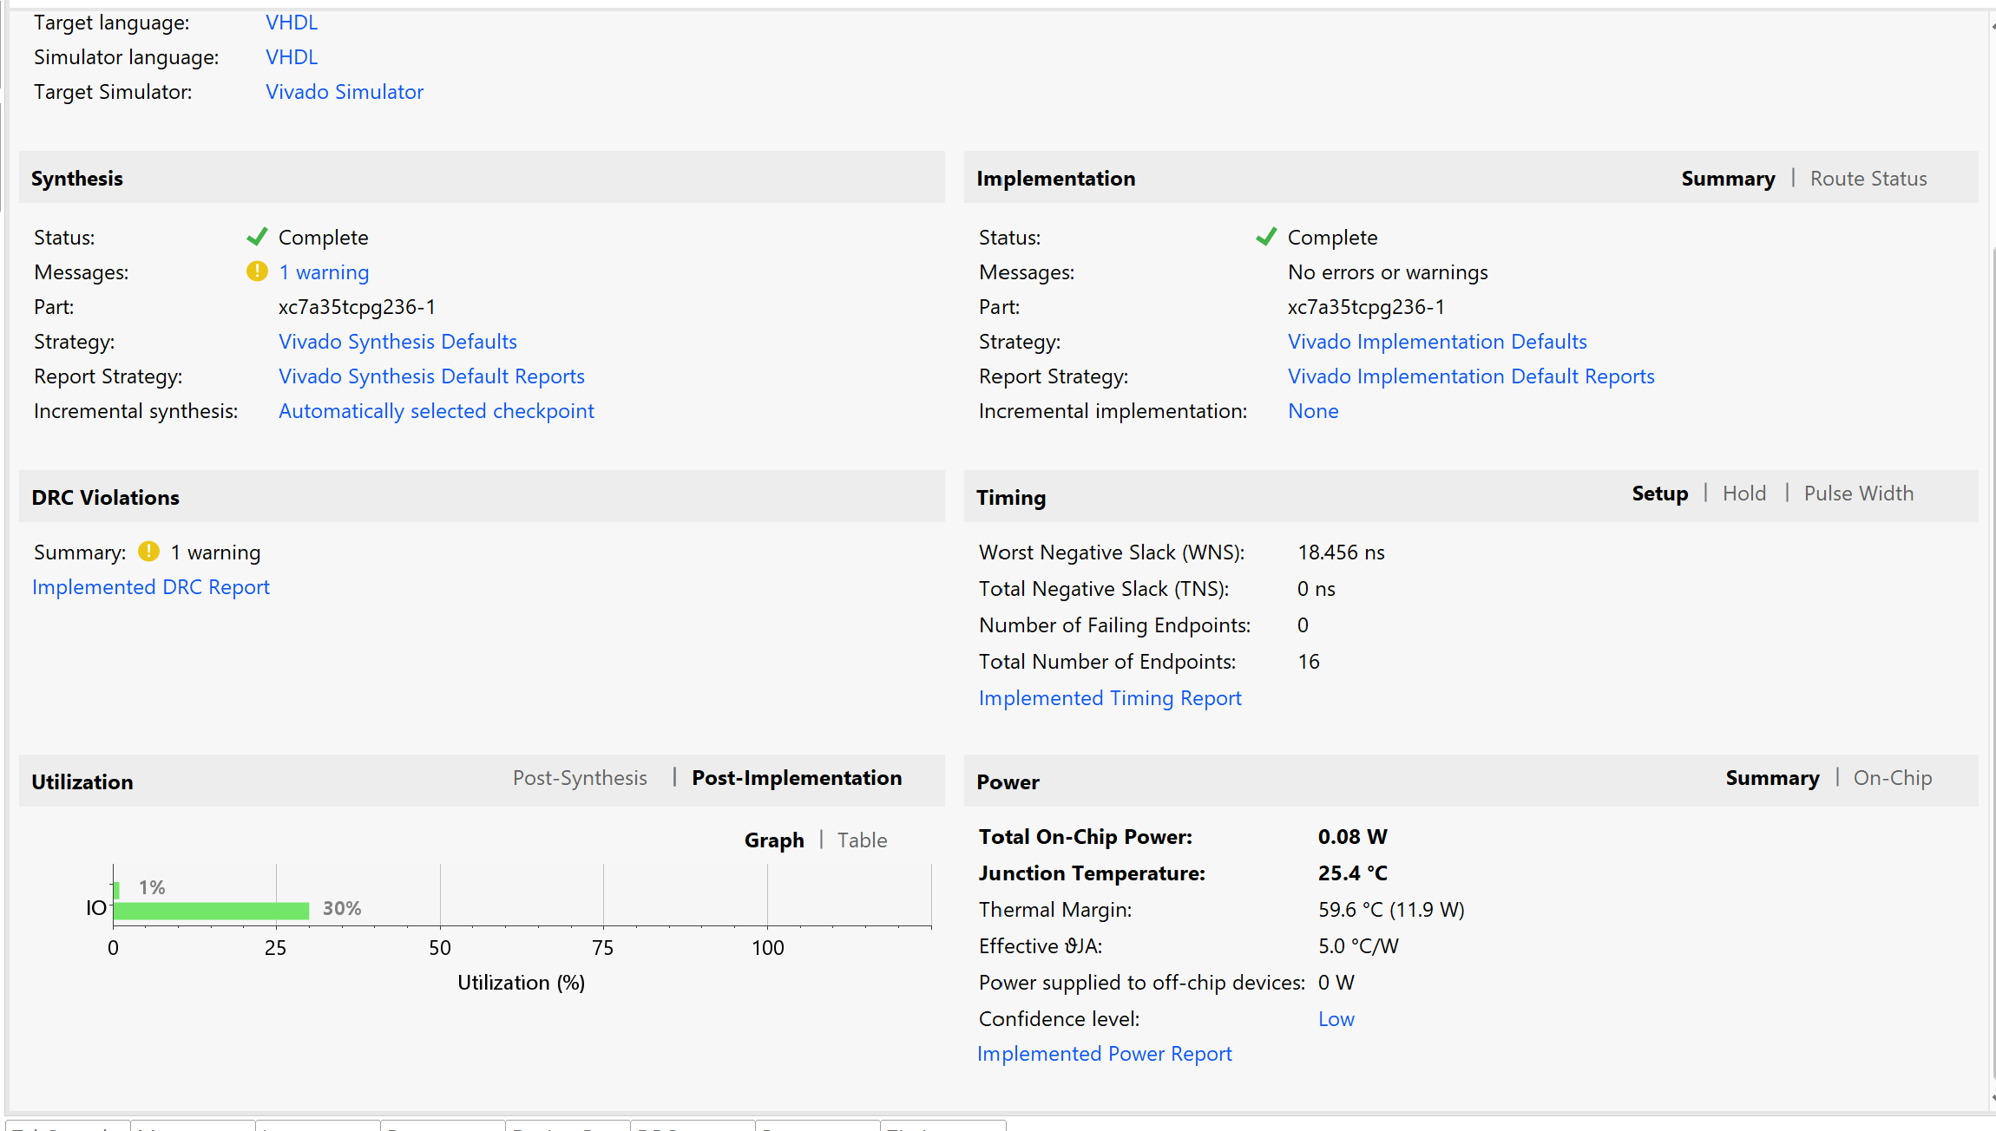

Timing Report
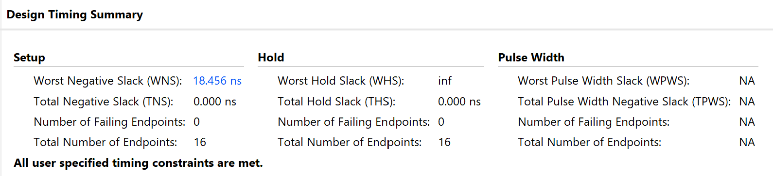

Utilisation Report
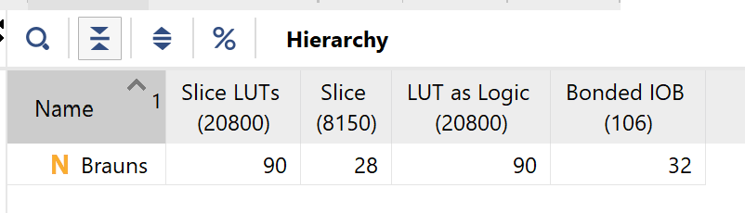

Power Report
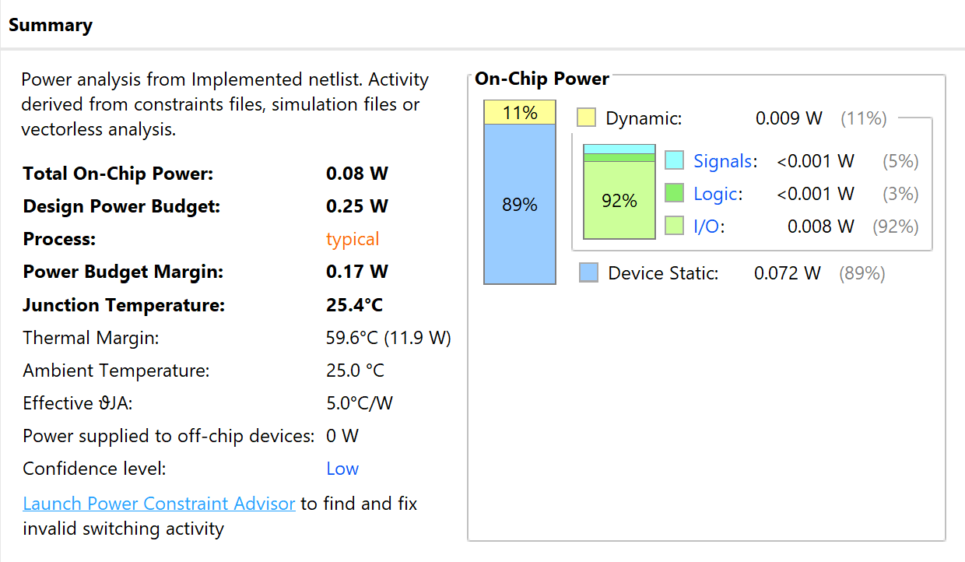

Wallace

Project Summary
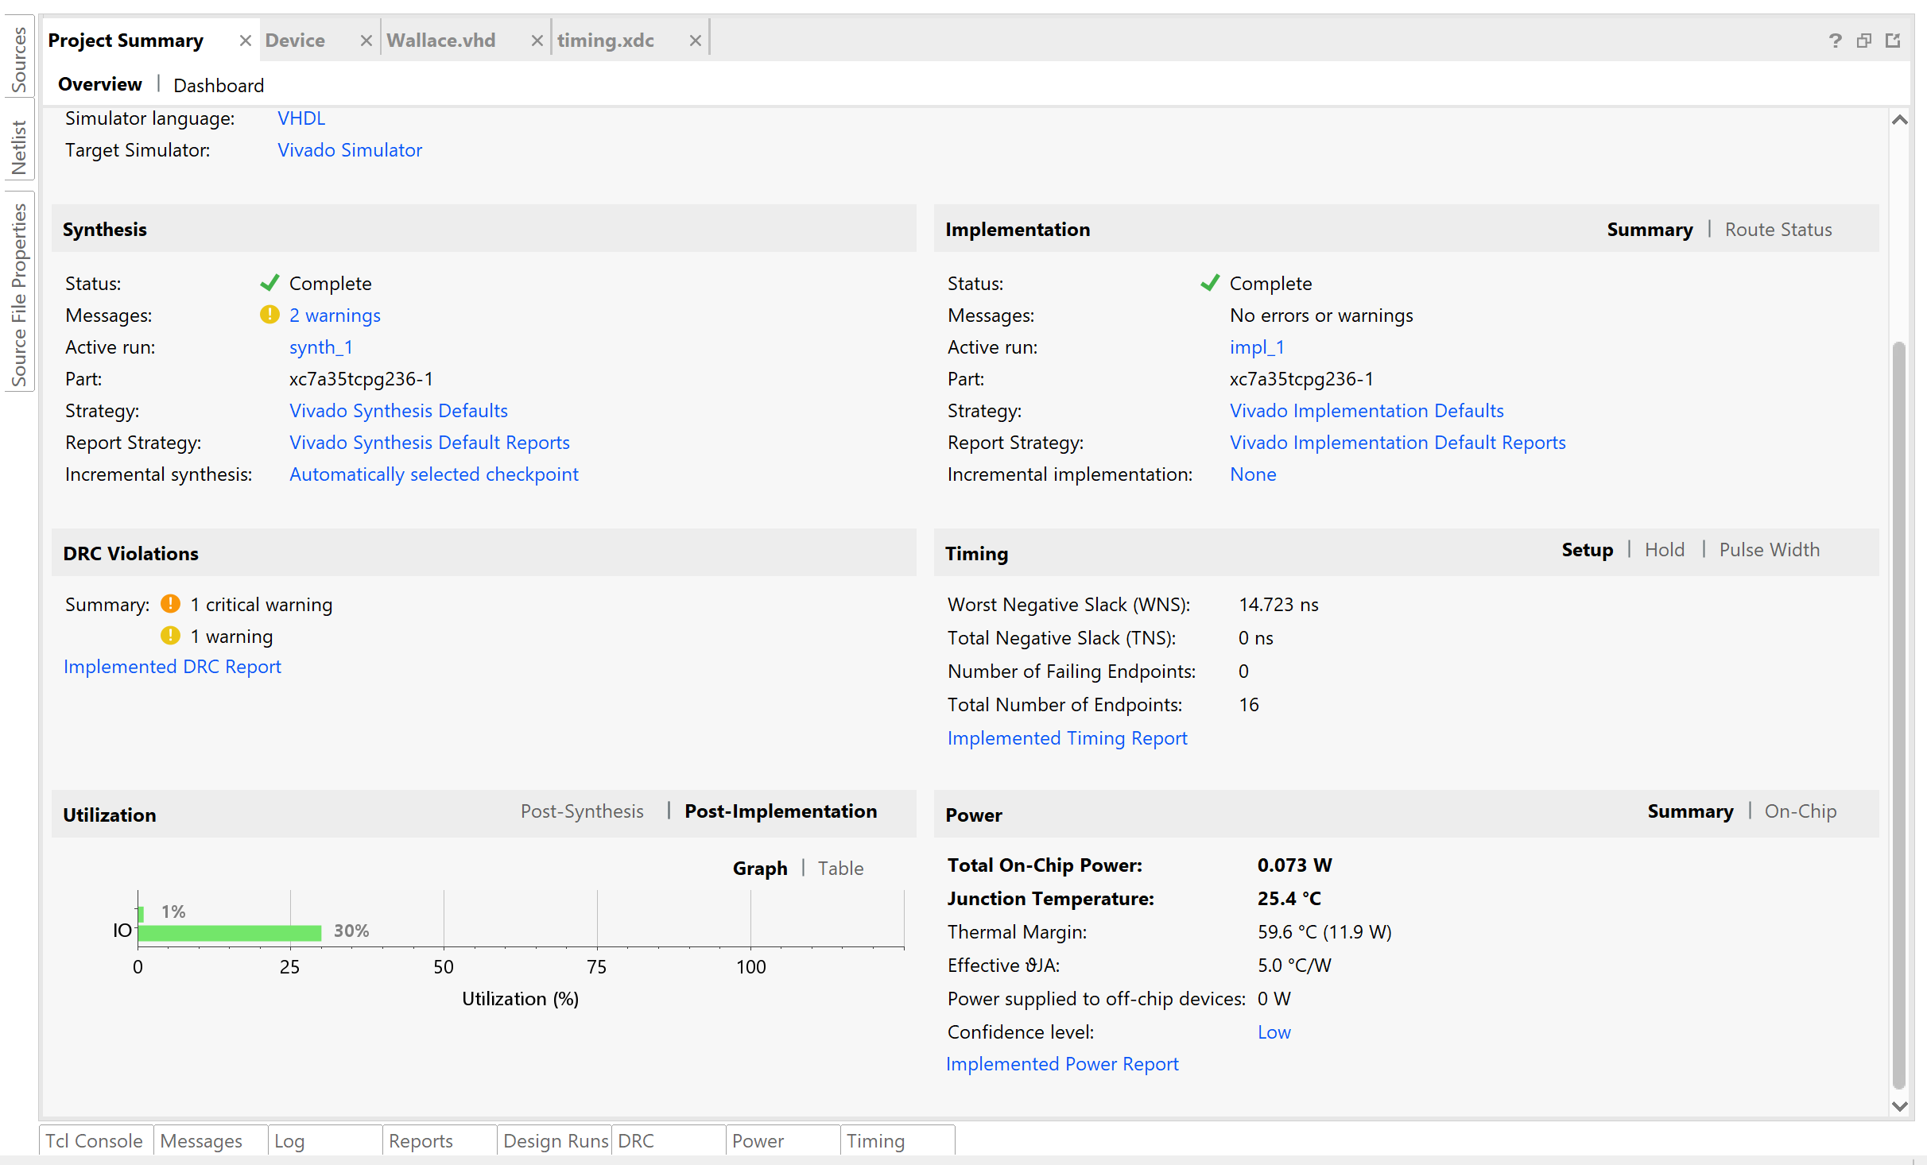

Timing Report
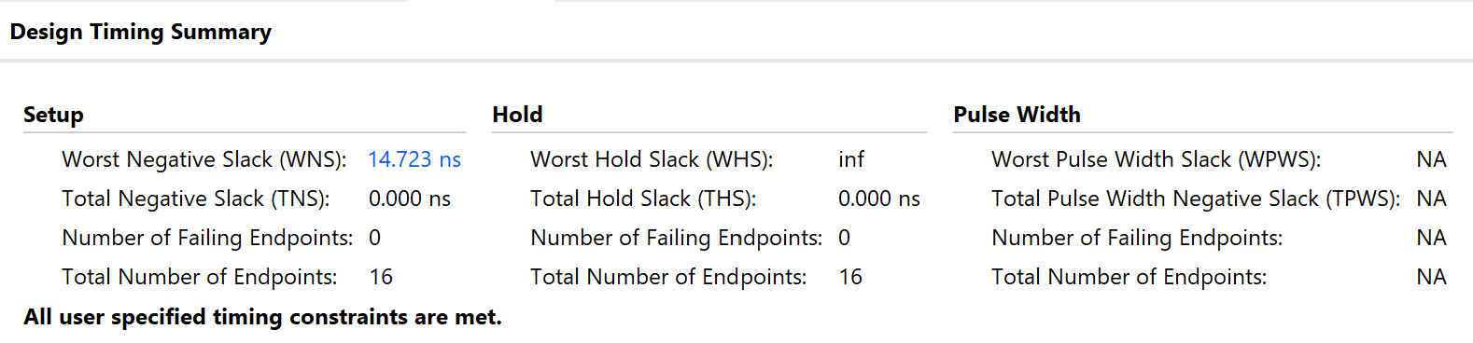

Utilisation Report
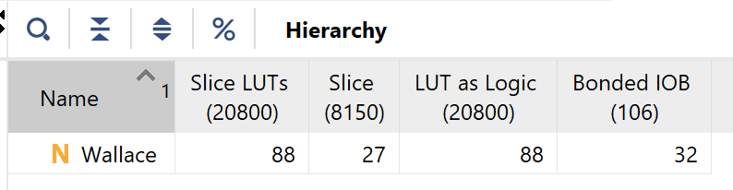

Power Report
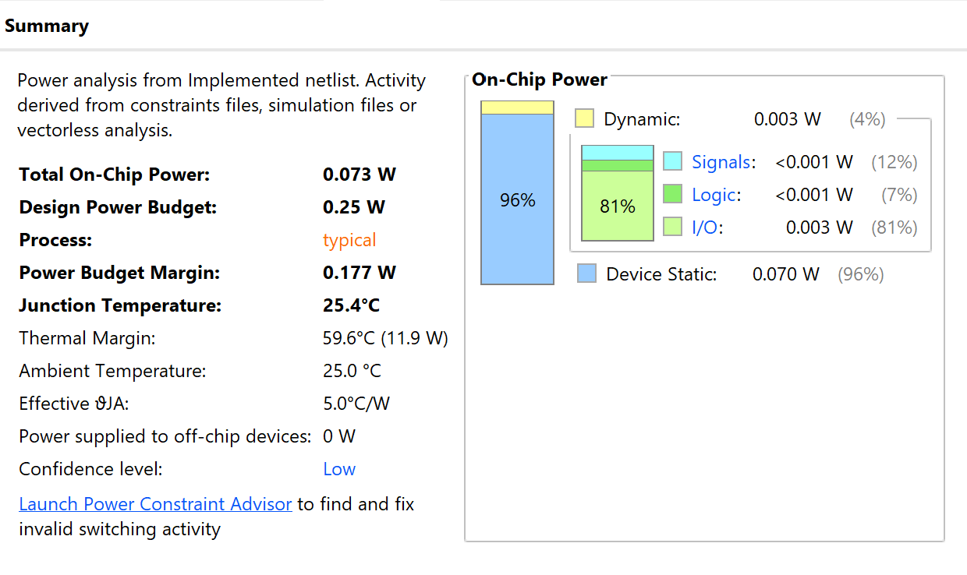

RTL Design

Braun
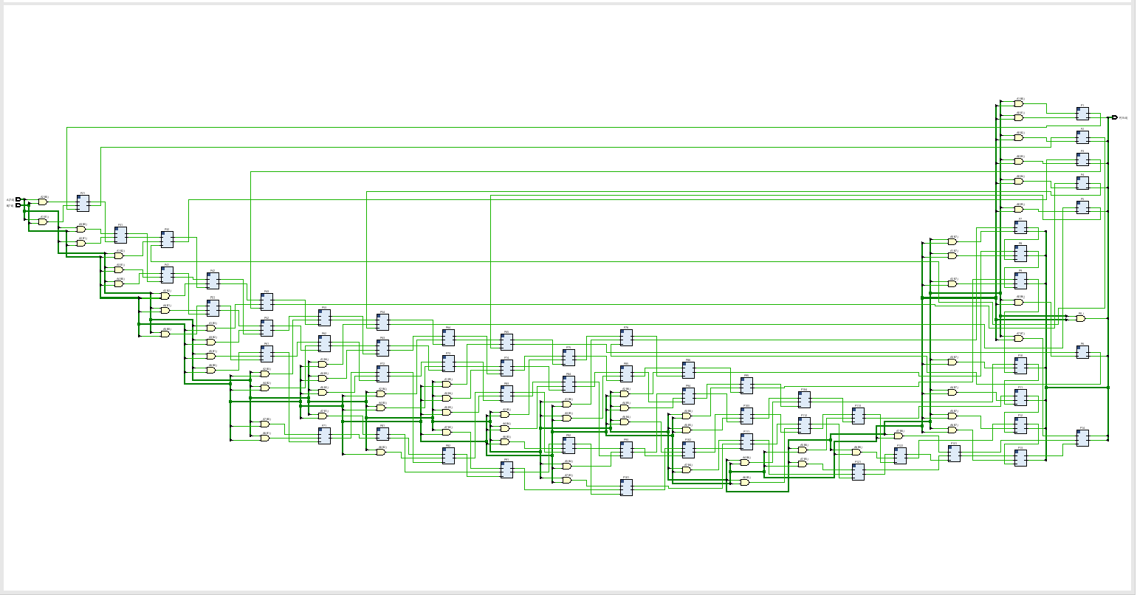

Wallace
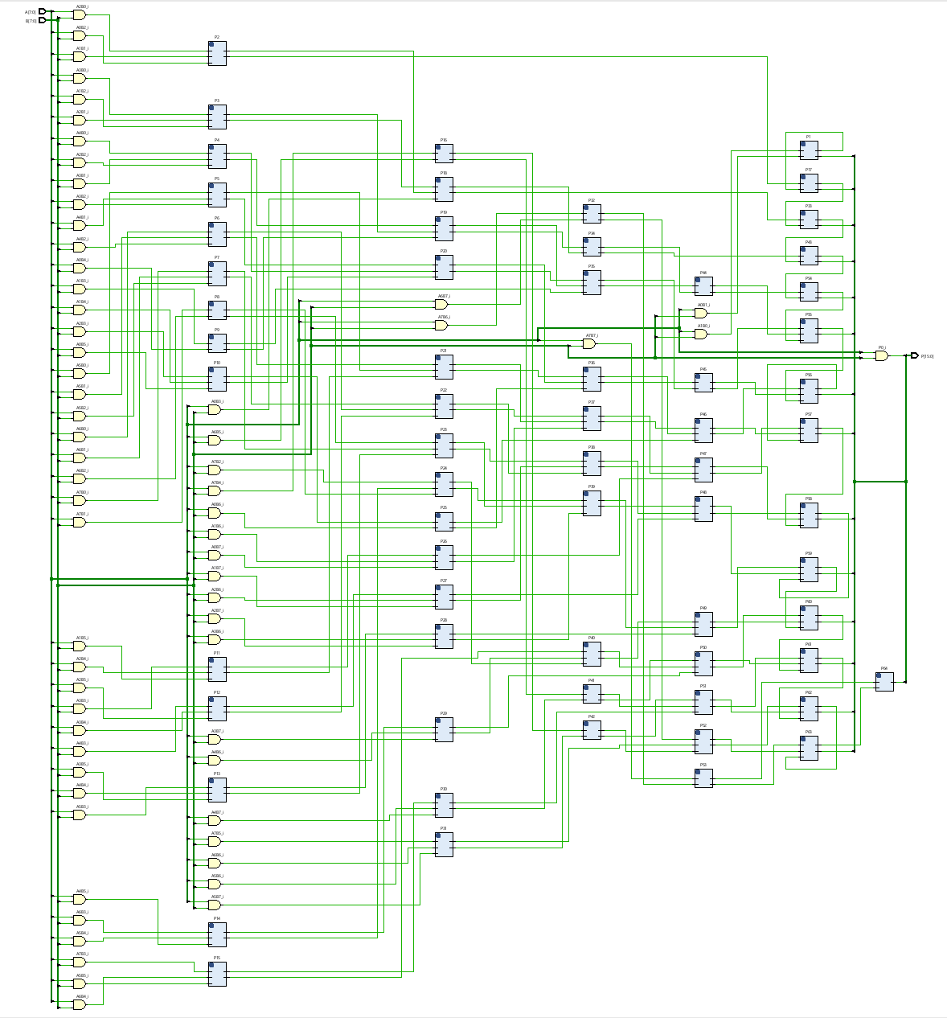

Schematic

Braun
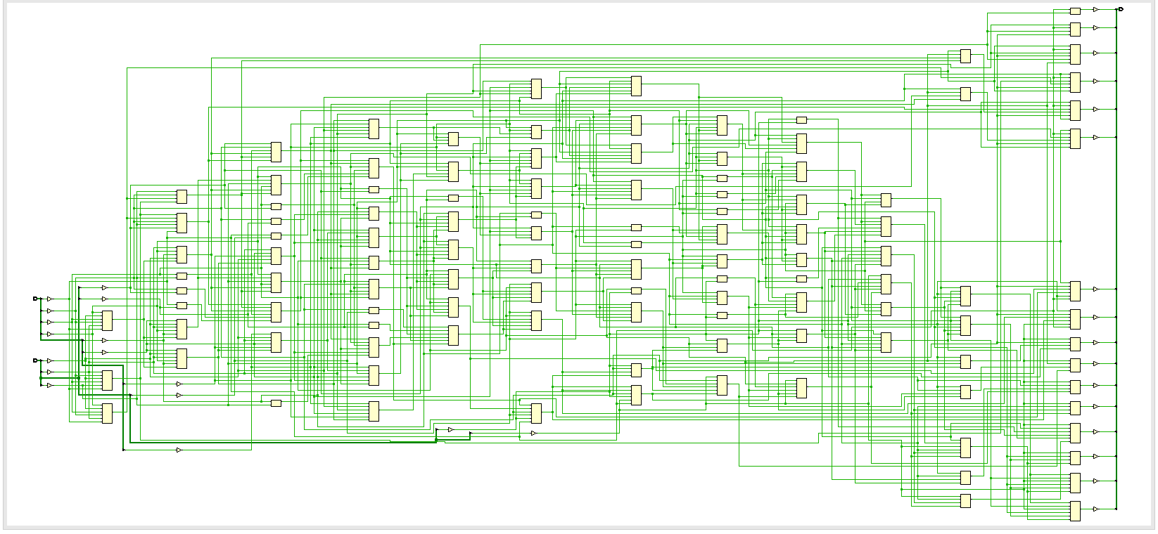

Wallace
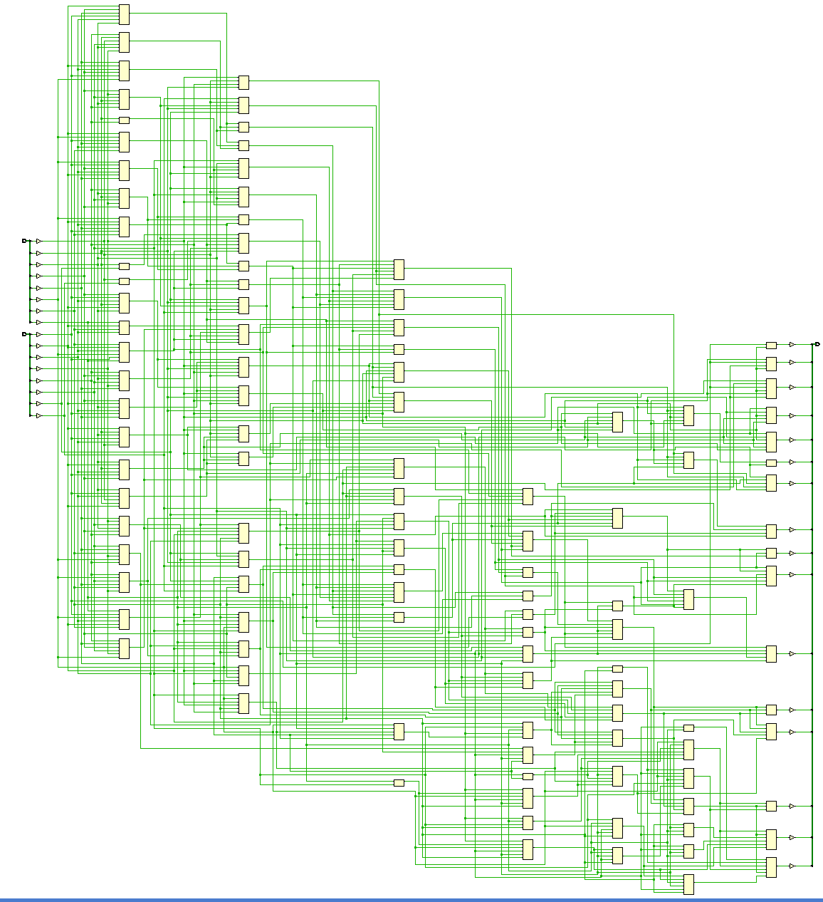

FPGA Design & I/O Planning

Braun
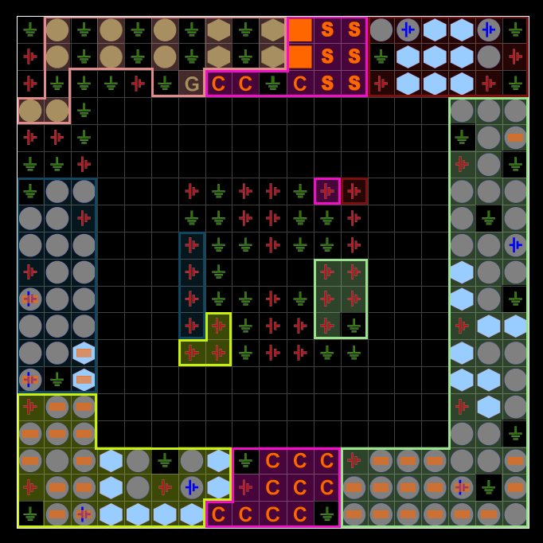
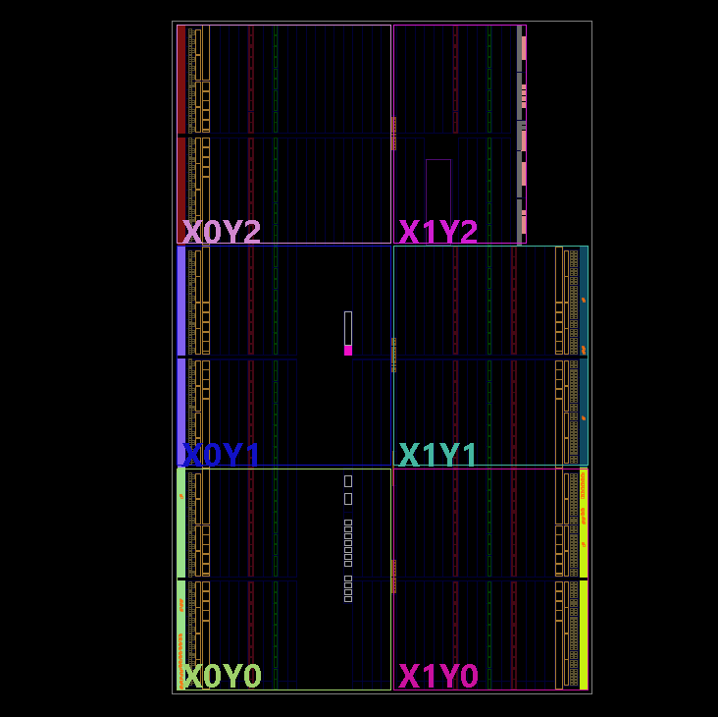

Wallace

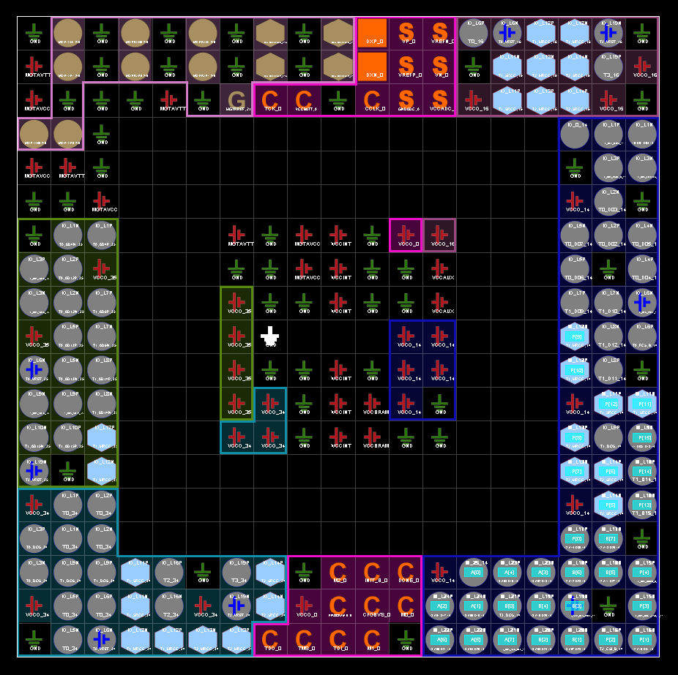

Simulated & Results

Simulation
Once both of the multipliers were created and programmed, their functionality was verified by forcing the clock and the constants of both inputs for A and B. By providing hex values and checking the output against the expected values over a wide range to test if there were any errors or deviations from the expected output.
This test was also performed on physical hardware, shown with additional random values to ensure function for all bit inputs.

Braun

Sample 1
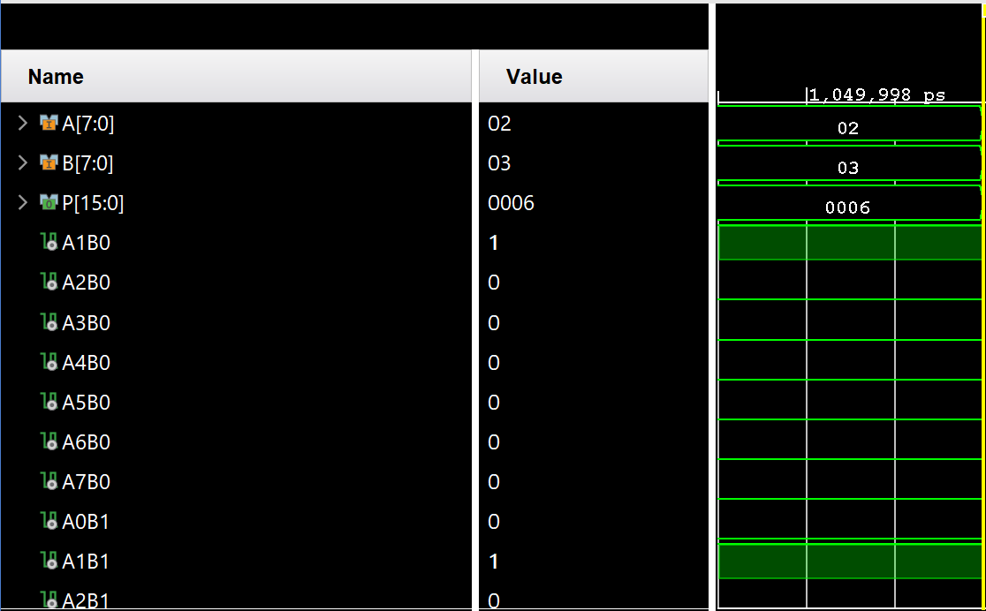

Sample 2
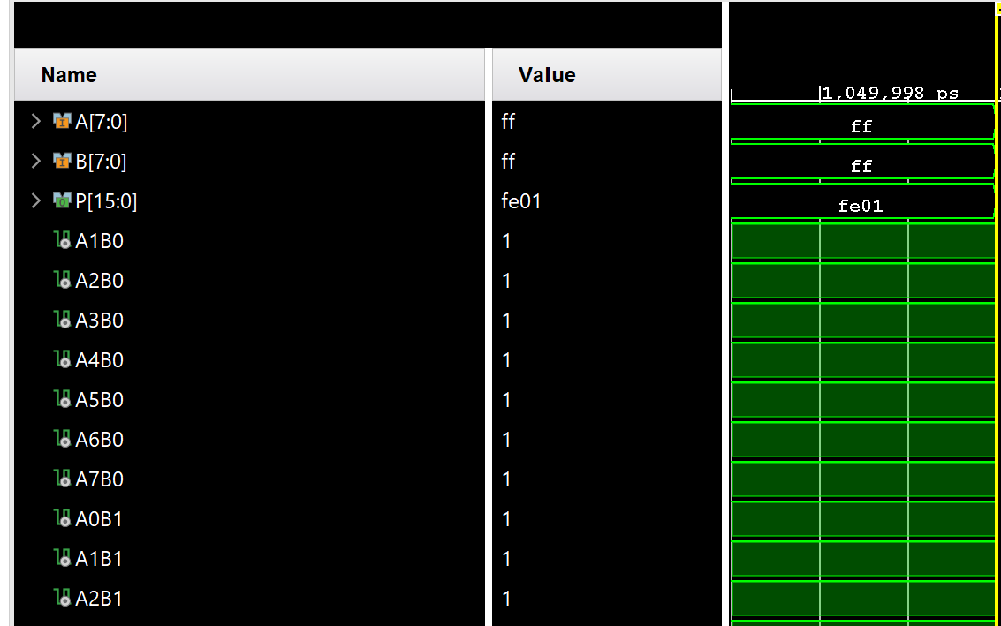

Sample 3
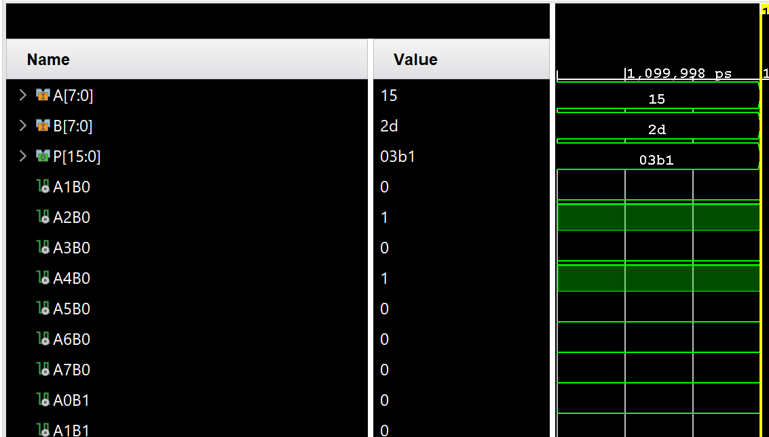

Sample 4
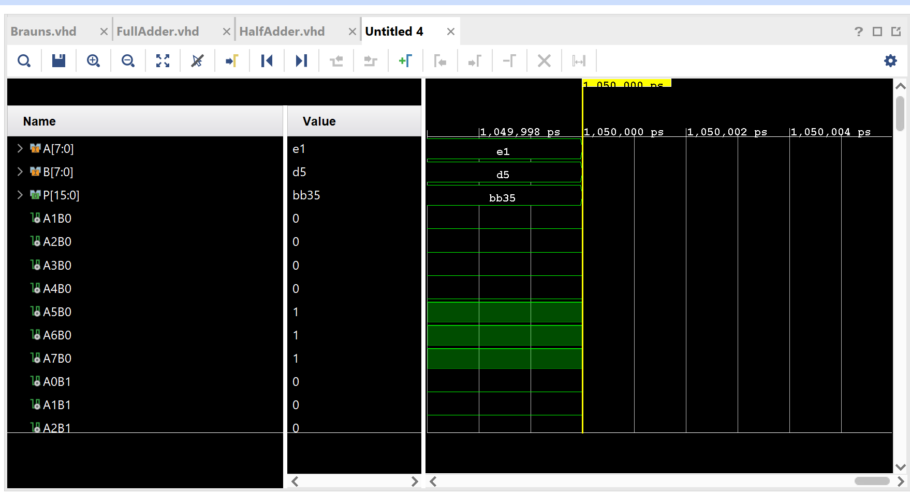

Hardware Sample 1
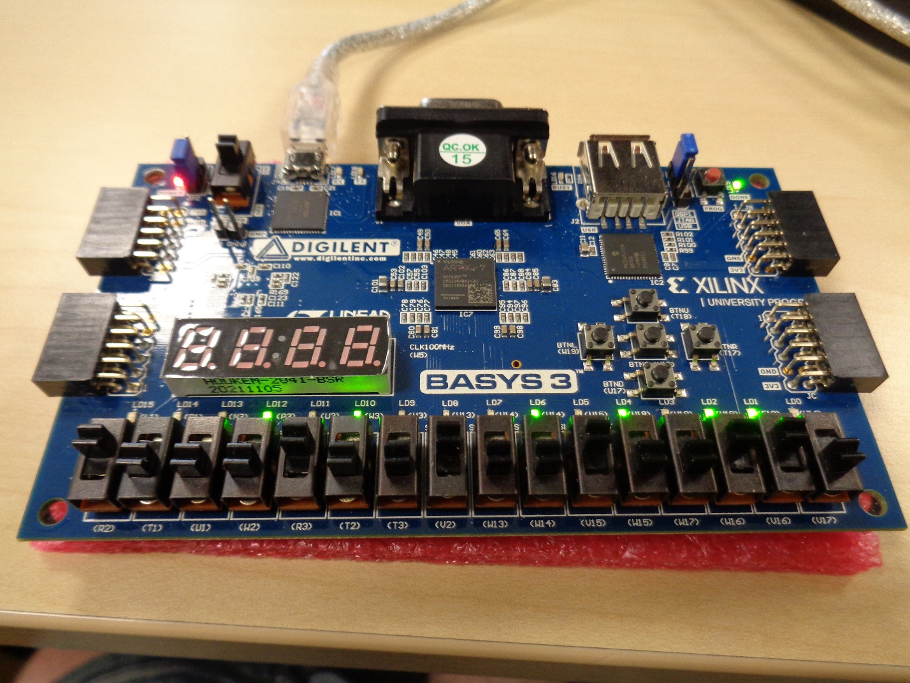

Hardware Sample 2
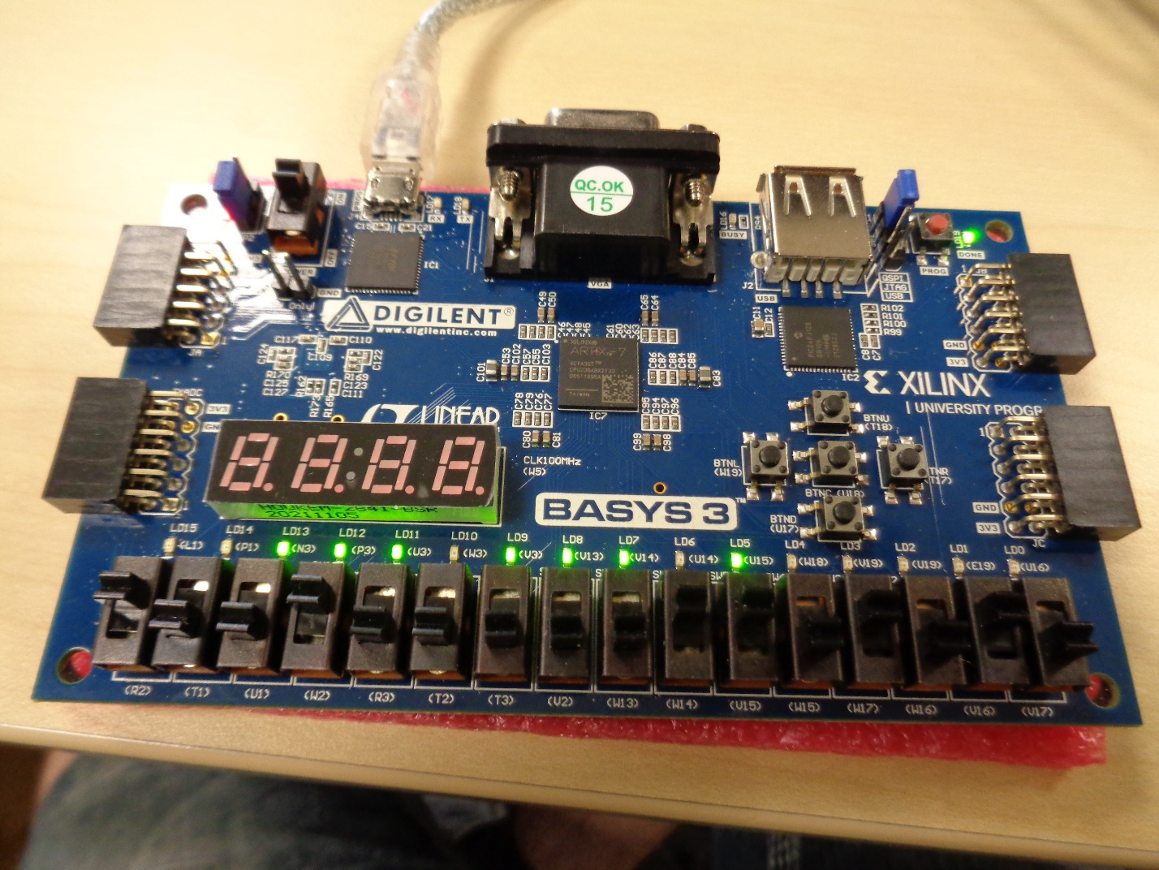

Hardware Sample 3
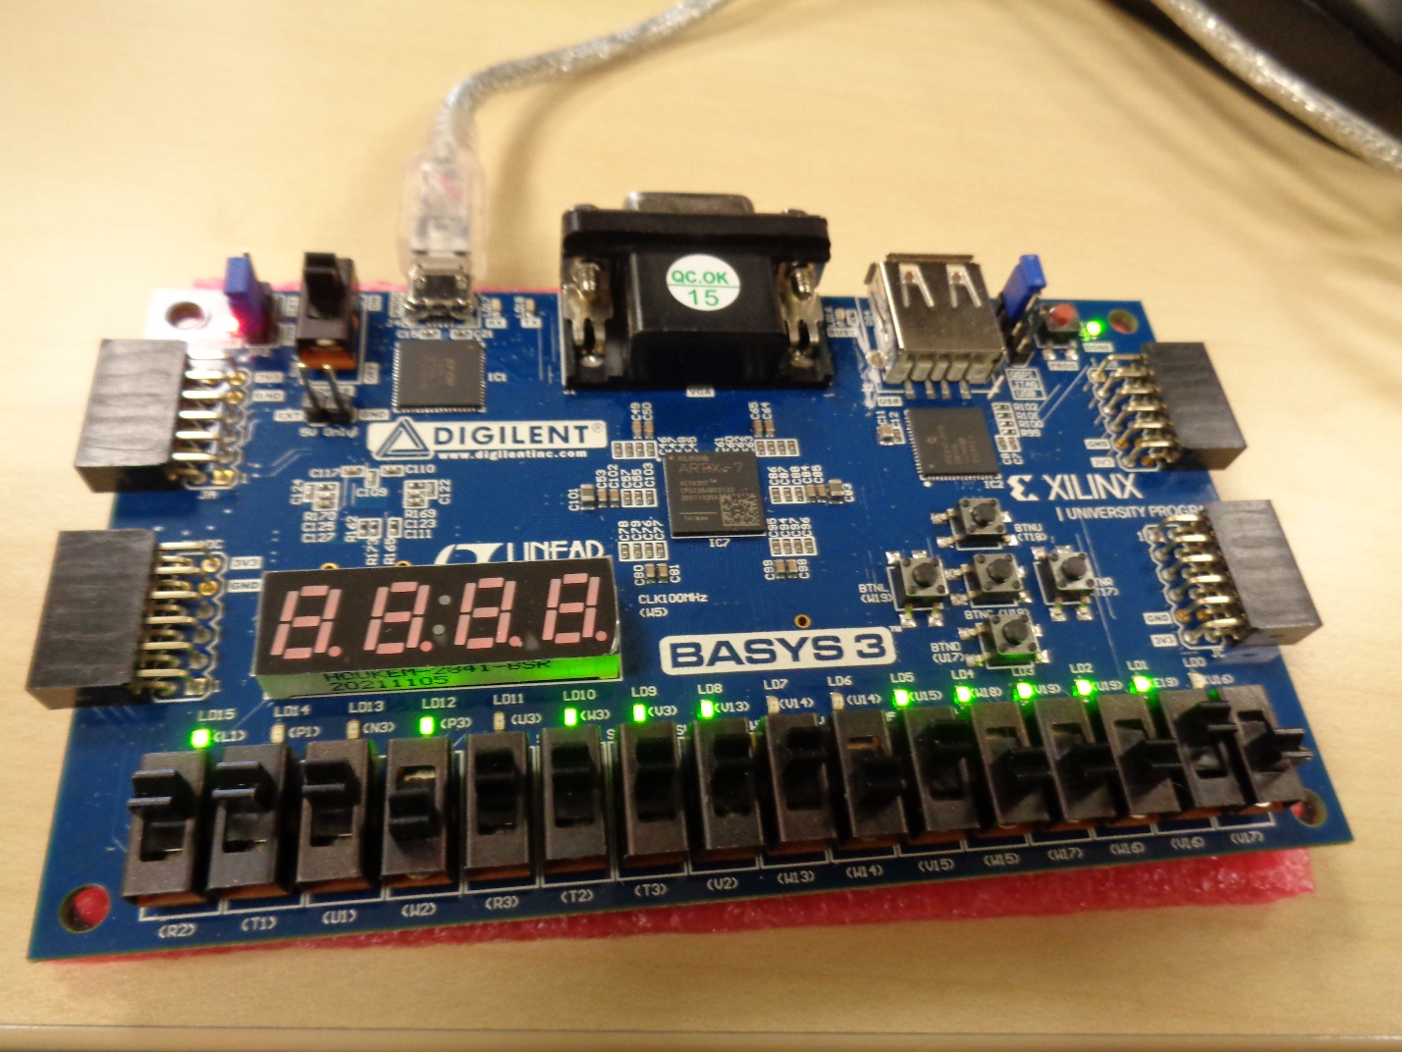

Wallace

Sample 1
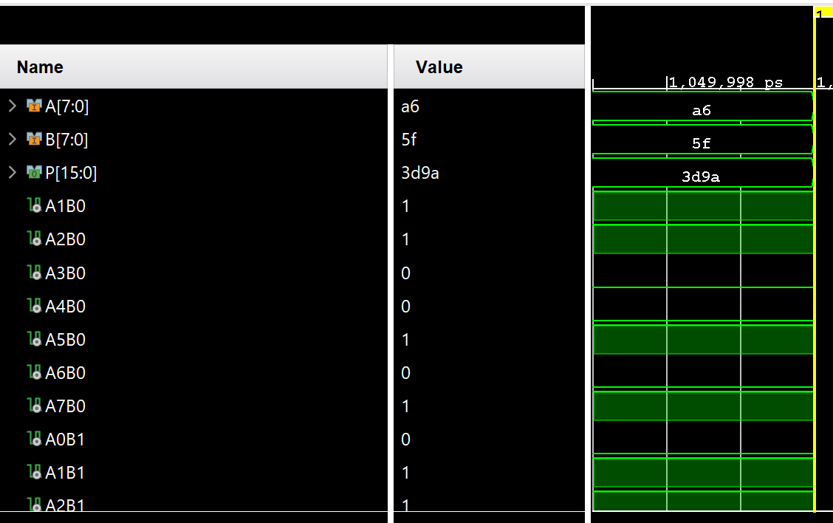

Sample 2
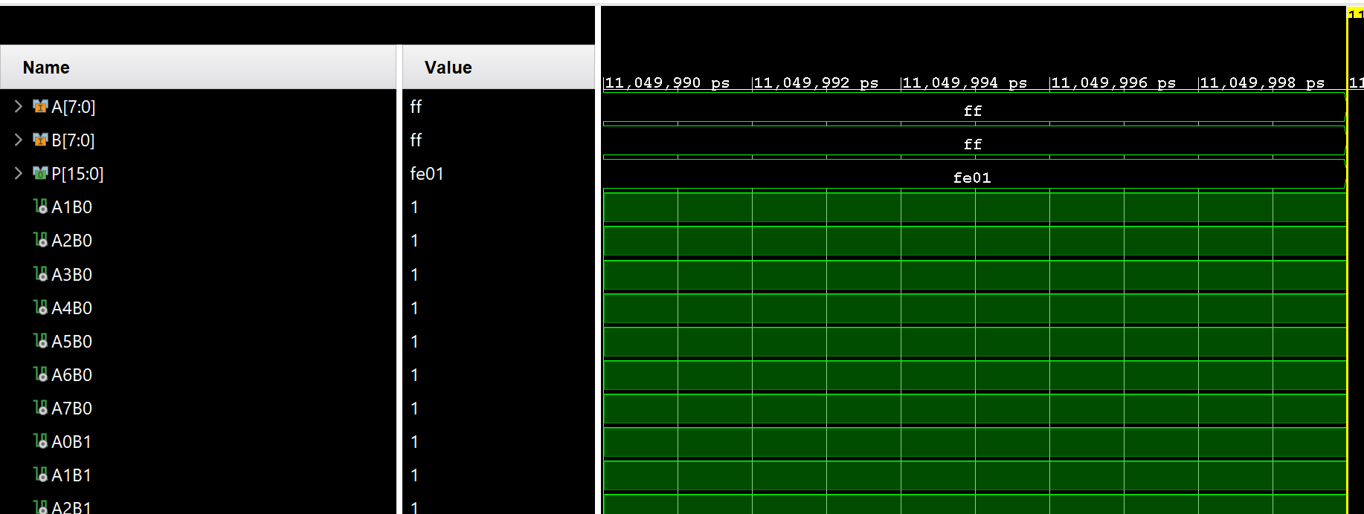

Sample 3
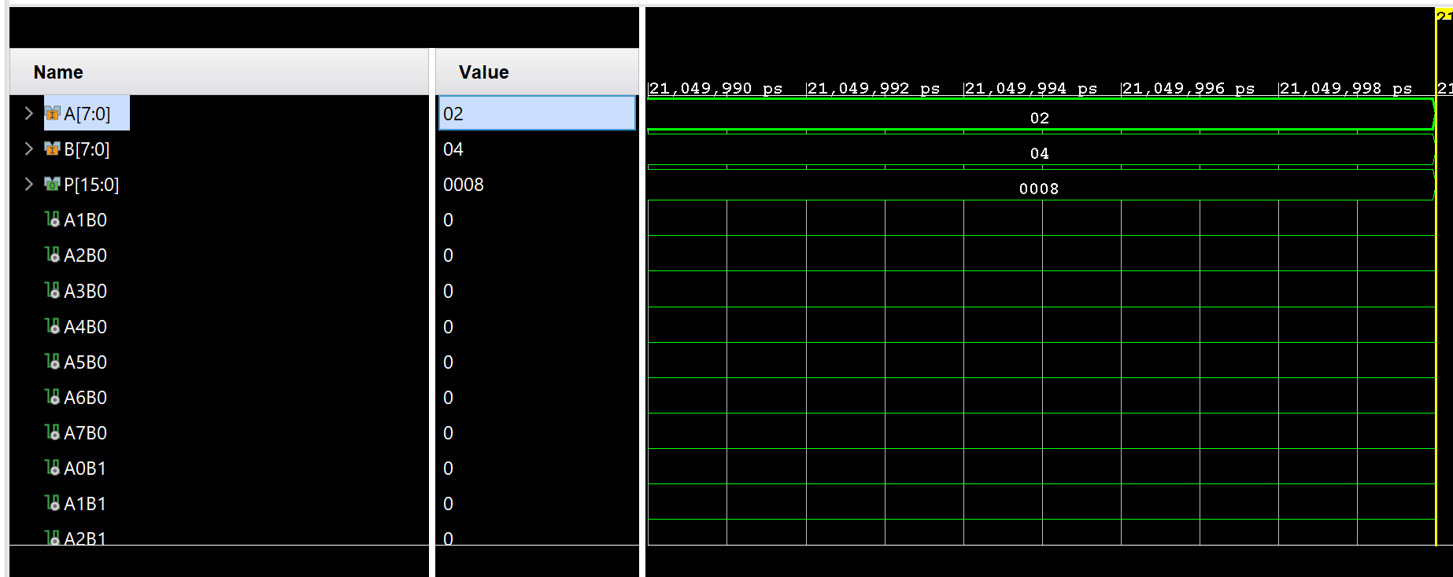

Sample 4
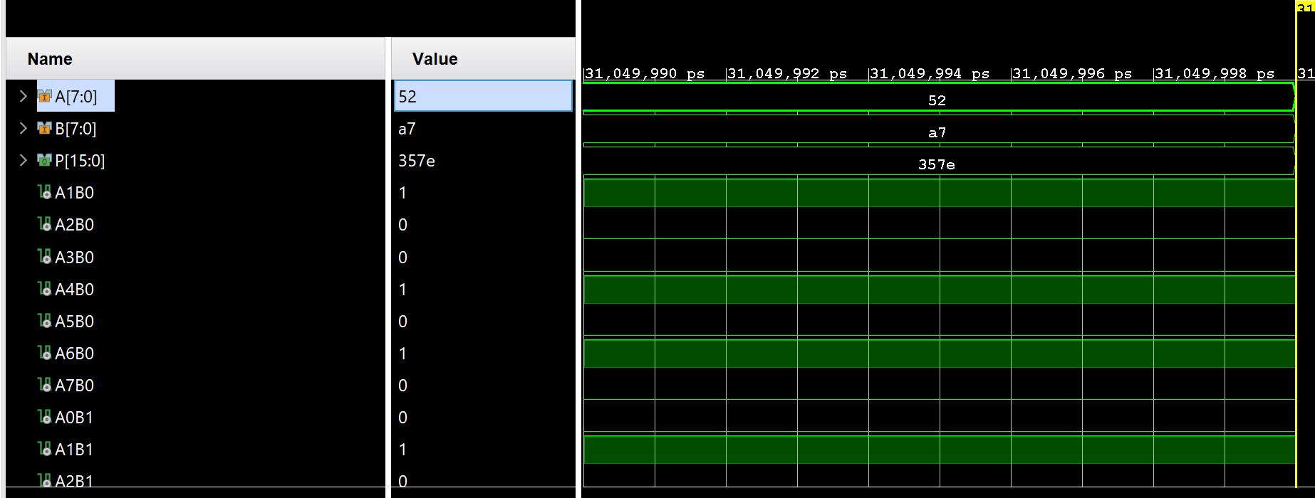

Hardware Sample 1
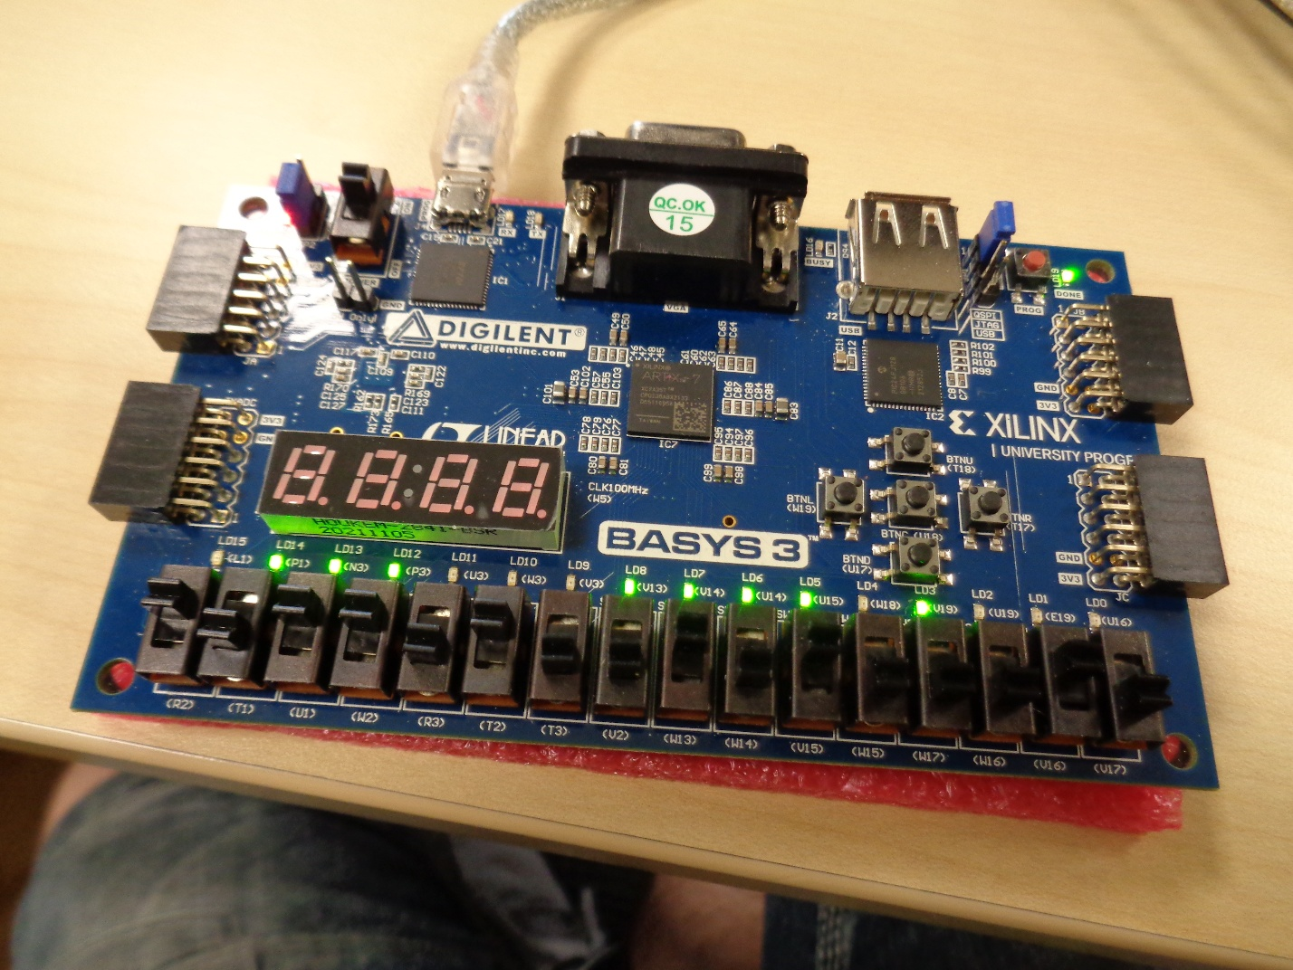

Hardware Sample 2
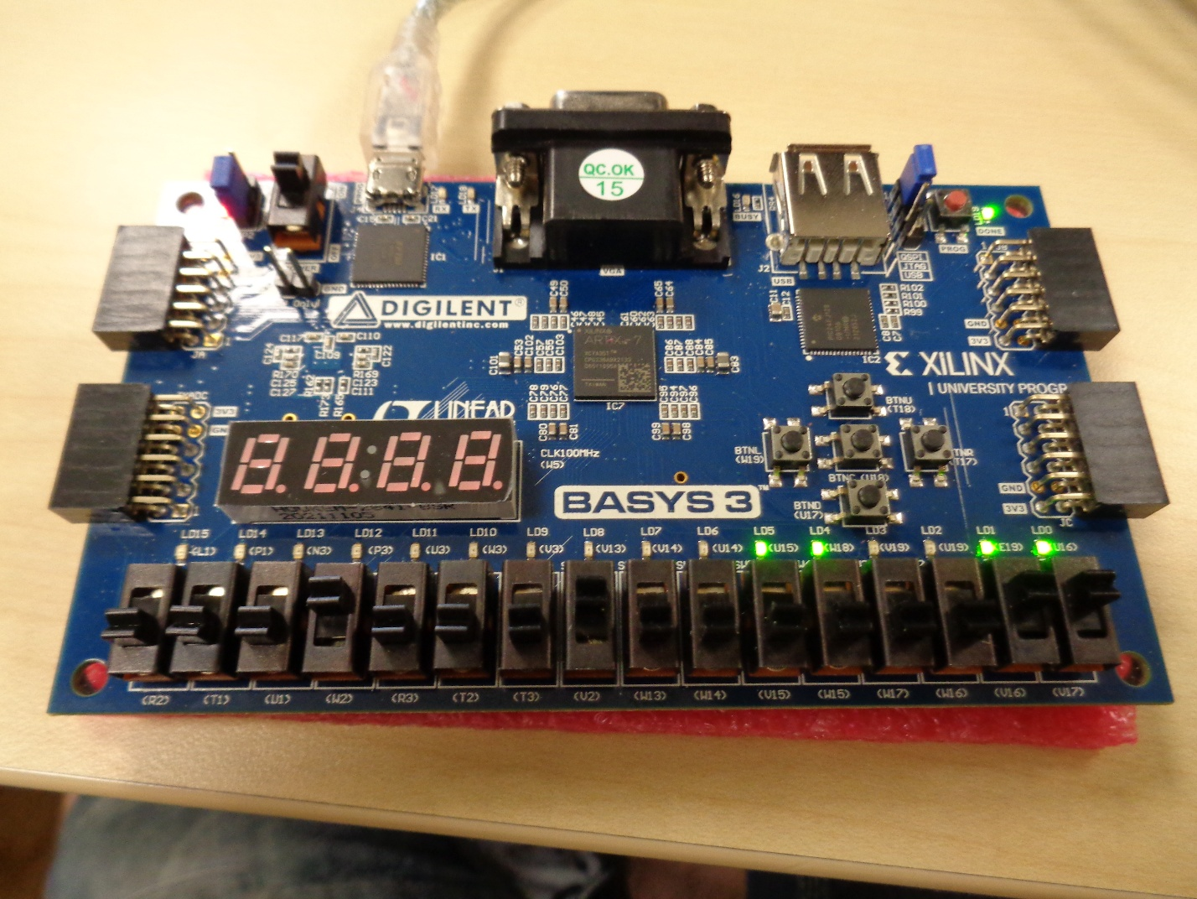

Hardware Sample 3
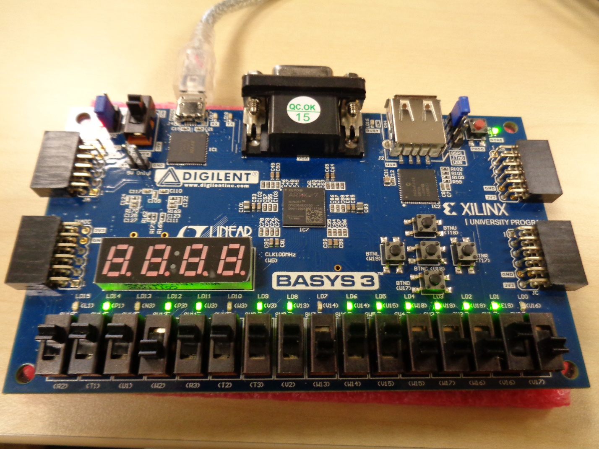

Analysis & Interpretation

Complexity
As shown in the RTL and the schematic diagram, the Wallace multiplier is far more complex in its construction and wiring compared to the Braun multiplier. Unlike the regular array of the Braun, the Wallace enacts multiple carry and sum connections between different stages. This is also illustrated in the flow/block diagrams, where the Wallace multiplier is considerably more complex.
However, it is worth noting that this also results in fewer addition stages and thus could reduce delay in larger versions.

Timing
When comparing the two multipliers’ timing reports, the Braun was shown to have a higher WNS, with both having an equal TNS of 0; this shows that the Braun operates with better timing and is quicker than the Wallace, albeit marginally. This is a result of Braun’s relative simplicity when compared to Wallace.
However, this seems to run against the theoretical, where it would have been expected for the Wallace to operate faster than the Braun; however, this could be an indication of an incorrect setup or simulation of the Wallace multiplier, and further testing would be required in this regard.

Utilisation
When comparing the utilisation of both multipliers, it is evident that Wallace makes more efficient use of its resources in this implementation, with a lower Slice LUT, Registers and LUTs as logic; the only equal measurement was the bonded IOBs; however, this is just due to the same bit inputs and outputs. Wallace is shown to use fewer LUTs due to its nature in being designed for fewer unnecessary processes and a reduction of partial products.

Power
When comparing the power of the two multipliers, Wallace showed a lower estimated power consumption and is likely to be more efficient, using less total power from the budget, and ergo having a larger power margin.
The Wallace also has a higher percentage of device static compared to the Braun, but a marginally lower value, showing that more power is lost from the Braun when directly compared.
Both multipliers have identical junction temperatures and thermal margins, with confidence level being low due to not considering simulated switching, only assumed signal switching characteristics intended for an initial assessment, but not precise results.
[4] [6] [7] [17] [18] [19]

Recommendations
Further recommendations for this report would include:
- Simulating with additional multipliers to have a more realistic comparison between them with each of their advantages and weaknesses, such as Dadda, Booth or Array
- Further refinement of the simulations to represent precise measurements in the aspects of power usage and timings, such as switching activity, workload as opposed to forced values and Realistic clock constraints
- Repeat the Simulations and implementations with varying bit-widths to demonstrate a broader range of operating cases
- Applying the implementation to different types of FPGA families to determine if architecture impacts the outcome

Conclusion
In conclusion, this project designed, simulated and implemented both the Brauns and Wallace tree Multipliers using AMD Vivado and programmed using VHDL. By using simulations and hardware implementation, the functionality was confirmed with the expected multiplication result.
In the comparison section, the trade-offs were demonstrated, with the Braun acting as a more simplified design and regular structure compared to the more complex Wallace. On the other hand, the Wallace performed better in terms of power consumption and resource utilisation owing to its more complex and refined nature.
Fundamentally, neither is superior; each has a differing design philosophy that diverges to achieve the best performance in different aspects, whether that be in speed or optimisation. With this fact in mind, they each have their own ideal applications.
This report demonstrates the clear fact that FPGA synthesis and implementation differ based upon the selected architecture and the resulting performance, which may not be reflected in entirely theoretical metrics

References

[1] | D. A. D. Gupta, “JETIR,” Designing of Various types of multipliers and their implementation on FPGA , vol. VI, no. 6, pp. 1066 - 1070, 2019.
[2] | R. K. Dwivedi and P. Khare, “VHDL Implementation of Fastest Braun’s Multiplier,” International Journal on Recent and Innovation Trends in Computing and Communication , vol. III, no. 5, pp. 2843 - 2846, 2015.
[3] | “A Review on Performance Evaluation of Different Digital Multipliers in VLSI using VHDL,” IJERT, C.G. India, 2018.
[4] | K. D. S. Santhosh, K. Y. G. Dr.Praveen, N. Chirag, A. R. Jeevan and A. Harish, “DESIGN IMPLEMENTATION AND PERFORMANCE ANALYSIS OF MULTIPLIER ARCHITECTURE,” International Journal Of Creative Research Thoughts (IJCRT), vol. XIII, no. 6, pp. 749 - 758, 2025.
[5] | Altera, “ Implementing Multipliers in FPGA Devices,” July 2004. [Online]. Available: https://www.intel.com/programmable/technical-pdfs/654539.pdf. [Accessed 28 June 2026].
[6] | B. N. V. S. D. Jahnavi, S. Mupparaju and D. Padmasree, “Design, Comparison and Implementation of Multipliers on FPGA,” International Journal of Engineering and Technical Research (IJETR) , vol. I, no. 7, pp. 66 - 73, 2013.
[7] | P. K. Sahu and P. N. Meena, “Comparitive Study Of Diffrent Multiplier Architectures,” International Journal of Engineering Trends and Technology (IJETT) , vol. IV, no. 10, pp. 4293 - 4297, 2013.
[8] | msimon, “Multiplication on FPGA,” Element 14, 22 September 2017. [Online]. Available: https://community.element14.com/technologies/fpga-group/b/blog/posts/multiplication-on-fpga. [Accessed 28 June 2026].
[9] | Andraka Consulting Group, “Multiplication in FPGAs,” Andraka Consulting Group, [Online]. Available: http://www.andraka.com/multipli.php. [Accessed 28 June 2026].
[10] | M. Ashour and H. Saleh, “An FPGA implementation guide for some different types of serial–parallel multiplier structures,” Microelectronics Journal, no. 31, pp. 161 - 168, 2000.
[11] | B. D. V. Prasad, N. S. S. Sanjeev and K. S. &. D. Nandan, “Review on Different Types of Multipliers and Its Performance Comparisons,” in Advances in Smart Grid and Renewable Energy, New Delhi, Springer, 2020, pp. 329 - 339.
[12] | “Different Types of FPGAs,” Lattice Semiconductor, 26 Febuary 2020. [Online]. Available: https://www.latticesemi.com/en/Blog/2020/02/25/19/33/Different_Types_of_FPGAs. [Accessed 28 June 2026].
[13] | L. S, D. P. R, M. S. Shetty, M. M. BM and D. C. Sharma, “FPGA Implementation of Different Multiplier Architectures,” International Journal of Emerging Technology and Advanced Engineering , vol. II, no. 6, pp. 292 - 295, 2012.
[14] | Farooq, U; Marrakchi, Z; Mehrez, H, “FPGA Architectures Overview,” in Tree-based Heterogenous FPGA Architectures Application Specific Exploration and optimization, Springer, 2012, pp. 7 - 48.
[15] | P. Paz and M. Garrido, “Efficient Implementation of Complex Multipliers on FPGAs Using DSP Slices,” Journal of Signal Processing Systems, pp. 543 - 550, 2023.
[16] | R. Anitha and V. Bagyaveereswaran, “Braun's Multiplier Implementation using FPGA with Bypassing Techniques,” International Journal of VLSI design & Communication Systems, vol. II, no. 3, pp. 201 - 212, 2011.
[17] | G. MADHU and A. CM, “COMPARISON OF DIFFERENT TYPES OF MULTIPLIERS WITH RESPECT TO SPEED, AREA AND POWER,” in IRF International Conference, Bengaluru, 2017.
[18] | S. P and A. A. Khan, “Comparison of Braun Multiplier and Wallace Multiplier Techniques in VLSI,” IEEE, Coimbatore, 2018.
[19] | AMD, “What is the Worst Negative Slack?,” AMD, 7 May 2023. [Online]. Available: https://adaptivesupport.amd.com/s/question/0D54U00006qTJxwSAG/what-is-the-worst-negative-slack?language=en_US. [Accessed 28 June 2026].
[20] | B. Singroul and P. Jaiswal, “A Review on Performance Evaluation of Different Digital Multipliers in VLSI using VHDL,” IJERT, C.G India, 2018.

Appendix

Braun Multiplier Code
----------------------------------------------------------------------------------
-- Company:
-- Engineer:
--
-- Create Date: 26.05.2026 14:53:19
-- Design Name:
-- Module Name: Brauns - Behavioral
-- Project Name:
-- Target Devices:
-- Tool Versions:
-- Description:
--
-- Dependencies:
--
-- Revision:
-- Revision 0.01 - File Created
-- Additional Comments:
--
----------------------------------------------------------------------------------

library IEEE;
use IEEE.STD_LOGIC_1164.ALL;

-- Uncomment the following library declaration if using
-- arithmetic functions with Signed or Unsigned values
--use IEEE.NUMERIC_STD.ALL;

-- Uncomment the following library declaration if instantiating
-- any Xilinx leaf cells in this code.
--library UNISIM;
--use UNISIM.VComponents.all;

use IEEE.std_logic_1164.all;
use IEEE.std_logic_arith.all;
use IEEE.std_logic_unsigned.all;

entity Brauns is
Port ( A : in STD_LOGIC_VECTOR (7 downto 0);
B : in STD_LOGIC_VECTOR (7 downto 0);
P : out STD_LOGIC_VECTOR (15 downto 0));
end Brauns;

architecture Behavioral of Brauns is

signal A1B0 : std_logic;
signal A2B0 : std_logic;
signal A3B0 : std_logic;
signal A4B0 : std_logic;
signal A5B0 : std_logic;
signal A6B0 : std_logic;
signal A7B0 : std_logic;

signal A0B1 : std_logic;
signal A1B1 : std_logic;
signal A2B1 : std_logic;
signal A3B1 : std_logic;
signal A4B1 : std_logic;
signal A5B1 : std_logic;
signal A6B1 : std_logic;
signal A7B1 : std_logic;

signal A0B2 : std_logic;
signal A1B2 : std_logic;
signal A2B2 : std_logic;
signal A3B2 : std_logic;
signal A4B2 : std_logic;
signal A5B2 : std_logic;
signal A6B2 : std_logic;
signal A7B2 : std_logic;

signal A0B3 : std_logic;
signal A1B3 : std_logic;
signal A2B3 : std_logic;
signal A3B3 : std_logic;
signal A4B3 : std_logic;
signal A5B3 : std_logic;
signal A6B3 : std_logic;
signal A7B3 : std_logic;

signal A0B4 : std_logic;
signal A1B4 : std_logic;
signal A2B4 : std_logic;
signal A3B4 : std_logic;
signal A4B4 : std_logic;
signal A5B4 : std_logic;
signal A6B4 : std_logic;
signal A7B4 : std_logic;

signal A0B5 : std_logic;
signal A1B5 : std_logic;
signal A2B5 : std_logic;
signal A3B5 : std_logic;
signal A4B5 : std_logic;
signal A5B5 : std_logic;
signal A6B5 : std_logic;
signal A7B5 : std_logic;

signal A0B6 : std_logic;
signal A1B6 : std_logic;
signal A2B6 : std_logic;
signal A3B6 : std_logic;
signal A4B6 : std_logic;
signal A5B6 : std_logic;
signal A6B6 : std_logic;
signal A7B6 : std_logic;

signal A0B7 : std_logic;
signal A1B7 : std_logic;
signal A2B7 : std_logic;
signal A3B7 : std_logic;
signal A4B7 : std_logic;
signal A5B7 : std_logic;
signal A6B7 : std_logic;
signal A7B7 : std_logic;
-------------------------------------------------
signal C1, C2, C3, C4 , C5, C6, C7, C8, C9,
C10, C11, C12, C13, C14, C15, C16, C17, C18,
C19, C20, C21, C22, C23, C24, C25, C26, C27,
C28, C29, C30, C31, C32, C33, C34, C35, C36,
C37, C38, C39, C40, C41, C42, C43, C44, C45,
C46, C47, C48, C49, C50, C51, C52, C53, C54, C55 : std_logic;

signal S2, S3, S4 , S5, S6, S7, S8,
S10, S11, S12, S13, S14, S15, S16, S18,
S19, S20, S21, S22, S23, S24, S26, S27,
S28, S29, S30, S31, S32, S34, S35, S36,
S37, S38, S39, S40, S42, S43, S44, S45,
S46, S47, S48 : std_logic;

---------------------------------------------------

component FullAdder
port (A : in std_logic;
B : in std_logic;
Cin : std_logic;
S : out std_logic;
Cout : out std_logic);
end component;

component HalfAdder
port (A : in std_logic;
B : in std_logic;
S : out std_logic;
Cout : out std_logic);
end component;

begin

A1B0 <= A(1) and B(0);
A2B0 <= A(2) and B(0);
A3B0 <= A(3) and B(0);
A4B0 <= A(4) and B(0);
A5B0 <= A(5) and B(0);
A6B0 <= A(6) and B(0);
A7B0 <= A(7) and B(0);

A0B1 <= A(0) and B(1);
A1B1 <= A(1) and B(1);
A2B1 <= A(2) and B(1);
A3B1 <= A(3) and B(1);
A4B1 <= A(4) and B(1);
A5B1 <= A(5) and B(1);
A6B1 <= A(6) and B(1);
A7B1 <= A(7) and B(1);

A0B2 <= A(0) and B(2);
A1B2 <= A(1) and B(2);
A2B2 <= A(2) and B(2);
A3B2 <= A(3) and B(2);
A4B2 <= A(4) and B(2);
A5B2 <= A(5) and B(2);
A6B2 <= A(6) and B(2);
A7B2 <= A(7) and B(2);

A0B3 <= A(0) and B(3);
A1B3 <= A(1) and B(3);
A2B3 <= A(2) and B(3);
A3B3 <= A(3) and B(3);
A4B3 <= A(4) and B(3);
A5B3 <= A(5) and B(3);
A6B3 <= A(6) and B(3);
A7B3 <= A(7) and B(3);

A0B4 <= A(0) and B(4);
A1B4 <= A(1) and B(4);
A2B4 <= A(2) and B(4);
A3B4 <= A(3) and B(4);
A4B4 <= A(4) and B(4);
A5B4 <= A(5) and B(4);
A6B4 <= A(6) and B(4);
A7B4 <= A(7) and B(4);

A0B5 <= A(0) and B(5);
A1B5 <= A(1) and B(5);
A2B5 <= A(2) and B(5);
A3B5 <= A(3) and B(5);
A4B5 <= A(4) and B(5);
A5B5 <= A(5) and B(5);
A6B5 <= A(6) and B(5);
A7B5 <= A(7) and B(5);

A0B6 <= A(0) and B(6);
A1B6 <= A(1) and B(6);
A2B6 <= A(2) and B(6);
A3B6 <= A(3) and B(6);
A4B6 <= A(4) and B(6);
A5B6 <= A(5) and B(6);
A6B6 <= A(6) and B(6);
A7B6 <= A(7) and B(6);

A0B7 <= A(0) and B(7);
A1B7 <= A(1) and B(7);
A2B7 <= A(2) and B(7);
A3B7 <= A(3) and B(7);
A4B7 <= A(4) and B(7);
A5B7 <= A(5) and B(7);
A6B7 <= A(6) and B(7);
A7B7 <= A(7) and B(7);

P0 : P(0) <= A(0) and B(0);

P1 : HalfAdder port map (A=>A1B0, B=>A0B1, S=>P(1), Cout=>C1);

P21 : FullAdder port map (A=>A2B0, B=>A1B1, Cin=>C1, S=>S2, Cout=>C2);
P2 : HalfAdder port map (A=>S2, B=>A0B2, S=>P(2), Cout=>C9);

P31 : FullAdder port map (A=>A3B0, B=>A2B1, Cin=>C2, S=>S3, Cout=>C3);
P32 : FullAdder port map (A=>S3, B=>A1B2, Cin=>C9, S=>S10, Cout=>C10);
P3 : HalfAdder port map (A=>S10, B=>A0B3, S=>P(3), Cout=>C17);

P41 : FullAdder port map (A=>A4B0, B=>A3B1, Cin=>C3, S=>S4, Cout=>C4);
P42 : FullAdder port map (A=>S4, B=>A2B2, Cin=>C10, S=>S11, Cout=>C11);
P43 : FullAdder port map (A=>S11, B=>A1B3, Cin=>C17, S=>S18, Cout=>C18);
P4 : HalfAdder port map (A=>S18, B=>A0B4, S=>P(4), Cout=>C25);

P51 : FullAdder port map (A=>A5B0, B=>A4B1, Cin=>C4, S=>S5, Cout=>C5);
P52 : FullAdder port map (A=>S5, B=>A3B2, Cin=>C11, S=>S12, Cout=>C12);
P53 : FullAdder port map (A=>S12, B=>A2B3, Cin=>C18, S=>S19, Cout=>C19);
P54 : FullAdder port map (A=>S19, B=>A1B4, Cin=>C25, S=>S26, Cout=>C26);
P5 : HalfAdder port map (A=>S26, B=>A0B5, S=>P(5), Cout=>C33);

P61 : FullAdder port map (A=>A6B0, B=>A5B1, Cin=>C5, S=>S6, Cout=>C6);
P62 : FullAdder port map (A=>S6, B=>A4B2, Cin=>C12, S=>S13, Cout=>C13);
P63 : FullAdder port map (A=>S13, B=>A3B3, Cin=>C19, S=>S20, Cout=>C20);
P64 : FullAdder port map (A=>S20, B=>A2B4, Cin=>C26, S=>S27, Cout=>C27);
P65 : FullAdder port map (A=>S27, B=>A1B5, Cin=>C33, S=>S34, Cout=>C34);
P6 : HalfAdder port map (A=>S34, B=>A0B6, S=>P(6), Cout=>C41);

P71 : FullAdder port map (A=>A7B0, B=>A6B1, Cin=>C6, S=>S7, Cout=>C7);
P72 : FullAdder port map (A=>S7, B=>A5B2, Cin=>C13, S=>S14, Cout=>C14);
P73 : FullAdder port map (A=>S14, B=>A4B3, Cin=>C20, S=>S21, Cout=>C21);
P74 : FullAdder port map (A=>S21, B=>A3B4, Cin=>C27, S=>S28, Cout=>C28);
P75 : FullAdder port map (A=>S28, B=>A2B5, Cin=>C34, S=>S35, Cout=>C35);
P76 : FullAdder port map (A=>S35, B=>A1B6, Cin=>C41, S=>S42, Cout=>C42);
P7 : HalfAdder port map (A=>S42, B=>A0B7, S=>P(7), Cout=>C49);

P81 : HalfAdder port map (A=>A7B1, B=>C7, S=>S8, Cout=>C8);
P82 : FullAdder port map (A=>S8, B=>A6B2, Cin=>C14, S=>S15, Cout=>C15);
P83 : FullAdder port map (A=>S15, B=>A5B3, Cin=>C21, S=>S22, Cout=>C22);
P84 : FullAdder port map (A=>S22, B=>A4B4, Cin=>C28, S=>S29, Cout=>C29);
P85 : FullAdder port map (A=>S29, B=>A3B5, Cin=>C35, S=>S36, Cout=>C36);
P86 : FullAdder port map (A=>S36, B=>A2B6, Cin=>C42, S=>S43, Cout=>C43);
P8 : FullAdder port map (A=>S43, B=>A1B7, Cin=>C49, S=>P(8), Cout=>C50);

P91 : FullAdder port map (A=>A7B2, B=>C8, Cin=>C15, S=>S16, Cout=>C16);
P92 : FullAdder port map (A=>S16, B=>A6B3, Cin=>C22, S=>S23, Cout=>C23);
P93 : FullAdder port map (A=>S23, B=>A5B4, Cin=>C29, S=>S30, Cout=>C30);
P94 : FullAdder port map (A=>S30, B=>A4B5, Cin=>C36, S=>S37, Cout=>C37);
P95 : FullAdder port map (A=>S37, B=>A3B6, Cin=>C43, S=>S44, Cout=>C44);
P9 : FullAdder port map (A=>S44, B=>A2B7, Cin=>C50, S=>P(9), Cout=>C51);

P101 : FullAdder port map (A=>A7B3, B=>C16, Cin=>C23, S=>S24, Cout=>C24);
P102 : FullAdder port map (A=>S24, B=>A6B4, Cin=>C30, S=>S31, Cout=>C31);
P103 : FullAdder port map (A=>S31, B=>A5B5, Cin=>C37, S=>S38, Cout=>C38);
P104 : FullAdder port map (A=>S38, B=>A4B6, Cin=>C44, S=>S45, Cout=>C45);
P10 : FullAdder port map (A=>S45, B=>A3B7, Cin=>C51, S=>P(10), Cout=>C52);

P111 : FullAdder port map (A=>A7B4, B=>C24, Cin=>C31, S=>S32, Cout=>C32);
P112 : FullAdder port map (A=>S32, B=>A6B5, Cin=>C38, S=>S39, Cout=>C39);
P113 : FullAdder port map (A=>S39, B=>A5B6, Cin=>C45, S=>S46, Cout=>C46);
P11 : FullAdder port map (A=>S46, B=>A4B7, Cin=>C52, S=>P(11), Cout=>C53);

P121 : FullAdder port map (A=>A7B5, B=>C32, Cin=>C39, S=>S40, Cout=>C40);
P122 : FullAdder port map (A=>S40, B=>A6B6, Cin=>C46, S=>S47, Cout=>C47);
P12 : FullAdder port map (A=>S47, B=>A5B7, Cin=>C53, S=>P(12), Cout=>C54);

P131 : FullAdder port map (A=>A7B6, B=>C40, Cin=>C47, S=>S48, Cout=>C48);
P13 : FullAdder port map (A=>S48, B=>A6B7, Cin=>C54, S=>P(13), Cout=>C55);

P14 : FullAdder port map (A=>A7B7, B=>C48, Cin=>C55, S=>P(14), Cout=>P(15));
end Behavioral;

Wallace Multiplier Code
----------------------------------------------------------------------------------
-- Company:
-- Engineer:
--
-- Create Date: 23.06.2026 10:28:14
-- Design Name:
-- Module Name: Wallace - Behavioral
-- Project Name:
-- Target Devices:
-- Tool Versions:
-- Description:
--
-- Dependencies:
--
-- Revision:
-- Revision 0.01 - File Created
-- Additional Comments:
--
----------------------------------------------------------------------------------

library IEEE;
use IEEE.STD_LOGIC_1164.ALL;

-- Uncomment the following library declaration if using
-- arithmetic functions with Signed or Unsigned values
--use IEEE.NUMERIC_STD.ALL;

-- Uncomment the following library declaration if instantiating
-- any Xilinx leaf cells in this code.
--library UNISIM;
--use UNISIM.VComponents.all;
library IEEE;
use IEEE.std_logic_1164.ALL;

entity Wallace is
Port ( A : in std_logic_vector (7 downto 0);
B : in std_logic_vector (7 downto 0);
P : out std_logic_vector (15 downto 0));
end Wallace;

architecture Behavioral of Wallace is

signal A1B0 : std_logic;
signal A2B0 : std_logic;
signal A3B0 : std_logic;
signal A4B0 : std_logic;
signal A5B0 : std_logic;
signal A6B0 : std_logic;
signal A7B0 : std_logic;

signal A0B1 : std_logic;
signal A1B1 : std_logic;
signal A2B1 : std_logic;
signal A3B1 : std_logic;
signal A4B1 : std_logic;
signal A5B1 : std_logic;
signal A6B1 : std_logic;
signal A7B1 : std_logic;

signal A0B2 : std_logic;
signal A1B2 : std_logic;
signal A2B2 : std_logic;
signal A3B2 : std_logic;
signal A4B2 : std_logic;
signal A5B2 : std_logic;
signal A6B2 : std_logic;
signal A7B2 : std_logic;

signal A0B3 : std_logic;
signal A1B3 : std_logic;
signal A2B3 : std_logic;
signal A3B3 : std_logic;
signal A4B3 : std_logic;
signal A5B3 : std_logic;
signal A6B3 : std_logic;
signal A7B3 : std_logic;

signal A0B4 : std_logic;
signal A1B4 : std_logic;
signal A2B4 : std_logic;
signal A3B4 : std_logic;
signal A4B4 : std_logic;
signal A5B4 : std_logic;
signal A6B4 : std_logic;
signal A7B4 : std_logic;

signal A0B5 : std_logic;
signal A1B5 : std_logic;
signal A2B5 : std_logic;
signal A3B5 : std_logic;
signal A4B5 : std_logic;
signal A5B5 : std_logic;
signal A6B5 : std_logic;
signal A7B5 : std_logic;

signal A0B6 : std_logic;
signal A1B6 : std_logic;
signal A2B6 : std_logic;
signal A3B6 : std_logic;
signal A4B6 : std_logic;
signal A5B6 : std_logic;
signal A6B6 : std_logic;
signal A7B6 : std_logic;

signal A0B7 : std_logic;
signal A1B7 : std_logic;
signal A2B7 : std_logic;
signal A3B7 : std_logic;
signal A4B7 : std_logic;
signal A5B7 : std_logic;
signal A6B7 : std_logic;
signal A7B7 : std_logic;
-------------------------------------------------
signal C0, C1, C2, C3, C4 , C5, C6, C7, C8, C9,
C10, C11, C12, C13, C14, C15, C16, C17, C18,
C19, C20, C21, C22, C23, C24, C25, C26, C27,
C28, C29, C30, C31, C32, C33, C34, C35, C36,
C37, C38, C39, C40, C41, C42, C43, C44, C45,
C46, C47, C48, C49, C50, C51, C52, C53, C54,
C55, C56, C57, C58, C59, C60, C61, C62, C63: std_logic;

signal S1, S2, S3, S4 , S5, S6, S7, S8,
S9, S10, S11, S12, S13, S14, S15, S17, S18,
S19, S20, S21, S22, S23, S24, S25, S26, S27,
S28, S29, S30, S31, S33, S34, S35, S36,
S37, S38, S39, S40, S41, S43, S44, S45,
S46, S47, S48, S49, S50, S51, S52 : std_logic;

component FullAdder
port (A : in std_logic;
B : in std_logic;
Cin : std_logic;
S : out std_logic;
Cout : out std_logic);
end component;

component HalfAdder
port (A : in std_logic;
B : in std_logic;
S : out std_logic;
Cout : out std_logic);
end component;

begin

A1B0 <= A(1) and B(0);
A2B0 <= A(2) and B(0);
A3B0 <= A(3) and B(0);
A4B0 <= A(4) and B(0);
A5B0 <= A(5) and B(0);
A6B0 <= A(6) and B(0);
A7B0 <= A(7) and B(0);

A0B1 <= A(0) and B(1);
A1B1 <= A(1) and B(1);
A2B1 <= A(2) and B(1);
A3B1 <= A(3) and B(1);
A4B1 <= A(4) and B(1);
A5B1 <= A(5) and B(1);
A6B1 <= A(6) and B(1);
A7B1 <= A(7) and B(1);

A0B2 <= A(0) and B(2);
A1B2 <= A(1) and B(2);
A2B2 <= A(2) and B(2);
A3B2 <= A(3) and B(2);
A4B2 <= A(4) and B(2);
A5B2 <= A(5) and B(2);
A6B2 <= A(6) and B(2);
A7B2 <= A(7) and B(2);

A0B3 <= A(0) and B(3);
A1B3 <= A(1) and B(3);
A2B3 <= A(2) and B(3);
A3B3 <= A(3) and B(3);
A4B3 <= A(4) and B(3);
A5B3 <= A(5) and B(3);
A6B3 <= A(6) and B(3);
A7B3 <= A(7) and B(3);

A0B4 <= A(0) and B(4);
A1B4 <= A(1) and B(4);
A2B4 <= A(2) and B(4);
A3B4 <= A(3) and B(4);
A4B4 <= A(4) and B(4);
A5B4 <= A(5) and B(4);
A6B4 <= A(6) and B(4);
A7B4 <= A(7) and B(4);

A0B5 <= A(0) and B(5);
A1B5 <= A(1) and B(5);
A2B5 <= A(2) and B(5);
A3B5 <= A(3) and B(5);
A4B5 <= A(4) and B(5);
A5B5 <= A(5) and B(5);
A6B5 <= A(6) and B(5);
A7B5 <= A(7) and B(5);

A0B6 <= A(0) and B(6);
A1B6 <= A(1) and B(6);
A2B6 <= A(2) and B(6);
A3B6 <= A(3) and B(6);
A4B6 <= A(4) and B(6);
A5B6 <= A(5) and B(6);
A6B6 <= A(6) and B(6);
A7B6 <= A(7) and B(6);

A0B7 <= A(0) and B(7);
A1B7 <= A(1) and B(7);
A2B7 <= A(2) and B(7);
A3B7 <= A(3) and B(7);
A4B7 <= A(4) and B(7);
A5B7 <= A(5) and B(7);
A6B7 <= A(6) and B(7);
A7B7 <= A(7) and B(7);

P0 : P(0) <= A(0) and B(0);

P1: HalfAdder port map (A=>A1B0, B=>A0B1, S=> P(1), Cout=>C0);

P2: FullAdder port map (A=>A2B0, B=>A1B1, Cin=>A0B2, S=>S1, Cout=>C1);
P17: HalfAdder port map (A=>S1, B=>C0, S=> P(2), Cout=>C16);

P3: FullAdder port map (A=>A3B0, B=>A2B1, Cin=>A1B2, S=>S2, Cout=>C2);
P18: FullAdder port map (A=>S2, B=>C1, Cin=>A0B3, S=>S17, Cout=>C17);
P33: HalfAdder port map (A=>S17, B=>C16, S=>P(3), Cout=>C32);

P4: FullAdder port map (A=>A4B0, B=>A3B1, Cin=>A2B2, S=>S3, Cout=>C3);
P9: HalfAdder port map (A=>A1B3, B=>A0B4, S=> S4, Cout=>C4);
P19: FullAdder port map (A=>S3, B=>C2, Cin=>S4, S=>S18, Cout=>C18);
P34: HalfAdder port map (A=>S18, B=>C17, S=>S33, Cout=>C33);
P43: HalfAdder port map (A=>S33, B=>C32, S=>P(4), Cout=>C42);

P5: FullAdder port map (A=>A5B0, B=>A4B1, Cin=>A3B2, S=>S5, Cout=>C5);
P10: FullAdder port map (A=>A2B3, B=>A1B4, Cin=>A0B5, S=>S6, Cout=>C6);
P20: FullAdder port map (A=>S5, B=>C3, Cin=>S6, S=>S19, Cout=>C19);
P35: FullAdder port map (A=>S19, B=>C18, Cin=>C4, S=>S34, Cout=>C34);
P44: HalfAdder port map (A=>S34, B=>C33, S=>S43, Cout=>C43);
P54: HalfAdder port map (A=>S43, B=>C42, S=>P(5), Cout=>C53);

P6: FullAdder port map (A=>A6B0, B=>A5B1, Cin=>A4B2, S=>S7, Cout=>C7);
P11: FullAdder port map (A=>A3B3, B=>A2B4, Cin=>A1B5, S=>S8, Cout=>C8);
P21: FullAdder port map (A=>S7, B=>C5, Cin=>S8, S=>S20, Cout=>C20);
P25: HalfAdder port map (A=>C6, B=>A0B6, S=>S21, Cout=>C21);
P36: FullAdder port map (A=>S20, B=>C19, Cin=>S21, S=>S35, Cout=>C35);
P45: HalfAdder port map (A=>S35, B=>C34, S=>S44, Cout=>C44);
P55: FullAdder port map (A=>S44, B=>C43, Cin=>C53, S=>P(6), Cout=>C54);

P7: FullAdder port map (A=>A7B0, B=>A6B1, Cin=>A5B2, S=>S9, Cout=>C9);
P12: FullAdder port map (A=>A4B3, B=>A3B4, Cin=>A2B5, S=>S10, Cout=>C10);
P22: FullAdder port map (A=>S9, B=>C7, Cin=>S10, S=>S22, Cout=>C22);
P26: FullAdder port map (A=>C8, B=>A1B6, Cin=>A0B7, S=>S23, Cout=>C23);
P37: FullAdder port map (A=>S22, B=>C20, Cin=>S23, S=>S36, Cout=>C36);
P46: FullAdder port map (A=>S36, B=>C35, Cin=>C21, S=>S45, Cout=>C45);
P56: FullAdder port map (A=>S45, B=>C44, Cin=>C54, S=>P(7), Cout=>C55);

P8: HalfAdder port map (A=>A7B1, B=>A6B2, S=> S11, Cout=>C11);
P13: FullAdder port map (A=>A5B3, B=>A4B4, Cin=>A3B5, S=>S12, Cout=>C12);
P23: FullAdder port map (A=>S11, B=>C9, Cin=>S12, S=>S24, Cout=>C24);
P27: FullAdder port map (A=>C10, B=>A2B6, Cin=>A1B7, S=>S25, Cout=>C25);
P38: FullAdder port map (A=>S24, B=>S25, Cin=>C22, S=>S37, Cout=>C37);
P47: FullAdder port map (A=>S37, B=>C36, Cin=>C23, S=>S46, Cout=>C46);
P57: FullAdder port map (A=>S46, B=>C45, Cin=>C55, S=>P(8), Cout=>C56);

P14: FullAdder port map (A=>A6B3, B=>A5B4, Cin=>A4B5, S=>S13, Cout=>C13);
P24: FullAdder port map (A=>A7B2, B=>S13, Cin=>C11, S=>S26, Cout=>C26);
P28: FullAdder port map (A=>C12, B=>A3B6, Cin=>A2B7, S=>S27, Cout=>C27);
P39: FullAdder port map (A=>S26, B=>C24, Cin=>S27, S=>S38, Cout=>C38);
P48: FullAdder port map (A=>S38, B=>C37, Cin=>C25, S=>S47, Cout=>C47);
P58: FullAdder port map (A=>S47, B=>C46, Cin=>C56, S=>P(9), Cout=>C57);

P15: FullAdder port map (A=>A7B3, B=>A6B4, Cin=>A5B5, S=>S14, Cout=>C14);
P29: FullAdder port map (A=>C13, B=>A4B6, Cin=>A3B7, S=>S28, Cout=>C28);
P40: FullAdder port map (A=>S14, B=>S28, Cin=>C26, S=>S39, Cout=>C39);
P49: FullAdder port map (A=>S39, B=>C38, Cin=>C27, S=>S48, Cout=>C48);
P59: FullAdder port map (A=>S48, B=>C47, Cin=>C57, S=>P(10), Cout=>C58);

P16: HalfAdder port map (A=>A7B4, B=>A6B5, S=> S15, Cout=>C15);
P30: FullAdder port map (A=>C14, B=>A5B6, Cin=>A4B7, S=>S29, Cout=>C29);
P41: HalfAdder port map (A=>S15, B=>S29, S=>S40, Cout=>C40);
P50: FullAdder port map (A=>S40, B=>C39, Cin=>C28, S=>S49, Cout=>C49);
P60: FullAdder port map (A=>S49, B=>C48, Cin=>C58, S=>P(11), Cout=>C59);

P31: FullAdder port map (A=>A7B5, B=>A6B6, Cin=>A5B7, S=>S30, Cout=>C30);
P42: HalfAdder port map (A=>C15, B=>S30, S=>S41, Cout=>C41);
P51: FullAdder port map (A=>S41, B=>C40, Cin=>C29, S=>S50, Cout=>C50);
P61: FullAdder port map (A=>S50, B=>C49, Cin=>C59, S=>P(12), Cout=>C60);

P32: HalfAdder port map (A=>A7B6, B=>A6B7, S=>S31 , Cout=>C31);
P52: FullAdder port map (A=>S31, B=>C30, Cin=>C41, S=>S51, Cout=>C51);
P62: FullAdder port map (A=>S51, B=>C50, Cin=>C60, S=>P(13), Cout=>C61);

P53: HalfAdder port map (A=>A7B7, B=>C31, S=>S52, Cout=>C52);
P63: FullAdder port map (A=>S52, B=>C51, Cin=>C61, S=>P(14), Cout=>C62);

P64: HalfAdder port map (A=>C52, B=>C62, S=>P(15), Cout=>C63);

end Behavioral;

