
Contracting Methods in Project Management



Programme: BA (Hons) Business Management
Module: Project Management
Module code: LCBB6006
Module Lecturer: Dr Shujun Xiao
Student name: Liuba Furnica
Student ID: 2324363

Table of Contents
Introduction 1
Main Body 1
Conclusion 7
References 8

Introduction
Project management is defined as the application of knowledge, skills, tools, and techniques to project activities to meet project requirements (Project Management Institute (PMI), 2021). Good project management enables businesses to deliver projects successfully, make optimal use of existing resources, and manage risks (Kerzner, 2022). But many companies do not have all the skills, experience or funding to perform every step of a project themselves. This is why businesses typically resort to contracting, which implies engaging other organisations or professionals to do some or all of the project’s tasks (Walker, 2015). The choice of a suitable contracting technique is crucial, as it may affect the project’s cost, quality, time to completion, and overall success (Lock, 2020).
This essay illustrates the four basic contracting strategies used in project management. These approaches include Turnkey, Multi-contracting, Do-It-Yourself (DIY) and Multi-contracting combined with DIY. Varied methods will have varied levels of client engagement, accountability and influence over the project. The essay aims to describe each contracting approach and critically assess their advantages and disadvantages. Relevant examples will also be discussed, including the sorts of projects that fit each strategy. Finally, the report will demonstrate that there is no single optimal contracting approach, since the most appropriate choice depends on the project's size and complexity, available resources, and the organisation’s objectives.

Main Body
1. Turnkey Contracting is a project delivery technique in which the entire project is the responsibility of one contractor, from design and procurement to building, testing and final handover. The customer gets a finished, ready-to-use project, and thus has minimal engagement in the project’s day-to-day administration (PMI, 2021; Kerzner, 2022).
2. Multi-contracting is when the client has separate contracts with multiple specialist contractors. In this way, the client is not dependent on a single business but supervises and organises all contractors throughout the project. Each contractor is tasked with a certain activity such as building, electrical systems or mechanical installation (Lock, 2020).
3. Do-It-Yourself (DIY) contracting is when an organisation executes a project utilising its own personnel and assets, without engaging outside contractors. The company takes responsibility for the planning, execution and delivery of every step of the project in-house (Lock, 2020).
4. Multi-contracting + DIY: Multi-contracting combined with do-it-yourself (DIY) is a hybrid approach in which the company completes some project tasks itself and hires external contractors for more specialised work. This allows the company to maintain control of important tasks while seeking help from external sources when needed (Kerzner, 2022).

Figure 1. Comparison of the advantages and disadvantages of the four project contracting methods.
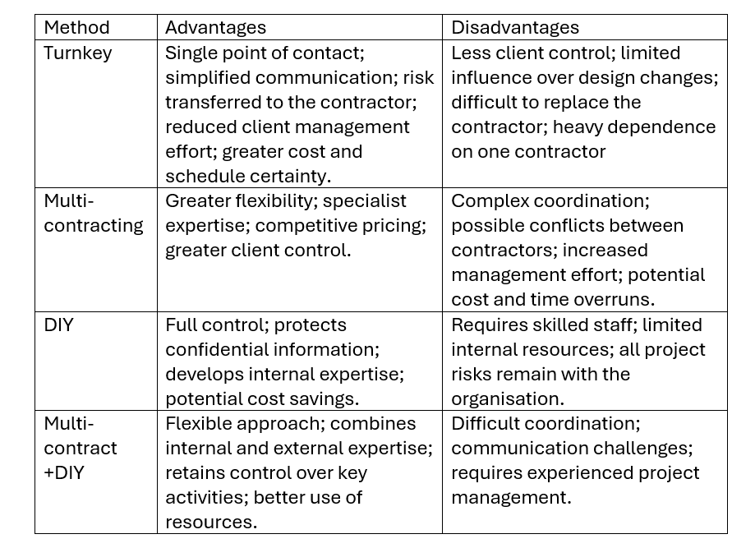
Source: Author’s own work, based on PMI (2021), Lock (2020) and Kerzner (2022).

Suitable Projects for Each Contracting Method
1. Turnkey Contracting
Turnkey contracting works best for large, complex projects where the client may lack the technical know-how or resources to manage multiple contractors. Having a single contractor responsible for the entire project simplifies communication and provides clearer accountability. Examples include power stations, airports, oil and gas facilities and water treatment plants where a single contractor can provide a full, ready-to-use project (Masterman, 2002).
2. Multi-contracting
Multi-contracting is suited for projects when a number of different expert contractors are needed, and the client wants more control over quality, costs and decision-making. This method is often employed on projects with multiple technical specialities as each contractor is accountable for a specific element of the job (Lock, 2020). Examples include hospitals, universities, commercial buildings, and major residential complexes, where construction, electrical installation, plumbing, and heating systems may be undertaken by distinct contractors (Walker, 2015).
3. Do-It-Yourself (DIY)
Contracting through do-it-yourself approaches is most effective for small or sensitive projects, when the organisation has the manpower, expertise and equipment to do the job. The business has complete control of the project by carrying out the work in-house and may retain sensitive information (PMI, 2021). This strategy is typically applied to internal IT system upgrades, office refurbishments, and staff training initiatives when external contractors are not needed (Burke, 2013).
4. Multi-contracting + DIY
The combination of multi-contracting and DIY is best suited for projects where the business wants to retain key operations in-house and outsource specialised work to external contractors. This enables the business to retain control over crucial decisions while incorporating external knowledge as needed (Kerzner, 2022). For example, while producing a new product the business could do the design, planning and testing in-house but use specialist vendors to make electrical parts, packaging or other components. This approach also applies to digital transformation initiatives in which internal resources manage critical systems while external contractors provide professional software or cybersecurity support.
Critical Analysis and Comparison of the Four Contracting Methods
The selection of contracting technique can have a considerable influence on project performance in terms of cost, quality, risk, communication and project completion. Each strategy has its merits, but none is suited to every project. The most acceptable strategy relies on variables such as project complexity, organisational competencies, resources availability and the amount of control necessary (Kerzner, 2022). To summarise, the ideal contracting approach is a balancing act between flexibility, risk and managerial effort, not focusing on a single benefit.
Client Control and Responsibility
One of the most important differences between the four types of contracting is the amount of control the customer retains. Minimum engagement of the customer is required in a Turnkey contracting since a single contractor is accountable for the whole project delivery. This allows for easy administration of projects and puts a lot of risk on the contractor making it ideal for organisations with minimal technical expertise or project management experience (PMI, 2021). But less engagement also implies less input from the customer on design revisions and decisions once the contract is granted.
Multi-contracting offers the customer far better control. This is because the client has direct employment and supervision of numerous skilled contractors. This allows for improved control over quality, prices, and performance, but also increases management duties. Delays, disagreements and extra expenses are likely to be caused by inadequate communication amongst contractors (Walker, 2015).
DIY contracting offers the maximum level of organisational control – everything is done in-house. This is especially helpful for projects containing proprietary information or strategic company knowledge. However, total control means that all project risks are in the organisation and need appropriate skills and resources to deliver good results (Burke, 2013).
The DIY plus multi-contracting combines the strengths of both internal delivery and outsourcing. Recent research suggests that collaborative project delivery can improve communication, shared responsibility and project outcomes when responsibilities are clearly defined (Ashcraft, 2022). Critical functions are retained in-house, while speciality activities are outsourced to external specialists. This balance enables businesses to remain flexible without losing control over strategic choices, but it takes professional project management to successfully coordinate both internal teams and external contractors (Nicholas and Steyn, 2020).

Cost, Risk and Resource Management
Cost is typically seen as a key issue when choosing a contracting technique; however, the cheapest choice is not necessarily the best. Turnkey projects tend to have higher upfront contract fees, since contractors include risk into their bids. However, the project delivery responsibility still primarily lies with the contractor which may be an advantage for customers in terms of fewer unexpected costs (Lock, 2020).
Competitive tendering for distinct job packages between multiple contractors can lower costs through multi-contracting. However, poor coordination among contractors can lead to delays, duplication of work, and contractual conflicts, resulting in increased total project costs despite reduced individual contract pricing (Walker, 2015).
DIY contracting might look less expensive since companies do not include in contractor profit margins. However, this strategy is only cost effective provided the business has the competent staff, equipment and adequate capacity in place. Otherwise, any financial savings may be outweighed by delays in recruiting, training or project (PMI, 2021).
Often the DIY plus multi-contracting approach is the optimum compromise between cost and efficiency. Organisations can outsource expert work and carry out ordinary or strategic work in-house. This enables better use of the current resources without outsourcing the entire project but calls for careful preparation to minimise communication issues between internal and external teams (Kerzner, 2022).
Suitability for Different Types of Projects
The characteristics of a project strongly influence the most suitable contracting method. Factors such as project size, complexity, risk and client capability should all be considered before selecting a procurement strategy (Kumaraswamy, 2024). Turnkey contracting is particularly suitable for large infrastructure projects where the client requires a complete solution, such as power stations, airports or water treatment plants. In these projects, the technological complexity and high levels of risk make a single point of accountability ideal (Masterman, 2002).
Multi-contracting is better suited for projects with numerous technical specialities, such as hospitals, universities or commercial ventures. Different contractors might offer different types of professional skills, such as structural work, electrical systems, plumbing, and heating installations, with the customer coordinating the overall delivery (Walker, 2015).
DIY contracting is usually best for smaller internal tasks where secrecy is required. For example, improving an organisation’s internal IT system, refurbishing the office or implementing internal training courses. These initiatives are dependent on existing organisational expertise; therefore, outsourcing may not provide much value (Burke, 2013).
The DIY with multi-contracting method is particularly well-suited for businesses conducting product development or digital transformation initiatives. As an example an enterprise could design and test a new product domestically but outsource speciality manufacturing or software development. This enables the business to protect intellectual property while tapping into external knowledge where appropriate (Nicholas and Steyn, 2020).
Overall Comparison
The choice of a contracting method can have a significant impact on project performance, including cost, quality, risk, communication and project completion. Recent studies also suggest that selecting the appropriate contracting method is a key decision influencing project success (Demetracopoulou et al., 2024). Turnkey contracting is best for businesses that want simplicity and risk transfer. Multi-contracting is better when the customer needs greater control and specific skills. DIY contracting is best used when businesses have enough internal capability and secrecy is critical. Finally the hybrid strategy gives the greatest flexibility by integrating internal knowledge with external expertise but demands the most coordination and project management.
Therefore, project delivery success is less about picking the “best” contracting technique and more about choosing the strategy that fits the project objectives, complexity, available resources and organisational competencies (Kerzner, 2022; PMI, 2021).

Conclusion
This article has discussed four contracting strategies used in project management. These methods include Turnkey, Multi-contracting, DIY and multi-contracting mixed with DIY. Each technique has benefits and drawbacks in terms of control, risk, cost and project management duties. The customer has less engagement in the project with turnkey contracting and a lot of the risk is taken on by one contractor . Multi-contracting allows the client to have more control but there is more coordination involved . DIY provides companies full control and keeps information secret, but relies on strong internal skills. The hybrid method blends internal knowledge with external expertise, providing flexibility for increasingly complicated projects.
There is no such thing as a contractual process that fits all projects. The best option will rely on the size and complexity of the project, the resources available, the skills of the organisation and its strategic objectives. Therefore, project managers should be attentive in choosing these elements before picking a contracting technique to enhance the chances of successfully delivering the project.

References
Ashcraft, H. (2022) 'Transforming project delivery: integrated project delivery', Oxford Review of Economic Policy, 38(2), pp. 369–384. https://doi.org/10.1093/oxrep/grac001
Burke, R. (2013) Project Management: Planning and Control Techniques. 5th edn. Chichester: Wiley.
Demetracopoulou, V., O'Brien, W.J., Khwaja, N., Feghaly, J. and El Asmar, M. (2024) 'A critical review and analysis of decision-support processes and tools for project delivery method selection', Engineering, Construction and Architectural Management, 31(1), pp. 487–505.
Kerzner, H. (2022) Project Management: A Systems Approach to Planning, Scheduling, and Controlling. 13th edn. Hoboken, NJ: Wiley.
Kumaraswamy, M. (ed.) (2024) Routledge Handbook of Construction Project Procurement and Delivery: Fundamentals, Trends and Imperatives. Abingdon: Routledge.
Lock, D. (2020) Project Management. 11th edn. Abingdon: Routledge.
Masterman, J.W.E. (2002) An Introduction to Building Procurement Systems. 2nd edn. London: Spon Press.
Nicholas, J.M. and Steyn, H. (2020) Project Management for Engineering, Business and Technology. 6th edn. New York: Routledge.
Project Management Institute (PMI) (2021) A Guide to the Project Management Body of Knowledge (PMBOK® Guide). 7th edn. Newtown Square, PA: Project Management Institute.
Walker, A. (2015) Project Management in Construction. 6th edn. Chichester: Wiley.

