Name of the student: Alexandru Baractaru
Student’s ID: 2129397
Module code: LCBB5005

GOOGLE HEADQUARTERS PROJECT IN LONDON

Table of Contents
Introduction 2
Main Body 2
Conclusion and Recommendations 7
Reference List 8
Appendices 10
Appendix 1 10
Appendix 2 10
Appendix 3 11

Introduction
In the arena of technological progress in the world, it has been seen that project management procedures are getting more scientific in approach. The reason behind this may be deeply rooted in the context of making the management processes more accurate and fast as these projects are mainly executed within strict deadlines. This essay aims to provide a rationale supporting the future impacts of the reputed Google HQ project at King’s Cross in London. It will discuss what areas will be affected by the successful completion of the project and how it can show new direction in the operational attributes of the IT sector based in the UK.

Main Body
Google’s headquarters project in the UK is probably the first ambitious central operational premise construction process as managed by Google. It is currently under process at King’s Cross in London, the UK. This ambitious project by the tech giant, Google and its parent organisation, Alphabet is aimed at flourishing its IT operations and supporting central web services to all industries based in the UK. According to an official report from an authentic source, the project is taking a whopping 650,000 sq ft of area which means that the HQ will take the most of the area for its functional purposes (theguardian.com, 2024). The initial investment in this project has been estimated as amounting to almost 1 billion GBP which is generally considered one of the biggest projects that the UK have ever experienced since its rise through the industrial revolution (standard.co.uk., 2024). This HQ has been constructed with a unique plan which includes the use of a 200 m running trail at its rooftop while a 25 m area has been allocated for a modern swimming pool. This project will surely have an important impact on the IT scenario in almost all industrial sectors based in the UK.
Such kings of ambitious projects need a distinct approach to management principles as these projects are based on a wide spectrum of rational points of future productivity in a region. Google’s London HQ project is also no exception in this context as it is dependent on the future implications and profitability it can provide to all its consumers in the region, the UK. The core principles attached to this project have been discussed here with justified points and rationale. First of all, a formal structure of a project management process should be taken into consideration. This formal structure provides a distinct look at the project attributes and the designs made to conduct the project. Such elements are generally made available in the relevant project charters and plans (Trach and Bushuyev, 2020). For example, the project plan of Google provides a delineation of its formal structure where it has mentioned that the project will occupy almost 650000 sq ft of area. This element helps a lot in maintaining the formal approach of the project while presenting a depiction of structures to be included in a construction project. Secondly, the use of project sponsors is also attributed as a key principle of a project management process. It includes the use of a more distinct way of presenting the entities that are directly funding or helping the project in its promotional and functional purposes.
Thirdly, goals and outcomes are engaged in the context of making a project directed towards its success more efficiently within the given deadline. In the case of Google, its London HQ is also attributed to such goals that can be achieved with its collaborative execution of the project. Goals and objectives are necessary principles in project management scenarios, however, they are also dependent on another principle which denotes the distribution of roles and responsibilities (Kania et al., 2021). In this sphere, the roles and responsibilities are distributed in a way that can suit the segmented task allocations within a huge project as such projects are difficult to be handled by only one entity. For example, Google has used Gillespie, a renowned construction agency as its prime construction management agent in the project. On the other hand, other suppliers of raw materials and technical equipment are also engaged in the process of distributing accountabilities and responsibilities. It comes with another project-related principle and that is the risk management process. In this process, any potential risk gets detected and noted for further evaluation.
This evaluation focuses on certain factors such as the probable frequency of the detected risks and the potential impact they can contribute to the project and its execution process. Markings are then provided with a detailed attribute to project the intensity of the risks and thus, it makes the decision-making process for planning and applying mitigation procedures for curbing such issues more effective. The whole projection of this management process is dependent on a major principle and that is the application of the communication approach. It provides opportunities to share information and discuss better suggestions from all personalities involved in the project.
In the project of London HQ by Google, it has been seen that the projection of the management approach has been similar to the Kanban approach (refer to Appendix 1). This approach focuses on the increasing factors of productivity while projecting the dynamics related to collaborative team management (Orlov et al., 2021). In similar construction projects, such approaches are also frequently used due to their functional character of focusing more on teamwork potential. It is seen that in future projects, this approach will also be used in maintaining the skill-based areas relevant to the execution processes.
Apart from this, the project is also taking an Agile management approach and this is more profound than the previous one in the context of Google’s HQ Project (refer to Appendix 2). This project delineates a theoretical view which suggests that efficiency in collaboration along with flexibility in the work process provides a distinct positive impact on the predictable outcome of a project (Wiechmann et al.,2022). The rationale behind this consideration is also seen as the approach is more future-proof as it includes a predictable future context for driving similar projects. Thus, these two approaches of project management have been identified as being used by the teams that are engaged in the construction of Google’s London HQ at King’s Cross.
The useful tools that have been used in Google’s HQ Project in London can be rendered as an ideal way of using technical attributes in managing such a huge construction project. The attributes used in the process of making a detailed analytical overview of the tools have been elaborated below.
First of all, the utilisation of a network diagram has been seen as the primary use of a project management technique. A network diagram provides a clear description of the segmented tasks in a project and how they are getting started or ended (Bharathi and Sivasankari, 2021). It is actually a delineation of the timeframe for each task included in the project. The delineation of the diagram is generally done using certain software which provides relevant nodes to be used flexibly in manoeuvring the proposed tasks and their deadlines. The only limitation this technique has is seen in the absence of flexible editing of a static network diagram However, it has been mitigated using customisable diagrams to support a project.
Secondly, the use of the Gantt chart along with WBS is also included in the general considerations of tools that provide a delineation of a timeline to be taken or has been taken by a project to get completed successfully (refer to Appendix 3). It is perhaps the simplest way to produce a depiction of each task in a project and how much time is consumed by the completion (Shibuya and Chen, 2021). It is generally provided with a table with some distinct colours in cells to project the differential attributes of timelines attached to specific tasks in a project.
It is followed by the use of a Risk matrix as an effective tool in the project management process. A risk management matrix is generally mentioned with several cells including specific risks connected to a project. In this case, the first execution is dependent on the detection of potential risk factors that can detrimentally affect the future outcome of a project. It is dependent on the issues discussed with employees working on a project or the electronic aids that simultaneously check the proceedings made on a project. It is also related to the use of a risk management plan that includes a budget allocated by the hierarchy to address the mitigation of these potential issues detected by the officials.
Stakeholder mapping is the fourth important tool that is used to maintain a good approach to the engagement of stakeholders in a project (Kujala et al., 2022). This management tool is definitely used with the notion of a more useful context based on the promotional aspects related to a business project. For example, Google’s London HQ project has taken the companies using its cloud-based systems as the most powerful stakeholders in its project. The rationale behind this application is rooted in the conduction of a market analysis prior to the initiation of a project.
These elements are generally included in the context of the Project budget and it is the core tool that provides the monetary allocations for each task to be performed to meet the project completion status.
The life cycle of a project is generally provided with the help of elaboration using five prime elements such as initiation, plan, execution, monitoring and closing. Firstly, the initiation process is denoted as the most introductory phase of a project. It has a great expansion on its planning criteria. It generally starts with the detection of requirements or needs to increase the productivity or market expansion of a business organisation. After detecting the need, the process includes the process of suggesting a suitable plan to promote a project that can help the organisation in addressing the detected issue. It proceeds to present a primary budget which primarily projects the funding to be allocated or needed to conduct the project (Portny and Portny, 2022). The second point of this life cycle is mentioned in the planning phase, this phase includes a detailed overview of the project which will be developed using a team. This process is more dependent on gathering information about the required raw materials to be used, equipment to be required and the manpower needed to be utilised in the development of the project. Apart from this, the budget gets used by the officials to get thoroughly perused if there is any need to amend it.
After that, it projects the use of a more eloquent phase and this is perhaps the most functional stage in a project’s life cycle. The execution phase includes the use of teams and officials as manpower in generating the core HR resource for completing a project (Belizón and Kieran, 2022). This context is more complex in the customisation of a project in a smooth way. Motivations are needed in this phase as they provide an emotional boost to the employees to be involved more in the executive tasks. It is thus, followed by a monitoring process. This monitoring process helps in maintaining a suitable aspect of observing the flow of work in the development of a specific project. This phase is generally handled by manual efficiency using the executives that have the accountability to detect any fallacy in the proceedings and inform the same of the hierarchy of the company (Nicholas and Steyn, 2020). However, the monitoring of financial transactions made per task and dealings in the project is now being conducted by AI tools and mechanical means. The rationale behind this consideration is deeply rooted in the context of maintaining accuracy in detecting risks in the work process. The completion of the project meets the final stage of closing.
The project of London HQ by Google is one of the most ambitious projects ventured by any IT service provider for the UK. It can be seen as having a series of positive impacts on future executions in the industrial context of the UK. Some future effects of this project have been elaborated below with justified points.
Such a massive and successful IT project is obvious to promote the upcoming revolution in the IT facilities in the region. The cause behind this statement can be understood through the utilisation of this project to provide several IT services for enhancing data privacy for the industries flourishing in the region (Cheng et al., 2022). Due to the homeland usage for manufacturing and delivering IT services, the services and associated packages can be made cheaper to be purchased and applied by the business organisations of this country.
A headquarter needs a massive workforce and it is also applicable for the chosen company, Google. As per the official report published by the IT giant, Google on its official site, almost 3000 new employment can be generated through this project (theguardian.com, 2024). It has a definite and positive impact on the employability scenario of the native communities. The process can open a new scope to employ local talents to make the HQ fully functional.
Google is a reputed and one of the most popular IT service providers in the world and this company has opened its HQ at King’s Cross in London. It means that the Data services in the region are going to be more enhanced due to the presence of a central hub of the IT giant in the native land. In this case, the retail and other IT companies based in the region can be the future beneficiaries of the enhanced data service provided by Google.
An increase in business operations is always a pointer to increased revenue collection for a country and the same goes for the UK in this context. This project will impact the future dealings in the taxes and profitability of the business scenario. As Google is a USA-based company, thus, the UK may avail the massive scope of FDI through its business dealings from its London HQ.
The core competency in the context of making revolutionary progress in business processes in the UK, the project is definitely going to contribute heavily to its technological advent. Thus, the positive impacts of this project are indeed more feasible in the UK’s future technological as well as employability scenario.

Conclusion and Recommendations
The productivity of this project can be enhanced using a series of automation in the management. Automation in mechanical aspects can provide the company with a detailed parameter for experiencing the increase in accuracy level in the context (Elghaish et al., 2020). It is also useful in reducing the fallacies of human executions in project development. Apart from this, using the native technology of the UK in monitoring the development of the project will also be helpful as it will make the support line more effective in handling thye process.
It can be concluded from this essay that the use of agile management is the best way to manage a process as it provides opportunities to include work-based flexibility. Google’s London HQ project has been provided with a brief overview. It has been followed by the principles and approaches connected to project management in this case. It has also presented the future impacts of the project in the UK.

Reference List
Belizón, M.J. and Kieran, S., 2022. Human resources analytics: A legitimacy process. Human Resource Management Journal, 32(3), pp.603-630.
Bharathi, S.D. and Sivasankari, R., 2021. CONSTRUCTION PROJECT PLANNING AND ANALYSIS OF TIME ACCELERATION USING PRECEDENCE DIAGRAM METHOD (PDM).
Cheng, M., Adekola, O., Albia, J. and Cai, S., 2022. Employability in higher education: a review of key stakeholders' perspectives. Higher Education Evaluation and Development, 16(1), pp.16-31.
Elghaish, F., Abrishami, S. and Hosseini, M.R., 2020. Integrated project delivery with blockchain: An automated financial system. Automation in construction, 114, p.103182.
Kania, E., Śladowski, G., Radziszewska-Zielina, E., Sroka, B. and Szewczyk, B., 2021. Planning and monitoring communication between construction project participants. Archives of Civil Engineering, 67(2).
Kujala, J., Sachs, S., Leinonen, H., Heikkinen, A. and Laude, D., 2022. Stakeholder engagement: Past, present, and future. Business & Society, 61(5), pp.1136-1196.
Nicholas, J.M. and Steyn, H., 2020. Project management for engineering, business and technology. Routledge.
Orlov, E.V., Rogulenko, T.M., Smolyakov, O.A., Oshovskaya, N.V., Zvorykina, T.I., Rostanets, V.G. and Dyundik, E.P., 2021. Comparative analysis of the use of kanban and scrum methodologies in it projects. Universal Journal of Accounting and Finance, 9(4), pp.693-700.
Portny, J.L. and Portny, S.E., 2022. Project management for dummies. John Wiley & Sons.
Shibuya, M. and Chen, X., 2021. Production Planning and Management Using Gantt Charts [J]. Journal of Mechanics Engineering and Automation, 11(3).
standard.co.uk., 2024. “google-hq-new-office-kings-cross-london-plans” Available at: https://www.standard.co.uk/homesandproperty/property-news/google-hq-new-office-kings-cross-london-plans-b994436.html#:~:text=The%20building%2C%20known%20as%20KGX1,hall%20with%20views%20over%20London. [accessed on 23 Apr 2024]
theguardian.com., 2024. “behold-londons-landscraper-googles-new-uk-hq-as-long-as-the-shard-is-tall” Available at: https://www.theguardian.com/business/2022/jul/01/behold-londons-landscraper-googles-new-uk-hq-as-long-as-the-shard-is-tall [accessed on 23 Apr 2024]
theguardian.com., 2024. “google-commits-to-massive-new-london-hq” Available at: https://www.theguardian.com/technology/2016/nov/15/google-commits-to-massive-new-london-hq [accessed on 23 Apr 2024]
Trach, R. and Bushuyev, S., 2020. Analysis communication network of construction project participants. Scientific Review Engineering and Environmental Sciences (SREES), 29(3), pp.388-396.
Wiechmann, D.M., Reichstein, C., Haerting, R.C., Bueechl, J. and Pressl, M., 2022. Agile management to secure competitiveness in times of digital transformation in medium-sized businesses. Procedia Computer Science, 207, pp.2353-2363.

Appendices

Appendix 1
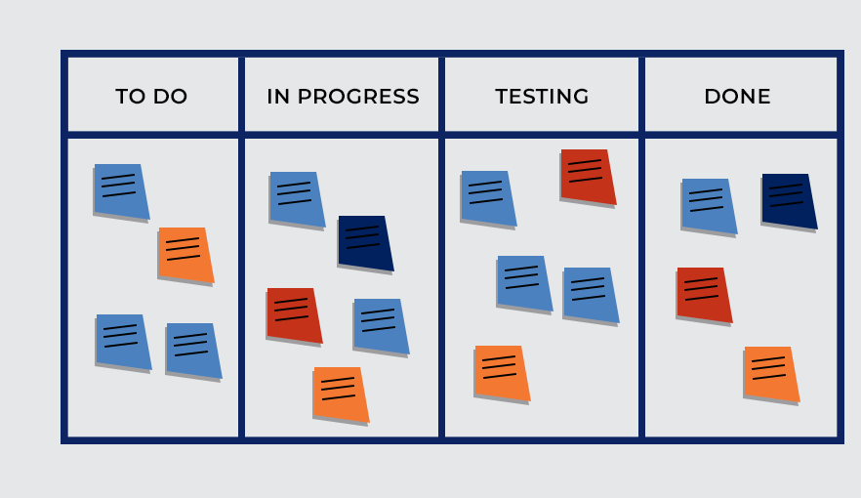
Figure 1: Kanban Board
(Source: Orlov et al., 2021)

Appendix 2
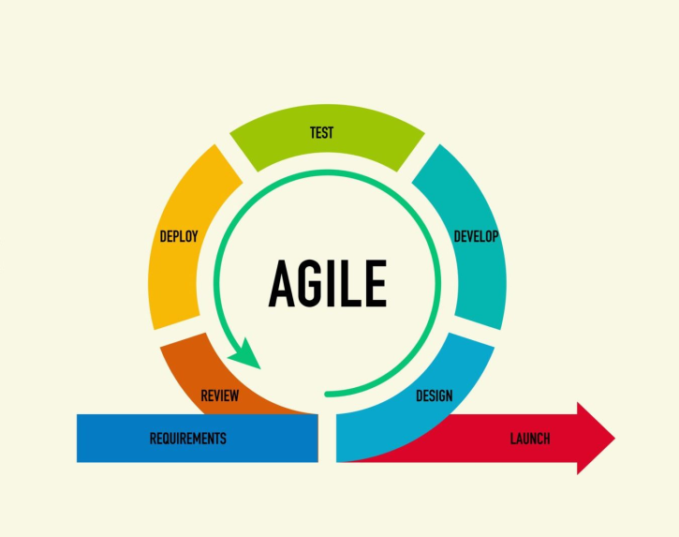
Figure 2: Agile Management
(Source: Wiechmann et al., 2022)

Appendix 3
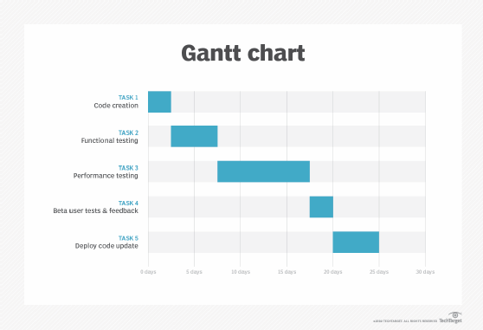
Figure 3: Gantt Chart
(Source: Shibuya and Chen, 2021)

