Literature review plan
How does Police forces promotion of equality, diversity and inclusion within its workforce affect the service they provide to the public?

Introduction
The intention behind this chapter of the dissertation is to establish what policies and processes are in place in forces across the UK in relation to equality, diversity and inclusion. It will also establish the research that currently exists in relation to the equality, diversion and inclusion withing the workforce of the police in the UK and how this represents the communities they work within. It will utilise the research that is already available to establish if areas with workforces that represent the communities of the area has any impact of the service provided and public confidence within the police in that area. This also strives to evaluate the changes within the diversity of police work forces over time and how and why they have changed within this review of the literature currently available, this chapter aims to identify, address and evaluate the areas that are without research, why this could be and how to direct the research to address the gap in the academic area.
To locate the research to complete this literature review multiple sources will be examined from search engines such as google scholar as well as University of Wales, Trinity St Davids (UWTSD) online library as well as other online documents. These will be identified through searches such as ‘equality, diversity and inclusion in policing’, ‘Diversity of police work forces’ and ‘Benefits and drawbacks of a diverse workforce’. This nature of these searches and similar searches will to identify the related research that already exists and help to establish areas which are missing.

What is equality, diversity and inclusion?
‘Equality, diversity and inclusion (EDI) ensure the fair treatment and opportunity for all. It aims to eradicate prejudice and discrimination on the basis of an individual or group of individuals protected characteristics’ according to the University of Edinburgh. (The university of Edinburgh, 2021). This means that if there is equality, diversity and inclusion withing a group such as a work force, a school or a social group that no one will treated differently or included or excluded from something based on their protected characteristics. Protected characteristics are characteristics belonging to an individual that research shows still receive significant discrimination (University of Dundee, 2023). There are 9 of these characterises and they are identified within the equality act 2010. They include; age, disability, gender reassignment, marriage and civil partnership, pregnancy and maternity, race, religion or belief, sex, and sexual orientation. These characteristics are factors which can be measured to be able to assist in monitoring equality, diversity and inclusion within a group of individuals.

Equality, diversity and inclusion in the workplace
Equality
When looking at how Equality, diversity and inclusion affect the work place, they must be looked at individually as they each have different ways that they effect the work place. Equality which is when every member of a group, society or family have the same status, rights and responsibilities (Collins, 2019). Examples of how equality can be shown in a work place are things such as employees being paid the same wage whether they were male or female, promotions being granted based of skill and not influences by disability, sexuality or gender and adaptations made so that disabilities don’t prevent individuals form being able to carry out a role (The GC index, 2019). Equality is not about not treating individuals differently, it is about ‘levelling the playing field’ for everyone to give them the same opportunity for success.

A real life example of where equality can be highlighted is Dr Xander Van Der Poll. He is a Bristol university student who broke his back becoming paralysed from the waist down in his first year of medical school. He is now a qualified doctor working for the NHS as a wheelchair user (Bristol university, 2024). Since this Dr Van Der Poll and his wife Kirsty run an Instagram page educating people about how they navigate life as a disabled couple. One of these videos answers the question ‘how I perform CPR as a wheelchair user’ (Ourchaoticadventure, 2024). This shows Dr Van Der Poll performing CPR to the same standard as any other employee of the NHS with some adaptations from his employers to enable him to do so. This highlights the importance of equality and how employers must provide said ‘level playing field’ to allow each individual to succeed.

Diversity
Diversity is the fact of many different types of things or people being included in something, a range of different things or people (Cambridge dictionary,2019). Diversity in a work place is when the work force includes a variety if individuals with a diversity of characteristics such as gender, sexual orientation, age, race, religion disability and culture (Desk bird, 2023). As well as these characteristics there are also other factors which can increase diversity such as life and professional experience, language skills, geographic location and personality traits among many more. These characteristics mean that the work force will have a wide range of experience and skills that they wouldn’t have if everyone had the same background providing a more well rounded group and more unique ideas to solve problems and innovate.
An example of a company who are making strides within diversifying their work force is Johnson and Johnson (He, G, 2023). They are a medical, pharmaceuticals and consumer good company who have received multiple awards in relation to their efforts surrounding equality, diversity and inclusion including winning the best employer for diversity three years in a row. To achieve this Johnson and Johnson have utilised employee resource groups, mentoring programmes and incorporated diversity initiatives. This has lead to increased numbers of diverse individuals in management roles within in the company. As well as this, Johnson and Johnson have also approached the same diversity within their advertising, breaking down stereotypes and tackling unconscious bias. The diversity within Johnson and Johnson along with many other companies are prioritizing diversity which will expand form their work force throughout their whole company and reflect on society also.

Inclusion
Inclusion is the ‘act of including someone or something as part of a group’ (Cambridge dictionary, 2019). When considering inclusion within a workplace it can look a variety of ways for example hiring from multiple different backgrounds, develop systems to address misunderstandings, create a space where employees feel respected, being aware of unconscious bias’s as well as many more (Coach Diversity institute, 2024). Inclusion is involving people of many different experiences, expertise and backgrounds to build a team which is more diverse and non-discriminatory.

When looking at real life examples of inclusive companies it appears clear that the common quality withing a company that ranks highly for inclusion within the work force and that is that they don’t appear to have ‘completed’ their inclusion within the company. It is something they are striving to continue to improve every year and to develop, something that still needs to be worked on. This is highlighted in the top two companies listed by the website inclusive companies in their 2023/2024 survey. The top company was West Midlands Fire Service (Inclusive Companies, 2024). Within their case study for the survey the chief officer has highlighted his personal commitment to inclusion within the work force. He has identified the improvements the service has made while still appreciating that there is more work to be done to improve the level of inclusion within the staff at West Midlands Fire Service. The second ranking company within this survey was UK Power Networks (Inclusive Companies, 2024). UK Power Networks have climbed four places within in this survey from last year to this year. Within their case study the companies CEO Basil Scarsella has spoken of how they as a company work consistently to evolve their business to be more diverse and inclusive. These case studies show that to develop an inclusive work force is something a business or service must show commitment to over an extended period of time and that it is not something that will change without dedication.

Equality, Diversity and Inclusion within Policing
Policing Vision 2025
The 2018 to 2025 National Police Chiefs Council (NPCC) diversity, equality and inclusion strategy has been developed to tackle the issues surrounding diversity, equality and inclusion within police forces in the UK to reach the collective vision set by the National Police Chiefs Council by 2025 (NPCC, 2018). Within the pledge made by the NPCC they highlight that although there has been a large amount of work done within police forces to improve diversity, equality and inclusion there is a significant amount of progress left to be made. When looking at the previously high ranked businesses and their outlook on the work it take to thrive when delivering equality, diver and inclusion within a work force, they also appreciate that the working on it is a long term project that requires dedication and commitment. This means that the policing vision is looking to achieve a realistic goal but understanding that this end goal of the vision will still not be perfect and the work must be ongoing.

As part of this vision to improve equality, diversity and inclusion within policing is a strategy to do so. This strategy is broken down into three sections to focus on, communities, partners and organisation. When they looking to carry out each part of this strategy they strive first to understand each part, for example to improve the equality, diversity and inclusion within the organisation they must first understand the current organisation, the things that are going well and the things that need improvement in relation to equality diversity and inclusion. Once each area is understood a plan of how this can be developed is implemented. For example when looking at partners, this would be to utilise a joint delivery programme. This is the intentional step made to improve the area. And then finally the desired outcome which for example for communities would be to increase confidence.
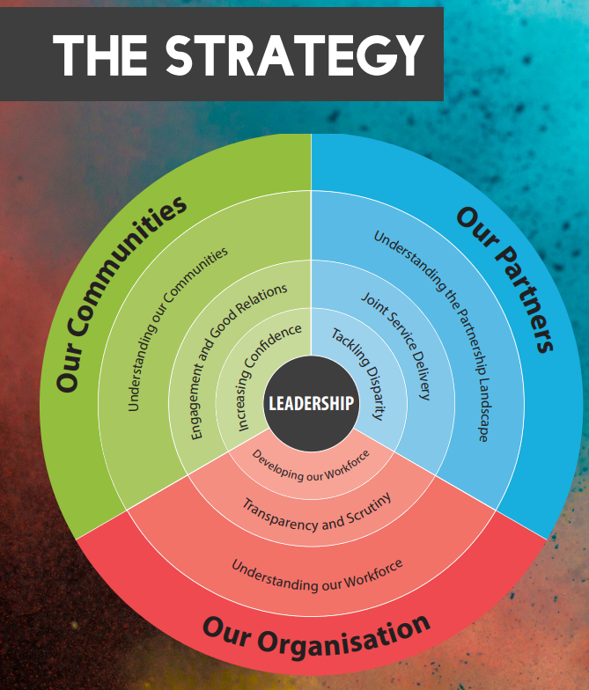
The strategy encompassed within the policing vision 2018 (NPCC, 2018).

Metropolitan Police Diversity and Inclusion Strategy for Engagement (STRIDE) 2021-2025
Alongside national strategies like previously discussed individual police forces often implement their own strategies to tackle equality, diversity and inclusion. For example the metropolitan police have their own diversity and inclusion strategy called STRIDE (Metropolitan Police, 2024). The metropolitan police say that through their strategy they aim to ensure everyone that lives works and visits London feels and stays safe. They aim to do this through . Within their strategy the metropolitan police outline the diversity within their communities in London stating that 40 percent of Londoners were born outside of the UK and there are over 300 languages spoken in London. They also outline how the diversity of London is one of the things that makes it such a successful city (Metropolitan Police, 2021). The key message that the metropolitan police are stating with in this strategy is that they ‘will take visible and effective action, together with communities and our partners to make changes which are so important for London safety and trust in the met and for the wellbeing and capability of colleagues’. This statement shows the importance to the metropolitan police that they are representing their community and their work force to provide a service that meets the needs of that the community in order to provide them a good service.

Workforce Diversity
Police workforce diversity data from 2021 is based of self declaration data of individuals and has been analysed to establish the comparison between different protected characteristics of police officers and staff and the communities they serve (Police UK, 2021).
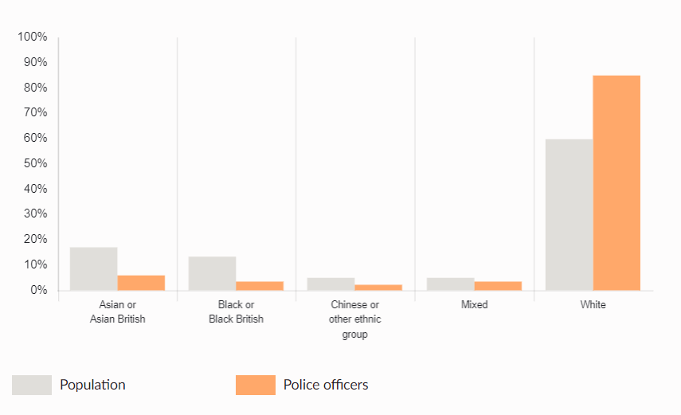
Police officer ethnicity in metropolitan police (Police UK, 2021).

This chart displays the percentage of Metropolitan police officers of different ethnicities along side the percentage of the population of the same ethnicities. The chart shows that the percentage of officers that defined their ethnicity as white is over 25 percent more than of the percentage of people who define their ethnicity within the local population as white. This is the only ethnicity documented within this chart where there is an over representation of one ethnicity within police officers. When looking at the statistics shown within this chart there is an under representation within police officers and staff of these ethnicities compared with that of the population. As such when viewing the diversity of the metropolitan police force compared with the population it serves, it is not representative of the communities. This is why the strategies such as Police vision 2025 and metropolitan diversity and equality strategy for engagement (STRIDE) 2021 -2025 are so vital to put increasing the diversity within police forces at the forefront of forces priorities.

Importance of Equality, Diversity and Inclusion in Policing
The importance of equality, diversity and inclusion within policing comes back to the basic principles of policing in the UK. There are 9 Peelian principles of policing in the UK who were developed by Sir Robert Peel when he developed the metropolitan police in 1829 (Rank Success, 2022). The main principle of this that are relevant to consider when analysing equality, diversity and inclusion is ‘police are the public and the public are the police’. This principle highlight the importance of public support of the police and the idea of policing by consent. This relies on the public having confidence in the police and that the public feel as though the police represent them. When there is a police force with an under representation of characteristics such a race, religion, gender or LGBT+ the public see less representation of themselves within the police and as such moves away from the basic principle of policing in the UK.

Conclusion
When considering the information that is available in relation to equality, diversity and inclusion it appears that it is a very big topic across policing and all types of work forces in the UK. It is something that people are making big commitments to improve diversity of across companies and forces in the UK. Equality diversity and inclusion is embedded in policing back to its very foundation and the idea that the police service should represent the communities it serves. The Peelian principles highlight the importance of a representative force and how it aids to improve public confidence in the police allowing forces to work more effectively with the support of the public. As such the large strides that police forces are taking in improving all the aspects of diversity within their forces is well utilised to improve the running of their forces effectively.

Word count: 2416 words

Bibliography
The University of Edinburgh (2021) What Does equality, diversity, and Inclusion mean? Available at: https://www.ph.ed.ac.uk/equality-diversity-and-inclusion/about-edi/what-does-equality-diversity-and-inclusion-mean (Accessed: 13th October 2024).
‌
University of Dundee (2023) The protected characteristics explained. Available at: https://www.dundee.ac.uk/corporate-information/protected-characteristics-explained (Accessed: 13th October 2024).
‌
Collins (2019) Definition of equality. Available at: https://www.collinsdictionary.com/dictionary/english/equality (Accessed: 13th October 2024).

‌The GC Index (2019) Equality, Diversity & Inclusion Explained. Available at: https://www.thegcindex.com/equality-diversity-inclusion-explained/ (Accessed: 13th October 2024).
‌
Ourchaoticadventure (2024) One of the most common questions I get as a doctor in a wheelchair is about how I do CPR. Available at: https://www.instagram.com/ourchaoticadventure/reel/C-BE-n0obCg/ (Accessed: 13th October 2024).

Bristol University (2024)Doctor, athlete, wheelchair user: Meet the unstoppable Xander. Available at: https://www.bristol.ac.uk/news/2024/july/paralysed-student-graduates.html (Accessed: 22 October 2024).
‌
Cambridge Dictionary (2019) DIVERSITY | meaning. Available at: https://dictionary.cambridge.org/dictionary/english/diversity (Accessed: 22 October 2024).
‌Desk bird (2023) What are Examples of Diversity in the Workplace? Available at: https://www.deskbird.com/blog/examples-diversity-workplace (Accessed: 22 October 2024).
‌
He, G. (2023) 15 Examples of Diverse Companies. Available at: https://teambuilding.com/blog/diverse-companies (Accessed: 22 October 2024).
‌
Cambridge Dictionary (2019) INCLUSION | meaning. Available at: https://dictionary.cambridge.org/dictionary/english/inclusion (Accessed: 22 October 2024).
‌
Coach Diversity Institute (2024) 9 Examples of Inclusive Behaviours in the Workplace. Available at: https://coachdiversity.com/blog/examples-of-inclusive-behavior-in-the-workplace/ (Accessed: 22 October 2024).
‌

Inclusive companies (2024) West Midlands Fire Service. Available at: https://www.inclusivecompanies.co.uk/2023casestudies/west-midlands-fire-service/ (Accessed: 3rd November 2024).

‌Inclusive companies (2024) West Midlands Fire Service. Available at: https://www.inclusivecompanies.co.uk/2023casestudies/west-midlands-fire-service/ (Accessed: 3rd November 2024).

‌
National Police Chiefs’ Council NPCC (2018) Policing Vision 2025. Available at: https://www.npcc.police.uk/SysSiteAssets/media/downloads/publications/publications-log/2018/npcc-diversity-equality--inclusion-strategy-2018-2025.pdf (Accessed: 3rd November 2024).

National Police Chiefs’ Council NPCC (2018) Policing Vision 2025. Available at: https://www.npcc.police.uk/SysSiteAssets/media/downloads/publications/publications-log/2018/npcc-diversity-equality--inclusion-strategy-2018-2025.pdf (Accessed: 3rd November 2024).

Metropolitan Police (2024) Met Diversity and Inclusion Strategy (STRIDE). Available at: https://www.met.police.uk/police-forces/metropolitan-police/areas/about-us/about-the-met/met-diversity-and-inclusion-strategy-stride/ (Accessed: 3rd November 2024).

Metropolitan Police (2021) Engagement Equality Learning Protection The Met’s Strategy for Inclusion, Diversity and Engagement STRIDE. Available at: https://www.met.police.uk/SysSiteAssets/media/downloads/force-content/met/about-us/stride/strategy-for-inclusion-diversity-and-engagement-stride-2021-2025.pdf (Accessed: 3rd November 2024).
‌
Police UK (2021) Workforce diversity. Available at: https://www.police.uk/pu/your-area/metropolitan-police-service/performance/workforce-diversity/ (Accessed: 3rd November 2024).

‌Police UK (2021) Workforce diversity. Available at: https://www.police.uk/pu/your-area/metropolitan-police-service/performance/workforce-diversity/ (Accessed: 3rd November 2024).

Rank Success (2022) What Are the 9 Peelian Principles? Available at: https://policepromotion.blog/2022/05/02/what-are-the-9-peelian-principles/ (Accessed: 3rd November 2024).
‌

