An Inquiry in to the Evolving Roles Between Textile Companies/Designers and Consumers in Developing a More Sustainable Future.

Submitted in partial fulfilment of the requirements for the degree BA (Hons) University of Wales Trinity Saint David, Swansea. 11th December 2019

Name: Rebecca Sian Davies

Personal Number: 1703304

Course: BA (Hons) Surface Pattern Design

Word Count: 4412

Summary of Topic

This text explores the current fashion textile industry model. With focused discussions on the role of the consumer in the designer/company relationships. And the fast fashion industry, inquiring into the devastation this causes to the natural environment. Compared with sustainable production models, that are being introduced into the industry.

Introduction

The intention of this text is to explore the current fashion textile industry, firstly by looking at the relationship between the consumer and the designer/company. It has been acknowledged here by (Powers, 2015, pg. 87) that “Such collaborative work between designers and consumer researches would be beneficial for a better understanding of… the context of consumer marketing”. Which relays how pivotal this relationship can be when depicting the direction and habits of the fashion industry.

Focusing on fast fashion industry and what drives it. With discussions about the waste this phase of the fashion industry produces and the effects this is having on the environment. Insight from Quinn, depicting these environmental effects, is utilised in further understanding the specific causes of destruction.

Means of production will also be analysed, with reference to crude-products (Braungart and Mcdonough ,2008, p.33), the Industrial Revolution and how this has shaped mass production today. Supported by Walter Benjamin’s (2008, p.4) explanations of the “aura” and how the emotional connection with design has been severed by mechanical production. And the beliefs of the Arts and Crafts movement, from focused perspective of William Morris. Questioning the importance of the quality and the time spent on creating a design, and how this translates to the beauty and durability of a design.

This information could be utilised in understanding how we may change the way we value what we have today. And perhaps this comparison could give reasoning as to why so much is consumed, and possibly even taken for granted, in todays’ society.

The second chapter of this text will focus on the case studies of the fashion giant Levi’s and the smaller, newer brand Doc Cotton, focusing on cotton production. As well as providing insight into the aesthetic stereotyping attached to sustainable design, and how a high-end brand like Dolce and Gabbana have questioned this in their newest Spring/Summer 2020 fashion show.

The main aim is to gather a stronger understanding of the current models of production available and how they are affecting the environment. As well as to find where brands are already tackling the current issues facing the fashion industry, and how transferable these methods are, with intention for them to be applied throughout the industry.

Chapter 1

Consumerism being “the preoccupation of society with the acquisition of consumer goods” Lexico (2019). We are also living in the age of heightened environmental consciousness, which provokes a conflict with our need to be so preoccupied with consuming, as this definition suggests that we are.

Anuschka Rees (2016) published an article discussing this conflict viewing shopping as a “bad hobby”, and articulating that “Buying less, becoming a more conscious consumer, shopping for quality not quantity: All of that is hard enough as it is the age of social media and fast fashion.”. Here Rees (2016) draws attention to social media’s role in the consumers need for fast fashion, implying that the current consumer culture has emerged from “the age of social media” Rees (2016).

There is an empathy, however, towards the difficulty the consumer faces when, shopping for fashion in an environmentally conscious way, as it is often in the designers’ choices, the lack of environmental consideration can be found. Kenton (2019) stipulates that, it is this societal relationship to consumer goods that has, naturally, had its own effect on the rate at which goods are made. Further exploring the relationship between social media and fast-fashion, with regard to trend spreading and consumer patterns would be beneficial to understand how modern media influences have impacted the relationship between the fashion provider and their customer.

Already, living in a 21st century society, there is an active awareness with regard to these patterns of our consumerism. From here, this chapter will be exploring the relationship between the consumers’ response to trends and the way that the fashion industry has evolved to cater to this, with links to the similar issues witnessed in previous industrial revolution and environmental effect of consumerism today.

‘Fast-fashion’ has become a more frequently utilised term for the garments bought and sold on the high street, due to their quick production, from catwalks to retail, low sale prices and significant sale volumes (Kenton, 2019). The catwalks are where the trends tend to begin, setting the aesthetic for that season’s fashion, from the two main Haute Couture collections a year; the grouped seasonal aesthetic trends of the Spring/Summer collection to be followed by the Autumn/Winter collection later on that year, with an occasional Resort collection just before the Spring. Fast-fashion retail stores, however, split these two collections into as many as 12-24 collections a year, whereas back in 2000, they stuck to the same two collections as haute couture (McKinsey & Company, 2016).

Consumers feel the need to keep up with these trends and spend their money “…fuelling a throwaway fast fashion culture…” (Butler and Wood, 2019), and encouraging companies to keep producing garments at this irresponsible rate. The House of Commons Environmental Audit committee (2019), found that “Reacting rapidly to offer new products to meet consumer demands is crucial to this business model”, the business model being the fast-fashion industry. This suggests that without the demand, from trend-driven consumers, for new collections, the fast-fashion market would no longer have a supporting market audience, therefore making it disadvantageous and superfluous.

Due to this mentality, fast- fashion garments are then being used in such a way that is comparable with perishable goods, with their use by date being when the next trend begins. Meaning that each garments’ lifespan only needs to last as long as the trend it was designed for. Consequently, resulting in a massive turn-over of fashion waste with every new trending collection. It has become apparent that investigating the impact of textile waste, especially that of the fashion industry, is imperative to understanding the full impact that this consumer societies relationship with fast-fashion, is having on the environment.

Fast-fashion appears to be spreading like an epidemic through the consumer market, and is having a drastic impact on our environment. According to Forbes (2018) in “a recent Pulse Of The Fashion Industry report stated that fashion generates 4% of the world’s waste each year” which equates to approximately “92 million tons” Forbes (2018)* a year. From these statistics, the opinion that the fashion industry is a dangerously polluting industry in the world, is supported and justified.

Moreover, due to the number of processes used on the printed and dyed textile waste that the industry produces, there are chemical ingredients that increase the severity of the damage this waste is having on the environment. “Clothing can take decades to decompose, all the while leaching deadly chemicals and gases into the soil around it.” Quinn (pg.109, 2010). This statement by Quinn highlights the chemical damage of textile waste. Where he goes on to refer to the chemicals as ‘deadly’ implies that these chemicals are having an effect on peoples’ health, as well as the eco-systems’ well-being.

Braungart and McDonough (2008 pg.33) further discuss this issue, by describing industrial products as “crude-products” and state that the design intention behind the industrial design system at the time was to make products that were affordable and that followed set regulations, functioned well enough, had a long enough lifespan to meet customer expectations, and that they looked attractive. These product outcomes were christened “crude-products” Braungart and McDonough (2003 pg. 33) however, due to the toxic composition of the materials and chemicals used to make them.

It was stated that, in the findings from research on “household contaminants” Braungart and McDonough (2003, pg. 35) they discovered that “…more than half of the households showed concentrations of seven toxic chemicals that are known to cause cancer in animals and suspected to cause cancer in humans...”. Where the society appears to be becoming more aware of the environmental damages that fast-fashion is at the heart of, it’s perhaps less discussed the direct impact this industry could be having on our physical health. Possessing this knowledge could further convince consumers to reconsider their “bad hobby” Rees (2016), because they make a difference to themselves, through the intention of protecting their health, in a way that they may not feel that they can protect the environment.

Quinn’s (pg. 109, 2010) previous statement that garments take “decades to decompose”, also brings attention to the fact that this waste can be decomposing for an extended amount of time. This implies that the additional tonnes of waste added to landfills every year, are added before the last years’ waste has significantly depleted. This finding presses further on the previously addressed concern that the volume of waste was only going to continue to increase, as it shows that each years’ waste is building upon the previous years’ waste, not replacing it, in the landfills year after year. This consumer apathy towards their clothing is a mentality that is not far removed from the views of products and garments evident, before and after the Industrial Revolution.

Much like now, production during the Industrial Revolution became more focused on using the new factories and technology available for manufacturing products. The first Industrial Revolution was a period of manufacturing evolution, which began in Britain from “mid 18th century to 1830” Duignan (2019) and re-occurred a second time from “mid-19th century until the 20th Century” Duignan (2019) this time throughout “Britain, continental Europe, North America and Japan” Duignan (2019), where machines started to be used to mass produce products at a rate like never before.

This description of industrialisation by Braungart and McDonough (pg. 19, 2008), “Industrialist wanted to make products as quickly as possible and to get the greatest volume of goods to the largest number of people” highlights the way that production became more about the speed of product turn out, which has now resulted in the generic, ephemeral products, that we now associate with mass production. And it’s this need to mass produce at the high speed that has been adopted by the fast fashion industry, as concurred in Stanton’s (2019) article “of course the Industrial Revolution planted seeds for what we know fashion to be today”. The use of the term ‘planted seeds’ implies that the original idea was taken from the methods introduced by the Industrial Revolution, but has been grown and evolved to best cater to the fast-fashion industry. Considering this, there is a growing urge to slow down the fashion production line, and perhaps revert back to seasonal collection releases

Consequently, the industrialisation of production in Britain and Europe, meant that the value of the craftsmanship and the individuality of a product lessened. Due to the quicker turn-over of these products, the consumption of them hastened, which began to build the relationship between production and consumption that is reflected today, in the consumers views towards fast-fashion. The compromise made here resulted in products becoming industrial and impersonal, potentially making them harder to grow personally attached to or make an emotional with. Walter Benjamin (2008, p.4) discussed this emotional quality and value of a product as it’s “aura”. To summarise Benjamin’s in-depth descriptions, the Tate (2019) defines the aura as “a quality integral to an artwork that cannot be communicated through mechanical reproduction techniques…”, suggesting that the aura of a product is the energy it carries, from the care and creativity harnessed to make it in the first place.

Using such a mechanical process used in making these products could also add to the coldness of the outcome, whereas in hand finishing and hand crafting there is an awareness of the emotional and creative energy transfer from the maker to the product, that is lost during mechanical reproduction. It could be argued that the over use of mechanical production has detached the designer from the manufacturing of their products, which could offer an explanation as to why they can be so irresponsible with their material, chemical and product durability decisions Kwan (pg. 2 2012)

Showing that there are emotional motives in favour of returning to slower production methods and hand finishing some garments, would also offer a less wasteful means of fashion production. Hand-finished garments may even elevate the consumers’ experience with the garment, as they and allow time for emotional connections to be formed. Current durability levels of the garments produced for fast-fashion means that each piece is worn through before the consumer has a chance to “build up deeper emotional feelings for the products” Kwan (pg.3 2012), which is another notion in favour of slow-fashion.

Previously, products for the home, or for the person, would have been handed down and valued for generations, perhaps for their durable practical use, expense or for their afore mentioned “aura” Benjamin (pgs. 4-7, 2008). In another text Benjamin explains that “Even the most perfect reproduction of a work of art is lacking in one element: its presence in time and space…” Benjamin (pg. 324, DATE). Here, although he is referring to artwork, his opinions could be applied to fashion, as recreating a garment over and over makes its’ value decrease. Alternatively, this statement could also refer to the way a garment would not have to be a “perfect production” (Benjamin pg. 324 Date) its self to be valuable, it could be a repaired pre-owned version, and its value would become multi-layered.

It was during the 1860’s that designers such as William Morris and art critics such as John Ruskin, aired their distaste for these new industrialised products and thus put into action the Arts and Crafts movement. As corroborated by the summary published by the V&A (2019) “the birth of the Arts and Crafts movement in Britain in the late 19th century marked the beginning of a change in the value society placed on how things were made.” The Arts and Crafts movement was considered an ‘aesthetics’ movement because the individuals who fronted the movement were “Artists and aesthetes like John Ruskin and William Morris” (Braungart, 2008, p18) both of whom were motivated by a concern for “a civilization whose aesthetic sensibility and physical structures were being reshaped by materialistic design” (Braungart, 2008, p.18) .
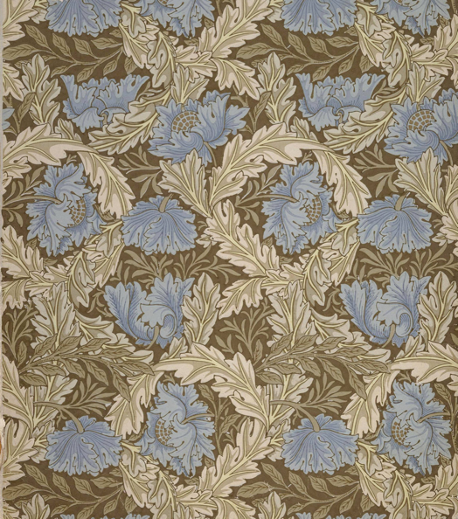
Morris was an artist whose work was highly decorative with organic motifs that were printed from wood carvings and hand drawn designs. He even devised a rule, recited in The Life of William Morris (Mackail pg. 63 1996), that every person could live by: “Have nothing in your houses that you do not know to be useful, or believe to be beautiful”. By outlining this initiative for others, he has displayed empathy towards his customers’ needs and, in a way, agreed to only make things that would live up to his set standard. From this image (Fig 1), it is clear to see the detail and consideration that he put into each design. This design displays the values he believed everyone should share, when participating in their own design practice, and depicts the quality that can be achieved through hand rendered design.

Morris clearly believed in the value added to the product, through the consideration and time spent on the design for the look and function of it, as well as the enjoyment that was had from making said product. Morris is quoted by Mackail (pg. 64, 1996) to have remarked that “No work which cannot be done with pleasure in the doing is worth doing”. Mechanical production would remove the opportunity for the crafts person to feel the pleasure of their practice, which corroborates with Morris’ opposed views of the Industrial Revolution.

The emphasis put on the durability of products also appears to be particularly poignant in today’s society, especially in the fashion industry. It would appear that, part of the necessity for the rapid turn-over of collections in fast-fashion seems to be that, these garments lifespans are short due to the use of cheap, non-durable fabrics and construction methods. This would mean that each garment would wear down quickly, to the point that they would not even be suitable for repurposing, repairing or for charitable donation, forcing the owner to have to dispose of their worn garments.

This notion is supported by research from the BBC (2018), informing “...with nations such as Rwanda instead opting to generate textiles independently, in part because of the low quality of donated products from fast-fashion retailers”. As discussed in this report, countries abroad, such as Rwanda, would have bought from our countries used and donated clothing stock. But this market is in decline due to the poor quality of the garments, illustrating the knock-on effect of fast-fashion and just how wasteful it is BBC (2018).
Additionally, shown here is an already established market for second-hand garments. which should be increasing the value and importance of garments with elevated longevity and durability, and provide a motive for clothing donations over disposal, or even recycling. If designers were to take this market into consideration when creating their collections, they would already be increasing the life span of a garment. In turn reducing the rate at which waste is produced and disposed of.

Topics discussed in this chapter, outline the topics of concern that the fast-fashion industry has generated over the years. From the trend chasing relationship between the fashion designer/company, to waste of a gluttonous volume, with highly poisonous toxicity levels. The knock-on effects of the Industrial Revolution, isolating production to cold mechanical masses of products, with no “aura” Bengamin (2008), or beauty in their design. And the need for garments that are durable enough to cope with long term use. These concerns shall be used as criteria in the next chapter, for comparing and analysing the sustainable practice of the chosen case studies.

Chapter 2

“The awareness for the need of sustainable fashion developed 15 years ago,” Fashion Nex (2019). A concerning fact to realise, given the current state of the fashion industry: A mass produced nightmare “driven by the desire for the acquisition of capital” Braungart and McDonough (2008).

There are practitioners and designers, that are integrating sustainable practice into their production of fashion. In order for a companies’ practice to be sustainable, they must be working towards “conserving an ecological balance by avoiding depletion of natural resources” Lexico (2019). The designers/companies in this chapter are either introducing sustainable changes into their practice, or they are a brand born of the need for sustainable fashion. These new brands are therefore working in response to this industries’ need for change.

As well the designers and companies that are making changes to their practices, to reduce their negative environmental impact, fashion designers are also beginning to break down the aesthetic stereotypes that are associated with sustainable fashion.
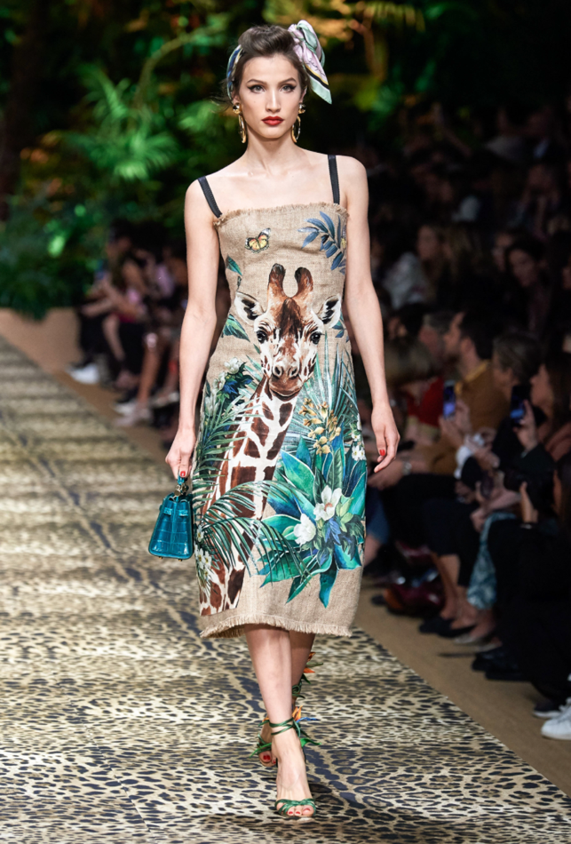
As suggested by Stella McCartney (2019) mentioning sustainable fashion to an average consumer “immediately conjures up images of oatmeal coloured fashion”. This stereotyping is likely due to the better-known biodegradable fabrics, such as hemp, that naturally have “oatmeal” colouring. Hemp is a bio-degradable fabric, it is also a very durable fabric because “the fibre is made up of a large portion of silica (sand), withstanding the test of time.” Thomas (2016), which also means that, if composted, over time will bio-degrade into sand.

This presumptuous idea of hemp being ‘unfashionable’ is questioned by the likes of Dolce and Gabbana (2019) in their new ready-to-wear Spring/Summer 2020 collection, with dresses made of hemp fabrics, that are altered slightly but are not really over tailored in to a fitted shape; they maintain a raw edge at the hem of the dress and maintain the shape of an extended, rectangular burlap sack.

But the dresses are printed with designs that have been hand painted Madsen (2019), featuring various tropical animals and foliage, making the designs very relevant and fashionable, whilst using a completely biodegradable fabric. This hand painted and printed design makes each dress a work of art, and is comparable with the design practice of the afore mentioned William Morris, during the Arts and Crafts movement. This design style and medium increases their value, to a level comparable with buying an original painting or other piece of artwork.
It interesting to see that they haven’t dyed the hemp, because it is the sand in hemps’ fibres that gives it that sandy, “oatmeal” McCartney (2019) colour, which is visible in Fig 2, which, as mentioned previously, can be viewed as part of the sustainable fashion stereotype. But the way the garment has been designed to include the natural tone, alongside the brighter natural colours of the leaves and the giraffe, takes away from its plainness and allows this previous stigma to be overlooked.

Perhaps in future, designing onto the hemp would allow to make hemp fashion more desirable and interesting, without applying a mass of harsh chemicals or dyes, giving the garments made a relatively chemical free production method and outcome.

The way that they have decorated this garment with design has come from an awareness of the growing epidemic that is fast-fashion. Steffano Gabbana is quoted, in the interview with Madsen (2019) to say that the fast-fashion designs that are being sold are created “without passion” and that Dolce and Gabbana wanted to make their SS 2020 Ready-to- Wear collection out of materials that “evoked a feeling of the organic.” Madsen (2019), which illustrates their collection to stand for a completely different kind of fashion than that on the high-street.

Dolce and Gabbana are by no means strong advocates for sustainable fashion however, as their Code of Ethics: 3.7 Relations with the Environment (find date), refers to ensuring “sustainable consumption of paper, water, energy and to adhere to the provisions relating to waste separation”. But there is no mention of sustainable textile usage or recycling, nor is there stipulation of sustainable textile production. Therefore, as much as Dolce and Gabbana provide examples of how hemp can be used in a high fashion context, their overall and overall practice is not encouraging of environmentally conscious design ethics.

A selection designers and brands, are beginning to incorporate the practice of sustainable fashion production, often along-side the brands already existing, unsustainable clothing lines. This way of practicing should be inspiring to clothing brands that are intimidated by the idea of having to re-produce their entire range with environmentally friendly means of production because, by integrating a new sustainable line into their brand, they may find ways to cross over production with the rest of their garments. Which could potentially allow them to gradually use solely sustainable production methods.

This change in practice can be unbeknownst to the consumer as there will need to be little difference between the styling and fabric colour/quality of their already existing products, and the new sustainable garments. A specific brand example of this is Levi’s, predominantly denim wear designer brand, whose new production methods and plans provide specific case study support for these statements.

Levi’s are an example of sustainable fashion line integration, as they have their “Water<Less” Levi’s(2019) range, a range that confronts an issue, not previously addressed in this text, that is the amount of water used during textile production. According to the findings of Fluence Corp (2018) “it’s estimated that the amount of water needed to grow, dye and process the cotton for just one pair of blue jeans ranges from 500-1,800 gallons”. It is explained in the same article by Fluence Corp (2018) that, the water used to make this singular pair of jeans, due to the dyes and chemicals used in the colouring and finishing processes, will contribute to water pollution.

Denchak, from The Natural Resources Defence Council (2018) explains that, water pollution is such a concern because, every organism on earth has to drink water to survive. But if this water is toxic, it will also kill the animals and micro-organisms that keep the environment thriving. As well as being the cause for 1.8 million human deaths in 2015, Denchak (2018). This emphasises the need for textiles production companies to consider what chemicals are being used during their dying process, and a need to explore dyes with more naturally based compositions.

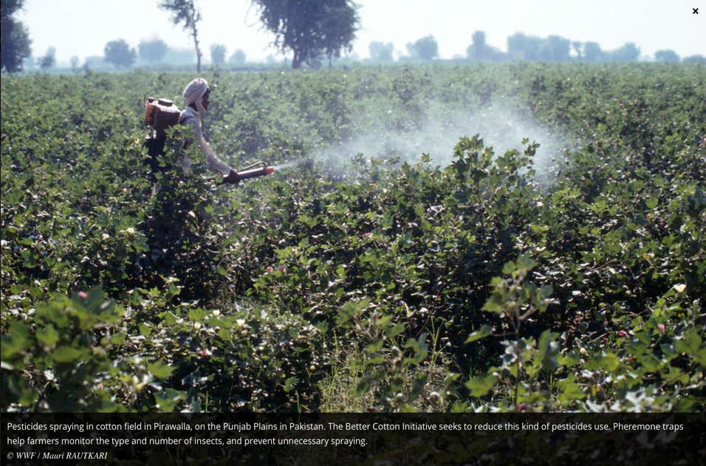
In the same article by Fluence Corp (2018) they also discuss the water used during the cotton farming process and how this water can be just as pollutive, as that used in textile production, due to pesticides and chemical fertilisers. As seen in Fig.3, the pesticides are released as a gas, which would pollute the air as well as the water, as the cotton plants are watered. Even the fact that the person distributing the pesticide has to wear a protective suit, supports the reasoning that the pesticide is highly toxic.

References are made with regard to the water used in cotton farming, in an article by The Guardian (2015) where they refer to it “virtual water”. This because many companies that go on to use the farmed cotton, do not include the water used during farming, in their water-footprint calculations; A potentially deceptive way for some manufactures to hide the volume of water pollution their practice is responsible for, so that they can appear to be a more environmentally conscious brand than they are.

Taking this into consideration, it would be wise to look at the water usage of a company when considering their levels of sustainability, as it is a factor that is easy to remain ignorant to, due to the fact that garments involvement with water occurs completely behind the scenes, and therefore is not apparent from the final product that the consumer will see in store.

In their sustainability statement (last updated 2019), Levi’s claim that “So far, we have saved more than 1.8 billion litres and recycles more than 129 million litres of water”. These statistics are impressive, and to contextualise how much of their water usage this is they have stated that currently “more than 40% of all Levi’s products” (levis 2019) are produced using their “Water” Levi’s (2019) initiative. In terms of how many products Levi’s produces, 40% would technically be a substantial portion of product.

However, this is still less than half meaning that their practice is currently using more unsustainable production methods, than sustainable ones. Levi’s have promised that this percentage should double by 2020, meaning that 80% of their collection would then be produced under their “Water” Levi’s (2019) initiative, significantly reducing their water waste.

In their sustainability statement Levi’s (2019), they engage with the consumers personal practice in conserving water, by listing suggestions in how they can use less water in their day-to-day life. This quite an unusual, yet positive, interaction between designer and consumer, as the designer is using their platform to encourage their customers to part-take in a more sustainable life style, and to go beyond shopping sustainably. They are sharing their morals and values with regards to their practice, and in turn providing their customers with the means to do the same. Efforts made here create a more personable relationship between the company and the consumer, re-defining the customer and designer relationship.

Nonetheless, they haven’t stopped there. Levi’s most prominent raw material is cotton, and they are even taking care and approaching the sourcing of their cotton with environmentally conscious attitude. In their Better Cotton Initiative (2019) they claim that Levi’s “trains farmers to use less water, pesticides, insecticides and synthetic fertilizer” which is their way of trying to cut down the harmful chemical output from farming their raw materials. A commendable aspect of this practice is that they have taken their responsibility for the environment beyond the construction and production processes of the jeans themselves, and are addressing the environments sensitivities from the start, which pushes their pledge of sustainability that extra step further.

Currently “more 20% of the cotton” (2019 sustainability pledge) they use is considered to be their ‘Better Cotton’ which, as with their water usage, isn’t really a significant enough percentage of their product collection for serious appraisal. Again however, they have stated that “By 2020, our goal is for 100% of our cotton to come from more sustainable sources” (levis 2019).

Although this is an incorrigible and reassuring plan, their Better Cotton Initiative was “launched in 2010” (levis 2019), which would imply that it in the last nine years, they have only just surpassed using ‘Better Cotton’ to make 20% of their products. This begs the question of whether or not their plans are realistic in the timeframe they have given themselves, given how long it has taken to get them to make the few conversions that they have already.

But given the fact that they are now actively using this cotton in their denim production, converting the rest of their products should be smoother, supporting statements made here previously; that starting a sustainable fashion collection, would provide the means for sustainable practice throughout the brand. It is apparent that Levi’s, as a brand, is trying to turn around their environmental impact, from sourcing their raw materials to the finishing of the final product. And if they follow through on the promises and plans that they have made for 2020, they would have eradicated a high percentage of their productions damaging impact.

Newer designers and fashion companies, who have generated their collections and brands amidst this environmental awakening, are incorporating the need for sustainable and durable fashion into their brands identity, from the start.

Doc Cotton is a sustain able fashion brand, that was founded in 2018 Doc Cotton (2018). They are a Peckham based brand, and all of their garments are made in house, by their seamstresses Doc Cotton (2018). Producing garments by hand in this way, allows for a connection with the garments, that has been lost in fast-fashion, though mechanical mass production. Where “commodities, as Marx understood it, were alienated from the workers who made them” Bari (2019) and have been through-out the fast fashion industries, Doc Cotton have each designer and seamstress’ name marked into the box of the garment they design. This direct link between the customer and the designer is quite unique and can create a stronger emotional connection between the consumer and the brand, as a whole.

Their focus is on using 100% organic cotton from “…a family run organic cotton farm in Greece” Davies (2018). Providing this information in interviews, and on their own website Doc Cotton (2018) is unusually open for any brand. More often than not “…companies often have no idea where elements in the clothes they produce originate…” Fashioned from Nature (2018). By knowing exactly where their cotton has originated, and being able to communicate this with their customers, Doc Cotton have changed the relationship between the designer and the consumer.

Both of these brand characteristics could make the consumer want to keep going back to the Brand for their garments, as they can feel more involved in the designing and production of their own clothing. Especially considering that each garment is made to order, there for there is, minimum waste with no excess garments to dispose of. As opposed to this, there are the likes of fast fashion chains who over produce their garments. For example, H&M have been “…accused of burning 12 tonnes of unsold clothing per year…” Hendriksz (2017) , because they over produced their products and then could not sell them all before that seasons’ trends wore off. An issue Doc Cotton does not face, as their designs are completely customisable and, as mentioned, made to order.

Doc Cotton have also recently, in 2019, opened up a marketplace on their website where independent designers can sell their clothing designs Ourgoodbrands (2019). The designers that sell their work through Doc Cotton only have to upload their designs and all of the manufacturing and material sourcing is done by Doc Cotton (2019). Providing their own ethical clothing is already commendable. But in providing up-coming designers with the resources and the support to create their own ethical fashion line, means that they are shaping future designers as well. And instilling the attitude in these new designers that ethical fashion is possible and attainable.

#LovedClothes is the newest policy that has been released by Doc Cotton, where their customers can receive a 20% discount off their next purchase when they return their used garments to Doc Cotton Ourgoodbrands (2019). Providing an incentive for the consumer to be more environmentally conscious with their used garments, may make them look into the to the other benefits of re-cycling their used garments. Doc Cotton will also send the customer updates about the destination of their old garments. Further insight into the new purpose given to their used garment, keeps the conversation open between the brand and their customer. This could help to create a deeper trust in the fashion industry, if this practice was to become more widespread, and upheld.

Between the two case studies combines, they have created a structure, easy enough for any fashion designer or company to take inspiration from. Just by ethically sourcing raw materials and considering the farming processed, like Levi’s, the textile industry could seriously reduce their toxic waste output. Additionally, if there was incentive for consumers to return their used clothing, back to the brand it came from, for them to recycle them, the waste output from individual and collective brands would decrease. Made-to-order garments are also an incorrigible exercise, as this would made mass and over production redundant. In turn slowing down the rate at which trends come and go. Plus, fashion would become so much more personal, and the interactions between designer and consumer would become a more positive collaboration.

Conclusion

It is evident from the research gathered that, the current relationship between the consumer and the fashion designer/company, has become one of supply and demand, in its most extreme form. Consumers needs to gorge themselves on cheap, toxic, meaningless fashion, has definitely provided an excuse for excessive mass production of fast fashion. And with the mechanical re-production of garments being made so easy, by the industrial machines available, companies do not seem to look for alternative means of making.

But when they do look for the alternative means of production, not only do they improve the ethical quality of their product. They also improve the quality of the relationship between the brand and their consumer audience. The “aura” Benjamin (2008) of the garments that comes with hand production, would be an uplifting alternative to the coldness of machine production.

Perhaps a respect could be restored in the views of consumers, towards their clothing, if they are able to respect where it came from. From the research compiled in this text, it is evident that emotional value seems to be placed on items that have been made by a person, as this can make the production process more relatable.

With design integrity coming in to play with the higher end fashion market, like the Dolce and Gabbana hemp dress Fig 2. Dolce and Gabbana is a very high-end brand, with high price points and high-profile customers. Their awareness of the mundane design that comes from mass production, as compared with the views of William Morris, shows that the fast fashion industry is even having an impact on the higher end of fashion design.

The craftsman ship and skill needed to create the design for that dress, could be considered a more luxe version of the hand designed patterns sold on Doc Cotton. Which means that this hand painted, bespoke aesthetic is being made more accessible to all consumers and is sold at a more realistic price for the average consumer. And the fact that the garments are made sustainably can almost go unnoticed, as they do not appear to be much different to those sold on the high street.

A proposal for taking this forward, would be to find a way of bringing bespoke fashion to the high street. In stores at the moment, garments are readily available for purchasing, which may be fuelling the consumers ability to buy in excess. Inevitably leading to brands buying garments in bulk, in anticipation of consumer demand. But if there was a way of turning stores into places where hand finished garments could be ordered and made in store, the purchasing of a garment could become more of an experience. And the collaboration between the fashion designer/seamstress and the customer would become even more personal.

Ultimately, making all clothing by hand will not be able to keep up with the current consumer demand for clothing. The consumer mentality towards clothing would need to shift, in order for fashion companies to have to change. As the clothing companies would have to take the consumer’s views and buying habits, into account when creating new collections.
Concisely, with Marx views of a garments’ alienation from its designer Bari (2019), the discussed methods of production should counteract that, and open up possibility for far more personal relations between the garment and its designer.

Emotional, environmental and personal welfare should all be at the forefront of design. Without creating a desirable garment, a designer cannot hope to sell their products. But what makes the garment desirable is where the fashion industry needs to be restructured. With the way these desires are met, being the responsibility of the designer. And brands like Doc Cotton (2018) have proven that there is a way of having a say in what happens to the garment after it is used. Used garments can be repurposed and recycled. And for the well ness of the planet, they should be.

The Bib

Benjamin. W, Translation by: Underwood. J.A. (2008) The Work of Art in the Age of Mechanical Reproduction. Penguin.

Benjamin. W, (1935) The Work of Art in the Age of Mechanical Reproduction
Available in: Cazeaux. C (2000) The Continental Aesthetics Reader (page 322-339) Routledge

Bird .J. (2018)
Available at:
https://www.forbes.com/sites/jonbird/2018/09/09/fashions-dirty-little-secret-and-how-it’s-coming-clean/#31e069d51771
(Accessed: 7th November 2019)

Braungart. M and McDonough. W. (2008) Cradle to Cradle: Remaking the Way We Make Things. Publisher

Butler. S. and Wood. Z. (2018) The Guardian, MP’s criticise high street fashion’s throw away culture.
Available at:
https://www.theguardian.com/fashion/2018/nov/27/mps-criticise-high-street-fashion-throwaway-culture
(Accessed 7th December 2019)

Cooper .K. (2018) BBC
Available at:
https://www.bbc.com/news/amp/world-44968561
(Accessed: 9th November)

Davies. R, (2018) Community Changers: Doc Cotton
Available at:
https://medium.com/@sustain_ability/community-changers-doc-cotton-ea1e33d642a9
(Accessed 9th December 2019)

Denchak .M.(2018) Water Pollution: Everything you need to Know, The Natural Resources Defence Council.
Available at:
https://www.nrdc.org/stories/water-pollution-everything-you-need-know
(Accessed 23rd November 2019)

Doc Cotton (2018)
Available at:
https://doccotton.com/about-us/
(Accessed 9th December 2019)

Duignan. B, The Editors of Encyclopaedia Britannia, Industrial Revolution
Available at:
https://www.britannica.com/event/Industrial-Revolution
(Accessed 1st December 2019)

Ehrman. E , V&A Publishing, Fashioned from Nature, Published for V&A exhibition Fashioned from Nature
(CHECK HOW TO REFERENCE THIS)
Not used yet check reference

Fashion Nex (2019) Ethical and Sustainable Fashion: The Need of the 21st Century.
Available at:
http://www.fashionnex.com/sustainable-fashion-article/42/ethical-and-sustainable-fashion-the-need-of-the-21st-century
(Accessed 23rd November 2019)

Fluence News Team. (2018) The water footprint of the blue jean. Available at:
https://www.fluencecorp.com/blue-jeans-water-footprint/#
(Accessed 12th November2019)

Hemmings. J, (2016) Making Meaning lecture.
Available at:
https://www.jessicahemmings.com/making-meaning-craft-labour-lecture/?hilite=%27consumer%27%2C%27culture%27
(Accessed 4th December 2019)

Hendriksz. V., (2018) H&M accused of burning 12 tonnes of new, unsold clothing per year.
Available at:
https://fashionunited.uk/news/fashion/h-m-accused-of-burning-12-tonnes-of-new-unsold-clothing-per-year/2017101726341
(Accessed 9th December 2019)

House of Commons, Environmental Audit Committee, (2019) Fixing Fashion: Clothing Consumption and Sustainability, Parliamentary Copyright House of Commons, published by House of Commons, (16th Report of Session 2017-19)

Kenton. W. (2019)
Available at:
https://www.investopedia.com/terms/f/fast-fashion.asp
(Accessed 6th November 2019).

Leahy .S. (2015) World Water Day: The Cost of Cotton in Water-Challenged India . The Guardian. Available at:
https://www.theguardian.com/sustainable-business/2015/mar/20/cost-cotton-water-challenged-india-world-water-day
(Accessed 12th November 2019)

Lexico, (2019) ‘Consumerism’ Definition, Powered by Oxford Dictionaries.
Available at:
https://www.lexico.com/definition/consumerism
(Accessed: 30th October 2019)

Lexico (2019) ‘Sustainable’ Definition, Powered by Oxford Dictionaries.
Available at:
https://www.lexico.com/definition/sustainable
(Accessed 10th December 2019)

Liu, F. and Richards, J. and Shen, D. (2013) ‘Consumers’ awareness of Sustainable Fashion’ Marketing Management Journal ,Volume 23, Issue 2, Page 134-147, Published by Marketing Management Association.
Available at:
http://www.mmaglobal.org/publications/MMJ/MMJ-Issues/2013-Fall/MMJ-2013-Fall-Vol23-Issue2-Complete.pdf#page=141

Mackail. J. W., (1996) The Life of William Morris, Dover Publications ltd.

Madsen. A. C, (2019) Spring/Summer Ready-to-wear, Dolce and Gabbana
Available at:
https://www.vogue.co.uk/shows/spring-summer-2020-ready-to-wear/dolce-gabbana
(Accessed 6th December 2019)

Ourgoodbrands, (2019), Design your clothes with Doc Cotton. Sustainably. Affordably.
Print-y.
Available at:
https://ourgoodbrands.com/design-your-clothes-doc-cotton-sustainably-affordably-print/
(Accessed 10th December 2019)

Powers. K. I, (2015) The Psychology of Design: Creating Consumer Appeal, Chapter 6, [Color] Design and Purchase Price: How Vehicle [Colors] Affect What Consumers Pay for New and Used Cars. Taylor Francis Ltd.

Quinn, B. (2010) Textile Futures: Fashion, Design and Technology. Berg, Oxford: International Publishers Ltd.

Rees. A, (2016) Why Shopping is a Bad Hobby (and What to do Instead)
Available at:
https://anuschkarees.com/blog/2016/7/25/why-shopping-is-a-bad-hobby-and-what-to-do-instead
(Accessed 1st December 2019)

Remy .N. and Speelman .E. and Swarts .S. (2016)
Available at:
https://www.mckinsey.com/business-funcions/sustainablility/our-insights/style-thats-thats-sustainable-a-new-fast-fashion-formula
(Accessed 6th November 2019)

Stanton. A. (DATE) What is Fast Fashion Anyway?
Available at:
https://www.thegoodtrade.com/features/what-is-fast-fashion
(Accessed 7th December 2019)

The Tate, 2019 [last updated] Aura Definition.
Available at:
https://www.tate.org.uk/art/art-terms/a/aura
(Accessed 3rd December 2019)

VAM (Victoria and Albert Museum), 2019 [last updated]
Available at:
https://www.vam.ac.uk/articles/arts-and-crafts-an-introduction
(Accessed 7th November 2019)

World Fair Trade Organisation (2004) History of Fair Trade.
Available at:
https://wfto.com/about-us/history-wfto/history-fair-trade
(Accessed 4th December 2019)

Check authors and dates
Websites
Dolce and Gabbana Corporate, 1996 [last updated],2019
https://www.dolcegabbana.com/corporate/en/group/code-of-ethics.html

Levi’s

https://goodonyou.eco/levis-ethical/

https://www.levi.com/GB/en_GB/features/sustainability

https://www.levistrauss.com/how-we-do-business/use-and-reuse/

Modern painters, summer 1996, v9, no 2 martin gayford – check write up
Also check for the books on sheet

