

Student Name :- Patel Manthan Sureshbhai
Student Id :- 2241308
Programme :- MBA- Master Of Business Administration
Module :- Marketing Management
Module Code :- LCMB7001
Lecturer Name :- Tushara balendran
Date :- 01/09/2023

Table of Contents

1. Introduction 3
2. PESTEL Analysis of Starbucks 3
3. Model of Porter’s Five Forces 5
4. SWOT Analysis of Starbucks 7
5. Advantages and Disadvantages of SWOT Analysis 8
6. Segmentation, Targeting and Positioning of Starbucks 9
7. Marketing Mix (7Ps) of Starbucks 10
8. Recommendation for the Future 12
9. Conclusion 12
10. Reference 13

1. Introduction
Starbucks, a well-known international network of coffee shops, has come to be associated with exceptional coffee and a distinctive social environment. This research explores Starbucks' strategic environment and examines its place in the coffee business through a thorough examination. We learn a lot about the company's strengths, weaknesses, opportunities, and future directions by looking at elements like PESTEL impacts, Porter's Five Forces, SWOT insights, and marketing strategies. Understanding these factors will help you better appreciate how Starbucks operates in a changing business climate while adjusting to local and international trends and consumer preferences as it navigates a competitive market.

2. PESTEL Analysis of Starbucks
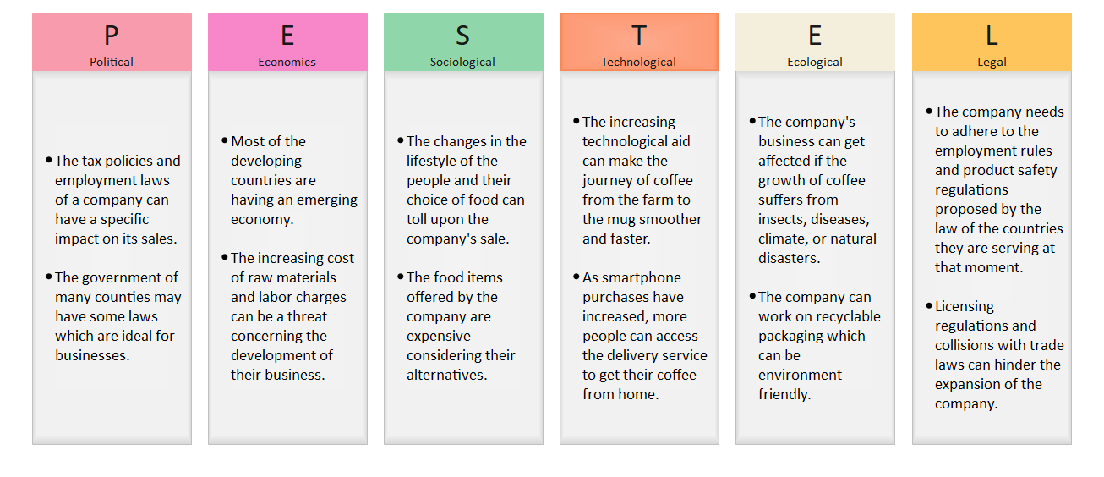
Figure 1: PESTLE Analysis of Starbucks
(Source: Detailed Pestle Analysis of Starbucks: EdrawMax Online, 2023)

- Political :-
As a multinational network of coffee shops, Starbucks operates in several nations with differing tax laws and labour laws. The profitability and operations of the corporation may be considerably impacted by political choices about taxation. The financial performance and expansion ambitions of Starbucks may be impacted by changes in tax rates or laws. Additionally, the diverse salaries, working hours, and benefit rules and regulations in other nations have an impact on how Starbucks handles its workers.
- Economic :-
The growth of Starbucks into emerging markets brings both possibilities and difficulties. The burgeoning middle class in emerging markets implies a bigger client base. However, Starbucks' sales and profitability may be impacted by the monetary policies and exchange rate movements in these nations (Jacoba, 2022). The company's operating expenses and pricing strategies may also be impacted by the rising cost of raw commodities like coffee beans along with labour costs.
- Social :-
The growth of Starbucks into emerging markets brings both possibilities and difficulties. The burgeoning middle class in emerging markets implies a bigger client base. However, Starbucks' sales and profitability may be impacted by the monetary policies and exchange rate movements in these nations. The company's operating expenses and pricing strategies may also be impacted by the rising cost of raw commodities like coffee beans along with labour costs.
- Technological :-
Technology development has affected how Starbucks communicates with its consumers. Digital services like mobile ordering and payment have been integrated as a result of the widespread use of smartphones and mobile applications (Yu et al., 2021). In order to improve customer experience, boost convenience, and maintain competitiveness in a world that is becoming more and more digital, Starbucks needs to make use of these technology tools.

- Environmental :-
Regarding its effects on the environment, Starbucks is under more and more criticism. Because it sells coffee on a huge scale, its activities generate waste, especially single-use packaging. Starbucks may address this by emphasizing the adoption of sustainable practices, such as providing and promoting recyclable packaging, investigating compostable alternatives, and funding waste reduction programs to reduce its environmental impact.
- Legal :-
Starbucks must adhere to a complicated regulatory framework that includes licensing requirements, rules for the safety of its products, and employment laws. Maintaining a healthy workplace atmosphere and avoiding legal issues require adherence to employment regulations (Jacoba, 2022). To avoid legal problems and preserve customer trust, a company must guarantee the safety and quality of its products. Additionally, following licensing laws is necessary for Starbucks outlets to operate uniformly in all legal countries.

3. Model of Porter’s Five Forces :-
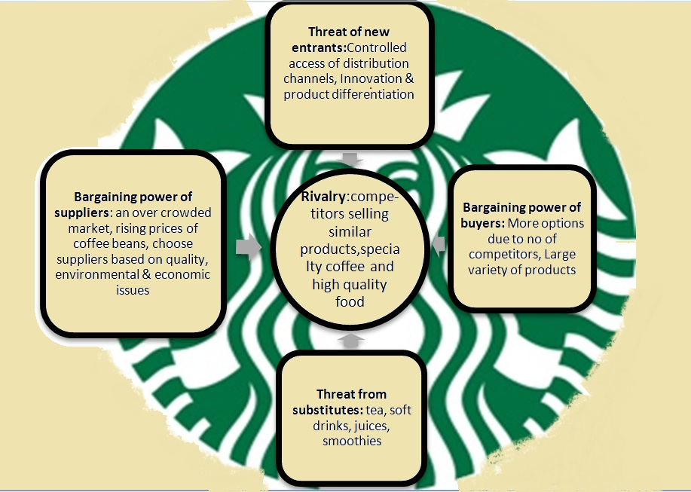
Figure 2: Porter’s Five Forces of Starbucks
(Source: Valérie, 1970 )

- Bargaining Power of Suppliers :-
Growers of coffee beans, dairy providers, and producers of numerous additional components are among Starbucks' suppliers. The corporation has some influence over suppliers thanks to its size and well-known brand (Musonera, 2021). However, since Starbucks' products depend on the quality of its coffee beans, suppliers may have considerable negotiating leverage.
- Bargaining Power of Buyers :-
Starbucks offers a wide range of customers, including both private citizens and corporate entities. Although there are substitutes for Starbucks' goods, its distinctive offerings-such as specialized drinks and a friendly atmosphere-and strong brand assist in limiting consumers' ability to bargain.

- Threat of New Entrants :-
Potential new entrants are attempting to take a piece of the coffee business because the sector has a very low barrier to entry (Musonera, 2021). But Starbucks' wide-ranging worldwide reach, well-known brand, and economies of scale provide obstacles for potential competitors.
- Threat of Substitutes :
Other coffee shops, fast-food restaurants, and homemade beverages can all be used as alternatives to Starbucks' products. While there are equivalents, Starbucks' emphasis on developing a distinctive and immersive customer experience, together with its extensive selection of drinks and foods, helps lessen the danger of alternatives.
- Competitive Rivalry :-
There are many participants in the extremely competitive coffee sector, from small local cafés to large international chains. Starbucks is up against competition from conventional coffee shops as well as fast-food restaurants and convenience stores that sell coffee-related goods. Product innovation, price, and customer experience are some of the elements that influence the competition (Ye, 2022). Starbucks stands apart from rivals because to its focus on fostering a pleasant environment and providing high-quality drinks and food.

4) SWOT Analysis of Starbucks :-
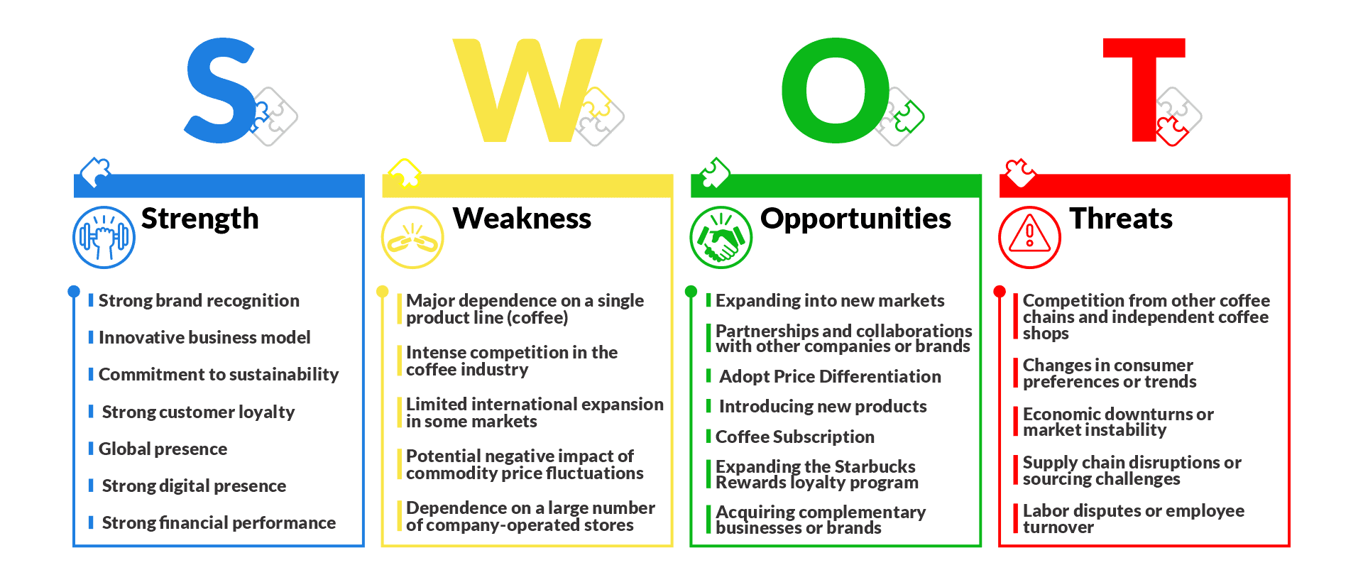
Figure 3: SWOT Analysis of Starbucks
(Source: Pereira, 2023)
Strengths
In the world of coffee, Starbucks is one of the most famous and renowned trademarks. Its logo, retail layout, and customer service have all helped to develop a strong brand. Starbucks has developed a devoted clientele. Strong relationships with clients have been cultivated via its personalized rewards program.
Weaknesses
There are a ton of rivals in the coffee sector, from neighbourhood cafés to global conglomerates. Coffee and associated goods are the main source of revenue for Starbucks. Due to its reliance on a single product line, the business is more susceptible to changes in customer tastes and price volatility in the coffee market (Luo, 2023). Due to its reliance on a single product line, the business is more susceptible to changes in customer tastes and price volatility in the coffee market.

Opportunities
Starbucks may take advantage of possibilities as it plots its route for the future. The opportunity to capitalize on developing coffee cultures and promote brand loyalty across various client segments exists when a company expands into new and developing areas. Growth and the attracting of a larger consumer base can be fueled by the launch of innovative items that respond to health-conscious trends and changing tastes.
Threats
As Starbucks travels its path, it must also handle any dangers that could have an effect on its course. Agility in product offers is necessary given the constantly shifting environment of customer preferences (Liu et al., 2022). Additionally, market instability and economic uncertainty provide difficulties that need for careful planning. Starbucks needs to be vigilant about these dangers and devise plans to preserve its resilience in the face of shifting market dynamics.

5. Advantages and Disadvantages of SWOT Analysis :-

Advantages
A variety of advantages that the SWOT analysis framework provides add to its strategic significance. It offers a systematic prism through which a business may objectively evaluate the internal strengths and weaknesses of the organization. Finding areas of excellence and opportunity for progress is made easier with the help of introspection. Additionally, a firm may acquire a comprehensive awareness of its position in the market, allowing informed decision-making and strategy alignment, by scanning the external landscape for opportunities and risks.
Disadvantages
However, SWOT analysis has its limits just like any other technique. It reduces complexity and could leave out complicated relationships between variables (Penchev, 2021). Furthermore, the framework could not have any hierarchy because several components are frequently mentioned one after another. Additionally, due to its static character, it sometimes fails to take into account the dynamic fluctuations in a corporate environment.

6. Segmentation, Targeting and Positioning of Starbucks
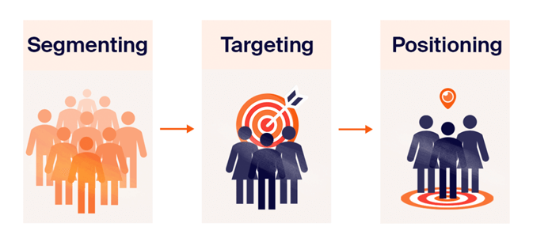
Figure 4: Segmentation, Marketing and Positioning
(Source: STP Marketing: Segmentation, targeting, positioning model, 2023)
Segmentation
Starbucks uses a deliberate technique to divide up its wide range of customers. It acknowledges that the interests and demands of various client groups vary. Based on demographic, psychographic, and behavioural variables, the corporation divides its market (Panwar et al., 2022). In terms of demographics, Starbucks serves people of various ages, socioeconomic classes, and vocations.
Targeting
Starbucks' targeting approach is centred on appealing to distinct market niches while upholding a recognizable brand. Urban professionals looking for a convenient and superior coffee experience are the company's main target market. Starbucks aims to appeal to a younger clientele seeking a hip and premium coffee shop setting by providing specialty coffee and handmade drinks.
Positioning
Starbucks has intentionally positioned itself to provide customers beyond simply coffee. It markets itself as a "third place," a cozy and pleasant area where patrons may congregate, work, or unwind. This stance is consistent with its focus on providing a distinctive experience that goes beyond the beverage itself (George, 2021). In addition, Starbucks has positioned its brand as ethically aware, putting an emphasis on ethical sourcing, sustainability, and community involvement.

7. Marketing Mix (7Ps) of Starbucks
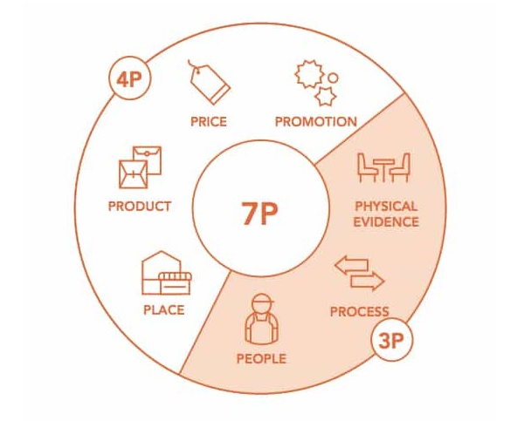
Figure 5: Marketing Mix of 7P
(Source: Nguyen, 2021)
Product
Starbucks sells a variety of things other only coffee, such as teas, baked goods, sandwiches, and mugs & tumblers. High-quality, premium coffee beverages are its main offering, which is accompanied by a wide range of food selections to suit a range of tastes and preferences.
Price
Starbucks' premium brand positioning is reflected in its price policy. Customers are prepared to pay more for Starbucks' goods because of the great quality, welcoming atmosphere, and overall experience they receive (Coline, 2020). Additionally, the business uses value-based pricing for its loyalty program, luring consumers back with exclusive offers and benefits.

- Place
Starbucks' enormous distribution network is evidenced by the company's global presence. The corporation carefully places its outlets in busy places including cities, shopping centres, and airports. Starbucks also utilizes digital channels by enabling consumers to place orders using its mobile app for pickup or delivery inside stores, increasing convenience.
- Promotion
Starbucks uses both traditional and digital marketing strategies to promote its name and goods. To reach customers, it uses innovative campaigns, influencer partnerships, and social media marketing. Starbucks Rewards encourages recurring business while seasonal beverages and limited-time deals stimulate product exploration.
- People
Starbucks focuses a lot of emphasis on its baristas since they represent the company's public face. The business makes training investments to guarantee top-notch customer service and a uniform shopping experience across its extensive worldwide network of locations (Musonera, 2021). The pleasant and cheerful environment that Starbucks seeks to create is enhanced by the baristas.
- Process
The procedures at Starbucks are intended to increase client happiness. This covers the speedy handling of orders, beverage customization choices, and on-the-go customer assistance. The drive-thru option and the mobile ordering procedure simplify the consumer experience even further.
- Physical Evidence
Customers' perceptions of Starbucks locations are significantly influenced by their physical surroundings. The "third place" status is a result of the warm atmosphere, comfy seats, and relaxing background music (Al-Asdoudi, 2023). Starbucks' dedication to sustainability and moral behaviour is also reflected in the architecture of its retail locations.

8. Recommendation for the Future :-
Starbucks should put an emphasis on innovation in its menu selections for long-term success, including more plant-based alternatives and taking advantage of changing consumer preferences. It is essential to embrace technology, improving mobile app features and individualized promotions to better engage clients. Additionally, opening up unexplored markets, particularly in developing nations, might encourage expansion. Starbucks could aggressively address environmental issues by stepping up its efforts toward recyclable packaging and sustainable sourcing while keeping its distinctive brand identity (Chen and Wang, 2023). The continuation of providing great customer service will be ensured through a comprehensive approach to staff development and retention. Starbucks will be better positioned for ongoing success in a dynamic market environment if it adopts these measures.

9. Conclusion :-
In conclusion, Starbucks leverages its strengths in brand awareness, customer loyalty, and a distinct "third place" posture to stand as a global leader in coffee shops. The company's strategy focuses on innovation, expansion, and sustainability providing a bright future despite obstacles brought on by fierce competition and shifting consumer tastes. Starbucks can stay relevant and keep providing outstanding customer experiences by adjusting to expanding areas, broadening its product line, and embracing technological improvements. Starbucks is well-positioned to handle the changing business environment and maintain its position as a leader in the coffee sector /because of a dedication to ethical business practices and employee growth.

10. Reference :-
Al-Asdoudi, N., 2023. The effect of the behavioral marketing mix on the consumer. The Egyptian Journal of Media Research, 2023(83), pp.575-619.
Chen, Y. and Wang, Y., 2023. Research on Financial Analysis and Development of Starbucks. Highlights in Business, Economics and Management, 10, pp.81-87.
Coline, D., 2020. Marketing Mix-Starbucks. Publications Études & Analyses.
Detailed Pestel Analysis of Starbucks: EdrawMax Online (2023) Edrawsoft. Available at: https://www.edrawmax.com/article/starbucks-pestel-analysis.html (Accessed: 28 August 2023).
George, R., 2021. Market Segmentation, Targeting, and Positioning. In Marketing Tourism and Hospitality: Concepts and Cases (pp. 221-246). Cham: Springer International Publishing.
Jacoba, J., 2022. Starbucks Strategic Analysis.
Liu, X., Tang, Y. and Wang, Y., 2022, April. Consumer Satisfaction for Starbucks. In 2022 7th International Conference on Social Sciences and Economic Development (ICSSED 2022) (pp. 1475-1482). Atlantis Press.
Luo, Z., 2023. What should Starbucks do to Survive the Pandemic:--Starbucks SWOT Analysis. Academic Journal of Management and Social Sciences, 3(3), pp.34-37.
Musonera, E., 2021. Strategic marketing case analysis: Starbucks. Journal of Business and Social Science Review, 2(11), pp.12-22.
Musonera, E., 2021. Strategic marketing case analysis: Starbucks. Journal of Business and Social Science Review, 2(11), pp.12-22.
Nguyen, B.E. (2021) The Marketing Mix (New Models: 7P, 4C, Siva), Nguyễn Lưu Bảo Duy. Available at: https://nguyenluubaoduy.com/marketing-mix-new-model-7p-4c-siva/ (Accessed: 28 August 2023).
Panwar, S.N., Goyal, S. and Bafna, P., 2022, December. Analytical Study of Starbucks Using Clustering. In International Conference on Hybrid Intelligent Systems (pp. 1013-1021). Cham: Springer Nature Switzerland.
Penchev, D., 2021. SWOT analysis as a research method in pedagogy. Педагогика, 93(5), pp.669-678.
Pereira, D. (2023) Starbucks Swot Analysis (2023), Business Model Analyst. Available at: https://businessmodelanalyst.com/starbucks-swot-analysis/ (Accessed: 28 August 2023).
STP Marketing: Segmentation, targeting, positioning model (2023) Sender. Available at: https://www.sender.net/blog/stp-marketing/ (Accessed: 28 August 2023).
Valérie, A. and (1970) The competitive environment of Starbucks: Porter’s Five forces, Enjoy starbucks. Available at: http://enjoystarbucks.blogspot.com/2011/11/competitive-environment-of-starbucks.html (Accessed: 28 August 2023).
Ye, J., 2022. Analyzing the Future Development Prospect of “Starbucks”. iBusiness, 14(3), pp.150-163.
Yu, H., Li, S., Li, G. and Wang, D., 2021. How to Maximize Business Opportunities-Take Starbucks, for Example. Learning & Education, 10(2), pp.132-133.

