Workplace culture and its impact on organisational efficiency
  - requesdted by JULie
Taslima begum | 1713205 | 03//04/2020

Introduction
In this report, the researcher will be applying the internal and external factors to M&S using the deal Kennedy and the SWOT model. The report will analyse employee behavior, knowledge and skills and qualities. The ethical stance of M&S will be discussed and along with management behaviors. The conclusion will also analyse how an employee acts according to the M&S values in a ethical and cultural organisation.

Contents
Introduction 1
findings 2
Task 2 13
Task 3 16
Task 4 20
recommendations 21
References 22

Executive summary
The researcher has used 2 models to analyse this report as well many articles to support the discussion as well as books. Mainly discussing the workplace and its values toward employees and how this can be improved, and they are doing well already as a company.

findings
Task 1

The researcher will be appointing an analysis of the internal and external context of the organisation, using appropriate models and tools
Internal:
The researcher will be discussing the model Deal Kennedy and how his culture elements fit in with the workplace M&S. The speed at which companies learn whether their actions and strategies are successful.
- Tough-Guy
- Macho Culture
- Work hard and Play Hard Culture
- Bet-Your-Company High-stakes Culture
- Process Culture (mindtools, no date)
The internal context has 4 main strategies: sector, size, structure, and culture.
Size: M&S (2020) have stated that they are one of the Britain's oldest and best-known retailers of clothing, food, and homeware. M&S employ 60.000 people worldwide more than 450 stores in 30 countries and serve tens of millions of customers every week. (marks in time, no date) The business started in 1884 named as penny bazar in Leeds.

Structure:
M&S (1884) follow their ethical code of conduct which is if there was an issue from an employee’s side then this should be reported to the line manager and if not acted up on then senior manager who will take into further investigation. This shows that at M&S some situations cannot be dealt with employee department managers they have to be taken to line or senior management.
Alex (2020) addresses Employees being able to express their stories in their work environment is very important through their stories they would be discussing good days and bad day at work as well as positive and negative outcomes. M&S have a stories page on their website where employees have many stories to share about their experience at M&S. Most of the stories on their page is regarding employees having a successful career and how the organisation has helped them build them self-up to where they are now from becoming a shop floor staff to mangers and department managers as well as senior managers. (Alex,2020)

However according to The Guardian (2016) ‘The workers working overseas in sri Lanka, Bangladesh and India are not being paid sufficiently. Under the British chains plan, an environmental and society policy, it promised to process to ensure their suppliers are able to pay the workers a fair living wage. In those countries.’ “M&S said its target was achieved in 2015. But a report by the workers’ rights group Labour Behind the Label said workers from three factories in Sri Lanka, another three in India, and two in Bangladesh were all being paid well below the amount required for a decent standard of living.”
This does not show they have a good structure in place for their employees overseas. It is disappointing that they are paid so less when mentioned in their ethical behaviour code of conduct that they treat all their employees with respect and fairly even the ones working overseas.

M&S(2020) structure their company with the ‘creation of a new Technology Operating Model, which will drive significant efficiencies in how M&S exploits new technology, including the adoption of industry agile methods, effective from 1st March 2018.’
Steve Rowe, M&S CEO said: “We are committed to transforming M&S for our colleagues, customers and shareholders by delivering digital-first retailing across our stores and offices.
Following up from this M&S are showing by bringing technology into their cultural organisation system this will make big changes and transform the business to a success.
Mullins (2016) view on technology is that ‘Managers will have access to technology which will assist them to perform well and in order to train their colleagues to widen their knowledge to learn new skills and to benefit M&S in the future’
Culture:

M&S 2017 initiated that they carry out ritual ceremonies where all staff members from different departments get together and share their journey at work discussing issues at the workplace as well as a general catch up with other colleagues, the purpose of these meetings are to help employees with managing their health conditions. This is an opportunity for colleagues to share their journeys and support each other.

M&S (2017) carry out these ritual ceremonies in their London offices, this is done through M&S buddy network and yammer group app, this was a huge success for colleagues who suffer mental health issues. The yammer group also used as a tool for recognition and rewards.

O.C.T, (2017) reports that the culture network in a workplace allows employees to seek and gain career advice, give out their ideas, become friends beyond the boardroom and truly learn from one another. Both internal and external networking are essential for career development and self-fulfillment. But it is the internal networking that can help organisation such as M&S create a close-knit culture of employees even if they don’t necessarily work together daily.

M&S (2020) have also stated Their workplace culture is also an environment employer build for their employees by trusting in their values and beliefs interactions and their behaviors and attitude towards the workplace. Which M&S is very good at as they take employee voice very seriously and there are many stories on the M&S careers page about different employees having impact in the organisation because they were listened to?
The Guardian (2012) indicates M&S are always intending to improve the expectations of employees, stake holders and customers. They work in partnership with suppliers to improve the environment and create fair workplaces. Initiatives cover a range of challenges in the global supply chain, which M&S reckons to accounts for about 80% of its footprint.’

This shows good ethical and sustainable system in the organisation by having a fair place to work and improving environmental performances.
According to Deal Kennedy and his cultural elements M&S fits in under the culture type Work hard Play hard. This is because M&S is a team effort organisation and all employees work together to make this organisation a success and always having feedback of their managers. Making sure their employees are reaching new heights.
According to Mindtools ‘The cultural work hard play hard is when Employees themselves take few risks; however, the feedback on how well they are performing is almost immediate. Employees in this culture must maintain high levels of energy and stay upbeat. Heroes in such cultures are high volume salespeople.’
As Mullins (2016) quotes; ‘The culture and structure of an organisation develop over time and in response to a complex set of factors. Which therefore culture can influence people’s attitudes and behaviors at work. Culture is a clearly an important ingredient of effective organizational performance.’ (Laura. M, 2016, pg.546)

Sector:
M&S is a public limited company who allows their employees customers and the general public to buy shares from their business this allows their individual to feel part of the organisation but most importantly this motivates employees in the organisation. Motivating your staff is the key success to a successful organisation supporting each other takes a big part in organisations like this. As Mullins (2016) say, ‘a person’s work motivation, satisfaction and performance are determined by the comparative strength of economic rewards, intrinsic satisfaction and social relationship.’ (Laura. M, 2016, pg. 254)
M&S focus on building a sustainable business for long term, generating the value through consist profitable growth as they say in their code of ethical and behaviour policy book.( 1884) that they keep an honest and ethical standard of all the performances.

Moving forward the researcher will be discussing the external context of M&S using the SWOT analysis to analyze the organisation culture and other aspects have influenced its success.
Stated by Carl. M (2013) pg. 33 A SWOT analysis is when examining an internal strengths and weaknesses in the organisation and also examining external opportunities and threats.

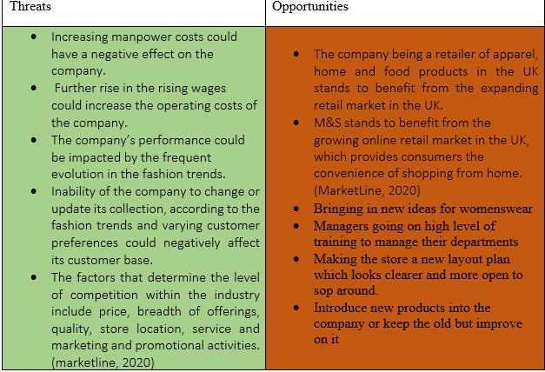
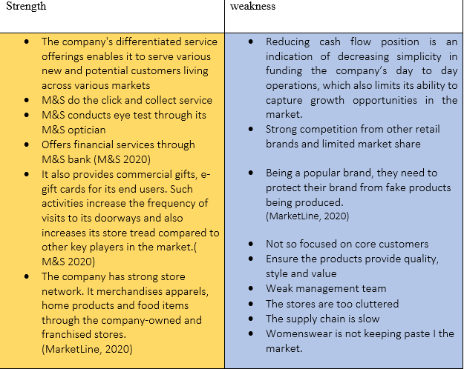
(M&S 2020)

Strength: M&S have a wide market ground as they cater not only for food but also home wear, clothing, shoes, beauty, and children wear. They also provide numerous of services under one organisation such as opening accounts with the M&S banks as well as opticians, click and collect service and providing different types of gift cards. M&S has its door opens for all age range for all the different service of products they provide for their customers. This demonstrates they are a strong organisation.

Weakness: M&S have to protect their brand from fake products being made as their brand is popular, they are in a lot of competition with other big supermarkets such as Asda because Asda sell similar products but more less in price. Less chance of the company growth as funding is reducing.

Threats: M&S raising employee wage can affect their operating costs of the company. The organisations performance can be affected as fashion trend are changing regularly and trying to live up to customer expectations could not be matched. Therefore, chances of losing customers. M&S can also be affected by other companies doing better promotional offers on their products and M&S can’t afford to do that.

Opportunities: M&S can improve their quality and design in women clothes, for example explore the market buy doing online surveys or doing clothing range appropriate to age for different women. M&S can also think about rearranging store layout to make it more open and spacious for customers easy to move around. Also training managers on higher level to develop good management ship in their departments. M&S have a wide range of products they could have shop floor advertisements posters etc. of their best-selling products, help with sale growth.
The Guardian indicates (2013) Marks & Spencer is one of those brands that is iconic on the high street and would be missed if it were not there. Marks and spencer are a well-known brand on the high street. What they need to address is the age group they are targeting, because at the moment they are not targeting any particular group. The company is trying to please everybody but actually are pleasing nobody. They ned to add style and be bold and target whoever they think their customer id with fashionable items of good quality. ‘However, you can have the best garments with the best quality at a good price, but if you don't have your distribution systems in order you are going to suffer. Too often the wrong sizes are in stores and customers are not going to wait for their size to come in. They are going to go online and buy it somewhere else.’

Summarising M&S is an on growing supermarket in the uk as they cater for all types of products as well as food. They have a big growing online retail market which allows customers to shop online. The organisation prioritised development in the old and new market. M&S as an external organisation, they are a company that have full potential in expanding their growth as an organisation and lots of opportunities for them to grow bigger and better than they already are however the downside is they have a lot of competitors on the market which also provide their customers with the similar service with low prices. Which also they need to update on their fashion trend for women’s clothing, as well as categorising their fashion trend to suitable ages.

Task 2
The researcher will be discussing the organisational ethical stance whether employees or management behavior matches their code of conduct.
As stated on M&S (2020) corporate page their ethical code of conduct for employees are that all staff members are treated equally regardless age gender, gender reassignment, nationality, sexuality, disability, and religion. All staff are trained equally starting from appraisals to promotions and all employees are committed to equal opportunities policy. All staff members are treated with dignity and respect and the organisation would like this in return to each other and their customers. M&S are committed to allowing employees voice their opinions and ideas and taken them in to consideration. They also follow the discrimination and harassment policy to stop any kind of form of bullying etc. they also care about the wellbeing of each other and managers to provide occupational health support. However, managers have additional responsibilities under the code to:
- Manager’s to follow and understand the code of conduct to who they manage
- Offer guidance and advice according to the code
- Maintain and provide requirements of the code
mangers role is also to have the responsibility of listening to your employees either through an open-door policy or regular meetings with your staff. Performance management will not work unless it’s done on a regular basis by using the tools; appraisal systems, development plan, and setting SMART targets to your employees.
“performance management is an ongoing process of communication between a supervisor and an employee that occurs throughout the year, in support of accomplishing the strategic objectives of the organization. The communication process includes clarifying expectations, settings objectives, identifying goals, providing feedback, and reviewing results.” (Hr. Berkeley. 2019)

M&S (2020) also believe that the organisation is following the higher standards of ethics, honesty, integrity and recognise as an employee or manger you have an important role in maintaining this aim. They believe it’s an environment that employees that have or are facing issues raise their voice and this is dealt with following the code of conduct.
According to Marianna Cal nan (2015) M&S staff are using a network called the yammer network which connects all staff members together. Starting from February 2015. The head of employee relations and employee engagement department at M&S, Sarah find later comments, yammer is an app which colleagues use to congratulate each other on live feed. When they have succeeded in a task or hit a target mark.
M&S includes employee of the month award, which is stated on their internal communication page, which recognises employees that demonstrate M&S values of being innovative and inspirational. This is also awarded because of the employee outstanding achievements by M&S workers that show commitment and passion to their coworkers and go the extra mile for customers. (Marianna 2015)
Sarah points that celebrating the hard work of employees is very important to M&S and its recognition is one of the most important factors inspiring the team to keep up the good work and keep them motivated. ( Marianna 2015)
This clearly shows how M&S value their staff and really take initiative of their hard work and following their ethical system to keep their staff motivated safe and happy.
However, The Guardian (2016) emphasizes that Thousands of employees could lose their jobs at M&S if they do not agree to change their pensions and pay, according to an MP. Employees that have worked there for many years, they could face pay cuts that could potentially cost thousands of pounds after M&S removed bonuses for working weekends and anti-social hours. Also cutting on bank holiday payments and changed pension payments. Employees can lose up to £1000 a year and 700 employees could lose more than £2000 a year. In which case this shows that M&S finding it hard to stick to the equal opportunities ethical system as they are cutting pay of employees which can cause them £1000 of loses. Which they will need to act upon if they want a successful business as well as keeping their employees at work.

Task 3

The researcher will be moving forward in the report discussing the skills, knowledge, and behaviour of an employee and how they will perform well according to the values of M&S.

M&S have 4 main values they have been following since 1884.
- Inspiration- aiming to excite and inspire the customers
- Innovation- improve things for better
- Integrity- striving to do the right thing
- In touch- actively listen, and act thoughtfully
Managers and employees at M&S are likely to perform well at the organisation if there values align with M&S values therefore the employees by doing the Barrett model(2013-2020) on themselves can see which value matters to them most and see if it matches M&S values. The Barrett model can be applied to an individual as well as a group of team and organisations. Richard Barrett completed the model in 1988, which was used for the grounds for the ‘cultural transformation tool’. This tool is used to plan cultural values of organisations and their management system. (tools hero, 2013-2020)

The Harvard business review (2015) article states that main reason people want a job is because.
“Play is when you are motivated by the work itself.
Purpose is when the direct outcome of the work fits your identity. You work because you value the work’s impact.
Potential is when the outcome of the work benefits your identity. In other words, the work enhances your potential which in that case you are heading to become like a store manager or director etc.” (Lindsey 2015)
Going back to M&S values and what they look for in their employees M&S (2020) also believe that the organisation is following the higher standards of ethics, honesty, integrity and recognise as an employee or manger you have an important role in maintaining this aim. They believe it’s an environment that employees that have or are facing issues raise their voice and this is dealt with following the code of conduct.
It is important to have values, beliefs and attitudes in the workplace, as this will make you true as a person working for that organisation. It develops one life through secure and comfortable surroundings.
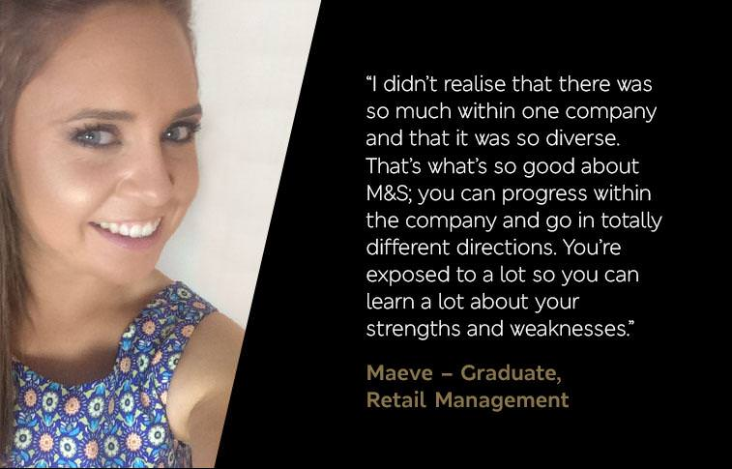 (Maeve M, 2015)
This shows M&S caters for everyone’s attitudes, beliefs and values as they are such a diverse organisation. And it brings out better in their employees and they learn about their strengths and weaknesses.
M&S are very strong in their values and beliefs as an organisation and on their employees. They allow their employees progress and build a confidence within themselves. They are a very diverse company. Also, they help you learn a lot about your strengths and weaknesses. They have a huge careers page on their website and many stories on their employees and managers stating how M&S have helped them build a career by sticking to their values and beliefs as a company.
Simon Knox (2003) has stated “that employees play a key role in creating values. That employee’s satisfaction accounts 52 percent of customer satisfaction. This is why companies have created the reward and recognition system for their employees that is closely linked to business results.” (Simon. K 2003, pg. 247)
Catherine, (2019) reported explaining how valuing your employees is so important in the work culture. “leading us through peak season, know your customers, know your business and know your team. Connection is key.”
Catherine 2019 also stated that “By getting to know my team really well and being able to pick up on the little signs, I can usually see that they need support before they ask – that goes a long way. Know your customers, know your business and know your team. Connection is key. Being clear with my responses helps the team be clear with how we move forward and work as a team to grow our business.”
Catherine (2019) moved forward saying Having fun at work makes M&S great, so it is important that a great store manager can really motivate teams, particularly in the busy Peak period. Every year, M&S take on thousands of new seasonal colleagues and whether it is in a store, distribution centre or Support Centre, managers focus on teamwork to help each colleague train and focus their tasks. That means each staff member can just get on with their work, and get it done, effectively. (Catherine, 2019)
Store managers believe by being clear, being present and motivated towards your employees will bring the passion out of the staff to work.
Laura Mullins (2016) quoted; ‘The relationship between the organisation and its members is influenced by what motivates them to work, and rewards and fulfilment derived from it.’ (Laura. Mullins, 2016, pg. 254)
Managers spend a bit of time each day with colleagues, communicating daily priorities and expectations. This helps colleagues focus and get work done efficiently.
Store Manager Catherine knows that being present is about taking the time to talk and listen to what colleagues need from This just shows how much Catherine values her staff by having the time to listen and take on their ideas on board. And trying to connect with them to help them move forward in their jobs. her at their busiest time of year.

Task 4

Conclusion
concluding M&S have a very structured cultural workplace where they value their employees and expect high standards of work from their employees as well as being a diverse company. The internal context of M&S is showing how inside of M&S is being processed around employees and managers, by using technology into their business. As well as using different ways to connect with each other to discuss work matters and keep everyone connected to one another. They are also a PLC company that allows employees and customers buy out shares from their companies to make business growth and in other words making employees part of the organisation and motivating them working towards success. The external context of M&S is showing how M&S is doing well as a company. Which was discussed in a SWOT analysis. They have strength and weaknesses but also opportunities which can help them grow more. M&S value their staff voice, this they have stated clearly how employee voice matters and they will take immediate action if needed. M&S codes of ethics and behaviours (1884) outlines their standard as an organisation which therefore helps to shape and strengthen their culture. Its stated on their ethics code of conduct book that all members of staff are expected to maintain these high values wherever in the world they conduct business. M&S show good and bad

recommendations
M&S can improve on their overseas employees by paying them their fair wage. As they are more of a poorer country than UK and some cannot live on what they are getting paid. And if mentioned in their code of conduct all employees are paid and treated fairly then they need to act upon it and have a few members of the head of department go out to the overseas company and check to see if they are getting paid and treated fairly. This do not show a positive cultural workplace if overseas employees are being neglected.
M&S can also better themselves in upgrading their fashion trend by asking their employees in different departments and age range in what they would wear and what they think customers will approve of. This is M&S including their employees not just as a staff member on the shop floor but also being part of a big department on the shop floor this would make employees more motivated towards their job role and shows a good cultural involvement.

References

Reference report M&S
- Alex, (2020) [read our stories] available at: https://careers.marksandspencer.com/inside-mands/our-apprenticeships-are-shaping-leaders-of-the-future accessed: 20/02/20

- Catherine (2019) [leading us through peak season] available at: https://careers.marksandspencer.com/node/905 accessed: 23/03/2020

- Carl. M (2013) [Introduction to marketing] Canada 12th edition pg. 33

- Graham. R (2016) ‘Thousands of staff could lose jobs if they reject pay deals.’ The Guardian available at: https://www.theguardian.com/business/2016/sep/21/marks-and-spencer-staff-jobs-pensions-pay-working-conditions accessed: 30/03/2020

- Hr. Berkeley (2019) [performance management overview for non- represented staff/ human resources]

- Impraise (2019) [SMART goals at work: examples for what, how and why]
Available at: https://www.impraise.com/blog/s,art-goals-in-the-workplace-what-how-and-why
Accessed: 30/03/2020

- Laura. J Mullins /Gill Christy (2016) [management and organisational behaviour] eleventh edition, Great Britain, Pearson Education limited pg. 254

- Laura. J Mullins /Gill Christy (2016) [management and organisational behaviour] eleventh edition, Great Britain, Pearson Education limited

- Lynn (2012) “M&S: doing the right thing leads to change –for the better”. The Guardian, 30thmay

- Lindsey. M, Neel. D (2015) ‘how company culture shapes employee motivation’ Harvard business review available at : https://hbr.org/2015/11/how-company-culture-shapes-employee-motivation accessed: 30/03/2020

- Marianna C (2015) ‘Marks and spencer takes a mixed approach to staff motivation’ employee benefits available at : https://employeebenefits.co.uk/issues/may-2015/marks-and-spencer-takes-a-mixed-approach-to-staff-motivation/ accessed: 30/03/2020

- M&S (1884) [code of ethics and behaviour] available at : https://corporate.marksandspencer.com/documents/policy-documents/code-of-ethics.pdf accessed: 28/03/2020

- Maeve McKeever, (2019) M&S careers [living our values from the inside out]
Available at: https://careers.marksandspencer.com/inside-mands/living-our-values-from-the-inside-out
Accessed: 30/03/2020
- M&S (1884) [code of ethics and behaviour] available at : https://corporate.marksandspencer.com/documents/policy-documents/code-of-ethics.pdf pg. 1,3 accessed: 28/03/2020

- M&S (2004) [MARKS AND SPENCER GROUP PLC SUMMARY OPERATIONAL REVIEW] availble at: https://corporate.marksandspencer.com/media/press-releases/archive/2004/12072004_marksandspencergroupplcsummaryoperationalreview accessed: 01/04/2020

- M&S (2018) [MARKS & SPENCER ANNOUNCES TECHNOLOGY TRANSFORMATION PROGRAMME] availble at : https://corporate.marksandspencer.com/media/press-releases/2018/marks-and-spencer-announces-technology-transformation-programme accessed: 01/04/2020

- M&S (2018) [NEXT STEP IN REORGANISATION OF M&S MANAGEMENT AND DIRECTOR DEPARTURE] availble at : https://corporate.marksandspencer.com/media/press-releases/2018/next-step-in-reorganisation-of-m-and-s-management-and-director-departure accessed: 01/03/2020

- O.C Tanner (2017) [how to encourage networking that boosts company culture] available at: https://www.entrepreneur.com/article/287768 accessed: 25/02/2020

- Sarah. F, (2016) [read our stories, international women days] available : https://careers.marksandspencer.com/inside-mands/10-minutes-with-sarah-head-of-organisational-development accessed on : 02/02/20

- Simon. K (2003) [ customer relationship management] oxford pg.247

- Simon. N (2013) ‘what experts say: marks and spencer’ The Guardian available at: https://www.theguardian.com/business/2013/may/12/marks-and-spencer-tips-retail-survival accessed: 02/04/2020

- Sarah. B (2016) ‘Asian workers making M&S clothes paid far less than living wage- report’ The Guardian available at : https://www.theguardian.com/business/2016/feb/14/marks-and-spencer-workers-sri-lanka-india-bangladesh-earnings-living-wage-labour-behind-the-label accessed: 02/04/2020

- Unknown (2017) [Just be a colleague be a buddy]
Availbe at: https://careers.marksandspencer.com/inside-mands/don%E2%80%99t-just-be-a-colleague-be-a-buddy accessed: 13.02,2020)

- Unknown, (2020), [M&S Stories] available at: https://corporate.marksandspencer.com/stories accessed: 20/02/20

- Unknown ( 2020) [M&S careers] availble at : https://careers.marksandspencer.com/search/keyword/network accessed: 25/02/2020

- Unknown (2020) ‘Marks and spencer group plc.’ MarketLine available at : https://corporate.marksandspencer.com/ accessed: 28/03/2020

- Unknown ( 2020) [M&S careers ] available at : https://careers.marksandspencer.com/inside-mands accessed: 28/03/2020

- Unknown, (2013-2020) [Barrett Model] available at: https://www.toolshero.com/psychology/barrett-model/ accessed: 31/03/2020

