

Advanced Diploma in Logistics and Transport

M3X9409 Strategic Context

Student: P121168 Adrian Carruthers
Assignment 2

Lecturer: Ged Edwards

I declare that this assignment is all my own work and that I have acknowledged all materials used from the published or unpublished works of other people. All references have been duly cited.
STRATEGIC CONTEXTS
Critically appraise the procurement and resource planning used within an organisation, such as the UK MOD, to meet the organisation’s strategic objectives such as Army 2020.

Introduction
In today’s environment businesses large or small all have many things in common, person group or one thing in common, a goal, aim, a collective vision. In the same way we wish to gain the best value for money through purchasing a simple product to finding a way to ad future value or to provide tangible benefits short term to intangible benefits to for example company image or product (brand/image) long term. The same can be said for the competitive advantage, in business gaining and maintain the advantage will determine the survival of a product, service to the business entirely.
Creating a sustainable competitive advantage (SCA) inside the market of an area is one key example an idea that transpires into an action plan with the stakeholders at the heart of any decision-making process. For a plan to take place one needs to address what it is that the customer wants or needs (value). This must be unique, rare and hard to imitate.
If we take china version of a Landover (Land wind X7), BMW X1 (Brilliance V5), and Mini Cooper (Lifan 330) they all are similar and produce the similar output, similar technology but at a lower price that the real thing, why? According to Jack Yan, Motoring writer, creator and publisher of car encyclopaedia Autocade suggests that one reason is that china produce cheaper alternatives based on what the demand is and the needs of stakeholders (target audience) to some degree some might say the Chinese government where expectations and home producers can be of an advantage (orientation). The SCA of a segment of the industry locally.
https://www.quora.com/Why-do-the-Chinese-automobile-makers-copy-the-designs-of-the-top-automobile-brands
History
Bayerische Motoren Werke or Bavarian Motor Works (BMW) March 7, 1916 began as a manufacturer of aircraft engines from 1913 to 1918. Bayerische Motoren Werke GmbH after various interventions from Franz-Josef Popp, Camillo Castiglioni and Max Friz, Bayerische Motoren Werke GmbH became BMW AG “Aktiengesellschaft” (corporation owned by stakeholders). Banned from manufacturing aircraft engines 1919, BMW turned to boat and trucks although in secret remained on track towards aircraft until 1965. 1920-1929 focussed on Motorcycles before the development of Cars and winning various accolades, development carried on until the introduction of the V8 in 1951. 1959 Herbert Quandt aids in BMW independence on a global scale and the well renowned Boxer engine still in production to this day. 1965 saw BMW focus solely on Motorcycles and cars and 1966 saw the production of the 16-valve Apfelbeck engine, today from 1970 BMW HQ still located in Munich delivering the likes of BMW 5 Series (E12 ("E" being “Entwicklung", development). The next 4 decades saw the development of the M series to Liquid cooled engines and SUVs (sport-utility vehicles), to entering F1. In order move with the times and a greener alternative, such is BMW foresight one can see in 1972 the first electric 1602e car where today the new BMW i5 is realised. http://www.bmwdrives.com/bmw_history/bmw-1990.php
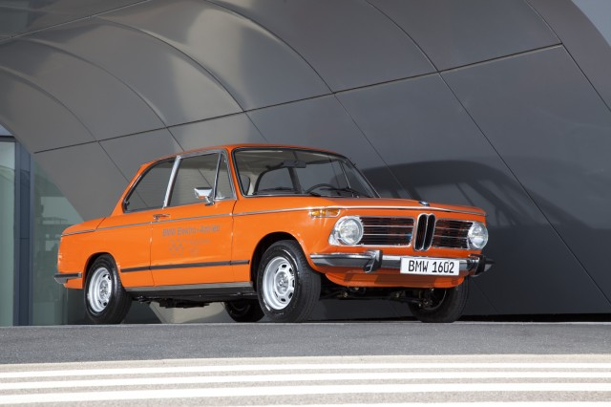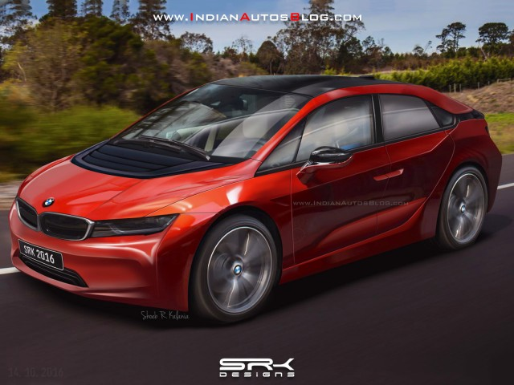
https://www.greencarreports.com/news/1109129_six-new-electric-cars-coming-for-2018-and-2019
https://www.greencarreports.com/news/1097357_bmw-releases-new-video-on-first-electric-car-1972-bmw-1602e
Procurement
Definition:
“A process whereby organisations meet their needs for goods, services, works and utilities in a way that achieves value for money on a whole life basis in terms of generating benefits not only to the organisation, but also to society and the economy, whilst minimising damage to the environment. https://www.cips.org/Documents/Resources/Knowledge%20Summary/Sustainable%20Procurement.pdf
So, what is meant by procurement and resource planning? According to Diemo Urbig Humboldt University of Berlin explains that Porter’s Value chain 1985 is a customer orientated marketing processes considered to be primary activities where (directly contribute to the production of the goods or services) and secondary (support) activities influence the primary activities. Where all activities equal or should equal a total cost with a positive margin, meaning that processes are working well, however analysis of the entire chain will aid to determine the links weak or strong to provide the business with a formidable tool in continuous evaluation in the aim to maintain the competitive advantage.
https://pdfs.semanticscholar.org/8af1/3d7790b2a6b8589c34f1a024c9e089d7f900.pdf
As we can see in fig 1 the background activities internal ultimately optimize and balance the output as one value activity increases so the value of a second activity increases potentially in this case how procurement and resource planning define the value to the customer.
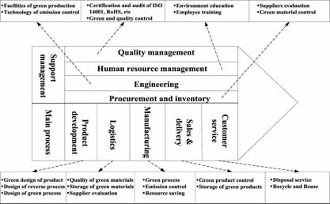
Fig 1.
https://imageserver.ebscohost.com/img/imageqv/actual/q4g/20111101/27688686.jpg?ephost1=dGJyMMTo50Sepq84yOvsOLCmr1Cepq5Srqa4SK6WxWXS
In the next paragraph I aim to look at the procurement and resource planning at BMW.
BMW Procurement process
Communications
The first step in the process of procurement at BMW, BMW conduct a varied and extensive research in the suitability of a supplier via the means of an OEM (Original equipment manufacturer) industry sustainability questionnaire. This ensures the Corporate Social Responsibility (CSR) is maintained via an evaluation to ensure the quality standard. Area of Mandatory requirement are specific based on BMW requirement such as Audit and management systems, the mandatory being legal requirements. Some of these minimum requirements:
- Company Management (General)
- Social Sustainability
- Business Conduct and Compliance
- Environmental Sustainability
- Supplier Management
- Conflict Minerals
Below an example of the OEM SAQ on CSR -Requirements for BMW Group suppliers
Requirements | Legal and statutory requirements | Relevant for companies with several employees:
Your company should publish a sustainability report. | EU Directive on non-financial reporting (publicly-listed corporations with more than 500 employees) | >500
Your company should have a policy that outlines your principles regarding the respect for human rights, forced or compulsory, child labour, working conditions, wages and benefits, non-discrimination, freedom of association and collective bargaining. | ILO Labour Standards/ Political framework in discussion | >50
Your company should have a formal health and safety policy in place. Your company should organize specific health and safety activities at the site. | Constitution/ Labour Law | >50
Your company should have a formal business conduct and compliance policy in place. | Commercial Law / UN Global Compact | >50
Your company should have a formal environmental policy in place. | Environmental Law / Industry Standard | >50
You should implement an environmental management system. Your company should certify its environmental management system. Your company should conduct environmental audits by external organizations at the site. | Environmental Law / Industry Standard | >100
Your company should have a supplier sustainability policy in place. Your company should communicate your supplier sustainability policy to your suppliers. | Industry Best Practice / Political framework in discussion | >100
Fig 2
An example of the legal and statutory requirements (Fig 2)
Working with the bounds of 70 countries no less and 1200 suppliers BMW see costs as an important advantage in that it sources 60% of its raw materials within Europe simply as most of the manufacturing takes place with Europe. BMW focus its stakeholders at the heart of all operations, this means that a central common sustainable policy on goods, raw materials are subject to a stringent set of legal binding rules to suppliers and sub suppliers.
A key area with the supply chain is the risk potential therefore hence BMW seek the advantage analysing supply chain mapping around products. It does this by:
- Identifying risks
- Conducting self-assessments
- Conducting assessments and audits
- Media screening
- Human rights contact supply chain
- Supply chain assessments
- Improvement to performance indicators
A filtering process where issues from the following guidelines handed by various policy standards that direct and guide suppliers, furthermore BMW aim to aid suppliers in reaching the standard. Considering their view, questionnaires and scorecards. If indeed the supplier does not reach the award through its activities, BMW can intervene and educate. Questionnaires based on the following and graded appropriately, all concession must meet a green standard to achieve an award of supply and sub supply.
- Social
- Labour
- Safety
- Ecological
- Governance
- Environmental
These can be examined before the award has been achieved, furthermore systems are in place such as the ISO 4001 (International Organisation for Standardisation) and EMAS (Eco-Management and Audit Scheme), tools used to provide assurance that any impact environmentally is being monitored and improved, this proves a good evaluation to external stakeholders. Other tools such as screening and human rights can be identified through E-Listening.
In many areas of any process potential and existing stakeholders are brought in at any opportunity in the aim to promote Multilateralism, Intercultural competence and serves to bind powerful nations in a unilateral agenda, discouraging unilateralism, in that and gives voice and influence (the buy in) encouraging the future “economy of scale”. BMW demonstrate commitment through dialog on a yearly basis worldwide committing to focus groups to promote views from external consultants, academics, environmentalists, scientist to even celebrity speak. This incorporates BMW, s image and brand further. By presenting facts at these annual meetings can encourage stakeholders from other associations or indeed competition. BMW also promote trust and aim is to create a comprehensive learning process with constant development of ideas to help better achieve our sustainability objectives. Just one of the many objectives in Fig 3 from BMW group that can be similar in competitive organisations such as Mercedes.

Fig 3.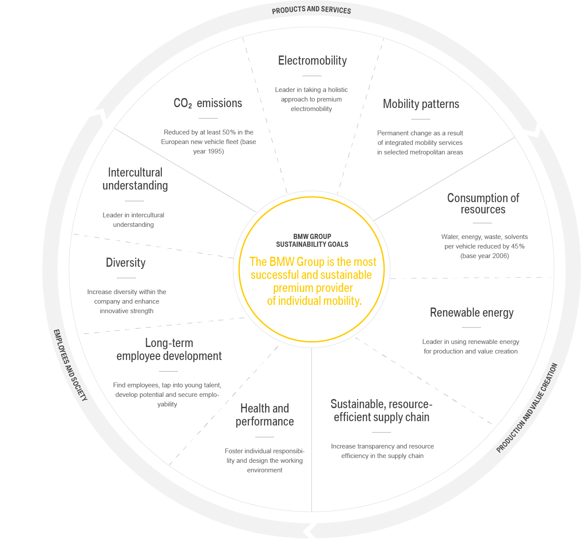
https://www.bmwgroup.com/en/responsibility/sustainability-at-the-bmw-group.html
Competition
BMW vs. Mercedes-Benz – The New Age Competition
Germany is known for quality and luxury within the automobile industry BMW, Audi and Mercedes the most popular German brands have earned the reputation for high quality, powerful and well-designed cars.
In 2016 Mercedes overtook BMW outselling the 2 million mark the first time since 2004. However, Audi and BMW broke their own records also Audi up $1.87 million up + 3.8% and BMW up 5.3% but did include Mini and Rolls Royce. Audi in terms of sales have increased more than its rivals however become a more common unit today where BMW and Mercedes still hold the luxury and quality status renowned for their success and still today holds this key brand images.
https://netivist.org/debate/bmw-vs-mercedes-benz
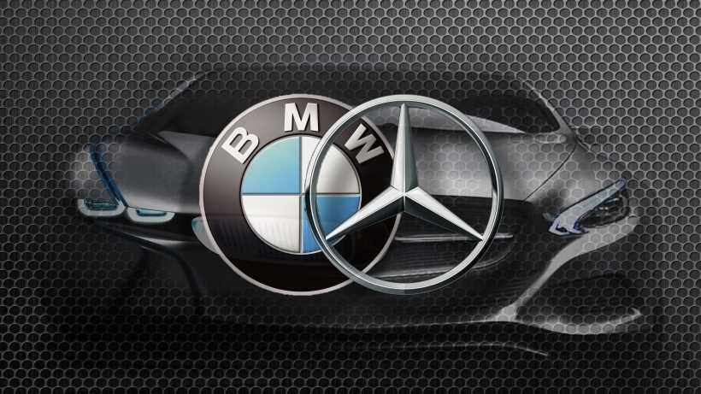

In terms of market worth in 2008 BMW revenue stood at $72.51 Billion, with an operating income of $1,255.41 million and a profit of $441.61 million. In the same year Mercedes Benz revenue stood at $47.77 billion with an operating income of $800 million. BMW in 2017 saw an increase in revenue to € 98.6 billion and a net profit of € 8.7 billion 2017 BMW revenue stood at $98.68 Billion with earning at $8.62 billion. 2018 Daimler Group revenue up by 7% to €164.3 billion (2016: €153.3 billion), with a net profit up by 24% to €10.9 billion.
Slight difference here between the two and characterised by different opportunities. According to BMW AG (NASDAQOTH: BAMXF) said on March 21 that its profit before tax in 2018 will be at least equal to the 10.65 billion euros ($13.1 billion) it made in 2017, despite a plan to spend big on autonomous-driving technologies and the development of a new range of electric vehicles.
https://uk.finance.yahoo.com/news/bmw-expect-strong-profit-2018-190300540.html
More sales for Mercedes but also more diverse products such as Busses, Truck and although electric in smaller sales per product, overall sales are up globally, I feel this is down to affordability being diverse also. BMW on the other hand have at least 8 plugin hybrid units available and BMW i3 fully electric unit and a further 12 fully electric unit by 2025. The competitors could be viewed with slight difference however they both share the same visions for the future of their product, in this case the green and electric dimensions of transportation. How the two competitors and their green concept within automobiles come to fruition would be an interesting topic in the future.

Survey
Carried out from customer reviews
In terms of competition in 2014 saw a survey carried out with BMW and Mercedes-Benz and four other luxury car brands ranked by respondents using “Luxury” and “Performance” as parameters. From the survey on a scale of 1 to 6, 1 representing the brand in the list they found represented the parameter the least, 6 on the other hand was the brand they felt represented the parameter the most.
Perceptual map of luxury car brands

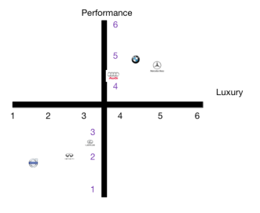
https://bmvsmb.wordpress.com/tag/survey/
The survey although not extensive could have used Performance and Prestige however Prestige according to prof. Bassell Koppelman School of Business at the City University of NY Mercedes fall into top position. The survey indicates that Mercedes-Benz is being associated the brand with highest degree of luxury with a mean of 5,0. Bavarian Motor Works (BMW) were associated as being the highest performing car of all the listed luxury brands scoring the highest mean of 4,88. The difference between the two brands were that BMW scored lower in the luxury scale (mean of 4,44) but higher in performance whereas Mercedes scored a lower rating in the performance scale (mean of 4,66) but higher in luxury.
So fair to say in competition although at the top of the industry in some aspect they both appeal to different customers in their own brand right, so the need to remain vigilant and in the resource finding and allocation to the supply chain is key to have the ability to achieve an optimum supply chain.
Resource planning
At BMW secondary resource programmes and renewable resources through an environmental management system (EMS) ensure the lowering of the energy used to produce vehicle, in doing so adds value to reducing costs, impact on the environment and save on scarce resources such as:
- Energy consumption − 36.0 %
- Water consumption − 31.3 %
- Process waste water − 45.1 %
- Waste for disposal − 78.9 %
- Solvent emissions − 51.4 %
- CO² emissions − 45.7 %
https://www.bmwgroup.com/content/dam/bmw-groupwebsites/bmwgroup com/responsibility/downloads/en/2015/BMW_SVR_2015_RZ_EN_OfficePrint.pdf
Currently BMW have an EMS throughout all its sites in conjunction with the International Declaration on Cleaner Production of the United Nations Environment Programme in 2001 apart from motorcycle production in Manaus/BR recognised by ISO 14001 national standard.
BMW operate aim to save not only on energy usage but the complete cycle through the recycling process at the end of life in any unit, again saving on costs we can see in fig 3.
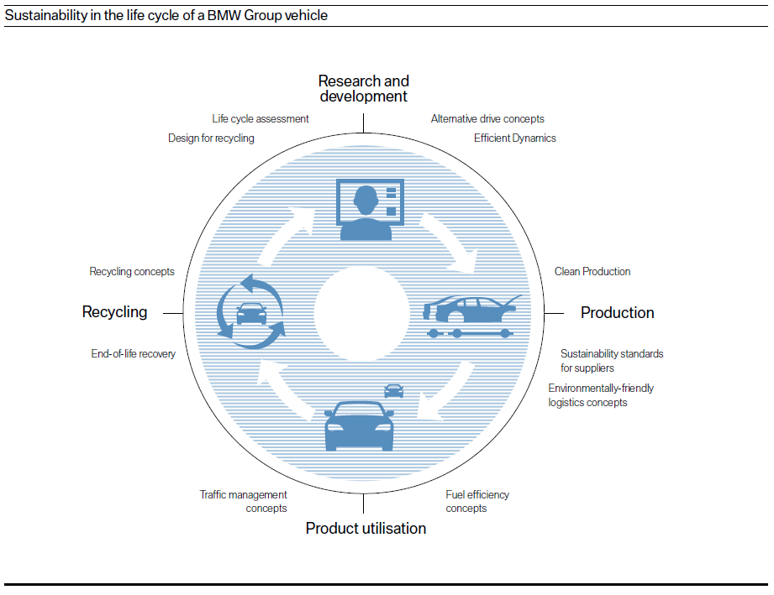
Fig 3.
https://www.bmwgroup.com/content/dam/bmw-group websites/bmwgroup_com/responsibility/downloads/en/2015/BMW_SVR_2015_RZ_EN_OfficePrint.pdf
In accordance with ISO 14040/44 (life cycle based environmental assessments) an example here would to base the BMW 7 Series. Optimisation of the drivetrain and more efficient use of resources in materials and production led to a reduction of 25 % in greenhouse gas potential (measured in CO² equivalents) throughout the entire life cycle of this vehicle, compared to the previous. Furthermore, BMW have founded a centre of competence 2015 to achieve further dialogue with more dense populations and urban mobility with local stakeholders. Forming an e alliance partnership Munich/DE, operating a strategic approach on improving their framework in electromobility, similar Hamburg/DE and Berlin/DE.
HRM
‘Today for tomorrow’
BMW currently invests more than € 200 million a year through strong codetermination, Social dialogue and close cooperation between the social partners. Through training and further education in resourcing of staff via “Qualitative Human Resources Planning”. This seeks to develop current employees and future employees at the right time in line with future development and needs, or before the need arises. Recruitment of younger employees before the need arises ensures a safeguard and transfer of knowledge meaning retention of skills. Some of the areas is diversity by global sourcing creating a diverse workforce that can enhance innovative strength. It does this though the pillars:
- Gender
- Cultural background
- Age and experience
Considering the following through any process of the workforce:
- Health management
- Qualifications
- Work environment
- Retirement models
- Communications
- Change management
Apart from encourage more females within the workforce at low and high levels BMW consider a good education is the key to success globally world. Support students on their way from basic through higher education and onward to starting vocational training or embarking on a career. Conducting corresponding projects within locations that are tailored to the respective local areas. BMW develops training programmes successfully since 2012. Students receive mechanical engineering training and, after successful completion, could start as a technician at the BMW Group. The “BMW Scholars Programme” in Spartanburg.
Conclusion Vision and future
The procurement process at BMW is one that directly interacts with law, policy, a specific set of rules that all communicate and interact with. In doing so the process not only allows BMW to pick and choose based on price and location but feel through internal processes from suppliers and sub supplier, them themselves can optimise their own system to benefit the future impact not only on the environment but for their own stakeholders and community within, with the ability to provide to different stakeholders with sub-contractors. BMW vision for the future is one that bring enthusiasm, to bring about the ultimate drive via there 4 main units (BMW, MINI, Rolls-Royce and BMW Motorrad) over the next 100 years. By bringing the very best in resources to the family in terms of employment allows consistency, through media investment and interaction globally makes a bigger picture smaller and coherent. Sharing rather than owning values to maintain supply chains to ultimately bring all units to self-drive (Vision), all hybrid and electric to reality ultimately maintaining the global brand that is BMW.

Wording
2650 approx.

GRAHAM J. HOOLEY, NIGEL PIERCY and BRIGITTE NICOULAUD, 2014. Marketing Strategy and Competitive Positioning. 5th ed. edn. GB: Financial Times/ Prentice Hall - M.U.A.
http://annualreport2017.daimler.com/to-our-shareholders/highlights-of-2017
https://bmvsmb.wordpress.com/tag/survey/
https://b2bpapp6.bmw.com/public/en/kommunikation/nachhaltigkeit/OEM_SAQ_on_CSR_requirements_for_BMW_Group_suppliers_english_05-2016.pdf
https://netivist.org/debate/bmw-vs-mercedes-benz
http://recomparison.com/comparisons/100226/bmw-vs-mercedes/
https://uk.finance.yahoo.com/news/bmw-expect-strong-profit-2018-190300540.html
https://uk.finance.yahoo.com/quote/BMW.DE/financials?p=BMW.DE
https://www.bmwgroup.com/en/company.html
https://www.bmwgroup.com/content/dam/bmw-group-websites/bmwgroup_com/responsibility/downloads/en/2010/11670_SVR_2010_engl_Online-Version.pdf
https://www.bmwgroup.com/content/dam/bmw-group-websites/bmwgroup_com/responsibility/downloads/en/2015/BMW_SVR_2015_RZ_EN_OfficePrint.pdf
https://www.bmwgroup.com/content/dam/bmw-group-websites/bmwgroup_com/responsibility/downloads/en/2016/BMW_GROUP_KeyIndicators_Supplier_Management.pdf
https://www.bmwgroup.com/content/dam/bmw-groupwebsites/bmwgroup_com/ir/downloads/en/2017/BMW-Group SustainableValueReport-2017--EN.pdf
https://www.bmwgroup.com/en/next100/perspectives.html
https://www.daimler.com/documents/investors/news/capital-market-releases/daimler-mercedes-benz-ir-release-en-20180201.pdf

