TITLE PAGE

NAME: NDEY YASSIN LOWE

STUDENT NUMBER: 1815270

MODULE CODE: BMSK5102

TITLE: DEVELOPING RELATIONSHIPS AND WORKPLACE ACHIEVEMENT

LECTURER: SUJEEWA HERATH

TABLE OF CONTENT

- Title Page………………………………………………………………… Page 1
- Table of content…………………………………………………………. Page 2
- Introduction……………………………………………………………… Page 3
- Methodology……………………………………………………………. Page 4
- Development Vehicle in the workplace……………………………… Page 5
- Motivation………………………………………………………………. Page 6
  - Process of motivation……………………………………………… Page 7
  - Motivation Theories………………………………………………… Page 8
  - Herzberg two-factor theory………………………………………… Page 9
- Commitment……………………………………………………………... Page 10
  - Importance of commitment………………………………………… Page 11
- Feedbacks………………………………………………………………. Page 12
- Case study………………………………………………………………. Page 13
  - Motivation……………………………………………………………. Page 14
  - Commitment…………………………………………………………. Page 15
  - Feedback………………………………………………………….... Page 16
- Personal Development plan…………………………………………… Page 17
  - Johari Window………………………………………………………. Page 18
  - SWOT Analysis……………………………………………………… Page 19
- Conclusion………………………………………………………………. Page 20
- References………………………………………………………………. Page 21
- References………………………………………………………………. Page 22

INTRODUCTION
A successful business understands its market and how best to differentiate its product so as to appeal to its target. It should also know how to recruit, develop, train, motivates and retain its employees.
There is a difference between motivating someone into wanting to do something or merely getting them to do it. Successful motivation is based on appealing to an individual’s intrinsic drives rather than using external threats and rewards.
Herzberg two-factor theory and Maslow’s theory are the most common motivation theories. Frederick Herzberg argued that motivating an individual involves identifying and using a range of ‘satisfiers’, while Maslow identified a hierarchy of needs that someone have to fulfil to reach self- actualisation.
Three development vehicles evaluated are motivation, commitment, and feedbacks. I look at how it affects the individual and organisation and what needs to be done to achieved job satisfaction. Critically accessing how it relate to my interviewee, Aisha, and the organisation she works for.

METHODOLOGY
I evaluated three development vehicles in an organisation, appropriate for the development needs of an employee using motivation, commitment and feedbacks. Looking at the different types of motivation like the Maslow’s theory and Herzberg two-factor theory.
Organization needs to assess the individual needs of each employees to increase production and to be more motivated. The organisation must enhance employees job engagement and develop a climate of trust.
Using SWOT analysis and the Johari Window model to evaluate and assessed the needs of an individual and looking at how to tackle their threats by using their strength and overcoming the weaknesses by taking advantage of their opportunities. Planning on what to do, how to do it and when to do it, is important in any career development.
I did an interview with Aisha, who works for Midland Mencap, a non- profit organization for people with learning disability. She works for the company for over ten years and is still committed. During the interview, we discussed about her career prospects and why she is still with the company. Her motivator factors, her action plan, and set of needs using the Herzberg and Maslow’s motivation theories.

DEVELOPMENT VEHICLES IN THE WORKPLACE
Ragins and Dutton (2007: 9) defined workplace as “a reoccurring connection between two people that takes place within the context of work and is experienced as mutually beneficial.” Workplace satisfaction cannot be achieved without personal development.
Personal development vehicle is applied to achieve self-actualisation. Development vehicles are the main driving force behind the success of an organisation or individual. There are many development vehicles that can benefit both the individual and the organisation. Motivation, commitment, training, employee engagement, rewards. Learning and development, performance management, feedbacks are all significant development vehicles important for the success of any organization. Both an organisation and employees needs a personal development plan. Organisation should engage and motivate employees and identifying areas that needs improvement. Focusing on the important principle of performance management.

MOTIVATION
Motivation is the force that drives someone to achieve a goal or to satisfied one’s needs. There are many reasons that motivates people to work. For example:
- Financial rewards
- Good working conditions
- Benefits like private health care, good pension schemes and more
- Sense of belonging
There are two types of motivations.
- Extrinsic motivation
- Intrinsic motivation
Extrinsic motivation is when employees are being rewarded with good wages, bonuses, promotion, incentive schemes, the ability to buy shares, punishment like disciplinary action.
Intrinsic motivation is provided by the work itself. Employees are involve in the day to day running of the business, feel value and appreciated.

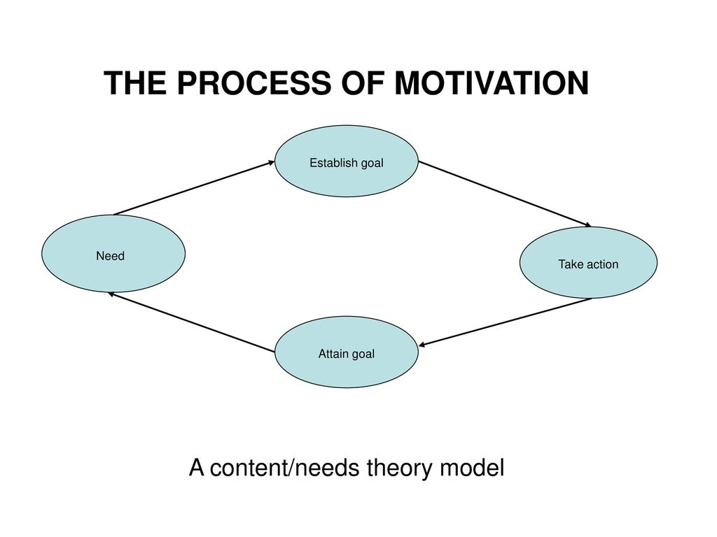
According to Maslow (1954) hierarchy of needs, “people are motivation by their needs, which is translated into goals for them to attain.” Maslow’s recognised five sets of needs – physiological, safety, social, esteem and self-actualisation. Maslow’s however realised that only one percent of people attain self-actualisation.

MOTIVATION THEORIES
There are different types of motivation theories:
- Two factor model theory (Herzberg)
These two groups of factors affect job satisfaction:
1) Those intrinsic to the work itself.
2) Those extrinsic to the job such as pay and working conditions.
- Process /cognitive theory
These have to do with expectancy, goal and equity theories.
- Content / needs theory (Maslow)
These are the needs and goals that people aspire to. People motivated by their needs and translated into goals for them to attain.
- Instrumentality theory
This theory of motivation is the belief that success will bring rewards or that efforts will lead to a successful outcome.
- Reinforcement
People realize that certain actions help to achieve goal while others are unsuccessful. The successful ones are repeated when the similar tasks arises.
- Vroom’s expectancy theory
When someone believes that hard work earns success or reward. Therefore, people who are in need of successful outcome will increase their performances to gain rewards.

HERZBERG’S TWO-FACTOR THEORY MODEL
Herzberg’s two - factor theory model has two sets of needs in the workplace. These are the
hygiene and motivator factors.
HYGIENE FACTORS
- Quality of supervision
- Company policies
- Relations with others
- Personal life
- Rate of pay
- Job security
- Working condition
MOTIVATIONAL FACTORS
- Achievement
- Career advancement
- Personal growth
- Job interest
- Recognition
- Responsibility
- Rewards

COMMITMENT
Commitment is another development vehicle that is particularly important. It represents the strength an individual is identified with. Commitment refers to attachment and royalty in a particular organisation. Beer et al (1984) identified commitment in their concept of human resource management as a key dimension because it ‘can result not only in more loyalty and better performance for the organisation, but also in self-worth, dignity, psychological involvement, and identity for the individual’.
MOWDAY et al (1982) identified three characteristics of commitment.
- A strong desire to remain a member of the organisation
- A strong belief in and acceptance of the values and goals of the organisation
- A readiness to exert considerable effort on behalf of the organisation

Commitment to an organisation is one of the developing vehicles that play an important part in human resources philosophy. It relates to the feelings of individuals about their organization. It is key because without commitment, there will be lack of loyalty or better performance. When a person is attached to his or her job, remaining a member of the organisation will be desirable.
According to Appelbaum et al (2000),’ organizational commitment is a multidimensional construct that reflects a worker’s: identification with the organisation (loyalty), attachment to the organization (intention to stay), and willingness to expand effort on the organization’s behalf (discretionary effort)’.
If you are committed to your job or organisation, you will develop a climate of trust and tend to contribute immensely for it to be successful. Believing in the organisation’s values and goals is a factor for commitment. Without commitment, you will have problem fitting in any organisation.

IMPORTANCE OF COMMITMENT
Commitment is particularly important in an organisation because it improve results, workers becomes more creative and contribute immensely in the organisation.
Walton (1985) suggest that improved performance would result if the organisation replaced the traditional control-oriented approach by a commitment strategy.

FACTORS AFFECTING COMMITMENT
- Satisfied with career opportunities.
- Find their word challenging.
- Received training the previous year.
- Satisfied with the performances appraisal system.
- Thinking that managers are good at managing and leadership.
- Satisfied with the company’s performance and communication.

FEEDBACKS
Feedback is the provision of information to people on how they have performed in terms of results, events, critical incidents and significant behaviours. Feedbacks can be positive when it tells people that they have done well, constructive when it provides advice on how to perform better, and negative when it tells people that they have done badly. Feedback reinforces effective behaviour and suggests where and how behaviour needs to change and enable employees and organisation to communicate and have the opportunity to learn and develop. Both positive and negative feedbacks are important performance management activities.
Positive Feedback
Positive feedback is when you recognise and appreciate an individual effort. Positive feedbacks is good for a company because it increase the rating of an organisation and the confident of the employee. When you give constructive, positive feedback, your employees will feel valued and connected to the team. Positive feedback should be use carefully and frequently to employees to bring out their best performance,
Negative Feedback
Negative feedback tells people that they have done badly. Negative feedback can be difficult for both the manager and the employee. Receiving negative feedback can be a turning point in the employee – manager relationship. The method of tactics used by the manager is particularly important. Manager should apply “best fit” approach from a set of best practice negative feedback. Confident employee could handle negative feedback and learn from experience. Most managers believes that negative feedbacks can been effective. Appraisal system adapted to improve performances and behaviour change.
According to Dixon (1994), ‘Leadership is no more than exercising such an influence upon others that they tend to act in concert towards achieving a goal which they might not have achieved so readily had they been left to their own devices’. Being a leader means motivating people to perform their utmost best to gain a desired result. You should possess certain leadership skills to be a good leader. A Leader should be able to give constructive and honest feedbacks to his team.

CASE STUDY
My case study is based on my friend, Aisha’s experience as employee of Midland Mencap, a non-profit charity organization providing care for people with learning disability. Midland Mencap provide a wide range of safe, secure and quality flats, houses and bungalows across the city to suit your needs. They also provide the right care, support and advice to help you live the life you choose. Midland Mencap believe in a world where everybody is valued and included as active and equal citizens in their community regardless of need. They organise wide range of leisure and recreational activities to suit all like short trips, holidays, discos, family Christmas parties, day centres, sports and many other meaningful social activities across the city for all ages. Midland Mencap is involve in providing training and development of their staffs as well as delivering training to other organisations.
Aisha have experienced of working in different sector of the health and care industry but Midland Mencap stood above all of them. She has work with the company for more than ten years counting.
Interviewing Aisha about her job, there is no doubt of her commitment, motivation and love for her job. I critically assessed the benefit of those three development vehicles I have evaluated earlier as an individual and its potential benefits to the organisation.

MOTIVATION
Hygiene Factors
- Rate of pay – The number one motivation for her is the good wages and private pension scheme. Wages are increase yearly.
- Fantastic working environment – Staffs work well as a team.
- Relations with others - The atmosphere is very friendly and relaxed.
- Personal life – Since most of the staffs are foreigners and do take care of their families back home, staffs are motivated to work harder to earn more money.
- Job security – There is a sense of belonging for as long as you abide by the company’s code of conducts, your job is secure.
- Quality supervision – supervision is done monthly where you can discuss any issues employees have and how to address it.
Motivational Factors
- Personal growth - training is provided all the time with hourly payment.
- Career advancement - NVQ courses in Health and social care provided to staffs free of charge.
- Job interest - Well trained trusted staffs.
- Achievement – Midland Mencap is one of the region’s leading learning disability charities.
- Recognition – Hold the highest quality ratings with OFSTED, The Care Quality Commission and The Supporting People Programme.

COMMITMENT
Working with Midland Mencap, Aisha met all the 3 commitment characteristics identified by MOWDAY et al (1982)
- A strong desire to remain in the company - She is very committed to her job because it is her main source of income. Besides, the working environment is very friendly and relax. Aisha always look forward to going to work because she make some genuine friends at work. Staffs work as a team and the bundle of the work is share equally.
- Employees belief in the value of the organisation to treat service users with respect and dignity.
- Employees do all efforts on behalf of the organisation – Absent staffs are quickly cover by the company’s own staffs instead of agency staffs saving the company money.

Exhausting all three characteristics of commitment, there is no doubt of Aisha’ commitment to her job and the organisation.

FEEDBACKS
Feedbacks are encouraged at Midland Mencap. Every month, employees have supervision where they can express their feelings, concerns and what they need to improve on as well as trainings required. Feedbacks are also welcome from service users and their families whether negative or positive. Complains against a staff are taken seriously and investigated properly. If necessary, a warning letter will be served to the staff and vice versa, if a staff makes a complain, the same procedure applies. Aisha once scraped off the paint of a service user while helping her with moving her sofa. She complained about it to the manager and she was called at the head office to give her version of what happened. Even though, she was doing her a favour, moving a sofa was not part of her duties and responsibilities. She was removed from working with her and was served a warning letter. In essence, Midland Mencap take feedbacks and complain seriously.

POSITIVE FEEDBACK
The training we received from Midland Mencap enabled us to empower our staff and for the staff to take ownership of their role in working with children with additional needs. The training was delivered in such a way that staff actually looked forward to their interactive role within that training – it was fun and interesting while getting across a very important message.
(Reviewed by Julie Gibson)

NEGATIVE FEEDBACK
I have worked in this sector for over 10 years and Mencap is the worst employer I have come across. An absolutely appalling company to work for. No union recognition, no rights, no care shown for its workforce and no care shown to the disabled. If I had a relative with learning disabilities, I will make sure they stay well away from this organisation. (1/5 Stars) (Reviewed by support worker)

PERSONAL DEVELOPMENT PLAN
Personal development plan sets out the actions someone propose to take to learn and to develop themselves. Developing a personal development plan will help you improve your skills to do your job better and progress into a better job. A self-awareness test helps you to know your strength and weaknesses. It is a conscious knowledge of one’s own character, feelings, motives, and desires (Oxford Dictionary, 2018). Focusing attention outward toward the environment (consciousness) and inward towards yourself (self-awareness).

JOHARI WINDOW
One of the self-awareness tests you can use is Johari Window. It was created by It has four levels of consciousness.
- Open Areas – things that you know about yourself and people know about you as well.
- Hidden Areas – things that you know but it is hidden from other people.
- Blind Areas – things that people know about you, but you do not know yourself.
- Unknown Areas – things that you do not know about yourself and others do not know either.

OPEN THINGS  - A good team worker  - Caring and supportive  - Being like by others  - Helping others  - Motivated and committed  - Accepting people as they are  - Perfectionist  - A good listener  - Reliable and trustworthy | BLIND AREAS  - A leader  - Continuous improvement  - Doing a great job  - An asset to the company  - Do not believe in herself
HIDDEN THINGS  - Financially secure  - Hate meeting new people  - Stand up for what she believes in  - Secretive  - Very independent  - Talkative and very funny | UNKNOWN AREAS  ?

Individual can build trust by disclosing information to others and learning from the others about the information they in turn disclose about themselves. With the help of honest feedbacks from others, you can become aware of some your negative and positive blind area and decrease the hidden areas.
SWOT ANALYSIS
To finish off her self-awareness diagnostic, I did a SWOT self-analysis test on her strengths, weaknesses, opportunities and threats.
Strengths – One of the most important strength she possesses is being caring and helpful. You cannot be a good carer if you do not have these qualities. Motivated and committed to her job will bring her security on the job. In essence, she has the qualities to be best in her job. No wonder, her employees think that she is an asset to the company.
Weaknesses – Not believing in herself will hinder her to climb up the ladder at work even though her employer and co-workers know that she can lead. To be a leader, you need to be influential and confidence which she lacks. Being a perfectionist have its negative and positive effect in her job setting. It is time consuming and dealing with people with learning disabilities, they do not have too much patient especially if you are performing a task close to them. On the other hand, performing your job well is part of her duties and responsibilities.
Opportunities – on the job trainings, studying for her National vocational qualification (NVQ) level 3 in Health and Social Care will help her get promoted to a supervisory level. The company knows that she is exceptionally reliable and have been with the company for ten years. She is already a team leader and have the opportunity to further her career as the company offer free courses to their employees.
Threats – if she is not promoted after her level 3 course, she is threating to leave the company and work at a hospital instead for better pay wages. Sacking is also quite common in care. Mistakes and accidents could happen and if the service user or families do not like you, you will be taken from that job. Every complain is taken seriously because the company will rather lose staffs than lose their paying consumers.
Looking at Aisha’s strengths, weaknesses, opportunities and threats, I complete my interview using the STAR method structure.
- Situation – Aisha have a good chance of success in her job as the company value her. She is a good team leader.
- Task – Aisha wants to focus on her NVQ level3 to get promoted.
- Action – Aisha tries hard to meet the needs and demand of her job. she abides by the company’s code of conduct to treat all service users with dignity and respect.
- Results – The impact of the above make it possible for her to be working for the company for many years.

CONCLUSION
In conclusion, Organisations needs to apply all the development vehicles that are essential for any organisation to be successful. By understanding the factors that motivate employees like valuing their views and opinions, providing opportunities for training and career progression, providing a safe and healthy environment to work in, engaging employees, rewards for a job well done, job security, good wages, encouraging feedbacks and more, will potentially benefit the organisation and the individual.

REFERENCES
- Eisele, L., Grohnert, T., Beausaert, S. and Segers, M. (2013), “Employee motivation for personal development plan effectiveness”, European journal of training and development, Vol.37 No.6, pp. 527- 543.
- Gawel, JE. (1996) “Herzberg’s Theory of Motivation and Maslow’s Hierarchy of Needs,” Practical Assessment, Research, and Evaluation: Vol. 5, Article 11.
DOI: https://doi.org/10.7275/31qy-ea53.
Available at: https://scholarworks.umass.edu/pare/voI5/iss1/11. (Accessed: 16 July 2020).
- Herzberg, F., Mausner, B., & Snyderman, B.B. (1959). The motivation to Work (2nd ed.). New York: John Wiley & Sons.
- Luft, J. and Ingram H (1961) “Human relations training news”. Available at: http://www.richerexperiences.com. (Accessed: 17 July 2020).
- Nixon, J, and Helms, MM. (2010) Journal of strategic and management. Available at: https://www.emerald.com. (Accessed: 20July 2020).
- McElroy, JC. (2001) Managing workplace commitment by putting people first. Available at: https://doi.org/10.1016/S1053-4822(00)00054-1. ( Accessed: 17 July 2020).
- Meyer, JP and Hersovitch, L (2001) commitment in the workplace, Human resource management review 11 (3) pp 299 – 326. Available at: https://doi.org/10.1016/s1053-4822(00)00053-X. (Accessed: 20 July 2020).
- Mowday, R., Porter, L. and Steers, R. (1982), “Employee – Organisation Linkages: The psychology of committed, absenteeism and turnover”, Academic, Press, London.
- Oxford Reference (2020) Instrumentality – expectancy theory. Available at: https://www.oxfordreference.com. (Accessed: 13 July 2020).
- Ragins, B.R. and Dutton, J.E. (2007) Positive Relationships at Work: An Introduction and Invitation in: Dutton, J. E. and Ragins, B.R., Eds, Exploring Positive Relationships at Work, Lawrence Erlbaum Associates, Mahwah, 29-45.
- Reh, F.J. (2018) “How to give positive feedback”.
Available at: http://www.thebalancecareers,com/managementskills ( Accessed: 19 July 2020).
- Saha, R., (2016) Factors influencing organizational commitment – Research and lessons. Management Research and Practice, 8(3), pp.36 – 48.
- Smith, T. (2020) “A comprehensive overview of vroom’s expectancy theory”. Available at: http://www.totalassignmenthelp.com (Accessed:13 July 2020).
- The Feedback Project (2001) 360-Degree Feedback: Best practice guidelines, Roehampton, University of Surrey
- The voice of learning disability( 2019 ) Available at: http://www.midlandmencap.org,uk (Accessed: 15 July 2020).
- Understanding the Johari Window model – self-awareness (2013). Available at: http://www.selfawareness.org.uk (Accessed: 16 July 2020).
- Wainwright, B. (2019) What is employee commitment. Available at: https://www.effectory.com. ( Accessed: 15 July 2020).
- Walton, R E (1985), “From control to the workplace”, Harvard Business Review, Vol 63, No. 4,1985, pp77 - 84.

