1．Introduction

1.1 Organizational culture
Rousseau (1973) defined culture in the Social Contract: "Culture is custom, habit, especially public opinion". The culture of an organization determines its internal atmosphere; it is a certain (intangible) product from the way its members think and behave while working there (Kampf & Ližbetinová, 2015). The organizational culture was defined by Deal and Kennedy (1982) as a set of explicit informal rules that impose a particular standard of conduct. Edgar Schein (1990) asserts that a "organizational culture" consists of a variety of characteristics, including a common "pattern of basic assumptions" that group members have come to rely on as they gain experience successfully resolving both internal and external organizationally significant challenges.
According to Ravasi and Schultz (2006) and Allaire and Firsirotu (1984), organizational culture represents the collective values, beliefs, and principles of its members, which can help people in an organization in order to better understand which of their actions are considered acceptable or not acceptable (Griffin & Moorhead, 2005).
Indeed, due of its transdisciplinary and interdisciplinary nature (psychology, sociology, medicine, history, economy), developing a unique definition of organizational culture is difficult. (Reiman & Oedewald, 2002).
Over the last few decades, there has been a great deal of research into organizational culture. The findings demonstrated a strong connection between organizational culture and company performance(Peters & Waterman, 1982). Khanif et al. (2019) examines classified departments to describe the role of corporate culture construction in the advancement of enterprise management systems. Eric G (2012) considers corporate culture to be a "asset." It is a "strategic asset" in the sense of providing a source of competitive advantage, and it is the essence or core of a company model. Many organizational problems are intimately related to corporate culture. As an illustration, consider how organizations are designed, how people interact with one another, what matters most, how choices are made, and how businesses interact with their customers(Youngblood M., 2000). Also it plays a key role in solving many fundamental problems (McCarthy, 1998), shaping organizational procedures (Jarnagin & Slocum, 2007), raising managerial standards(Shaw D.,2021),and facilitating or impeding the achievement of the organization's goals. (Denison, 1990). Since employees share the same values and expectations for behavior, companies with strong corporate cultures typically outperform those without. (Stacho & Stachova, 2013).

1.2 Dalian Houren Technology Ltd.
The Houren Company was established in September 2017 and is located in Dalian, a Chinese sea town. It is an internet-based technology company that specializes in integrating big data and AI to aid adolescent learning.
Its corporate vision is to connect 100 million families with the best "teachers". The "出口成章" APP created by the company uses AI to evaluate students' proficiency in reading, writing, and pronouncing Chinese characters as well as reading articles, which will aid students in developing their learning capacity.With more than 15 million registered users, “出口成章”is currently one of China's top 10 educational service tool APP, accounting for more than 15% of the market for similar products.
According to Adizes' enterprise life cycle theory, the Houren Company has progressed from the " Go-go " to the " Adolescence."
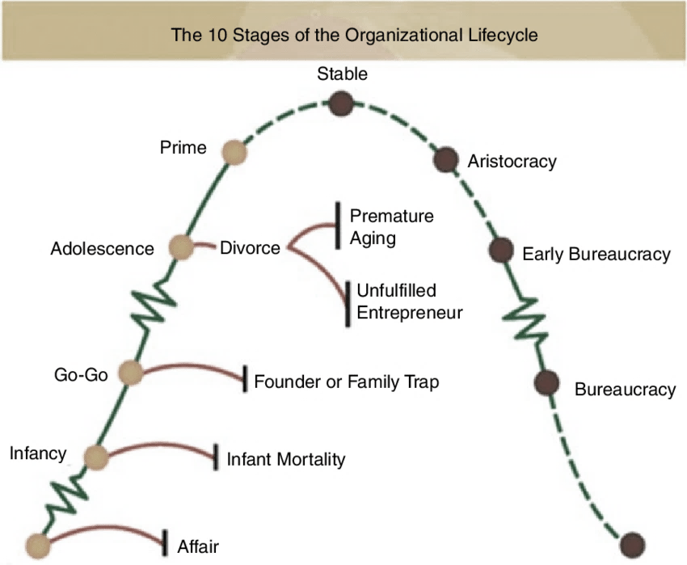
Figure 1 Adizes' enterprise life cycle
This stage will bring about an increase of the number of users and sales size. At the same time, in order to stay competitive in the online education industry, the organizational culture of the Houren Company must evolve.

2. Corporate culture analysis of Houren

2.1 Culture Types
Terrence Deal and Allan Kennedy were among the first scholars to focus on corporate culture research. They published the book Company Culture in 1982, which called for two characteristics to discern different forms of company culture:
· Feedback Speed: The rate at which a company receives feedback and returns.
· Degree of Risk : The level of uncertainty and risk associated with business operations.
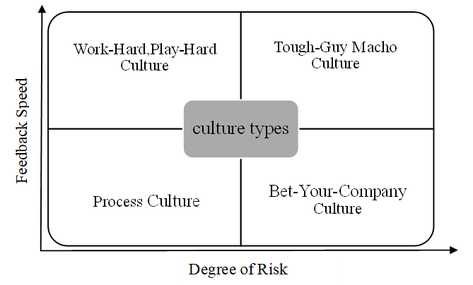
Figure 2 Deal and Kennedy’s Culture Types
Corporate culture can be classified into four types based on these two factors:
· Tough-Guy Macho Culture
The world of individualists, who like to take risks and get quick feedback on their decisions.
Teamwork is not appreciated, and creating a coherent culture is tough.
· Work-Hard, Play-Hard Culture
Work and play are equal, and staff members are encouraged to take on fewer risky tasks.
This culture recognizes that there is healthy rivalry among employees and that one individual does not constitute a company.
· Process Culture
Employees find it hard to assess the results of their job in the absence of rapid feedback, so they pay greater focus to the process.
Process performance and attention to detail, also referred to as "bureaucratic culture"(Koretskaya & Palt, 2016).
· Bet-Your-Company Culture
Making decisions is risky, and the feedback and return periods are long.
Focus on long-term planning, preparation, and research.
Houren, as an Internet technology company, can swiftly acquire market feedback, and the risk level of corporate actions is low. As a result, Huren's corporate culture should be one of Work-Hard, Play-Hard Culture.

2.2 Cultural Web
The Cultural Web, created in 1992 by Gerry Johnson and Kevan Scholes, provides one such approach for examining and modifying organization's culture.
According to Cultural Web, there are six interconnected components that can each be examined to gain insight into corporate culture, including what works, what doesn't, and what needs to be changed.
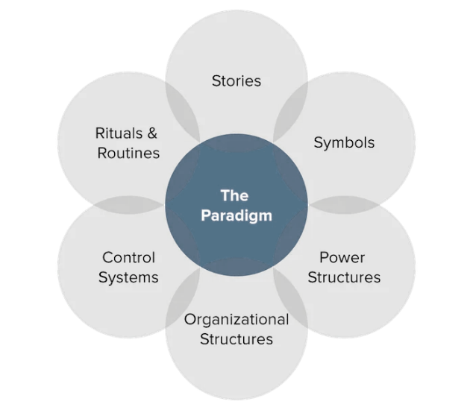
Figure 3 Cultural Web

2.2.1 Stories
Stories and myths are referred to as historical occurrences by Johnson and Scholes(Mithun.S, et al., 2022). Employees keep famous people or events alive by talking about them all the time. These stories serve as the organization's collective "memory" and frequently provide insight into its core values.
Houren has been faced with the conflict of "students are the users, and parents are the payers" because "出口成章" is an education platform for teens, therefore it must strike a balance between the game and knowledge of the platform. After much consideration, management decided to continue with the product's educational purpose rather than the enormous profits that could be realized by increasing gaming. Employees cherished the story, and each employee practiced the core of educators in their own work, eager to assist the organization in finding a balance between education and profit.

2.2.2 Rituals and Routines
The daily behavior and actions of people that indicate appropriate behavior. Employees gain an understanding of what is expected of them and what is considered "normal" behavior through a variety of repeated conditions.
Houren has created a "table tennis room" for staff to exercise and socialize. The company has also decided to throw a party and serve a variety of afternoon tea to its employees every time the user base increases by 2 million. At the party, it will also honor outstanding contributions and offer employees a chance to mingle with other employees. A culture of freedom and solidarity has been developed as a result of these actions to some extent. However, there aren't any regular group-building activities; the activity type is single.

2.2.3 Symbols
The company's visual representations, such as its logos, office spaces, corporate identity, dress code, and commercials. Symbol definition is a step in the branding process for businesses. This includes how customers, partners, and other stakeholders view a company's visual elements both inside and outside the business.
Houren has no formal dress code, and its offices are divided by partitions and wrapped in slogans describing the company's vision and values. It is noticeable that the business lacks a unique logo.

2.2.4 Organizational Structure
This includes both the organization chart's structure and the unwritten lines of power and influence which indicate who's contributions are most valued.
Houren has 120 regular employees with an average age of 27.2. Six divisions make up the company's flat management structure. Each department is then subdivided into a number of groups or centers in accordance with various functions.

Figure 4 The organizational structure of Houren
It is clear that Houren's human resource department reports to the president's office, indicating that the corporation does not prioritize human resource management in its development strategy. At the same time, it is easy to cause a rift between the staff of other departments and the human resource management team, which is detrimental to the effective development of the work.

2.2.5 Control Systems
The ways that the organization is controlled. These consist of rewards, financial mechanisms, and quality systems (including the way they are measured and distributed within the organization).
Houren's existing performance evaluation system is imperfect and does not serve as a powerful motivator. Employees think that work is not focused on performance and that there is less external competition. Employee motivation will decline as a result of the lack of reward.

2.2.6 Power Structures
This is what some call ‘real power’ within an organisation. It is essentially the seat of authority, and it can take a variety of forms. It could be a single individual, a group of executives, an entire group, or a department with sway over the entire firm.
The ideological and cultural level of the company leader has a significant impact on the way Houren's corporate culture is constructed. Executives at Houren Company are often with a master's degree or above and born in the 1980s. They are more inclined to trying new ideas than executives from other organizations, which is beneficial for changing the organizational culture.

3. Houren corporate culture existing problems
Edgar Schein (1988) 's model of organizational culture identifies the different levels of organizational culture.
Based on the analysis above, it is concluded that the Houren 's existing culture mostly has the following issues:

Figure 5 Shein's model of organizational culture

3.1 Artifacts level
Visible manifestations of culture, such as dress codes and decorations.
Houren's lack of a distinguishing logo prevents it from properly conveying its corporate culture. This not only robs employees of their sense of community but also fails to leave an eternal impression on users immediately. However, the company's decorating scheme is a little dull and does not fit the staff's young age. The lack of options for employee communication is a result of the division of workplaces across multiple departments.

3.2 Values level
How a company explains its culture, such as official policy and recognized views.
Houren Company has some policies and procedures in place, such as a personnel management system, a compensation and reward system, an attendance system, and so on. However, in the specific implementation process of some rules and regulations, some system management failures occur owing to errors in the system itself or the system is not adequately implemented, resulting in an ambiguous and unspecified system culture. At the same time, corporate culture management is still in its early stages, therefore integrating corporate culture construction and corporate management systems is insufficient.

3.3 Underlying assumption level
The core of organizational culture is shared basic assumptions(David, 2022). They are the fundamental beliefs and practices that might sometimes go unnoticed.
Houren emphasizes on business skills while training new employees, but instruction regarding corporate culture is insufficient. According to interviews with Houren employees, almost half of them only understood the enterprise's fundamental values, mission, vision, business philosophy, and other items in words, without completely comprehending its connotation and essence.

4. Conclusion
The term "corporate culture" refers to a distinctive culture that progressively develops in a company's production and operation practices and is recognized and adhered to by all employees. Companies from various nations, religions, and nationalities will have different corporate cultures, and cultures of companies at various stages of development will also differ. As a result, efforts on corporate culture should be revised often to reflect changes in both the external environment and the company itself.
The main source of a company's competitive advantage is an organizational culture that is favorable to enterprise development (Potkány & Benková, 2008). Companies are becoming more conscious of the fact that the concept of organizational culture itself offers the prospect of gaining extra value without making substantial investments (Sukiennik, 2019).
The optimization of enterprise culture is critical when Houren enters a new stage of the enterprise life cycle. The existing problems are identified and described using Schein's hierarchical model of organizational culture by identifying Houren's corporate culture and assessing its cultural network.
Houren has to recognize and address issues in its corporate culture with the assistance of the human resource management department. Only in this way can Houren maintain its competitive advantage and continue to expand.

5.Recommendations

5.1 Artifacts level
· Build an open office with a beautiful environment.
· Establish rest places and provide free coffee and tea.
· Design a memorable brand logo.

5.2 Values level
· Revise or improve the scientific management system.
· Encourage employees to contribute to the development of system culture.
· Make the system more transparent and equitable.

5.3 Underlying assumption level
· Carry out company culture training and disseminate Houren's corporate story.
· Create employee walls to highlight and reward outstanding employees.
· Hold activities to strengthen teams on frequently.

