Evidence of Participation – Simulated Interview
To ensure our team reached the conclusion of having a candidate to interview and being able to carry out a high quality and professional interview for the candidate we communicated well as a team and considered all ideas from all team members. To allow us to communicate, we decided to set up a Microsoft Teams channel to share documents and schedule in meetings for various discussions. We also set up a WhatsApp group, in case any members of the group experienced any technology issues and could then communicate quickly with the other team members. These methods worked well for us with no issues regarding communications arising. The Microsoft Teams meetings allowed every member to voice their opinion and share ideas. As we uploaded documents such as the shortlisting matrix table and the interview questions table to the channel, all members could edit and add on any comments where they felt necessary. The chat function worked well to keep up to date with any new uploads or changes between meetings.
We begun our work by scheduling in meetings for creating the shortlisting criteria, discussing shortlisting dates, preparing interview questions, and then finalising details for the interview. These dates and times were agreed by all team members and the recording evidence of this can be found in the appendix.
Prior to the first meeting, I shared documents with the team using the files function on our Microsoft Teams Channel that may I thought would be useful for all members moving forward with this project. These documents included the candidate’s CV’s and blank interview questions template. I decided to share these prior to any discussions as this would ease the discussions moving forward. Evidence can be found in the appendix, item 1.
We then met for the first time to discuss what essential and desirable criteria we would set out to score the candidates CVs against. We had decided prior to the meeting that each team member would collate their personal ideas after analysing the CVs for what we should include in the shortlisting matrix. In this meeting I presented my ideas and contributed the aspects I felt we should score against. Equally important, I listened and considered any points presented by my team members. Evidence of this meeting can be found as item 2 in the appendix. Following this meeting we had a template of the shortlisting matrix set out in a table, which I uploaded to the files of the teams’ channel to allow all members to edit if they thought applicable. Please see item 3 in the appendix, the table can be seen below also as item 5 as we used this to shortlist the candidate’s CV’s.
Prior to the next meeting, we discussed on the teams channel a few changes needed to the shortlisting matrix template and then once we met in our Microsoft Teams meeting, we discussed and adapted a few of the shortlisting criteria points to ensure we were marking to the highest of standard and as fairly as we could. We then discussed each criterion against each CV and ensured each member of the team were happy with what was decided. We saw that different members of the team had marked slightly differently using scoring totals for essential and desirable, once we discussed and ensured that each member understood and was using the same scoring matrix, we discussed each CV. As this discussion was carried out, we found that different members of the team had interpreted points on the CV’s differently and it was interesting to then discuss and conclude on the various points.
Following this meeting, we were left with one individual who scored the highest and this was the candidate that we would then proceed to interview. At the end of this meeting, it was decided by the next meeting we would collate a series of questions each based on the shortlisting matrix, and we would then discuss these questions in the next meeting and set out in a template ready for the stimulated interview task. Evidence from this can be found in the appendix. Item 4 is a recording of the meeting held with item 5 being the shortlisting criteria matrix including all scores for each candidate.
We then met as a team again on Microsoft Teams to put in place the interview questions that would be asked during the assessment. I contributed to this stage of the preparations by suggesting questions to be included and feeding back my thoughts on other questions being discussed. We as a team decided to appoint 3 questions per person to be asked in the hope of having enough time to ask two and the third as a backup, these are noted in red on the table below as item number 6 in the evidence appendix. I prepared for this stage of the preparations by researching into common interview questions and then adapting these to the needs of the job description provided to us. We also in this meeting appointed roles within the interview setting with one member appointed to fetch the candidate, two to do the welcoming and then one to close the interview. In the appendix, item 6 can be seen as the Form for a candidate interview assessment, including the questions that we had decided and instructions for the interview process. I had the opportunity to feedback my thoughts on this and offer any changes that I saw suitable. Running up to the interview, we as a group discussed a few further points such as that we are happy and feel it is appropriate to prompt the applicant if we feel the question has not been adequately answered or if they may have more to offer. Item 7 in the appendix is the recording of the meeting we held to discuss interview questions.

In the time then running up to the assessment, we kept in touch with each other on WhatsApp and on the Microsoft Teams Channel to ensure we were happy and confident prior to the assessment.

On the day of interview, we conducted the interview for Karen Jullus using the Interviewing template prepared in the previous meeting. Included as item 8 in the evidence appendix is the table where the notes, I took on paper during the interview have been typed up and included in a table to retain records. Item 9 on the appendix below is the recorded evidence of the interview that we held with our candidate, alongside this item 10 on the appendix is the interview questions with notes taken during the interview held on the 22nd of June 2023.

Evidence Appendix
- Sharing documents with the team
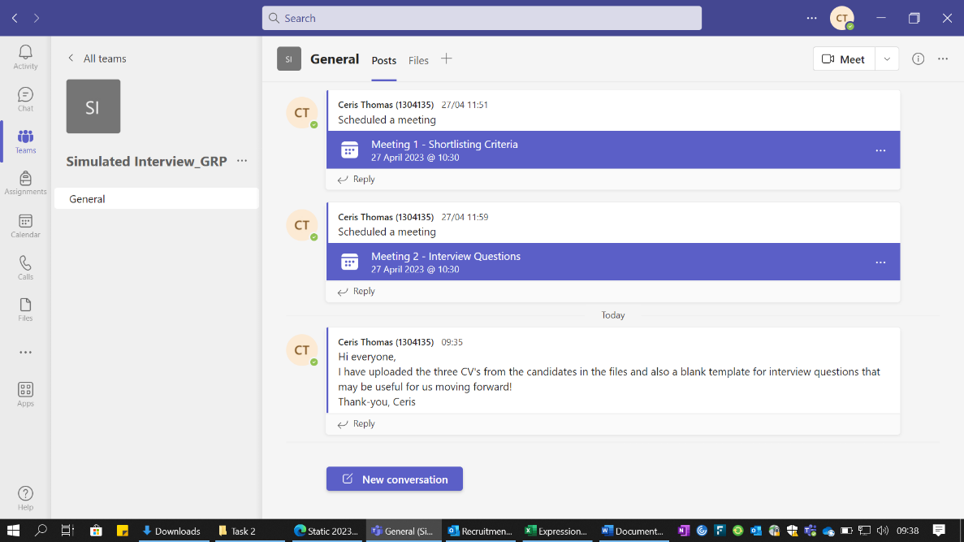

- Meeting - 15/05/2023 - Meeting 1 - Shortlisting Criteria-20230515_103937-Meeting Recording.mp4
- Sharing shortlisting Matrix template with team members
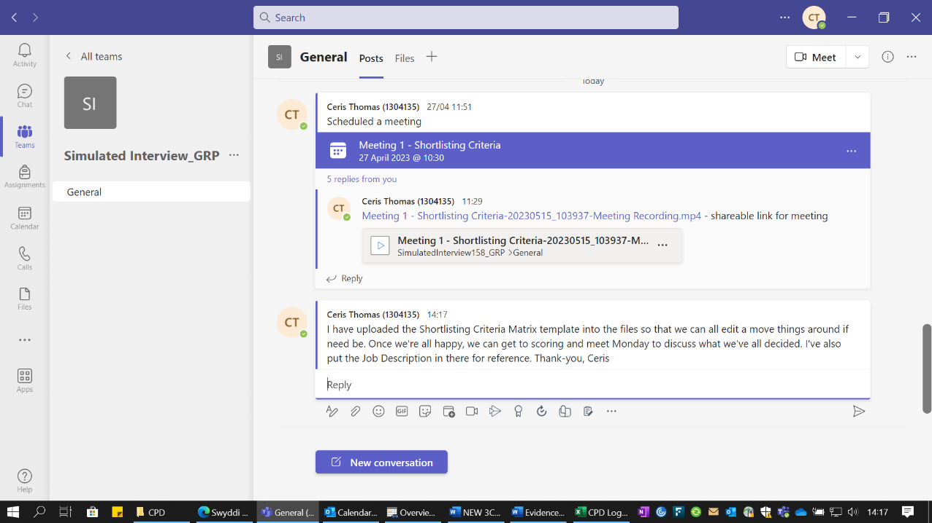

- Meeting - 22/05/2023 - Discussion of scores -20230522_100625-Meeting Recording.mp4
- Shortlisting Matrix Table with scores from all 3 CVs received.
Karen Jullus
ATTRIBUTES | ESSENTIAL | DESIRABLE | TOTAL
Qualifications | Minimum of 5 relevant GCSE of level C and above or equivalent.  3 | Holding the below qualifications or willingness to work towards:  CIPD People Practice Level 3 Minute Taking Skills  Pitman Training or equivalent.  3 | E – 3  D - 3
Experience | Experience of using IT software’s (including Microsoft packages)  3 | Has previously worked in an administrative role.  3 | E – 3  D - 3
Experience |  | Has previous experience of working within a team.  3 | E – 3  D - 3
Knowledge |  | Awareness of GDPR regulations and how to correctly handle sensitive and confidential information.  2 | D - 2
Skills | Can demonstrate general Administration Skills | Excellent organisational and interpersonal skills. | E – 3  D - 2
Skills | Excellent communication skills verbally and written, to include whilst using telephone and communicating online. | Welsh Language Level 1 and has a strong command of English Language skills. | E – 3  D - 2
Personal qualities | Can effectively manage time and work towards deadlines. | Can be self-motivated and can work effectively without supervision. | E – 2  D - 2
Personal qualities | Can effectively manage time and work towards deadlines. | Can demonstrate attention to detail whilst being able to multitask and prioritise. | E – 2  D - 2
Additional Requirements

TOTAL SCORE |  |  | E - 11  D – 10  T - 21
Interview – Y/N |  |  | Y

Sian Jackson
ATTRIBUTES | ESSENTIAL | DESIRABLE | TOTAL
Qualifications | Minimum of 5 relevant GCSE of level C and above or equivalent. | Holding the below qualifications or willingness to work towards:  CIPD People Practice Level 3 Minute Taking Skills  Pitman Training | E – 3  D - 0
Experience | Experience of using IT software’s (including Microsoft packages) | Has previously worked in an administrative role. | E – 1  D - 1
Experience |  | Has previous experience of working within a team. | E – 1  D - 1
Knowledge |  | Awareness of GDPR regulations and how to correctly handle sensitive and confidential information. | D – 0
Skills | Can demonstrate general Administration Skills | Excellent organisational and interpersonal skills. | E – 1  D - 2
Skills | Excellent communication skills verbally and written, to include whilst using telephone and communicating online. | Welsh Language Level 1 and has a strong command of English Language skills. | E – 1  D - 2
Personal qualities | Can effectively manage time and work towards deadlines. | Can be self-motivated and can work effectively without supervision. | E – 2  D - 2
Personal qualities | Can effectively manage time and work towards deadlines. | Can demonstrate attention to detail whilst being able to multitask and prioritise. | E – 2  D - 2
Additional Requirements

TOTAL SCORE |  |  | E – 7  D – 5  T - 12
Interview – Y/N |  |  | N

Joanne Thomas
ATTRIBUTES | ESSENTIAL | DESIRABLE | TOTAL
Qualifications | Minimum of 5 relevant GCSE of level C and above or equivalent  3 | Holding the below qualifications or willingness to work towards:  CIPD People Practice Level 3 Minute Taking Skills  Pitman Training  3 | E – 3  D - 3
Experience | Experience of using IT software’s (including Microsoft packages) | Has previously worked in an administrative role. | E – 2  D - 2
Experience |  | Has previous experience of working within a team. | E – 2  D - 2
Knowledge |  | Awareness of GDPR regulations and how to correctly handle sensitive and confidential information. | D - 1
Skills | Can demonstrate general Administration Skills | Excellent organisational and interpersonal skills. | E – 2  D - 2
Skills | Excellent communication skills verbally and written, to include whilst using telephone and communicating online. | Welsh Language Level 1 and has a strong command of English Language skills. | E – 2  D - 2
Personal qualities | Can effectively manage time and work towards deadlines. | Can be self-motivated and can work effectively without supervision. | E – 0  D - 1
Personal qualities | Can effectively manage time and work towards deadlines. | Can demonstrate attention to detail whilst being able to multitask and prioritise. | E – 0  D - 1
Additional Requirements

TOTAL SCORE |  |  | E – 7  D – 9  T - 16
Interview – Y/N |  |  | N

- Interview Form for a Candidate Interview Assessment, including questions and instructions.

Divide your interview questions into five main areas. This helps to provide a logical structure to the interview and, where appropriate, can help in the division of question areas between interview panel members. For example:

- Question Area 1 – qualifications and experience
- Question Area 2 – managerial abilities – where appropriate
- Question Area 3 – personal qualities – based on the person specification on the job description
- Question Area 4 – technical abilities – based on the requirements of the role

The interview questions should consist of a number of core questions asked of all applicants plus supplementary questions that are specific to each application. Keep copies of all your questions. Before the interview, think about the type of response that would indicate that the candidate was a good performer in this area. During the interview, rate the responses given by the candidate according to the following criteria:

- Rate 4: excellent performance
- Rate 3: good performance, i.e., above average.
- Rate 2: fair performance, but below average.
- Rate 1: poor performance.

Summarise the responses to each question area overleaf and, at the conclusion of the interview, decide on an overall rating for this candidate.

Name of candidate: | Karen Jullus
Job title applied for: | People Assistant
Date of interview: | 22/06/2023
Interviewer(s): | Nia Davies, Ceris Thomas, Rosanna Baxter, Daisy South

Rose – meet candidate in foyer and welcome into the interview room.

Nia and Ceris to do the introduction.

Nia:
- Thank for expressing an interest in working for Health Care on Hand, application and attendance;
- Introduce interview panel members;
- Confirm the details of the vacancy applied for (eg: speciality area/title, band, tenure, base etc);

Ceris:
- Explain planned structure and timings;
- Reassure not to worry if we take notes or prompt for further info;
- Explain that we are happy to repeat or rephrase questions if required.
- Confirm that there will be an opportunity for questions at the end.

Questions Prepared
Noted in red are backup questions if time allows;

Question Area 1 – qualifications and experience
Nia Q1 – Tell us about yourself and talk us through your CV.
Ceris Q2 – Can you please tell us how you prepared for this interview today?
Rose Q3 – Can you give us an example of when you faced a challenge and how you overcame this within a professional capacity.
Daisy Q4 – Based on the role you have applied for, what previous experience do you have that best matches the requirements of the job for which you have applied?

Rating:
Question Area 3 – technical ability/ ability in relation to the job role
Nia Q5 – Can you give us an example of when you have successfully worked as part of a team.
Nia – Q9 What do you believe are the most important values of a people assistant?

Rating:
Question Area 4 – personal qualities
Ceris Q6 - You have been asked to present a report on statistics of hire time of the company by Friday, it is now Wednesday and due to your workload, you are unable to fulfil this. How would you deal with this situation and manage the teams expectations?
Rose Q7 – How do you respond when there is a lot of pressure to meet deadlines and manage expectations?
Daisy Q8 – Can you highlight what aspects of this role you are interviewing for interests you the most.
Ceris Q10 – We are looking for someone who has excellent attention to detail and high levels of accuracy.
Rose Q11 – Can you give me an example of where you have developed and used these skills.

Rating:
General questions
Daisy Q12 – What do you do in your spare time?
FINAL QUESTION Daisy – Do you have any questions for us?

Close - Daisy

- Thanks for interest, hoping they’ve enjoyed the experience etc
- Interviews up until close of play
- Check contact number

7. Interview Questions Meeting – 5/6/2023 - Meeting 2 - Interview Questions-20230605_103501-Meeting Recording.mp4
8. Record of responses

Question Area 1 – qualifications and experience
1. Tell us about yourself and talk us through your CV.
Noted that they did not remember what was noted on the CV as they applied a while ago. Previous administration experience. Would be a good asset to our team.

2. Can you please tell us how you prepared for this interview today?
Noted again they can’t remember applying for the job. Looked at company website, looked at company values and this is what they were looking for and read about care.

3. Can you give us an example of when you faced a challenge and how you overcame this within a professional capacity.
Has children and every day is a challenge to leave the house. Must be patient and repeat commands. Explain in a different way if they don’t do what is asked. In work it can be a challenge getting though the work e.g emails. Like to priorities easiest tasks first.

4. Based on the role you have applied for, what previous experience do you have that best matches the requirements of the job for which you have applied?
Noted again they don’t remember applying for the job. Noted they have skills from previous admin roles. Prompted to note what admin skills they have, they then noted that they are good at talking on the phone, organising themselves and being busy. Other experience of helping others and refers to the JD noting helping others.

Rating:
Question Area 3 – technical ability/ ability in relation to the job role
5. Can you give us an example of when you have successfully worked as part of a team.
Sits as a Chair on a PTA – is part of the team and managed the team. Successful in raising money. Make sure everyone has the information they need to carry out the task, this can be with people with low confidence and distribute tasks accordingly. Confidential of any information shared.

Rating:
Question Area 4 – personal qualities
6. You have been asked to present a report on statistics of hire time of the company by Friday, it is now Wednesday and due to your workload, you are unable to fulfil this. How would you deal with this situation and manage the teams expectations?
Noted that they would not be confident in providing a report and asked if there would be training opportunities provided. We reassured that there would be internal and external training. Noted they’d be happy to undertake training.

7. How do you respond when there is a lot of pressure to meet deadlines and manage expectations?
Never been in a position of meeting deadlines as they get the work done. Referred to the PTA and organising events, if they don’t organise, they don’t happen. Promoted to give examples outside of workplace, referred again to the children leaving the house example.

8. Can you highlight what aspects of this role you are interviewing for interests you the most.
Likes to stay busy at work, wants to learn more about using excel, wants to get back into a job after being out of work for a while.

Rating:
General questions
FINAL QUESTION – Do you have any questions for us?
Asked us if there is anything you’d like them to expand on.

Further comments
Confident interview needed a few prompts to get to the outcome we wanted for the questions.

9. Interview Recording - Meeting in _General_-20230622_092351-Meeting Recording.mp4

Declared Word Count – 2,922

