Yanick Mukanda Gracia Student ID: 2210554

CertHE Computing Skills for Workplace
ACCA4026 Component 1 e-Portfoilo
Level 4

Contents
Task 1. e-Commerce Website builders/software solutions 3
Shopify 3
Wix 4
Task 2. Mind-map of contemporary software applications 5
What is mind mapping? 5
Create a mind map of contemporary software applications 7
Microsoft application 8
Microsoft Word 8
Microsoft PowerPoint 9
Microsoft Excel 10
Microsoft Access 11
Practical Application 13
IF function 13
VLOOKUP 14
Task 4. Communication and Collaboration applications 15
Testing Outlook feature: Scheduling a meeting 16
Testing Ms Teams feature: video conference call 18
Reference 22

Task 1. e-Commerce Website builders/software solutions

Shopify
Shopify is one of the world’s leading cloud-based e-commerce platforms, which is designed to let businesses of any size to be able to build or run and scale an online store without needing advanced technical knowledge. Founded in Canada in 2006, it now powers millions of merchants across more than 170 countries, making it a widely adopted solution for both start-ups and established enterprises [1].
At its core, Shopify provides an all-in-one hosted solution: users do not need to buy or manage web servers, install software or handle security updates manually. The platform includes a drag-and-drop store builder, a large library of free and paid professional themes, and customisation options for layout, branding and product display. This makes it accessible to entrepreneurs who may lack coding skills, while also offering HTML/CSS access for developers wanting deeper changes [2].
Key business features include comprehensive product management — supporting physical goods, digital downloads, services and subscriptions — plus inventory tracking, multi-channel selling and integration with marketplaces like Amazon, eBay and social media platforms such as Facebook, Instagram and TikTok. Payment processing is streamlined through Shopify Payments, available in the UK and many other regions, which accepts major cards, digital wallets and local payment methods; it also works with over 100 external payment gateways [1].
Operational tools cover order management, shipping label printing, tax calculation — including compliance with UK VAT rules — customer accounts and basic CRM functions. Built-in analytics and reports give real-time data on sales, visitor behaviour and marketing performance, helping owners make informed decisions. For growth, the Shopify App Store offers thousands of add-ons to extend functionality — from email marketing and SEO tools to loyalty schemes and advanced fulfilment integrations [2].
Shopify’s pricing structure is tiered, from low-cost entry plans suitable for hobbyists to high-level packages with advanced features like international selling, custom reporting and dedicated support. Reliability, high uptime and PCI-DSS compliance for card security are handled centrally, reducing compliance burdens for small businesses operating in the UK and abroad [3]. In short, Shopify balances ease of use with powerful scalability, making it a robust choice for businesses planning to expand their online presence over time.

Wix
Wix began in 2006 as a general website builder and has since developed a strong, dedicated e-commerce capability known as Wix Stores, becoming a popular choice for small-to-medium UK businesses wanting flexibility alongside creative control. Unlike platforms built purely for selling, Wix positions itself as a complete web solution, combining high-quality design freedom with solid online retail features [4].
Its defining strength is a highly visual, intuitive drag-and-drop editor — one of the most flexible on the market — where almost every element can be moved, resized or styled exactly as the user wishes. Hundreds of mobile-responsive e-commerce templates are available, categorised by industry, from fashion and art to food and services, and users can customise every detail without writing code. This appeals strongly to businesses where visual identity and brand presentation are priorities [5].
For trading functions, Wix Stores supports selling physical goods, digital products, bookings, events and subscriptions. Merchants can manage unlimited products, organise them into categories and variants, set pricing rules and track stock levels. It integrates with major UK and international payment providers including Stripe, PayPal, Square and Wix Payments, which handles card transactions, Apple Pay and Google Pay directly. Shipping options can be set up with real-time carrier calculations, flat rates or free delivery, and tax rules can be configured specifically for UK VAT and international sales [4].
Beyond selling, Wix includes built-in marketing tools: SEO settings, email campaigns, social media links, blog capability and discount/coupon generators. It also offers customer management dashboards, order tracking and automated emails, helping to build relationships and retention. Additional features such as Wix Bookings, Wix Restaurants and Wix Multilingual extend its utility for service-based or cross-border businesses [5].
Pricing is transparent, with specific e-commerce plans starting at a mid-range level compared to basic website packages, and includes hosting, security and updates. While its scalability for very large inventories or high-volume sales is sometimes seen as less advanced than dedicated e-commerce giants, Wix’s greatest advantage is that it lets businesses build a fully branded website and shop in one place — ideal for those wanting a distinctive, professional site without switching between different systems [6].

Task 2. Mind-map of contemporary software applications

What is mind mapping?
Mind mapping is a visual technique used to capture, organise and connect ideas, information and concepts around a central theme (Buzan, 2006). Unlike linear notes or lists, it follows the natural way the brain makes associations: you start with one core topic in the centre, then branch out into sub-topics, adding further details, keywords, images or links as required [7]. It can be drawn by hand or created digitally using software such as MindManager, XMind, MindMeister or free online tools. Each branch represents a distinct category or line of thought, and cross-links show relationships between different areas. This non-linear structure makes it easier to see the ‘big picture’ as well as individual details at a glance.
Benefits in business operations
Mind mapping offers several practical advantages that support day-to-day and strategic work:
- Clarity and understanding: Complex processes, projects or problems are broken down into simpler, related parts. This helps teams and individuals grasp how different functions — such as sales, stock control, finance or customer service — rely on one another.
- Planning and organisation: It is widely used for project planning, creating workflows, defining roles and mapping out requirements. For example, when choosing or implementing software solutions, a mind map can list features, costs, risks and stakeholders side-by-side. This reduces the chance of missing key steps or dependencies [8].
- Communication and collaboration: Visual maps are easier to explain and discuss than dense documents. In meetings, they build shared understanding quickly, help record contributions in real time, and serve as a clear reference point for everyone involved — especially useful in multi-functional teams or when working with external suppliers [7].
- Problem-solving and innovation: By encouraging branching and association, mind mapping supports creative thinking and helps identify new connections or opportunities. It is often used alongside SWOT analysis, risk assessment and brainstorming sessions to improve decision-making.
- Documentation and knowledge management: It creates concise, visual summaries of procedures, policies or system features, which are quicker to update and navigate than long reports — useful for training, handovers and keeping track of which software supports which business activity.
In short, mind mapping turns abstract information into a structured visual network. For businesses using various of different software applications, it is an effective way to show what each tool does, how they link together, and where gaps or overlaps exist — exactly the purpose required for the rest of this task.
The mind-map has ‘Contemporary software applications supporting day-to-day business operations’ as its central theme. Six main branches radiate outwards, each grouping tools by core function, with sub-branches for examples, key features and how they connect to other areas — reflecting how businesses rely on integrated systems [8].
1. E-commerce & sales
This branch links directly to the earlier analysis of Shopify and Wix Stores. It also includes Square POS for in-person and online sales, and Amazon Seller Central for marketplace trading. Sub-points cover store building, payment processing, inventory sync and multi-channel reach. Connections show how sales data feeds into finance and customer-management branches [1]
2. Finance & administration
Tools here handle money, records and compliance: Xero, QuickBooks and Sage are highlighted as widely used UK solutions. Features include invoicing, bank feeds, VAT calculation and reporting. Cross-links show they receive data from sales platforms and feed into tax and payroll processes — essential for accurate, timely decision-making (UK Department for Business and Trade, 2024).. Communication & collaboration
This branch underpins daily work: Microsoft 365 and Google Workspace provide documents, email and calendars; Slack and Teams enable instant messaging; Zoom and Google Meet support meetings. Sub-branches note cloud access, real-time editing and file sharing, showing how these tools help teams work together whether in-office or remotely (TechRadar, 2025).Customer & data management (CRM)
Systems such as Salesforce, HubSpot and Zoho CRM store contact details, interaction history, buying patterns and sales leads. They connect to e-commerce and marketing tools, helping businesses personalise service, track enquiries and build loyalty — a key benefit when competing online [4]

5. Operations & productivity
Project and task management tools include Trello, Asana and Monday.com; alongside mind-mapping software like XMind and MindMeister. These help plan workflows, assign tasks, track progress and visualise goals — exactly the kind of organisation discussed in Task 2a. Links to finance show how time and resource use feeds into cost control.

6. Security & compliance
Essential but often overlooked, this branch lists Microsoft Defender, Norton and cloud security features built into platforms like Shopify and Wix. Key points: anti-virus, data encryption, backups and PCI-DSS compliance for payments. It connects to every other branch, showing that safe operation is a requirement for all software use.
Overall, the mind-map makes clear that no tool works in isolation — modern business software forms an ecosystem. Visualising these relationships helps identify gaps, overlaps and opportunities to choose or combine solutions effectively, which is vital when recommending or implementing systems in practice[7].

Create a mind map of contemporary software applications

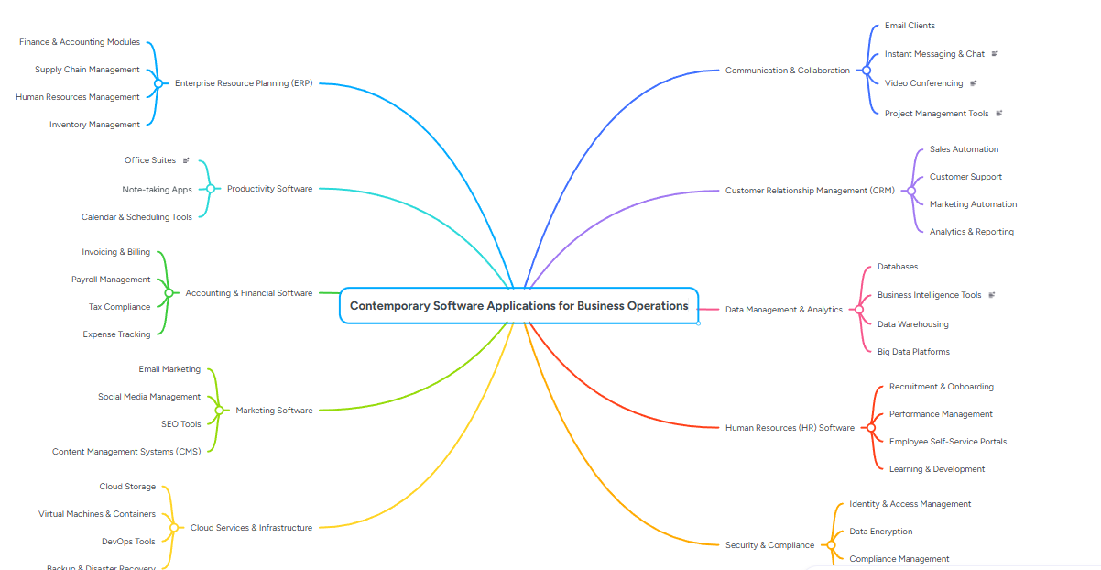
As you can see on this screen this is screenshot of the mind map which explains the process of how the business operates and what the procedure of a business operation

Microsoft application

Microsoft Word
Office software is the main backbone of modern business operation, that enables organisation to be able to implicate, store present, and analyse information efficiently, below is the detailed explanation of the four core Microsoft office solution: word, PowerPoint, Excel, and Access, covering their main purpose of their own key features and benefits, limitation, and business use cases [9]
Office package is the main industry standard word processor is known for implicating and formatting and managing written business documents
Major Features
- Advanced formatting: Styles, templates, headers/footers, tables, images, SmartArt, and page layout control.
- Automation: Mail merge, macros, table of contents, citations, bibliography, cross-referencing .
- Collaboration: Real-time co-editing via OneDrive/SharePoint, comments, track changes, version history.
- Accessibility & Security: Spell/grammar check, Editor AI, read-aloud, password protection, PDF export .
- Integration: Embed Excel charts, PowerPoint slides, link to other Office apps.
Business for Benefits
Consistency: with Microsoft word has a consistency template which allows business to use for brand compliance across letters, reports policies
Efficiency: it allows business to merge automated personalised letters/invoice; styles reduce rework
Teamwork- Remote/hybrid teams edit and review in real time without version confusion.
Limitation Not for large data: Poor database or heavy spreadsheet functionality.
- File size: Very long/complex documents may slow down or corrupt.
the limitation for MS word it has a limited capacity of word size of 512MB
- Learning curve: Advanced formatting and macros take time to master.
-The cost for full desktop version requires Microsoft 365 this comes with a monthly subscription of £4.60- £9.90

Microsoft PowerPoint
Purpose: Visual presentation software to communicate ideas, data, and strategy clearly.
Major Features
- Design tools: Themes, layouts, slide master, colour schemes, image/video/audio embedding.
- Animation & Transitions: Build-ins, motion paths, slide transitions, screen recording.
- Data Visualisation: SmartArt, charts linked to Excel, infographics, interactive hyperlinks.
- Delivery: Presenter view, speaker notes, timer, laser pointer, live sharing, online broadcast.
- Collaboration: Comments, shared editing, cloud storage, co-authoring across devices [10].
Limitations

- Risk of over-design: Too many animations/effects distract from key messages.
- Static by default: Less dynamic than web-based dashboards; not for real-time updates.
- Data limitations: Charts work best with summarised data, not raw datasets.
- File bloat: Embedded media can make files large and hard to email.

Microsoft Excel
Purpose: Spreadsheet application for organising, calculating, analysing, and visualising numerical data.
Major Features
- Structure: Rows/columns/cells; multiple worksheets per workbook; tables and ranges.
- Calculations: 400+ built-in functions (SUM, VLOOKUP, IF, financial/statistical formulas).
- Analysis: PivotTables, Pivot Charts, conditional formatting, data validation, sorting/filtering.
- Visualisation: Line/bar/pie charts, histograms, sparklines, maps, conditional colour scales.
- Automation: Macros, VBA scripting, Power Query, Power Pivot, real-time cloud sync.
- Security: Protect cells/workbooks, audit formulas, track changes, restrict access [11].
Limitations
- Not a true database: Struggles with >100,000 rows; risk of duplicate/inconsistent data.
- Formula errors: Mistakes in links/functions can cascade across sheets.
- Security gaps: Workbooks easily copied/shared; no role-based access control.
- Learning curve: Advanced features (Power Query, VBA) require training.

Microsoft Access
Purpose: Relational database management system (RDBMS) to store, organise, retrieve, and report on structured business data.
Major Features
- Relational Design: Create tables, define primary/foreign keys, avoid duplication, link related data.
- Query Tools: Filter, sort, combine data; build complex search logic without coding.
- Forms: User-friendly interfaces to input/edit data safely, reduce entry errors.
- Reports: Auto-generate formatted summaries, invoices, customer lists, and analytics.
- Automation & Integration: Macros, VBA, import/export Excel/CSV/SQL, connect to other systems.
- Security: User-level permissions, encryption, password protection, audit trails.
Benefits for Business
- Data Integrity: Single source of truth; no duplication; enforce rules/validation.
- Efficiency: Queries retrieve specific data in seconds vs. searching spreadsheets.
- Growth: Handles 100k–2GB datasets; ideal for SMEs scaling beyond Excel.
- Cost-Effective: Included in many Microsoft 365 business plans; cheaper than SQL Server for smaller use.
- Customisation: Build bespoke systems: CRM, inventory, asset tracking, membership management.
Limitations
- PC-Only: Not available on Mac/mobile; limited web-browser functionality.
- Scaling Cap: Not suitable for enterprise-scale or multi-user heavy-load operations.
- Technical Learning: Relational logic and design require training; no drag-and-drop simplicity [12].
- Compatibility: Less universal than Excel; users often need Access installed to open.
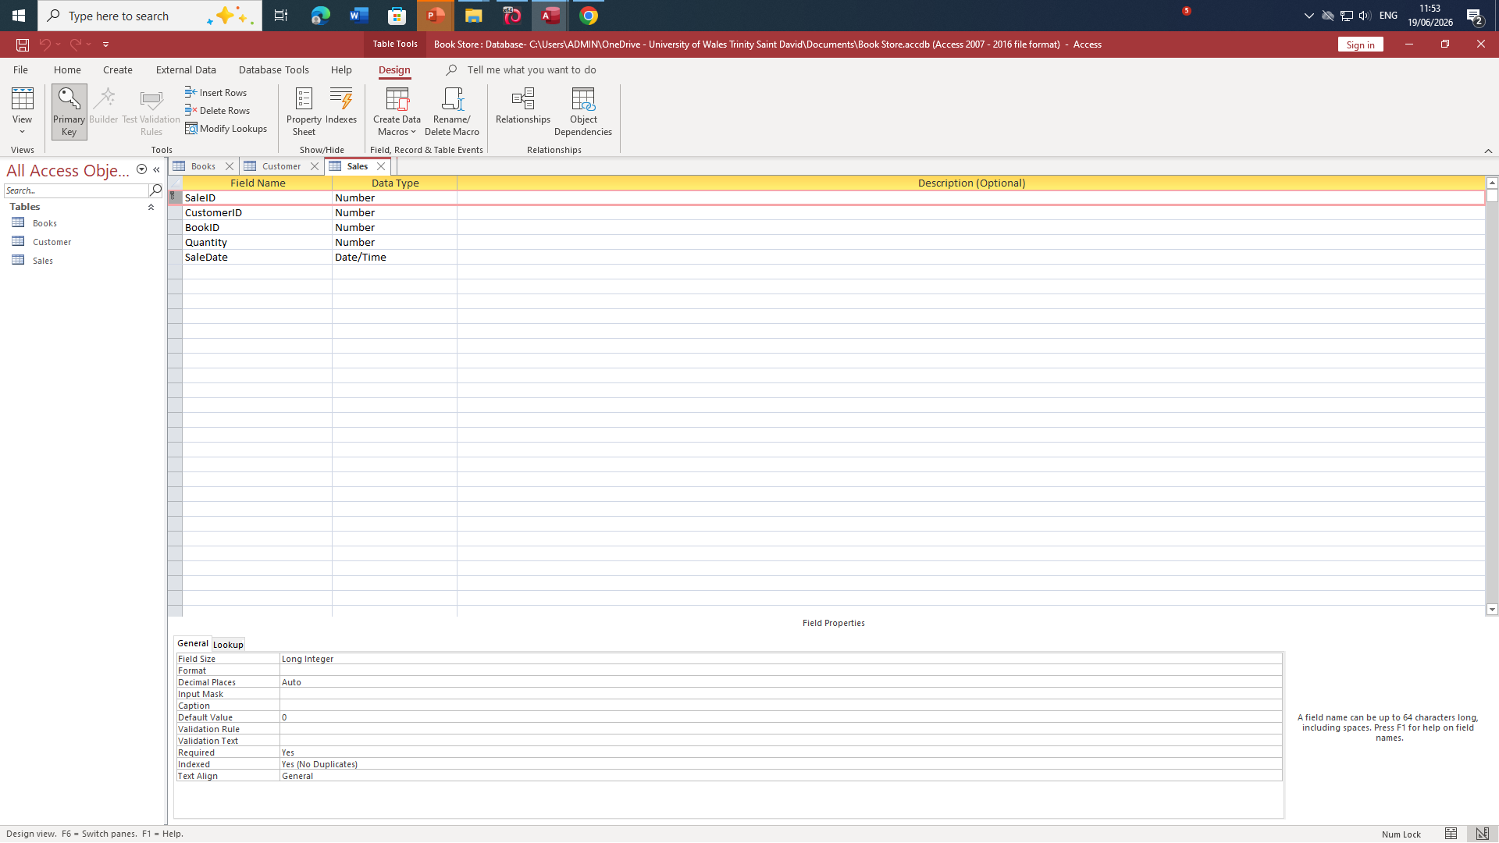
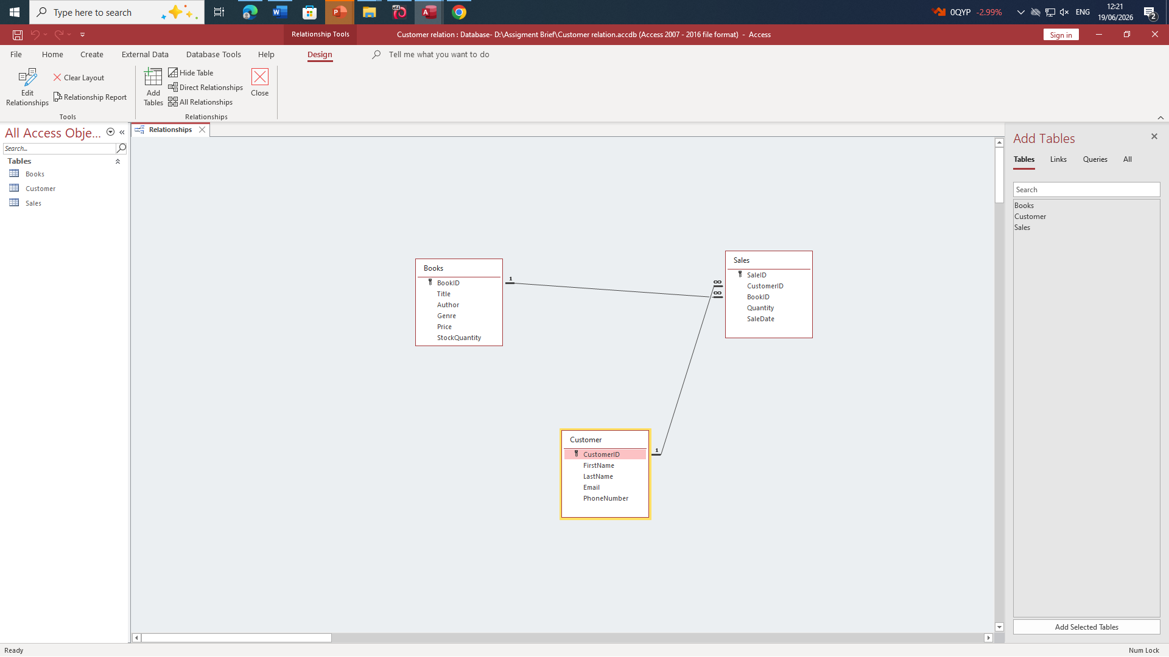

Practical Application

IF function

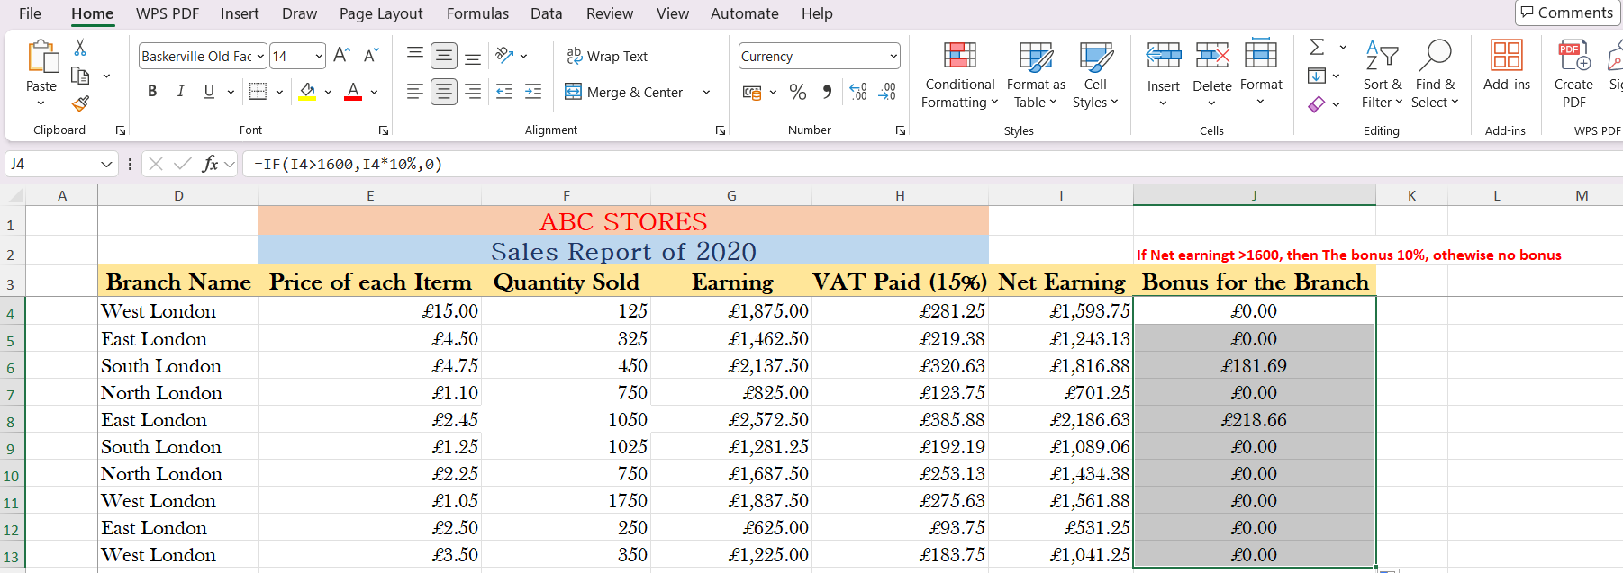
This is a screenshot of the IF function which shows the example of the calculation like for instance on the screenshot states if one of the net earning is more than £1,600 then the bonus will be 10%

VLOOKUP
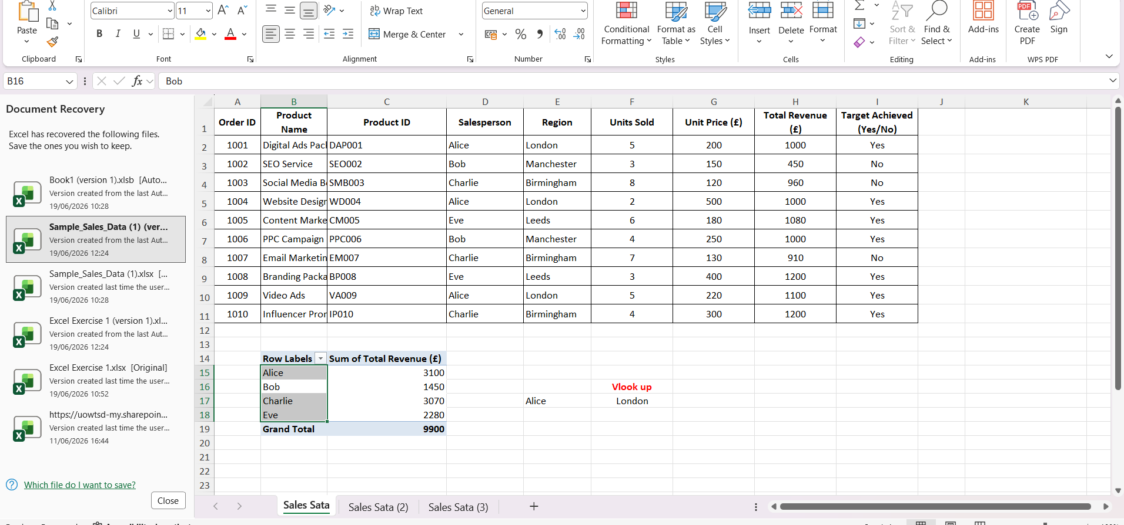

This is a screenshot of the VLookup Pivot Table which shows the number of units everyone has done
Purpose: To retrieve and display matching information from a separate data table by searching vertically down the first column of a defined range. Essential for linking datasets and automating lookups.
Note: This task is based on your own practical activities.

Task 4. Communication and Collaboration applications
MS Teams: A collaboration app for personal, family, and business use.
Provides an all-in-one platform for communication, meetings, and file sharing.
Available on desktop, mobile devices, and web browsers.
Who Uses Microsoft Teams?
Individuals & Families – Stay connected with loved ones.
Businesses & Enterprises – Enhance team collaboration.
Educational Institutions – Virtual classrooms and remote learning.

Outlook: A widely used email application in businesses and organizations worldwide.
Part of Microsoft 365 (O365), available as a desktop application and cloud-based tool [15].
Common Features:
- Sending & receiving emails
- CC & BCC, pinning emails
- Contacts & Calendar for scheduling
- Task lists & automatic replies
- Email signatures
- Spam & junk mail filters

Testing Outlook feature: Scheduling a meeting

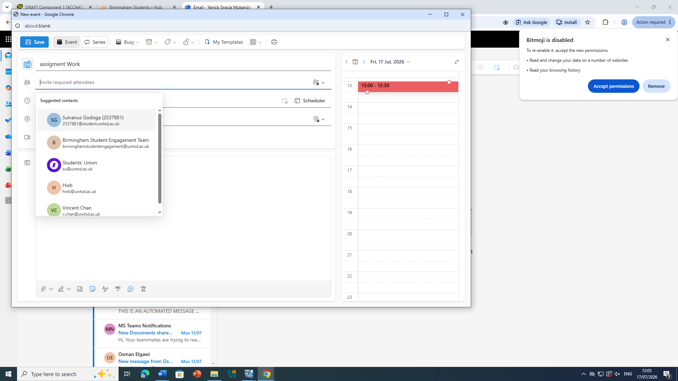

Testing Ms Teams feature: video conference call
In this screenshot as you could see on this screen I used this app to implicate a video conference call
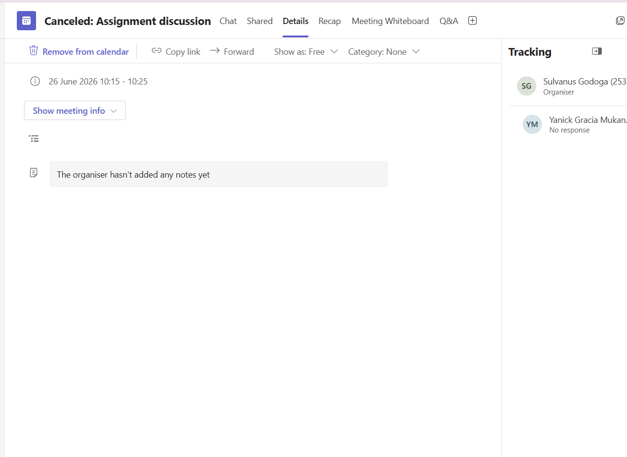

Using Microsoft Team, I conducted a video conference call with my classmate

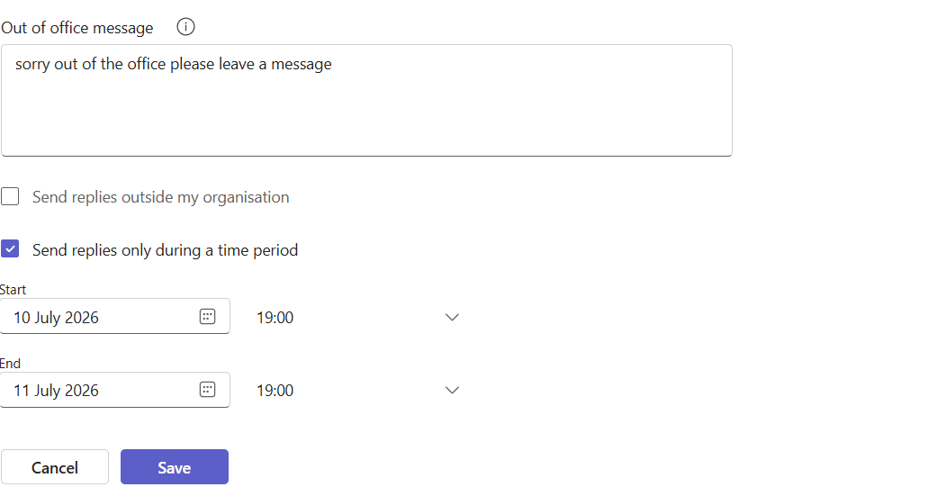

With this feature you could change it this will notify other members that you are out of office this can also be done via the app you can choose when to set the out of office hours various organisations use this prompt for work purposes
Microsoft Teams acts as the central hub within the Microsoft 365 ecosystem. While it also offers strong communication features, its core design is built around structured workspaces and real-time document collaboration — making it a standard choice for organisations already using Office applications [13]
Key Features & Business Benefits:
- Team & Channel Workspaces: Each “Team” represents a department, project, or whole organisation; channels organise work stages or topics. Every channel automatically provides access to shared files, a shared notebook, calendar, and meeting scheduling.
- Simultaneous Co-authoring: Defining feature — Word, Excel, PowerPoint files stored in linked SharePoint/OneDrive open directly within Teams. Multiple authorised users can edit at the same time; coloured cursors, presence indicators, and inline comments eliminate “version confusion” and email-attached file chains.
- Complete Meeting Platform: Supports everything from daily stand-ups to large-scale webinars — including breakout rooms, live captions, recording, and transcription features.
- Enterprise-Grade Compliance: Fully supported by Microsoft Purview, offering encryption, retention policies, legal hold, and eDiscovery — fully suitable for regulated industries and UK public services handling sensitive data.
- Cross-Platform Access: Fully functional apps for Windows, macOS, iOS, Android, and web — consistent experience wherever work takes place.
- Low-friction Adoption: Deep integration with familiar Office tools means minimal extra training required for most users.
Modern business- in the modern business whether office-based, remote or hybrid- depends entirely reliable digital tools to support teamwork. Communication tools focus on how each information is exchanged between people and teams, while collaboration tools can provide shared workspace where work is created and implicated, using this feature you can and edit and keep track of each task completed these types of technologies can reduce email overload to ensure that everything is under control and support compliance

Reference

- Shopify Inc. (2026) About Shopify: The all-in-one commerce platform. Available at: https://www.shopify.co.uk/about (Accessed: 16 June 2026).

- Ecommerce Platforms (2025) ‘Shopify review: features, pricing and performance’, Ecommerce Platforms, [online]. Available at: https://ecommerce-platforms.com/shopify-review (Accessed: 16 June 2026).

- UK Department for Business and Trade (2024) Digital tools for small business: e-commerce solutions. London: HMSO.

- Wix.com Ltd. (2026) Wix Stores: build your online business. Available at: https://www.wix.com/ecommerce/stores (Accessed: 16 June 2026).

- TechRadar (2025) ‘Wix review: flexible design meets solid selling features’, TechRadar, [online]. Available at: https://www.techradar.com/reviews/wix-ecommerce (Accessed: 16 June 2026).

- Small Business UK (2024) Choosing a website builder for retail and service businesses. Available at: https://www.smallbusinessuk.net/guides/technology/website-builders (Accessed: 16 June 2026).

- Buzan, Tony, and Barry Buzan. The mind map book. Pearson Education, 2006.

- Windura, Sutanto. Mind map for business effectiveness. Elex Media Komputindo, 2008.

- Lambert, Joan. Microsoft Word step by step (Office 2021 and Microsoft 365). Microsoft Press, 2023.

- Bossé, Chantal. Microsoft PowerPoint Best Practices, Tips, and Techniques: An indispensable guide to mastering PowerPoint's advanced tools to create engaging presentations. Packt Publishing Ltd, 2023.

- Winston, Wayne. Microsoft Excel data analysis and business modeling (Office 2021 and Microsoft 365). Microsoft Press, 2021.

- Eckstein, Jonathan, and Bonnie R. Schultz. Introductory relational database design for business, with Microsoft Access. John Wiley & Sons, 2018.

- Ilag, Balu N., and Arun M. Sabale. "Microsoft teams overview." Troubleshooting Microsoft Teams: Enlisting the Right Approach and Tools in Teams for Mapping and Troubleshooting Issues. Berkeley, CA: Apress, 17-74. 2022.

- Kepczyk, Roman H. "Microsoft Outlook: Improving Communications and Productivity." CPA Prac. Mgmt. F. 6 (2010): 14.

