BLOGGING TO COMMUNICATE

1. Marketing mix concept of Tesco
Tesco is a British multinational company. It is basically a general merchandise and groceries retailer. The Tesco supermarket which is the biggest part of this brand sells many types of household and food products. It also sells a very wide range of clothing products. The branches of this brand are spread across many regions of the world. The marketing mix concept also applies to this particular brand. This particular concept is utilised to avoid the weaknesses. It is also used to optimize the strengths. There are basically 4 different aspects of this concept.
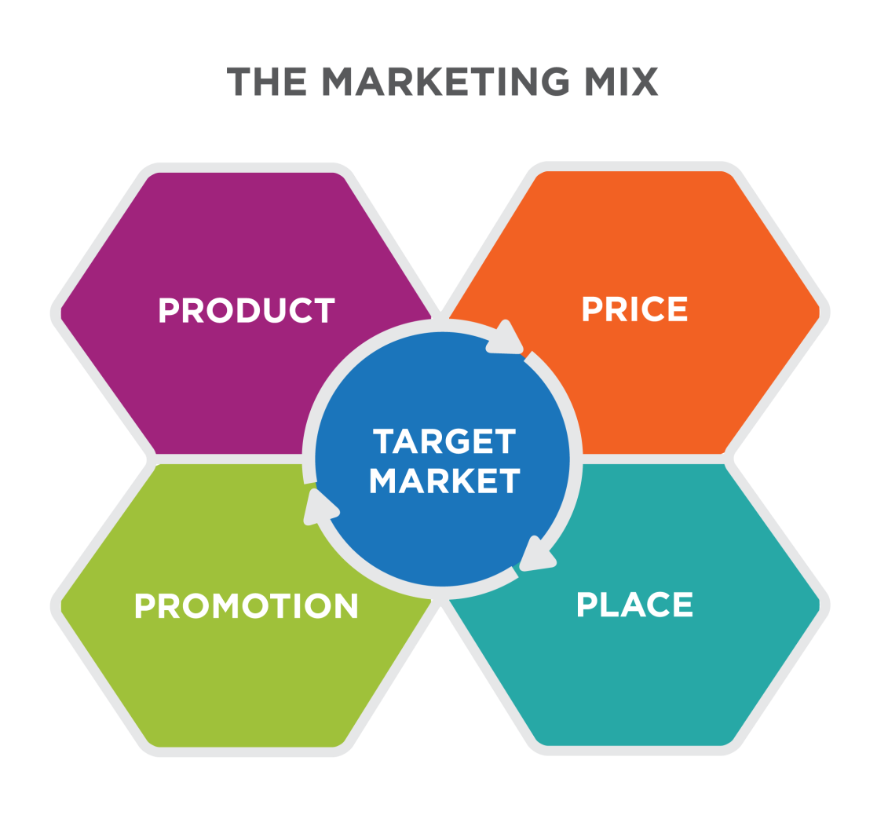
Price- This particular brand mainly follows a competitive pricing strategy. In this particular pricing strategy the costs of the products are mainly based on the market competition and the market scenario. Though it is a very common pricing strategy, this particular brand has used this pricing strategy with great effectiveness (Rėklaitis and Pilelienė, 2019). Due to this particular pricing strategy this particular brand has made a lot of profit in recent times. Using this particular pricing strategy in an effective manner has contributed to the success of the brand. The management of this particular brand studies the market scenario and makes pricing decisions accordingly. This particular pricing strategy has suited this particular brand and it has helped them to increase their profit margin to a very big extent.
Product-A wide range of products is sold by this particular brand. in the Tesco supermarket products from food to clothing are sold at a reasonable rate. Due to the availability of basic commodities this particular brand is very popular among middle income and low income group people. due to this particular factor the client base of this particular brand is very high. This is a strength of this particular brand as due to the high client base the profit margin is also high for this particular brand. Within the clothing and food departments there is a lot of variety from which the clients can choose from. As a result the satisfaction of the clients is very high as they get most of the things they Desire from this particular brand at an affordable price.
Place-This particular brand has around 800 different branches all across the world. The supermarket chain is mainly UK-based but it has also got 57 different branches spread across different parts of the world. Other than the United Kingdom in Scotland, this particular brand has got a very strong presence. The huge client base of this brand is due to the spread of the brand in different places.
Promotion- This particular brand has used digital mediums to advertise their products so that more and more people are influenced by those advertisements. This particular brand has also used different types of social media platforms to advertise their products and also introduce the different offers or discounts they are offering in the prices (Rėklaitis and Pilelienė, 2019). Their promotional strategies have proved to be highly useful.

2. Market segmentation of Tesco
In the marketing segmentation concept, a huge number of clients with Tesco is broken down into smaller segments or smaller fragments so that the analysis of these segments becomes much simpler or easier. By doing this the profit margin can be calculated in a much simpler manner. This particular process has proved to be highly useful for making different types of analysis. The marketing segmentation has many different aspects and each aspect needs to be analysed carefully.

Geographic- A very important role is played by the geographical location of the branch in the preference of a particular product or a particular brand by the customers residing in that location. As a result this particular brand management has made business Strategies and marketing strategies according to the location of the branch. The marketing department of this particular brand has made a very intricate study on the behaviour of the various customers and their preferences and choices in a definite location. It has then manufactured products according to the preferences and choices of the customers or clients residing in that particular location. In this way this brand has been able to increase the overall profit margin and the overall turnover within a short period of time.
Demographic-This particular brand generally targets customers from the middle income and low income group. This is because they sell the most essential items like clothing and groceries. However, there are a lot of varieties in the clothing sector full stop within the varieties (Martin, Javalgi and Ciravegna, 2020). There is also a section whose price is extremely high and it is only made for the high income group individual. The target age group of customers of this particular brand is generally 22- 45 years of age. Though this particular brand sells accessories and clothing for men but mainly they sell a lot of products for women. However, the demographic strategy of this particular brand is also dependent on the location of the branch of this particular brand. The primary target of this particular brand is to increase the profit margin as much as possible over a short period of time.
Physiographic-In the physiographic aspect the emotional aspects of the different customers are analysed in a proper manner to understand the buying pattern of the customers. It is a very essential aspect for marketing strategy making with this particular company.
Behavioural- In this particular aspect the various buying patterns of the customers are analysed in a very minute manner. It is very similar to the physiographic aspect but it mainly focuses on the buying patterns of the customers. This pattern is used to make strategies by the marketing department of the brand for increasing the overall profit margin.

3. Targeting strategies of Tesco
Locating the target customers is a very essential thing for increasing the overall profit margin in business. Tesco has been doing this job in a very efficient manner and it is one of the primary reasons for the success of this particular brand. for locating the target customers and the buying patterns and the buying behaviour of the customers are studied very keenly by the marketing department of this particular brand (Kim, Kang and Lee, 2021). Accordingly strategies are made and promotional campaigns are done to attract more and more customers to buy the products from this particular brand.

It is a very essential aspect to increase the overall popularity and also the annual turnover of the brand within a short period of time. Due to this particular factor this brand has got a very renowned name all across the world. it can identify the potential customers from whom a lot of buying is expected. In this way the forecasting is done by this particular brand and due to the proper levels of forecasting the future strategies are also prepared in an efficient manner by this definite brand. To find the target customers who can contribute to the overall development of the brand is extremely important for the overall growth of the brand. However, this particular brand devices strategies in different ways to find loyal customers who will contribute to the overall growth and development of the brand. Other than customers there are so many different other stakeholders who are associated with this particular brand. Hence, finding the right stakeholders who can contribute to the overall growth and development of the brand in a positive manner is a very essential thing for this particular brand. Therefore, all the strategies including the advertising and promotional strategies are also based on finding the loyal customers and the right stakeholders (Martin, Javalgi and Ciravegna, 2020). This is an extremely essential aspect for the overall improvement of the brand within a short period of time.

4. Positioning with respect to business
Positioning in business is a very essential strategy for the overall growth of a brand. Tesco wants to establish or position itself within the top brands of the world to get a very good reputation and survive in the global business market. for this particular purpose it must have loyal stakeholders and also customers. As of September 2020, Tesco was the market lead followed by Sainsbury and ASDA with a market share of 26.8%.
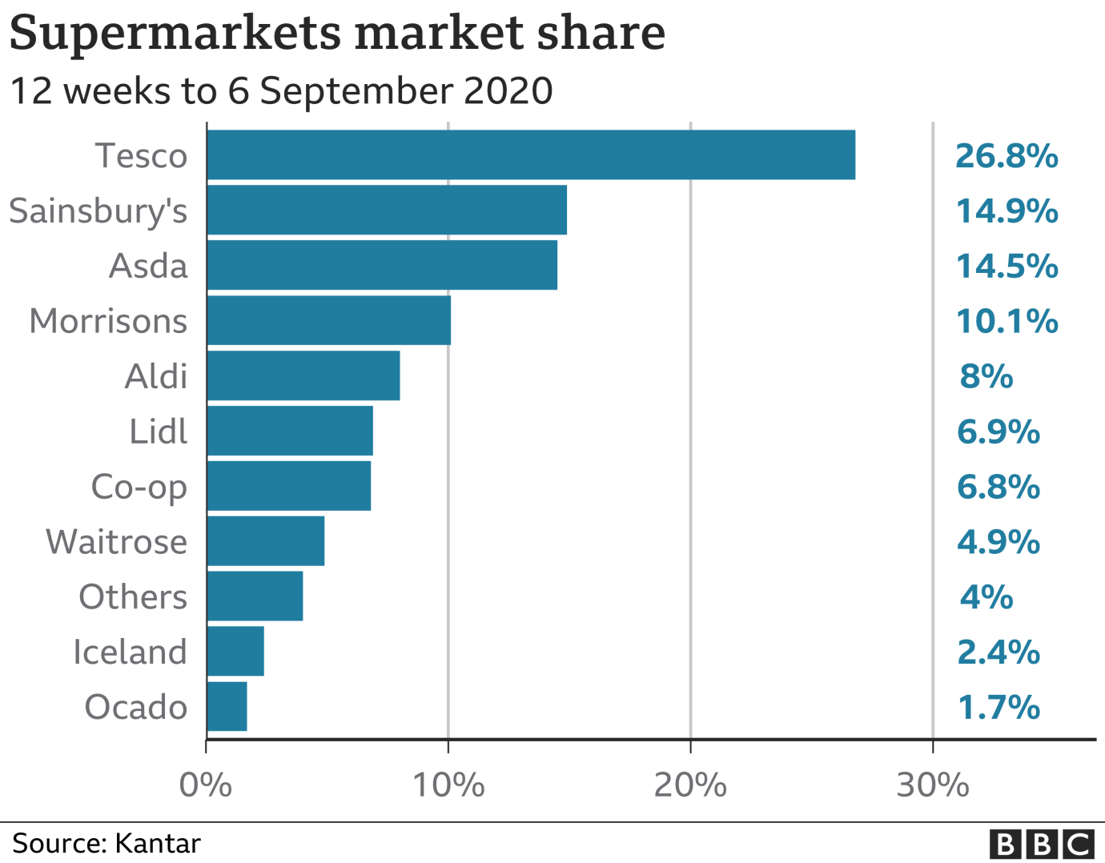
For the overall growth and development of the brand it needs to have a long-term strategy which will be beneficial for the increase of profit margin and the annual turnover of the brand (Amin and Priansah, 2019). Hence, for this particular purpose this particular management of the brand is trying to develop such a strategy so that it can establish itself into the top brands of the world. Only then it can survive in the Global Business market as the Dynamics of this Global Business market change extremely fast. The quality of product this particular brand manufactures has also improved and this shall also help them to establish itself into a very reputable brand which the customers can trust always. The skill level of the workers is another essential aspect for the establishment of the brand into a reputable brand. For this particular purpose, training and workshops are regularly conducted for the employees of this brand so that their skill levels can improve and they can deliver the best within a very short period of time. This particular brand has already established itself into a very honest and trustworthy brand among those customers all over the world. As a matter of fact this particular brand wants to expand to different parts of the world and make a name for itself for making the best quality products.

5. Different aspects of marketing communication
Advertising in marketing communication
It is a very important part of marketing communication. Good level of marketing communication can be done through proper levels of advertising. By the process of innovative advertisement potential customers can be transformed into active customers which will result in the overall profit of the company. Tesco has utilised this particular aspect for proper marketing communication and also development of the brand.
Marketing in a digital manner
This particular brand has used many types of social media platforms to launch and advertise their products in many different innovative manners (Zhao et al, 2020). They have done this or used this particular strategy as the management group knows very well that a huge number of people in today's times use social media. For this purpose Tesco has advertised their products through social or digital media so that they can reach out to more customers. For example, once Tesco asked their customers to share their personal recipe on social media in a campaign called ‘Food Love Stories’. It encouraged customers to make their favourite food for the people they love.

Sales promotion in marketing communication
Sales promotion is a very essential aspect of marketing communication. Proper sales promotion or promotional events of the products of this particular brand has helped to attract a huge number of customers and increase the overall client base of this particular brand. Due to this particular aspect Tesco supermarket has made promotional events of the various products and services a very essential priority of the marketing communication aspect. For example, the ‘Boxing Day’ sale of Tesco allows customers a maximum of 75% discount on several products. The marketing department of this particular brand has understood very well that sales promotions are extremely essential for increasing the popularity of their products and ultimately selling their products to their customers.

6. Marketing communication effects
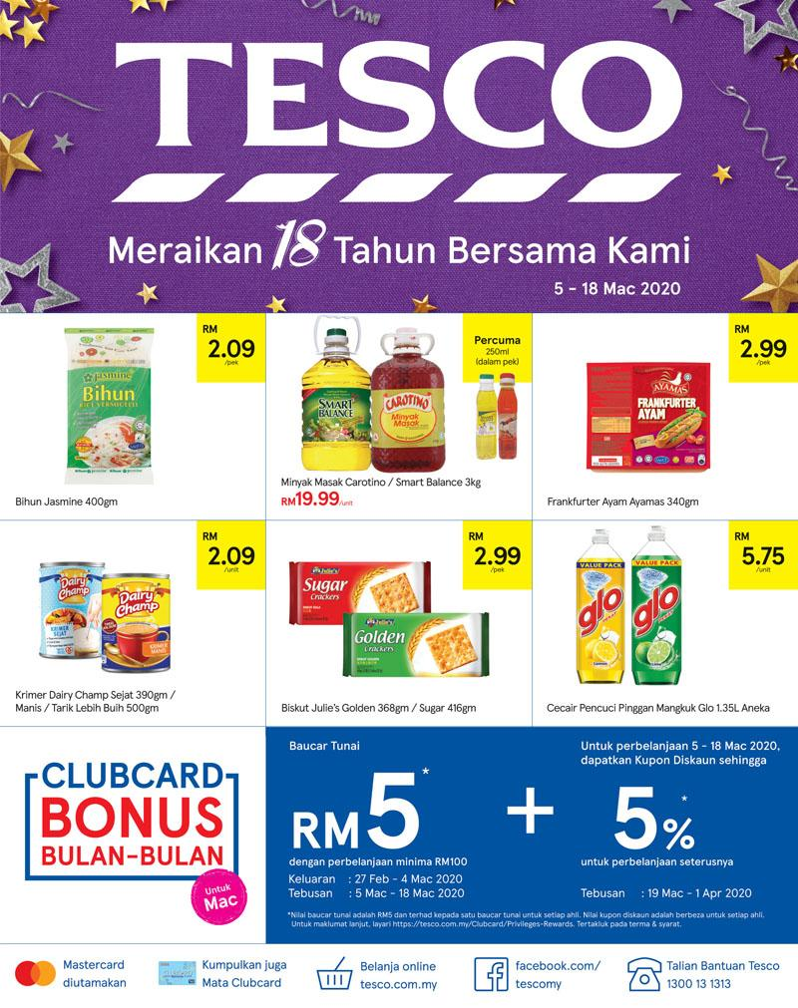
Tesco uses the marketing communication techniques in a very effective way to make huge margins of profit and also increase the reputation of the brand. The way this particular brand and the marketing department of this particular brand interacts with different clients across the world leaves a positive impression and effect into the minds of clients and other stakeholders. Due to this purpose the clients and the stakeholders are always interested in contributing to the growth of the brand. This is an extremely positive development for the brand and it was only possible because of good and efficient levels of marketing communication. To reach out to the customers and influence their buying patterns is a very essential aspect to survive in the competitive global business industry (Ascarza et al, 2017). For these particular purpose proper levels of marketing communication is a very vital aspect. Tesco offers club card bonus and special weekly discounts in order to boost sales. Without proper levels of marketing communication this particular aspect can never be fulfilled or completed in a proper manner and as a result the growth of the company could suffer. However the efficient marketing and strategic team of this particular brand always pays extra attention towards proper marketing communication for the overall growth of the brand in the right way. This is a very essential aspect of the brand for its overall development. Without this aspect the brand could not have flourished.

Reference List
Journals
Ascarza, E., Ebbes, P., Netzer, O. and Danielson, M., 2017. Beyond the target customer: Social effects of customer relationship management campaigns. Journal of Marketing Research, 54(3), pp.347-363. Available at: https://www0.gsb.columbia.edu/mygsb/faculty/research/pubfiles/15032/SSRN-id2664794.pdf
Amin, M.A.S. and Priansah, P., 2019. Marketing Communication Strategy To Improve Tourism Potential. Budapest International Research and Critics Institute-Journal (BIRCI-Journal), 2(4), pp.160-166. Available at: https://pdfs.semanticscholar.org/5563/334c881bb2a151493ffdc805c7e0a8915281.pdf
Kim, J., Kang, S. and Lee, K.H., 2021. Evolution of digital marketing communication: Bibliometric analysis and network visualization from key articles. Journal of Business Research, 130, pp.552-563. Available at: https://e-tarjome.com/storage/panel/fileuploads/2019-12-23/1577103894_E14119-e-tarjome.pdf
Martin, S.L., Javalgi, R.R.G. and Ciravegna, L., 2020. Marketing capabilities and international new venture performance: The mediation role of marketing communication and the moderation effect of technological turbulence. Journal of Business Research, 107, pp.25-37. Available at: https://e-tarjome.com/storage/panel/fileuploads/2019-12-22/1577018918_E14117-e-tarjome.pdf
Rėklaitis, K. and Pilelienė, L., 2019. Principle differences between B2B and B2C marketing communication processes. Organizacijų vadyba: sisteminiai tyrimai= Management of organizations: systematic research. Kaunas: Vytauto Didžiojo universitetas; Sciendo, 2019, T. 81. Available at: https://www.vdu.lt/cris/bitstream/20.500.12259/101336/1/ISSN2335-8750_2019_N_81.PG_73-86.pdf
Zhao, X., Zhu, Z., Alfifi, M. and Caverlee, J., 2020, April. Addressing the Target Customer Distortion Problem in Recommender Systems. In Proceedings of The Web Conference 2020 (pp. 2969-2975). Available at: https://dl.acm.org/doi/pdf/10.1145/3366423.3380065?casa_token=Gfo9_oTlGn8AAAAA:-UWX1hAulGAH4zgbFV9w0RwRKwdEIJaOnnFyt-ifkvDie-9UalEDeTsiY43PYD9ZFf-64lIRuVMfXQ

