University of Wales Trinity Saint David
Wales Institute of Science and Art


Vehicle Electronics

Vehicle Electronics - ACHA4031

Reid Lupton
2517853
31/03/2026

Contents
1 Task 3 1
1.1 Scope Time Division Calculations (6) 1
1.2 Function Generator output square wave (6) 1
1.3 Capacitor charge and discharge wave marked at correct points. (6) 1
1.4 Basic Capacitor Calculations (6) 1
1.5 Capacitor discharge table (5) 1
1.6 Plot log(V) Gradient (5) 1
1.7 Gradient Calculations and Compare(8) 1
1.7.1 Gradient Calculations 1
1.7.2 Comparison table 1
1.8 Capacitor Uses (5) 1
1.9 Inaccuracies Question (4) 1
1.10 Risk Question (10) 1
2 References 2

Task 3

Scope Time Division Calculations (6)

Function Generator output square wave (6)
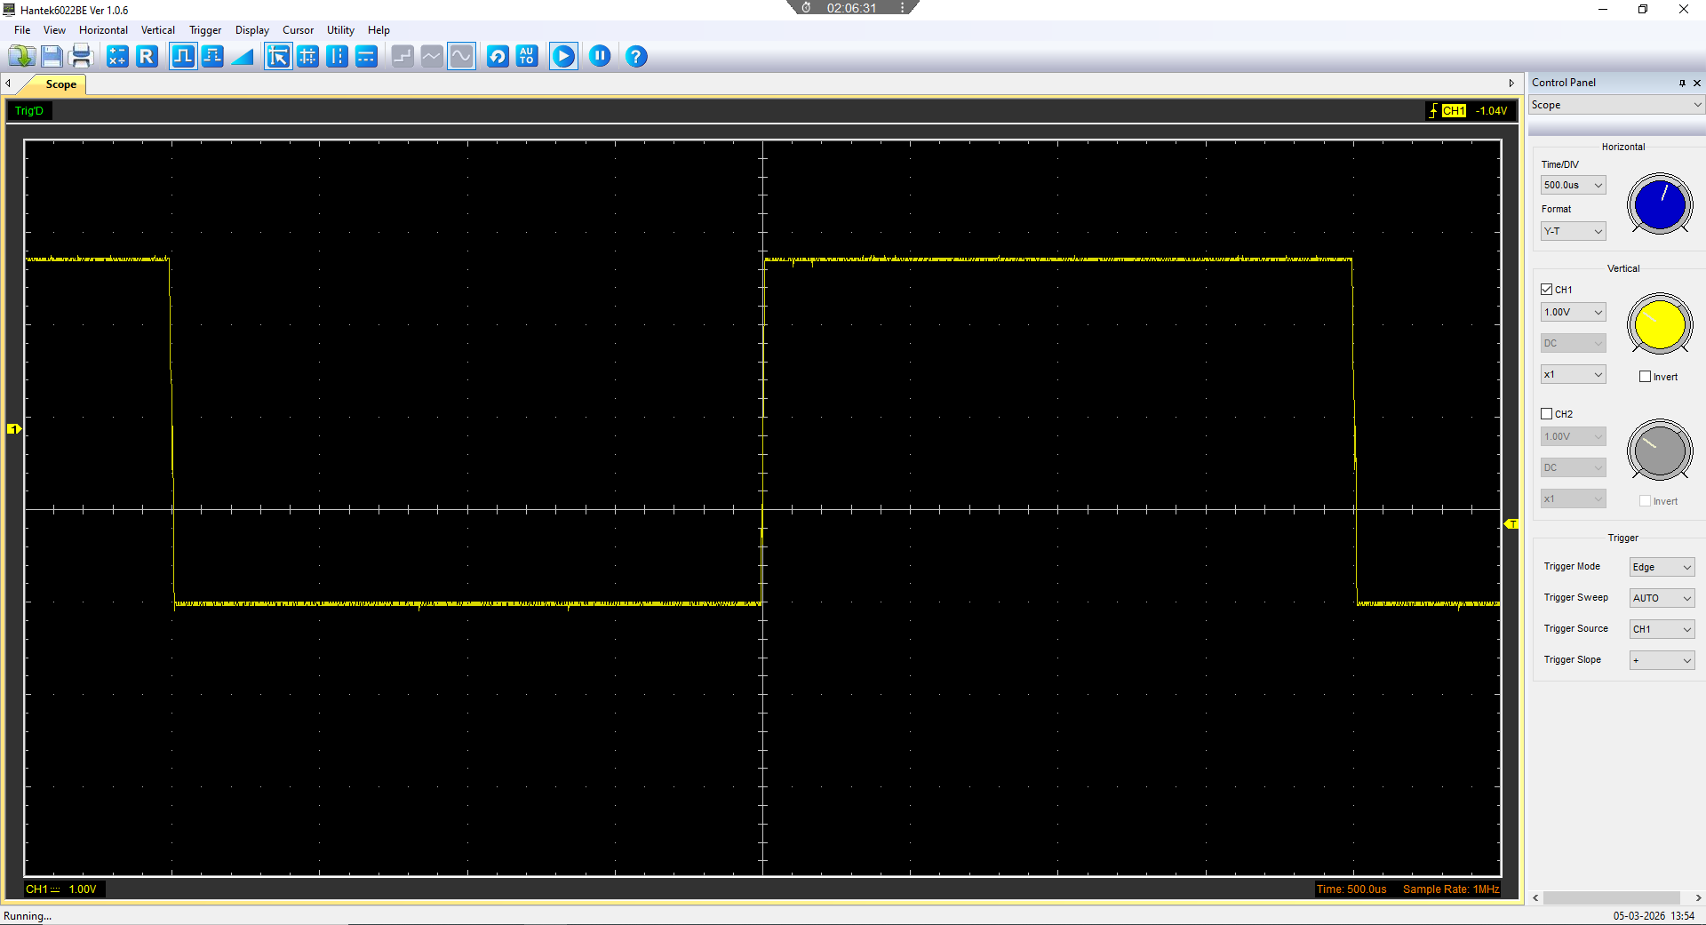
Figure 1- AC Square wave displayed on the oscilloscope

Capacitor charge and discharge wave marked at correct points. (6)
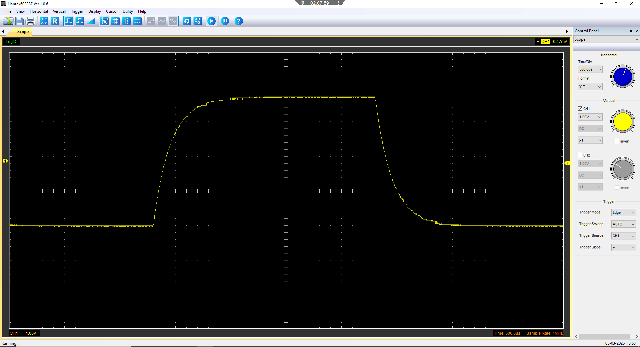
Figure 2- shows the wave form of a capacitor charging and discharging

Basic Capacitor Calculations (6)

Capacitor discharge table (5)
Time (s) | Voltage (V) | ln (V) | dy = y2 – y1  dy = ln(V)2-ln(V)1 | dx = x2- x1  dx = Time2 – Time1 | dy/dx
0.000999 | 3.6667 | 1.299292 | x | x | x
0.001055 | 2.851 | 1.04767 | -0.251622265 | 5.6E-05 | -4493.25
0.001111 | 2.2236 | 0.799128 | -0.248542306 | 5.6E-05 | -4438.26
0.001167 | 1.7844 | 0.579082 | -0.22004528 | 5.6E-05 | -3929.38
0.001223 | 1.5648 | 0.447758 | -0.131324204 | 5.6E-05 | -2345.08
0.001279 | 1.3138 | 0.272924 | -0.174834319 | 5.6E-05 | -3122.04
0.001335 | 1.1883 | 0.172524 | -0.100399987 | 5.6E-05 | -1792.86
0.001391 | 1.1255 | 0.118227 | -0.054296333 | 5.6E-05 | -969.577
0.001447 | 1.0314 | 0.030917 | -0.087310279 | 5.6E-05 | -1559.11
0.001503 | 1 | 0 | -0.030917103 | 5.6E-05 | -552.091

Plot log(V) Gradient (5)

Gradient Calculations and Compare(8)

Gradient Calculations

Comparison table
 | Capacitance | Delta | Percentage difference
Actual | 1 µF | x | X
Marker Calculation
Gradient Calculation

Capacitor Uses (5)
number | Area of use | Use
1 | General Electrical | Smoothing the output od DC power supplies
2 | General Electrical | Storing electrical charge and discharge the charge.
3 | General Electrical | Filtering noise
4 | Automotive | Ignition systems
5 | Automotive | Filtering voltage from alternators
6 | Automotive | Stop start systems in modern vehicles
7 | Automotive | Indicator relays use capacitors to control timing of the indicators
8 | Motorcycle | Batteryless ignition systems
9 | Motorcycle | Filtering voltage from alternators
10 | Motorcycle | Indicator relays use capacitors to control timing of the indicators

Inaccuracies Question (4)
The data collected could be inaccurate due to the inconsistencies with the equipment used. The scopes used on the experiment was unreliable and data changed significantly between scopes.
A possible inaccuracy in the data collected could be the oscilloscope being set up incorrectly in software used to display and measure data.

Risk Question (10)

Modern vehicles have Controller Area Network(CAN) which is used to allow different Electronic Control Units(ECUs) to communicate. These CAN systems use a standardized cyber security risk management guidelines. These guidelines are called ISO/SAE 21434. CAN bus systems are not required to be encrypted or require device authentication.
A cybersecurity mitigation for these systems could be message authentication. As standard CAN bus can operate without sender IDs, however this allows spoofing attacks. This can allow for the vehicle to be started without the key as the attacker could spoof a trusted ECU. If every message is required to have a sender ID it would be significantly more challenging to spoof trusted ECUs. A drawback to this approach might be the need for specialised tools to diagnose issues and interact with the CAN system.
Another mitigation strategy could be encrypting the messages sent over the CAN bus system. This can prevent an attacker from being able to interact with the system. However, this will hinder the performance of the CAN system and will require specialist tools to diagnose issues and interact with the CAN system.

References

CAN Bus Security: The Unseen Cybersecurity Battle in Connected Vehicles | TechLatest. [no date]. Available at: https://tech-latest.com/can-bus-security-the-unseen-cybersecurity-battle-in-connected-vehicles/ [Accessed: 19 April 2026].

How Capacitors Work | HowStuffWorks. [no date]. Available at: https://electronics.howstuffworks.com/capacitor.htm [Accessed: 19 April 2026].

Oscilloscope - Wikipedia. [no date]. Available at: https://en.wikipedia.org/wiki/Oscilloscope [Accessed: 19 April 2026].

What is a Capacitor, And What is Capacitance? | Electrical4U. [no date]. Available at: https://www.electrical4u.com/what-is-capacitor/ [Accessed: 19 April 2026].

