Student name: Raul Trif
Student number: 2030167

Organizational Structure &Culture
Module code and title: LCBB4003 Introducing the Modern Workplace
Table of Contents
Introduction 2
Impact of Amazon’s organizational structure in its success 2
Vertical organizational structure 2
Impact of organizational structure in Amazon’s success 5
Impact of Amazon’s organizational culture in its business success 6
Influence of Amazon’s working environment to drive optimization in employee performance 8
Conclusion 9
Reference 10

Introduction
Organizational structure of any business farm is so critical for their persuasion of objectives that it helps delivering better values to the market which drives in accelerated sales and profit. Catlin-Legutko and Klingler, (2012) think structural orientation determines the effectiveness of company’s value chain through which processes can be optimizes and operational superiority would gradually bring in distinctive competence. Above it, organizational culture and traditional behavioral theories which are implemented in team works and business assignments, influence the employee motivation and determination of putting level best efforts in accomplishment of organizational goals and objectives. Amazon, the global e-commerce giant has proved these theories so well that they have set a new benchmark for businesses upcoming with their impressive success even during the economic recession in corona pandemic which has provided them a great fortune. This assignment investigates Amazon’s organizational structure and behavioral culture in order to establish whether these forces are truly impacting their success or not.

Impact of Amazon’s organizational structure in its success
The heavy portfolio which Amazon pursues can only be managed effectively only through strict and well-furnished organizational structure which helps decision making in optimized way. Organizational structure basically determines the way in which organizational resources would pass through the business channels towards the accomplishment of business objectives. The information and command passing channels it establishes are a major source of competitive effectiveness in business operations.
With a huge volume of customer segment throughout the globe, Amazon has been serving so effectively ever since its introduction that it is almost remain unchallenged in its targeted segment and has been continuously pushing greater value. This persuasion has been benefitting through the establishment of vertical organizational structure of Amazon. The structure entrails the information flow must passes from top level to downward direction.

Vertical organizational structure
A vertical corporate structure seems to be the classic top-down arrangement wherein administrators communicate downwards detailed guidelines towards staff members (Hersey, Blanchard and Johnson, 2017). Usually symbolizes a hierarchical organizational structure, well with CEO or chairman at the top. Top executives and other senior management would be the next layer downwards.
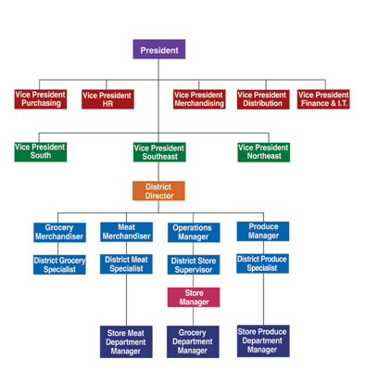
Figure-1: Illustration of vertical organizational structure.
Amazon firmly implements a vertical organizational structure all through its globalized business faculties. Any such top-down framework promises to somehow be unyielding and challenging to reform. Fortunately, Amazon apparently treated things brilliantly. Usually, senior managers constitute a majority of something like the actions, trying to give the impression of even a hierarchical organization. Woo, Keith and Thornton, (2015) noted that Amazon primarily began with a simple streamlined framework however transformed into such a hierarchical design which has supported them to implement rapid decision to adjust with the changing situations like recent COVID-19 pandemic. They were so fast and fluent toward easing the shopping and delivery system that customers who were already belonged to their potential sales were wholly transformed their habit into Amazon shopping as well as the new customer additional was exponential to the timeframe. There customer retention during pandemic period grew up-to 34% in 2020 and reported global sales of almost $260 billion (Işık, İbiş and Gulseven, 2021). The figure further increased in the first quarter of 2021 by $108.5 billion reporting a proportionate increase by 44% of the same period of last year as reported by Weise, (2021).
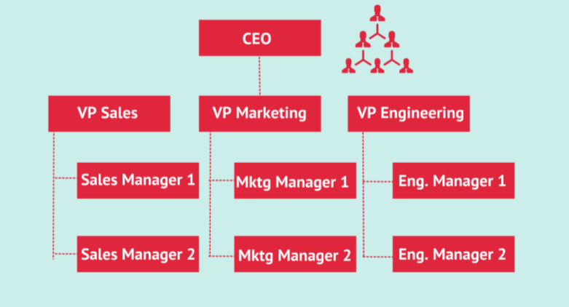
Figure-2: Proposed organizational structure of Amazon (Zotov, 2021)
The whole operation revolves around the decisions of CEO, the position was previously for founder of Amazon, Jeff Bezos now the Chairman of the corporation and currently the new CEO is Andrew Jassy. The board also consists of CFO, CEO for different services like web services, consumer treatments etc. divisional chiefs and geographic leaders. The above tiny team of professional administrators communicates directly to the Chief executive. This board, besides the CEO, specifies the organizational objectives, manages obstacles, and determines the direction of the business. Thus, their decisions are reviewed by the most experienced professionals in this discipline and therefore, Tomblin, (2010) thinks error detection is rather easier in this format of organizational structure. Such professionals are indeed the directors of their relevant department and also have a deep understanding of the associated techniques. This format highly encourages effective resource distribution and implementation of decisions throughout all the bodies of the organization.
Even extremely knowledgeable Company directors are just not frequently supplanted. Professionals remain largely in the very same role spanning periods. This thing helps understanding the sales and market trends and improvise strategies with accordance. Throughout this fashion, 'portfolio' seems to have been fundamental towards the company's future and even in the recent pandemic period they have demonstrated a large show of diversity in both distribution and offerings. Up to a specific point, each global offices usually established in different that promote a local strategy intended audience. Regarding international diversification, subdivisions are quite well determined.

Impact of organizational structure in Amazon’s success
Amazon’s organizational structure can well be characterized under three specific attributes as noted by Özsahin and Yürür, (2021) and they are:
Just about the only geographical divisions included are indeed Overseas and North America, ignoring the fact that perhaps the business is rather well everywhere. Just about the only geographical divisions included are indeed Overseas and North America, ignoring the fact that perhaps the business is rather well everywhere.
Just about the universal geographical divisions included under Amazon’s business are indeed Overseas operations and North America, ignoring the fact that perhaps the business is rather well-established everywhere around globe. Therefore, Byung Gon, (2016) commented that the company's primary interests and tangible geographic regions are factored into the equation.
Global hierarchy represent a worldwide identity of Amazon’s decision making where CEO is responsible for constructing the strategies depending on the environmental factors and communicate with divisional and regional chiefs for further delivery and implementation. This sort of centralized decision-making theory helps in rapid reaching out to strategic moves.
The global functional groups help in inclusion of actual market information and help business constructing decisions for global expansion. Every functional area is addressed by a VP or executive leader.
Their corporate structure appears robust, while it has facilitated the business's expansion plans. Supervisory recommendations can indeed be enforced quicker efficiently. Commercial and e-commerce constraints across various geographic locations may well be resolved appropriately. Investors, Chief executives, and administrators might well be accessible instantly. The priority is already on the consequences rather than for the technique (Hunter, 2021). Therefore, it is quite clear how it helps the business catering a great fortune during this pandemic period.

Impact of Amazon’s organizational culture in its business success
Amazon seems to have a corporate culture which thus empowers organizational resilience and adaptability towards e-commerce industry requirements. It has been practicing transformational corporate culture where they consistently emphasize on resource optimization. The element of corporate environment of either an organization provides the norms and principles which it part of a professional' actions. Amazon's workplace culture, as instance, encourages its employees should look outside the box in terms of coming up with new and innovative but also responses. As such world's greatest ecommerce website, this corporation has always been searching for innovative brains. Nonetheless, in order to sustain skilled workers, Briken and Taylor, (2018) proposes Amazon needs fortify its corporate environment in order to manipulate capacity building toward brief competitive edge.
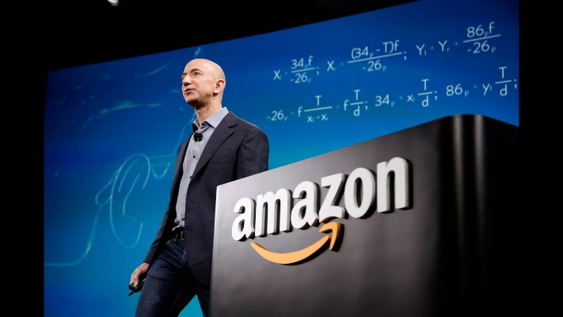
Figure-3: Dynamic and transformational organizational culture of Amazon set by Jeff Bezos has been boosting employee motivation and thus, capacity.

Amazon seems notable for such organizational way that embraces professionals to experiment and show initiative. Such behavioral environment should be responsible again for business's purpose of accessing out conceivable outcomes for using computation technologies to generate excellent internet shopping options. The key attributes of Amazon’s organizational culture that are driving it massive success according to Meyer, (2017) are discussed as follows:
- Strict and straight business initiatives: Amazon encourage the employees to really be aggressive in terms of sharing and launching newer business initiatives. Such corporate management element may well be witnessed between how the enterprise revolutionized the retailing of such a broader variety of markets worldwide, commencing primarily books, adopting bandwidth cloud computing. It promotes risk-taking tendency among the employees. The above corporate culture system enables Amazon with determine this same optimum conceivable option for addressing concerns while strengthening their e-commerce organization.
- Customer focused attitude: Amazon fosters professionals' commitment upon that requirements & preferences of customers. The business keeps committed to finding new tendencies and customer preferences, whereby it combines itself into online buying and support industries. Amazon's competence at delivering shoppers being perpetuated through this organizational values attribute as that of the online business expands.
- Unique practices: Amazon enables staff to have seen individuals and ones cooperate as differentiated from customary marketing practices. Norms, and per the company, restricts prospective business advancement. Consequently, via the same element of corporate environment, Amazon provides opportunities to learn well beyond boundaries throughout maximizing the e-commerce company's business prospects.
These attributes of organizational culture of Amazon clearly define its accomplishment of greatest sales and profits in pandemic period other than any other related businesses available. The business’s innovative working culture promotes employees to share their creative ideas and this is how they are regularly advancing at their particular aspect and deliver greater value consistently. Customer centric operations entail a major competitive advantage for the business to listen to the customer preferences and market trend. Situational variables are well-considered in their flexible business model and transformative managerial decision-making process.

Influence of Amazon’s working environment to drive optimization in employee performance
Employees are the biggest asset a business could possibly have. Amazon as a global business leader, has a tremendous reputation for outstanding employee management which helps them to achieve greater potentials out of employees and implement their ideas toward brining innovation in the organization. Moreover, in response to some of the market criticisms about wage and compensation, Amazon has recently increased a very notable percentage of salaries to its employees.
Overall, Amazon follows a transformational organizational culture which stimulate employee behavior where they can truly believe that they individually have special potentials and they are capable of inputting dynamic ideas which change the business prospects. The way Amazon manages its workforce is popularly called “HUMAN ENGINEERING”.

Figure-4: Picture illustrating driving employee potentials through developing capabilities.
Human engineering is the discipline examines individuals' psychosomatic characteristics within connection towards the requirements imposed on them because of the particular professions and the technologies they should deploy to really do such activities (Noe, Hollenbeck, Gerhart and Wright, 2017). This is rather a scientific workforce management system which helps the organization to identify the areas where their employees lack in potential amount of competence to serve their organizational objectives. This process is followed by launching training and development programs for the employees to develop qualities required by the job.
Moreover, Amazon has developed certain matrix to compare employee performance against to. This way they can identify the individuals who are underperforming. Over it, their organizational culture and norms compel their employees to agree to some particular principles. One amongst such, "Buyer Devotion," which emphasizes about this business's sincere passion to supporting their clientele, is also said to be featuring prominently beyond employee empowerment even honest contentment about customer service. Amazon leaves the implementation section of any strategy upon the employees according to the regional convenience and customer comfort. Moreover, they have launched frequent feedback system which enables them to review employee performance and provide adjustment when necessary. Besides, this initiative encourages their employees toward organizational dedication as they encounter their company’s interest in developing their capacity and sharpening their working methodologies. Feedback management system follows a yearly centralized review directly supervised by Amazon’s HR director himself. Their secret performance management tool enables managers to analyze their subordinates and keeps their employees focused on own assignment to outstand other colleagues.

Conclusion
To uphold the sales and profit volume that Amazon achieved so far this business can expand its operations into different e-commerce marketplaces, characterized by high emerging regions. To develop its strategic offerings and positioning further, Amazon can draw diversified operations which expands its portfolio further and increases its charm in competitive market. To adopt the regional culture of emerging markets, Amazon can launch strategic partnership with local enterprises for having information and acquiring market knowledge. Increasing employee engagement and cherishing employee satisfaction would bring more organizational goodwill as an excellent workforce managing business as well as attractive to young talents who could drive better sustainable business opportunities.

Reference
Briken, K. and Taylor, P., 2018. Fulfilling the ‘British way’: beyond constrained choice-Amazon workers' lived experiences of workfare. Industrial Relations Journal, 49(5-6), pp.438-458.
Byung Gon, R., 2016. The Multi-level Analysis on the Causal Relationship among Organizational Structure, Organizational Culture, and Organizational Effectiveness. Korean Review of Organizational Studies, 13(1), pp.33-62.
Catlin-Legutko, C. and Klingler, S., 2012. Organizational management. 8th ed. Lanham, Md.: AltaMira Press.
Hersey, P., Blanchard, K. and Johnson, D., 2017. Management of organizational performance. 4th ed. New Delhi: Pearson India Education Services.
Hunter, R., 2021. Compulsive Shoppers Flourish on Amazon during COVID-19 Pandemic. Journal of Medical Science And clinical Research, 09(03), pp.43-47.
Işık, S., İbiş, H. and Gulseven, O., 2021. The Impact of the COVID-19 Pandemic on Amazon's Business. SSRN Electronic Journal, 22(12), pp.34-45.
Meyer, P., 2017. Amazon.com Inc.’s Organizational Culture Characteristics (An Analysis) - Panmore Institute. [online] Panmore Institute. Available at: <http://panmore.com/amazon-com-inc-organizational-culture-characteristics-analysis>
Noe, R., Hollenbeck, J., Gerhart, B. and Wright, P., 2017. Fundamentals of human resource management. 6th ed. Harlow: Pearson edition.
Tomblin, M., 2010. Theory Development in Enterprise Systems and Organizational Learning. Journal of Organizational Computing and Electronic Commerce, 20(4), pp.398-416.
Weise, K., 2021. Amazon’s profit soars 220 percent as pandemic drives shopping online.. [online] Nytimes.com. Available at: <https://www.nytimes.com/2021/04/29/technology/amazons-profits-triple.html>
Woo, S., Keith, M. and Thornton, M., 2015. Amazon Mechanical analysis for Industrial and Organizational Psychology: Advantages, Challenges, and Practical Recommendations. Industrial and Organizational Psychology, 8(2), pp.171-179.
Özsahin, M. and Yürür, S., 2021. The Effect of Organizational Structure on Organizational Justice Perceptions of Employees: A review of Amazon's business boom during pandemic. International Journal of Organizational Leadership, 7(4), pp.440-453.
Zotov, V., 2021. Organizational Structure Modeling of Innovative Company. Revista Gestão Inovação e Tecnologias, 11(4), pp.1469-1477.

