ASSIGNMENT

ON

DATA Security,Governance and Compliance
ACCA7028

BY

XIN FANG
17/PG/CE/SC/DCS/004
COMPUTER SCIENCE DEPARTMENT
UNIVERSITY OF WALES TRINITY SAINT DAVID

SUBMITTED TO

Dr Carlene Campbell
Faculty of Architecture, Computing & Engineering
School of Applied Computing
UNIVERSITY OF WALES TRINITY SAINT DAVID

January, 2022

Analysis of three different security frameworks for application data security based on a given scenario
1 P2DR
ISS companies in the United States believe that no technology can completely eliminate the security vulnerabilities in the information system. Information security is relative to the information system. In fact, it is a temporary balance between the ideal security strategy and implementation. ISS company proposes an adaptive network security model ASM (adaptive network security model) P2DR security model (as shown in Figure 1).
The first is policy, the second is protection, the third is detection, and the fourth is response. P2DR model refers to the use of firewall, identity authentication, encryption and other protection tools, while using vulnerability scanning, Intrusion Prevention and other system detection tools to understand and evaluate the security status of the information system, and adjust the system to the "safest" and "lowest risk" status through targeted response.
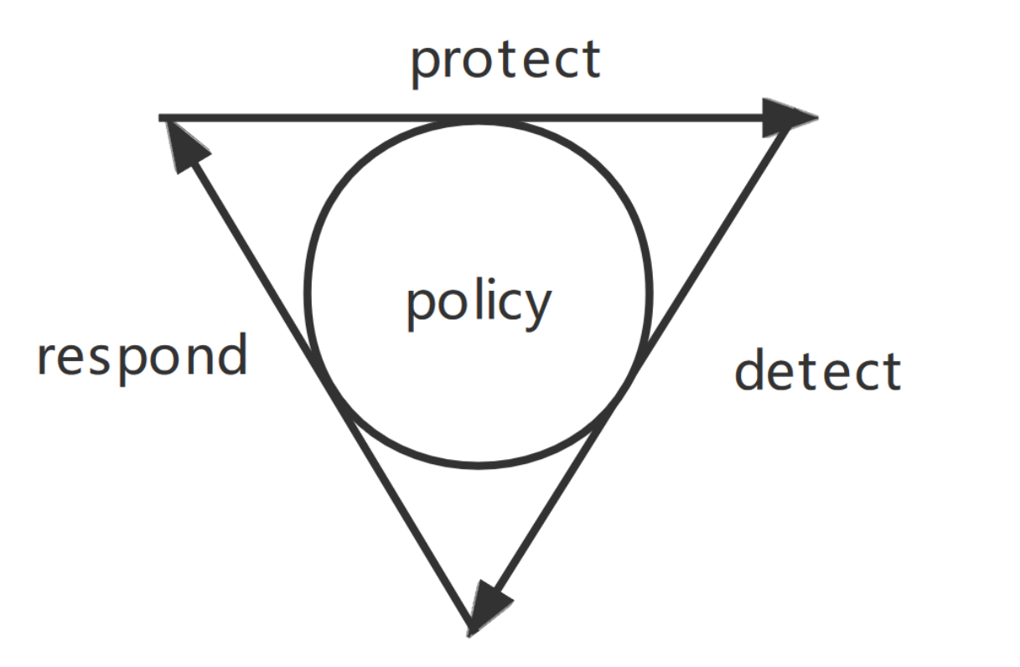
Figure 1
P2DR's definition of security is a new concept. P2DR model believes that all activities related to information security, including attack behavior, protection behavior, detection behavior and response behavior, will consume time. Therefore, time can be used to measure the security and security capability of a system. But it ignores many internal factors. Such as the uncertainty between personnel, personnel flow, the instability of the strategy in the actual implementation process, and the improvement of personnel quality.
In this regard, Chinese information security experts have made some improvements marked by the "information assurance technology framework" (IATF) formulated by the national security administration of the United States, and put forward the WPDRRC dynamic information security model. Its core idea is the deep defense strategy, which adopts a hierarchical and diverse security measures to ensure the security of information system. Compared with P2DR, it considers the influence of other factors more fully and carefully, and improves the reliability of the system.
2 ISO 27000 Series
2.1 Background and composition:
ISO 27001 was formerly BS 7799 Part II. BS 7799 was written by the British Department of trade and industry and published by the British Standards Institute (BSI) in 1995.
ISO27001 and iso27002 are important contents of ISO27000 series standards. This paper mainly introduces the PCDA cycle model and the control measures of building control system.
At present, ISO / IEC 27001 standard is internationally recognized as the best standard to realize information security management. Different technologies are used to provide a framework for protecting information. The standard emphasizes comprehensive safety management based on risk management. At present, this method has been widely recognized all over the world.

2.2 Analysis:
ISO27000 series standards have many advantages. ISO27001 standard requires to formulate information security strategy, determine the scope of management system, clarify management responsibilities, determine control objectives and select control measures through risk assessment. Once the system is established, the organization should continue to maintain and improve the information security management system to maintain the effectiveness of the system and effectively improve the initiative of enterprise information security management, which will increase customers' trust in the company's business and help the company obtain more customers.

2.3 PDCA model
Similar to the ISO9001 quality management standard in ISO 9000 series, ISO 27001 standard proposes a PDCA reference model for the establishment, implementation, operation, monitoring, evaluation and improvement of information security system, emphasizing the continuous cyclic improvement based on PDCA model (Figure 2)

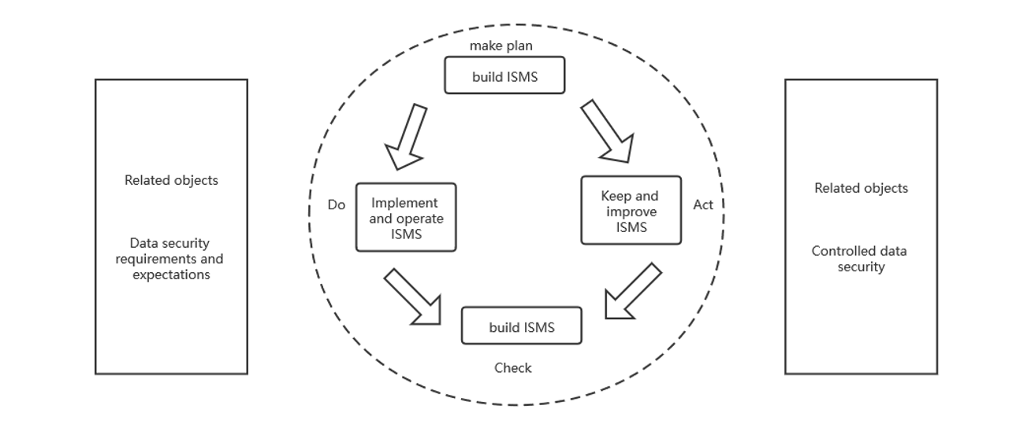
Figure 2
Information security construction method based on PDCA model
Planning --establish information security management policies, objectives, processes and specifications consistent with the overall strategy, objectives and policies of the organization to manage information security risks.
Implementation -- policies, control measures, processes and specifications for the implementation and operation of the information security management system.
Inspection -- evaluate the effectiveness of information security management against the policies and objectives of the information security management system, and report the results to the manager for review.
Disposal -- based on the results of internal audit and management evaluation of the system, take corrective and preventive measures to continuously improve the organization's information security management system.
ISO 27001 standard divides the activities in the field of information security management into 114 specific security management and control measures, and the standard based management system provides all-round security for important information assets of enterprises. The business demand oriented information security management system construction method is the biggest feature of ISO 27001 standard, which can ensure that the management activities in the system meet the needs of enterprise business management and control to the greatest extent. Carry out information security construction around information assets, and protect the confidentiality, integrity and availability of information assets by identifying assets and threats, making up loopholes and controlling risks.
3 ITIL security model
3.1 Background：

ITIL, the Information Technology Infrastructure Library, was formulated by the British government department CCTA （Central Computing and Telecommunications Agency) in the late 1980s. It summarizes the best practices in IT service management in various industries in the UK. ITIL is the IT service management of enterprises (ITSM) practice provides an objective, rigorous and quantifiable standard and specification.
3.2 Composition:
ITIL mainly includes six modules, namely business management, service management, ICT infrastructure management, it service management planning and implementation, application management and security management. Service management is the core module, which includes two process groups: service provision and service support
IT service management (ITSM) is a set of methodology for the operation and management of IT system, which is the core content of ITIL.
ITSM most emphasizes the organic combination of process, personnel and technology, that is, the PPT principle of ITSM: business is the core, process is the key, technology is an important factor, and personnel accept process management.
The construction of ITSM requires:
Standard process
Using advanced technology
Improve personnel management
3.3 Analysis：
ITIL can improve the operation efficiency of IT department by 25-30%, and bring the following business value:
1. Ensure that IT processes support business processes and improve the quality of business operations as a whole;
2. Provide more reliable business support through accident management process, change management process;
3. Customers have more reasonable expectations for IT and are more aware of the costs they need to pay to meet these expectations;
4. Improve the productivity of customers and business personnel;
5. Provide more timely and effective business continuity services;
6. Establish a more harmonious working relationship between customers and IT service providers;
7. Improved customer satisfaction.

ITIL has been widely used in Europe, North America and Australia. More than 10000 famous enterprises in various industries around the world have brought us many successful cases of implementing ITIL. The implementation of ITIL has greatly improved the quality of enterprise IT services and promoted the integration of it and business.
Combined with the above three frameworks and standards, it can be analyzed that the background, internal principle and trial scope of each framework are different. For example, ITIL focuses on 10 core service management processes, while ISO 20000 not only has requirements for service management processes, but also adds requirements for the overall service management system, such as management commitment, service objectives and continuous improvement. The core of ISO 20000 and ITIL is the service management process, but their processes are different. ISO 20000 is mainly based on 10 core processes of ITIL v2, And add business relationship management, supplier management and service reports. These three processes are also discussed as independent processes in ITIL v3. However, technology is always improving. The shortcomings and vulnerabilities of each framework need to be improved by constantly specifying new standards that fit the application scenario.

Design of information security system of Coffillue ompany based on ISO27001 and P2DR

Coffillue Coffee company overview

Coffillue sells Jamaican Blue Mountain coffee, one of the best and most popular blended coffees in the world. They use cloud services to serve employees and customers. It is estimated that nearly 95% of the company's network is wireless based. The company also has a large number of online and social media to promote its activities.
Due to its huge staff and international customer base, the company has recently faced great pressure. The existing security information system can not meet the current security requirements at the same time. Now the company is mainly worried about the security of employee personal data, customer data and billions of dollars worth of intellectual property rights. Information security is the top priority of the company, but everything is chaotic. There is no established policy to meet their security needs.
We analyze the company's current information and existing problems, combined with ISO 27000 series standards and P2DR model, analyze and explain the design of the system from the aspects of law and ethics, safety management, safety strategy, risk management, emergency plan and protection mechanism.
Coffillue Coffee's current problems

(1) The company's network management level needs to be improved. 95% of the company's networks are wireless based and contain a lot of social media. This shows that once there is a problem with network security, all work will be seriously affected.
(2) The company has a large user base, and there are loopholes in data protection. Each different kind of user uses his own device to access the company's network and resources. At present, the company does not have a login management system strictly classified by authority, and the data and secrets in the system are vulnerable to attack.
(3) There is no excellent risk handling ability. Once the company's network data security is threatened, there should be a set of systematic and scientific solutions.
Design goals

In view of the current problems of coffee companies, based on some existing frameworks, design a reasonable information management system, which can help the company protect the data security of employees and customers and high-value intellectual property rights, and make the company have a certain ability to deal with security threats.
1 Ethical and Legal Analysis of Coffillue Coffee Company
  - Ethics：
Ethics refers to the principles and norms that should be followed in dealing with the relationship between people and society. It refers to a series of concepts guiding behavior, and is a philosophical reflection on moral phenomena from a conceptual perspective. Many industry organizations have formulated corresponding codes of conduct, such as the ten commandments of computer ethics.
For coffillue, we should first pay attention to privacy disclosure and protect the personal information security of employees and customers. The second is the issue of information security. The data generated by individuals include actively generated data and passively left data. Their deletion right, storage right, use right and right to know belong to the rights of individuals, but it is difficult to ensure security in many cases. Some information technologies have security vulnerabilities, which may lead to data leakage, forgery, distortion and other problems, affecting information security. These need to be solved by standard provisions.
1.2 Law： The operation and development of the company should always be under the legal framework, which may involve computer crime law, privacy law, etc. Relevant laws and regulations should be reflected in the company's rules and regulations through regulations.
2 The company's security strategy
The specified company security policy should be based on the basic process of P2DR model, combined with the specific situation of the company and combined with ISO standards. After analyzing the specific situation of the company, this paper will design security policies from three aspects: Physics, management and network.
2.1 Physical security strategy:
Physical security includes environment, equipment and media security, which is mainly to avoid the damage of information system caused by earthquake, fire and other accidents or human factors. Environmental security is the security protection of the environment where the information system is located; Equipment safety refers to the security protection against theft, destruction and magnetism of equipment; Media security is the protection of storage media and transmission media
2.2 Network security policy
The security requirements to be solved for network communication mainly include:
(1) Network communication infrastructure security policy
Authentication and access control:
For the access of key network devices, users must adopt high-strength identity authentication mechanism to solve the problem that static password authentication is easy to be eavesdropped and cracked. At the same time, for administrator users, it is best to adopt a hierarchical authority control mechanism to separate the authority of query, modification and audit, so as to avoid the security risk caused by excessive concentration of personal power.
(2) Network boundary security policy
For various complex security threats from the Internet and other external networks, such as hacker intrusion, DOS / DDoS attack, virus, worm, Trojan horse, malware and spam, effective detection and defense must be carried out to avoid the interruption of internal normal network communication and business services, computer system crash Billions of dollars of intellectual property leaked or lost, etc
(2) Network access security policy
Network access security is mainly to ensure that the subject of network access is personnel For the operation safety of (users), the network system shall be able to record the target objects accessed by different types of users using network resources, the behavior process of access and the information content of access, provide effective analysis, statistics and alarm mechanisms, and timely find illegal network access behavior and notify the network administrator for handling.
(4) Redundant backup
In order to ensure business continuity to the greatest extent, reliable redundant backup mechanism shall be adopted for all important business server hosts to ensure that online business processing and data access process will not be interrupted due to server system failure.
2.3 Managed security policy:
(1) Technical policy
Establish a centralized safety management and monitoring platform for the whole network through technical means, centrally analyze the safety event information generated by various equipment and software in the system, timely find and deal with safety accidents, and establish a perfect safety early warning, response, treatment, repair and protection mechanism, So that all kinds of security systems deployed in the network can effectively interact and work together in a unified way, so as to give full play to the maximum efficiency of the security system.
(2) Organization system construction policy
Establish the overall information security management organization structure, be responsible for the security management and supervision of the information system, further strengthen the construction of security management system and strengthen its implementation, so as to ensure that the security management of the whole information system is at a high level.
(3) System construction policy
System construction is the basis of information system security construction. The company must establish a set of security management system to ensure the implementation of information security solutions. Establish and improve various rules and regulations such as password management, data encryption, identity authentication, regional division principle, access control strategy, virus prevention, security audit, emergency response, data recovery, etc.
(4) Personnel security policy
The company has a wide variety of personnel. Safety management should give play to the subjective and dynamic role of technicians. The company should strengthen the management of different personnel and improve their safety awareness and safe operation ability through safety training.
3 Risk Management
The information security risks faced by the coffee company's network system come from two aspects. One is the value of information assets. The so-called value of information assets refers to the losses caused to the normal operation of the organization due to information leakage, system stagnation or network damage. The higher the value of information assets, such as billions of intellectual property rights, the higher the security risk is bound to be; The second is the source of threat and the possibility of threat conversion into attack.
Considering the security of the system, the risk assessment of the system is mainly carried out from three aspects. Physical (mainly refers to the security risks caused by equipment operation failure), network (mainly refers to the security risks existing in transmission lines and network equipment), data (mainly refers to the security risks threatening information data). Therefore, we evaluate the company from these three levels, identify possible potential risks, and design relevant management measures.
3.1 Physical security risks
1. Physical environment security risk
(1) Risks caused by network interruption, data mining loss and equipment damage caused by environmental accidents such as earthquake, flood and fire;
(2) Risks caused by system downtime and data loss due to the failure of UPS, precision air conditioner and other power equipment in the data center room:
(3) Risk caused by illegal intrusion due to the failure of security monitoring of data center computer room to effectively monitor the environment and information system;
2. Physical equipment security risk
(1) Risks caused by the failure of equipment such as switches, etc. relied on by the network system, which directly affects the normal operation of the system and various applications:
(2) Risks caused by information leakage or data loss caused by illegal theft or destruction of personal computers such as desktops and portable computers.
3. Communication line safety risk
(1) Risks caused by unexpected interruption of the communication line of the information system due to the failure of the communication line itself, malicious disconnection or excessive voltage, resulting in the unavailability of information system resources:
(2) The important data of the information system may have errors in the transmission process, resulting in the risk caused by the destruction of information integrity and availability.
3.2 data management security risks
Data security is the core security issue in the network. The company has billions of intellectual property rights. If the data is illegally copied or destroyed in the storage process, the data access and processing process is accidentally interrupted, or illegally stolen or tampered in the transmission process, it may cause huge economic losses to the company. According to the information characteristics of the company, it can be determined from the following aspects:
For the data stored on the server, whether the existing network and system platform have sufficient control and monitoring means to prevent information leakage; For the data stored on the staff's computer hard disk, will users intentionally or unintentionally share the data storage directory with network neighbors for arbitrary access, or actively spread the data to illegal recipients through the network or physical means. A reasonable management system should be designed to avoid similar risks.

3.3 network security risk
(1) Security risks of network access
The company's network is mainly through cloud servers, which will inevitably bring great pressure to the servers. In the activity of data interaction between networks, any attack on any link of TCP / IP network communication process may threaten the security of important information data. There are certain security risks in both Wan communication link and LAN communication link.
(2) Security risks of network equipment and servers
Network access strategy, source and target of network access and network access behavior will directly affect the stability and security of the company's network. If there is no appropriate network access control, no appropriate restrictions on terminal access and the use of network address, and no supervision and audit measures for network access behavior, it is easy to cause the abuse of network resources and information disclosure, ranging from reducing the network work efficiency to economic loss or reputation loss.
Coffillue coffee can increase edge servers and public networks to share the pressure of cloud servers, which can better deal with network security risks. And to supervise and audit the network behavior, we can establish a complete set of rules to manage the company's hardware equipment. Reduce the risk of physical information and establish rules to ensure data security, so as to protect important information such as intellectual property rights from disclosure.

Physical security risk

risk management
risk assessment
Develop measures
Data management risk

Network security risk

Figure 3
4. Company safety management
After comparing and analyzing the three frameworks in task 1, this paper believes that ISO27000 and P2DR are the most suitable information security frameworks for this case. Therefore, this paper uses the combination of ISO27000 and P2DR to design an information management system in line with the situation.
Formulate 6 main steps according to the actual situation of the company
(1) Preliminary work: collect the company's specific information and the current situation of the information system, clarify the construction progress of the information security management system, and determine the scope of application of the information security management system.
(2) Risk assessment and analysis: formulate a risk assessment plan, collect the company's asset information according to the plan, analyze its weaknesses and assess risks. Investigate and evaluate the confidentiality, integrity and availability of the information system.
(3) Establishment of risk control and information security system: according to the control scope, establish the information security management system framework in line with ISO 27001 and P2DR standards, and build the information security management process.
(4) Operation and improvement of information security management system: during this period, problems existing in system planning shall be found in time, the root causes of the problems shall be found out and corrective measures shall be taken.
(5) Review and approval: system audit includes internal audit and external audit. The external auditor evaluates the company's information security management system.
(6) Continuous improvement: improve new information security issues.
5 Protection of network system
The function of firewall is to check the network communication at the network entry point according to the security rules set by users, and provide internal and external network communication on the premise of protecting the internal network security. By using firewall to filter unsafe servers, improve network security and reduce the risk of hosts in the subnet, and provide access control to the system: prevent attackers from obtaining useful information attacking the network system, record and count network utilization data, illegal use of data, attack and detection policy execution. Firewall is a passive security defense tool.
The deployment of firewall mainly needs to realize the following functions:
(1) Isolate safe areas.
By adopting the LAN security partition mode, the physical interface of the firewall corresponds to the corresponding security area, and the security policy is set according to the protection level of the security area, so that the communication between different areas can be monitored by the firewall.
(2) Provide rich AAA functions.
By providing users with common security credentials such as one-time port (OTP), S / key, domain authentication and digital certificate.
The authentication method enriches the security authentication methods, and realizes the control of user authentication and user authorization more flexibly and widely.
6 overall structure design
According to ISO 27001 and WPDRRC security model, first collect the company's specific information, clarify the main contents of information security management, and make preliminary preparations for the security plan. Then, starting from reality, according to P2DR model and ISO standard, analyze problems, risks and requirements, and design security strategy. Then it makes an objective risk assessment on the current situation, value and potential risks of the company's information assets and information systems, and designs the overall framework of system security management. Finally, it analyzes the company's own protection and emergency handling. This gives the overall block diagram.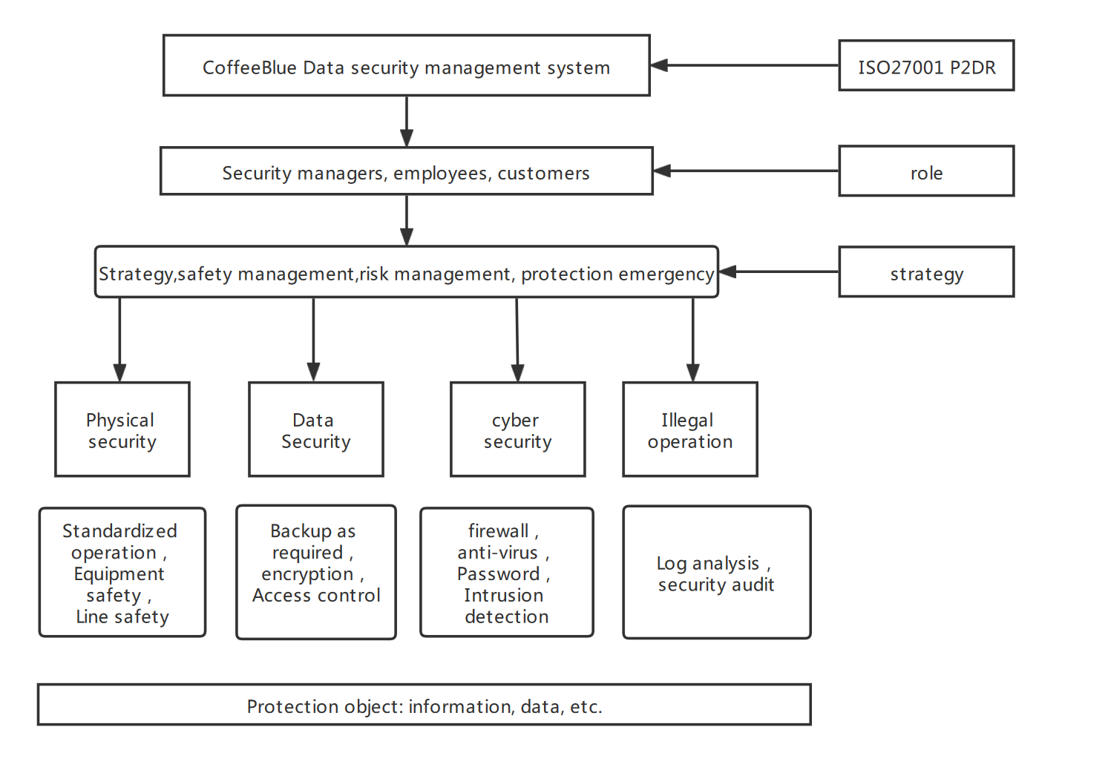
Figure 4
References
[1] Wang Haijun Research on network information security protection strategy of prison system based on P2DR model [J] Cyberspace Security, 2021,12 (Z3): 69-72
[2] Ahmad Iqbal Hakim bin Suhaimi,Nurulhuda Noordin,Mohd Faizul bin Ya’kub. Assessment of Malaysian E-Passport PKI based on ISO 27000 Series International Standards[J]. Journal of Physics Conference Series,2020,1551(1):
[3] Feng Dengguo, Zhang Min, Li Hao Big data security and privacy protection [J] Journal of computer science, 2014,37 (01): 246-258
[4]Choquette, Steven J.(Office of Reference Materials, Materials Measurement Laboratory, National Institute of Standards and Technology (NIST), Gaithersburg; MD; 20899-2300, United States);Duewer, David L.;Sharpless, Katherine E.Annual Review of Analytical Chemistry, v 13, p 453-474, June 12, 2020
[5] Zhang Yueyue,Zhang Cheng,Xu Yunjie. Effect of data privacy and security investment on the value of big data firms[J]. Decision Support Systems,2021,146:

