ACCOUNTING FUNDAMENTALS
( LCBB4001 )

Presented by Ana Maria Dragoi ( 2027456 )
Table of Contents

Introduction 3
Question 1: Financial statements of Kedison PLC 4
a.) Preparation of income statement and financial position for the year ended 31st December 2020 4
b.) Reason behind the statement of financial position balances 6
Question 2: Ratio analysis for Choco PLC on 31st December 2020 and 2019 7
a.) Calculation of different types of ratios 7
b.) Comment on the financial statement for the financial performance of Choco PLC 15
Conclusion 16
References 17

Introduction

Accounting fundamentals are considered to be important for the business because it allows the management to manage their expenditure and to track their incomes effectively. It also provides information to investors, management, customers, and even the government to understand the financial position of a business during a year. The accounting fundamentals include preparing an income statement till managing the funds in cash flow.
This assessment has shed light on the preparation of income statements and balance sheets for the company Kedison PLC in order to identify its financial position. Furthermore, ratio analysis has been performed for the company Choco PLC to understand their performance during the year.

Question 1: Financial statements of Kedison PLC

Preparation of income statement and financial position for the year ended 31st December 2020

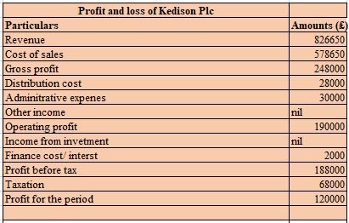
Figure 1: Income statement of Kedison PLC
(Source: self-developed)

A financial statement is a set of books that is prepared in a business to identify its performance during a year. The financial statement helps the management to make long-term decisions on the basis of financial activities and performance. Furthermore, it is also helpful for the investors to understand the earning capacity of a business before investing in it. It is important for a business as it determines financial transactions and significant information for making future decisions (Osadchy et al. 2018, p.25). The financial statement has been prepared for the company Kedison PLC for the year 2020 to understand their revenues, expenses, and the profit determined during the year.
The books of financial statements have been prepared for the year 2020. From the above figure, it can be identified that the business has conducted a revenue of £826650 with the cost of sales volume of £578650. The gross profit has been computed by subtracting the value of sales cost from the revenue generated during a year. The value of gross profit is observed to be evaluated at £248000. Additionally, there were certain expenses that had been deducted such as distribution cost, administrative expenses to find the operating profit. The operating profit has been evaluated at £190000. The net profit during the year after deducting finance cost and taxation is recorded at £120000.

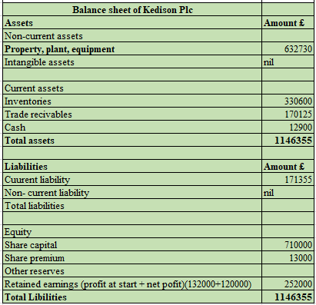
Figure 2: Balance sheet of Kedison PLC
(Source: self-developed)

A balance sheet is an important element under financial statements that provides a brief understanding of the final position of Assets and liabilities during a year. The motive of preparing a balance sheet is to provide the financial position of a company after considering necessary adjustments (Pelekh et al. 2020, p.197). It is also known as a snapshot of both aspects of financial position at a single point of the place. The balance sheet has been prepared for the business of Kedison PLC for the year 20020 in order to understand their movement of cash, investments, plant and equipment, and even liabilities. From the above conducted financial position of Kedison PLC, it can be identified that the company has property, plant, and equipment as their non-current asset and it has been valued at £632730. The management has inventory, trade receivables, and cash balance as their current asset during the year. The value of inventory and trade receivable is observed to be recorded at £330600 and £170125 respectively. However, the value of cash has been recorded in the financial position at £12900. The value of total assets is computed at £1146355 and that is the combination of current and noncurrent assets of Kedison PLC.
The liability side of the business Kedison PLC is observed to be the mixture of current and noncurrent liabilities that have been recorded in the books. The management only has the value of the current liability and that has been recorded at £171355. Furthermore, the equity side of Kedison PLC includes a share capital value of £710000 and a share premium of £13000. Additionally, Kedison PLC was having their retained earnings at the starting at £132000 and the value of net profit also gets included in it of £120000. The total value of retained earnings in the final book is computed at £252000. Therefore, the total balance recorded in the balance sheet is £1146355.

Reason behind the statement of financial position balances

A balance sheet is considered to be an important element of accounting fundamentals that are used to prepare a business to identify the final position of Assets and liabilities during the year. The reason behind the tally of the balance sheet is the accounting fundamentals of the matching principle. The accounting principle indicates every transaction is recorded in two different places that affect both sides (Braun, 2019, p.25). Furthermore, every transaction is registered under two different accounting heads in a business as it has been recorded in two different ledger accounts.
The balance sheet is prepared to reflect two different accounts that are assets and liabilities owned by a business during a year. The accounting principle of double-entry is the major reason behind balances of the balance sheet (Datta and Fuad, 2017, p.119). As mentioned before, every accounting entry is recorded in two different places to maintain the consistency and the accuracy of books. Therefore, any purchase of assets with cash will affect both cash accounts and assets accounts. Similarly, if a business is purchasing a car of £10000 with the contribution of £5000 equity and £5000 loan. Therefore, the assets side of the balance sheet will indicate a car of £10000 with its corresponding entry of £5000 and £5000 entries in liabilities.

Question 2: Ratio analysis for Choco PLC on 31st December 2020 and 2019

Calculation of different types of ratios

- ROCE ratio
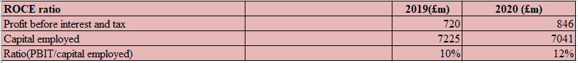
Figure 3: ROCE ratio
(Source: self-developed)

Meaning: This ratio is performed to identify the financial efficiency of a company during a year and to measure its profitability index. The ideal ratio is considered to be between 10% to 20% that indicates a good ratio for the company (Nariswari and Nugraha, 2020, p.87). The motive of preparing this ratio is to identify capital efficiency and even the profitability of a business.
2019: In the year 2019 the business was having its PBIT valued at £720 with the capital employed value of £7225. The ratio is reflecting a figure of 10% that has been computed by dividing PBIT with capital employed.
2020: In 2020, choco PLC is having their PBIT valued at £846 with the value of capital employed of £7041. The value of the ratio is 10 computed at 12% that indicates a slight improvement.

Reason: The reason behind an increase in the ratio is an increase in the value of their PBIT during a year.
Ways to improve: The management can improve its ratio by increasing its operating profit along with its capital employed.

- ROE ratio
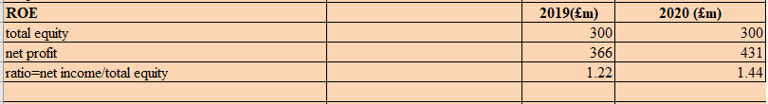
Figure 4: ROE ratio
(Source: self-developed)

Meaning: The ROE ratio is computed to identify the effectiveness of managing funds of equity shareholders during a year (Öztürk and Karabulut, 2018, p.109). The ideal ratio is considered to be between 15 to 20%.
2019: in the year 2019, the business is having a total equity balance of £300 with a net profit balance of £366. The ratio has been computed at 1.22% in 2019.
2020: In the current year, Choco PLC is observed to be having no changes in their equity balance as it remains the same. However, the net profit has been increased to £431 with a ratio balance of 1.44%.

Reason: Increase in the net profit is the major reason behind an increase in the ratio during the current year.

Ways to improve: The management can improve its ratio by reducing its operating expenses and increasing its profit margin.

- EPS ratio
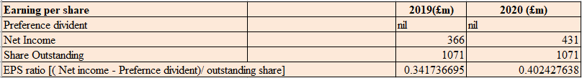
Figure 5: EPS ratio
(Source: self-developed)

Meaning: The importance of Earning per share ratio is to identify the ability of businesses in generating income in each of their shares (Janice and Toni, 2020, p.25). A good EPS ratio is considered to be between 1% to 5% that indicates the percentage of growth in each share.
2019: In 2019, Choco PLC was having there net income of £366 with a share outstanding value of £1071 and an EPS ratio of £0.34.
2020: In the current year, the management of Choco PLC has improved their net income to £431 with a share outstanding of £1071 and a ratio value of £0.40.

Reason: The reason behind the change in the ratio is an increase in the net income of Choco PLC in the current year.

Ways to improve: Choco PLC can improve its EPS ratio by increasing its net profit margin during a year.

- N.P ratio
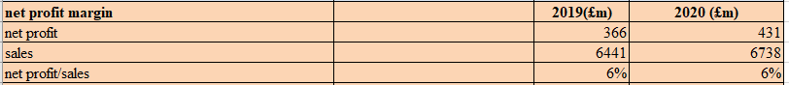
Figure 6: N.P ratio
(Source: self-developed)

Meaning: The net profit ratio indicates the ability to generate profit with the help of its revenue (Haralayya, 2020, p.170). The ideal ratio is considered to be between 10% to 20%.
2019: The business is having a net profit of £366 with a sales margin of £6441 and a ratio of 6%.
2020: In this year, choco PLC is having a net profit of £431 and a sales volume of £6738 with a ratio of 6%.

Reason: The reason behind no changes in the ratio is due to a similar increase in the net profit and sales volume of Choco PLC.

Ways to improve: the business can improve it by increasing its revenue and decreasing its expenses of raw materials.

- Assets turnover ratio
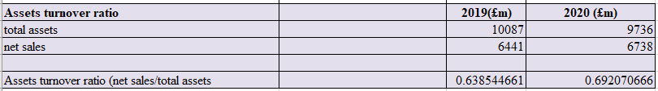
Figure 7: Assets turnover ratio
(Source: self-developed)

Meaning: Asset turnover indicates the efficiency of using assets by a business to generate its revenue effectively (Puspasari et al. 2017, p.25). The ideal ratio is considered to be between 0.25 to 0.5 during a year.
2019: In the last year, Choco PLC is having their total asset value at £10087 with a net sales valuation of £6441 and a ratio of 0.63%.
2020: in the current year, the business is having a total asset valuation of £9736 with net sales valued at £6738 and a ratio of 0.69.

Reason: Increase in net sales becomes the major reason behind the improvement in the turnover ratio.

Ways to improve: The management can improve its ratio by increasing its asset efficiency and accelerating its accounts receivable.
- Stock holding
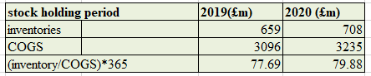
Figure 8: stock holding
(Source: self-developed)

Meaning: The stock holding indicates the time required by Businesses to hold their stocks for future use. The ideal holding period is considered to be between 1 to 2 months for 30 to 60 days (Sari and Muniarty, 2021, p.101).
2019: in the last year, the business was having an inventory valuation of £659 with a COGS value of £3096 and holding days of 78 days approximately.
2020: In the current year, the holding period has increased by 2 days, indicating poor management of forecasting sales as the inventory valuation has increased to £708 with COGS of 3235.

Reason: The reason behind an increase in the holding period is due to an increase in the closing inventory because of poor management of forecasting sales.

Ways to improve: The company can improve its ratio by enhancing the supply of inventory and by managing accurate forecasting for their upcoming sales.

- Collection ratio
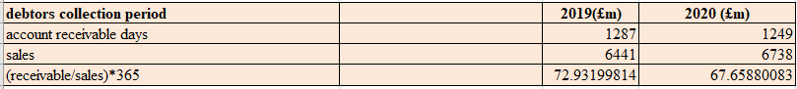
Figure 9: collection ratio
(Source: self-developed)

Meaning: The collection ratio indicates the time required by a business to collect their payments from their debtors (Purnomo, 2018, p.25). The ideal collection days are considered to be between 30 to 40 days.
2019: the management is having their accounts receivable of £1287 with a sales volume of £6441 and a collection period of 73 days.
2020: Choco PLC is having accounts receivable of £1249, a sales volume of £6738, and a collection period of 67 days.

Reason: the management has decreased its collection period from 72 days to 68 days but decreased its account receivable.

Ways to improve: The business can improve its collection period by offering a discount to its debtors for early payments. Furthermore, they can implement its payment terms and conditions.

- Current ratio
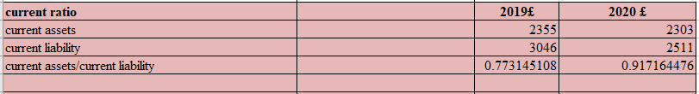
Figure 10: current ratio
(Source: self-developed)

Meaning: The current ratio indicates the ability to overcome liabilities with the help of assets and the ideal ratio is considered to be 2:1 (Nuryani and Sunarsi, 2020, p.304).
2019: the business is having a current asset of £2355 with a current liability of £3046 and a ratio of 0.77.
2020: Choco PLC is having its current asset valued at £2303 with current liabilities in the balance of £2511 and A ratio value of 0.91.

Reason: the reason behind the increase in the ratio is decreased in the current liability during the current year.

Ways to improve: The company can improve its ratio by settling down their current liabilities and collecting their payments faster to improve the balance of their assets.

- Gearing ratio
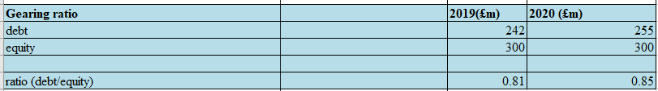
Figure 11: gearing ratio
(Source: self-developed)

Meaning: The gearing ratio is computed to identify the ability for overcoming debt with equity. The ideal ratio is considered to be under 2% that indicates a good position of equity over debt.
2019: In 2019, Choco PLC is having their debenture value of £242 with an equity value of £300 and a ratio of 0.81%.
2020: the business is having its debt valued at £255 with an equity value of £300 and a ratio of 0.85%.

Reason: the debenture value of Choco PLC has increased that has created a challenging situation for the business to overcome with its equity.

Ways to improve: Choco PLC can improve its ratio by decreasing its loan and increasing its profitability management.

- Interest coverage
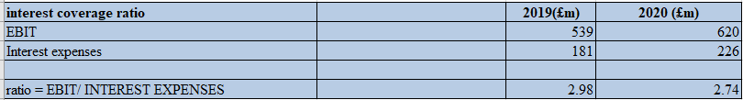
Figure 12: interest coverage
(Source: self-developed)

Meaning: The importance of interest coverage is to identify the ability of a company to overcome their due interest on time. The ideal coverage ratio is considered to be between 2.5 to 3%.
2019: Choco PLC was having its EBIT value at £539 with interest expenses of £181 and a ratio of 2.98% in the last year.
2020: In this year, Choco PLC is having its EBIT valued at £620 with their interest expenses of £226 and a ratio of 2.74%.

Reason: the reason behind the decrease in the ratio is due to an increase in the value of EBIT and even interest expenses by £81 and £45 respectively.

Ways to improve: Choco PLC can improve its ratio by decreasing its borrowing funds and settling down some of its debts.

Comment on the financial statement for the financial performance of Choco PLC

The ratio analysis has been prepared for the business of Choco PLC in
order to identify their financial performance and compared it to last year. Therefore, it can only be commented that the performance is observed to be slightly improved by the management during the current year that indicates a good financial position. The business has managed to decrease the value of their current liability that has helped them to improve the performance of the current ratio. However, it will be helpful for the business to focus on their sales as there are no big changes that can be observed during 2020.
The net margin of Choco PLC showed no changes at all that determines a weak position of the net ratio. Therefore, it can only be suggested that the management needs to decrease their expenses that will help them to and have their net profit during the year. Furthermore, the management of Choco PLC can improve its sales position by implementing marketing techniques such as online sales.

Conclusion

This assignment will be concluded by the importance of accounting fundamentals that have been used to prepare the financial statement and ratio analysis for both companies. The financial statement has been prepared to identify the income and expenses made by the business during the year. Furthermore, the balance sheet has been prepared to analyze the final position of Assets and liabilities on the ending date. The ratio has been computed in order to analyze the movement of the financial health of a business in comparison to last year. Therefore, the financial statement is reflecting a positive outcome as the business has maintained a good net profit during the year. Additionally, the ratio analysis is reflecting a superior performance in comparison to its last year.

References

- Braun, E., 2019. Accounting for market equilibrium–comparing the revenue-expense to the balance-sheet approach. Accounting, Economics, and Law: A Convivium.
- Datta, S. and Fuad, S.M., 2017. Valuing intangible assets: A balance sheet approach for DS30 listed companies. Australian Academy of Accounting and Finance Review, 2(2), pp.119-135.
- Haralayya, B., 2021. Ratio Analysis at NSSK, Bidar. Iconic Research And Engineering Journals, 4(12), pp.170-182.
- Janice, J. and Toni, N., 2020. The Effect of Net Profit Margin, Debt to Equity Ratio, and Return on Equity against Company Value in Food and Beverage Manufacturing Sub-sector Companies listed on the Indonesia Stock Exchange. Budapest International Research and Critics Institute (BIRCI-Journal): Humanities and Social Sciences, 3(1), pp.494-510.
- Nariswari, T.N. and Nugraha, N.M., 2020. Profit Growth: Impact of Net Profit Margin, Gross Profit Margin and Total Assests Turnover. International Journal of Finance & Banking Studies (2147-4486), 9(4), pp.87-96.
- Nuryani, Y. and Sunarsi, D., 2020. The Effect of Current Ratio and Debt to Equity Ratio on Deviding Growth. JASa (Journal of Accounting, Auditing and Accounting Information Systems) , 4 (2), pp.304-312.
- Osadchy, E.A., Akhmetshin, E.M., Amirova, E.F., Bochkareva, T.N., Gazizyanova, Y. and Yumashev, A.V., 2018. Financial statements of a company as an information base for decision-making in a transforming economy.
- Öztürk, H. and Karabulut, T.A., 2018. The relationship between earnings-to-price, current ratio, profit margin and return: an empirical analysis on Istanbul stock exchange. Accounting and Finance Research, 7(1), pp.109-115.
- Pelekh, U., Khocha, N. and Holovchak, H., 2020. Financial statements as a management tool. Management Science Letters, 10(1), pp.197-208.
- Purnomo, A., 2018. Influence of the ratio of profit margin, financial leverage ratio, current ratio, quick ratio against the conditions and financial distress. Indonesian Journal of Business, Accounting and Management, 1(1).
- Puspasari, MF, Suseno, YD and Sriwidodo, U., 2017. Effect of Current Ratio, Debt to Equity Ratio, Total Asset Turnover, Net Profit Margin and Company Size on Profit Growth. Journal of Human Resource Management , 11 (1).
- Sari, W.I. and Muniarty, P., 2021. The Effect of Gross Profit Margin (GPM) on Profit Growth at the Indonesian Employee Cooperative (KPRI) Torch of Teachers Bima. Ilomata International Journal of Management, 2(2), pp.101-105.

