Module code: BMSW 4002
Module Leader: Yohan Mendis
Assignment Title: Business report

Tania Akhter 1813921
Table of Contents
Introduction 3
Importance of effective communications 4
Methods of communications 4
Ethics of communication from company to employee. 5
Types of effective communications: 5
Two-way communications 6
Functions of communications 7
Communication model: 7
Process of communications: 7
Importance of consultation and employee voice. 8
Benefits of employee engagement programs. 8
Recommendations 9
Other forms of communication tools that can improve operations process. 10
Action Plan: 12
Conclusion 14
References 15

Introduction

This report is prepared for a large discount store in Birmingham. Which employs a total of twenty employees with a convenience store with added 3 people. This report with focus on how communication can be improved using available tools and technology. A market research will be conducted on similar stores operations and technology they adapted to grow their business and streamline the business process.
Analysis will reflect on effective communication methods used within current organisation. highlight benefits of consulting with employees. recommendation on effective method of communications for the store including an action plan outlining roles and responsibility and cost association to implement each recommended action. Wroblewski (2018) ” when the communication is also inspiring, it can do wonders to create and cement employee loyalty.”

Current Organisational structure

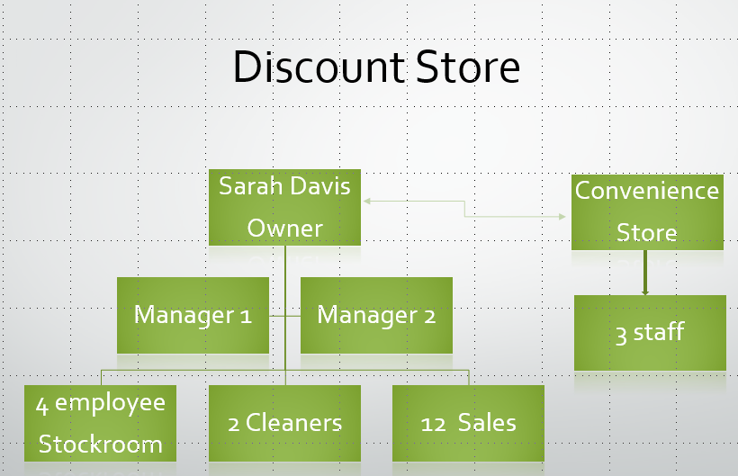

Importance of effective communications

In all work places communication is an important part of the company’s success. communicating clear instructions and process makes working environment enjoyable and less stressful. Without clear communications, instructions may get lost in transit and result in business loss.
Communication can be in written, verbal and non-verbal. Huntington (2019) the way individuals deliver nonverbal messages can be just as important as verbal dialogue. All these forms of communication can be as important as others and effective. Specially in a small business it is important to communicate information clearly and diplomatically.

Methods of communications
There are various forms of communications that occurs in the process of operating a business. Some are more useful than others depending on the situation.
- Written communication includes emails, letters, memos, proposals, training manual, policies and social media.
- Verbal communications include face to face telephone, video conferencing in groups or individually.
- Non-verbal communication may include body language, miming, eye contact, and using facial expression. It can be as basic as what you wear for example wearing different uniform can communicate different groups of people and their responsibilities

Ethics of communication from company to employee.
While communications are important ,it is also important to maintain ethical and host information flow. Discount store can follow the below guidelines to maintain their communications.
- Be timely: ensure employees are informed directly from management and not from third party. If information is confidential say so privately maintain trustworthiness with sensitive information.
- Be honest and factual: there may be time where you can not all information to the employee but what ever information you relay make sure its honest and credible.
- Be purposeful and clear: always define clear purpose of the communication avoid including jargon and meaningless information whether its written or verbal.
- Be respectful and fair: present information in a respect and unbiased format, avoid using hurtful or derogatory language.

Types of effective communications:
- Regular team meeting: regular group meetings keeps employees accountable and focused. Its lets employees mix from different department, keep casual, short and informative.
- Mentoring: be approachable and create easy on boarding process for employee, ease their learning process by assigning mentors as their go to person for at least good period of times.

Two-way communications

In two-way communication, information flows in two-ways: information form sender to receiver and response from receiver to sender. In the diagram Below for Discount store organisation.
Sarah Davis send instructions to managers, and managers send information back to her, whereas managers communicate between themselves to manage employees.
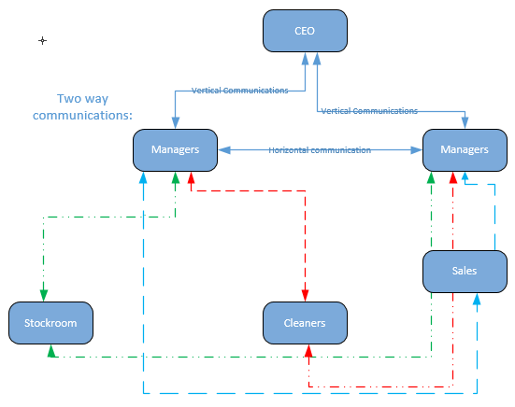

Functions of communications
The business communication com (2013) “ According to Elliot Jaquer, “Communication is the sum totals of directly and indirectly, consciously an unconsciously transmitted feelings, attitudes and wishes.”

Communication model:
A communication model is a pictorial representation of communication flow that shows a structure of the communication process which various components are linked and interconnected. There are always two-way communication happens either vertically or horizontally. The flow diagram above shows the communications flows within discount store.

Process of communications:
The model below illustrates in any process of communications there are multiple entity involved, a sender or communicator who has message to send. Sender needs a channel to convey this message to the receiver. And according to the receivers understanding they send a feed back to the sender.
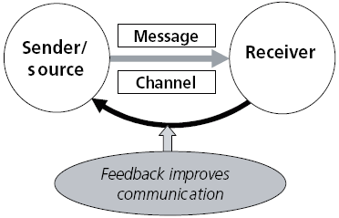

On our organisation (discount store) a simple example will be :

Sender/message >> Senders main intention to communicate message : for example, this will be Sarah Davis declaring 2% of bonus increase.
Channel >> How to communicate is the channel: this might be email or had written notice to the managers.
Sales Assistant >> Whom to send the message is the receivers: possibly to the Sales Assistants
Feedback sent to sender once the message received: >> message acknowledged.

This model works in a smaller organisation or communicating with handful of people. Even thou this same process applies to mass communications, but occasionally flow becomes incomplete and distorted. For example, if it’s a marketing department sending out messages the target audience will vary, and it will almost certainly in majority of the cases will be one way. For example, people might delete marketing message , others will respond.
“On unit 2 models of communications” 7 different communications models are described varying from pre war to post war , individual to mass media.

Importance of consultation and employee voice.

Business performance and reputations are important, and employees are main enabler in this. Therefore, it is important that everyone in the organisation ore able voice their opinion in the organisation they work for. Whether its a formal discussion or an informal forum. Many successful organisations run internal employee engagement programs. Ingham (2015) “ensuring that everyone working in an organisation is able to talk or write about what they see as important”

Benefits of employee engagement programs.
Employees who feels they can voice their opinions in an organisation are more focused about their work and more productive at work. As they know they can freely voice their opinion.
HR department often run competition and survey for gather employee opinion and data is analysed to improve onboarding, personal development programs. This allows employees to express their feelings and they feel more valued it also extends trusts from management to the employees.
Sharing information with employees enhances team work and allows them to network and share idea with other employees that generates skills and knowledgebase about company’s operation and process which eventually leads to better customer service and earns a good reputation.
Employee voice helps organisations build workable culture, identifies underlying issues and overcome difficulties . allowing employees to talk, fills them with confidence and shows that company wants to adapt to changes for better. It also helps avoid negative comments posted externally. If employees can talk their problems openly and express how they feel about certain issues, it helps build a more positive environment that works for everyone.

Recommendations

Everyday new communication technology is emerging and its changes how small organisation interact with internal and external customers. How they maintain their business process. Technologies like internet are easy to implement and costs are affordable, and it massively speed up business process and communication. For discount store managers it can benefit from communications with employees to make all level of decision by collecting fact and analysing data. For example, sales assistant, warehouse employee even cleaners can provide useful data. With the help of online analytical process i.e. gathering inputs information from customers.
It doesn’t matter how big or small the organisation is it is important to adapt adequate tools in technology and train their employees to communicate effectively. These tools can be video conferencing, wireless printers, interactive website, chat messaging to answer customers query.

Discount store provided very little information on how employees and management communicate. They also have small convenience store run by three people. A lot of recommendations are made to improve communications internally and externally. In any business the main objective is to make profit and increase sales. In order to do that cutting cost is vital at the same time long term business strategy needs to be in place. Below is some recommendation that will streamline the business process and improve business communications internally and externally.

Onboarding and Relationships
To maintain effective relationship between employee, managers and all department I would recommend a regular group meeting guiding and assisting employees with their work, addressing their difficulties listening to their concern, appreciating their good work and highlighting nay any improvements
Career development program
Implement a career development program where employees can see the steps to go up the ladder. This will encourage employees to take up the training programs internally or externally, offer incentives on certain achievements, e.g. 1 % pay rise. Allow managers to monitor and use employee skillsets to companies’ advantage and motivate them to success.
Employee effort programs:
Open a platform for employees to voice their concerns or even their ideas , make them feel they are part of the decision-making process. Implement a monthly suggestions scheme with a small prize as an incentive. This can be in the field of safety, quality, cost cuttings etc. Do let them know if their idea is selected, they would feel part of the company’s success.

Other forms of communication tools that can improve operations process.

- A notice board would help maintain shift rota, break times, on-leave schedules etc. this will give visibility to shift managers and asses employee’s whereabouts.
- Install an internet for research and communication purpose, be it email, instant messaging or anything online.
- An email system is a must for effective communication to keep teams in touch with everything that goes on internally and externally. This way data will be safe and easy to maintain. The company can make use of free email system or with marginal fee when purchased as a package with hosting service.
- Social media presence is crucial for any organisations, specially Facebook, twitters, LinkedIn etc, from advertising to share information, this will broaden company’s online presence.
- A website is a must to advertise special offers , discounted product , new products , company can also run an ecommerce system to accept orders from online customers which can be directly processed from warehouse. No interaction from sales department is needed. Sales department can make use of their time on the shop floor and answering calls.
- A Stock control system will maintain correct ordering, accurate maintenance of stock , balancing demand and supply. This will prevent overstocking, it will prevent filling up warehouse with less demanding products. It can generate various executive reports from the most popular item sold to most profitable items of the month. It will also prevent miss ordering, as the system can automatically place an order or flag up as the stock level hits a threshold.
- Online Marketing, designing digital brochures with offers, and online marketing will improve communication with customers with regular email marketing to all subscribed members. Allowing them to be aware of the new offers and discounts.

Action Plan:

Task | Enabler | Cost | Detail | Target
Internet line | Manager | £50 monthly | Business broadband line for internet access | 1 month
A notice board | Manager | £100 | Put up a notice board internally in a public place visible to everyone | 2 weeks
Onboarding program | Manager | 1 week | Induction program detailing where to go who to talk to. | 1 month
Suggestions program | Manager | 1 week | Suggestion scheme to access monthly suggestions | 1 month
Career development program | Manager | Varies on the chosen trainings etc | Pick training programs that will benefit employee progressions | 3 months
Email system | Manager | Monthly subscription program or a package around £200 for a year for 25 mailboxes | Email package for all employees | 1 month
Website | Manager | Around £2000 | Build a e commerce site with all dynamic’s functionality | 3 months
Social media/online marketing | Manager | Can start off with minimum budget of £1000 | Write social media profile and advertise on target audience. | 3 months
Stock control system | Manager/CEO | This will be the costliest system so far, it can cost from £5000 to what ever the company afford | This will help warehouse and sales, and managers to track all aspects of sales and stock | 6 months

Conclusion

This report consists of initial analysis of case study discount store, as there is no information regarding the company’s current information flow. The report describes communication within the workplace its functions and methods can be beneficial to discount store. Describes different aspect of effective communication to engage employee within the operations and make them valuable to companies’ success. There are some important recommendations made against different shortfalls within the company and how to modernise the business process and make it cost effective. A detailed action plan is included to implement the changes and benefit it will bring to the company.

References

Huntington, S. 2019. Https://smallbusinesschroncom/nonverbal-communication-can-workplace-21523html. [Online]. [20 July 2019]. Available from: https://smallbusiness.chron.com/nonverbal-communication-can-workplace-21523.html

Wroblewski, M.T. 2018. Https://smallbusinesschroncom/effective-communication-methods-organization-2html. [Online]. [24 July 2019]. Available from: https://smallbusiness.chron.com/effective-communication-methods-organization-2.html

Ingham, J. 2019. Https://wwwworkstarscom/recognition-and-engagement-blog/2015/05/12/the-benefits-of-employee-voice-at-work. The Benefits of Employee Voice at Work. [Online]. [30 July 2019]. Available from: https://www.workstars.com/recognition-and-engagement-blog/2015/05/12/the-benefits-of-employee-voice-at-work/
Foley, B. 2018. How to Write an Effective Executive Summary. 04/10/2018. How to Write an Effective Executive Summary. [Online]. [4 August 2019]. Available from: https://www.surveygizmo.com/resources/blog/how-to-write-executive-summary/
Thebusinesscommunicationcom. 2013. The Business Communication. [Online]. [4 August 2019]. Available from: https://thebusinesscommunication.com/what-is-communication-functions-of-communication/
Balaji, S. 2011. COMMUNICATION PROCESS,TYPES,MODES,BARRIERS. [Online]. [4 August 2019]. Available from: https://www.slideshare.net/SruthiBalaji/communication-31071323
Ramey, K. 2013. USE OF COMMUNICATION TECHNOLOGY FOR ORGANIZATIONAL COMMUNICATION. [Online]. [4 August 2019]. Available from: https://www.useoftechnology.com/communication-technology-organizational-communication/

