Student Name:Elena Alexandra Tanase
Student number:2245516
Module title and code: Introduction to Business LCBB4007
Lecturer Name:Laila Maazouz
Assigment Title: Resit

Contents
Element 1: Introduction 3
Element 2: Depth of Analysis and Application to Stakeholder Engagement Strategies 4
2.1 Stakeholder Identification and Categorisation 4
2.2 Roles and Stakeholder Representation in Visual Evidence 5
2.3 Engagement Strategies Used 9
2.4 Effectiveness and Challenges of Stakeholder Engagement 12
Element 3: Ethical Consideration and Awareness, and Reflective Insight 13
3.1 Community Interest and Ethical Duty in Public Infrastructure 13
3.2 Transparency, Trust, and Informed Participation 14
3.3 Corporate Social Responsibility (CSR) and Sustainability 15
3.4 Reflective Insight on Theories and Practice 16
3.4.1 Skills Developed and Future Relevance 16
Element 4: Conclusion and Recommendations 17
References 19

Table 1 Stakeholder Matrix for Cardiff Crossrail Phase 1 4

Figure 1 Map showing proposed tramway and worksite areas for Phase 1 7
Figure 2 Demographic breakdown of survey respondents 8
Figure 3 Age comparison between TfW data and UK Census (Butetown) 9
Figure 4 Stakeholder interest in the project proposals. 10
Figure 5 Public agreement on the need for a mass transit link 11
Figure 6 Agreement on proposed public realm enhancements 12
Figure 7 Streets most affected by proposed tram route 12
Figure 8 How often people use affected streets 13
Figure 9 haveyoursay.tfw.wales 16

Element 1: Introduction
The concept of stakeholder management in project management refers to the process of identifying, analysing, and engaging individuals or groups who affect or are affected by a project's outcome (Project Management Institute, 2021). It is especially vital in the infrastructure projects where public resources and while community interests are very much involved as effective stakeholder management fosters transparency and builds trust as well as reduces the risk of social resistance or delay (Erkul, Yitmen and Çelik, 2016). When implemented well, it ensures that diverse voices are considered, thereby supporting informed and ethical decision-making. With local communities stakeholder management alliance project works with the public interest as it helps to balance the economic development with Environmental Protection as well as social responsibility (Afieroho et al., 2023). Through inclusive participation projects gain legitimacy and public support and this reduces heavily the opposition as well as encourages any sort of long term acceptance. This is particularly important for urban transport initiatives where community daily life and mobility are directly affected.
The Cardiff Crossrail Phase 1 project provides a fitting example. It is a public transport infrastructure scheme aimed at improving east–west connectivity across Cardiff through a light rail system. The first phase focuses on constructing a tram route from Cardiff Central station to Cardiff Bay (Graham, 2024). This project has strategic importance for sustainable mobility in the region. The main objective of this project would be to reduce the road congestion' as well as enhanced public transport accessibility by supporting decarbonization in order for sustainability initiatives as well as enable sustainable urban growth as long term plans suggest the network will expand to connect more communities (Hakimian, 2024). This will seemingly integrate housing development with efficient and low emission transport. As such stakeholder management is not only a deliberant tool but also a mechanism for to ensure that the infrastructure projects like Cardiff Crossrail Phase 1 genuinely reflect community needs and support sustainability goals.

Element 2: Depth of Analysis and Application to Stakeholder Engagement Strategies

2.1 Stakeholder Identification and Categorisation
Stakeholder management is a central feature in public infrastructure projects as previously discussed especially when transport development interacts with the diverse urban populations as this project. As Cardiff Crossrail Phase 1 designed to connect Cardiff Central to the Bay demonstrates the complexity of managing stakeholder groups with different interests, levels of power, and degrees of influence.
Stakeholders can be classified using the power-interest grid a framework that visualizes both internal and external stakeholders' power and their level of interest in the project. The stakeholders were also classified as primary and secondary based on the level of influence over the project. Primary stakeholders include the Cardiff council, the Welsh government and the transport for Wales as well as the local residents and the commuters. Secondary stakeholders included the local businesses, environmental groups, contractors, disability advocacy organisations as well as the general media.
Table 1 Stakeholder Matrix for Cardiff Crossrail Phase 1
Stakeholder | Category | Power | Interest | Role/Impact
Cardiff Council | Primary | High | High | Planning, funding, and political leadership
Welsh Government | Primary | High | High | Strategic funding and policy alignment
Transport for Wales | Primary | High | High | Project execution and operations
Local Residents | Primary | Medium | High | Affected by disruption and accessibility
Commuters | Primary | Medium | High | Daily users benefiting from improved service
Local Businesses | Secondary | Medium | Medium | Economic impact from changes in access/footfall
Environmental Groups | Secondary | Medium | High | Concerned with environmental footprint
Construction Contractors | Secondary | Low | Medium | Deliver construction and infrastructure
Disability Access Groups | Secondary | Low | High | Advocate for inclusive design
Media/Public Interest Bodies | Secondary | Low | Medium | Shaping public opinion and awareness

This classification is not static. Stakeholder positions may shift across project phases. For example, local businesses may exert more influence during construction, while disability access groups may become more prominent during design review stages.

2.2 Roles and Stakeholder Representation in Visual Evidence
The Cardiff council which is a primary stakeholder leads the planning and coordination aspect of this project as the project authorities they ensure that the schemes align with the citywide transit and development goals. The Cardiff council also worked closely with the transport of Wales which served as the delivery partner that are responsible for operating planning, construction logistics as well as public engagement both held high power and high interest.

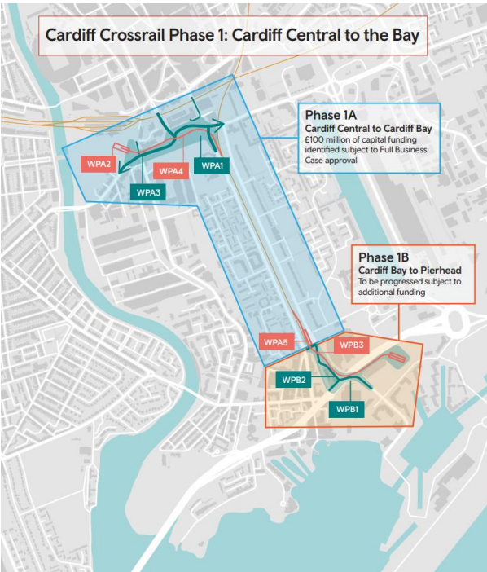
Figure 1 Map showing proposed tramway and worksite areas for Phase 1
The map had highlighted the geographic impact on communities in Butetown and the City Centre. It demonstrates the worksite areas (WPA1 to WPA5 and WPB1 to WPB3), each aligned with key stakeholder zones. Cardiff Council and TfW had to coordinate stakeholder input from both residential and commercial corridors impacted by the route (Transport for Wales, 2025).
Local residents is a high interest group, but they have medium power, and they were directly affected by the planned tram routes as well as road closures and their response were measured through online and in person consultations and their demographic results are shown in figure 2.
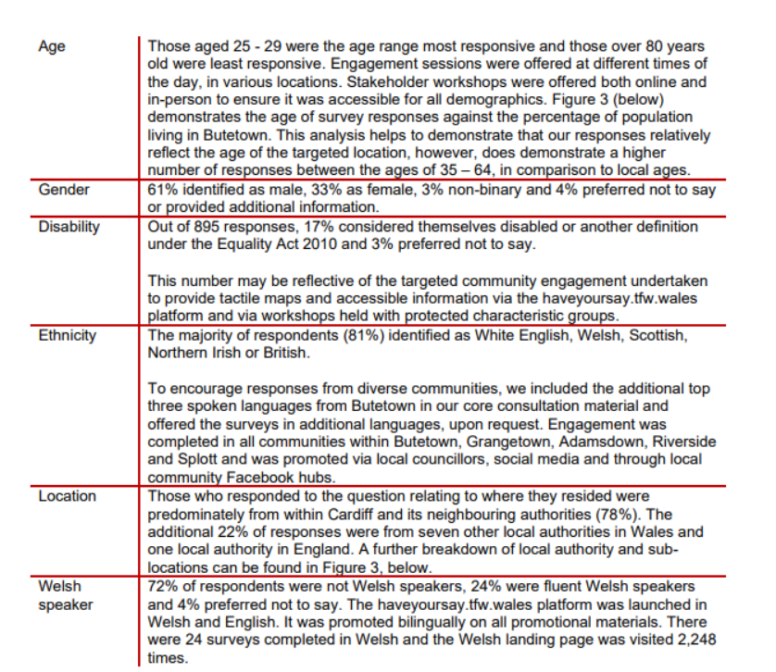
Figure 2 Demographic breakdown of survey respondents

The data shows that there is a gender split of 61% male and 33% female with a notable number of non binary and undisclosed respondents and there are around 70% respondents that were identified as disabled this reflects on the efforts to include the protected groups (Transport for Wales, 2025). The Cardiff residents particularly from Butetown, Grangetown, and Adamsdown, were well represented. The project team ensured participation by hosting events in multiple locations as well as different formats targeting typically the under presented groups as the inclusivity highlighted the involvement of disability advocacy groups as well as ethnic minority stakeholders and this has contributed to the insights that was gained from the survey and this insights are often overlooked in transport planning.
Commuters who depend on East West connectivity where another primary stakeholder group and these individuals may not live within the project boundaries but directly affected by the transit delays and route improvements. Their representation also explored in figure 3 comparing TFW consultation data to the UK census.
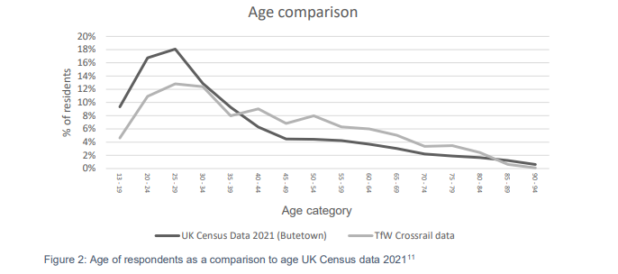
Figure 3 Age comparison between TfW data and UK Census (Butetown)
The age analysis shows a strong engagement from the people that are aged 25 to 39, who are the demographic most likely to commit to daily use (Transport for Wales, 2025). This aligns with the group’s mobility patterns and their interest in improved services. However, it should be noted that the lower participation of elderly stakeholders reflects a digital exclusion challenge in the stakeholder outreach. Motivations for participation also reflect stakeholder interest types and this is shown in Figure 4 which captures these distinctions.
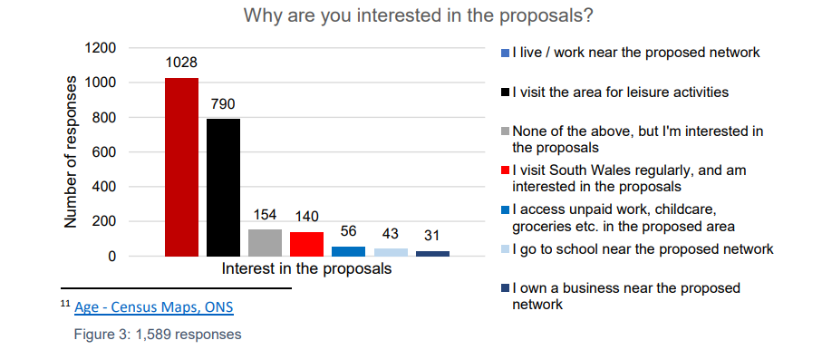
Figure 4 Stakeholder interest in the project proposals.
Most respondents cited living or working near the route as their reason for engagement and this reflected the daily impact on local residents and workers as a significant number cited regular visits to South Wales or for other leisure activities (Transport for Wales, 2025). This represented A secondary stakeholder such as tourist or cultural organisations that are indirectly depended on accessible public transport.

2.3 Engagement Strategies Used
TfW deployed a combination of consultation methods designed to address stakeholder diversity:
- Online surveys: Hosted on the bilingual platform haveyoursay.tfw.wales, which received thousands of visits (Transport for Wales, 2025).
- Printed and in-person communications: Posters and feedback stations were placed at major intersections and transport nodes.
- Workshops and pop-ups: Held in local community hubs, markets, and libraries, including tactile materials and interpreters.
- Feedback loops: Project updates and results were shared in newsletters, social media, and council bulletins (Transport for Wales, 2025).
These efforts were designed to reach people with varying digital literacy, language needs, and time availability.
Public agreement with the project’s objectives is shown in Figure 5, confirming overall support from both primary and secondary stakeholders.

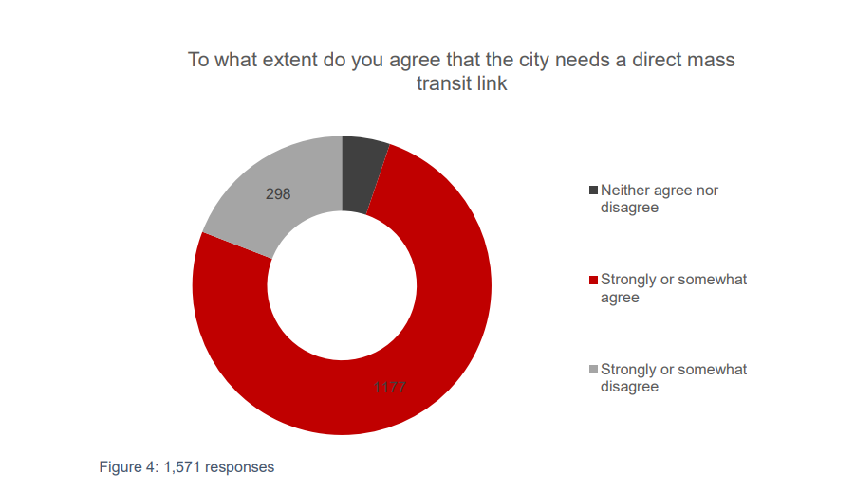
Figure 5 Public agreement on the need for a mass transit link
Out of the 1,571 responses, 1,177 strongly or somewhat agreed with the need for a mass transit link (Tfw.wales, 2024). This feedback strengthened the business case and confirmed that both policy actors, such as Cardiff Council, and end users, such as commuters and residents, are aligned on the core principles of the project. Beyond the broad support specific infrastructure proposals were also rated by stakeholders as figure 6 shows support for segregated cycleways and improved pedestrian spaces and greening city structure.
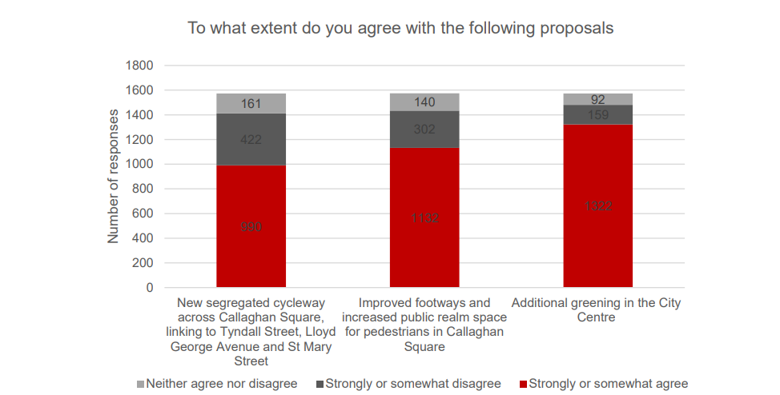
Figure 6 Agreement on proposed public realm enhancements

This reflects positive input from environmental groups, local businesses, and urban design advocates, who see these changes as beneficial to economic vitality and environmental health. . Figure 7 illustrates use of roads impacted by the tram project.

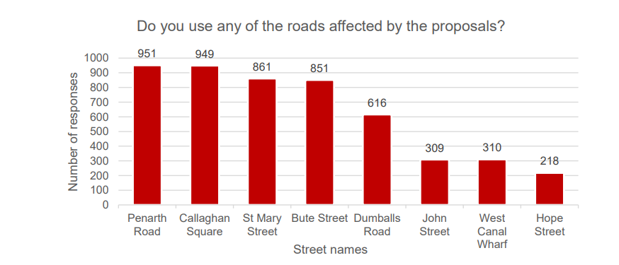
Figure 7 Streets most affected by proposed tram route
Penarth Road, Callaghan Square, and Bute Street were cited most frequently (Tfw.wales, 2024). This confirms local business owners, commuters, and delivery logistics operators as key stakeholders. Business owners may face temporary access issues, which could reduce revenue during construction unless mitigated by signage and support.

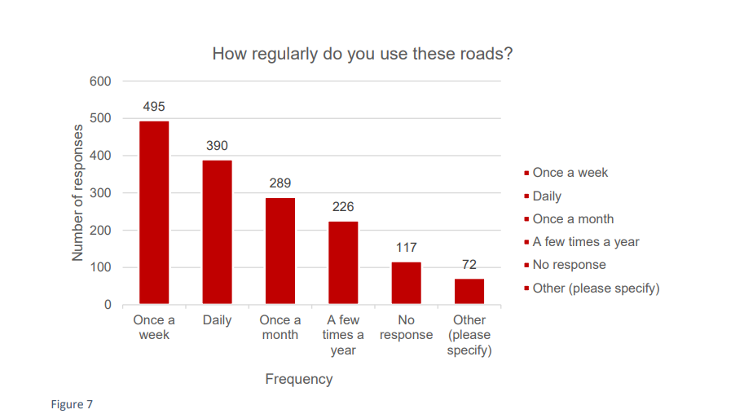
Figure 8 How often people use affected streets
Over 495 respondents used the roads weekly or more often. This highlights how service disruption or rerouting disproportionately impacts workers, shoppers, and service providers.

2.4 Effectiveness and Challenges of Stakeholder Engagement
What worked well:
- High turnout and diverse demographic participation suggest consultation strategies were accessible.
- Tailored communication reached key community groups via schools, social media, and faith groups.
- Strong visual branding and bilingual content increased reach across Welsh and English speakers.
What didn’t work:
- Older and digitally excluded groups remained underrepresented.
- Feedback fatigue emerged due to overlapping consultations in Cardiff.
Key challenges:
- Balancing priorities: Conflicts arose between economic growth (promoted by Cardiff Council and Welsh Government) and fears of gentrification (voiced by local residents).
- Disability access: While materials were inclusive, only 17% of respondents identified as disabled—suggesting further outreach may be needed.
- Scepticism of promises: Some communities expressed mistrust due to past delays in infrastructure delivery.

This analysis demonstrated the scale and variety of stakeholder engagement in Cardiff Crossrail phase one project. By using a mixed communication method and targeting specific interest groups the stakeholders and the project lead stakeholders ensured broad community input however managing long term engagement remains a challenge especially when trust and accessibility issues are not fully resolved. Stakeholder insights from each group work primary and secondary are very critical for not only the approval but also on delivering a transport system that makes the Cardiff’s sustainability, equity and connectivity long term goals.

Element 3: Ethical Consideration and Awareness, and Reflective Insight

3.1 Community Interest and Ethical Duty in Public Infrastructure
At the heart of ethical stakeholder engagement lies the principle of public accountability as Cardiff Crossrail Phase 1 is a publicly funded urban transport project that impacts A diverse population, many of whom live in areas already subject to socio economic pressure thus the ethical foundation of stakeholder management must begin with the duty to serve the community interest above institutional convenience. Ethical stakeholder management ensures that planning decisions are not only technically sound but also morally defensible and socially beneficial too (Carroll, Brown and Buchholtz, 2023). In this context the project organisers had the distinct moral obligation to ensure that local residents were not only simply informed but meaningfully involved as well. The consultation strategies that were adopted including the online service, the physical pop-ups as well as the translated materials demonstrated an effort to honour this obligation, but the ethical engagement also requires the project organisations to demonstrate an effort to understand as well as examine who did not participate and the reason (Carroll, Brown and Buchholtz, 2023). The relative underrepresentation of the elderly, disabled, and digitally excluded communities reveals a gap in this practice. While workshops and accessibility tools were offered the effectiveness of outreach to these groups remains limited. Ethically this concerns about the procedural justice the fairness of engagement process itself. For a project that intends to serve the future generations placing long term community well-being at the centre of decision making not only makes it ethically sound but essential to legitimacy as projects that serve the short term growth without listening to the voices of those who are displaced, disrupted or marginalised often faces backlash, delays as well as the loss of trust from the community the stakeholders (Carroll, Brown and Buchholtz, 2023). In the case of Cardiff Crossrail the steps toward inclusivity were taken but ethical scrutiny reminds us that inclusion is not fixed achievement, but it requests continuous attention and evaluation.

3.2 Transparency, Trust, and Informed Participation
Transparency is another vital value in the stakeholder management especially in infrastructure development where the stakeholders must not only be aware of what is planned but also understand how and why the decisions were made (Wasieleski and Weber, 2021). This project demonstrated a commitment to transparency through the use of public facing platforms to spread awareness using platforms such as social media, haveyoursay.tfw.wales where updates, proposals, and visual materials were made accessible. Regular updates helped stakeholders track the project’s status, which aligns with ethical best practices by supporting informed participation (Wasieleski and Weber, 2021).
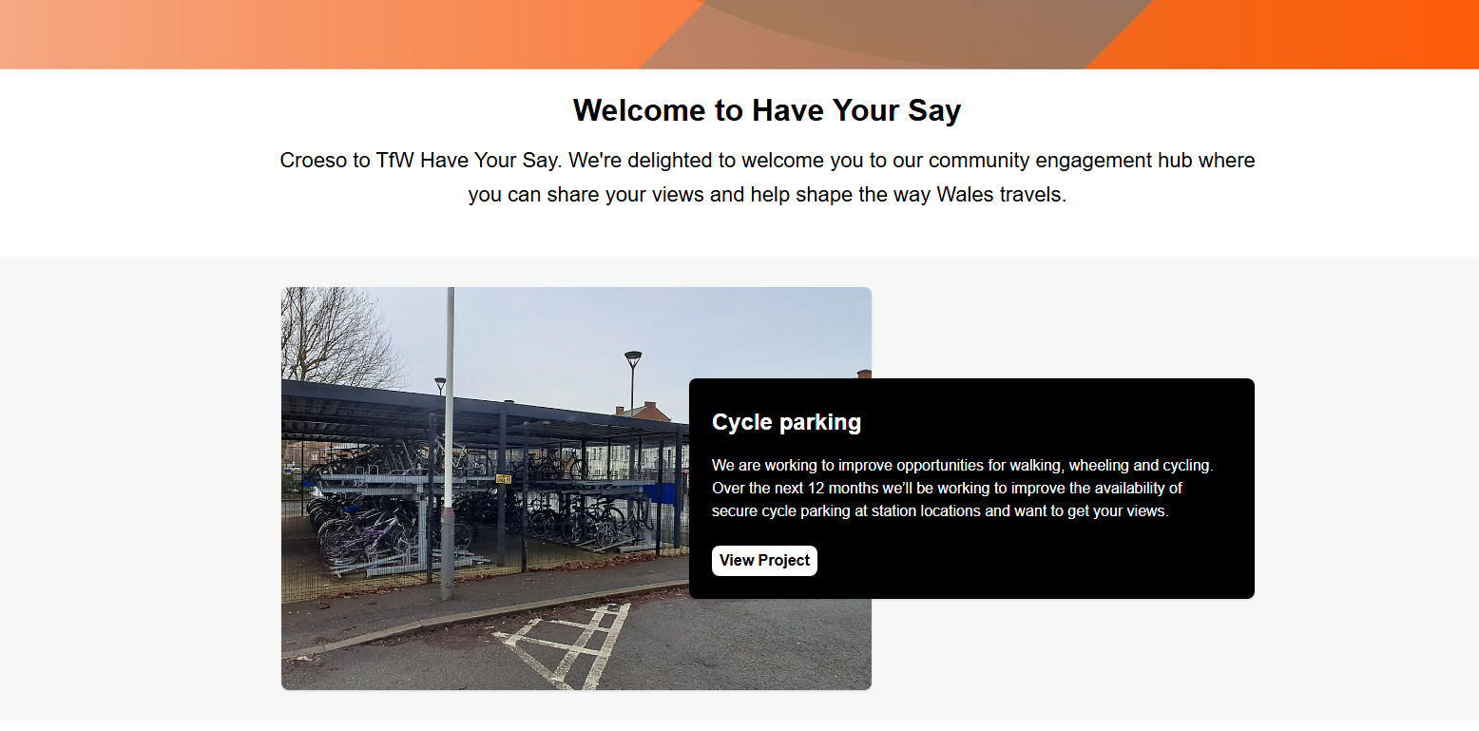
Figure 9 haveyoursay.tfw.wales
Yet transparency goes beyond the simple publishing of documentary it also includes being honest about limitations, trade-offs as well as uncertainties (Wasieleski and Weber, 2021). For example, while the Crossrail consultation presented clear benefits such as reduced congestion and decarbonization, but it put less emphasis on potential negative effects such as temporary displacement, traffic routing as well as business disruption during construction process. Ethical transparency requires acknowledging both benefits and costs especially for those likely to bear the brunt of the disruptions which is the general public. When stakeholders perceive that engagement is being used to validate pre-made decisions rather than shape them, trust will erode. To build long-lasting trust, transparency must be proactive rather than reactive. The Cardiff Crossrail process made strides in this area by offering feedback summaries and visual updates based on responses.

3.3 Corporate Social Responsibility (CSR) and Sustainability
The corporate social responsibility in a public project context is referring to the organisation duty to consider the wider social, environmental as well as economical impact of its actions (Haerens and Zott, 2020). Although it should be noted that TFW is a public entity rather than a private corporation the CSR principles are still applicable to them. This includes engaging ethically with the communities and investing sustainable development as well as promoting social equality (Haerens and Zott, 2020). First the Cardiff Crossrail project integrates several CSR aligned practises firstly the project promotes sustainability through modal shift. Encouraging people to use light rail instead of private cars. This supports environmental goals such as air quality improvement and carbon reduction. Secondly the use of green infrastructure cycleways and pedestrian paths contributes to social and environmental well-being (Austin, 2014). The project is attempting to fulfil the economic responsibility by improving access to the employment, education as well as services for undeserved population. However, it should be noted that CSR also requires ethical self-assessment Haerens and Zott, 2020). It is not enough to implement high-level sustainability goals the project must also monitor whether these goals are being achieved equitably and effectively. A project that reduces carbon emissions but increases displacement fails in the ethical CSR terms.

3.4 Reflective Insight on Theories and Practice
Engaging with stakeholder strategies used in Cardiff Crossrail phase 1 has deepened my understanding of how theory translates into real world complexity. The renowned stakeholder theory argues that organisations must consider the needs of all those affected by their actions not just shareholders or funders (Freeman, Harrison and Zyglidopoulos, 2018). This theory applies well in the infrastructure project where long term social and environmental impacts must be balanced with political and economic pressure (Freeman, Harrison and Zyglidopoulos, 2018). Applying frameworks like the power-interest matrix helped me see that influence, not just formal authority, shapes outcomes. For instance, local residents may have limited decision-making power but they exert significant influence on public opinion and media coverage. On the other head strategic bodies like Welsh government have high power and long-term interest but may be less affected by short community disruption. This experience has also taught me the importance of intersectionality in stakeholder engagement, as not all stakeholders fit neatly into predefined categories some may be residents, while others may be workers. An inclusive stakeholder strategy must account for these overlapping identities and avoid treating groups as homogeneous.

3.4.1 Skills Developed and Future Relevance
Working through this analysis has helped me build a number of academic and professional skills. These include:
- Critical thinking: Evaluating ethical trade-offs and interpreting stakeholder feedback.
- Communication analysis: Understanding how different messaging and channels affect engagement outcomes.
- Ethical reasoning: Applying moral principles like fairness, justice, and responsibility to real-world scenarios.
- Research skills: Synthesising policy documents, consultation data, and stakeholder theory.
- Systems thinking: Understanding how transport, housing, and environment interact in urban planning.

Element 4: Conclusion and Recommendations
The analysis of stakeholder engagement in Cardiff Crossrail phase 1 reveals that public infrastructure projects will require proactive and inclusive as well as ethically grounded strategies to balance competing needs. Throughout the use of various diverse engagement tools that includes online platforms, local workshops as well as targeted outreach through social media the project team successfully involved a broad spectrum of stakeholders. Primary stakeholders include the Cardiff council, the Welsh government and the transport for Wales as well as the local residents and the commuters. Secondary stakeholders included the local businesses, environmental groups, contractors, disability advocacy organisations as well as the general media.
To improve future stakeholder engagement, the following recommendations are proposed:
- Enhance outreach to digitally excluded and elderly populations through door-to-door consultations and accessible printed materials.
- Establish clearer feedback loops so participants understand how their input is used.
- Engage underrepresented groups earlier in the process using trusted community intermediaries.
- Monitor outcomes not just during planning, but throughout construction and delivery phases.

References
Afieroho, U.E., Li, Y., Han, Y., Soomro, M.A. and Mladen Radujkovic (2023). Transformational Community Engagement in Urban Infrastructure Public-Private Partnerships: A Governmentality Approach to Create Social Value. Buildings, [online] 13(5), pp.1225–1225. doi:https://doi.org/10.3390/buildings13051225.
Austin, G. (2014). Green infrastructure for landscape planning : integrating human and natural systems. Abingdon, Oxon: Routledge.
Carroll, A.B., Brown, J.A. and Buchholtz, A.K. (2023). Business & society: Ethics, sustainability, and stakeholder management. 11th ed. Boston, Ma: Cengage Learning.
Erkul, M., Yitmen, I. and Çelik, T. (2016). Stakeholder Engagement in Mega Transport Infrastructure Projects. Procedia Engineering, [online] 161, pp.704–710. doi:https://doi.org/10.1016/j.proeng.2016.08.745.
Freeman, R.E., Harrison, J.S. and Zyglidopoulos, S.C. (2018). Stakeholder Theory: Concepts and Strategies. Cambridge: Cambridge University Press.
Graham. (2024). GRAHAM awarded Cardiff Crossrail Phase 1 - Graham. [online] Available at: https://www.graham.co.uk/about-us/news/graham-awarded-cardiff-crossrail-phase-1 [Accessed 16 Apr. 2025].
Haerens, M. and Zott, L.M. (2020). Corporate social responsibility. Detroit: Greenhaven Press.
Hakimian, R. (2024). Graham appointed to design and build £100M first phase of Cardiff Crossrail | New Civil Engineer. [online] New Civil Engineer. Available at: https://www.newcivilengineer.com/latest/graham-appointed-to-design-and-build-100m-first-phase-of-cardiff-crossrail-19-11-2024/ [Accessed 16 Apr. 2025].
Project Management Institute (2021) A Guide to the Project Management Body of Knowledge (PMBOK Guide), 7th edn. Newtown Square: PMI.
Tfw.wales (2024). Cardiff Crossrail phase 1 | Transport for Wales. [online] Tfw.wales. Available at: https://tfw.wales/projects/metro/south-wales-metro/cardiff-crossrail.
Transport for Wales (2025). Cardiff Crossrail Consultation Report. [online] Transport for Wales. Available at: https://tfw.wales/sites/default/files/2025-02/Cardiff-Crossrail-Consultation-Report-FINAL-05-02-25_ENG.pdf.
Wasieleski, D.M. and Weber, J. (2021). Stakeholder management. Bingley Emerald.
‌

‌

