Business Plan for

Paws & Beans Cafe - A pet-friendly coffee shop that can offer a cozy and welcoming environment for both humans and their furry companions.

Produced By:
GROUP MEMBERS:
Student Name | Student No.
Gheorghita Elena Tudorache | 2238425
Connie Tucay Gagua | 2242243
Iulian Vasile Girtu | 2133038
Tudor Adalbert Radu | 2243696
Dated: 18/11/2024
Module Name: Entrepreneurship
Module Code: BMIH5001
Lecturer Name: Chris Wilkin

Table of Contents
1. EXECUTIVE SUMMARY 4
2. THE BUSINESS IDEA 5
2.1 The Product/Service 5
2.2 SWOT Analysis Summary 5
3. THE TEAM 5
3.1 Key Personnel 5
3.2 Skills Gaps & Key Partners 7
4. MARKET RESEARCH 8
4.1 Market Information, Trends and External Factors 8
4.2 Customer Profiles 8
4.3 Competitor Profiles 9
5. MARKETING PLAN 10
5.1 Price 10
5.2 Product 10
5.3 Placement 10
5.4 Promotion 10
6. KEY RESOURCES 11
6.1 Premises 11
6.2 Equipment 11
6.3 Key Suppliers 11
7. FINANCES AND START-UP SUPPORT 11
7.1 Financial Summary 12
APPENDICES 13
Appendix A – SWOT Analysis 13
Appendix B – PEST Analysis 14
Appendix C – Copy of Pitch Supporting Material 15
Appendices D - CV 29
Bibliography 31

AI Declaration
I declare that I have not used any applications of artificial intelligence in writing this business plan. Everything in this assignment is my own self-work. I have taken assistance in attaining the research and information from Google scholar and some online articles and websites.

1. EXECUTIVE SUMMARY
Paws & Beans Café is an innovative concept of a coffee shop integrated with pet amenities situated in a highly populated area of Birmingham, UK. The café provides gourmet coffee, nutritious light meals, and a pet restaurant where dogs are served biscuits and piers along with pet-friendly ice cream. As the rate of pets rises, people's desire for establishments that allow pets also grows. The target market for Paws & Beans Café includes pet enthusiasts and families with pets seeking a place where they can spend ample quality time with their beloved pets. The cafe can offer a better value proposition by offering high-quality products alongside a comfortable and pet-friendly environment.
The income is forecasted to be £180,000 in the first year with important costs of £118,960 and thus the net profit of £61,040. For these reasons, the business requires capital to finance start-up expenses such as rent and equipment. For the short term, the business aims at integrating the society well, coming up with frequent pet related events, and obtaining branding by the year end.

2. THE BUSINESS IDEA

2.1 The Product/Service
Paws & Beans Cafe is an industry of food and beverage especially focused on people with their pets or people who love their pets in the UK, Birmingham. It offers a place where customers can receive high-quality, freshly brewed coffee, speciality beverages, and fresh and healthy foods alongside their pets in a warm, wooden interior design. They serve artisan coffee as well as an exotic menu to include lavender lattes, honey cappuccinos, and more, pet bases products like 'puppuccinos' for dogs, and 'cat-puccinos' for cat lovers. There are many creative pet-friendly meals, which include dog cookies, ice cream, pet-safe whipped cream, and many more delights. An additional facility of Paws & Beans is pet pet-friendly area or pet play area where pets can move freely under supervision on the premises (Blackwell, 2011). Other amenities, such as shaded sitting areas together with water dispersion areas and tie-down points, are also a comfort to both the pets and their owners. There are daily/weekly activities like pet meetups, pet birthday celebrations, adoption, and pet photography sessions that make many people who own pets make it their routine destination.
Value Proposition: Customers obtain good quality coffee, comfortable and pet-friendly places, and appealing events as part of the package and thus a perfect venue to network for pet lovers.

2.2 SWOT Analysis Summary
Some of the strengths include different unique concepts, and it targets events for pets and their owners only. Also adding to this appeal is a variety of food options, which include treats for both the customer and their pet, thus offering a memorable experience. However, some of the weaknesses include - the product could be expensive to maintain its quality. Hence, the relatively high costs or price range could limit the market or target niche.
Local shelters and pet services must be offered as partners, enabling the cafe to find new clients, becoming closer to the community, and growing the trend of pet-friendly spaces contributes to the cafe market potential. On the other hand, threats from other pet-friendly businesses and any economic conditions may lead to reduced spending. To avoid risks, the cafe will employ strict hygiene measures, competitively price its products, and rely heavily on Internet marketing.

3. THE TEAM

3.1 Key Personnel
Name and Company Position: Cafe Manager
Skills and Experience: Hospitality management experience involving customer relations and prior experience with pets or pet-loving clients. Cognizant with health/safety measures and food safety measures.
Role and Responsibilities: A lot of responsibility for daily operations, managing staff and making certain that customer service is excellent.

Name and Company Position: Operational Head
Skills and Experience: Qualified in making speciality coffee, latte art and handling customers. Some of my previous work experience in artisanal coffee establishments and passion for animal rights.
Role and Responsibilities: Make cocktails, ensure proper preparation of the cocktails, create cocktail recipes and track coffee products.

Name and Company Position: Pet Lounge Supervisor
Skills and Experience: Knowledge of pets' treatment, their behaviour, and communication with customers. Certification in animal care or pet handling, though, is desirable.
Role and Responsibilities: One must oversee animals in the common area, constantly observe animal behaviours, and control the pet's playpen.

Name and Company Position: Event Coordinator
Skills and Experience: Organisational experience in special event planning with a focus on community development and partnership involvement. Ideally, the candidate should be knowledgeable about events such as adoption fairs with pets.
Role and Responsibilities: Organise at least one pet meetup every week, adoption days and pet parties.

Name and Company Position: Marketing and Social Media Manager
Skills and Experience: IT experience and Computer skills and knowledge of social media and community. Observe that other skills, such as creative and compelling copy and appealing photographs, are desirable for advertisement.
Role and Responsibilities: Interact with specific groups online, spread information regarding attractive points of pet-friendly accommodations, and control accounts to sustain brand awareness.

3.2 Skills Gaps & Key Partners
3.2.1 Additional Staff Requirements (Roles and Responsibilities):
- Animal Care Assistant: To oversee the interaction of the pets and be responsible for the cleanliness of the pet lounge. This role meets the demand for experienced animal handling, which is crucial in creating proximity that is comfortable for the pets and the customers.
- Kitchen Helper: Supports the café chef in the preparation of all food and snacks for human and canine customers while ensuring proper hygiene is upheld (Rae, 2008). The need for this position is justified based on the need to enhance order in the kitchen and address compliance with food safety laws.
- Customer Service Associate: A customer-facing position that would involve welcoming the guests, taking their orders, and ensuring the tidiness of the dining area. This also does away with cases where customers find themselves attending to rude or unfriendly staff members, thus making the café experience even more pleasant.
3.2.2 Training and Development
- HACCP Training: Training every worker in food safety from an accredited food safety organisation like ServSafe, which costs between £100-150 pounds per worker.
- Pet Handling Certification: Ideally offered by a local animal training agency for employees to learn safe animal management with costs ranging from £200 per employee.
- Customer Service Workshop: An in-house, certificated hospitality trainer to offer a workshop on communication and hospitality up to £500.
3.2.3 Outsourced Support / Key Partners
- Pet Shop Localisation: Ensures supply of quality pet foods and products for the pet’s menu to be sourced locally thus cutting on home production.
- Digital Marketing Agency: Facilitates social media and event advertising to increase awareness, it is at £300 per month.
- Local Shelter Partnership: Participants in the co-coordination of adoption activities, which creates more worth and publicity for the owning community as a few gain shared publicity.

4. MARKET RESEARCH

4.1 Market Information, Trends and External Factors
The pet industry is poised for growth because more people own pets than ever before and spend money on such goods and services as pet-friendly. The demand for pet lovers in the UK has increased by 3.8% in the year 2023 and it is expected to grow at 6.5% respectively. The CAGR is expected with a market cap of £140 billion, with a percentage of households that own a pet at 70% (Statista, 2024). This trend demonstrates there is an increasing need for spaces and services in pet-friendly, thus increasing the potential of Paws & Beans Café. Moreover, the millennials also feel that their pets are part of the family, 60% of this population wants the places for communication about pets (Buhalis and Chan, 2023). From the PEST analysis (attached in the Appendix below), the findings got several key external factors influencing the operations of Paws & Beans Café. From a political perspective, it is mandatory to abide by food safety regulation and locals' support towards small businesses. In terms of economics, the growth in the pet market could mean increasing demand for the products, but inflation may be an issue for the products (Manzolini et al. 2024). In the social aspect there is growth of pet ownership and tendencies of providing spaces for pets as the café aim is to have a loyal audience. To reach target customers, technology that focuses on digital marketing and various forms of social media must be adopted. To build on these discoveries, the café will have to adhere to the set laws and policies, set fair prices for their products and use computer and internet services to popularise the café and its business success.

4.2 Customer Profiles
- Young Professionals (25-35): Composed of millennials for whom pets are family members, who mingle in establishments that are pet-friendly, and who prefer authentic, shared experiences that are often sourced from local artisans.
- Families with Children (30-50): Those who have children or are planning to have them, cozy with community activities, appreciate and prioritise areas that can guarantee child and pet friendly.
- Pet Enthusiasts & Retirees (50+): Pet owners who are elderly or retired, who prefer a casual and welcoming environment, and who engage in outings such as meet-ups or adoption-related events.

4.3 Competitor Profiles
- Local Coffee Chain: This is one of the most popular cafés to have quality coffee, but not cater for pets (Hariyatmi, 2022).
Strengths: Large number of customers, brand recognition, serving a variety of coffee products. Weaknesses: No locations with pet-friendly areas or with a distinct pet food list.
Competitive Strategy: Paws & Beans is going to have elements, such as complete pet-friendliness, a themed menu, and events like pet meetings, which will make it stand out from competitors.
- Pet Supply Store with Cafe: This business involves the sale of pets and other pet products, including foods, and then a small section where it sells foods and beverages as a café (Heath, 2020).
Strengths: It has opportunities to offer a wide supply of pet-care products for any pet owner to benefit from.
Weaknesses: The number of options in a café is low, and the atmosphere of a café is different from that of the traditional coffee shops.
Competitive Strategy: In fact, with proper arrangements such as comfortable chairs and sofas, pet owner a friendly environment as a café and pet lounge, Paws & Beans has a better image for pet owners who want to spend time with their pet in a café (Nelson, 2013).
- Pet-Friendly Park Café: Based on the location, it is assigned near a famous park. The café provides outside dining and is pet-friendly (Saarnivaara, 2021).
Strengths: High visibility and good outside area convenient for pets.
Weaknesses: Less area indoors and few set cocktails only.
Competitive Strategy: It will provide flexibility for both indoor and outdoor options with selective drinks and foods for the pets and their owners since people will not shy away since it will rain.
USP: Paws & Beans Café serves speciality coffee, features a specially designed pet area and hosts pet-friendly events, making it a destination that is unrivalled in the market.

5. MARKETING PLAN

5.1 Price
Paws & Beans Café will adopt a competitive pricing technique that will be keen on the quality of the foods offered to the customers. For instance, the products arising from artisanal practice, such as coffee, will cost between £3 and £5 and specialty pet foods which will cost between £1.50 and £4.

5.2 Product
The overall look and feel of the café will be rustic and warm, with wooden furniture and comfortable chairs. Brand positioning will be fun and sophisticated, and the colours of the logo will be earth tones with pet-related designs (Alves et al. 2022). Pet treats' packaging will also be sustainable in a bid to reduce the bad impact of packaging on the environment.

5.3 Placement
Food and other related items will be sold both from Paws & Beans Café and through an online website that is also associated with this Café (Hisrich et al. 2008). For convenience, local delivery services will be employed, as an effect of which, the customers will be able to obtain food menus for both themselves and their pets.

5.4 Promotion
For awareness creation, the café will adopt social media marketing platforms that will target pet-friendly activities and exclusive meals. Promotions of partnership with local shelters for adoption events shall improve connection with the community (Rickman and Roddick, 2013).

6. KEY RESOURCES

6.1 Premises
The Paws & Beans Café will need 1,500 to 2,000 square feet, which will encompass a designated coffee preparation zone, a pet resting area, an indoor dining area, and an outdoor dining area. This café should preferably be situated in a pet area that has a lot of pedestrian activities. Rent in such areas typically ranges from £2,500 to £4,000 per month, depending on location and size (Pinney and Costa-Font, 2024).

6.2 Equipment
Some of the vital utensils consist of commercial coffee makers, which cost between £1,500 to £5,000, grinder, which costs between £300 to £1,000, and kitchen appliances for food preparation which cost between £1,000 to £3,000. The furniture and the seating area, which consists of tables and chairs, may cost between £500 to £2,000. Potential suppliers include suppliers like Amazon for kitchen equipment and local furniture stores for seating (Barringer and Ireland, 2018).

6.3 Key Suppliers
Essential suppliers will include local coffee roasters for high-quality beans (e.g., Union Hand-Roasted Coffee), which cost around £10-£15 per kilogram, and pet treat manufacturers providing eco-friendly snacks at approximately £5-£10 per pack (Burns, 2022). A local bakery may produce fresh pastry products that will complement the menu presented to consumers.

7. FINANCES AND START-UP SUPPORT
Year 1: Expenses
Items | Amount (£)
Company Registration | 60
Rent/Rates | 12,000
Staff Wages | 60,000
Travel/Accommodation | 2,000
Telephone (mobile) | 600
Broadband | 600
Utilities | 3,600
Marketing and Materials | 10,000
Insurance | 1,200
Capital Expenditure/Equipment | 10,000
Training & Development | 2,000
Accounting/Legal | 2,500
Outside Services | 3,000
Stock/Materials Purchases | 15,000
Bank Charges | 300
Office Consumables | 1,000
Loans Repayments | 0
Total Expenditure | £118,960

Year 1: Profit and Loss Summary Highlights
Item | Amount (£)
Total Income | 180,000
Total Expenditure | 118,960
Profit/Loss | £61,040

Year 1: Income
Item | Amount (£)
Sales A (Coffees & Beverages) | 90,000
Sales B (Pet Menu) | 30,000
Sales C (Food & Snacks) | 30,000
Capital Introduced | 20,000
Funding | 0
Loans/Borrowing | 10,000
Total Income | £180,000

7.1 Financial Summary
The financial features of the Paws & Beans Café business plan are derived from extensive analysis of financial requirements for a good café business as well as market trends and potential sales figures. The major costs include - rent at £36,000 represents a monthly expense for rent, and it is common for a café in a busy area to spend £3600 monthly. Staff wages at £60,000, which are usually calculated based on the number of employees, hours worked and their wages. Marketing expenses are £10,000. Marketing is usually funded based on the targeted market and the outlay required to capture the market. The estimated additional income of £180,000 originates from sales of coffees and beverages (£90,000), pet meals (£30,000) and food and snacks (£30,000). The market research reveals a high demand for pet-friendly businesses. Also, £20,000 in capital introduced consists of the proprietor's funds and potential funding opportunities described in the marketing plan.

APPENDICES

Appendix A – SWOT Analysis
Strengths | Weaknesses
Unique Concept: Merges a coffee shop with features that cater to lovers of animals and pet owners in a speciality market. | Higher Initial Costs: The additional charges should be provided for pet friendly environment (pet accommodation area, outdoor dining area).
Community Hub: Hyperlocal targeted promotions (adoption days, pet meet-ups) create a sense of pet community and are sources of repeat business. | Maintenance: Higher levels of cleaning and maintaining the environment for the pets and people who touch or meet the facility (Mariotti and Glackin, 2012).
Differentiated Menu: It has different services, such as pet-friendly snacks and beverages that have a special and interesting atmosphere for both people and animals. | Limited Audience: May also stick to customers with pets only, hence reducing the overall market for the cafe.

Opportunities | Threats
Local Partnerships: Partnering with shelters for rescue pets or selling the products in pet stores will help to attract more customers. | Competition: Other related businesses that allow customers to make purchases with their pets may reduce the novelty of the initiative.
Growing Market: Opportunities for future expansion are vast owing to the current increased popularity of pet adoption as well as related services. | Economic Downturns: When there is an economic downturn, customers may be able to focus on essentials only, such as food at cafes that accept pets and attract more customers.
Online Engagement: Sharing stand-out events and various pet-friendly benefits on social media increases audience awareness and customer engagement. | Liability Risks: Special caution should be taken with the fact that many hotels manage pets at the facility, and this entails significant risks whose management needs to be ensured.

Appendix B – PEST Analysis
Political Factors: It will be important to consider local ordinances concerning food safety and the acceptance of businesses that allow pets. They will also need to ensure that they fully observe all the health codes and obtain all requisite licenses. Moreover, customers of the café can be extended from those who have a taste of local cuisine and have support from local government in the form of promoting small businesses and community support.
Economic Factors: A rapidly evolving market of pet services, which is expected to reach more than £140 billion in 2024, proves that there is a demand for such services (Pinney and Costa-Font, 2024). However, economic changes and inflation can have a way on the deliberate decision to go for the restaurant and spend more on it. Decisions about pricing will be made based on the understanding of local economic conditions.
Social Factors: Taking and raising a pet raises some concerns and demands that basically call for consideration of pet-friendly locations. Pet-friendly spaces would thus be useful to millennials and Gen Z consumers because they value the experiences and engagements of their communities. Also, pet owners seek socialisation, and this brings events into the market land.
Technological Factors: Modern tools of digital marketing and social media use pinpoint advertisement to address potential customers properly. The café can increase the number of people by launching an online ordering system and using Instagram or Facebook to create a strong presence of the café and boost interaction.

Appendix C – Copy of Pitch Supporting Material
Slide 1
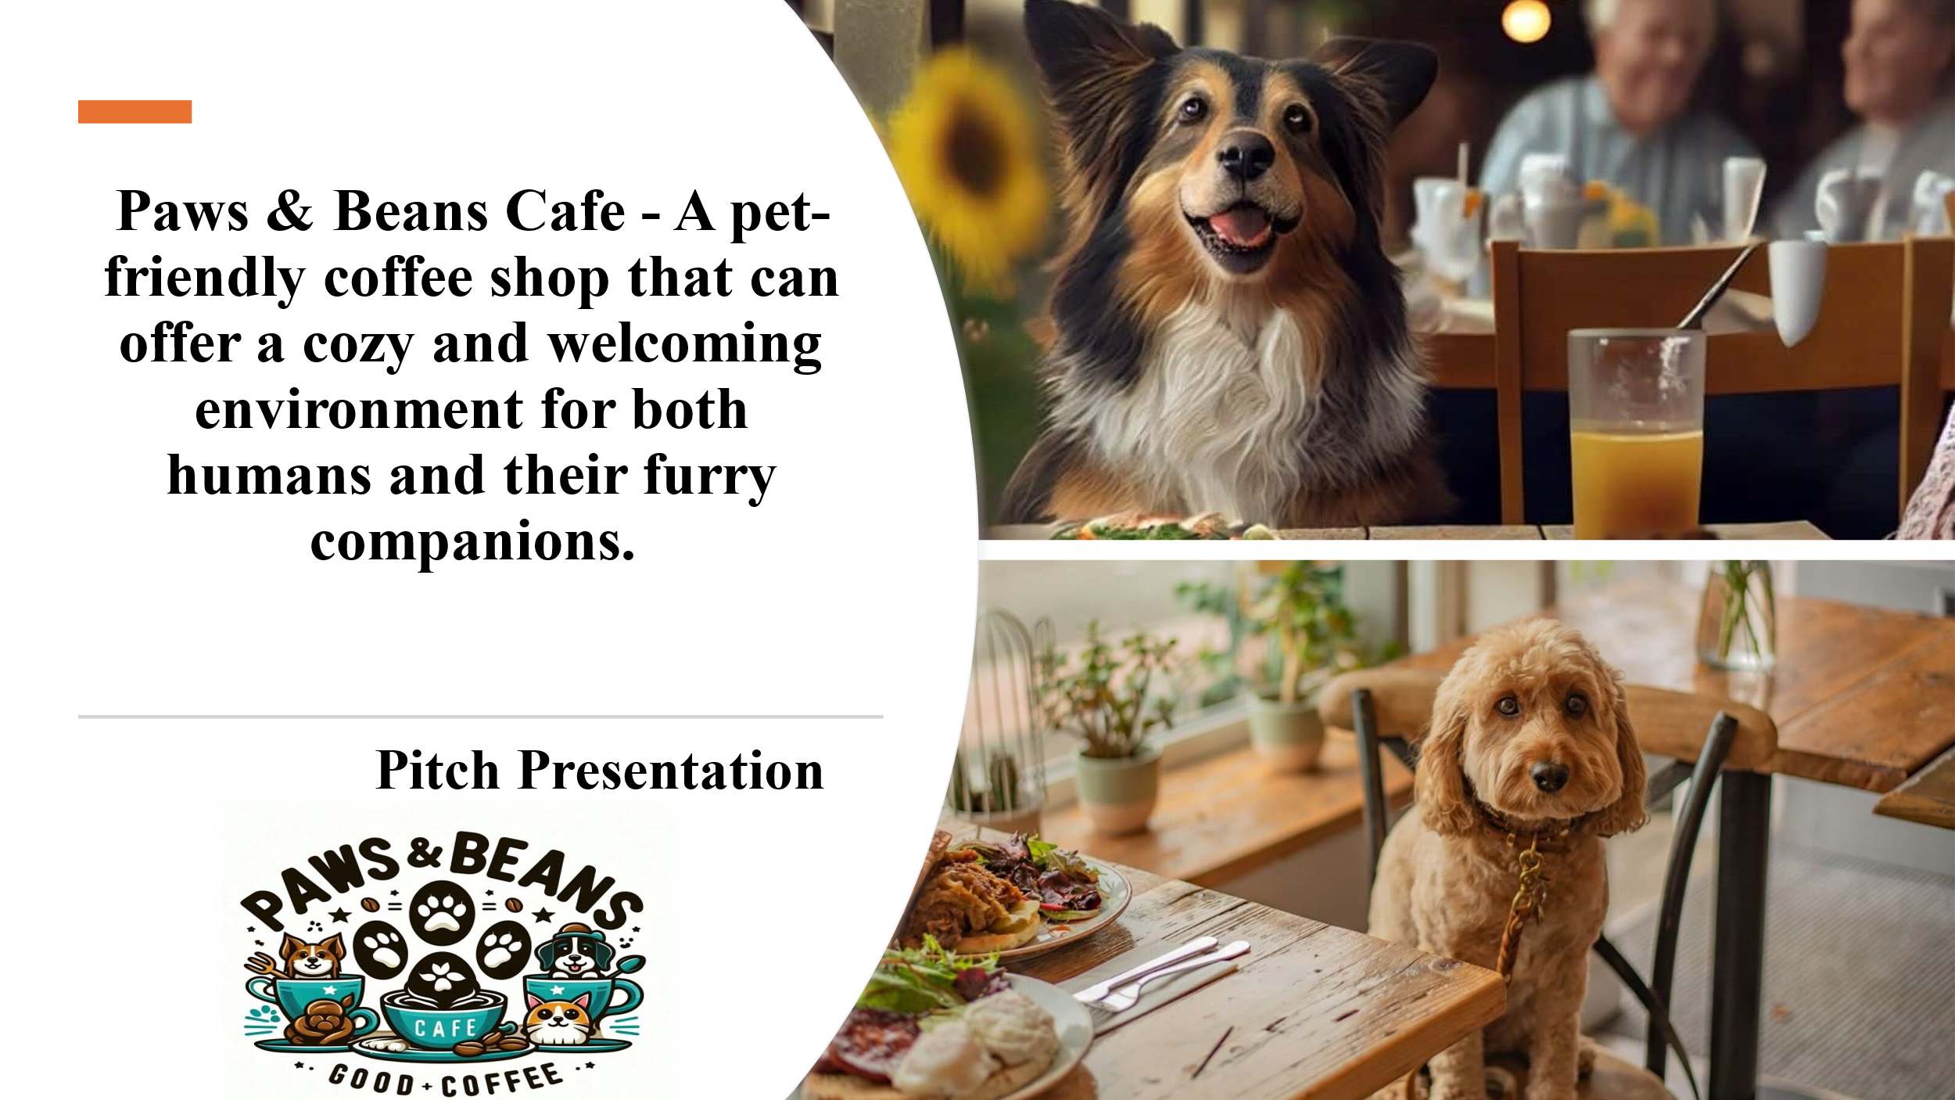

Slide 2

Slide 3 – Connie Gagua

Paws & Beans Cafe is a specialised café service which includes high-quality coffee and a pet-friendly atmosphere that aims at animal lovers and pets. A thoroughly selected location's main area of the UK is the city of Birmingham - 22 The Hawthorns, Woodbridge Road Birmingham, B13 9DY with a huge flow of people with several income level criteria. The link is accessed by https://www.zoopla.co.uk/house-prices/moseley/woodbridge-road/the-hawthorns/b13-9dy/ . The café is aimed at an unusual target audience of pet lovers who want to spend time in a cafe with their pets and enjoy high-quality products.

Slide 4– Connie Gagua

The targeted market for Paws & Beans Cafe is the growth of pet adoption across households, but especially within urban settings where people look for better facilities across dining establishments for both them and their pets. This found a definite market for quality pet products for pet owners, especially when they go out with their pets, but few establishments offer this (Bartram, 2024). It means that the given market lacks a proper establishment for effective communication between both pets and their owners, as well as a place to feed those animals (Heath, 2020).

Slide 5– Connie Gagua

The competitive strategy for Paws & Beans Cafe is based on the positioning of the cafe as a superior quality house of coffee while presenting a pet-friendly environment. Among its special products, it is essential to mention the drinks that can be consumed by both the customer and his pet, such as "Puppuccinos" and "Cat-puccinos." Enclosed sections for animals prevent contact with other guests, which keeps owners relaxed and creates a fun experience at the café.

Slide 6

Primarily, Paws & Beans Cafe targets its products to the working population in cities like Birmingham where adults and middle-aged, interested in highly quality and healthy products. These customers are interested in maintaining good health and care about places where their pets could be with them. These points suggest that the café fulfils their lifestyle desires, providing an environment for people to gather and spend time with their pets (Hoy et al., 2024).

Slide 7

The company provides an extensive list of products and services starting from the standard fare of coffee and tea menu to non-conventional pet-friendly drinks. Treats are made from nutritious ingredients for both people and animals to fit the diet of the targeted group of customers. Also, the café will have pet products, grooming stations, and social functions, becoming a pet lifestyle centre.

Slide 8

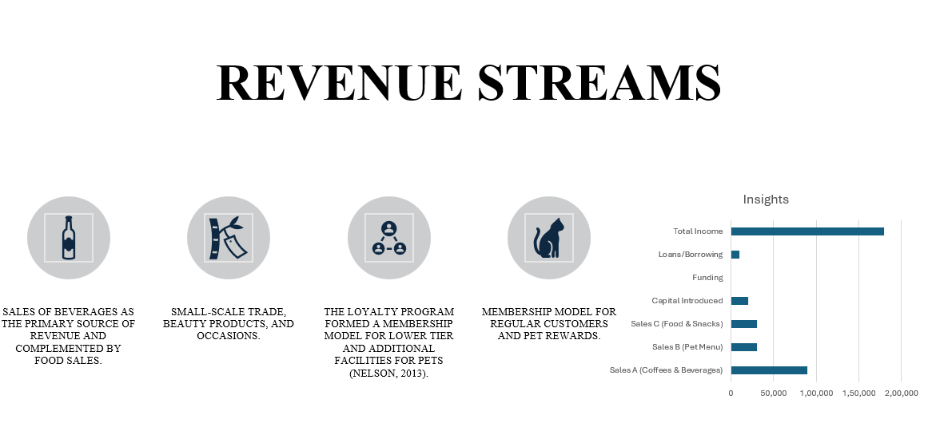
There are multiple ways of generating income at Paws & Beans Cafe however, the main source will be in foods and beverages served to the customers. Secondary ways include merchandise, pet grooming services and events which cater for owned pets. Further, the policy of membership will also be implemented to provide the clients with extra bonuses and to build a constant clientele. In Year 1, taking into consideration the pet-friendly specialty, the present business expects roughly 50% of revenues from coffee and beverages (£90,000), 20% from the pet menu (£30,000) and 20% from foods and snacks (£30,000). Market research indicates a gradual increase in foot traffic and especially those with pets especially in urban centres like Birmingham. Based on the concept of appealing to the community and café novelty, the goal is to increase the number of customers within the first year by 20–25% every quarter and turn Café into a steady, successfully operating business. The total income forecast of £180,000 is based on expectations of first year success and subsequent gradual increase in clients.

Slide 9

The main strength of Paws & Beans Café is the uniqueness of the concept on which the cafe is based. Being an open space, the café ensures that all the clients feel as though they are part of a group and that they continue to support the café. It operates with local competitors being chain coffee shops such as Starbucks and Costa Coffee and pet shops such as Pets at Home. But none of these two joins together coffee services with a pet-friendly policy. The current business work with a team of suppliers such as Rave Coffee which supplies organic beans, Pukka Tea which supplies us organic teas and Barker & Barker supplying with pet products feeds. Pet furniture and equipment are from PetSafe and KomfiPet to guarantee the security and comfort of family pets and their owners.

Slide 10

Target demographic of clients include pet owners who will be reached through social media with the aid of popular pet influencers and local brands. Interesting and informative content will draw attention to the products that the café offers, and the constant organisation of events allows to establish contact with the target audience and attract customers (Barringer and Ireland, 2018).

Slide 11

The analysis of income and expenses demonstrates the constant revenue increase depending on the target audience's need for comfortable and pet-friendly apartments. Capital expenditure will be used to make initial purchases such as furniture, IT and communication hardware, equipment and other amenities that will meet high standards, plus the cost of advertising both online and offline. The café aims to achieve its breakeven in two years, hence proving its viability in terms of revenue generation. Paws & Beans Café funding will be sourced from personal equity, small business loans, and other interested angel investors in the inspirational pet friendly market. More capital will be sought from crowdfunding sites such as Kickstarter, focusing on those that adopt the company’s vision focusing on pets.

Slide 12

Overall, Paws & Beans Cafe has a novel, highly attractive business idea that is promoted with pet population growth. In this regard, this venture offers the stakeholders a golden opportunity to invest in this company that appeals to lovers of pets and quality Café consumers. The investment will help Paws & Beans Cafe to find new opportunities and become a world-class provider of pet-friendly services.

Slide 13

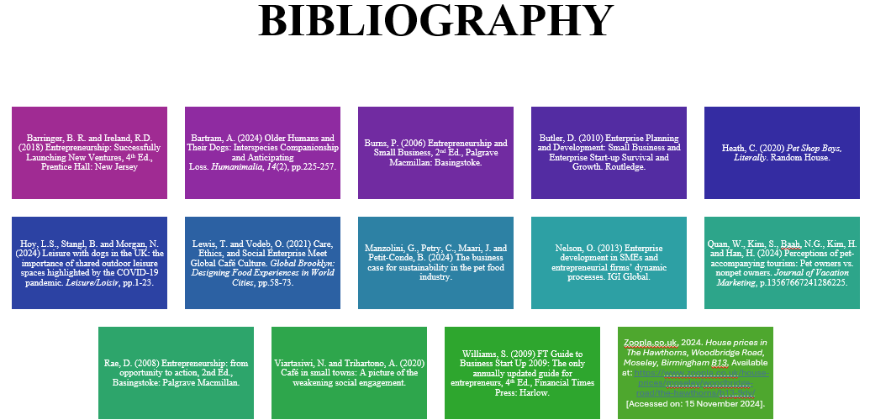

Slide 14

Appendices D – CV
CONNIE TUCAY GAGUA

Present address:
Contact Number: 07808838720
E-mail address: 2242243@student.uwtsd.ac.uk

KILLS
I can adapt to different settings, dedicated, hardworking and very
organized, I can work under pressure and with minimum
supervision, good team worker, knowledgable in MS Office(MS
Word, Excel, PowerP
KILLS
I can adapt to different settings, dedicated, hardworking and very
organized, I can work under pressure and with minimum
supervision, good team worker, knowledgable in MS Office(MS
Word, Excel, PowerP
KILLS
I can adapt to different settings, dedicated, hardworking and very
organized, I can work under pressure and with minimum
supervision, good team worker, knowledgable in MS Office(MS
Word, Excel, PowerP
KILLS
I can adapt to different settings, dedicated, hardworking and very
organized, I can work under pressure and with minimum
supervision, good team worker, knowledgable in MS Office(MS
Word, Excel, PowerP
KILLS
I can adapt to different settings, dedicated, hardworking and very
organized, I can work under pressure and with minimum
supervision, good team worker, knowledgable in MS Office(MS
Word, Excel, PowerP
SKILLS

I can adapt to different settings, am dedicated, hardworking, and very organized, I can work under pressure with minimum supervision, great team worker and am knowledgeable in MS Office (MS Word, Excel, and PowerPoint). Can communicate and understand English well. Knowledgeable on OMS Gateway/Kornit System.

EDUCATION

University of Wales Trinity Saint David, 5th year
1 Kings Road, Swansea SA1 8PH
BA International Hotel Management

WORK EXPERIENCES:

GI Group
GOUSTO – Omega Business Park South, Fairchild Road, Warrington WA53TZ
21 September 2023 to Present
Production Operative

Job Description
- Picking customer’s order

The Hut Group On Demand – Altrincham, Greater Manchester
03 September 2019 to 23 July 2023
Senior Warehouse Colleague

Job Description:
- In charge of monitoring the daily KPIs
- In charge of monitoring consumables in the department
- Helping the team to resolve the issues we encountered on the daily basis
- Printing daily job sheets (orders) and artwork from the system
- Checking the quality of the finished product before sending it to dispatched department (outbound)
- Communicating/Planning with the team manager or shift manager regarding daily orders, backlogs, KPIs, and any issues (e.g. machine issues, stocks)

The Hut Group - Warrington
January to September 2019
Sewing Machinist

The Hut Group - Warrington
13 December 2017 to December 2019
Warehouse Operative

AM 2 PM (The Hut Group) – Warrington
19 September - Present
Warehouse Operative

Gap Personnel (Get the Label) – Warrington
12 May 2017 - 09 September 2017
Warehouse Operative

Bibliography
Alves, H.M., Sousa, B., Carvalho, A., Santos, V., Lopes Dias, Á. and Valeri, M. (2022) Encouraging brand attachment on consumer behaviour: Pet-friendly tourism segment. Journal of Tourism, Heritage & Services Marketing, 8(2), pp.16-24.
Barringer, B. R. and Ireland, R.D. (2018) Entrepreneurship: Successfully Launching New Ventures, 4th Ed., Prentice Hall: New Jersey
Blackwell, E. (2011), How to Prepare a Business Plan: Planning for Successful Start-up and Expansion, (5th Ed) Sunday Times Business Enterprise Series, Kogan Page.
Buhalis, D. and Chan, J. (2023) Traveling with pets: designing hospitality services for pet owners/parents and hotel guests. International Journal of Contemporary Hospitality Management, 35(12), pp.4217-4237.
Burns, P. (2022) Entrepreneurship and Small Business, 5th Ed., Palgrave Macmillan: Basingstoke.
Hariyatmi, S. (2022) A COMPARATIVE KEYWORDS ANALYSIS IN PET CAFÉ AND REGULAR CAFÉ REVIEWS: A CORPUS STUDY. LLT Journal: A Journal on Language and Language Teaching, 25(1), pp.93-106.
Heath, C. (2020) Pet Shop Boys, Literally. Random House.
Hisrich, R.D., Peters, M.P. and Shepherd, D.A. (2008) Entrepreneurship, 7th Ed., McGraw Hill: NY.
Manzolini, G., Petry, C., Maari, J. and Petit-Conde, B. (2024) The business case for sustainability in the pet food industry.
Mariotti, S. and Glackin, C. (2012) Entrepreneurship: Starting and Operating a Small Business (3rd Ed), London: Prentice-Hall.
Nelson, O. (2013) Enterprise development in SMEs and entrepreneurial firms’ dynamic processes. IGI Global.
Pinney, J. and Costa-Font, M. (2024) A Model for Consumer Acceptance of Insect-Based Dog Foods among Adult UK Dog Owners. Animals, 14(7), p.1021.
Rae, D. (2008) Entrepreneurship: from opportunity to action, 2nd Ed., Basingstoke: Palgrave Macmillan.
Rickman, C., and Roddick, D. (2013) The Small Business Start-Up Workbook: A step-by-step guide to starting the business you have dreamed of. London, How to Books.
Saarnivaara, T. (2021) How do pet hospitality businesses respond to customer expectations?
Statista, (2024). Pet Food Market in the UK- Statistics & Facts. Available at: https://www.statista.com/topics/10264/pet-food-market-in-the-uk/#topicOverview. [Accessed on 25th October 2024]

