Strategic travel and tourism management

Crossrail:
It’s impact upon travel & tourism in London
And
it’s affect on London Heathrow; Virgin Atlantic.

By Rebecca Hollow
P144700
BA(hons) International Travel and tourism management
Submission date: 24th November 2017

Executive summary
This report aims to provide an understanding of the impact of Crossrail (The Elizabeth line) when operational on travel and tourism in London and its affect on London Heathrow Airport and Virgin Atlantic. The report also explores key strategic management tools in an attempt to understand the case of Crossrail and how investment in infrastructure can bring about social and economic improvements of a location.

Table of contents
- Introduction............................................................................................. Page 4.
  - What is strategic management?.................................................. Page 4.
  - What is Crossrail?....................................................................... Page 4.
  - Crossrail’s strategy...................................................................... Page 4.

- Crossrail’s impact on travel and tourism in London................................ Page 5.

- Crossrail’s impact on Heathrow and Virgin Atlantic................................ Page 6.

- Strategic models..................................................................................... Page 7-9.
  - Porter’s five forces model............................................................ Page 7.
  - Porter’s five forces: Crossrail....................................................... Page 8.
  - VIRO analysis of Crossrail........................................................... Page 9.

- Conclusion.............................................................................................. Page 10.

- Appendices............................................................................................. Page 11.

- References.......................................................................................... Page 12-13.

1.0 Introduction

  - What is strategic management?
Strategic management refers to the process of analysing a situation which faces the firm and upon this analysis, allows the firm to develop a strategy and in turn implement it appropriately to bring about a competitive advantage against rival firms in the same industry.
According to Henry (2011) there are three types of strategy, including:
- Corporate strategy – concerned with industries which the firm wants to compete with.
- Business strategy – How the firm is going to compete within the industry or market.
- Functional strategy – Concerned with the decisions made at the functional level such as: Research and development (R&D), marketing and finance.
Strategic management is therefore the driving force for how a firm achieves and sustains its competitive advantage over rival firms.

  - What is Crossrail?
Cross rail is a new underground line which will eventually link Paddington in the west to Liverpool street and Canary Wharf in the East. The £15 billion project will also be linked with already existing lines at Heathrow airport, Reading, Shenfield and Abbey Wood. Crossrail trains will be around 200m long with nine walk-through carriages and will have the capacity to hold 1500 passengers.
Crossrail will increase London’s rail capacity by ten percent and could potentially bring an extra 1.5 million people to central London (Jacobs Engineering Group, 2015).

  - Crossrail’s strategy
According to Dodgson et al (2015) Crossrail’s management purposely utilises an ‘open innovation’ strategy that incentivizes the cooperation between partners, contractors and clients, to innovate in the project and to continue post opening, when the line goes into operation.
Crossrail’s objective when focusing upon its strategy is to ‘deliver a world-class railway’.

2.0 Crossrail’s impact on travel and tourism in London
Crossrail will increase connectivity and reduce journey times, making London even more competitive in terms of its transportation links. When Operational, the new line will connect west to east and stations along the central line.
According to Johnson (2017) 2018 is set to see a transformational year when part of the Elizabeth line goes into operation. The new line will have two stations along Oxford street and with this increased connectivity is predicted to bring in an extra sixty million additional visitors and increase turnover by £1 billion each year by 2020 (Johnson, 2017). The increase in visitor numbers and in turn their spend, may create wider economic benefits to London and surrounding areas where new stations have been built.
Similarly, Tyrell (2017) suggests that the West End remains the place for retail investment. “With spending by international shoppers increasing and the Elizabeth line delivering new visitors more frequently and faster, the appeal for the ‘New West End’ is focused on maximising the visitor experience in London, making sure visitors have a positive experience with its unrivalled wealth of shopping, leisure and cultural opportunities’. Crossrail will deliver higher numbers of visitors to the West End and as a result tourist attractions may see an increase in sales revenue.
However, it is important to highlight that it is difficult to predict exactly how the Elizabeth line will impact tourism specifically in London. Whilst predictions can be made, an actual answer may not arise until years after the line goes fully operational.

3.0 Crossrail’s impact on London Heathrow & Virgin Atlantic
When fully operational, the Elizabeth line will reduce the journey time between Heathrow and Central London (Liverpool street) by almost half, from fifty-five minutes to just thirty-four minutes (City of London, 2015). Heathrow Airport operator BAA suggests that the improved time between the airport and the city demonstrates a commitment to better public transport links and complement the existing Heathrow express (Sheil, 2008). However, Brown (2017) says “Crossrail is a great development and it will increase connectivity and people’s awareness of the train option, but it cannot match our ’15 minutes, every 15 minutes’ service and neither will it have the big seats and large luggage spaces that our air passengers value”. According to BBC News (2017) Heathrow will be at the heart of a much-awaited integrated transport network who’s customers will receive its benefit.
From May 2018, four trains an hour will run between Heathrow’s terminals (2, 3 & 4) and Paddington. And from December 2019, six Elizabeth trains per hour will run, increasing services to places such as Ealing Broadway, Southall, Hayes and Harlington (Crossrail LTD, 2017), thus demonstrating increased transportation links between airport and key areas of London. Any extra capacity at the airport will strengthen its position as an airport hub. Also, from April 2018, Heathrow will introduce the use of Oyster and contactless payments for all rail services coming to the airport (Smith, 2017). This will be a competitive payment strategy which will enable passengers to choose a more sustainable mode of transport to and from the Airport.
Even though it is evident to see that Crossrail is predicted to have a positive impact on the connectivity between central London and Heathrow Airport, it does not come without its uncertainty. According to Buying business travel (2017) Crossrail could face charges for using the Heathrow rail line. The airport wants to charge a substantial amount for each train using its line and also charge an additional operational fee. If this is to take effect, then Crossrail could see a significant increase in costs, some £42 million per year. This could have implications for the firm and may force them to increase fare prices to alleviate high costs of operating to and from Heathrow. However increasing fares and raising them higher than the ‘Heathrow Express’ may result in potential customers using the substitute ‘express’.
The operation of Crossrail to and from Heathrow will not only impact on the increased connectivity and the numbers of airline passengers but may also pose some effects upon companies at the airport, such as airline, Virgin Atlantic. If more people have accessibility to the airport, then the airline may see an increase in its own ticket sales and thus increasing profits. Furthermore, not only could potential airline customers of Virgin see benefits, but so could airline staff. The Crossrail line may be the answer to a ‘stress-free’ journey from home to work for some staff members and in turn lead to increased productivity and worker morale.

4.0 Strategic models
4.1 Porter’s five forces model
The five forces model is a tool used to evaluate the competitive arena from aspects based on the five fundamental forces (Ahlstrom, 2009), including:
- Industry competitors
- Potential entrants
- Buyers
- Substitutes
- Suppliers
Ahlstrom (2009) argues that all firms in a particular industry face forces which may significantly affect profitability. According to Moutinho (2000) the model suggests that segment profitability is affected by the five forces and these are the governing influence for strategy formulation (Farnham,2005).
Please refer to appendix 1 for Porter’s five forces analysis framework

4.2 Porter’s five forces: Crossrail / Elizabeth Line
Rivalry among existing competitors:
In the first instance it may seem as though Crossrail does not have any rivals due to its USP of transporting higher volumes of people across London at a faster rate. However, competition for Crossrail is substantially high due to the other well-established transportation modes in London, including; Bus, taxi, boat taxi, London underground, walking, Heathrow express.
The threat of new entrants:
The threat of a new entrant is highly unlikely when it first goes in to operation, however it is important to highlight that when ‘Crossrail 2’ eventually goes in to operation then this may be a threat to the Elizabeth Line. Furthermore, according to Hill (2013) London’s population is growing faster than ever before and the need for another Crossrail line is urgent, but this will not go into operation for at least another ten years.
Bargaining power of buyers:
Powerful customers are able to exert pressure to decrease prices, or increase the level of quality for the same price. This in turn affects the overall profitability of an industry. The bargaining power of buyers in Crossrail’s instance is rather high, as potential customers could switch to an alternative mode of transport instead of solely relying on the new Elizabeth Line.

Threat of substitute products or services:
As previously stated, the threat of a substitute service is high for Crossrail. The Heathrow express is an example of this. It runs every fifteen minutes out towards Paddington and whilst it may not have the volume of capacity which the Elizabeth trains will possess, it’s more frequent and it meets Heathrow’s airline passenger’s expectations of having ‘bigger seats and large luggage space’. However, the price of a single ticket, for a fifteen-minute journey is considered high at £32, Crossrail have yet to announce their pricing strategy but will consider this as a competitive advantage over its rival the Heathrow express.
Furthermore, the Heathrow Express introduced a new ticket purchasing strategy, which encourages people to buy in advance and save money, Crossrail may have to consider a similar strategy if it is to be successful at competing with its rivals. According to Asprey (2017) the Heathrow Express has experienced a nine percent increase in passenger numbers, which is promising but also notably pre-Crossrail and it is unknown whether the Express will lose this growing figure when the Elizabeth Line is operational. Crossrail’s ever-growing attractiveness is primarily due to its connectivity links to business areas such as Canary wharf and Farringdon.
Not only is Crossrail in competition with the Heathrow Express, but other modes of transport. It has been suggested that once Crossrail goes into operation, it will hit full capacity shortly after and this poses the same issue of over crowdedness pre-Crossrail.
Bargaining power of suppliers:
This force is primarily low for Crossrail and focus should be upon the four other fundamental forces as they appear to have greater impact on Crossrail when it goes in to operation.

4.3 VRIO Analysis of Crossrail
VRIO is an analytical framework used to evaluate an organisation’s internal capabilities and resources and to envision the promotion of a competitive advantage (Grunig, 2015). VRIO is an acronym for:
- Value
- Rare
- Imitability
- Organisational support
(Please refer to Appendix 2 for: VRIO framework)
Value:
When Crossrail goes in to operation it may be argued that it will exploit the competitive environment around it as many consumers, including: commuters and tourists may opt to utilize it, due to its capability of holding larger capacity and connecting more areas via the line. It will make the ease of access to key business areas such as, Farringdon and Canary Wharf easier. In the first instance, its internal capabilities will allow the firm to have a competitive advantage over other transportation modes due to its increased connectivity, however this competitive advantage may only be temporary forcing the firm to re-evaluate areas of its strategy, for instance pricing and frequency of services.
Rarity:
The internal resources of Crossrail are used to deliver the finished product/service. These resources give rarity to the finished project and will be demonstrated by the delivery of its unique trains which may hold up to 1500 passengers. Giving a more comfortable journey as a posed to London underground trains which are famous for over-crowdedness.
Imitability:
Due to the complexity of the ‘Crossrail’ project and the timescale to which it has taken, it may be argued that imitability for the firm is low. When operational it will be extremely unlikely for another company to imitate in terms of the intangible resources in which it possesses, such as its reputation, including the brand name ‘Elizabeth Line/ Crossrail’, the relationship with its customers based on quality and reliability. Crossrail’s innovative and creativity resource is also difficult to imitate. The firm has incorporated an innovative strategy system to allow it to adapt to the competitive environment in the future if necessary (Dodgson et al, 2015).
Organisation support:
Crossrail have several policies and procedures, including: minimising noise and vibration, health and safety and equality and diversity (Crossrail LTD, 2017). These policies and procedures aid its internal resources, enabling them to reach a competitive advantage.

5.0 Conclusion
It is evident to see from the information presented in the report that Crossrail is going to have an impact up on London in terms of transporting members of the population. One of Crossrail’s biggest impacts will be the predicted increase in the levels of people visiting London, as it will be able to ‘bring in’ a larger amount of people, a predicted 1.5 million. Of this amount businesses in the area will be able to target individuals for their skills and expertise, helping to make the business environment more competitive.
In terms of Tourism, it is difficult to predict what percentage from the forecast increase of 1.5 million people will be solely in London for tourism purposes. However, tourist attractions may see an increase in visitor numbers and in turn increase their profitability. Attractions such as the Olympic Park may see improvements in the levels of visitors and in turn could decrease the price of facilities such as the swimming pool, which will not only benefit the tourists and entice them back if they think its value for money, but may also encourage local people to use the facility on a more frequent basis.

6.0 Appendices
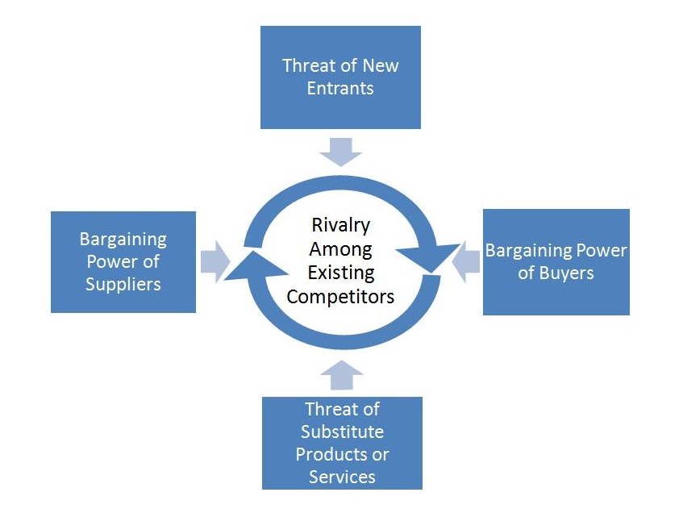
Appendix 1: Porter’s five forces analysis framework.

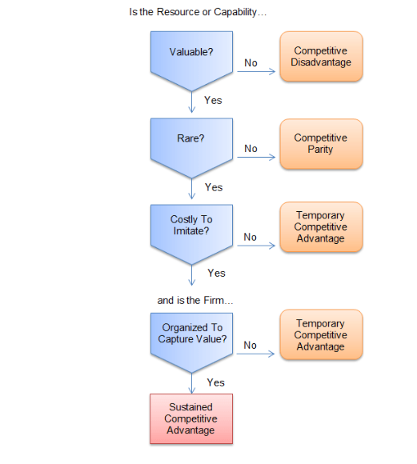
Appendix 2: VRIO framework

7.0 References
Ahlstrom, D and Bruton, D. (2009). Chapter 5: business and functional level strategy. In: International Management: Strategy and Culture in the Emerging World. Massachusetts: Cengage Learning. p129-163.
Asprey, B. (2017). Is Crossrail going to obliterate the Heathrow express. Available: https://londonist.com/london/transport/is-crossrail-going-to-obliterate-the-heathrow-express. Last accessed 22.11.17.
BBC News. (2017). New Elizabeth Line to serve Heathrow's Terminal 5. Available: http://www.bbc.co.uk/news/uk-england-london-40493290. Last accessed 23.11.17.
Brown, F. (2017). In Jasper, C. Heathrow Express braces for Crossrail to end airport monopoly next year: Former plans to increase its marketing efforts to boost awareness of its services. Available: https://www.bloomberg.com/news/articles/2017-06-30/heathrow-express-braces-for-crossrail-to-end-airport-monopoly. Last accessed 22.11.17.
Buying business travel. (2017). Crossrail's Heathrow plans threatened after legal row. Available: http://web.a.ebscohost.com.ezproxy.uwtsd.ac.uk/ehost/pdfviewer/pdfviewer?vid=6&sid=764c8fac-0520-4851-93b8-fb77c2b511fc%40sessionmgr4007. Last accessed 23.11.17.
City of London. (2015). The impact of Crossrail. Available: https://www.cityoflondon.gov.uk/business/economic-research-and-information/research-publications/Documents/Research-2015/Impact-of-Crossrail-briefing-paper.pdf. Last accessed 21.11.17.
Crossrail LTD. (2017). Heathrow Airport. Available: http://www.crossrail.co.uk/route/western-section/heathrow-airport. Last accessed 22.11.17.
Crossrail LTD. (2017). Learning legacy. Available: https://learninglegacy.crossrail.co.uk/?s=policy+and+procedures. Last accessed 23.11.17.
Dodgson, M, Gann, D, MacAulay, S and Davies, A. (2015). Innovation strategy in new transportation systems: The case of Crossrail. Transportation Research Part A: Policy and practice. 77 (1), p261-275.
Farnham, D. (2005). Chapter 2: The competitive environment. In: Managing in a strategic business context. London: CIPD. P7-36.
Grunig, R and Kuhn, R. (2015). Part 1: The idea of strategic planning. In: The strategy planning process: analyses, options, projects. New York: Springer. p7-15.
Henry, A. (2011). Part 1: what is strategy? In: Understanding strategic management. 2nd ed. London: OUP Oxford. p2-26.
Hill, D. (2013). Tomorrow's Tube: words about the future. Available: https://www.theguardian.com/uk-news/davehillblog/2013/dec/31/london-underground-writers-on-tube-future. Last accessed 22.11.17.
Jacobs engineering group. (2015). Jacobs renews Crossrail project representative role for five years. Available: https://search.proquest.com/docview/1691348686?accountid=130472. Last accessed 22.11.17.
Johnson, E. (2017). West End bucks national high street slump with another strong year. Available: https://www.retailgazette.co.uk/blog/2017/11/west-end-bucks-national-high-street-slump-another-strong-year/. Last accessed 22.11.17.
Moutinho, L. (2000). Segmentation, Targeting, Positioning and Strategic marketing. In: Strategic management in tourism. London: CABI. p121-166.
Sheil, V. (2008). Heathrow service boost seals Crossrail funding contribution. Planning London. 1794 (1), p1-6.
Smith, R. (2017). Heathrow's Terminal 5 after airport strikes deal with the government and TfL. Available: http://www.cityam.com/267806/heathrow-rail-services-boosted-elizabeth-line-deal. Last accessed 23.11.17.
Tyrell, J (2017), in Johnson, E. (2017). West End bucks national high street slump with another strong year. Available: https://www.retailgazette.co.uk/blog/2017/11/west-end-bucks-national-high-street-slump-another-strong-year/. Last accessed 22.11.17.

