BSc (Hons) Health and Social Care BMHP 6020
Draft of Chapter 4 Independent Project
Chloe Harries
Student name: Ghuzala Begum
Student ID: 2244713

This chapter will start off by providing a definition for thematic analysis and then go on to discuss the findings of the themes which have been identified from the collection of secondary academic literature. These themes are analysed in relation to existing research, theoretical frameworks, and contemporary practice.
A critical look at how holistic care implementation for elderly care provisions is enabled within healthcare and how the QOL of older people is affected with or without a person-centred approach. What kind of barriers and challenges can be identified to enable effective holistic care delivery will also be explored.98
“Thematic analysis (TA) is a method for identifying, analysing, and interpreting patterns of meaning (‘themes’) within qualitative data. TA is unusual in the canon of qualitative analytic approaches, because it offers a method – a tool or technique, unbounded by theoretical commitments – rather than a methodology (a theoretically informed, and confined, framework for research)” (Clarke and Braun, 2016).
One of the techniques is generating codes, as shown in the results summary table “See Appendix I”. Codes capture the interesting features of the data which can be potentially relevant to the research question, they act as the initial building blocks that are grouped together to create themes. Each theme captures a broader pattern of meaning and is unified by a central organising concept (Clarke and Braun, 2016).
The themes which have been identified are 1) Holistic Care in elderly Practice, 2) Impact of Holistic Care on Quality of Life in the Elderly and 3) Barriers and Challenges to Effective Holistic Care Delivery.
Thematic analysis is a flexible qualitative method that can be used across different theoretical frameworks and research questions. It goes beyond simply summarising data and focuses on interpreting meaning. “The final analysis is the product of deep and prolonged data immersion, thoughtfulness and reflection, something that is active and generative” (Braun and Clarke, 2019). 214

Theme 1: Holistic Care in Elderly Practice.

Holistic Care: “Complete or total patient care that considers the social, physical, psychological, cognitive, spiritual, and environmental well-being of the person, his or her response to illness, and the effect of the illness on the ability to meet self-care needs” (Jackson, Turner and Paterson, 2023).
While modern medicine reduces individuals to disease labels and relies on pharmaceutical ‘magic bullets’ (British Association for Holistic Medicine and Health Care, 2025), holistic healthcare integrates a broad spectrum of alternative and traditional practices to promote wellness. 82
Florence Nightingale born in the 1800s is well-known as the founder of modern nursing, rooted in holistic principles, nursing has long incorporated natural remedies and healing therapies, dating back to the 1700s (Thornton, 2019). Nightingale’s view was that “nurses should think critically about patient care, doing what was appropriate and necessary to help them heal” (Riegel et al, 2021). Early nursing was holistic and relationship centred, but by the late 1900s this approach was declined. Holistic practices were pushed aside for technology and profit-driven healthcare systems. Financial aspect became more important, nurses felt frustrated and constrained because the human connection was lost, weakening the caring aspect of nursing (Thornton, 2019).
However, thanks to Hippocrates and his principles of medicine, some of which hold controversial opinions, modern day medicine is inclined to adopt Hippocrates holistic approach which has become more relevant to modern day healthcare (Brigic et al, 2021). 123
With an ageing population (ONS, 2025) and most of whom will be living with chronic illnesses (Elston et al, 2019) the burden is on the NHS to support care needs but, because of the challenges affecting both formal and informal care systems in the United Kingdom the number of elderly people with unmet care needs is increasing (Abdi et al, 2019). It is important to understand what these needs are to then be able to address them.
A scoping review written by Sarah Abdi and others (2019) titled “Understanding the Care Needs of Older People” conducted a review using the Arksey and O’Malley original and enhanced framework to understand the needs. A comprehensive search was conducted across five electronic databases, supplemented by grey literature and reference list screening. The identified studies were analysed and categorised using the WHO International Classification of Functioning, Disability and Health (ICF) framework (Abdi et al, 2019).
The results highlighted that due to chronic illnesses older people encountered a variety of challenges with physical, social and psychological dimensions. The three main areas which required care and support are 1) social activities and relationships; 2) psychological health; and 3) activities related to mobility, self-care and domestic life (Abdi et al, 2019). The results also showed that older people desired to “cope with their illness and maintain independence” however, environmental factors disrupted these efforts, such as lack of professional advice regarding self-care strategies, poor communication and co-ordination of services and a gap in the knowledge of care and support needs (Abdi et al, 2019). 257
An integrative systematic review which looked at the holistic care impacts of individuals living in residential aged care facilities reported that since the Covid-19 outbreak, the ageing population being the most vulnerable, where affected badly because of the pandemic impacting them on all levels of QOL (Jackson, Turner and Paterson, 2023).
The study investigated various domains of holistic care and well-being including physical, social and psychological impacts. An increase in anxiety and depression was noted and in some cases thoughts of suicide (Jackson, Turner and Paterson, 2023). Following the pandemic and the negative effect it has left behind it has become prudent on public health departments and policy makers to identify any gaps and barriers to facilitate holistic care in the future (Jackson, Turner and Paterson, 2023). Using qualitative, quantitative and mixed methods the study concluded, the findings indicate that policy must prioritise quality-of-life domains, rather than focusing solely on survival rates. 152
The NHS Long-Term plan (NHS Confederation, 2025) “See Appendix J” includes sustainability of the NHS and Adult social care, with an increasing demand from an ageing population there is added pressure on adult social care services (House of Lords, 2017). The box below demonstrates statistical forecast of an ageing population and the health demands which will be expected. 52

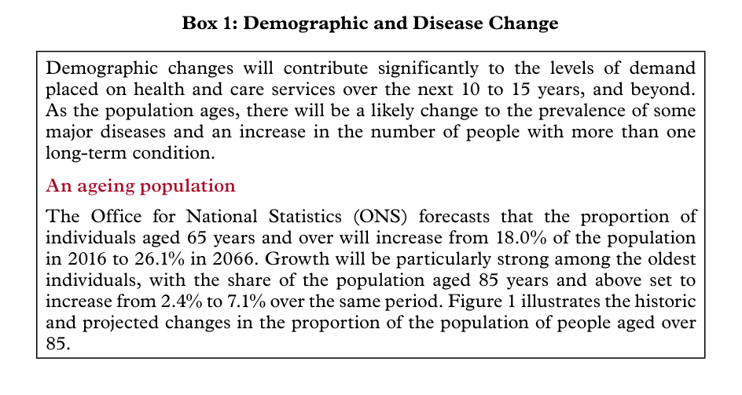

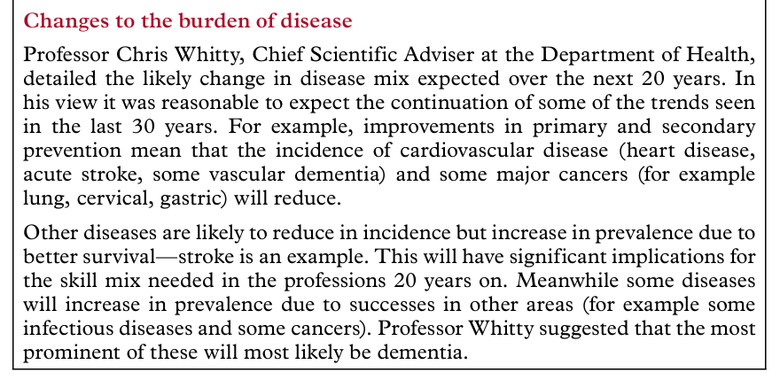
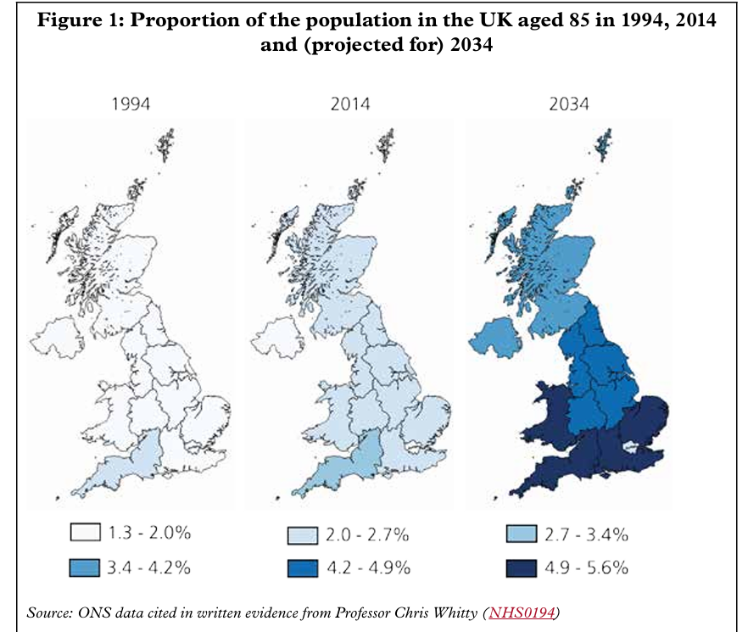

Figure 1 (House of Lords, 2017) demonstrates how the UK population is projected to age and the changes to the burden of diseases.
The NHS Long-Term Plan recognises the type of challenges which will arise and will need to maintain various aspects one of which is funding to adequately sustain adult social care. The government has implemented a range of social care policy reforms. A new Health and Social Care Levy was announced in September 2021 to increase funding for the NHS and adult social care. The overall responsibility of the social care policy is to not lose sight of those who matter. “It was made clear to us throughout our inquiry that social care is not about looking after people who are a burden on our society, but is about supporting people to lead fulfilling, meaningful lives” (UK Parliament, 2022). 141
Carl Rogers Humanistic Theory (Joseph, 2025) developed in the 1950s “Humanistic psychology is a perspective that emphasizes looking at the whole person and the uniqueness of each individual. Humanistic psychology begins with the existential assumptions that people have free will and are motivated to achieve their potential and self-actualize” (McLeod, 2025). Rogers developed client-centred therapy, later known as person-centred therapy, which is a non-directive approach focused on personal growth and psychological well-being, which aligns with holistic approaches.
According to Continuity theory, the continuation of long-standing activities plays a key role in promoting successful ageing by maintaining self-identity (Ng, Lim and Hsu, 2021) change is managed by keeping life as consistent as possible.
Ageing involves both growth and decline Developmental theory recognises losses (e.g. physical decline) but also ongoing growth, such as wisdom, emotional regulation, and self-understanding (Practical Psychology, 2023). 137
Positive and Negative Implications of Holistic Care
Holistic care is a complex concept that lacks a single, precise definition but is widely recognised as central to effective healthcare practice. By providing a comprehensive understanding of patients and their physical, psychological, social, and spiritual needs, holistic care enhances patient satisfaction, supports self-responsibility, and improves understanding of how illness affects daily functioning (Jasemi et al, 2017).
Findings from multiple studies indicate that the HCP and nurses’ neglect of holistic care is influenced by factors including time constraints, poor professional relationships, inadequate documentation and supervision, limited resources, ineffective management, insufficient knowledge and motivation, and misunderstandings of the holistic care concept (Jasemi et al, 2017). Holistic care is frequently criticised for being unspecialised, unscientific, inefficient, and overly time-consuming. 117
A journal by Arekelyan et al (2023) did an umbrella review of systematic reviews to see how effective are HBIs for older adults with multiple long-term conditions and frailty. The results found that HBIs can be effective for those admitted to hospital, but it is still unclear whether similar types of interventions can be as effective in communities. The review found no clear benefits of hospital based QOL which may lead to a reduction of emergency department return visits. And within the community no improvement in overall healthcare use, nursing home admissions, or mortality (Arekelyan et al, 2023).
Although there is heterogeneity in the components of complex interventions that have the same name, the study states that “NICE has highlighted the need for evidence on the effectiveness of such interventions in people with multiple long-term conditions” (Arekelyan et al, 2023) from this it is clear how the article connects directly to the theme. 153
This next article looks at the HCPs perspective of delivering holistic care (Wong et al, 2022) using the Theoretical Domains Framework via questionnaires. The aim of the authors is to identify what influences HCPs to deliver holistic care. It is suggested that despite policies, holistic care is not being delivered consistently. The reasons being a lack of communication, empathy and clinical skills, time constraints and a perceived impact on patient outcomes (Wong et al, 2022). Although professionals value holistic care it is not prioritised due to complexity and automaticity.
In comparison to the journal by Arekelyan et al (2023) this article studies how holistic care is delivered rather than the overall outcomes of holistic care. 115…1,329
Strabner et al, in their journal of “Holistic care program for elderly patients to integrate spiritual needs, social activity, and self-care into disease management in primary care (HoPES3): study protocol for a cluster-randomized trial” (2019) aimed to explore whether combining ‘disease management programmes’ with HBIs, such as spirituality, has any impact on outcomes of patients with polypharmacy. 57

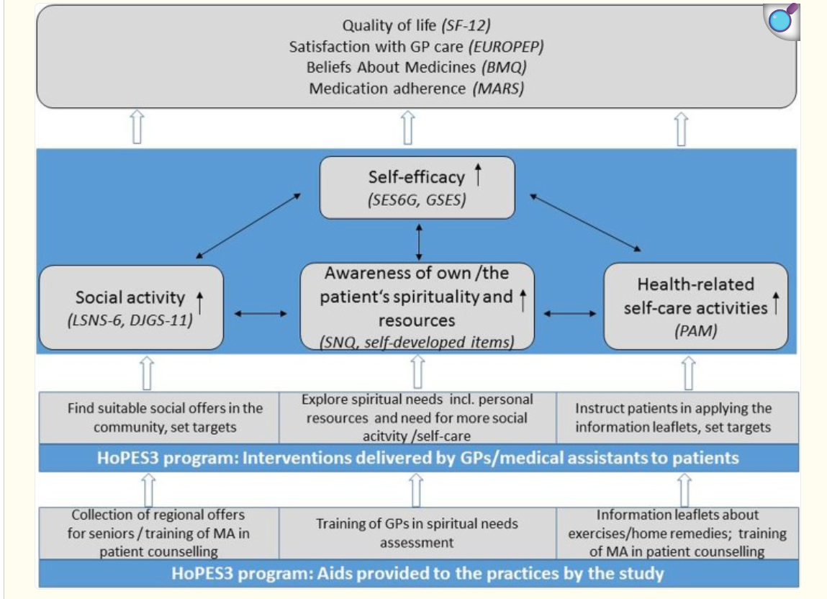
Logic model of the HoPES3 program (Stabner et al, 2019).
Research indicates that many patients are interested in discussing spiritual matters during medical consultations however, this aspect of care is often overlooked. And because this is a study protocol, HoPES3, it does not report outcomes, but the authors anticipate integrating a ‘spiritual needs assessment’ alongside disease management may strengthen self-efficacy and improve holistic well-being in elderly patients (Strabner et al, 2019). 71

Connections to Other Themes
- Interconnections:
  - Mention any connections between this theme and other themes in your dissertation.
  - Highlight how themes may overlap or influence each other.
The theme of ‘Holistic care in elderly practice’ not only interconnects but also overlaps with the next theme which is ‘Impact of holistic care on Quality of life in the elderly’. Since the era of ancient Greek philosophy and continuing into modern positive psychology, well-being has been conceptualised through two primary perspectives: hedonism (subjective well-being) and eudaimonism (psychological well-being) (Jiwattanasuk, Pannavoravat and Sirikanchana, 2022).
Subjective well-being describes how individuals assess their lives both emotionally and cognitively. It generally involves frequent positive emotions, fewer negative emotions, and a strong sense of life satisfaction. Psychological well-being refers to a person’s feelings and emotions that arise when engaging in activities that genuinely fulfil their needs. These needs are shaped by personal values, self-identity, and the inner motivation to achieve personal growth and fulfilment (Jiwattanasuk, Pannavoravat and Sirikanchana, 2022). Consequently, psychological well-being is evaluated as an important indicator of promoting quality of life.
In healthcare the questions which arise in relation to these concepts are “What course of treatment for a patient would be in his best interests? Would medication help him to lead a better life despite the side effects, or would he be better off with other therapies, or no treatment at all?” (Kim and Haybron, 2021). 215
Theme 2: Impact of Holistic care on ‘Quality of Life’ in the Elderly.
“WHO defines Quality of Life as an individual's perception of their position in life in the context of the culture and value systems in which they live and in relation to their goals, expectations, standards and concerns” (WHO, 2026). 39
In the 1960s doctors and health professionals started talking about QOL in medical studies. Medical treatments and strategies began to help people live longer, but that did not mean their daily lives felt much better or more comfortable. So, researchers began measuring QOL (Karimi and Brazier, 2016). Health Status Index (HIS) scale is the term given to the measurement of QOL. Over the years the new term for health status measures was introduced as Health Related QOL (HRQoL).
In the journal by Karimi and Brazier (2016) it states that it is problematic to define HRQoL in one definition, therefore in this literature there are four definitions.
- “How well a person functions in their life and his or her perceived wellbeing in physical, mental, and social domains of health”

- “Quality of life is an all-inclusive concept incorporating all factors that impact upon an individual’s life. Health-related quality of life includes only those factors that are part of an individual’s health”

- “Those aspects of self-perceived well-being that are related to or affected by the presence of disease or treatment”

- This final definition focuses on the value of health in HRQOL “Values assigned to different health states” (Karimi and Brazier, 2016).

The concept of HRQol overlaps with both heath and QoL, which can make it difficult to define clearly. Many HRQoL measures assess individuals’ perceptions of their health status rather than their overall quality of life. Researchers suggest separating measures of health status from measures of QoL, with HRQoL used to describe how health influences overall QoL with different tools, which can measure the value or impact of health on individual lives and describe how a person’s health affects their overall QOL, which researchers can analyse using statistics (Karimi and Brazier, 2016). 293
This theme of QOL is very significant to the topic of holistic care because it can be said that ‘Holistic healthcare involves coordinated care from multiple professionals to support the overall needs of people and improve their quality of life’ (Ventegodt et al, 2016). 44
Physical and mental health are key aspects of an individual’s overall well-being. Measures in this area include both objective and subjective indicators of health. They also consider people’s satisfaction with the healthcare system to understand how effectively the nation’s health needs are being supported (ONS, 2025).
In England, healthy life expectancy at birth was estimated to be 61.5 years for males and 61.9 years for females between 2021 and 2023. This represents a long-term decline compared with the period 2016 to 2018, when healthy life expectancy was 63.3 years for males and 64.1 years for females (ONS, 2025).
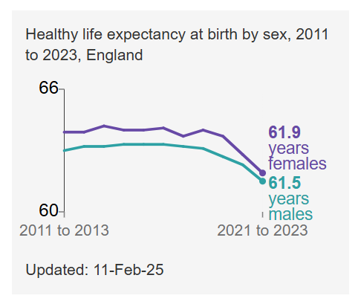(ONS, 2025).
In September 2024, 47.4% of adults in Great Britain reported that they were generally satisfied with the UK healthcare system.
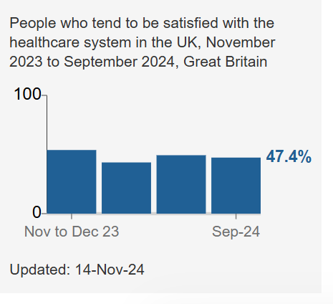(ONS, 2025).
In the past, the health field often viewed humans mechanistically and dichotomously (Redemptus, Weraman and Roga, 2023). Mechanistically the body was seen like a machine, where each part works separately. If something breaks, doctors fix that part. Dichotomously the body and mind were treated as two separate things. So, healthcare mainly focused on physical illness rather than the whole person. This way of thinking is beginning to change due to scientific developments and new knowledge. It is now understood that humans are more complex and health is influenced by many connected factors involving the body, mind, social life, and spirituality, in simple terms more holistically (Redemptus, Weraman and Roga, 2023).
The journal ‘Holistic Therapy to Improve Quality of Life in Chronic Disease Patients’ (2023) looks at different holistic approaches and their impact on individuals………

.

