Can Phone use Cure Cardiovascular Disease?
An overview of the use of telehealth to diagnose, treat, or prevent cardiovascular disease by M.M., MPH

BACKGROUND

Cardiovascular diseases
Globally, cardiovascular disease (CVD) is the number one cause of death (Nahar, et al., 2020). In the United Kingdom, over 4 million males and 3 million females are living with a CVD, and one dies every three minutes (British Heart Foundation, 2023).
Heart and circulatory disease healthcare costs in the UK reaches roughly £9 billion annually, while costing the wider economy around £19 billion. The latter includes informal and disability costs, and premature death (Cheema, et al., 2022).

Current Interventions
- Community pharmacy hypertension case finding
This CVD detection/ prevention intervention involves pharmacies conducting blood pressure tests on persons aged forty years or older. If the results are elevated, ambulatory blood pressure monitoring (ABPM) would be offered, and the results may be subsequently relayed to the patients’ GP (Community Pharmacy England, 2021). This program could lead to an increase in the rate at which hypertension is identified, and thus treated before it leads to CVD (Fuchs & Whelton, 2019). Another benefit lies in its potential to reduce the pressure at GP offices, as more people can be diagnosed at the community level without having to visit their physician (Public Health England, 2022).
- NHS Health Check
This offers persons between the ages of 40 and 70 years old the opportunity to have their overall health checked for free, allowing them to find out if they are at risk for several health conditions, including heart disease (Martin, et al., 2018). Scores are given to determine each persons risk of developing a cardiovascular condition within the next 10 years, and this information may be related to the patient’s GP (NHS, 2023).

Telehealth

Upon hearing the term ‘telehealth’, persons may think it is the use of telephones to treat, diagnose or prevent illnesses, but that is not the case. This refers to the provision/delivery of service by healthcare professionals using information and communication technologies (ICTs). These ICTs are used to exchange information relevant to diagnosing, treating as well as preventing injuries and diseases (Ryu, 2012). In short, telehealth facilitates remote healthcare delivery, including over the phone (Takahashi, et al., 2022).
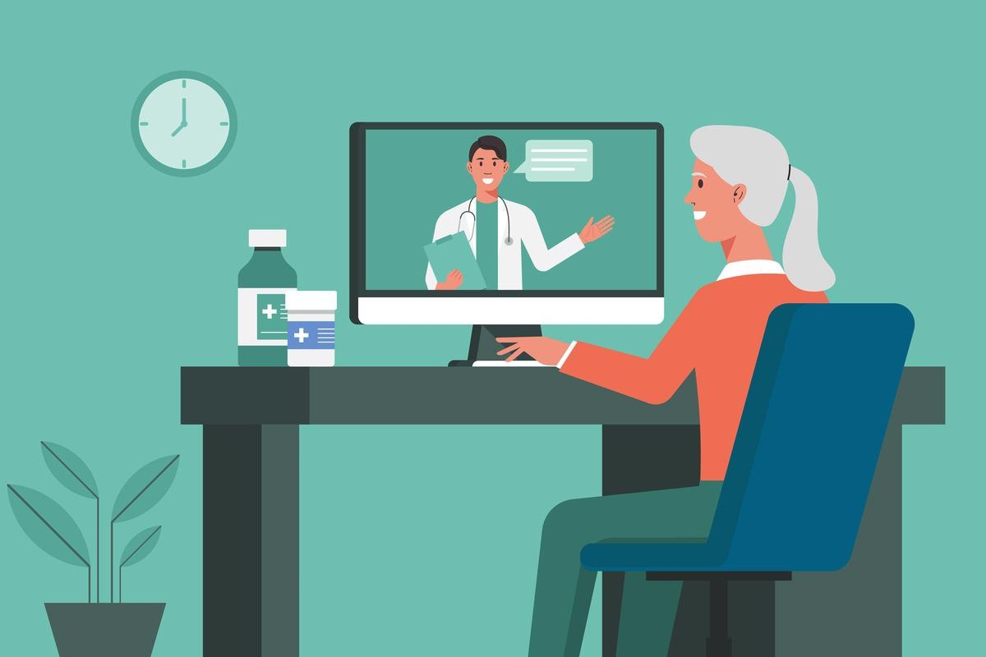
Figure 1. (Molineux, 2022)

Telehealth and CVDs
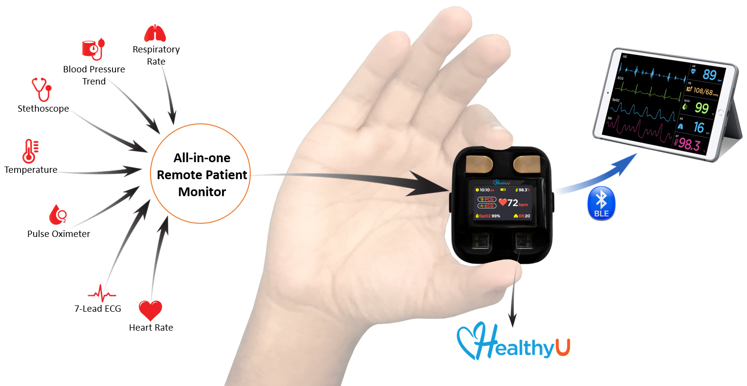
Figure 2. HealthyU™ by HD Medical Inc. is the first. (Business Wire, 2023)

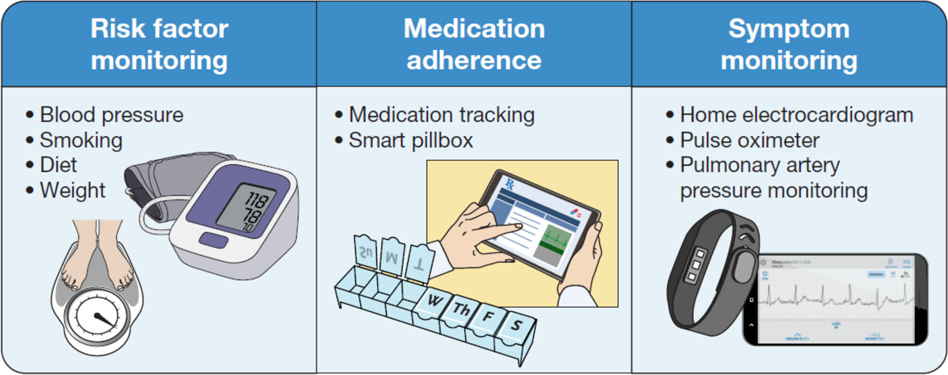
Figure 3. Application of telehealth CVDs monitoring, treatment and prevention (Takahashi, et al., 2022)

CVDs such as heart failure, arrhythmia, and coronary heart disease can all be managed via telehealth. Telephone or video calls, as well as remote monitoring devices can all aid in the continuous monitoring of patients by healthcare professionals. Adherence to medication, risk factor modification, and symptom monitoring can for congestive heart failure and coronary heart disease are possible via telehealth (Kavradim, et al., 2020).

Health Promotion Values and Principles

Participative and Empowering
Lack of control over outcomes has been identified as a major risk factor for disease, and empowering persons can counter this (Stepanian, et al., 2023). Telehealth reinforces the principle of healthcare promotion being participative and empowering for service users. It encourages people to take responsibility for their health, both as individuals and on the community level. The identification of the direct relationship between ill health outcomes such as CVD and personal behavior requires that persons make individual choices in order to have different health outcomes. Telehealth regards patients as vital partners in the process of health risk management. It gives people greater control over the actions that affect their health. At the same time, it encourages user participation in the decision-making process (M. Rimondini, et al., 2019).
Holistic and Intersectoral
Telehealth allows an intersectoral healthcare team of physiccials, therapists, nurses and social services to collaborate in providing holistic care to persons with multiple chronic diseases, as well as their caregivers (Lang, et al., 2020). Person-centred care needs can be addressed remotely by drawing on the expertise of multiple disciplines, while being mindful of how these different dimensions can influence overall health (Watanabe, et al., 2013). It should be noted, however, that telehealth should not be used in lieu of traditional care, but as a means of augmenting traditional health promotion practice. This is in recognition of the multi-strategy principle of health promotion (Lupton, 2015). Hospitalization and mortality rates for persons who experienced heart failure is lower for those who received combined telehealth consultation and monitoring when compared to those who received usual care (Kuan, et al., 2022).
It is a widely held view that the greater use of digital health technologies in the UK could make the NHS more sustainable, provided that digital literacy among the population is sufficiently high to make the service equitable (Salisbury, et al., 2016;Takahashi, et al., 2022).

Behaviour Change Theory

Health Belief Model (HBM)
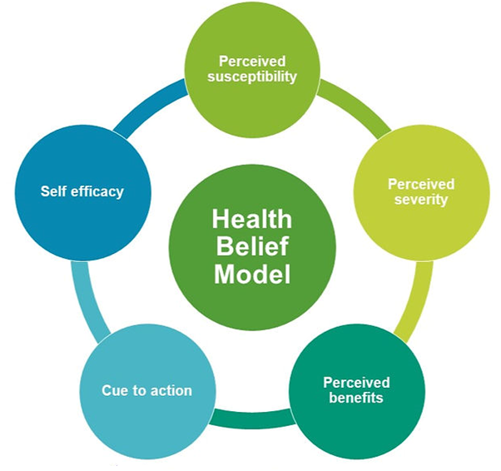
Figure 4 . Health Belief Model (The Aspiring Medics, 2023)
The use of telehealth to prevent, treat or manage CVD should consider behavoiural change theories in mind, as they can provide useful insight on how to overcome barriers to change.
HBM was developed as a socially and psychologically based means of explaining and predicting health-related behaviours and patterns, predominantly those related to the acceptance of and commitment to health services and interventions (Abraham & Sheeran, 2014). It is predicated on the idea that people’s decision to engage in healthy behaviour is based on how they feel about their own vulnerability to contracting a particular condition, their knowledge of the consequences, as well as the extent to which they believe that changing their behaviour will affect them experiencing a detrimental result (Becker & Maiman, 1975).
To that end, all six (6) constructs of the HBM will have to be addressed:
- Perceived susceptibility – the person’s view of their likelihood of becoming ill
- Perceived severity – how seriously the person believes that contracting an illness will affect him/her.
- Perceived benefits – how likely a particular course of action is to treat/ cure a condition, or reduce the threat it poses
- Perceived barriers – the things the person believes will inhibit their ability to execute the recommended actions.
- Cue to action – the prompt needed for the person to initiate the recommended health actions
- Self-efficacy –an individual’s level of confidence in his or her ability to successfully perform a behaviour
According to this model, in order to improve the efficacy of the proposed telehealth digital technology in treating and promoting healthy behaviours among people with CVD, the intervention will identify and reduce barriers through:
- Reassurance –potential users should be reminded that they possess the ability to overcome whatever obstacles they believe they might encounter, and that the level of care will not be diminished by engaging in the new programme. For example, healthcare practitioners can convey to patients how easy it is to communicate with their doctor, without having to visit the office. Patients could be shown that utilization of telehealth is in line with how they currently use their phones.
- Cues to Action – reminders via email and text message can serve as prompts for users to engage in the prescribed activity. This could be automated so that each patient is notified in a timely manner
- Perceived Benefits – persons should be made to understand the many benefits that telehealth provides, especially the time-saving aspect of in-home self-monitoring. This requires that the individual takes his or her own measurements (a doctor or other suitably qualified healthcare professional could provide instructions via video call or pre-recorded video), and submit them to the doctor for analysis and interpretation. All of this could be done without having to make a trip to the physician’s office.

Expected Outcomes
The majority of persons with CVD are seen by a physician only one to two times per year, except for when severe symptoms occur and require immediate attention (Hincapié, et al., 2020). Given the positive attitude that persons with CVD have towards the use of telehealth (García-Fernández, et al., 2019), it is expected that its utilization will increase, especially if the constructs of the HBM or kept in mind when designing or using a telehealth intervention.
Another important effect of telehealth in treating CVD risk factors is the reduction of healthcare resource utilization (HCRU), as personalized treatment, monitoring and evaluation would still be provided, without the need for patients to actually visit a physician (le Roux, et al., 2020). This will serve to increase the level of satisfacrion that patients have with the service they receive from their helathcare provider
Telehealth can lead to a greater sense of empowerment among users, as they play a more active role in their own health outcome. Instead of going in and waiting for a long time to see healthcare professional, persons are able to conduct certain tests from home, and report the results to their assigned healthcare provider. Thus, telehealth can actually lead to greater health equity (Kuziemsky, et al., 2022; Knaepen, et al., 2023). Telehealth practitioners, however, must be proactive in their approach to ensure that they do not exacerbate the digital divide that exists primarily among socioeconomic lines (Darrat, et al., 2021).

Conclusion
Whilst health related outcomes and behaviour can be improved through individualised face-toface interventions, the scalability of telehealth interventions for CVDs makes them ideal for reducing the demand and wait times at physicians’ offices. This also eliminates the need to travel, while preserving the person-centred approach provided by face-to-face visits (Direito, et al., 2019).
Data privacy concerns can influence telehealth adoption rates. It is thus important for policy makers to ensure that the necessary legislation and guidelines governing how patient data is collected, stored, and accessed by the different service providers is in place (Pool, et al., 2022). Moreover, current and prospective healthcare practitioners will need to be trained on how to safely and effectively use the different technologies being developed in providing care for their patients. Leone, et al., (2022) pointed out that clear and comprehensive telehealth guidelines and skills training are yet to be provided to Allied Health Professionals (AHPs) in the UK.
Finally, long-term studies will be needed in order to determine the efficacy of telehealth interventions on health outcome in the UK. These studies should also incorporate an assessment of the cost of telehealth interventions compared to traditional healthcare.

