22/1/2018 - Created the Risk Assessment document the team will be using throughout this term, I prioritised the Risk Assessment due to last semesters lack of team planning and a risk assessment, the team noticed how much of an impact the lack of the team planning had on production so plan on using the team plan better.

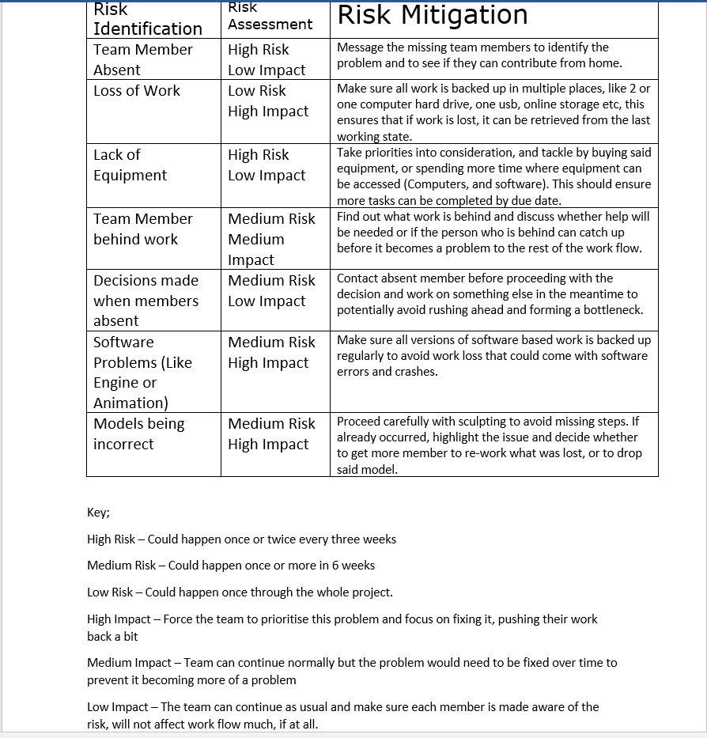

26/1/2018 - Adam and I created the gantt chart on Team Gantt to help follow the team progress easier than that of a basic google doc. It contains each task and time frame the team will carry out and when, it also contains dependencies so the team doesn’t set a task to start that is impossible to start without the completion of the other task, the Gantt will be finalised by the time in the first week with a big team meeting.

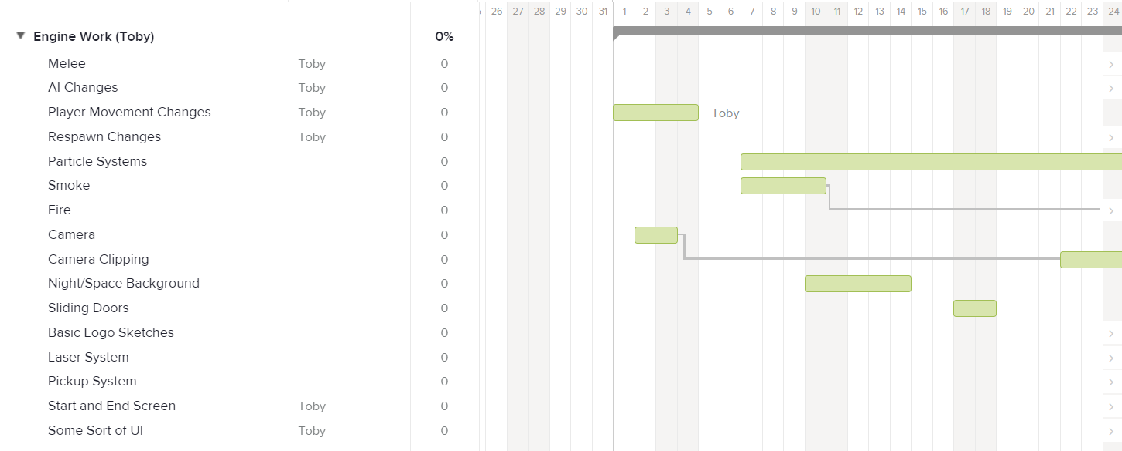

2/2/2018- Changed the way the Camera is angled and how it works. These changes allow the player to move the player whilst the camera is looking elsewhere whilst also moving in turn with the camera. This allows for the player to look around the map without the character model changing direction.

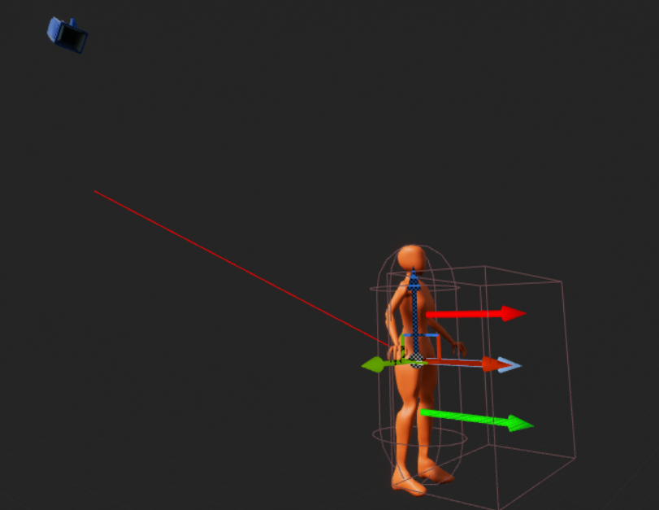

6/2/2018 - Started working on particle systems for smoke to add to walls and more to give a smoke effect as if the walls were blowing up or malfunctioning, this helps with the ruined spaceship feel we’re looking for. The smoke particle system will be refined to fit what the team wants which can then lead to the fire and laser particle systems when the team sees what the particles will look like.

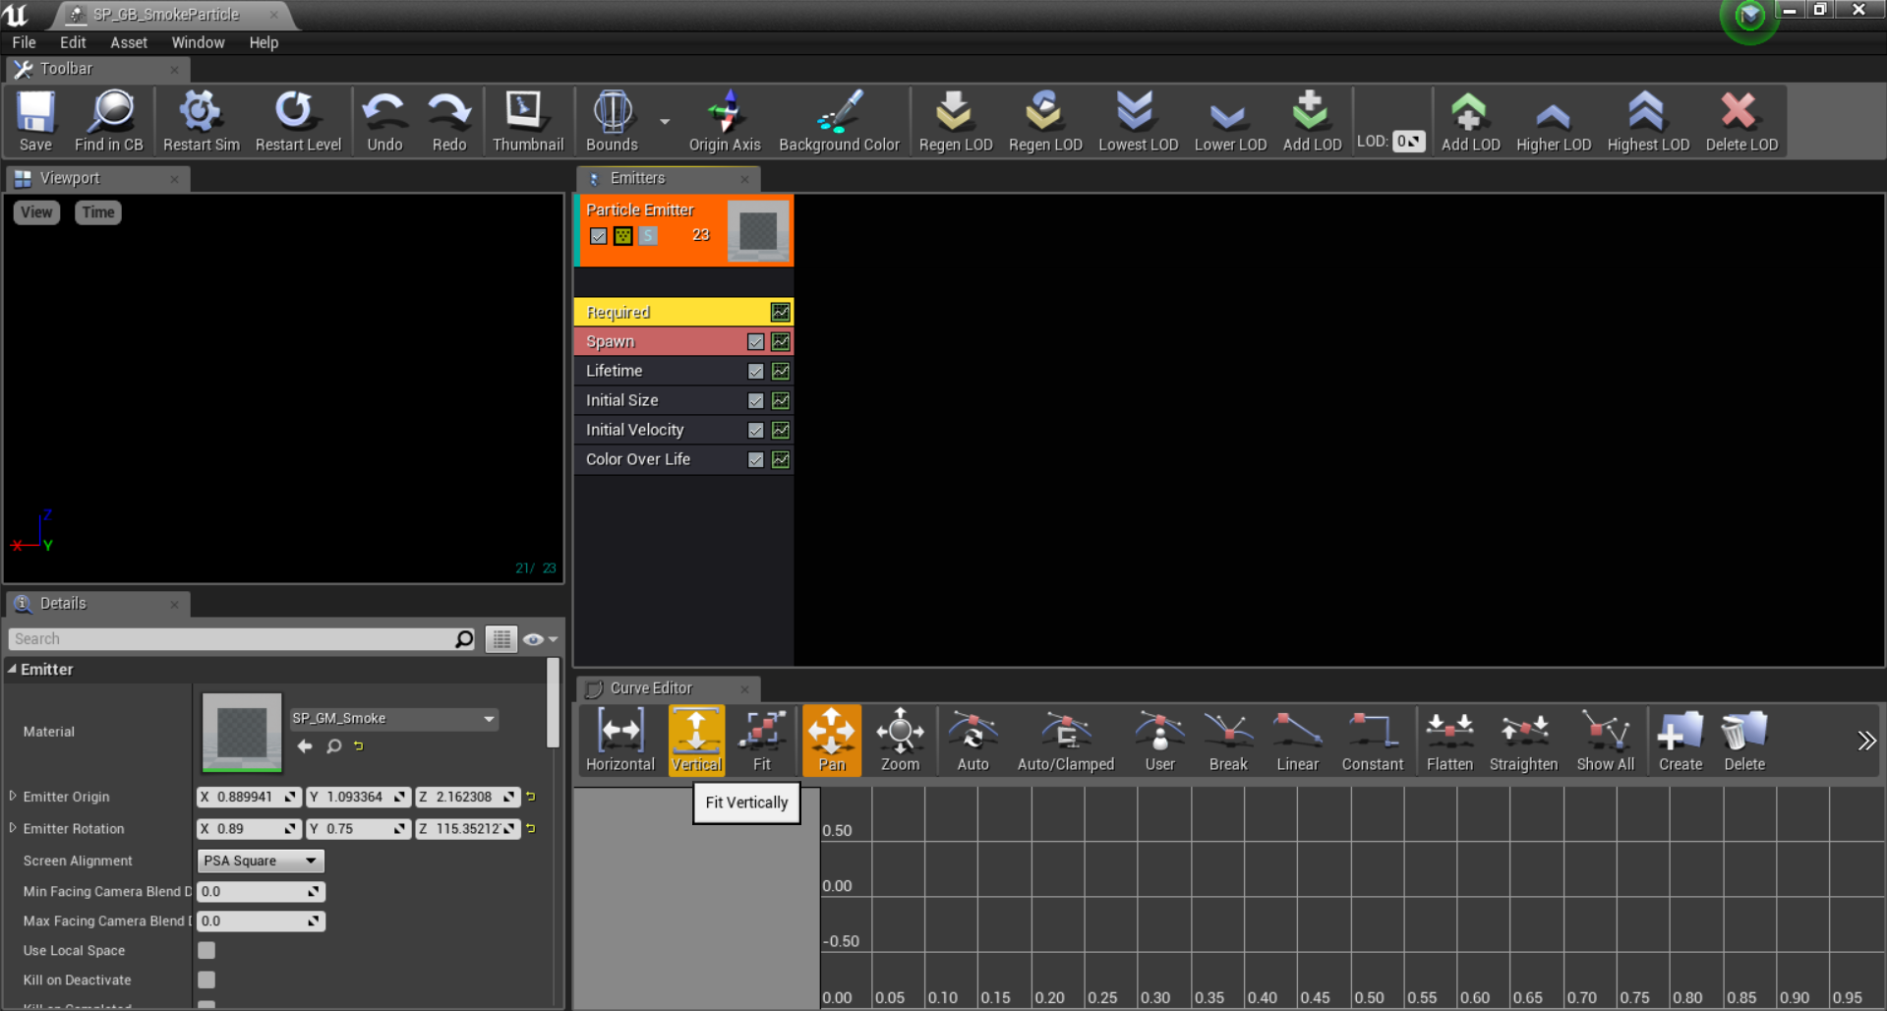

9/2/2018 - Once again worked on a new particle system for Fire to put around the map, however the tutorial used was of an out of date UE4 version which didn’t work well with the new updated version, therefore the particle system will be re made with a better tutorial and moved the skybox changes forward. Bu was scrapped.

12/2/2018 - Made the sky box for the world look like space instead of a clear blue sky with clouds. To do this a texture had to be downloaded and converted to a texture cube and attached to a sky sphere blueprint, this has worked perfectly, however the lighting will need to change.
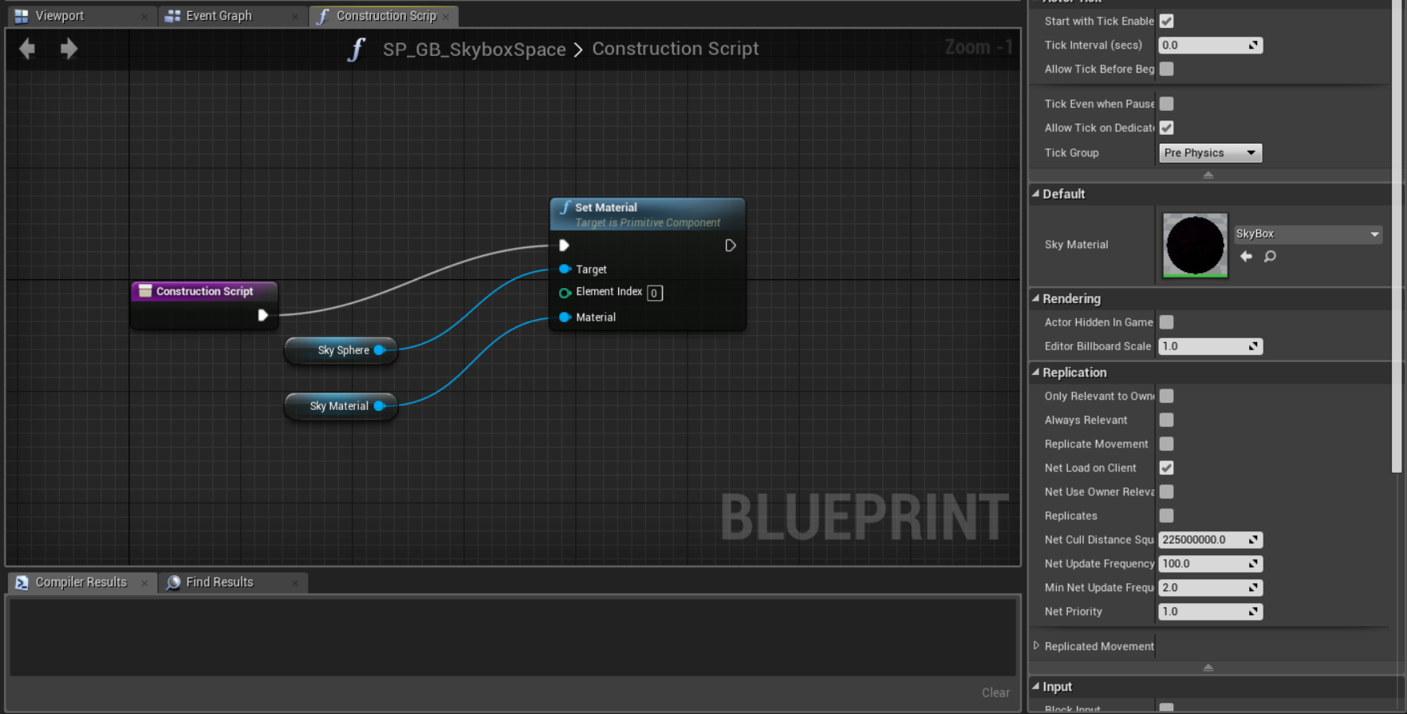

14/2/2018 - Made the Sky Box a higher quality and also continued working on the fire particle system, problems occurred and this was not completed and will need to be worked on and sorted asap.

17/2/2018 - Used Adam’s Sliding door assets to give them a parting blueprint so when the player walks up to the door the door opens and both door panels slide away in opposite directions. This method was used in the whitebox tests and was implemented for these doors but feel more like space station doors, not an entire wall moving out of the way.

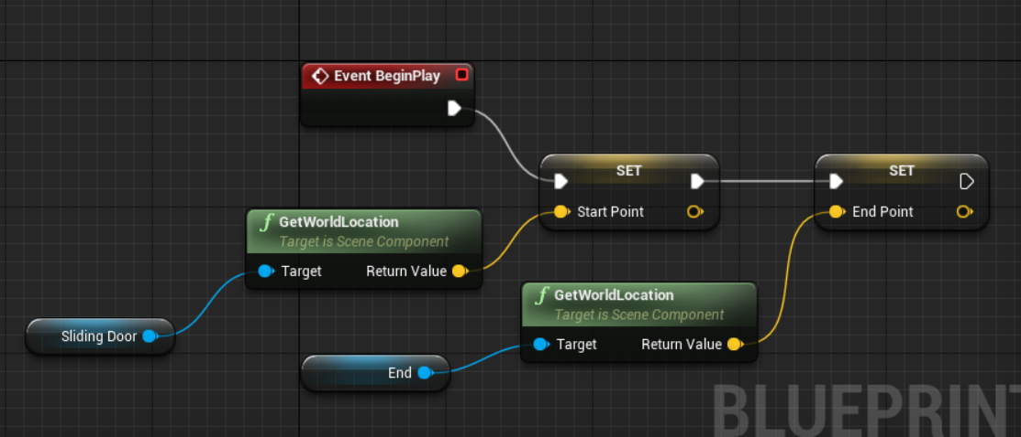
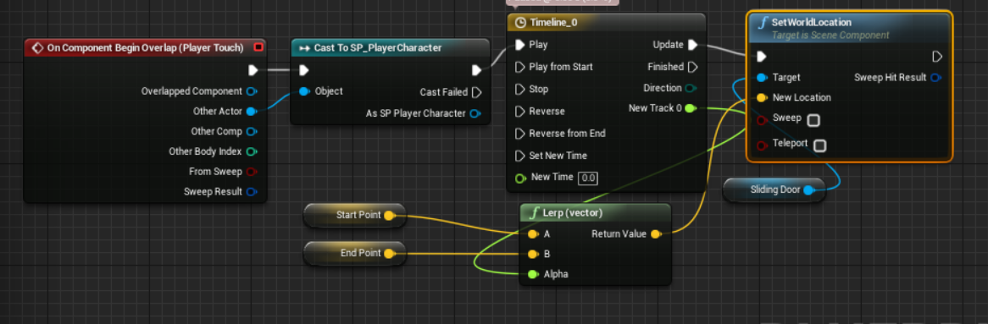
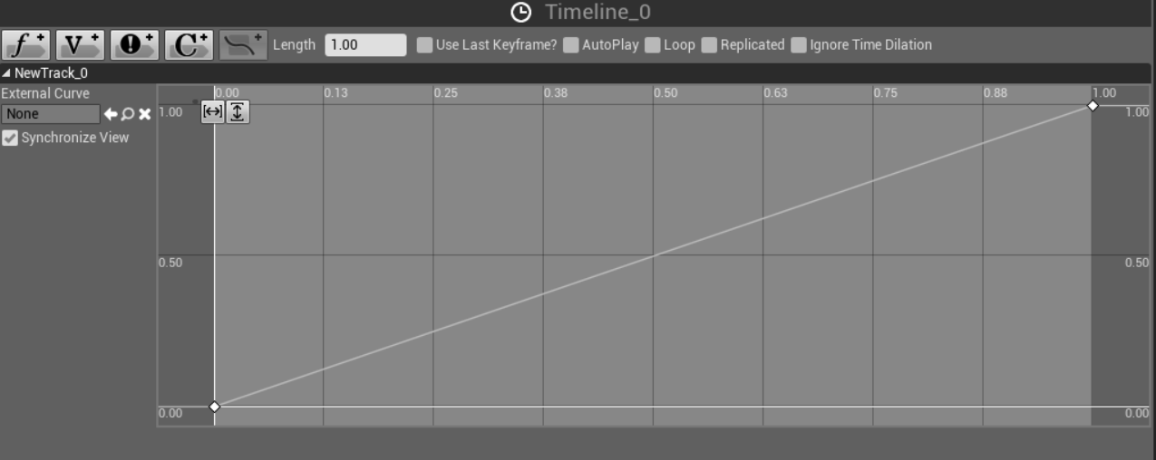

21/2/2018 - Started working towards the melee system so the game can have a functional playable feature, this is in its base forms and not much has been done except a few blueprint nodes, this will be finished by the end of the week ready to move on to enemy damage to make the game playable with a goal. Too prioritise this, Adam decided to incorporate the fire particle system that was causing troubles to himself so I could focus on melee as priority one.

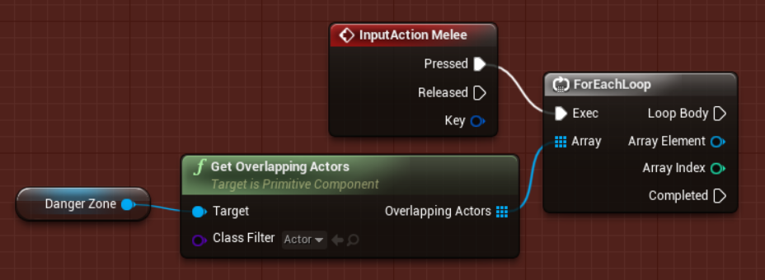

23/2/2018 - Completed a fully functional melee system that can kill enemies and gives the game a real gameplay element. This will be further worked on and tweaked as problems with damage have occurred and will need to be fixed, however, the system itself works. Furthermore, a new idea incorporating lasers and picking up crates was thought of and planned to be done by Friday 2nd March.

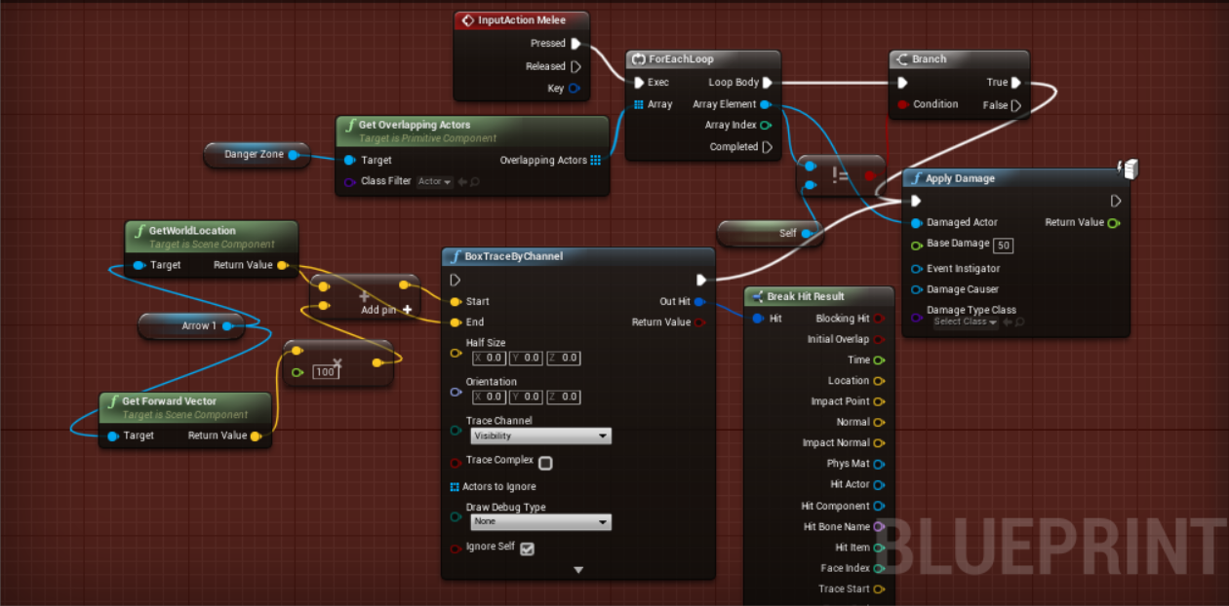

27/2/2018 - Pickup feature fully working and allows the player to pick up certain crates around the map, this will eventually be all crates and will work with a laser system that will damage the player, this was done using the following video; https://www.youtube.com/watch?v=HnR1Gf5gXcY

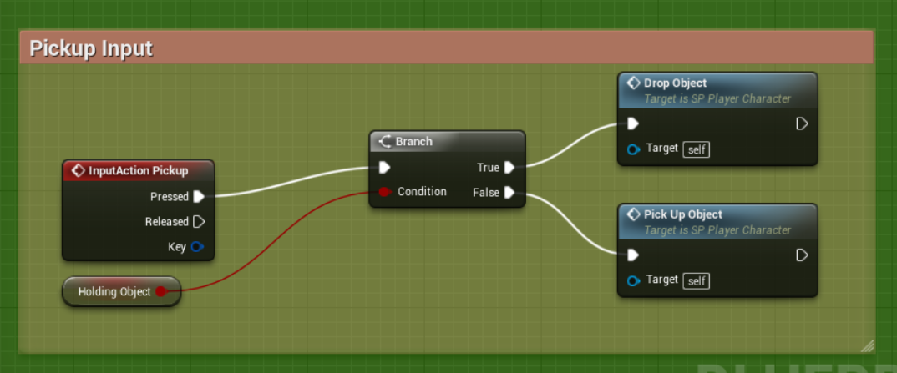
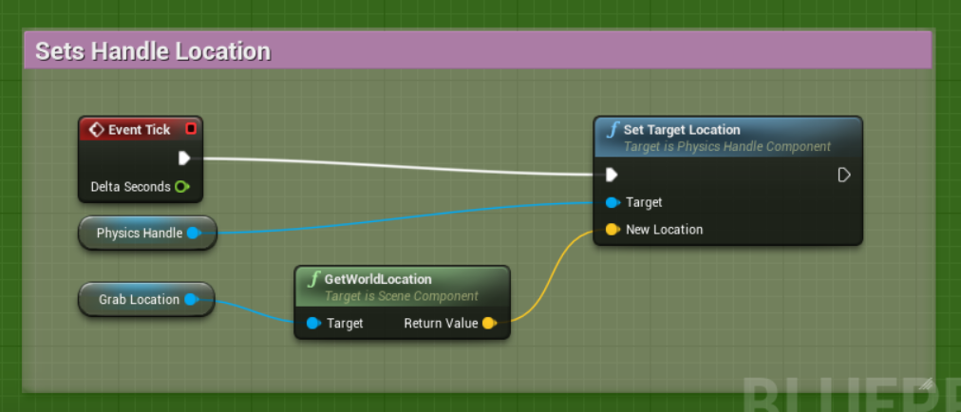
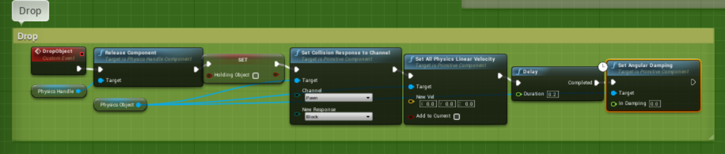
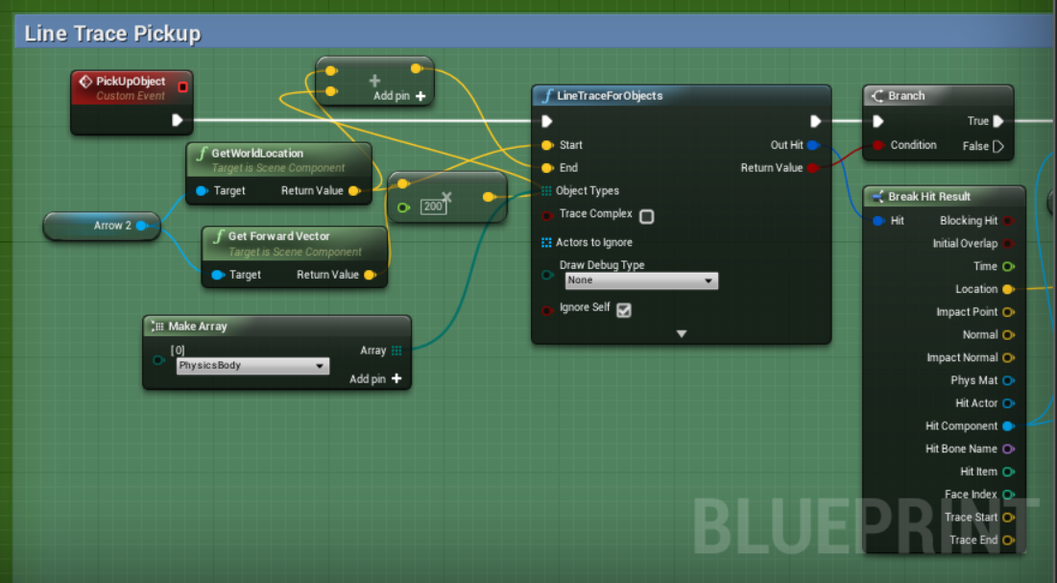
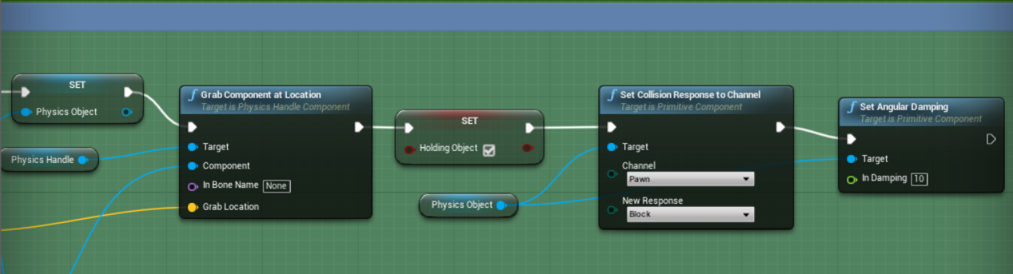
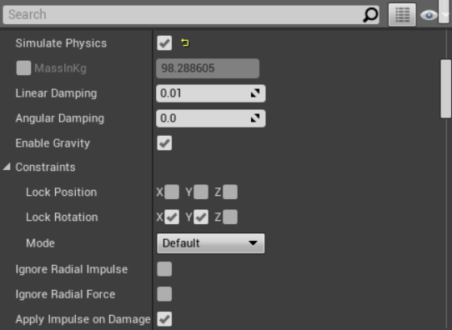

02/3/2018 - Made the laser feature work within the game, the line trace and mechanics work perfectly, however there is a visual glitch that doesn’t stop the laser asset stop when interacting with a crate, this will need to be fixed asap. This video was used https://www.youtube.com/watch?v=pkdm-M7Ywb0

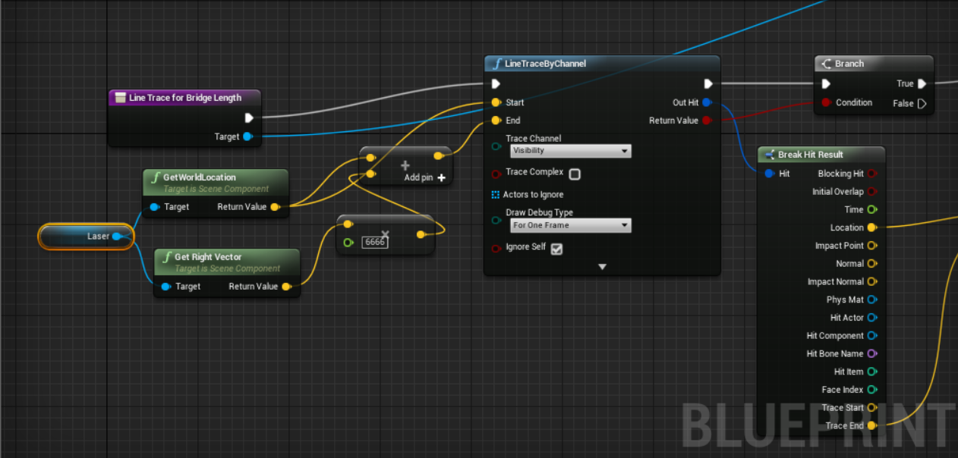
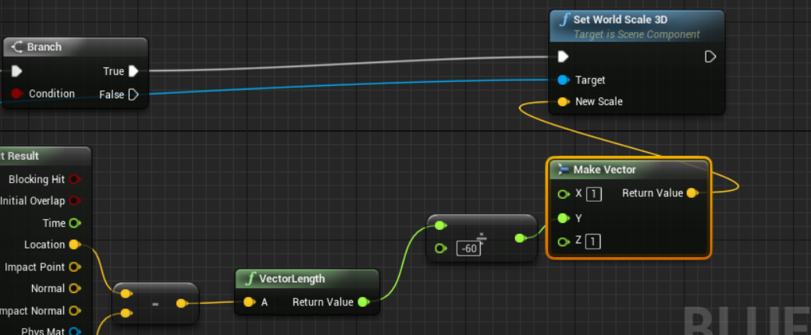

7/3/2018 - Attempted to fix the laser issues and damage issues, this was unsuccessful and has cause targets to be moved back, the laser still has a visual glitch and getting the laser to kill the player has also been unsuccessful

9/3/2018 - Started a full re work on the AI, the AI needed to be more advanced and needed Blackboards and Behaviour trees, over being a basic Actor blueprint that had basic pawn sensing and movement, due to the old AI, the game wasn’t fun and needed a change, Started by setting up the AI Components, ready to continue at home

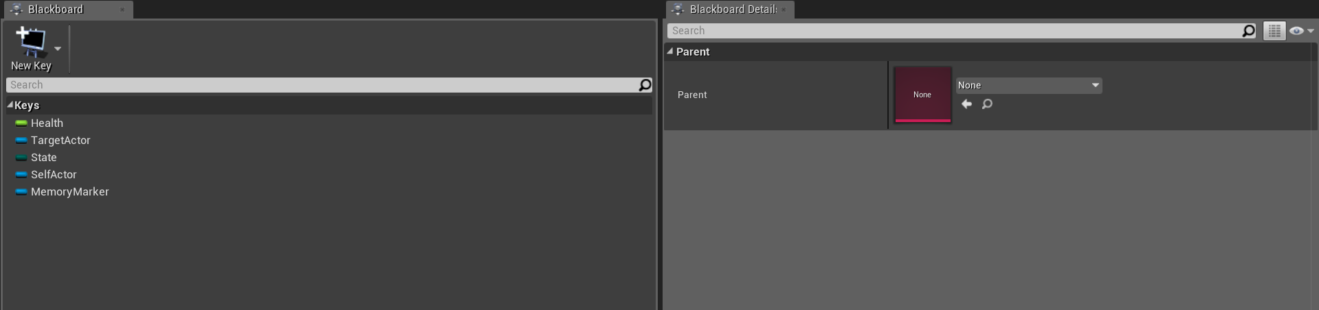
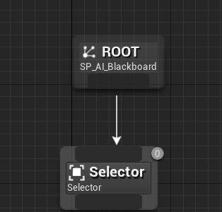
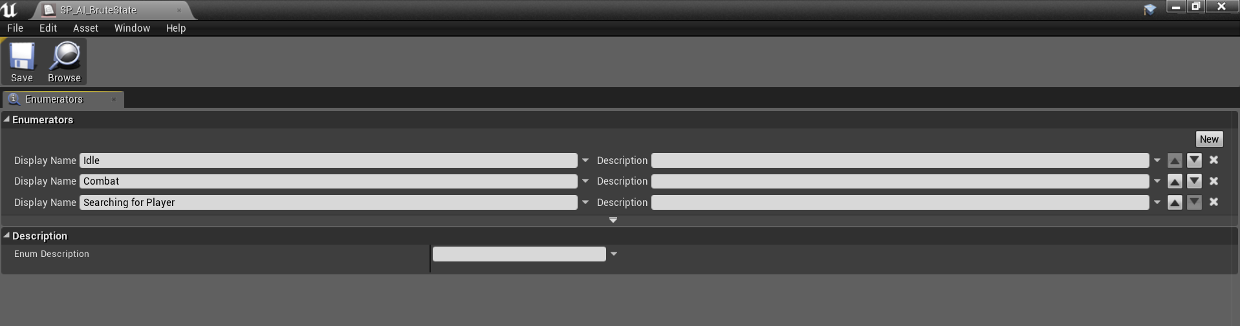
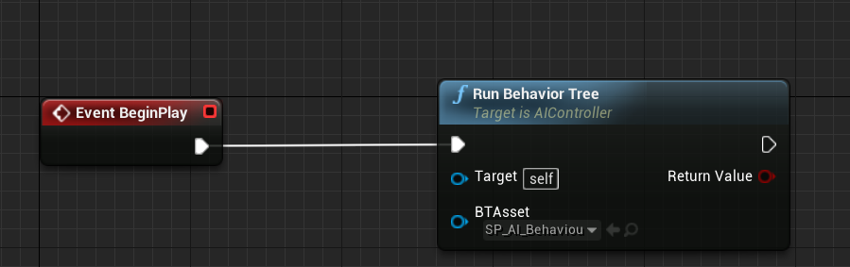

11/3/2018 - The second part of the AI changes, had a roaming system that has the AI roaming to random points on the map, this made it so the AI was constantly behaving like real enemies, not static meshes, at this point the AI doesn’t chase the player

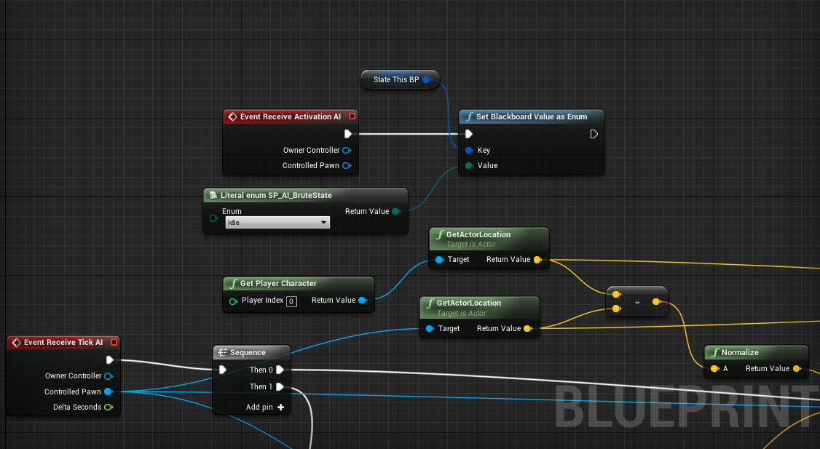

14/3/2018 - The AI now fires a Line trace towards the player constantly making them move towards the player, however a problem occurred that allowed the AI to see through walls, this made a stealth approach impossible as the player would not be able to hide behind walls that would be put into the updated level design.

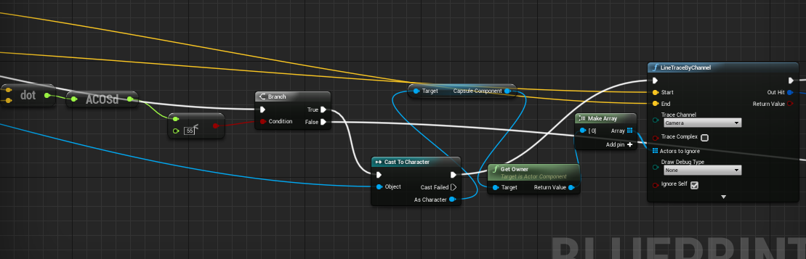
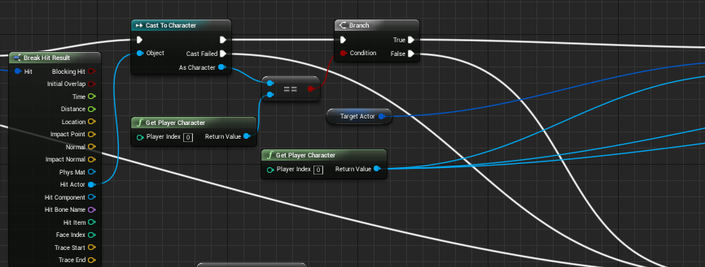
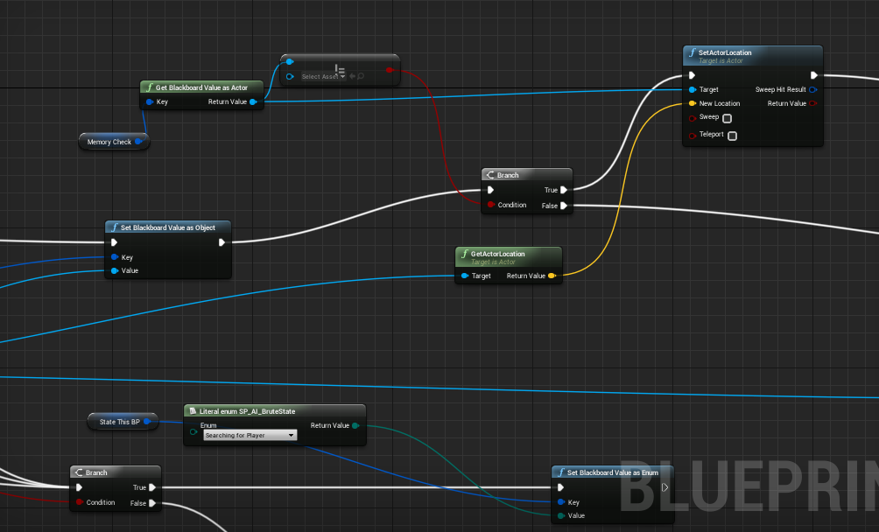

16/3/2018 - AI no longer can see through walls, making stealth possible in the future, this allows the player to either go aggressive or hide and wait for the AI to then kill the AI without being seen. This makes the game more fun but still has a few bugs.

18/3/2018 - Added a memory to the AI, this makes a marker for the AI to move to when they see the player, this is to prevent the player hiding behind a wall after being seen and the AI ignoring them, now the AI will check out the last spot the player was sighted.

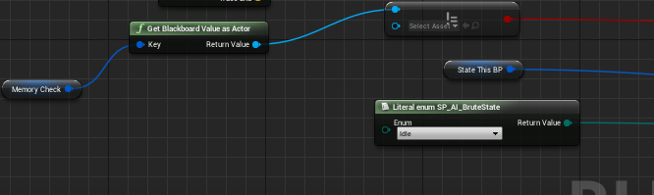
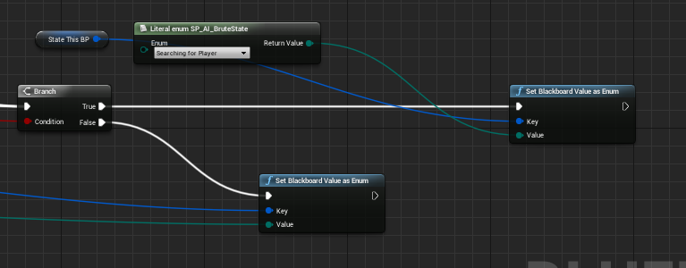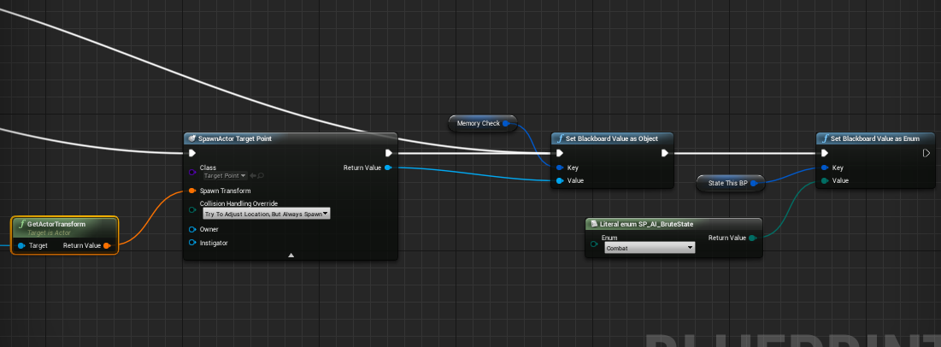

21/3/2018 - Set up the behaviour tree and Blueprint interfaces to allow damage to both the player and AI with a Parent class and child blueprint class. This inheritance allows health to inherit to both the player and the enemies.
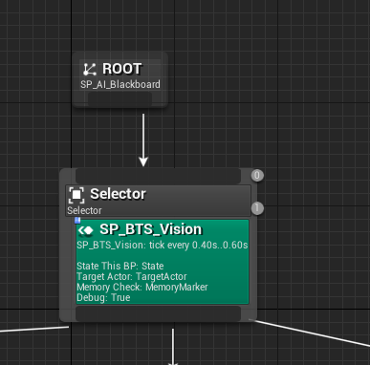
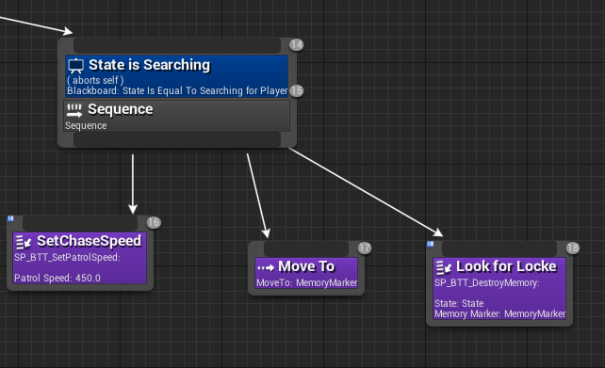
28/3/2018- Set up a damage system that made the AI fire a line trace at the player to damage the player, this meant projectiles or a gun would need to be used, the team didn't like the idea so the AI was once again changed
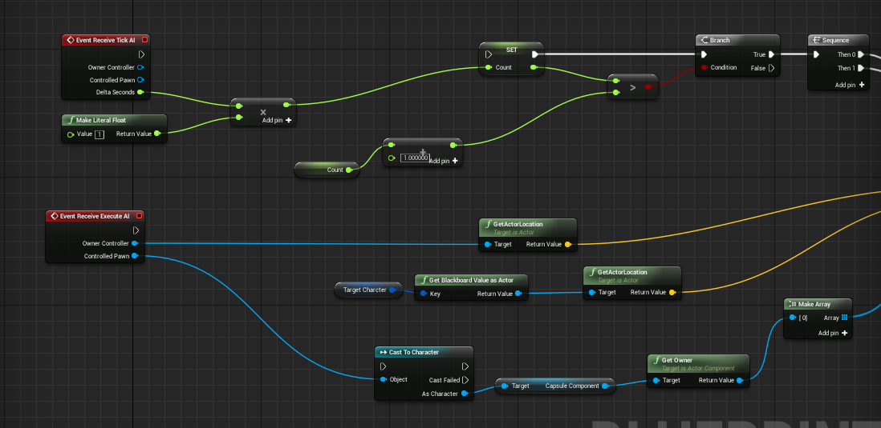
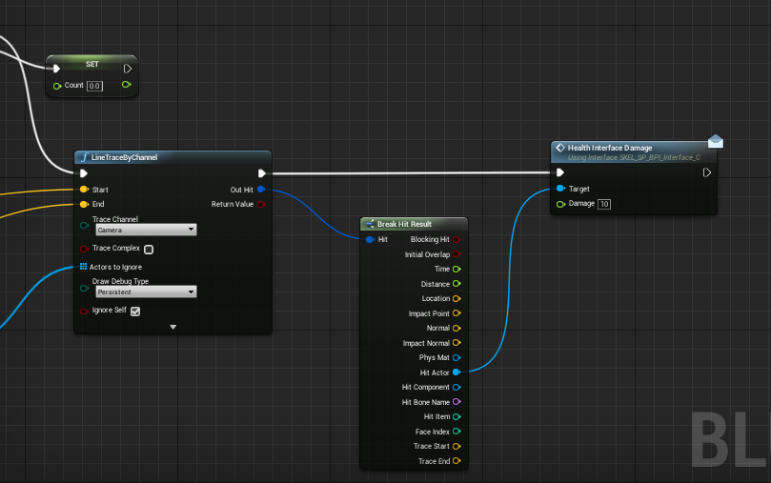
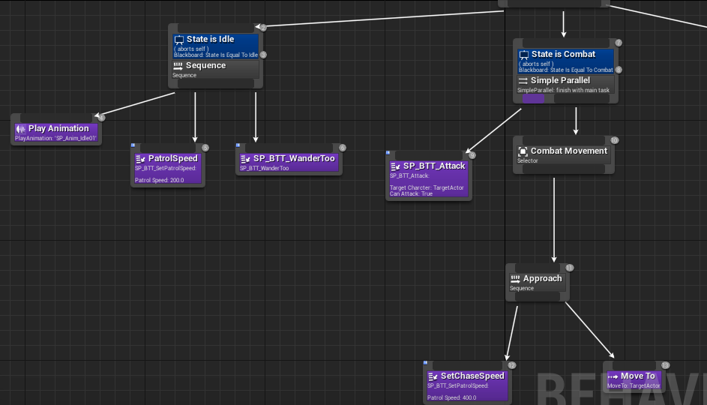
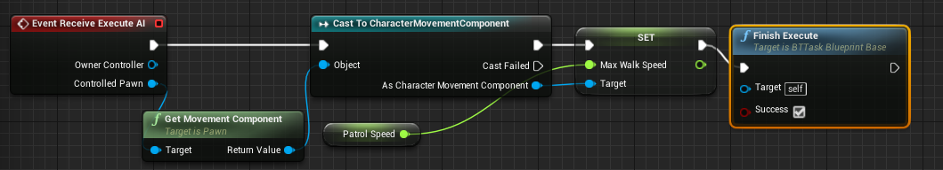
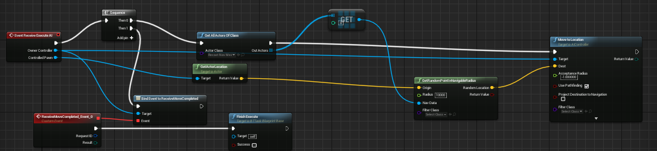

4/4/2018- A new Ai was found and shown to the group. This was liked and so a final AI decision was made. First the Brute uses a blueprint class instead of behaviour trees. This playlist was used for both AI combat and player combat to be done later. https://www.youtube.com/playlist?list=PLFY4PASroVXJq-NzsHi_nvsORUUSk0yuE

5/4/2018 - First the new AI blueprint was setup by duplicating the player blueprint and clearing its event graph, then the animation blueprint was set up, this animation blueprint will be used throughout for locomotion and other animation montages like attacks and run cycles.

6/4/2018 - set up the Ai to chase the player when the player walks through an initializer trigger box. This means however that the AI doesn't roam in a pattern. After this a blend space 1D blueprint was set up to allow the AI to play the Idle animation when standing still, then switch to the walk animation when chasing the player, additionally, the AI will detect distance from player so it doesn’t constantly try attack the player when it is far away from the player. Finally, I made an attack chooser, this uses a random integer selector and plays the attack animations binded to the values of the integer. This was used with Animation Montages.

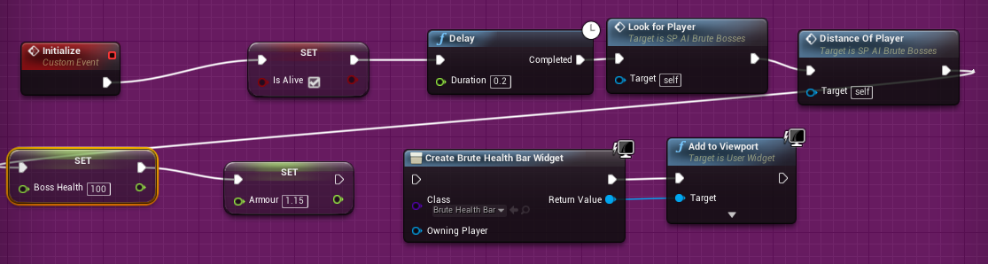

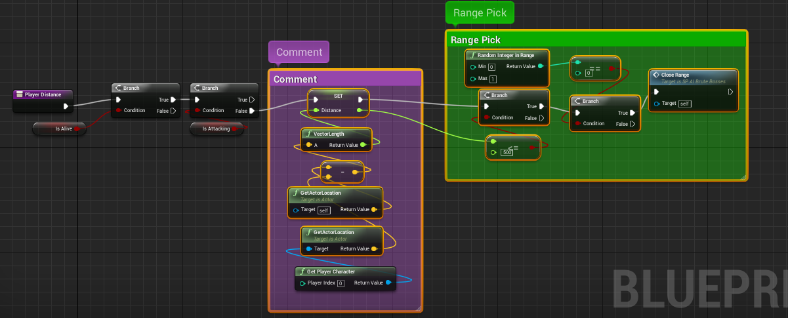
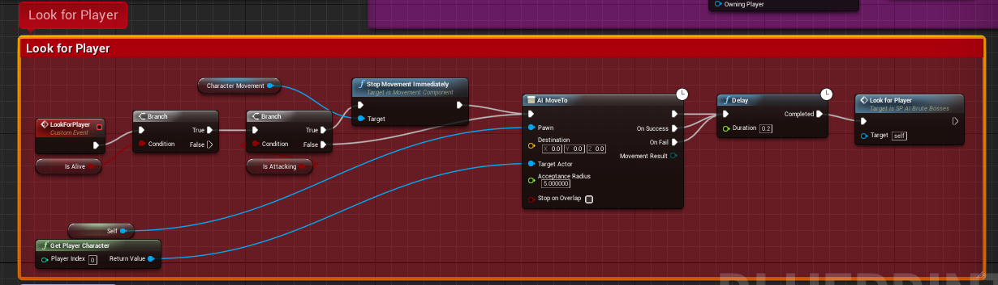
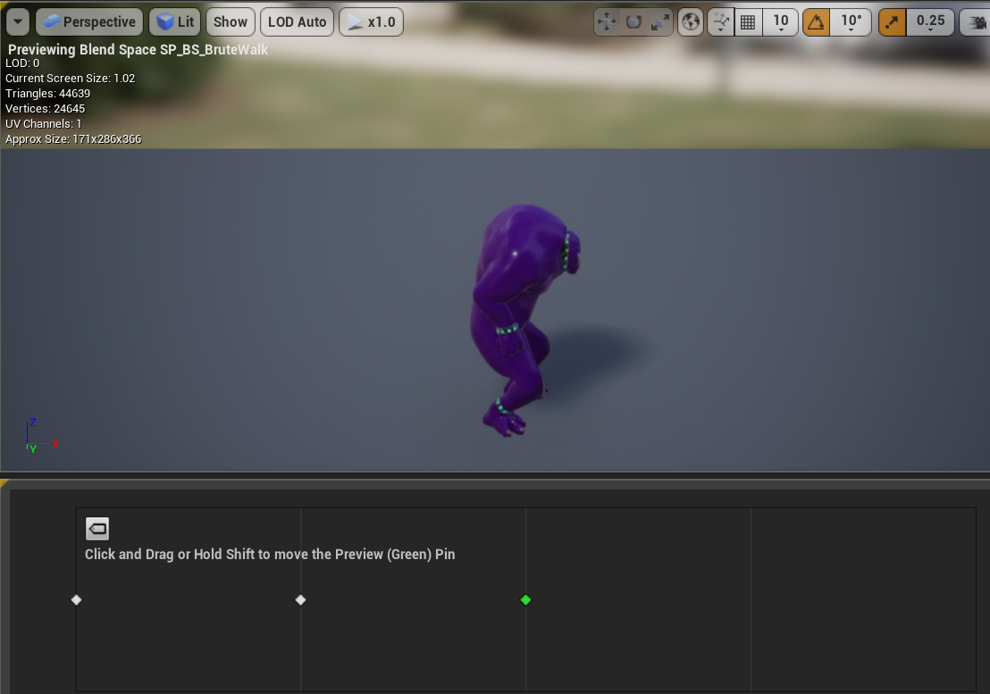
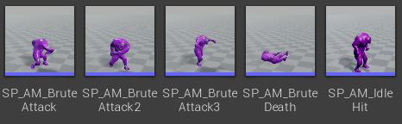
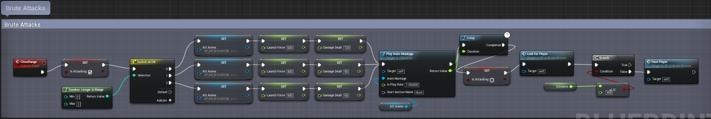

9/4/2018 - Downloaded the starter content and took two items from the particle folders, fire to use for the pits and an explosion, this explosion was then edited by removing the smoke and the flames, then the colour was removed, leaving an impact circle radiating outwards and sparks, that turned from orange to white, this edit was used for hit effects when the AI hits the player. To do this, two capsule collisions were put over the brutes fists and arms, these were used to identify collisions with the player to later apply damage to the player

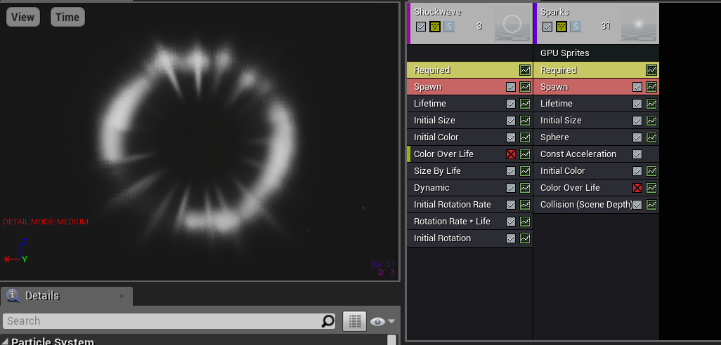
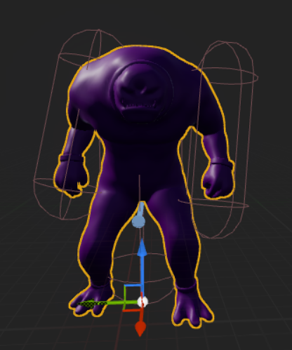

10/4/2018 - Set up the fist capsules to have no collision, this is so the animations of attacks can have notifies that notify coding to activate the capsule collisions so they overlap the player, then turn the fists off at certain points in the animations to stop the player being damaged throughout the animation, this allows for individual hits to be applied to the player.
The ERight and DRight are notifies that turn on collisions of the capsule collisions
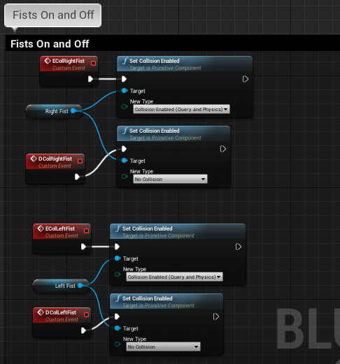
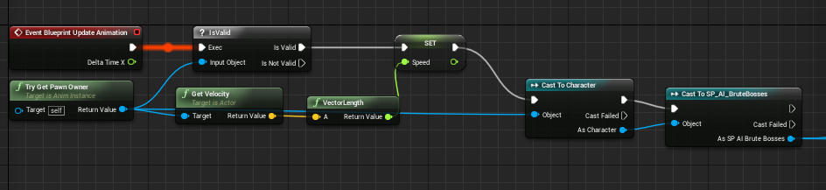
The animation blueprint that references the notifies on the montage. 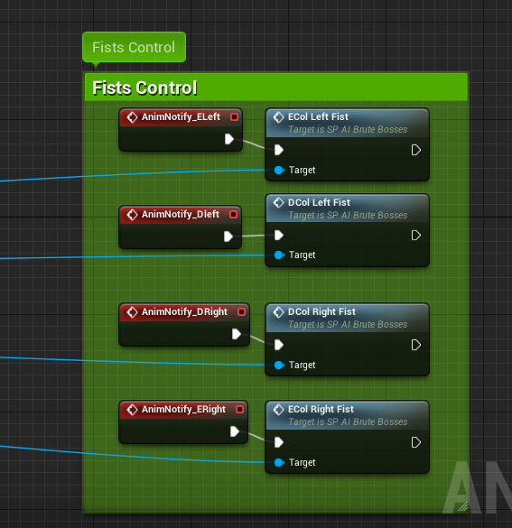Activates the fists in the animation blueprint.

12/4/2018 - After setting up the fist activation, the next part involved spawning a particle emitter at the location of a hit, when the brutes hit the player character, this spawns a sphere trace which then spawns the particle emitter that was made from the starter content explosion. After this the damage system was set up, this damage system works by making following the attack nodes, and applies damage based on the attack, this damage is a set damage applied using a variable, furthermore, when the ai hits 0 health the death animation will play and the ai will stop moving, however they will not despawn, and the animation clip has them fall halfway through the floor.
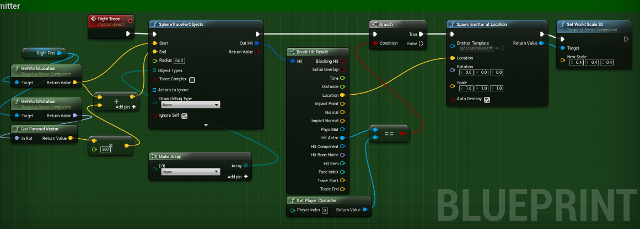
This is copied for the left fist below.

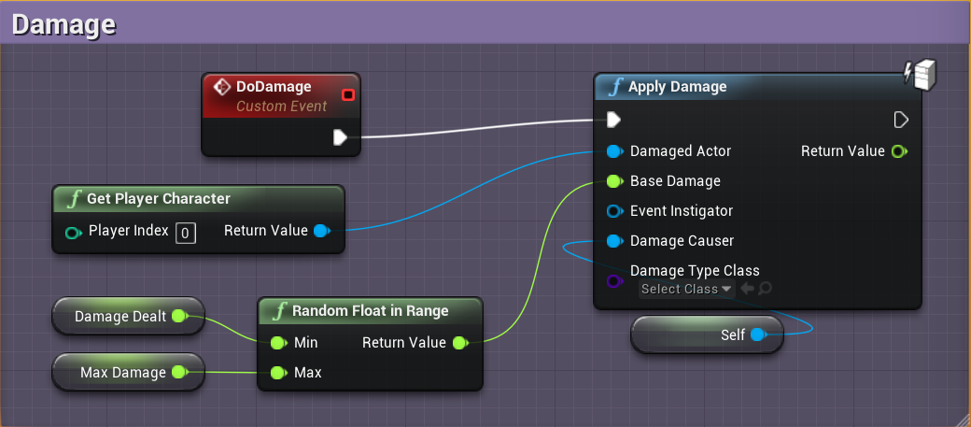

13/4/2018 - To finish the AI, a new function was made to launch the brute and make the brute face the player. After the AI was thought to be complete the player could walk behind the ai and the ai would keep attacking in front of them and not at the player, making the gameplay pointless and effortless, therefore a function was set up to make the ai face the player as they attack the player, this makes it so the player can’t hide behind the ai and abuse this, the other function that was made is called a Launcher function, this function launches the AI at certain points in the animation when a launch notifier is made on the animation, the brute will launch forward by a certain distance defined in the launch nodes using a variable, this was needed as the brute has a spin attack that looked wrong when the AI just stood still and spun, with the launcher the brute spins towards the player to stop the player from being able to dodge every attack. Finally, I also made a function that stops the AI moving as they attack so the animations have startup times and the brute doesn’t move forward when standing in a T pose getting ready to spin.

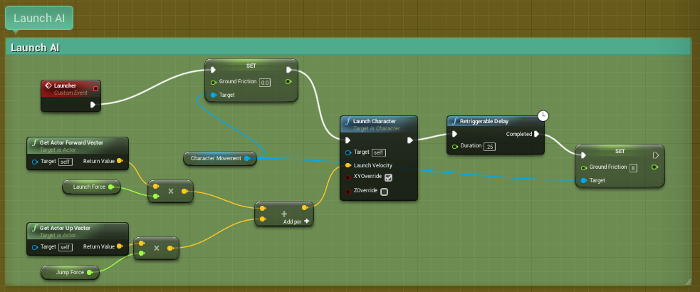
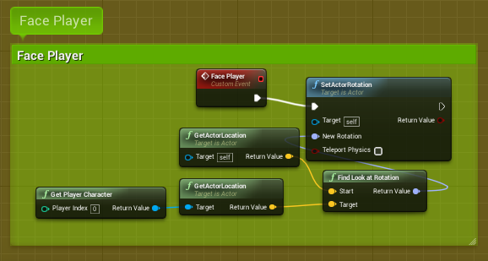
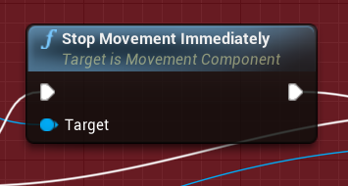

16/4/2018- The player also needed a new combat system that was very similar to the ai combat system, this involved using a lot of the same functions but including input actions, first off the animation blueprints, blendspaces and animation montages were set up first to save time therefore, this allowed the player to be in an idle animation, and then a running animation when the player moves the character.
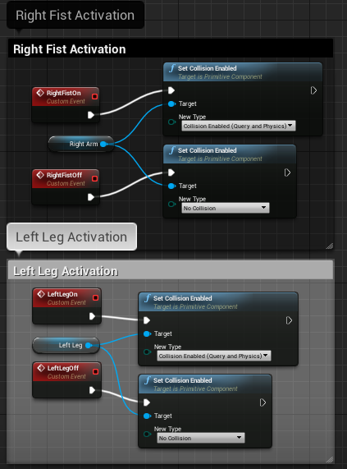
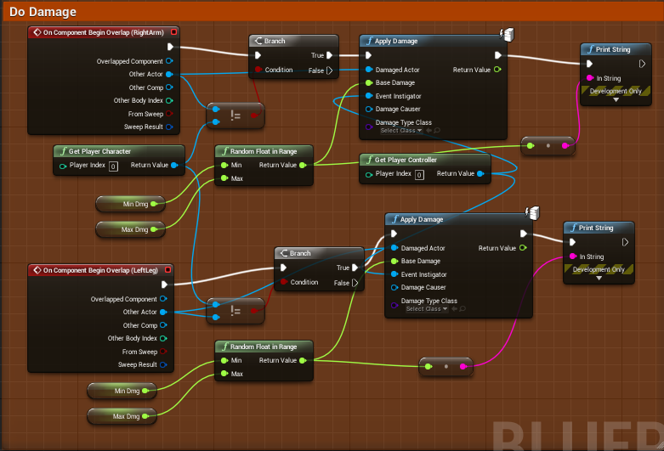
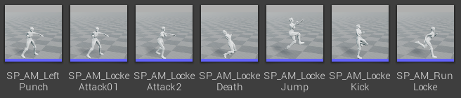

18/4/2018 - Used the same method of functions to set up the attacks, however instead of a random integer to decide the attack, the player instead uses a combo system, this plays the first attack then the second and then a third attack in a combo order instead of randomly selected. There are 3 hits to the combo, the first two hits are light punches and deal 40 damage allowing the player to kill the ai in 3 hits if they choose to use the light punch without executing the full combo, the final hit is a spinning kick which deals 60 damage, if this lands, the ai will die after the combo, or be left with one more light punch until death. Like the brute attacks these have launch properties and launch the player forward, furthermore, the player stops moving when using an attack to stop the player from walking away from the ai as they attack, giving the game some difficulty. To make this work, capsule collisions were added to the players right arm and left leg, the only two limbs used in attacks, these then need to be activated at certain points in the animation using notifies in the animation montage, which then link up in the player animation blueprint.

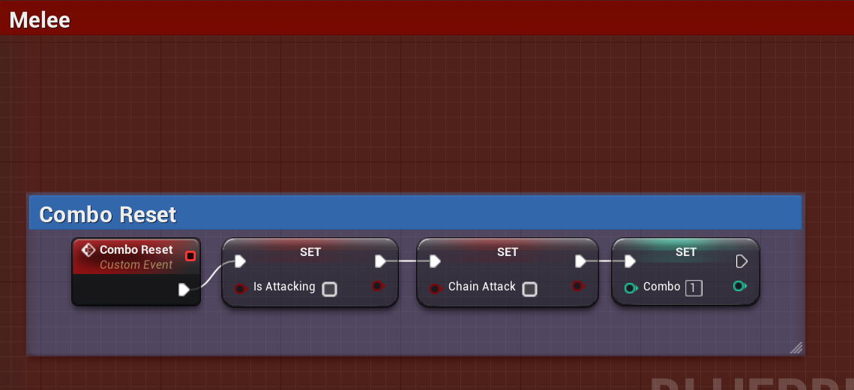
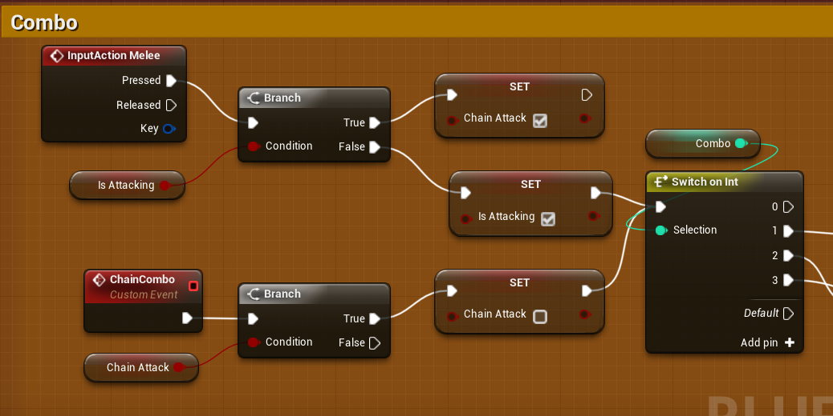
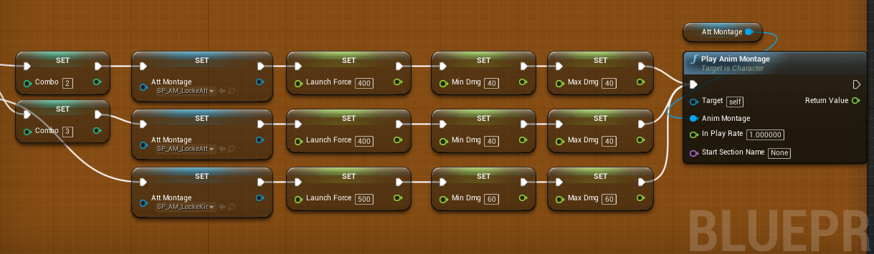
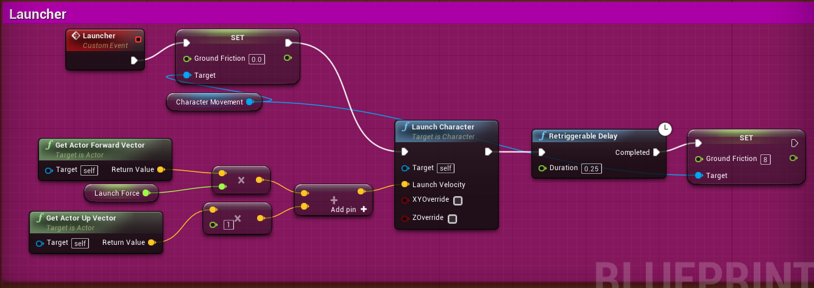

21/4/2018 - Next up was the player damage, health and health bar. This was all set up using new health variables to the old ones, that linked to all of the coding the brute searches for when applying damage. The player takes damage based on the attack the brute uses, this is then reflected in the player health bar widget set up in the bottom left corner of the screen, when this health bar hits 0 the player plays a death animation, however the player could get back up and keep playing after death, this needed to be fixed. The player attacks also now deal damage to the brutes allowing them to be killed by the player.

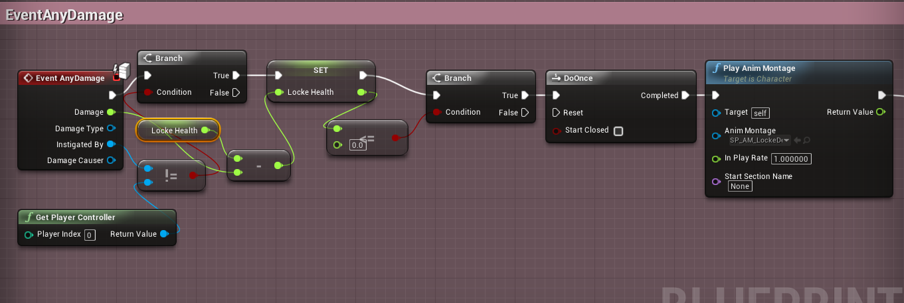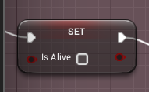

24/4/2018 - Made a start and game over screen. The screen is basic text with a basic button and only supports mouse control, if enough time is possible, a new improved one will be made, the start screen will load the level and start the game, the end screen is also red text that says GAME OVER and has a button. When the start screen is on screen, the player can use the mouse cursor to click the start game button and this will start the game and hide the mouse cursor. When the player’s health reaches 0, the death animation will play, and loop at the part of the animation where the model is on the floor, it will then disable all input and show the mouse cursor, this allows the player to press the restart button to jump back into the game.

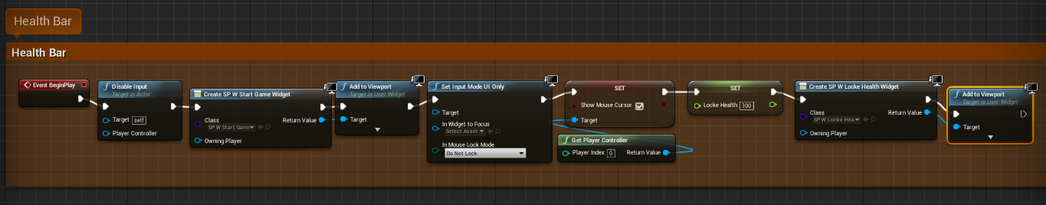
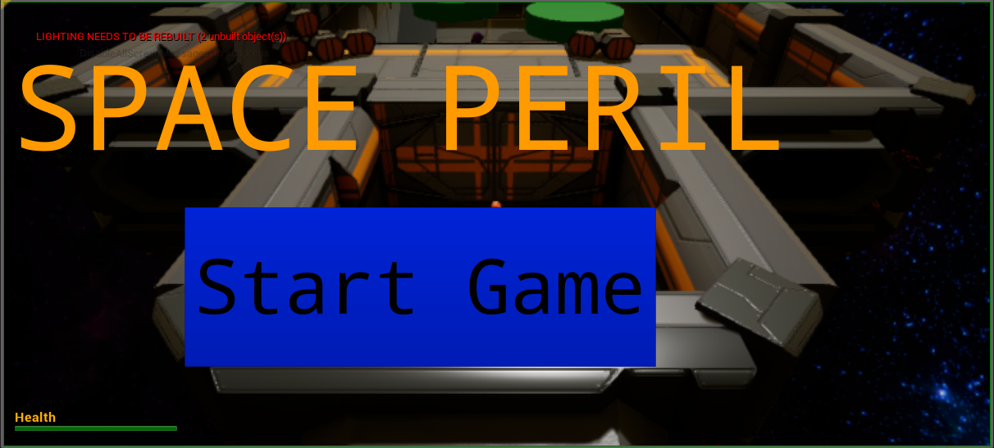
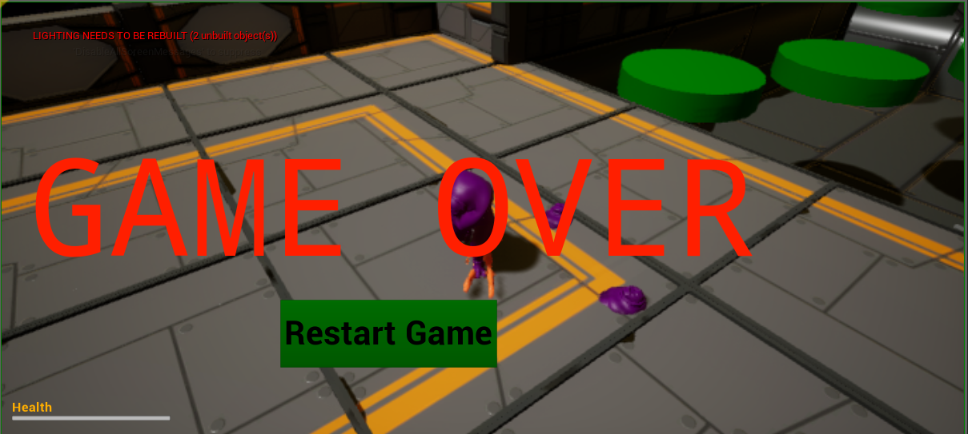

29/4/2018 - Upgraded the menu screens to have full graphics with buttons supplied by Virtus Learning Hubs on youtube. The menus made are Start Game, Game Over and a Level Complete menu. These menus have working buttons, one that starts the game, one that quits and one that displays a hidden image or text. These menus also can be navigated using the controller D-pad and buttons selected with the Gamepad bottom face button. The controls are on the start menu and credits are on both the death and level complete menu.
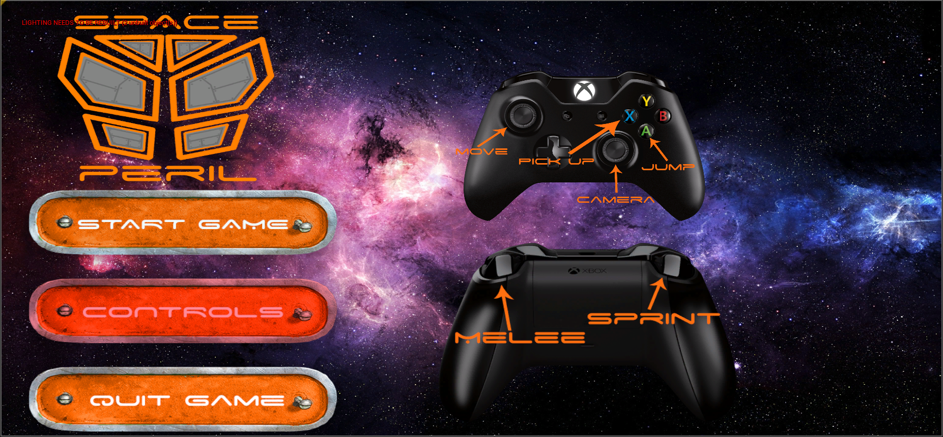
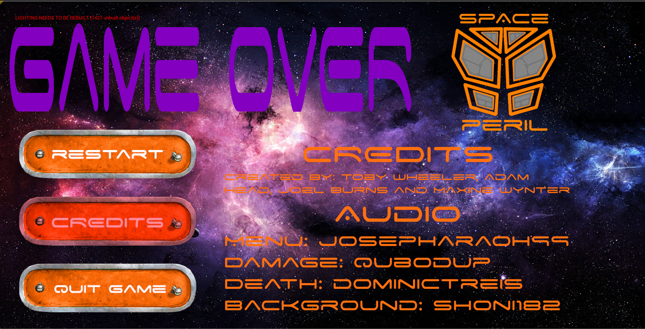
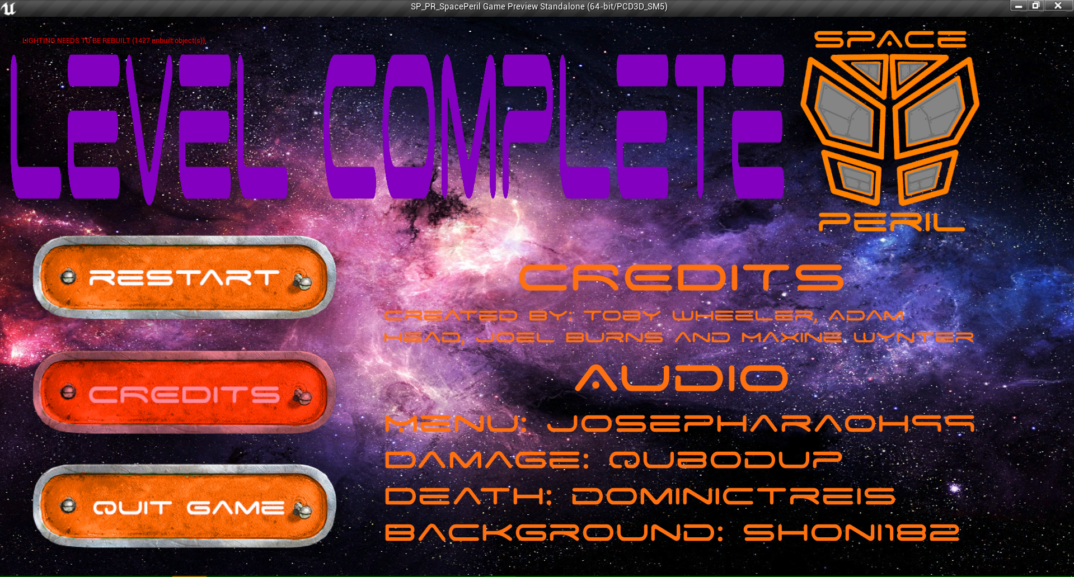

30/4/2018 - Finally, audio files were added to the game, the first audio file was a sound effect for damaging the enemies, this noise is a basic sound like a bang to simulate the player hitting the enemy. The second audio file is the background music, this background music has an eerie ambience and loops throughout the game. The third audio file is a death tune, this sad music plays when the player dies, and continues in the menu over the background music, after the clip finishes the background music keeps playing. Finally, a menu interface beep is set to play when the buttons on the menus are pressed.


