Data Analysis and Visualization
ACCA4002
(Assignment 1 Task 2 – Template)
University of Wales Trinity Saint David, London
Student Name: CRUCIANU MIRCEA ALEXANDRU
Student ID: 2025870

A)Skills required for study and employment
Since the beginning of the technological era the world is in a continuous development and people will adapt because this is human nature.
First, I would like to speak about three aspects that I will require for study the Cloud Computing course and also get a job as a Cloud Engineer.
Asef-m-m
 The first aspect will be the use of working tool. As you may know since the beginning of evolution humans to survive and mange with a lot of heavy problems, they invented a lot of tools that they’ve been used, such a rock or a stick. In present time, as we became more digitalize everything requires the correct use of a tool for clients to give them the best experience in terms of waiting time -delays, product innovations to make profit. This knowledge it will meant to be software and hardware.

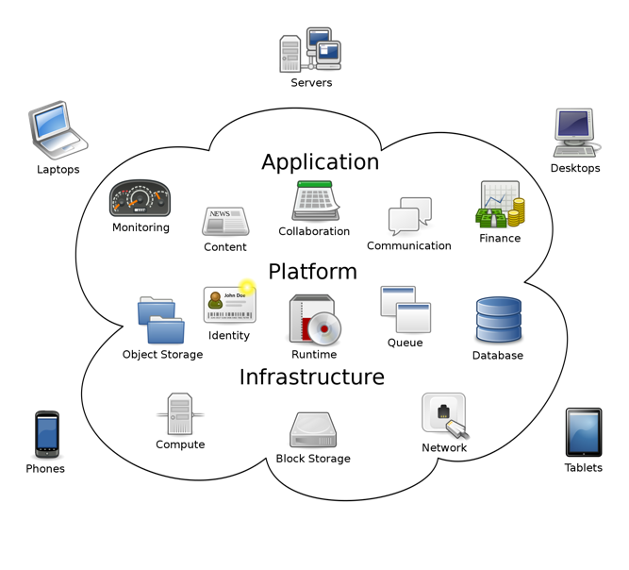
Sam Johnston - Created by Sam Johnston using OmniGroup's OmniGraffle and Inkscape (includes Computer.svg by Sasa Stefanovic)

The second aspect of a good Cloud Computing career it will be communication skill. As we know without a good communication the information that we have right now it will not be possible. The knowledge was passed from generation to generation. An effective communication is going to be possible when we can understand that we need to have the use of a language with words and meanings which will help facilitate communication. Similarly, when we look at the information technology, they require using a cloud computing translating tools to help translate and communicate between the systems. We are also creating the next generation tools that will help communication to be faster and easier like E-mails, Instant Messaging, Video-chat, Virtual Reality, Augmented Reality between the Cloud and business.



The last aspect of the abilities in Cloud Computing are essentials in development and it will be the problem solving. You can easily come up with a brilliant solution when you participate actively and anticipate with imagination and logic the problem that occurred and anticipate any potential future problems.
For this you will need to have analytical skills, you will need to interpret data, to see patterns, trends, this will help you making decisions and recommendations.
You will also need Innovative and creative thinking and a vision on how the solution will merge different types of problems. Beside this you will need to use your lateral thinking this is a situation where you will need to start from the beginning to find out a solution.
For the problem solving we can also mention adaptability and flexibility whenever in every situation, initiative to do everything, team-working and influencing skills or also a good leadership and resilience for a better emotional and mental welfare.¹
In the end I want to say that each individual develops his own set of skills and has the opportunity to learn other skills in order to bring him satisfaction at his workplace.

References
¹ targetjobs

B) Task2- Task Submit Score
One of the most interesting skill that all the Cloud Computing student should have is Critical Writing.
First, I would like to enumerate some learning and writing steps that everybody should be aware. You need to understand the meaning of the academic writing and to develop your argumentation when you write about a subject. You will need to know about plagiarism and how to use resources and how to find them.
About writing we can say that you will need to be precise in a critical and analytical way, by that we can say that after you ask the questions about the subject you will need to make a short evaluation.
At this evaluation the score was 4%, because I’ve used some citations but didn’t forget to mention the author of it and highlight it.
Using the Generic Assessment criteria¹ as a guide I can find my mark in 1st column that is named Exceptional being between 85-100% that means an extraordinary engagement vast range of substantial and unbelievable literature. This includes reading, referencing, academic conversations and academic honesty.
The inspiration was from the courses of Learning in the Digital Era course, that helped me to improve my writing and learning skills.

