Workplace Culture and Its Impact on Organisational Efficiency
MODULE CODE: BMSW5105

Just Eat Takeaway.com
LECTURER: KHAZA AHMED
STUDENT: COSTEL ANDONE(2027240)
Contents
1. Introduction 3
2. Determine the organisational structure of Just Eat Takeaway.com, debate it, and critically evaluate how it affects the culture of the company. 3
2.1 Company's organisational structure 4
2.2 Organisational Chart 6
3. Examine the external influences on Just Eat Takeaway.com's workplace culture and offer a critical evaluation of your analysis using a suitable framework. 7
3.1 SWOT analysis definition 7
4. Consider and debate the essential components of Just Eat Takeaway.com ethical organisational culture, and make recommendations on how to improve it. 12
4.1 McKinsey 7-S Model Framework 12
5. Explain the obstacles to Just Eat Takeaway.com's culture functioning effectively, offer pertinent recommendations that may improve Just Eat Takeaway.com workplace culture in the future, and make it clear how the recommendations will have a positive impact on organisational effectiveness. 15
5.1 The main barriers in the Just Eat Takeaway.com 16
5.2 Recommendation 16
6. Conclusion 17
7. References 18

1. Introduction
In Amsterdam, the Netherlands, there is a company called Just Eat Takeaway.com that provides internet food delivery. Connects approximately 250,000 regional eateries with tens of millions of customers through its websites and applications.
The business operates an online market place where supply and demand for food distribution and orders converge and covers 23 countries.
In order to create the business, two of the most well-known food delivery services in the world were combined in January 2020:
Customers will have access to the greatest variety of eateries thanks to this concept. The company's website or mobile app both accept orders from customers. Fees based on the Gross Merchandise Value (GMV) of food purchased through the company's marketplace are the main source of income for the business. Other services like online payments, the sale of goods and packaging, and the placement of advertisements also bring in money for the company.
The mission of Just Eat Takeaway is:
"Our mission is to be the best food delivery company on the planet. And of course, that wouldn't be possible without our 8,000 employees from around the world".

2. Determine the organisational structure of Just Eat Takeaway.com, debate it, and critically evaluate how it affects the culture of the company.
Each employee's responsibilities and their place within the wider system are made clear by a successful organisational structure. Simply said, the organisational structure determines who is accountable for what in order for the company to meet its objectives.

2.1 Company's organisational structure

The eService organisation is made up of specialist departments that provide the Company's Management Board with expert advice.
Plans and strategies that affect every facet of the company's operations are developed here (Fig:1) .
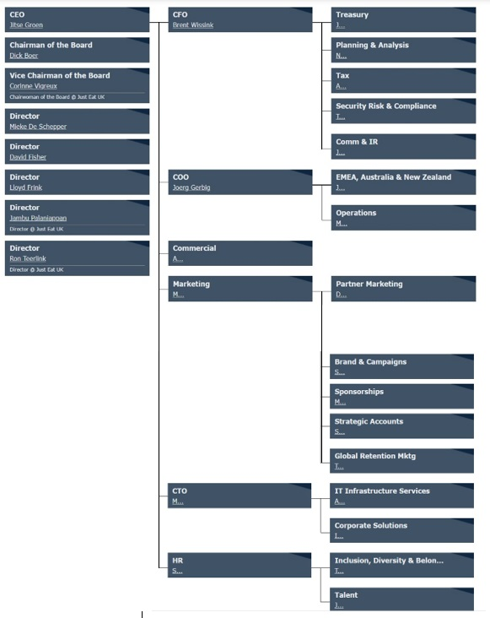
Figure: 1
Source: https://www.theofficialboard.com/org-chart/just-eat-takeaway-com-2

2.2 Organisational Chart
As an online marketplace for meal delivery, Just Eat Takeaway.com provides online ordering, payments, and occasionally order fulfilment. We employ a hybrid methodology that combines our logistical know-how with our market-place experience (where eateries manage their own deliveries). With this model, consumers are guaranteed the greatest selection of restaurants to choose from (Fig: 2) .
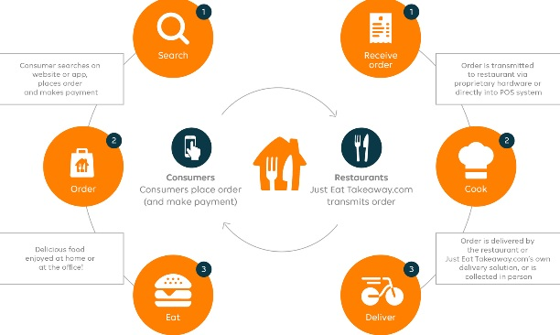
Figure : 2
Source: https://www.justeattakeaway.com/what-we-do
Our website and mobile applications both allow customers to place ordersTo a lesser extent, it also comes from the sales of goods and packaging as well as sponsored advertising. We also receive income from the delivery fees that customers pay for orders that Just Eat Takeaway.com delivers.

3. Examine the external influences on Just Eat Takeaway.com's workplace culture and offer a critical evaluation of your analysis using a suitable framework.

3.1 SWOT analysis definition
A research conducted by a company to pinpoint its internal advantages and disadvantages as well as external possibilities and dangers.

Using the SWOT analysis method, the strengths and weaknesses of Just Eat are analysed, as well as the opportunities and threats the company confronts as a result of the macroeconomic and competitive factors prevalent in the UK.

Significant information on both internal and external factors that may have an impact on an organization's performance is provided by SWOT analysis. It can assist corporate leadership in maximising performance, identifying new opportunities, controlling competition, maximising the return on resources invested, and minimising a variety of commercial and policymaking risks.
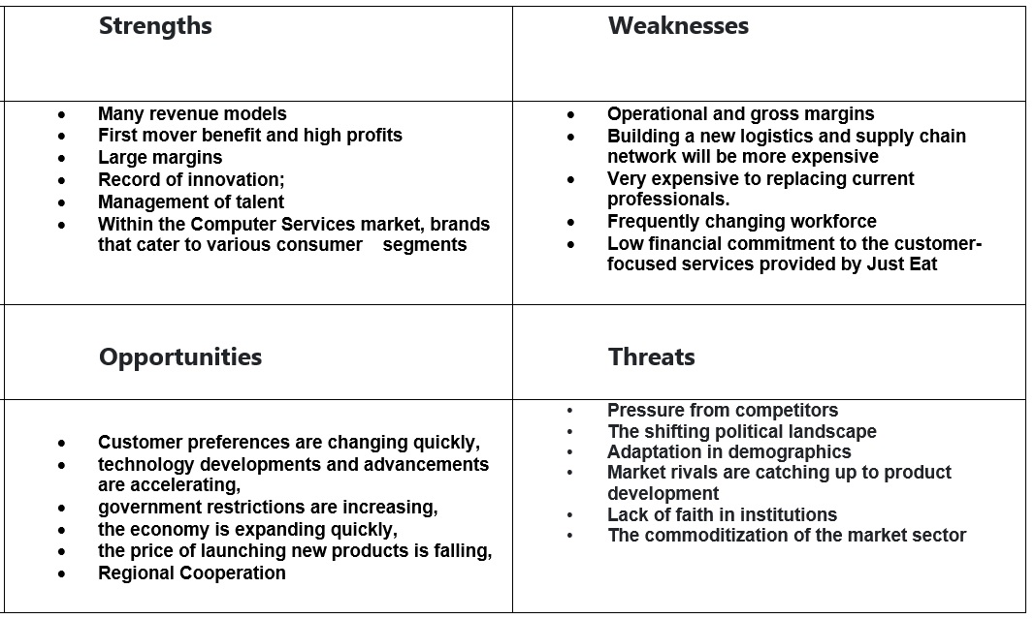

Strength
What do "Strengths" in the SWOT Analysis mean?
The firm's strengths are its capacities and resources that it can utilise to design, create, and maintain a competitive edge in the market.
Many revenue models Just Eat has made numerous forays into industries other than technology throughout the years.
First mover benefit and high profits. First mover advantage in a market that is getting more congested.
Large margins compared to competitors in the computer services sector - Even though Just Eats’ profitability is under threat, this company nevertheless generates larger profit margins than its rivals.
Record of innovation; While the bulk of technology players try to stay up with the times, Just Eat has a long history of consumer-driven innovation.
Management of talent
Human resources are essential to Just Eat's performance in the computer services sector through talent management and staff skill development.
Within the Computer Services market, brands that cater to various consumer segments. Within the computer services market, there are brands that appeal to different customer categories. Just Eat has been able to reach out to these different client segments with the help of its broad product offering. Additionally, it has helped the corporation diversify its revenue streams.

Weaknesses
What do the "Weaknesses" in the SWOT Analysis mean?
just Either the lack of a strength or the absence of resources or competences that are required but are not yet available might be considered a weakness.

Operational and gross margins .
Future pressure on the Just Eat financial statement could come from increasing operating and gross margins.
Very expensive to replacing current professionals.
Just Eats’ knowledge base is owned by a select few people, and replacing them in the existing environment will be very difficult .
Model of business.
Competitors in the computer services sector might readily copy the Just Eat business model. Just Eat takeaway.com must create a platform model that can combine suppliers, vendors, and end users in order to overcome these obstacles.
Frequently changing workforce.
At lower levels, there is also worry regarding the Just Eat. Pay increases may be necessary to retain the best employees at the company.
Low financial commitment to the customer-focused services provided by Just Eat. This could result in rivals having an advantage in the near future. Especially for products focused on customer services, Just Eat needs to raise its research and development spending.

Opportunities
What does the SWOT Analysis' term "Opportunities" mean?
Opportunities are locations where a business may be able to see potential for growth, earnings, and market share.

Customer preferences are changing quickly.
Customers are increasingly inclined today to experiment with and test new products on the market thanks to rising disposable incomes, easy access to information, and rapid acceptance of technical products. Just Eat must closely watch changes in both the larger technology sector as well as more general movements in the computer services industry.
Government restrictions are increasing.
Are making it challenging for players that are not organised to function in the computer services sector. This may present a chance for Just Eat to grow its consumer base.
The price of launching new products is falling.
Using specialised social networks and outside retail partners. Just Eat can take advantage of the recent trend of starting small before expanding after a new product achieves first success.
Regional Cooperation.
Just Eat may have expansion opportunities in foreign markets thanks to partnerships with regional players. Just Eat can bring global processes and execution expertise to the table, but the regional players are only skilled locally.
Threats
What does the SWOT Analysis term "threats" mean?
Threats are elements that may pose a risk to a company's business models due to shifting macroeconomic variables and shifting consumer attitudes. Threats cannot be eliminated but can be managed.

Pressure from competitors.
While the technology industry's new product launch cycles are getting shorter. It has increased the competitive pressures facing competitors like Just Eat. Due of the size of its consumer base, disruptors are able to more swiftly meet the demands of specific markets than Just Eat can.
The shifting political landscape
The Just Eat business could be impacted both locally and internationally by the US and China trade war, Brexit's effects on the European Union, and general instability in the middle east.
Adaptation in demographics
In light of the baby boomers' impending retirement, the younger generation is struggling to match their purchasing power. Young people are less brand loyal and more willing to try new things, which might increase earnings for Just Eat in the short term but reduce margins in the long run.
Market rivals are catching up to product development
Even while Just Eat currently leads the Computer Services industry in terms of product innovation, It is up against tough competition from both domestic and foreign rivals.
Lack of faith in institutions
And rising threat of legal actions against Just Eat because it is challenging to apply WTO rules and legislation in different areas. Legal processes have evolved into costly and drawn-out processes. It may cause Just Eat to make less investments in emerging markets, which would restrict growth.
The commoditization of the market sector
The growing commoditization of technology industry products presents the biggest obstacle for Just Eat and other participants in the market.

4. Consider and debate the essential components of Just Eat Takeaway.com ethical organisational culture, and make recommendations on how to improve it.

Ethical organisational culture
The collective mental programming that sets one group or category of people apart from others.
A system of common meaning that members have and that sets an organisation apart from others is referred to as organisational culture (Schein,1996).

4.1 McKinsey 7-S Model Framework

The approach was an attempt to address the common frustration executives had at the time in effectively addressing general management issues connected to organisational and strategic considerations.
The framework goes beyond the clichéd, oversimplified idea that "structure follows strategy" because it connects strategy to the other five parts as well. The following are the other components or variables of the framework that we will cover below, in addition to strategy and structure: shared values, skills, staff, systems, and style. According to the writers, understanding all seven factors
The seven components of the paradigm, according to the authors, are dependent on one another. The authors want to do this by drawing attention to the complexity of general management issues and addressing it more effectively. According to the authors, the framework's seven components must "fit" or be in harmony with one another in order for a plan to be successfully implemented (Fig: 3) .

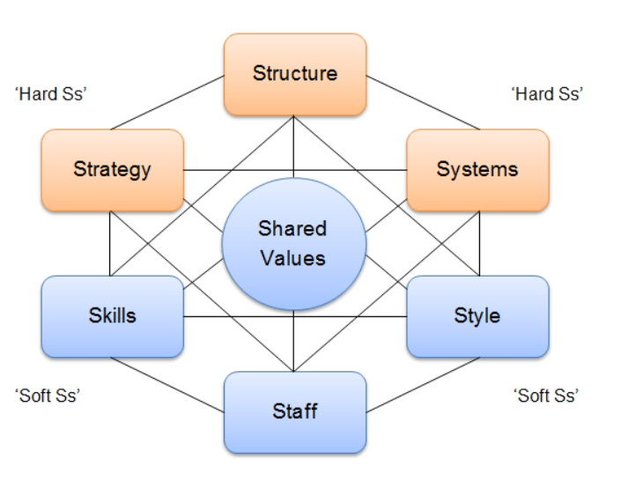
Figure: 3 - McKinsey 7S model
Source: https://strategicmanagementinsight.com/tools/mckinsey-7s-model-framework/

DESCRIPTION OF THE MODEL'S ELEMENTS

Strategy
A corporation's strategy is defined by the model as the group of steps it intends to take in anticipation of or in response to changes in its external environment. Through a series of actions, the company should be able to maintain or improve its competitive position by providing its customers with a unique value .
Structure
The primary issue associated with structure, according to the McKinsey model, is the ability to focus on the dimensions or design criteria that are currently essential to the corporation's progress and being ready to refocus as crucial dimensions move.
The guidelines for unit grouping that are used are a part of these measurements. Should it be determined by a customer, industry, functional, geographic, or other factor? The degree of formalisation of a unit's behavior, the degree of decentralisation of decision-making, or the necessity of horizontal coordination mechanisms between units are some additional design criteria.
Systems.
Systems, according to McKinsey and Company, are the formal and informal processes that enable an organisation to function. Understanding not only the official processes but also how the organisation actually operates is crucial, as such real work frequently relies on informal rather than official systems.
Style.
Although frequently overlooked, management style, particularly that of the CEO, plays a significant role in determining what the company can achieve strategically.
Staff.
Beyond the conventional distinction between "hard" concerns (pay scales and assessment systems) and "soft" issues, the McKinsey model takes into account Staff (morale, attitude, and motivation).
Skills.
By combining this element with a well-defined strategy, the organisation is able to assess its capabilities realistically in light of the essential success factors that characterise their industry. Getting rid of dated skills may be one problem, as they may act as a major barrier to the development of the new skills that are needed and the transformation that is required.
Common values.
The model, around which the organisation is cantered, is centred on superior goals and common values. These guidelines serve as the foundation for the corporate culture of the organisation and serve as its guiding principles.

5. Explain the obstacles to Just Eat Takeaway.com's culture functioning effectively, offer pertinent recommendations that may improve Just Eat Takeaway.com workplace culture in the future, and make it clear how the recommendations will have a positive impact on organisational effectiveness.

5.1 The main barriers in the Just Eat Takeaway.com

The pressure from rival businesses comes first.
It has exacerbated the competitive pressures that rivals like Just Eat are under. Disruptors are unable to respond to market demands more quickly than Just Eat can due to the magnitude of its customer base.
Baby boomers are about to retire, and the younger generation is finding it difficult to match their purchasing power.
Young people are less likely to stick with a brand and are more likely to explore new products from other companies, which could ultimately result in significant financial loss.
The market's rivals are catching up to the development of the services already offered by Just Eat Takeaway.com, which will cause a significant loss of the competitive advantage the company currently enjoys in terms of both orders and devoted customers in the future.
There is an increasing risk of legal action being taken against Just Eat Takeaway.com because it is challenging to apply WTO regulations and laws in various contexts. Trials are now expensive and drawn-out legal proceedings. Just Eat might decide to invest less in emerging regions as a result, which would limit growth.
The biggest challenge facing Just Eat Takeaway.com is the increasing commercialization of products in the technology sector.

5.2 Recommendation
1. Just Eat needs to keep a close eye on changes in both the broader technology sector and more general movements in the IT services industry, as today's customers are more likely to experiment and test new products on the market thanks to income that is more readily available, easy access to information, and rapid acceptance of technical products.
2. The organisation should boost industrial production and allow suppliers to provide a variety of products and services. This might make it possible for Just Eat Takeaway.com to significantly expand its market share.
3.The company Just eat Takeaway.com could enjoy the companies that are not organized to operate in the IT services sector. This may represent a chance for Just Eat Takeaway.com to increase its consumer base.
4. Due to the US economy's rapid growth relative to other industrialised nations, Just Eat Takeaway.com will have a chance to penetrate the US market. The know-how to compete in the US market is already available at Just Eat Takeaway.com.
5. Partnerships with regional players may also provide prospects for Just Eat Takeaway.com's expansion into foreign markets.

6. Conclusion
The organizational structure of the company was identified in this Just Eat Takeaway.com project, as well as the impact of the structure on the culture of the organization.
External factors were also discussed with the help of SWOT analysis, as well as elements of the ethical organizational culture.
The barriers that stand against the Just Eat Takeaway.com Company were highlighted and the necessary recommendations were also provided so that the company can set up its own position when it comes to online food delivery.
In conclusion, the company just eat takeaway.com is a titan when it comes to online food delivery.
There are many benefits of food delivery service and I believe that Just Eat Takeaway .com company expands your customer base and thus increases your income by offering customers a variety of options which will lead to loyalty on their part and convenience of unmatched.

7. References

Al-Eisawi, D., Serrano, A. and Koulouri, T., 2020. The effect of organisational absorptive capacity on business intelligence systems efficiency and organisational efficiency. Industrial Management & Data Systems.
Cacciattolo, K., 2014. Understanding organisational cultures. European scientific journal.
Channon, D.F. and Caldart, A.A., 2015. McKinsey 7S model. Wiley encyclopedia of management, pp.1-1.
Chung, H.F., 2008. The impact of a centralised organisational structure on marketing standardisation strategy and performance: the experience of price, place and management processes. Journal of Global Marketing, 21(2), pp.83-107.
Cox, A.M., Pinfield, S. and Rutter, S., 2018. Extending McKinsey’s 7S model to understand strategic alignment in academic libraries. Library Management.
Helms, M.M. and Nixon, J., 2010. Exploring SWOT analysis–where are we now? A review of academic research from the last decade. Journal of strategy and management.
Hopkins, A., 2006. Studying organisational cultures and their effects on safety. Safety science, 44(10), pp.875-889.
Kay, J., 1993. The structure of strategy. Business strategy review, 4(2), pp.17-37.
Liu, W., Zhang, J., Wei, S. and Wang, D., 2021. Factors influencing organisational efficiency in a smart-logistics ecological chain under e-commerce platform leadership. International Journal of Logistics Research and Applications, 24(4), pp.364-391.
Madsen, D.Ø., 2016. SWOT analysis: a management fashion perspective. International Journal of Business Research, 16(1), pp.39-56.
Maduenyi, S., Oke, A.O., Fadeyi, O. and Ajagbe, A.M., 2015. Impact of organisational structure on organisational performance. Nigeria: Thesis Submitted to Covenant University, pp.354-356.
Martins, E.C. and Terblanche, F., 2003. Building organisational culture that stimulates creativity and innovation. European journal of innovation management.
Maull, R., Brown, P. and Cliffe, R., 2001. Organisational culture and quality improvement. International Journal of Operations & Production Management.
McMillan, E., 2002. Considering organisation structure and design from a complexity paradigm perspective.
Pickton, D.W. and Wright, S., 1998. What's swot in strategic analysis?. Strategic change, 7(2), pp.101-109.
Roberts, J., 2018. Multinational business service firms: The development of multinational organisational structures in the UK business services sector. Routledge.
Schein, E.H., 1996. Culture: The missing concept in organization studies. Administrative science quarterly, pp.229-240.
Valentin, E.K., 2001. SWOT analysis from a resource-based view. Journal of marketing theory and practice, 9(2), pp.54-69.
Wright, D.T. and Burns, N.D., 1998. New organisation structures for global business: an empirical study. International Journal of Operations & Production Management.

