Student Name: Jordan Glasgow
Student Number: 1918303
Module: Introduction to Physiology
Module code: BMHP5003_BIRM
Program: BSc Health and Social Care
Lecturer: Mumtaz Goolam

Health Assessment Report

Contents
Introduction 2
Case Study 6
Normal and abnormal physiological conditions based on assessment findings. 7
Key Recommendations 8
Conclusion 9
Reference List 10

Introduction
Hypertension is a primary cause of death worldwide, as well as one of the main risk factors for cardiovascular disease and a major cause of early death. Because individuals seldom exhibit with particular symptoms in the early stages of the condition, hypertension is difficult to diagnose until medical issues arise. Hypertension is also difficult to control successfully, as continuous consistent treatment is needed after it is diagnosed, also due to lack of understanding and patient compliance. People's health may be improved by altering their behaviour, such as encouraging individuals to quit smoking and become more active, as well as encouraging health professionals to modify their behaviour in order to enhance the quality of treatment they deliver. There are several methods for assisting people to modify their behaviour, but these are frequently inefficient and must be improved and changed for diverse circumstances. Improving treatments is dependent on providing precise descriptions, particularly of the "active ingredients" that are responsible for change. Hypertension is a significant modifiable risk factor for heart disease and stroke. Hypertension can lower the risk of stroke by up to 42% and the risk of coronary heart disease by roughly 14% with proper treatment. However, smoking, obesity, diabetes, dyslipidaemia, and other lifestyle variables have been linked to cardiovascular disease and hypertension. Because effective hypertension management considers the patient's age, sex, race, nutrition, exercise, cigarette use, comorbid diseases, antihypertensive medication treatment, compliance, and blood pressure control, lifestyle is an important aspect. Bruno et al, (2016). investigated the prevalence of systemic arterial hypertension in young individuals and its relationship to modifiable risk variables. The key factors were discovered as male sex, obesity, and eating behaviours. In prior work, we created a way for reporting interventions in terms of 'behaviour change strategies.' This has been beneficial to both those implementing treatments and researchers. The medical examiner must be able to deliver quality, safe treatment to the patient and it is essential that they know how to assess the cardiovascular system effectively and detect both normal and abnormal assessment findings. It's critical to understand the many operations of the cardiovascular system before examining a patient. For detecting indicators of probable failure, a subjective examination of the cardiovascular and peripheral vascular systems is critical. The physician starts their subjective cardiovascular assessment with a focused interview. The in-depth interview entails questions about prior medical and family history, medicines, cardiac risk variables, and concerns presented. Chest discomfort, peripheral edoema, unexplained abrupt weight gain, shortness of breath dyspnoea, irregular pulse rate or rhythm, dizziness, or poor peripheral circulation are all symptoms connected to the cardiovascular system. Any new or worsening symptoms should be written down and reported to your doctor.

Since the 1960s, the rate of cardiovascular disease in the United Kingdom has been steadily decreasing Scarborough et al (2011). This drop occurred in many places of the world, including Western Europe, the United States of America, and Australia. Between 1968 and 1978, mortality from coronary heart disease fell by 20% in the United States Jones and Greene (2013). It was unclear why this drop occurred at the time, but subsequent modelling pointed to a greater understanding of CVD risk factors, as well as early preventive programmes and improved treatment. Using Scottish data from 1975 to 1994, Capewell et al (1999) found that risk factor reductions through prevention contributed 51 percent to the fall in death rate and improved coronary treatment by a factor of two CVD is frequently linked to the build-up of fatty deposits in the arteries (atherosclerosis) and a higher risk of blood clots. It's also linked to artery damage in organs like the brain, heart, kidneys, and eyes. CVD is one of the primary causes of death and disability in the United Kingdom, however it may often be avoided in large partly by making healthier lifestyle choices.
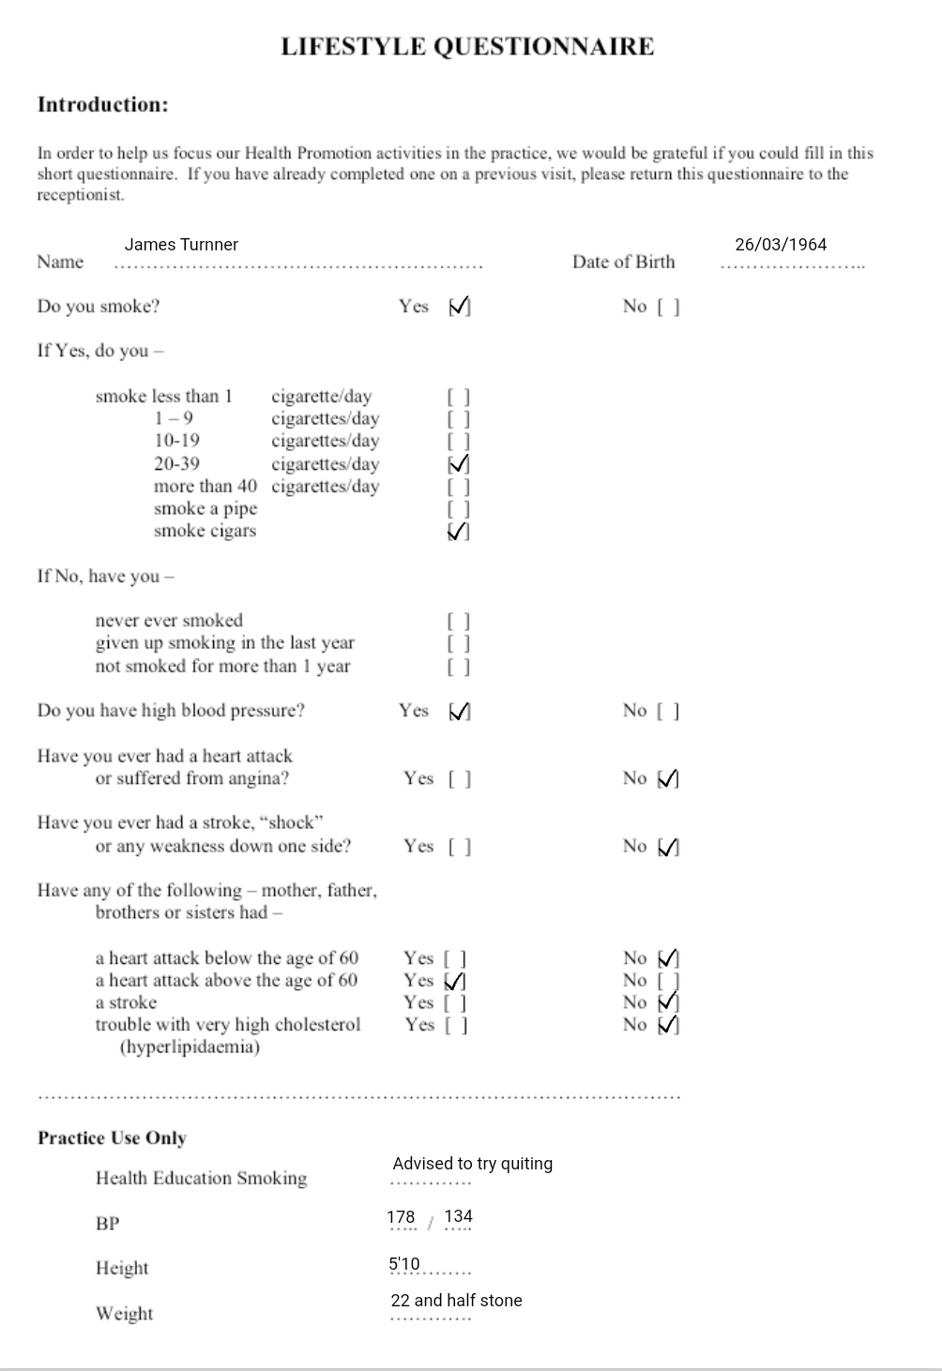

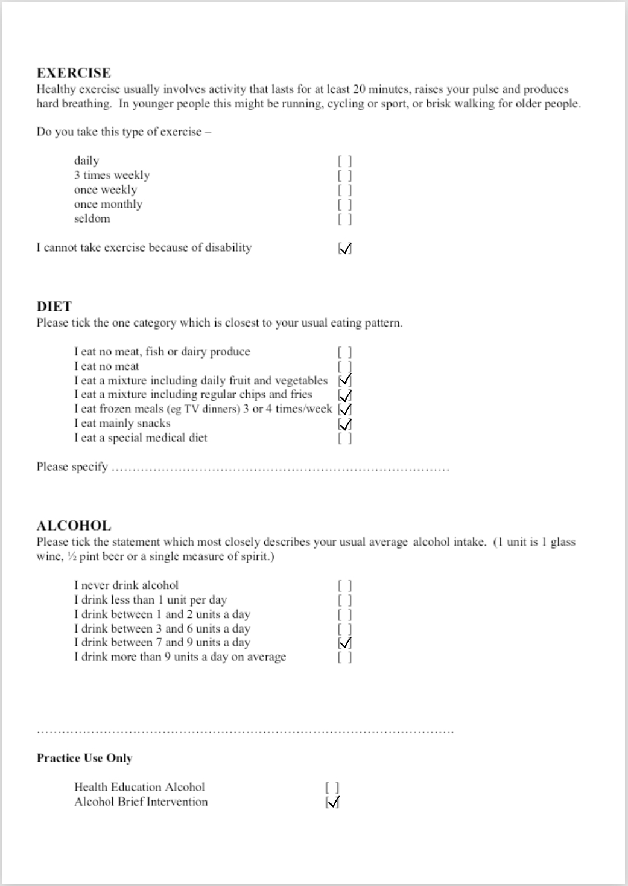

Case Study
The patient’s name is James Turnner he is a 58-year-old Black Caribbean male who lives alone in his council estate property after losing his wife four years ago to a stroke. Mr Turnner seeks treatment and or advice from myself at the clinic today after arriving at the clinic with complaints of abrupt weakness and an unexplained tightness of the chest. Mr Turnner states that for the past three weeks he has not had his usual pep in his step, and as the days go by, he has noticed that he feels too tired to even finish the smallest of household chores. His past medical history includes High Blood Pressure, Gout, and low Vitamin D, upon arrival Mr Turnner produced a copy of his patient medication history also known as a repeat prescription.
Mr Turnner is currently taking a group of medications aimed at lowering his blood pressure, along with a list of other medications for his other outstanding medical conditions the medication Mr Turnner is on is to be taken once daily. Mr Turnner is to take one 10 mg, amlodipine tablet in the morning, a 100mg Losartan tablet and also a 2.5 mg Indapamide tablet to try and counteract his high blood pressure, he takes these along with one 300mg Allopurinol and a 100mg Allopurinol as he also suffers from gout attacks causing both his joints in his feet and knees to lock up often leaving him unable to walk, and lastly Mr Turnner takes one Fultium-d3 800u capsule for low vitamin D.
Mr Turnner admits to having a forty plus year history of smoking cigarettes and went on to disclose that he continues to smoke at least 30 cigarettes a day with no intentions of quitting, in addition he has also become alcohol dependent since the passing of his wife.

Normal and abnormal physiological conditions based on assessment findings.
The cardiovascular system is made up of the following components, blood is a red-coloured fluid that circulates throughout the body, and the heart which is also known as the body's control centre. It transports and gathers blood to and from all of our body's organs. Blood vessels are the conduits via which our body's transport medium flows. The blood pressure of a person is a measurement of the force your blood exerts as it passes through your arteries. Blood pressure is measured by two numbers they go by the names of systolic and diastolic. When a patient is displaying an absence of a normal blood pressure range, they are at risk of serious health problems, including a heart attack and not least but still seriously a stroke.
Hypertension is often of greater concerns when discussing risks with patients as it can be a very worrying subject. The opposite of hypertension is hypotension and are both classed as a normal and abnormal function of the heart and describes how normal blood pressure is measured, and what it means when your blood pressure is too low or too high,.
My following findings will discuss how normal blood pressure is measured, what it means when your blood pressure is too low or too high, how blood pressure conditions are treated, and which lifestyle changes and recommendations Mr turner should look into by time he next sees his local healthcare provider i.e., how blood pressure conditions are treated, and when to seek medical advice from a healthcare provider
A person with a blood pressure reading consistently above 140/90 mmHg (or 135/85 mmHg at home) but with a low risk of other conditions will be advised to adjust their lifestyle your blood pressure must be consistently below 140/90mmHg (or 135/85mmHg at home) if you have a high risk of other medical problems, which means you'll be given medicine to lower it, along with lifestyle suggestions your G.P will recommend medication to lower your blood pressure and lifestyle changes if it consistently exceeds 160/100mmHg.
There are certain lifestyle adjustments Mr Turnner may do to help lower his blood pressure. Some of these will help Mr Turnner to lower his blood pressure in a matter of weeks, while others will take a little longer.

Key Recommendations
According to the NHS national health website Mr Turnner should consider reducing his daily salt intake to less than 6g (0.2oz), which works out to roughly around a teaspoonful, Mr Turnner should also learn how to limit the quantity of salt in his overall diet and try consuming a low-fat, well-balanced diet that is rich in fresh fruits and vegetables and relies less on frozen meals and take aways, there are many different ways in which Mr Turnner could learn how to eat more healthily, the first step I advise of Mr Turnner is to take action .
Mr Turnner should also have a look at some suggestions for increasing his physical activity limit as he is currently not getting any exercise, he should do so in a safe manner as long as it doesn’t affect his disability or cause him more mobility issues, in addition Mr Turnner has been advised by myself to limit his alcohol consumption we have discussed ways in which he could do this including making contact with groups and organisation such as Alcoholics Anonymous or the AA programme of recovery from alcoholism , I also advise Mr Turnner to download a drinks diary onto his mobile phone so to be able to keep track of his full alcohol consumption and discussed the risks associated with Coronary heart disease I explained that it is a phrase that defines what happens when a build-up of fatty substances in the coronary arteries blocks or interrupts your heart's blood flow, and the walls of your arteries might become furrowed with fatty deposits over time. The fatty deposits are known as atheroma, and the process is known as atherosclerosis. Atherosclerosis is caused by lifestyle factors such as smoking and consuming excessive amounts of alcohol on a regular basis. I also informed Mr Turnner that he is at higher risk of getting atherosclerosis due to having existing health conditions like high blood pressure (hypertension) or if his weight continues to go up and is not controlled it is very possible he could be at risk of becoming diabetic.
Mr Turnner’s weight is another cause for concern between him and his local G.P they need to work on bring his weight down to a reasonable size suggestion on how to lose weight. Drink less caffeine, which may be found in coffee, tea, and cola. Quit smoking with the aid of a trained professional.

Conclusion
Isolated systolic hypertension becomes more common as people become older, and it's linked to an increased risk of heart disease. All subgroups depending on baseline age, race, sex, blood pressure, serum cholesterol levels, and ECG abnormalities reaped the advantages. Angina Pectoris develops when your heart muscle does not receive a sufficient supply of blood for whatever reason, resulting in a searing discomfort in your chest. A person may also experience suffocation and breathing difficulties. The pathophysiology of angina can also be influenced by a person's blood pressure. Chest discomfort can be caused by high blood pressure. The pain might also be caused by a blockage in the heart's arteries. Pain and discomfort in the heart, which may extend to the arm, shoulder, neck, or throat, are frequent indications and symptoms.
High blood pressure can be managed using a variety of medications. Many people require a mix of medications to be effective If you're under 55, you'll likely be prescribed an ACE inhibitor or an angiotensin-2 receptor blocker (ARB), but if you're 55 or older, or if you're of African or Caribbean descent, you'll likely be prescribed a calcium channel blocker.
Blood pressure readings in the over-80s should be less than 150/90 mmHg at the clinic or surgery, and less than 145/85 mmHg on a home testing kit. While there are evident benefits to using blood pressure medications if you're under the age of 80, it's less clear if you're above 80. It's currently assumed that if you're taking medication for high blood pressure and reach the age of 80, you may keep taking it as long as it's treating you and not producing negative effects. If you have high blood pressure and are over the age of 80, your doctor will evaluate your other health risks when determining whether or not to treat your high blood pressure.

Reference List
Alcoholics-anonymous.org.uk. 2022. Alcoholics Anonymous Great Britain. (online) Available at: <https://www.alcoholics-anonymous.org.uk/> (Accessed 2 April 2022).
Bohatala.com. 2021. Cardiovascular Case Study Analysis. (online) Available at: <https://bohatala.com/cardiovascular-case-study-analysis/> (Accessed 18 March 2022).
De Heus, R. and Claassen, J., 2017. (BP.05.0) ORTHOSTATIC BLOOD PRESSURE CHANGES AMONG HYPERTENSIVE AND NON-HYPERTENSIVE PATIENTS WITH ALZHEIMER'S DISEASE. Journal of Hypertension, 35(Supplement 2), p.e260. (Accessed 2 April 2022).
Moyé, L., Davis, B., Hawkins, C. and Probstfield, J., 1993. Conclusions and Implications of the Systolic Hypertension in the Elderly Program. (online) Available at: https://pubmed.ncbi.nlm.nih.gov/8268898/ (Accessed 4 April 2022).
https://www.ncbi.nlm.nih.gov/pmc/articles/PMC5541164/#B5. 2016. (online) Available at: <https://www.semanticscholar.org/paper/Association-Between-Lifestyle-and-Systemic-Arterial-Bruno-Pucci/a687b3a3ea7c97a9f20ddb71c8a9549a53e69c8d> (Accessed 5 April 2022).
nhs.uk. 2019. High blood pressure (hypertension) - Treatment. (online) Available at: <https://www.nhs.uk/conditions/high-blood-pressure-hypertension/treatment/> (Accessed 2 April 2022).
nhs.uk. 2022. Coronary heart disease. (online)Available at: <https://www.nhs.uk/conditions/coronary-heart-disease/> (Accessed 3 April 2022).
Uhbristol.nhs.uk. 2017. (online) Available at: <http://www.uhbristol.nhs.uk/media/2978983/4_how_to_aim_objectives___standards_v4.pdf> (Accessed 18 March 2022).
Weber, MD, C., 2022. Ranges for Abnormal Blood Pressure. (online) Verywell Health. Available at: <https://www.verywellhealth.com/what-is-abnormal-blood-pressure-1763945#:~:text=Symptoms%20and%20Complications%20%20%20%20BLOOD%20PRESSURE,%20Above%2090%20%202%20more%20rows%20> (Accessed 1 April 2022).
Yang, M., Kang, S., Lee, J., Kim, Y., Sung, E., Lee, K., Kim, J., Oh, H., Kang, H. and Lee, S., 2017. The Effect of Lifestyle Changes on Blood Pressure Control among Hypertensive Patients. Korean Journal of Family Medicine, 38(4), p.173. (Accessed 3 April 2022).

