Walmart E-Business Report
Georgina Buckland 1404838 Contemporary Themes in E-Business
SBUS6104
Dr Roisin Mullins

Executive Summary
For this report, I will be investigating Walmart using a strategic formulation framework. To provide a basis for this investigation, I will begin with an introduction to the organisation and this strategic tool to build a comprehensive understanding on the topic at hand. Following this, I will provide a current matrix for each method and provide comparisons to that of 2009. Throughout my report, I will also comment on the strengths and weaknesses of each matrix as to evaluate their overall use.

Contents page
- Introduction 3
  - Company Overview 3
  - What is SFF? 4
- Main Findings 5
  - SWOT- Opportunities and Threats 5
  - CPM Matrix 6
  - EFE Matrix 7
  - SWOT Strengths and Weaknesses 8
  - IFE Matrix 9
  - SPACE Matrix 10
  - GS Matrix 12
  - IE Matrix 13
  - QSPM Matrix 14
- Conclusion 15
- References 16
- Appendix 18

- Introduction
  - Company Overview
Founded by Sam Walton in 1962, Walmart was originally created to, ‘help people save money so they can have a better life’. (Walmart, 2019) The company operates 11,300 stores with ecommerce websites in 10 countries. (Stambor, 2017) Global statistics reveal how Walmart is one of the largest businesses in the world. (Bhattacharyya, 2018) By ensuring consistent low costs while maintaining the offering of a wide variety of products to their customers, the company has maintained their competitive advantage and is continuing its attempts to extend their market share by also engaging middle to upper middle income shoppers. For this reason, I have placed where I believe Waitrose to be on a positioning map as seen below:

The Positioning Map
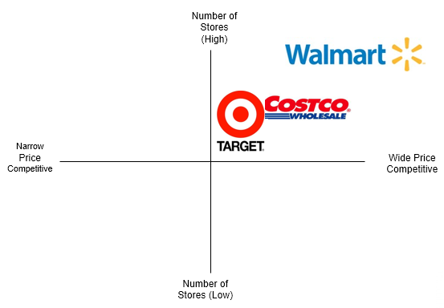


Adapted from (Kalafatis, 2000)
The Internet has assisted Walmart in the development of the business and has proved a great asset when reducing costs for the organisation. CEO Judith McKenna has admitted, ‘through innovation, we're creating a seamless experience to let customers shop anytime and anywhere online, through mobile devices and in stores. We are creating opportunities and bringing value to customers and communities around the globe.’ (Walmart, 2019). Walmart is a prime example of a business who recognises and appreciates the collective benefits of utilising online platforms.

  - What is Strategic Formulation Framework (SFF)?
Before we begin to explore the meaning of SFF, let us primary evaluate the essence of strategy itself. In their book, ‘Exploring Corporate Strategy’, Johnson and Scholes explain strategy as, ‘the direction and scope of an organisation over the long-term: which achieves advantage for the organisation through its configuration of resources within a changing environment to meet the needs of markets and to fulfil stakeholder expectations.’ (Johnson and Scholes, 1999) This elucidation is useful in demonstrating the effect of a company’s resources due to a volatile market. However, this classification has been somewhat criticised whereby other theorists believe it is not all dependant on the external environment but, ‘strategy can be articulated based on understanding of internal resources, capabilities and competencies, and access to external resources etc., which can be harnessed as sources of competitive advantage’. (Porter, 1980)
This is where SFF can be both invaluable and dynamic to businesses whereby the implementation of each matrix provides a framework to permit a better understanding of internal capabilities and the external environment. One definition to which I am a particular enthusiast, describes the essence of E-Business as, ‘the deployment of enterprise resources to capitalise on technologies for reaching specified objectives that ultimately improve performance and create sustainable competitive advantage.’ (Johnson and Scholes, 1999) Perhaps SFF is key to sustaining this sustainable competitive edge whereby ‘changing needs and new technologies come together to revolutionize the way in which business is conducted.’ (Chaffey, 2011)

- Main Findings

  - SWOT Opportunities and Threats
To achieve a positive strategic plan, an organisation must conduct a SWOT analysis on a continuous basis’. (Pearce and Robinson, 2013)

Opportunities | Threats
Enhancing sustainability considerations- ‘Walmart’s “Community Matters” campaign continues to generate good word of mouth publicity’. (Walmart, 2019)  Rich company heritage and links- John Lewis, owner of Waitrose is another ‘customer experience champion’. (Bader, 2018)  Advancements in online shopping- ‘ensures business growth and adaption to stay competitive in today’s rapidly changing environment’. (Porter, 1980)  Store extension plans and launch of Flipkart- Introduction into Indian market. - ‘Flipkart reported the market value of its sales in 2017 at $7.5 billion, with revenue of $4.6 billion, representing 50% growth.’ (Bhattacharyya, 2018)  Royal Warrant allows the company to source food, spirits and wine to Queen Elizabeth II.  Customer feedback- ‘The brand has kept track of all visitor feedback, an important element of a winning strategy and has used their comments to further enhance its performance.’ (Archer, 2016)  Expected increase in retail sales after a ‘flat’ end of 2018- ‘Sales volumes and orders expected to rise in the year to February.’ (CBI Press Team, 2019) | Increasing competition from ecommerce organisations, for example, strong competition from Amazon.  Closure of underperforming stores and cut back of staff and managers- ‘The supermarket chain is planning to cut five under-performing sites, which would see 498 staff facing redundancy consultation’. (Baird, 2015)  Barriers to entry in Indian market. – Laws and regulations of country.  Competition from Tesco- ‘As Tesco has brought down prices, Waitrose has been forced to follow, contributing to a 1% fall in sales at established stores in the half-year to July.’ (Stern, 2018)  Heavy reliance on IS systems- ‘Data breaches and other criminal activity can quickly negate any positive growth that you hope to achieve this year’. (Anon., 2018)

  - Competitive Profile Matrix
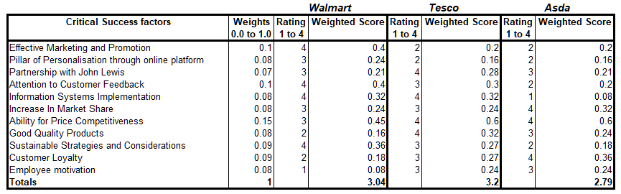
‘A CPM classifies a firm’s major competitors and its meticulous strengths and weaknesses in relation to an illustration firm’s strategic point.’ (Chaffey, 2011)

It is clear to see one substantial variance from Walmart’s current CPM compared to 2009. (Appendix 1). I felt it best to investigate this organisation in contradiction of Tesco and Aldi, purely because the recent increase in low cost stores has seen more price competition coming from these businesses.
This factor offers an elucidation as to why I have weighted price competitiveness at 0.15 I believe this to be key for Walmart’s sustained competitive advantage in face of budding competition. Price competitiveness was formerly seen as a major strength to the business, but I would argue the rise in close competition has noticeably had an effect on Walmart’s capabilities in this respect. (Baird, 2015) Resultantly, if Walmart was to sacrifice its entry to the mid/upper income market and place emphasis on maintaining low prices, this would reinforce the overall company mission and provide a stronger basis in which to maintain their market share. This option demonstrates a huge benefit of a CPM matrix where by comparing all competitors on one page, this helps to clearly analyse an individual company’s relative strengths and weaknesses to provide a basis for effective strategy formation. However, the usefulness of a CPM has been questioned. Perhaps this matrix is of limited use ‘because of its subjective selection and assessment of critical success factors and the lack of robustness in calculation in terms of assigning weights and ranks’. (Hanks, 2016)

  - External Factor Evaluation Matrix
An EFE is, ‘a well-known strategic tool has been used for the evaluation of external environment of a firm.’ (Finance and Business, 2018)
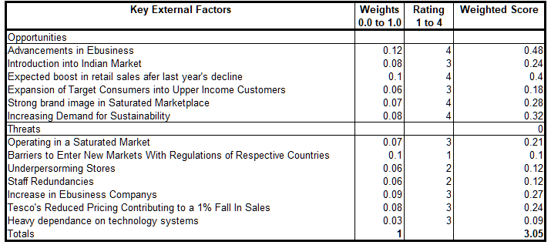
Contradictory to 2009, (Appendix 2), early 2019 saw a decline in retail sales. ‘A survey of 103 firms, of which 42 are retailers, showed that sales volumes for the retail sector stabilised, following a decline in the previous month’. (Rossollio, 2019) I have weighted an expected boost in sales at 0.1 because where currently, competitive pricing should be a focus for Walmart, this opportunity could subsequently enhance the entry into upper income customers to not only increase Walmart’s target audience, but also further strengthen the overall market share.
Another highly weighted opportunity is advancements in ebusiness. I have increased the weight score from 2009 as 0.12. The ability to, ‘increase an organisations perception on environmental shifts’, acts as a salient benefit to this matrix. (Jurevicius, 2013) In relation to the view of (Porter, 1980), Walmart can continue to utilise IT as a “weapon” to influence competitive forces in the market.
One aspect not present in 2009, was the regulations of respective countries. This is the heaviest weighting as Walmart currently faces huge reprisal for its introduction into Indian markets through its Flipkart venture. ‘Confederation of All India Traders filed a petition with the CCI on 28th May 2018 for the alleged violations done by Flipkart under Indian laws’, (Lyrer, 2018)
Although this tool has proven useful in the elucidations of the macro environment, we must take some time to recognise the potential limitations of the tool. Like that of other matrixes, perhaps using the empirical values to analyse an extensive viewpoint acts as a weakness in the determination of a strategy whereby the outputs created are formed on simplifications and over-generalisations. For this reason, Walmart must look into its internal strengths and weaknesses in correlation with these findings.

  - SWOT Strengths and Weaknesses

Strengths | Weaknesses
Acting as the largest company by revenue and the largest retailer in the world with unmatched scale of operations.  Strong market power over suppliers and competitors.  ‘Technologically advanced information system for order tracking, inventory, customer relationship management and sales that can be tracked in real time for better decision making and more efficient supply chain management’. (Efron, 2019)  Established brand image that is recognised on a global scale.  ‘Walmart stock jumped to its highest level in 2019 after the retailer's holiday quarter results topped expectations’. (Bhattacharyya, 2018)  ‘Over the last 12 months the supermarket has made significant improvements to its everyday strategies, enabling it to rise from 10th position to number seven in the UK Customer Experience Excellence rankings’. (Efron, 2019)  Customer experience and use of personalisation thorough the Walmart website. | Employee dissatisfaction- ‘numerous lawsuits related to its treatment of employees, including discrimination, unequal wages, unfair promotions, unpaid overtime, poor benefits and poor work environments’. (Anon., 2017)  ‘The company has high employee turnover and a lack of motivation among existing employees due to this lack of social responsibility towards its workers’. (Anon., 2017)  Some inferior quality goods and products making it difficult to compete in saturated market. – poor reflection of brand image.  Dependence on use of IT systems.  Lack of differentiation between other retail stores. Undifferentiated products.

  - Internal Factor Evaluation Matrix
‘IFE is used to examine the strengths and weaknesses in the functional area of a business’. (Hanks, 2016)
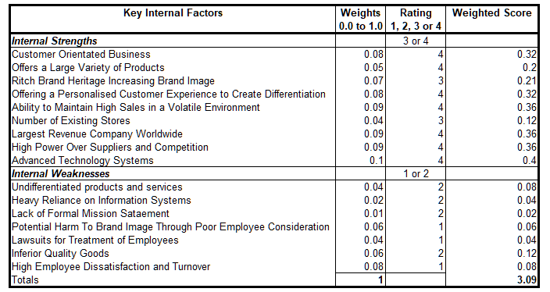
Walmart’s financial positioning has progressed since 2009, (Appendix 3). ‘The world’s largest retailer reported better-than-expected holiday quarter sales and profit and kept its outlook for the year.’ (Stern, 2018). (Prahalad and Hamel, 1990) reveal ‘sustainable competitive advantage is based on distinctive capabilities, which cannot easily be replicated by competitors.’ Resultantly the use of personalisation through Walmart’s online platforms and its ability to unswervingly offer low prices should remain a motivation and will consequently persist as such highly weighted internal strengths.

Since 2009, IS systems have progressed. In connotations to Ward and Peppard’s theory, Waitrose has gone beyond simply recognising what technology has to offer and instead has, ‘developed IS capabilities or competencies through a focus on the ways they manage and use IS, learning explicit lessons from its success and failure’. (Ward and Peppard, 2002) In an era of rapid technological change and resultant unpredictability, sustainable competitive advantage is no longer rooted in positioning, but depends more on organisational resources and skills’. (Prahalad and Hamel, 1990)
Employee dissatisfaction was not present in the 2009 IFE and yet is the heaviest weighting currently at 0.08. A past employee from Walmart has since revealed, ‘the management of their store tended to be "scared to death" of those above them in the corporate chain of command.’ (Hagel, 1999) suggest that the formation of a demand driven network is accomplished via the fulfilment of the community’s common needs. I would therefore argue that employees play a huge factor in a corporate strategy and therefore Walmart should perhaps reintegrate training procedures to a form an organisation based on effective leadership and teamwork.

Although this is a clear area of improvement for Walmart, one area of weakness of SFF could play a potentially hazardous role in Walmart’s progression. ‘The greatest failures of strategic management have occurred when managers took one point too seriously.’ (Mintzberg, 2008)

  - Space Matrix
This matrix ‘specifies whether aggressive, defensive competitive or conservative strategies are most suitable for a given organization, company or business.’ (Finance and Business, 2018)
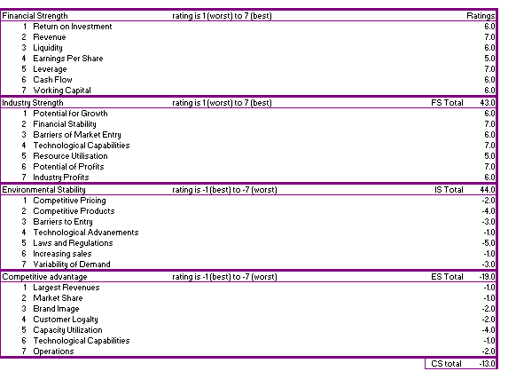
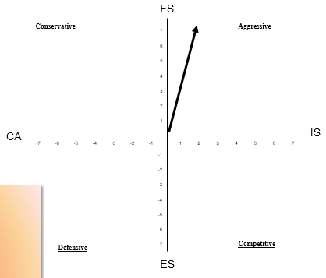

Likewise, to 2009, Walmart's directional vector is situated in the upper-right quadrant of the matrix, demonstrating an aggressive strategy. This visually expresses the organisation’s ‘outstanding current capability to utilize its Internal Strengths to surmount internal weaknesses, obtain the advantage of external opportunities, and evade external threats.’ (Johnson and Scholes, 1999) This portrays the consistency of Walmart’s positioning within the market it operates and due to strong strategies in place, the SPACE matrix does not diverge too far from that of 2009.
However, limitations of this matrix must be considered. It has been suggested that implementing a strategy based purely on binary logic can be somewhat risky. ‘In conventional dual logic, we have to place issues in two categories. For instance, in strategic planning, a strategic action is either aggressive or no aggressive – and nothing in between.’ (Simister, 2011)

2.8 Grand strategy Matrix
This Matrix is a, ‘four quadrant matrix in which all organisations can be positioned in such a way that identification and selection of appropriate strategy becomes an easy task.’ (Ingram, 2016)
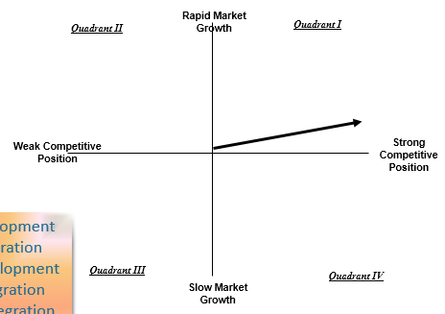

As a “prospector type” organisation, Walmart’s position since 2009 has displayed an increase of market growth. (Pearce and Robinson, 2013) The introduction into Asian markets has proved fruitful for the organisation however its resilience to the entry of Indian markets should be a current priority for Walmart. It also seems IS has played a significant part in this outcome where ‘the mix of new customers in online grocery is positive and encouraging’… ‘Those who shop both in store and online spend twice as much in total and spend more in stores.’ (Walmart, 2019). However, (Finnegan, 2008) recognises the, ‘complex and dynamic relationships between IOS and internal systems.’ Therefore, comparable to a SPACE matrix, this visual representation is extremely general due to its oversimplifications. For this reason, Walmart must ensure to evaluate other matrix to provide a richer understanding to its market positioning.

  - Internal External Matrix
IFE 3.09

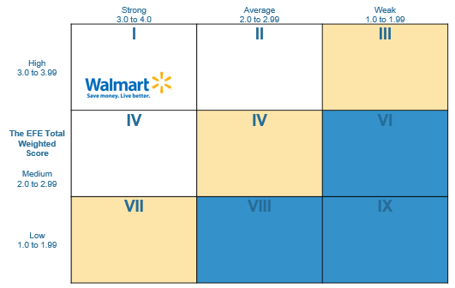
EFE 3.05

From looking comparatively to (Appendix 6), it seems Walmart’s positioning has stayed relatively consistent. The company remains in the intensive and integrative stage and hence, as previously identified, organisational growth is essential for development. The introduction to Asian market has proved a success for Walmart and for this reason, I would argue the entry into the Indian market could at to further develop Walmart.

  - Quantitative Strategic Planning Matrix
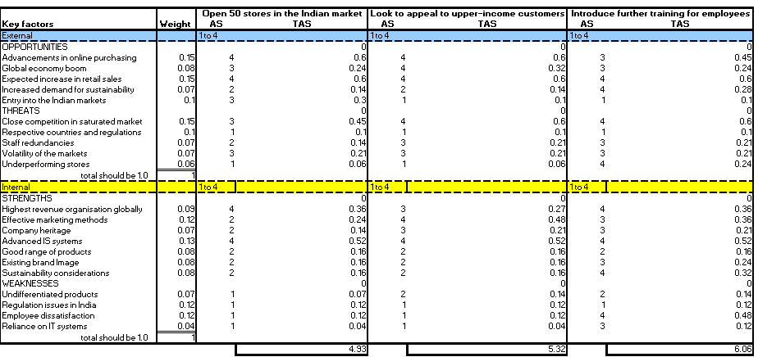
This tool is used to, ‘evaluate an alternative set of strategies’. (Ingram, 2016) It is particularly useful when calculating the score of multiple strategies to determine the best match strategy for the organisation.

One key difference to 2009, (Appendix 7), is the alterations of the strategy. Rather than focusing on the entry into Asian markets, a current QSPM focusses on the introduction to the Indian market where there are plans to, ‘continue to grow its wholesale cash and carry business, adding 50 new stores in the next four-five years’. (Lyrer, 2018)
In 2009, Walmart’s range of products were seen as the largest organisational strength, however, since then, competition has intensified which is why I believe their key strength is no longer their product range, as much as personalised customer experience and price competitiveness.
From this QSPM, it seems the training of employees would seem the best strategy for Walmart as to reengage staff and boost morale. In connotations to (Schoemaker, 1995), ‘Scenario planning is a further elaboration of the resource-based view and is proposed especially for uncertain environments with intense competition’.

3.0 Conclusion
To conclude, it is clear to see how SFF has proven successful in the analysis of Walmart. Since 2009, I would argue that the company’s financial positioning has strengthened due to their consistent sales an effective marketing methods. A salient factor to this would also be their advancements of IT within the organisation which proves an enhanced customer service. To further progress, it seems that the most beneficial strategy for Walmart would be investing into staff training and team leadership sessions to reengage employees and provide an overall higher quality to both Walmart’s performance and enhance customers experience as a whole.

References
Anon., 2017. Internal-External (IE) Matrix. [Online]
Available at: http://www.maxi-pedia.com/internal+external+IE+matrix
[Accessed 20 March 2019].
Anon., 2017. Walmart SWOT Analysis. Business Teacher.
Anon., 2018. 3 Ways Cyber Threats and Business Security Will Change in 2019. The Receptionist.
Archer, D., 2016. How Focusing on Customer Feedback Improves Walmart’s Outlook. The customer knowledge blog.
Bader, M., 2018. Strategic Analysis of the John Lewis Partnership Plc. s.l.:s.n.
Baird, N., 2015. Walmart's Struggle Isn't About E-Commerce, It's About Price. Forbes.
Bhattacharyya, S., 2018. Inside Walmart’s e-commerce growth. Digital UK.
CBI Press Team, 2019. Retail sales flat at start of 2019, but growth expected. CBI.
Chaffey, D., 2011. E-Business and E-Commerce Management: Strategy, Implementation and Practice. 5th ed. s.l.:Prentice Hall.
Efron, L., 2019. Why Wal-Mart Is Winning In A Losing Industry. Forbes.
Finance and Business, 2018. SPACE Matrix Strategic Management Method. [Online]
Available at: http://www.maxi-pedia.com/SPACE+matrix+model+strategic+management+method
[Accessed 20 March 2019].
Finnegan, 2008. Data Equivalence in Cross-Cultural International Business Research: Assessment and Guidelines. Journal of International Business Studies, 36(6).
Hagel, J., 1999. Unbundling the Corporation. Harvard Business Review, Issue 4.
Hanks, G., 2016. The Disadvantages of CPM Estimation. Chron, II(1).
Ingram, D., 2016. Link Between the SWOT Matrix & the Grand Strategy Matrix. Chron.
Johnson and Scholes, 1999. Exploring Corporate Strategy. 5th ed. London: Prentice Hall.
Jurevicius, O., 2013. Competitive Profile Matrix (CPM). Strategic Management Insight.
Kalafatis, S., 2000. Positioning strategies in business markets. Journal of Business and Management.
Lyrer, K., 2018. Walmart to open 50 new stores in India in the next five years. ETRise.
Mintzberg, H., 2008. Strategy Safari: The complete guide through the wilds of strategic management. 2nd ed. s.l.:Prentice Hall.
Pearce and Robinson, 2013. Strategic Management. 13th ed. s.l.:McGraw-Hill Higher Education.
Porter, M., 1980. Competitive Strategy: Techniques for Analyzing Industries and Competitors. 1st ed. s.l.:The Free Press.
Prahalad and Hamel, 1990. The Core Competence of the Corporation. Harvard Business Review, 68(3).
Rossollio, N., 2019. What the Unexpected "Fall" in December Retail Sales Really Means. The Guardian.
Schoemaker, P., 1995. Scenario Planning: A Tool for Strategic Thinking. 2nd ed. s.l.:Sloan management review.
Simister, P., 2011. Competitive Advantage In The SPACE Matrix. Differentiate Your Business.
Stambor, Z., 2017. What is Walmart's Ecommerce Strategy?. Digital Commerce 360.
Stern, N., 2018. Walmart Crushes The Quarter With A Blueprint For Retail Success. Forbes, I(1).
Walmart, 2019. eCommerce. [Online]
Available at: https://corporate.walmart.com/galleries/ecommerce
[Accessed 20 March 2019].
Walmart, 2019. Our History. [Online]
Available at: https://corporate.walmart.com/our-story/our-history
[Accessed 20 March 2019].
Ward and Peppard, 2002. Strategic Planning for Information Systems. 3rd ed. s.l.:Cranfield University.

Appendix

Appendix 1- 2009 CPM
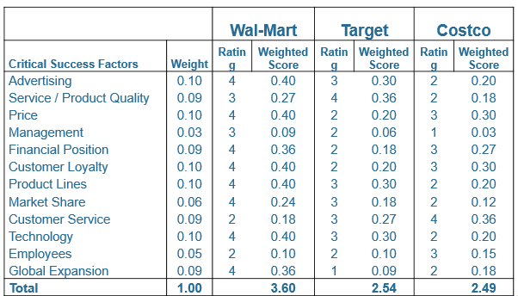

Appendix 2- 2009 EFE
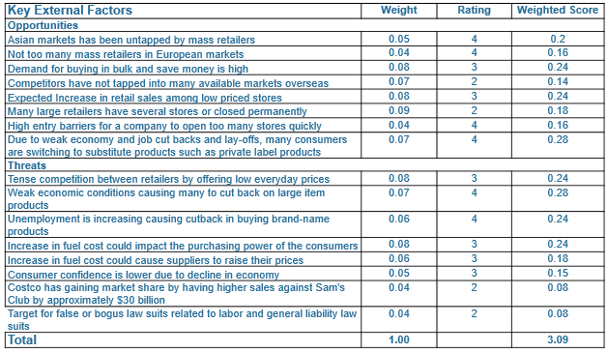

Appendix 3- 2009 IFE
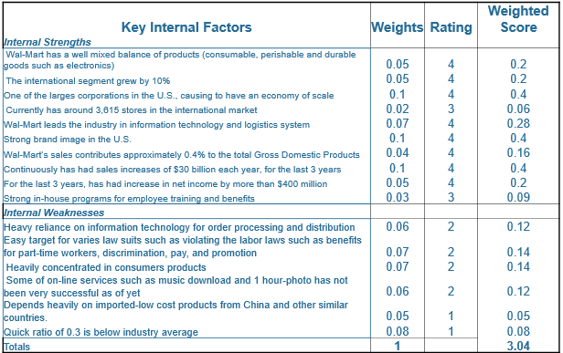

Appendix 4- 2009 SPACE Matrix
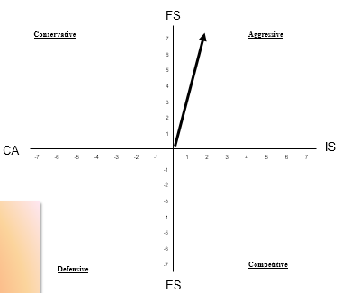

Appendix 5- 2009 GSM
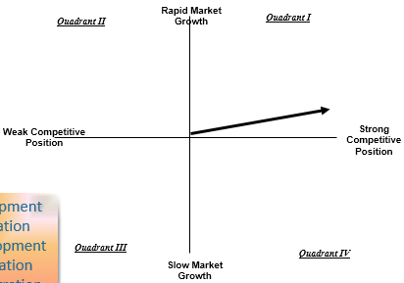

Appendix 6- 2009 IE Matrix
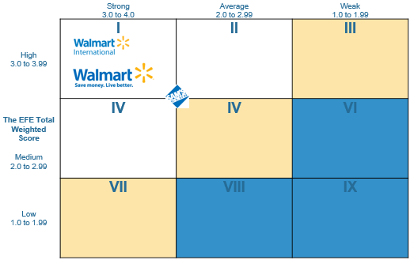

Appendix 7- 2009 QSPM


