Programme Improvement Project

Word Count: 2691

Introduction

Sexual health services play a critical role in promoting public health and addressing the needs of individuals in a highly sensitive and specialised area of care (Mitchell et al 2021). The current working definition of sexual health is:

“...a state of physical, emotional, mental and social well-being in relation to sexuality; it is not merely the absence of disease, dysfunction or infirmity. Sexual health requires a positive and respectful approach to sexuality and sexual relationships, as well as the possibility of having pleasurable and safe sexual experiences, free of coercion, discrimination and violence. For sexual health to be attained and maintained, the sexual rights of all persons must be respected, protected and fulfilled.” (WHO 2025).
Good population health is dependent upon good sexual health, which has long been recognised in the UK. The introduction of the Venereal Disease Act in 1917, followed by the Venereal Disease Regulations (1974), established standards that services were expected to meet to ensure accessible and effective care.
Building on this, several publications, such as the National Institute for Health and Care Excellence (NICE) Sexual Health Quality Standard (2019) and the British Association for Sexual Health & HIV (BASHH) standards, set a 48-hour target for appointment wait times. However, this standard is frequently breached due to barriers in clinic access, making it difficult for patients to receive timely care (Foley 2001).

The sexual health service of Swansea Bay University Health Board (SBUHB) offers sexual health testing and treatment, contraception, HIV services, Gender care, counselling and a Pregnancy Advisory Service- all highly sensitive and essential areas of healthcare. Currently, within SBUHB, appointments can only be booked via telephone, which poses a barrier to clinic access. This system may disadvantage patients who are unable to call during working hours, have hearing or speech difficulties, or experience anxiety around phone calls. Additionally, long wait times and engaged lines can further hinder access to appointments.

In particular young people disproportionately face difficulties due to transport issues or concerns around confidentiality (Lim et al 2022). It is this portion of the population, along with ethnic minorities and men who have sex with men (MSM) who are also impacted most by sexually transmitted infections (STI’s) (Office for Health Improvement and Disparities (OHID) 2022). The Public Health Wales (PHW) annual report for 2024 shows a substantial increase in infections such as gonorrhoea and syphilis, as well as a 39% increase in termination of pregnancy. These figures, coupled with the goals of the HIV Action Plan (WAG 2023) to eliminate HIV by 2030, are a driving force to improve services.

Public Health Wales (PHW) published a review of sexual health in Wales (PHW 2018). One of the findings from a patient survey conducted as part of the review was that patients would prefer a variety of means to book appointments. This is supported by the NHS Plan (2000) that suggested innovative IT systems be employed, as well as BASHH standards that advise services ‘consider’ online portals (BASHH 2019).
Therefore, a project to introduce an online booking system whereby patients are able to self-register and book appointments, has been suggested and discussed within the SBUHB sexual health workplace.
The project aims to enhance patient access, efficiency, and service delivery. By reducing reliance on telephone-only booking, the system will provide a 24 hour, 7 day a week alternative. This is anticipated to improve appointment availability and patient experience.
This change will lead to improved access by removing barriers caused by limited phone line hours, reducing staff workload by lowering call volumes, and decreasing waiting times to help meet the 48-hour appointment target, as seen in a similar project implemented by Foley (2001). Patients will gain the ability to book appointments at their convenience, leading to higher attendance rates. The system will also be fully auditable, allowing the reporting of data to ensure compliance with standards. This project will ensure that sexual health services can improve efficiency, enhance patient satisfaction, and ensure more equitable access to care.
Methods
To ensure that this change in service is effective, the Plan- Do- Study- Act (PDSA) framework (Deming 1983) will be utilised whilst following the digital standards set by the Welsh Assembly Government (WAG) (2022) and the Data Protection Act (1998).
PDSA cycles provide a method for evaluating and adapting interventions to improve workflow and clinical outcomes (Christoff 2018). The cyclical nature of the framework allows for small changes to be implemented so that we can learn from errors or faults before implementing on a larger scale (Christoff 2018). The PDSA framework is the most commonly used change management framework in healthcare (Varkey et al 2007), and when all components are documented, significant improvements in care and outcomes have been reported. Small incremental changes are more likely to produce effective outcomes (Donnelly & Kirk 2015).

Figure 1. ‘The PDSA Cycle’ (Deming 1986)
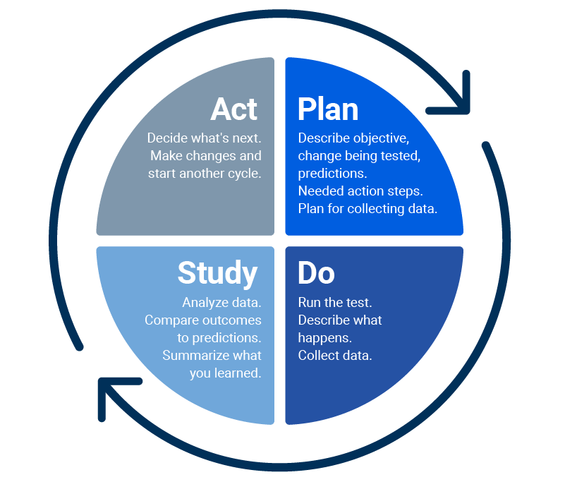

The planning phase is vital in order to lay a solid foundation on which to implement any change. The primary goals of this project are to improve accessibility, reduce waiting times, ensure confidentiality and enhance both patient and staff satisfaction.
The identification of stakeholders is crucial to understand their views, assess the influence and any resources that they may bring to the project (Rosenfeld & Wyer 2017). Early stakeholder involvement in the project allows the project manager to provide clarity on intended changes. This will help to overcome any barriers to implementation, by addressing any issues immediately (Rosenfeld & Wyer 2017). For this project, a framework such as Mendelow’s Matrix (1991) could be used to identify those that a. has power to influence strategies or resources, and b. who has a particular interest in the success of the project.
Figure 2: ‘Power/Interest Matrix’ (Mendelow 1991)
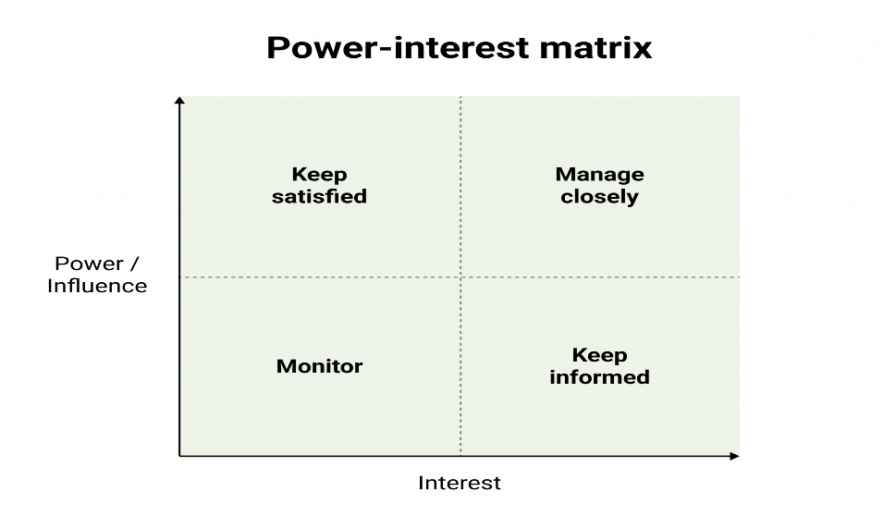
A framework such as this will help to identify who the stakeholders are, what their ‘stake’ or interest is in the project and what communication is required between the project manager and stakeholders. The prediction is that patients are likely to prioritise ease of use and confidentiality, whereas staff may focus on integration with existing technology and efficient appointment management. In addition, benchmarking of other services that already use online booking systems will allow for this project to avoid any difficulties that other services encountered.
Failure to involve key stakeholders in any changes can leave people feeling excluded and powerless (Crowfoot & Prasad 2017), whereas using a structured approach can ensure better delivery of healthcare and develop team work and leadership skills (Crowfoot & Prasad 2017).
One infamous example of poor change management is the UK’s National Programme for IT (NPfIT) which launched in 2002. The programme aimed to digitalise healthcare in England. However, due to its ‘top down’ approach and poor collaboration with local organisations and key stakeholders, organisations became distrustful and resistant to change (Justinia 2017). The programme was dismantled in 2011, and the cause of the failure has been studied at length.
As this example demonstrates, digital transformation involves challenges. Studies show that 66% to 84% of digital projects fail (Libert, Beck & Wind 2016), a significant proportion given the associated time and cost implications. One major challenge is to create consistency between the project plan, and the project implementation (Correani et al 2020).
Patients are key stakeholders in any project implemented by NHS organisations and must be kept informed. Their views and feedback should be taken into consideration when making any adaptations. With regards to staff, a multidisciplinary approach is the most effective strategy for this project, as it allows for inter-professional education and collaboration plus immediate decision making and problem-solving (Prybutok 2018). Involving the people who will be using the system most often, for example, clerical staff, nurse, and doctors will ensure that they are kept informed throughout, and appropriately trained. Additionally, it is necessary to ensure compliance with the Health Board’s policies and procedures. Fulfilling requirements such as data protection impact assessments (DPIA’s) will ensure compliance with the Data Protection Act (1998) by identifying and minimising data protection risks (Information Commissioner’s Office (ICO) 2025). Liaison with the Health Board’s IT department is critical for this to ensure compliance.
Prior to the start of this project, an analysis of the current electronic patient record (EPR) system in SBUHB was carried out (Williams 2025) and identified several challenges, which can help inform this project. A key issue highlighted was the inadequate staff training provided before the implementation of the technology. A detailed plan of how training will be carried out is necessary to avoid a known risk. The analysis of the EPR system recommended a ‘train the trainer’ model, making it a valuable approach for this project as well. Implementing a ‘train the trainer’ model would provide a time-efficient and sustainable approach to training the rest of the team (Nexo et al 2024), ensuring that there is a trainer available throughout the implementation process.
Engaging staff members who are motivated by the idea of the project as trainers can help resolve any resistance to change within the team. Resistance happens when the change is not understood, the change is imposed, the change is incompatible with the existing environment, the perceived costs outweigh the benefits, or if there is no well-defined purpose (Van de Ven and Hargrave 2004). Utilising tools such as the PDSA cycle can support change management to minimise the impact to staff (Geada 2020).
The next step in the planning process is the implementation of the new online booking system. A key consideration is ensuring integration with the existing bespoke software currently used within SBUHB sexual health services. At present, SBUHB relies on ‘MillCare,’ but since the company behind this software has gone into liquidation, it is anticipated that MillCare will soon be replaced by an ‘All Wales’ system. This will eventually standardise electronic records in sexual health across Wales.
With this in mind, the online booking system must be scalable and adaptable. It is essential that the system can function with the current software but also allow for data migration when the new national system is introduced.
Integrating the online booking system with the current software will streamline service delivery. If the systems were unable to communicate, staff would need to manually transfer data, leading to increased workload, and a higher risk of errors. Additionally, maintaining multiple different systems would come with significant cost implications, including software licensing and maintenance (Altaf 2022). Prioritising integration will not only improve workflow, but also contribute to cost-effectiveness and long-term sustainability. By preparing for the ‘All Wales’ system, potential challenges are mitigated and the long-term future of the system we are introducing will be ensured.
In the ‘do’ phase of the PDSA cycle, since this project introduces a new system rather than replacing an existing one, implementation can proceed without causing any service downtime. To promote awareness and accessibility, a link to the online booking system will be added to the sexual health webpage. In addition, the communications team will be contacted to advertise the new system on social media, with the hopes of reaching many patients.
Clerical staff will continue to be available to answer the telephone, ensuring that patients who are unaware of the new system or prefer traditional booking methods are still supported. The need for different booking methods is reinforced by a recent study which found that a variety of booking methods should be available to support those with inequalities, such as poor digital literacy or those from a lower socio-economic background who may not have access to technology (McLeod et al 2025). It was also recommended to consider additional interventions such as ‘text to speech’ or animations (McLeod et al 2005) which could be introduced in future.
The trial phase of the project will only allow patients to book a triage appointment. This will ensure that patients are not booked into inappropriate appointments. During this phase, a nurse will telephone the patients to assess their needs and schedule an appropriate appointment. If this initial stage proves successful, the process will be refined further by implementing a structured flowchart for ‘e-triage’. This flowchart will consist of mandatory questions, enabling the patients to be booked into an appointment with the most suitable healthcare professional based on their specific complaint. Similarly, a sexual health e-triage system was introduced in Chelsea & Westminster NHS Foundation Trust in 2006. A study of the service found that the triage was composed of questions that could extract accurate data and triage patients safely. In addition, the majority of patients liked the system (Jones, Menon-Johansson and Sullivan 2006). As digital transformation progresses, there is a possible role for artificial intelligence (AI) to assist e-triage in the future, as it is estimated to improve business productivity by 40% (Paul et al 2024). However, more research is required on the scope and safety of AI in healthcare (Paul et al 2024).
To support staff during this transition, designated ‘trainers’ and the project manager will be available to troubleshoot issues and provide assistance. Continuous monitoring will be in place, with regular opportunities for both staff and patients to provide feedback. Patients will receive a follow-up text message after their appointment, including a link to a feedback form to assess their experience and identify potential areas for improvement. This structured approach ensures that the system is functional, user-friendly, and adaptable to the needs of both patients and staff.
The project will be introduced for a one week trial period initially, followed by a meeting of stakeholders to discuss any challenges that have arisen and any changes required.

In the study phase of the PDSA cycle it would be appropriate to utilise a reputable framework to analyse the trial phase of the project. A framework such as the ‘FITT framework’ (Ammenwerth et al 2006) would be useful to analyse the fit between the qualities of the individual (staff and patients), for example, the digital literacy and motivation to use technology, the qualities of the system, for example, the usability, and the qualities of the clinical task, for example, the workflow and organisational processes (Ammenwerth et al 2006). When challenges are identified, adjustments can be made, resulting in a better ‘fit’ (Noblin et al 2017). In the last phase of the PDSA cycle, the themes from the data analysed will highlight any areas that need improvement (Tsiknakis & Kouroubali 2009) to allow for adoption of the project (Christoff 2018) and possible development of e-triage.

Figure 3. ‘The FITT framework’ (Fit between individuals, task and technology) (Ammenworth et al 2006).

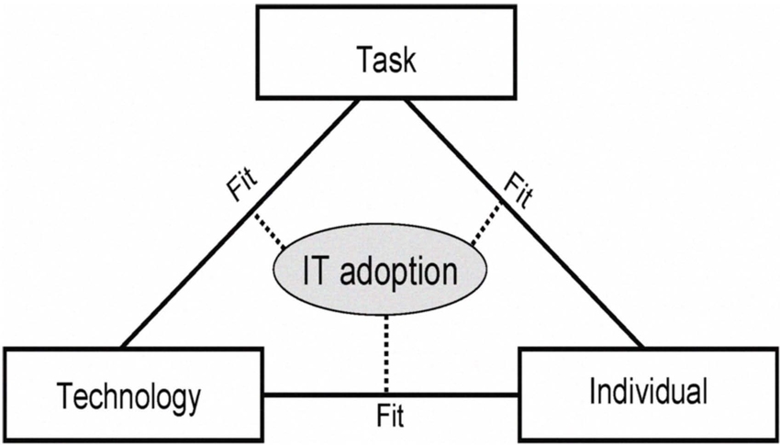

Discussion
The introduction of an online booking system for sexual health services at SBUHB is a significant step toward improving accessibility, efficiency, and patient satisfaction. Given the rising rates of STIs and increasing demand for services, innovations and digital solutions are essential to meet public health needs and national standards. The online booking system will alleviate pressure on clerical staff by reducing the telephone traffic, and address existing barriers to accessing the service. It will also contribute to achieving the 48-hour appointment target set by NICE (2019).
However, the introduction of any digital system in healthcare is complex. It requires careful planning, stakeholder engagement, and adherence to national standards, legislation and Health Board policies. Utilising the PDSA framework (Deming 1983) will ensure continuous evaluation of the system, minimising risks associated with implementation. Lessons from previous failed and successful IT projects highlight the importance of multidisciplinary collaboration and structured change management to avoid resistance from staff and ensure success.
A phased trial of the system will provide valuable insights into usability and effectiveness. Regular feedback from patients and staff will allow for adjustments, and frameworks such as the FITT framework (Ammenwerth et al 2006) will help to assess the project fully. While the implementation of digital technology can be challenging, the potential long-term benefits of enhanced efficiency, improved patient experiences, and better resource management justify the investment.
Overall, this project aligns with national digital health strategies and will future-proof sexual health services as healthcare demands evolve. By ensuring scalability and integration with upcoming systems, SBUHB can create a sustainable system that is high-quality and patient-centred.
I confirm this essay is my own original work and does not include text created by a generative artificial intelligence tool.

References
Altaf, Y (2022) “What is system integration and how can it help with digital transformation?” Entrepreneur. Available at: The Critical Role of System Integration In Digital Transformation | Entrepreneur accessed on: 8.2.25
Ammenwerth, E., Iller, C. and Mahler, C. (2006) “IT-adoption and the interaction of task, technology and individuals: a fit framework and a case study,” BMC Medical Informatics and Decision Making, 6(1), p. 3. Available at: https://doi.org/10.1186/1472-6947-6-3.
British Association for Sexual Health and HIV (BASHH) (2019) Standards for the management of sexually transmitted infections. Available at: Standards for the Management of STIs | BASHH accessed on 31.1.25
Christoff, P. (2018) “Running PDSA cycles,” Current Problems in Pediatric and Adolescent Health Care, 48(8), pp. 198–201. Available at: https://doi.org/10.1016/j.cppeds.2018.08.006.
Correani, A. et al. (2020) “Implementing a Digital Strategy: Learning from the Experience of Three Digital Transformation Projects,” California Management Review, 62(4), pp. 37–56. Available at: https://doi.org/10.1177/0008125620934864.
Crowfoot, D. and Prasad, V. (2017) “Using the plan–do–study–act (PDSA) cycle to make change in general practice,” InnovAiT: Education and inspiration for general practice, 10(7), pp. 425–430. Available at: https://doi.org/10.1177/1755738017704472.
Deming, E (1983) “Out of the crisis,” Massachusetts Institute of Technology Centre for Advanced Engineering Study xiii: Cambridge, MA
Donnelly, P. and Kirk, P. (2015) “Use the PDSA model for effective change management,” Education for Primary Care, 26(4), pp. 279–281. Available at: https://doi.org/10.1080/14739879.2015.11494356.
Foley, E. (2001) “Access to genitourinary medicine clinics in the United Kingdom,” Sexually Transmitted Infections, 77(1), pp. 12–14. Available at: https://doi.org/10.1136/sti.77.1.12.

Geada, N. (2020) “Change Management in the Digital Economy,” International Journal of Innovation in the Digital Economy, 11(3), pp. 37–51. Available at: https://doi.org/10.4018/IJIDE.2020070103.

Information Commissioner’s Office (ICO) (2025) “What is a DPIA?” Available at: What is a DPIA? | ICO accessed on: 8.2.25

Jones, R. et al. (2010) “eTriage – a novel, web-based triage and booking service: enabling timely access to sexual health clinics,” International Journal of STD & AIDS, 21(1), pp. 30–33. Available at: https://doi.org/10.1258/ijsa.2008.008466.

Justinia, T. (2017) “The UK’s National Programme for IT: Why was it dismantled?,” Health Services Management Research, 30(1), pp. 2–9. Available at: https://doi.org/10.1177/0951484816662492.

Libert, B.; Beck, M.; Wind, Y. (2016) “How to navigate digital transformation.”
Available at: How to Navigate a Digital Transformation accessed on 2.2.25

Lim, A.C. et al. (2022) “Changes in the time of COVID-19: a quality improvement initiative to maintain services at a youth sexual health clinic,” Sexually Transmitted Infections, 98(7), pp. 525–527. Available at: https://doi.org/10.1136/sextrans-2021-055265.

McLeod, J. et al. (2025) “Opening the digital doorway to sexual healthcare: Recommendations from a behaviour change wheel analysis of barriers and facilitators to seeking online sexual health information and support among underserved populations,” PLOS ONE, 20(1), p. e0315049. Available at: https://doi.org/10.1371/journal.pone.0315049.

Mendelow, A.L (1991) “Environmental scanning: The impact of the stakeholder concept. Proceedings from the second international conference of information systems”. P.407-418. Cambridge, MA
Mitchell, K.R. et al. (2021) “What is sexual wellbeing and why does it matter for public health?,” The Lancet Public Health, 6(8), pp. e608–e613. Available at: https://doi.org/10.1016/S2468-2667(21)00099-2.

National Institute for Health and Care Excellence (NICE) (2019) Sexual Health Quality Standard (QS178) Available at: Overview | Sexual health | Quality standards | NICE accessed on: 31.1.25

Nexø, M.A. et al. (2024) “The impact of train-the-trainer programs on the continued professional development of nurses: a systematic review,” BMC Medical Education, 24(1), p. 30. Available at: https://doi.org/10.1186/s12909-023-04998-4.

Noblin, A. et al. (2017) “Exploring physical therapists’ perceptions of mobile application usage utilizing the FITT framework,” Informatics for Health and Social Care, 42(2), pp. 180–193. Available at: https://doi.org/10.1080/17538157.2016.1178118.

Office for Health Improvement and Disparities (OHID) (2022) “Sexual and Reproductive Health and HIV: applying all our health”. Available at: Sexual and reproductive health and HIV: applying All Our Health - GOV.UK accessed on 5.2.25

Paul, J. et al. (2024) “Digital transformation: A multidisciplinary perspective and future research agenda,” International Journal of Consumer Studies, 48(2). Available at: https://doi.org/10.1111/ijcs.13015.
Prybutok, G.L. (2018) “Ninety to Nothing: a PDSA quality improvement project,” International Journal of Health Care Quality Assurance, 31(4), pp. 361–372. Available at: https://doi.org/10.1108/IJHCQA-06-2017-0093.

Public Health Wales (PHW) (2018) “Sexual Health Review 2017/2018: A review of sexual health in Wales”. Available at: A Review of Sexual Health in Wales - World Health Organization Collaborating Centre On Investment for Health and Well-being accessed on 5.2.25

Rosenfeld, R.M. and Wyer, P.C. (2018) “Stakeholder‐Driven Quality Improvement: A Compelling Force for Clinical Practice Guidelines,” Otolaryngology–Head and Neck Surgery, 158(1), pp. 16–20. Available at: https://doi.org/10.1177/0194599817735500

The Data Protection Act (2018) c.12
Available at: Data Protection Act 2018 (legislation.gov.uk) accessed 08.11.2024

The National Health Service (NHS) (2000) “The NHS plan. A plan for investment. A plan for reform”. London: Stationery Office

The National Health Service (Venereal Diseases) Regulations (1974) No.29 Available at: The National Health Service (Venereal Diseases) Regulations 1974
accessed on: 31.1.25

Tsiknakis, M. and Kouroubali, A. (2009) “Organizational factors affecting successful adoption of innovative eHealth services: A case study employing the FITT framework,” International Journal of Medical Informatics, 78(1), pp. 39–52. Available at: https://doi.org/10.1016/J.IJMEDINF.2008.07.001.

Van de Ven, A.H, Hargrave, T.J. (2004) “Social, technical and institutional change”. In ‘Handbook of Organisational Change and Innovation’. Pp.259-303. Academic Press.

Varkey, P., Reller, M.K. and Resar, R.K. (2007) “Basics of Quality Improvement in Health Care,” Mayo Clinic Proceedings, 82(6), pp. 735–739. Available at: https://doi.org/10.4065/82.6.735.

Venereal Disease Act (1917) (repealed November 1998)
Available at: http://www.legislation.gov.uk/ukpga/Geo5/7-8/21/content
accessed on: 20.01.25

Welsh Assembly Government (WAG) (2022) “Digital Service Standards.”
Available at: Digital Service Standards | GOV.WALES accessed on 2.2.25

Welsh Assembly Government (WAG) (2023) “HIV Action Plan for Wales 2023-2026”.
Available at: HIV action plan for Wales 2023 to 2026 | GOV.WALES accessed on 2.2.25

Williams, C (2025) “Sexual Health Software Application Assessment: Evaluating the Fit and Impact Using the FITT Framework” BMDS7009 Programme, Project and Change Management in Health and Social Care. University of Wales Trinity Saint David. Unpublished essay.

World Health Organisation (WHO) (2025) “Sexual Health and Wellbeing”. Available at: Sexual and Reproductive Health and Research (SRH) accessed on: 8.2.25

