
TechInnovate-people management and company performance
Recommendations
Roxana Meader (2222009) | 12/13/24 | BMSW5010_SWAN

Executive summary
This report has been compiled to give a clear image of the TechInnovate company’s present difficulties in acquiring and retaining staff. The report approaches the subject from a theoretical point of view and attempts to offer suggestions.
In the report there are discussed different theories and practices and an evaluation of the organisation HR and managerial performance.
Based on research the interpretation of the findings reveals that TechInnovate requires immediate improvement in HR practices and new training programs for all personnel, starting from managers to improve the performance management practices, conflict resolution and leadership, and continuing to all employees with coaching and mentoring on problems like diversity and inclusion, accountability, empowerment and communication.
The recruiting strategy had to be perfected and ensure retention, and the onboarding and training must facilitate motivation and higher levels of employee participation.
The organisation must work on promoting a positive and inclusive culture and create a safe workplace for all shareholders.

Contents

1.Executive summary 1
2. Introduction 3
3.Main findings 4-10
4.Conclusion 10-11
5. References 12-13

Introduction

This report has been requested by Rebecca Franci-Davies, the lecturer in charge of the learning module People Management (BMSW5010_SWAN).
The report has been compiled by Roxana Meader and is a summary of potential propositions designed to assist the company TechInnovate in creating more efficient and professional HR practices.
The research is based on secondary sources such as academic books and journals, that are supportive of the analysis carried out in the report.

Main findings
The present economic and business environment is shaped by the organisations that fuel the industry and the trade sectors. Small businesses and corporations ensure economic growth, social progress, diversity and opportunity in the employment market and technological advancements.
The studies based on organisational behavior are numerous and they are meant to present the tools necessary for the improvement of productivity and achievement of higher potential of the business.
In essence, it provides a clear image of:” people behavior, the process of management, the organisational context, processes and the execution of work and the interaction with the external environment” (Mullins,2002, p. 53).
Schneider’s theory implies that organisational profitability is centered on its people and their impact on the business environment, therefore the business must focus its strategies on attracting, selecting, employing and retaining people with similar values, interests, attributions and goals, to ensure organisational survival and growth. (Schneider, 1987).
There are several well-defined challenges that the organisation encounters and they will be referred to separately in this section. Any organisation growth and development rely on a well-defined strategy that will provide the tools necessary to align its resources, actions and goals with its vision, and anticipates the “long term direction of the organisation” (Johnson et al, 2017, pp 2-28).
Since its inception the term HRM referred to the management of people in report to work productivity and interactions. A recent definition or HRM defines it as “the management of employment” and it refers to the individual as well as the collective, the managerial or non-managerial parties, the entirety of policies and procedures necessary to provide the wellbeing of human resources and organisational prosperity. (Marchington, 2021, pp 83-84).
TechInnovate is founded on a close-knit start up culture, which doesn’t reinforce professional HR practices, nor does it provide a diverse and inclusive working environment. The necessity of implementing a more formal management and leadership approach to the human resource strategy is apparent.
According to Kotter management and leadership there are two interrelated, but distinguished notions in practice. While managers deal with planning, budgeting, controlling and problem solving, the leaders are the motivators of the employees, they create the vision and communicate it to the employees, and they empower them. Ideally those abilities should be embodied in any managerial candidate, however on an organisational level, the need for a team of employees with leadership skills is necessary. (Kotter,1998).
While the management term is relatively defined, there are several models that provide an interpretation for leadership.
Mullins argues that an efficient manager will address leadership differently in different ways and different situations (Mullins,2019, pp. 337-359) and although there is no perfect interpretation of the term, in practice a mixture of several approaches is usually utilized.
The quality and functional traits approaches are in essences referring to the leadership skills, assuming that they are either inherited or developed. The first approach is relatively inconsistent as advocates the importance of the traits as a set given from birth and not learned, and it can be subjective and not role focused. Carlyle’s great man theory is a relevant example of a trait approach, and it implies that certain individuals are born with leadership traits. The theory is outdated and biased and has been frequently criticized for its lack of scientific rigor and lack of reference to society and learning influences (Spector, 2016).
The following two are referring to the styles of leadership utilised in different situations.
John Adair believes that in terms of small teams, “people can be trained to become strategic leaders” (2007).

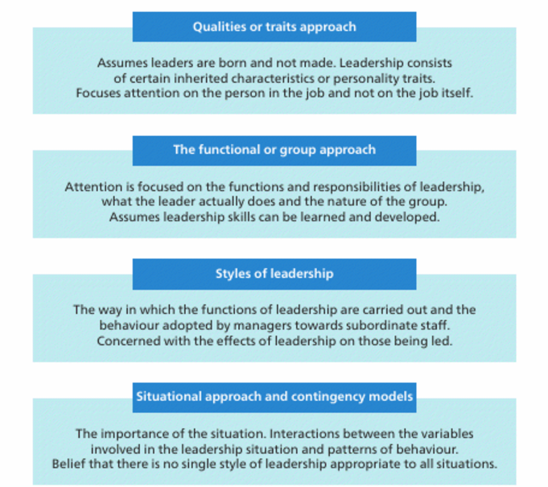
The following models underline the importance of the motivational and empowering factors that a leader can utilising to increase the overall team goals and productivity.
One of the theories that this model is based on is Vroom’s expectancy theory (1964) which states that “actions of an individual are driven by expected consequesnces”. While the theory offers valid insights into the effort, performance and reward dynamics, it lacks consideration for team motivation, practicability and cultural context. (Renko, Kroeck, & Bullough, 2012).
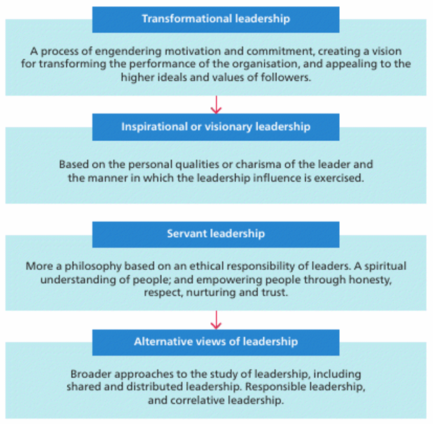
Over the past decade the interest in” alternative models of leadership in which leadership is not limited to the formally appointed leader, has grown” Fitzsimons, James, and Denyer, 2011). This allows the spread of managerial and leadership responsibilities and continuous improvement of the workforce potential.
TechInnovate requires an extensive strategy in terms of remodeling the leadership of the organisation.
The priority of the organisation is to establish the availability of the budget necessary for the improvement of the workforce. Strategic human resources “management practices are used for administrative and budgeting purposes and to enhance the business advantage” (Tokesky, Kornides, 1994).
As soon as the budget is allocated the HR will be responsible for designing and implementing a recruitment and training program. The entire process is based on correct assessments of the workforce already employed and of the skills and knowledge needed to be acquired. The assessments will provide a clear image of the current employee’s capabilities for the jobs and facilitate the integration and retention of new candidates that fit to the specific roles and duties. “The right matched employee, who received a comprehensive introduction to the role, is better equipped to succeed” (Burkholder, Edwards, & Sartain, 2004).
According to Armstrong recruiting is one of the most important strategical HR practices, and if the selection is done correctly, it will provide the organisation with a suitable skilled workforce (Armstrong, 2014, p 207). In present times most job advertising processes are online, and the candidates are selected from the job pool that is available. TechInnovate can advertise locally in Wales or nationwide, having the advantage that it can access talented professionals in the academic area proximity. The selection process aims to attract the candidates that are best suited for the job and the methods used are interviews and references. All recruitment and selection processes must abide by the Equality Act 2010.
Equally challenging as a HR practice is Retention. The engine of the organisation is comprised of long-term, experienced and trained employees. By investing in the present workforce that it possesses, TechInnovate guarantees an increase in staff motivation and productivity and by extension their commitment to the organisation. Studies reveal that employee empowerment, further training and benefits can lead to business performance and growth (Hood, 2022).
For the recruitment process to be viable and profitable, the organisation needs to implement robust onboarding and training practices. The new candidates must be efficiently inducted into the new roles and be given the opportunity to adapt and assimilate the culture and vision of the organisation. The transition into the new role must be supported by the entire team and further learning must be provided. By providing continuous training the organisation ensures the retention of staff in possession of advanced skills and the increase in employee engagement. The training methods vary from in-house training to outsources or advanced degrees (Claus, 2019).
An example of systematic training is the 70/20/10 Model that was created by McCall, Eichinger, and Lombardo in 1990 and used to create “effective learning and development programs” (Johnson, 2018).
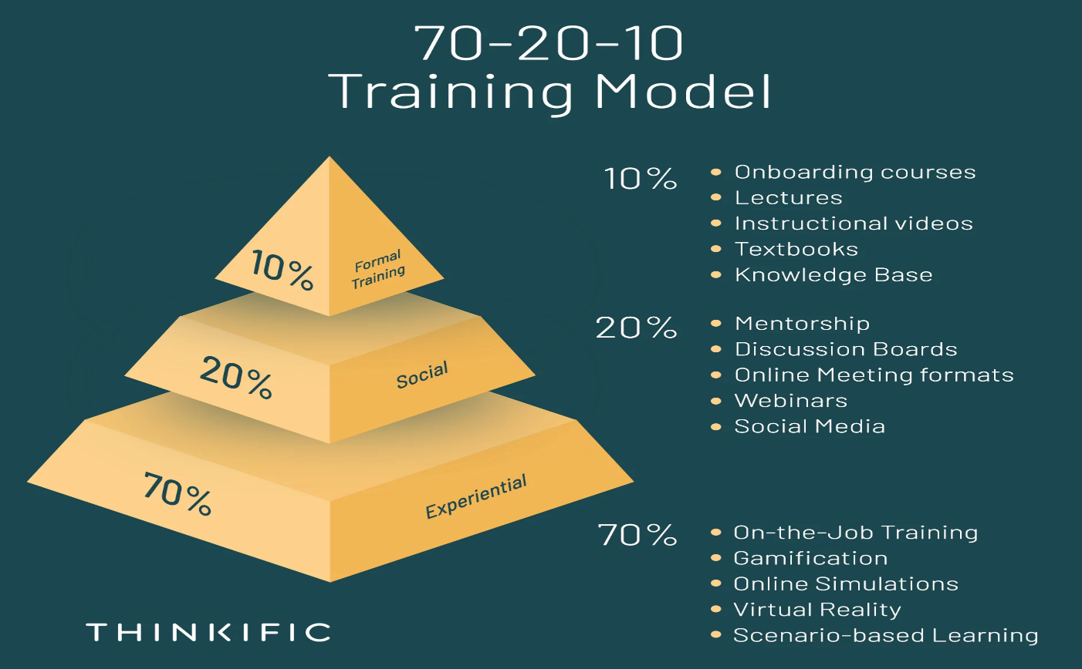
Performance management is one of the most important aspects of HR in an organisation. According to Armstrong, performance management is essential in providing benefits for the organisation and the staff.
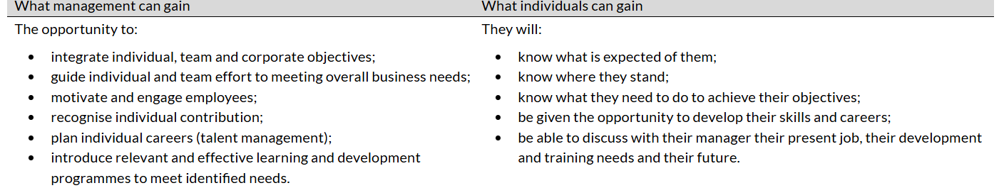
(Armstrong, 2021, p17).
TechInnovate is lacking a performance evaluation system, therefore the link between performance and employment expectations are not communicated clearly. The organisation must invest in performance evaluation systems that will provide periodic, formal and informal information about how well the employees are performing, what issues they might encounter and what further support or training is needed. This way the company ensures continuous feedback from staff, their engagement and the prevention of additional expenses that may be due to improper training or communication.
Company culture plays an important role in the organisation image and overall success.
“Organisational culture forms the glue that holds the organisation together and stimulates employees to commit to the organisation and to perform” (Van Den Berg, P. T., & Wilderom, C. P. M., 2004).
TechInnovate culture system is outdated and has become hostile to the organisation profitability. Managers need to promote continuous, clear communication between staff and management, let the employees know they are valued and empowered, allowing them the autonomy they need to fulfill their role individually. Autonomy motivated employees, allowing them to perform better and use their own initiative and creativity. Empowered employees are more inclined to display loyalty, efficiency and increased performance, that can lead to business efficacy. The employees’ voice must be heard and allowed to participate in decision making, the diversity of thought is an added benefit to the company’s growth (Dyer, 2018 pp 28-37). TechInnovate should implement an inclusive and diverse culture based on fair opportunities and rewards, open communication, transparency and collaboration.
In that regard the company should concentrate on training and retraining the staff on communication and inclusive practices but also coach the new management staff in leadership, accountability, effective communication, performance and time management, conflict resolution, empowerment, inclusion and delegation, and motivation strategies. “The managerial development must focus upon the personal traits and characteristics needed to cope with the demands of the managerial role” (BARKER, 1997). By encouraging the new managers to use the appropriate strategies and lead by example, the employees’ motivation, engagement and retention will increase, a strong company culture will be enabled, and the company performance will improve.
An organisation that promotes diversity and inclusion values is always successful in creating a safe and fair environment for all its stakeholders, is effectively promoting a healthy and strong culture and a superior vision and is enhancing its efficiency and overall image. By promoting diversity TechInnovate can make a statement to its stakeholders that they acknowledge, value and respect everyone,
regardless of race, ethnicity, gender, religion, etc. and create an inclusive and safe work environment that can motivate and inspire the employees (Kitner, 2024). TechInnovate should engage the leaders in diversity orientated coaching activities, educate the staff, promote inclusion and a positive culture and offer inclusive benefits for all personnel . By doing so the organisation may ensures better productivity, enhanced innovation, positive culture and increased motivation, provides lower conflict levels, empowered and happier employees, better chances of recruitment, improved workplace and increased staff engagement.

Conclusion

Although TechInnovate has experienced a rapid ascend and growth in the past two years, the time for change is imminent. The managerial strategy that the organisation used was functioning smoothly for a small size business setting. Nevertheless, the explosive growth brought forward several organisational management practices that cannot be utilised in the new format of the company.
With the expansion, the company also acquired more income and revenue, and the necessity of a greater workforce is implicit. With the employment of a new human resource manager, the organisation aims to set appropriate policies and practices and to acquire the right staff for the new positions.
The HR must assemble the team, but the workload is immense for a single person. Therefore, training and coaching are necessary for the team of managers that the company already has in its employment. The leadership team must be mentored in performance management, communication, conflict resolution, diversity and inclusion, accountability and empowerment, to motivate the staff and help create a positive organisational culture.
Different new practices must be established, such as a reward system for the existing employees and performance evaluation techniques, formal or informal, that must be used as often as every month to provide feedback and productivity information.
The recruiting process must be performed mindfully, and the selection should be focused on the candidates that have the aptitude and traits necessary for the role but also that resonate with the organisation culture. The successful candidates must be gradually introduced, inducted, assimilated and trained effectively, to ensure retention and avoid staff turnover.
TechInnovate must concentrate on promoting a positive culture of diversity and inclusion, based on communication, collaboration and employee’s empowerment.

Reference
Armstrong, M., & Taylor, S. (2014). Armstrong’s handbook of human resource management practice (13th edition.). Kogan Page.
Armstrong, M. (2021). Armstrong’s handbook of performance management: an evidence-based guide to performance leadership (Seventh edition.). p 17, Kogan Page.
Adair, J. (2007). John Adair Authority on leadership. In European business forum (Number 28, pp. 64-). Caspian Publishing Limited.
BARKER, R.A., 1997. How can we train leaders if we do not know what leadership is? Human Relations, 50(4), pp. 343-362.
Burkholder, N. C., Edwards, P. J., & Sartain, L. (2004). On staffing: advice and perspectives from HR leaders. Wiley.
CLAUS L., 2019. RECRUITING AND RETENTION. American Fastener Journal, 35(3), pp. 36-36,38,40.
Dyer, C. (2018). The power of company culture: how any business can build a culture that improves productivity, performance and profits. Kogan Page.
Fitzsimons, D., James, K.T. and Denyer, D. (2011), Alternative Approaches for Studying Shared and Distributed Leadership. International Journal of Management Reviews, 13: 313-328. https://doi.org/10.1111/j.1468-2370.2011.00312.x
HOOD, D., 2022. Top tips for recruiting and retention. Accounting Today, 36(12), pp. 38.
Johnson, G, Whittington, R, Scholes, K, Anwin, D and Regner, P (2017) Exploring Corporate Strategy, 11th edn, Prentice Hall, London.
Johnson S. J. (2018). The 70:20:10 framework and the transfer of learning. Human Resource Development Quarterly. 29(4), pp.383-402. [Online]. Available at: https://doi.org/10.1002/hrdq.21330 [Accessed 4 December 2024].
KITTNER, E. P. The Ethics of DEI: Cultivating a Positive Workplace: Committing to diversity, equity and inclusion initiatives is more than an ethical consideration -- it leads to stronger organizations and workplace cultures. On Balance, [s. l.], v. 20, n. 2, p. 36–39, 2024. Disponível em: https://research-ebsco-com.ezproxy.uwtsd.ac.uk/linkprocessor/plink?id=90e5e40e-4387-3d58-a505-a977d53bf651. Acesso em: 5 dez. 2024.
KOTTER, J., 1998. 21st Century Leadership. Executive Excellence, 15(5), pp. 5.
Marchington, M. (2021). Human resource management at work: the definitive guide. (Seventh edition.). pp 83-84, CIPD.
Mullins, L., J. (2002). Management and Organisational Behaviour. 6th ed. London: Pearson Education Limited. p.53.
Mullins, Laurie. Mullins: Organisational Behaviour in the Workplace, Pearson Education, Limited, 2019. ProQuest Ebook Central, https://ebookcentral.proquest.com/lib/trinity/detail.action?docID=5830196.
Renko, M., Kroeck, K. G., & Bullough, A. (2012). Expectancy theory and nascent entrepreneurship. Small Business Economics, 39(3), 667–684. https://doi.org/10.1007/s11187-011-9354-3
SCHNEIDER, B. (1987). THE PEOPLE MAKE THE PLACE. Personnel Psychology, 40(3), 437–453. https://doi.org/10.1111/j.1744-6570.1987.tb00609.x
Spector, B. A. (2016). Carlyle, Freud, and the Great Man Theory more fully considered. Leadership, 12(2), 250-260. https://doi-org.ezproxy.uwtsd.ac.uk/10.1177/1742715015571392
Tokesky, G. C., & Kornides, J. F. (1994). Strategic HR management is vital. Workforce Management, 73(12), 115-.
Van Den Berg, P. T., & Wilderom, C. P. M. (2004). Defining, Measuring, and Comparing Organisational Cultures. Applied Psychology, 53(4), 570–582. https://doi.org/10.1111/j.1464-0597.2004.00189.x
Vroom, V. H. (1964). Work and motivation. New York: Wiley.

