
Leadership and Management Skills for the Workplace

Module: Research Methods for Business
(LCM 6004/ BHAM) Level 6

Component 1 – Business Research Proposal

Tutor: Dr Dingning Liu
Student: Qasim Ali (2309098)
Submission Due date: 16/03/2026

Business Research Proposal
Improving Customer Satisfaction Through Technology Adoption: A Case Study of TOA Taxis, Birmingham

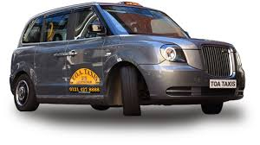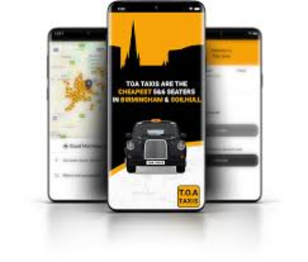

Table of Content

1. Introduction and Identification of the Business Problem--------------04
2. Research Aim, Objectives and Questions---------------------------------06

3. Critical Literature Review-----------------------------------------------------07

4. Conceptual Framework--------------------------------------------------------10
5 Research Methodology---------------------------------------------------------11

6. Expected Results and Analysis-----------------------------------------------14

7. Business Relevance and Practical Implications--------------------------14

8. Conclusion-----------------------------------------------------------------------16
9. References-----------------------------------------------------------------------18

1. Introduction and Identification of the Business Problem

1.1 Organisational Context
TOA Taxis is a long-established taxi operator in Birmingham, operating for over 50 years. Historically, the company relied on telephone bookings, traditional dispatch systems, and a fleet of licensed vehicles. While these systems were adequate in the past, the rapid digitalisation of urban mobility has created significant challenges for legacy operators. (TOA Taxis, n.d.)
Birmingham is the 2nd largest UK city with a highly diverse commuter population. Public transport options are extensive, but taxis remain vital for traveling, airport transfers, and on-demand journeys. Customers increasingly expect digital convenience for instant booking confirmation, live vehicle tracking, multiple payment options, and app-based support. Transport for London (2024) notes similar trends in London, and research suggests that these behaviours are being replicated in other UK cities, including Birmingham.
Legacy taxi operators like TOA are therefore facing both technological and cultural challenges: updating systems, training drivers, and reshaping customer perceptions to compete effectively with global ride-hailing platforms.

1.2 The Complex Business Problem
TOA Taxis faces a multi-dimensional business problem: declining customer satisfaction due to limited technology adoption. This issue is “wicked” (Rittel and Webber, 1973), involving overlapping factors:
TOA Taxis faces several challenges, including outdated booking systems, limited digital payment options, and inconsistent driver familiarity with technology. In addition, the company faces increasing competition from app-based services such as Uber and Bolt, which offer more convenient digital booking and payment features (Department for Transport, 2023).
If not addressed, these issues risk revenue loss, reduced customer loyalty, and weakened competitive positioning. The problem is further complicated by the fact that customer satisfaction is not solely influenced by service delivery but also by perceptions of technological competence, transparency, and convenience.
Mobile app market trends are massively impacting users’ preferences. However, the fact that Mobile app usage stats predicting users behaviors in 2024
users have become increasingly dependent on their mobile devices has given birth to new usage stats. Let us look into some of those mobile app industry trends.
- 88% of the time spent on mobile devices is on apps
- The retention rate in Android apps is 22.6% one day from download, 6.5% seven days from download, and 2.6% 30 days after download.
- The retention rate in iOS apps is 25.6% one day from download, and 4.3% 30 days after download.
- 70% of users switch away from an app because it’s very slow.
- 67% of users leave an app if there are multiple steps to find the information or take an action.
- 49% of millennials say that they hate apps that drain their battery too fast.
- 54% of millennials have more than 3 screens of apps active on their phone.
- Social networking apps are the most popular type of app with millennials, followed by messaging apps and then games.
- 73% of millennials shop on mobile at least 4x per week.
- 70% of millennials play games daily.
While these summarize the mobile app usage stats, let us get down to the specific usage trends.
1. An average smartphone user has 80 apps on their device
Out of the 80 apps, however, they usually use only 9 while they revisit 30 apps every month. It shows that while users have multiple apps installed in their phone, they use only a limited few.
2. An average user spends 3 hours 10 minutes on mobile apps
Approximately 3 hours and 10 minutes of users go into using their mobile phones, although this number is fast growing. Even in this time range, 90% of the time goes in applications like communication, entertainment, shopping, and social media.
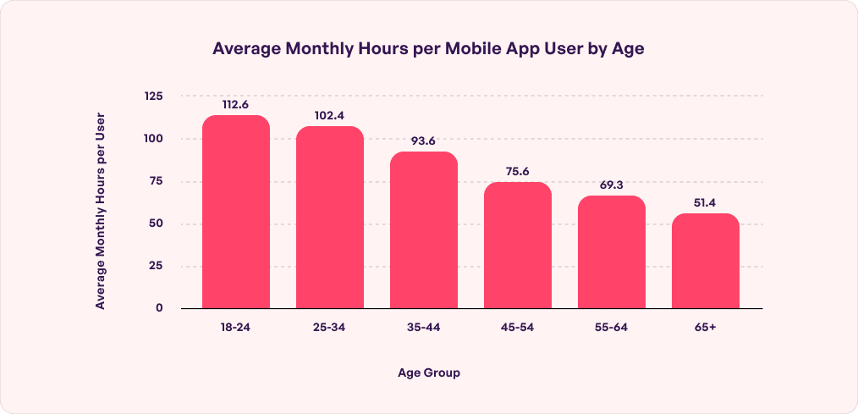
Figure 1. Average Monthly Hours per Mobile App User by Age
(Source:)https://neojn.com/blogs/mobile-app-usage-statistices/

2. Research Aim, Objectives and Questions

2.1 Research Aim
How technology adoption can improve customer satisfaction at TOA Taxis, Birmingham.

2.2 Research Objectives
- Measure current levels of customer satisfaction across various service touchpoints.
- Evaluate customer perceptions of TOA’s digital service quality, including app usability and real-time tracking.
- Examine the relationship between technology's usability and overall satisfaction.
- Identify digital service gaps that hinder performance and customer retention.
- Propose evidence-based recommendations for service improvement and strategic alignment.

2.3 Research Questions
- What factors currently influence customer satisfaction at TOA Taxis?
- How do customers perceive the usefulness and ease of use of TOA’s digital systems?
- Which digital service quality dimensions most strongly predict customer satisfaction?
- How can technology adoption enhance TOA’s competitive positioning and operational efficiency?

3. Critical Literature Review

3.1 Service Quality and Customer Satisfaction
Customer satisfaction is a function of perceived performance relative to expectations (Kotler and Keller, 2016). SERVQUAL (Parasuraman et al., 1988) identifies five dimensions: reliability, responsiveness, assurance, empathy, and tangibles. In taxi services, these translate to: Reliable and timely pickups ensure that customers reach their destinations on schedule. A responsive and rapid dispatch system helps reduce waiting times and improves service efficiency. Driver competence and safety provide assurance to passengers and build trust in the service. Personalised customer care demonstrates empathy by addressing individual passenger needs. Additionally, clean and well-maintained vehicles represent the tangible aspects of service quality and contribute to overall customer satisfaction.
However, SERVQUAL was designed before the proliferation of digital services and fails to capture app-based interactions, mobile payments, or real-time tracking. Recent studies indicate that these digital touchpoints significantly shape customer perceptions of reliability and convenience. Thus, while SERVQUAL remains useful, it must be integrated with digital service quality constructs to fully explain satisfaction in modern urban transport (Peng et al., 2024).

3.2 Customer Experience Across the Digital Journey
Lemon and Verhoef (2016) emphasise customer experience as cumulative across multiple touchpoints: booking, waiting, riding, payment, and feedback. Digital interactions, including app notifications, GPS tracking, and electronic receipts, directly influence perceived service quality and satisfaction.
This approach contrasts with SERVQUAL’s discrete attribute focus, offering a more holistic understanding of customer experience. However, while conceptual, the framework lacks practical measurement guidelines, highlighting the need for empirical data collection to capture satisfaction across the digital journey.

3.3 Technology Adoption Models
TAM (Davis, 1989) identifies perceived usefulness and ease of use as primary drivers of technology adoption. UTAUT (Venkatesh et al., 2003) extends TAM with social influence and facilitating conditions, reflecting organisational and peer effects. In the taxi context, these models explain both customer adoption of booking apps and driver adoption of digital dispatch systems.
Although widely applied, TAM and UTAUT focus on individual cognitive processes. Structural, market, and organisational influences, such as competitive pressures and cultural readiness, must be incorporated for a complete understanding of technology-driven satisfaction.

3.4 Digital Disruption and UK Market Dynamics
Bilgin et al. (2023) provides UK-specific evidence that ride-hailing services reduce traditional taxi numbers while increasing private hire vehicles. This demonstrates that legacy operators face significant competitive pressures, making timely digital adoption a strategic imperative.
Peng et al. (2024) analysed service quality in online car-hailing platforms using advanced SPC-PCN methods. Their findings demonstrate that improvements in digital service attributes, including app responsiveness, real-time updates, and payment transparency, directly increase customer satisfaction. This suggests that operational and digital upgrades are necessary for maintaining competitiveness.

3.5 Organisational Digital Transformation
Westerman, Bonnet and McAfee (2014) argue that digital transformation is not purely technological. Success requires alignment between technology, organisational culture, processes, and workforce skills. Even optimal apps fail if drivers lack digital competence or if internal processes are inconsistent. For TOA, this underscores that technology adoption must be accompanied by training, workflow redesign, and change management.

3.6 Identified Research Gap
Despite extensive literature, gaps remain:
Few studies integrate service quality, technology adoption, and customer experience into a single model. UK studies rarely focus on traditional taxi operators in mid-sized cities. Empirical links between digital service quality and satisfaction in legacy contexts are limited. This study addresses these gaps by applying an integrated framework to TOA Taxis in Birmingham.

4. Conceptual Framework
Framework:
Technology Adoption (TAM/UTAUT) → Enhanced Digital Service Quality (SERVQUAL + Digital Attributes) → Improved Customer Experience → Higher Customer Satisfaction → Increased Loyalty & Competitive Advantage
This framework integrates classical and modern theories to guide data collection, analysis, and practical recommendations.
Explanations:
- Technology Adoption. Technology Acceptance Model/Unified Theory of Acceptance and Use of Technology (TAM/UTAUT):
Captures user perceptions of app usefulness, ease of use, and social influence. Influences on how customers interact with digital systems.
- Enhanced Digital Service Quality (SERVQUAL + Digital Attributes):
Integrates traditional service quality dimensions with digital touchpoints: app functionality, GPS tracking, digital payments, and system reliability.
- Customer Experience:
Represents the cumulative journey, including app booking, vehicle waiting, ride, payment, and post-service feedback.
- Customer Satisfaction:
The ultimate outcome: overall satisfaction, loyalty, repeat use, and positive word-of-mouth.
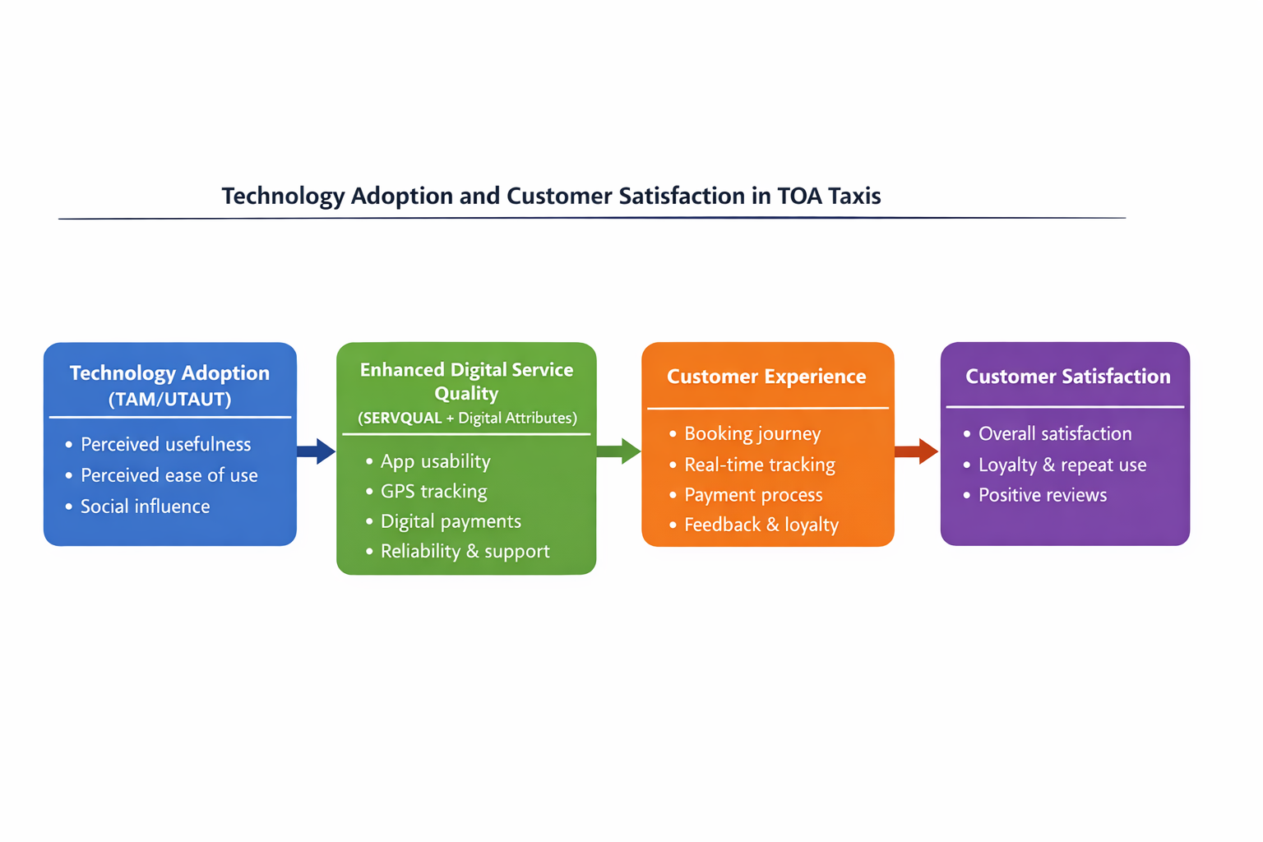
5 Research Methodology

5.1 Research Philosophy and Approach
- Positivist philosophy (Saunders et al., 2019) ensures objective measurement of service quality and satisfaction.
- Deductive approach: test hypotheses derived from TAM, UTAUT, and SERVQUAL frameworks.

5.2 Research Design
Cross-sectional quantitative survey:
Is a design to facilitate hypothesis testing and regression analysis within the TOA customer population however, as a point in time assessment , it cannot capture long term adaption trends.
- Efficient for hypothesis testing and regression analysis
- Generalisable to TOA customer population
- Limitation: cannot capture long-term adoption trends

5.3 Sampling Strategy
Parameter | Specification
Population | TOA Taxis customers (last 3 months)
Method | Stratified random sampling
Stratification | Age, booking method (app vs phone), travel purpose
Sample size | 250 respondents
Justification: ensures representativeness and sufficient statistical power (Hair et al., 2018).

5.4 Data Collection
Structured questionnaire covering:
- Demographics
- Technology adoption (TAM/UTAUT constructs)
- Digital service quality (SERVQUAL + digital metrics)
- Overall satisfaction
5-point Likert scale; pilot tested for clarity and reliability.

5.5 Data Analysis
Step | Method
Descriptive statistics | Demographics and satisfaction scores
Reliability | Cronbach alpha >0.7
Correlation | Associations between variables
Regression | Identify predictors of satisfaction

5.6 Validity, Reliability, and Limitations
Reliability: Cronbach alpha and pilot refinement
Construct validity: well-established scales (Davis, 1989; Parasuraman et al., 1988)
Limitations: Birmingham-only sample, cross-sectional design, self-reported measures

5.7 Ethical Considerations
GDPR-compliant, informed consent, anonymised data
Voluntary participation, secure storage
Adherence to professional research ethics standards

6. Expected Results and Analysis

The anticipated findings are expected to show a positive correlation between perceived usefulness, ease of use, and customer satisfaction. Digital service quality attributes such as app usability, GPS tracking, and payment integration are likely to emerge as strong predictors of satisfaction. Additionally, the study will help identify operational areas requiring digital improvement. Statistical techniques, including regression analysis and correlation matrices, will be used to measure the influence of each predictor and illustrate their interrelationships, supporting evidence-based recommendations.

7. Business Relevance and Practical Implications
The proposed research has direct relevance for TOA Taxis, providing actionable insights into improving customer satisfaction through targeted technology adoption.
Prioritise app-based booking, real-time tracking, and digital payments:
Customers increasingly expect convenience, immediacy, and transparency in transport services (Transport for London, 2024; Bilgin et al., 2023). By enhancing app-based booking, TOA can streamline the journey from booking to drop-off, reducing friction in customer experience. Real-time vehicle tracking not only improves reliability but also increases perceived safety and trust, both key dimensions in SERVQUAL (Parasuraman et al., 1988). Digital payments reduce transaction delays, improve efficiency, and align with broader urban mobility trends in the UK, where cashless and app-based transactions dominate. Implementing these digital solutions addresses both operational bottlenecks and customer expectations simultaneously.
Implement automated feedback and loyalty systems:
Collecting structured feedback through in-app surveys allows TOA to measure satisfaction in real time and respond promptly to issues. This continuous feedback loop supports a customer-centric approach, enabling rapid service improvements and increased responsiveness (Lemon and Verhoef, 2016). Loyalty systems, such as reward points or preferential pricing for frequent users, incentivise repeat usage, foster long-term relationships, and counteract competitive pressure from global ride-hailing platforms (Cramer and Krueger, 2016). Moreover, analytics from feedback systems can identify patterns in customer complaints or praise, providing empirical evidence to guide strategic decisions.
Train drivers in digital service usage:
Drivers play a crucial role in delivering both the human and digital elements of the customer journey. Training in app navigation, digital payment processing, and customer service best practices ensures consistency in service quality. According to Westerman, Bonnet and McAfee (2014), technology adoption without complementary skills development is unlikely to yield strategic benefits. Effective training also fosters employee engagement and reduces resistance to change, which is critical in legacy organisations where digital tools may be unfamiliar.
Align technology adoption with organisational strategy:
Digital transformation must be integrated with TOA’s overall strategy to achieve long-term competitive advantage. Technology adoption should not be viewed as an isolated initiative but as part of a wider operational and cultural shift that enhances efficiency, accountability, and innovation (Westerman et al., 2014). Strategic alignment ensures that investments in technology support organisational goals, such as reducing waiting times, improving driver allocation, and enhancing customer satisfaction, while also generating measurable financial and reputational returns.
Strategic impact
The combined effect of these initiatives is multi-dimensional:
Customer loyalty: Improved convenience, reliability, and engagement through digital channels increase repeat patronage.
Operational efficiency: Real-time tracking, digital payments, and automated feedback reduce delays, errors, and administrative overhead.
Competitive positioning: By embracing digital tools, TOA strengthens its market position against both traditional competitors and disruptive ride-hailing services.
In addition, implementing a data-driven approach enables TOA to monitor key performance indicators continuously, refine services based on evidence, and adapt quickly to emerging market trends. This approach aligns with both TAM/UTAUT models and SERVQUAL dimensions, linking technological adoption to measurable improvements in customer experience and satisfaction.
Ultimately, the practical implications of this research extend beyond immediate operational improvements. They provide a roadmap for sustainable digital transformation, balancing technological investment, staff capability development, and customer-centric strategies to secure long-term organisational success in a rapidly evolving UK transport market.

8. Conclusion
TOA Taxis operates in a digitalised urban transport environment. Traditional service quality models are insufficient. This research integrates service quality, technology adoption, and customer experience frameworks, offering evidence-based guidance for digital transformation, customer satisfaction, and sustainable competitive advantage.
In light of these findings, it is clear that TOA Taxis must move beyond traditional service paradigms and embrace a holistic digital strategy that incorporates ongoing technological innovation, systematic driver training, and robust feedback mechanisms. By leveraging empirical insights and aligning operational reforms with customer expectations, the organisation can deliver superior service experiences, foster loyalty, and maintain resilience in the face of industry disruption. This integrated approach positions TOA Taxis to not only meet the evolving demands of urban mobility but also to set new benchmarks for service excellence in the sector.

References
Bilgin, P., Mattioli, G., Morgan, M. and Wadud, Z. (2023) ‘The impacts of ridesourcing services on the taxi market: Empirical evidence from England and Wales’, Transportation Research Part A: Policy and Practice, 178, p. 103880.
Cramer, J. and Krueger, A.B. (2016) ‘Disruptive change in the taxi business: The case of Uber’, American Economic Review: Papers and Proceedings, 106(5), pp. 177–182.
Davis, F.D. (1989) ‘Perceived usefulness, perceived ease of use, and user acceptance of information technology’, MIS Quarterly, 13(3), pp. 319–340.
Department for Transport (2023) Taxi and private hire vehicle statistics, England: 2023. London: Department for Transport. Available at: https://www.gov.uk/government/statistics/taxi-and-private-hire-vehicle-statistics-england (Accessed: 11 March 2026).
Hair, J.F., Black, W.C., Babin, B.J. and Anderson, R.E. (2018) Multivariate Data Analysis. 8th edn. Andover: Cengage Learning.
Hamari, J., Sjöklint, M. and Ukkonen, A. (2016) ‘The sharing economy: Why people participate in collaborative consumption’, Journal of the Association for Information Science and Technology, 67(9), pp. 2047–2059.
Kotler, P. and Keller, K.L. (2016) Marketing Management. 15th edn. Harlow: Pearson.
Lemon, K.N. and Verhoef, P.C. (2016) ‘Understanding customer experience throughout the customer journey’, Journal of Marketing, 80(6), pp. 69–96.
Parasuraman, A., Zeithaml, V.A. and Berry, L.L. (1988) ‘SERVQUAL: A multiple-item scale for measuring consumer perceptions of service quality’, Journal of Retailing, 64(1), pp. 12–40.
Peng, Y., Zhang, Y., Hou, Y. and Liu, S. (2024) ‘Service quality improvement strategies of online car‑hailing based on SPC‑PCN method’, Electronic Commerce Research and Applications, 65, p. 101409.
Rittel, H.W.J. and Webber, M.M. (1973) ‘Dilemmas in a general theory of planning’, Policy Sciences, 4(2), pp. 155–169.
Saunders, M., Lewis, P. and Thornhill, A. (2019) Research Methods for Business Students. 8th edn. Harlow: Pearson.
TOA Taxis (n.d.) About TOA Taxis. Available at: https://www.toataxis.co.uk (Accessed: 11 March 2026).
Transport for London (2024) Travel in London: Report 17. London: Transport for London.
Venkatesh, V., Morris, M.G., Davis, G.B. and Davis, F.D. (2003) ‘User acceptance of information technology: Toward a unified view’, MIS Quarterly, 27(3), pp. 425–478.
Westerman, G., Bonnet, D. and McAfee, A. (2014) Leading Digital: Turning Technology into Business Transformation. Boston: Harvard Business Review Press.

