Applied programmable logic controllers
BEng Electrical and electronic engineering
Connor Daniel
1909665@student.uwtsd.ac.uk

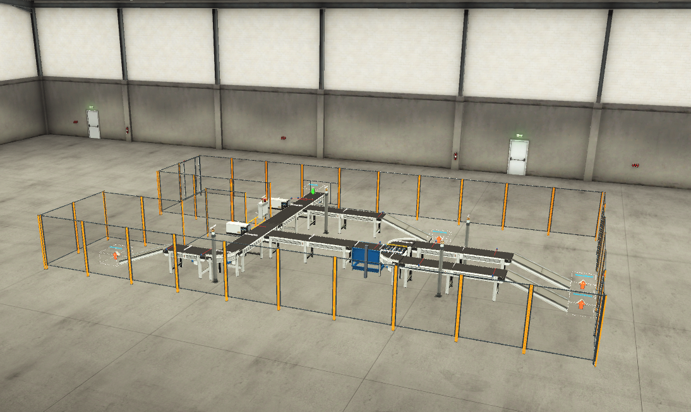
Table of Contents
Introduction 3
Existing systems 3
PLC overview 3
Basic components of a PLC 3
Power supply 3
Central processing unit (CPU) 3
I/O cards 4
The programming device and the human-machine interface (HMI) 4
Types of PLC 4
PLC program 6
Network 1 6
Network 2 6
Network 3 7
Network 4 11
Network 5 12
Network 6 13
Network 7 13
Network 8 14
Network 9 14
Network 10 14
Network 11 15
Network 12 15
Networks 13, 14, 15 and 16 16
Network 17 20
Network 18 20
Network 19 21
Network 20 21
Network 21 22
Network 22 23
HMI 24
Root screen 24
Alarm screen 25
Engineers’ screen 26
Factory I/O screenshots 26
Factory overview 26
Main panel 27
Large box line 28
Small and medium box line 29
Scale conveyor 31
Pallet box line 32
Tag table 33
Flow charts 36
Large box flowchart 36
Small and medium box line 37
Pallet box line 38
Conclusion 38
Bibliography 40

Introduction
This report is split in to two sections. The first half of the report will look in to the existing systems that are currently out there for PLC’s. This section will give a brief overview of what a PLC is and the main components that are essential to the its operation. After this a comparison table will be added to compare different types of PLC’s that are currently available. The table will highlight the pros and cons of each type of PLC and give an indication of where each PLC type is suitable for what type of application. The second half of this report is a PLC program which fits a specification. The report will provide screenshots and explanations of the program that has been built in Siemans TIA portal. The individual networks will be explained, stating why each component has been used. The report will also contain screenshots of the HMI that will be used by the operator and engineer to check the working function of individual components, run the machine and check for alarms present. The report will also provide screenshots and explanations of the build that has been created using the factory I/O software to complement how it works with the program that has been built. The report will then be concluded suggesting any improvements that could be made in the future.

Existing systems

PLC overview
A programmable logic controller (PLC) is a digital computer used to complete automation processes. PLC’s have a wide variety of applications they can be used for from specific machinery to basic factory lines, this is because a PLC can be programmed to complete the required job. The fact they can be programmed, simply modified and provide easy troubleshooting of the program makes the PLC a reliable and versatile option for industrial applications. A PLC will collect and process information from sensors and other input devices and provide and output based on the program it is being run with. [1] [2]

Basic components of a PLC
A PLC is comprised of 4 main components these are:
- A power supply
- Central processing unit (CPU)
- I/O cards
- The programming device and the human-machine interface (HMI)

Power supply
The power supply provides the PLC power for the CPU and I/O modules. The power supply will be run of 120VAC or 24VDC depending on the application of the PLC. The power supply does not supply power to field devices such as sensors, they must be connected to a separate supply.

Central processing unit (CPU)
The CPU contains the processor and the memory it will receive signals from the I/O cards and make a decision on what outputs to give based on the signal received and program installed on to the PLC. This is why it is known as the ‘brain’ of the PLC.

I/O cards
The I/O cards allow the PLC to read field devices such as sensors, buttons, switches and solenoids. These are what provide the CPU with information on inputs and give back outputs to.

The programming device and the human-machine interface (HMI)
The programming device will be a computer that is loaded with software from the manufacturer used to create the program for the machinery. This programming device allows the engineer to modify the program, create and modify the HMI screens and display information to the operator while the machinery is in process.

A human-machine interface (HMI) is what allows the operator of the machine to run the machine. It is a touchscreen that allows for control over a piece of machinery for example starting and stopping a conveyor and opening and closing a valve whilst not using the programming device. It can also help the operator and engineer with fault finding on a piece of equipment as it can provide information on warnings and alarms present.[1][2]

Types of PLC
 | Modular PLC’s [3] [4] | Compact PLC’s [3] [4] | Safety PLC’s [3] [4]
Pros | Scalability – The modular PLC allows has the capability to add modules to the desired amount. This makes them a suitable choice for any projects where changing requirements and expansion could be a factor.  Flexibility – The modular PLC allows cards to be interchanged. This means cards can be customized and swapped in and out for one another.  Maintenance – Due to the ability to swap cards out the maintenance of a modular PLC is easier as if a card is faulty, it can be easily replaced. This also lowers downtime and cost in the long run as the PLC card can be replaced instead of the whole unit.  Performance – The performance of a modular PLC is typically higher than other types offering higher speeds and processing power. | Space requirement – A compact PLC will require less space to fit compared to a modular PLC. This makes them a suitable fit for any projects that have limited space and a set parameter requirement.  Simplicity – A compact PLC will have an easier install process compared to other types due to its smaller size. They are also simpler when it comes to programming.  Lower initial cost – The start-up cost of a compact PLC is often lower due to the all-in-one unit.  Integrated I/O – Many compact PLC’s will come with integrated I/O modules, this reduces cost and simplifies wiring. | Safety features – This type of PLC has built in safety functions such as emergency stop. The safety PLC is also built to meet the requirements of safety regulations and standards.  Reliability – Due to these PLC’s being held to safety regulations and standards they are put under tests to ensure they perform when critical.  Flexibility – the safety PLC is easily integrated with the system already in place. This allows for the easy implementation of safety features for other types of PLC’s
Cons | Initial cost – Modular PLC’s will have higher start-up cost due to the pros listed above and the need to purchase multiple cards.  Space requirement – Due to the modular PLC having multiple modules the area needed to fit the PLC is larger when compared to other types.  Complexity – The modular PLC is more complex than other types when fault finding and designing the system due to the extra modules. | Scalability – Due to the compact PLC being an all-in-one unit there it does not offer any expansion, this means for larger projects where parameters may change it is not a good option.  Performance – Compact PLC’s have lower processing power and speed when compared to the modular PLC’S making it a less suitable option for larger projects.  Maintenance – As you cannot swap cards in and out of a compact PLC, this makes maintenance harder. This will also increase downtime if there is an issue and could also lead to higher cost once the PLC has been fitted. | Cost – Safety PLC’s come with higher costs due to the testing and standards they have to meet  Complexity – The introduction of safety functions to the PLC can make it more tasking when it comes to fault finding and programming.

PLC program

Network 1
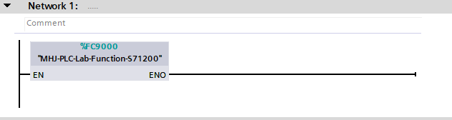
Network 1 allows Siemans TIA portal to communicate with factory IO.

Network 2
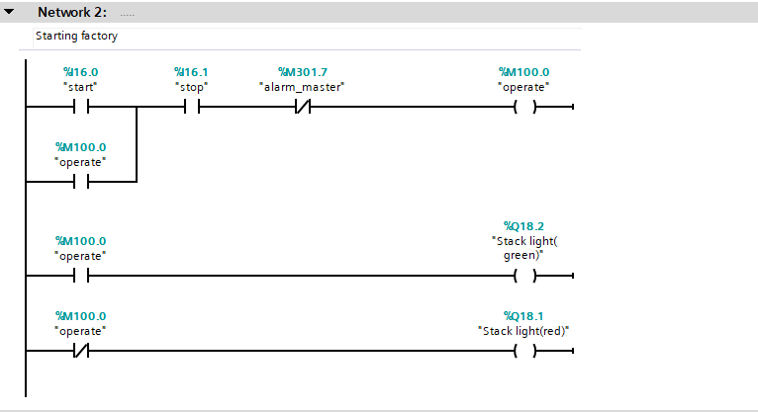

Network 2 shows how the factory stop and starts bringing on the tag ‘operate’ and holds this tag on until the stop button is pressed or an alarm is raised. This network also shows how the green and red light for the stack light on the panel in the factory are turned on and off. If the factory is running and the ‘operate’ tag is high then the green light comes on and if the factory has stopped running the red stack light will come on.

Network 3
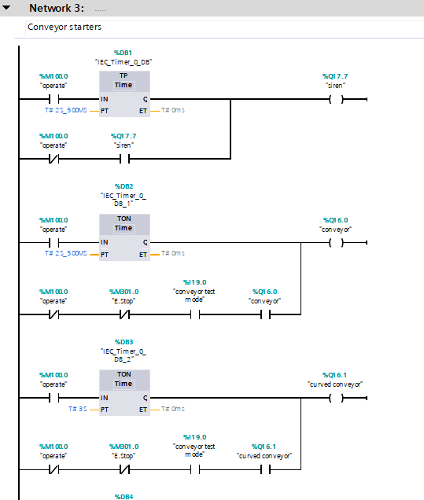
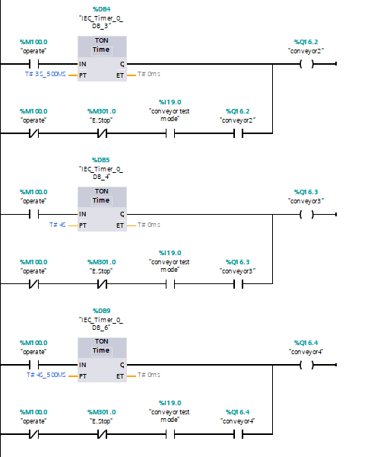
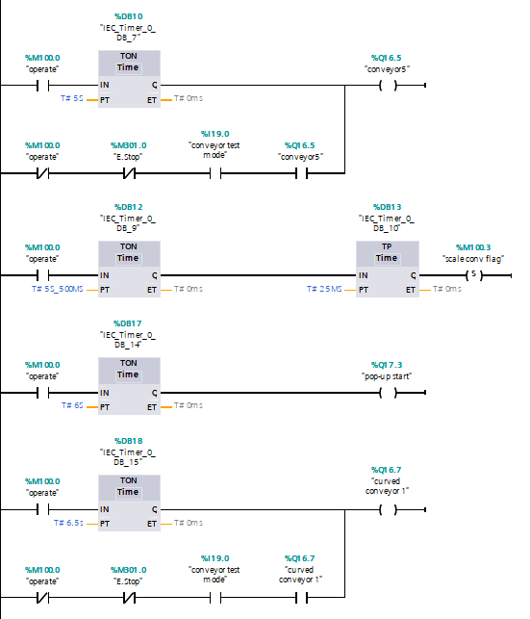
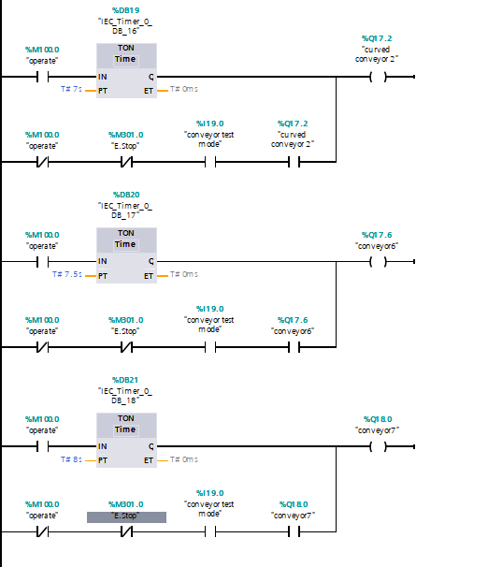
Network 3 shows how the ‘operate’ tag brings on the siren and the individual conveyors. As shown from the screen shots above the siren and conveyors are brought on using TON timers spaced 0.5 seconds apart. This is done to ensure the PLC doesn’t crash and has time to process bringing each conveyor on. Network 3 also shows a TP timer for the scale conveyor this is so the scale conveyor has time to calculate the weight of the box on the conveyor to decide which way to send it. Network 3 also shows how the conveyor test on the engineers’ screen has been implemented in to the program with use of a normally closed ‘operate’ and E-stop. A normally open conveyor test mode and the conveyor it is connected to. This means as long as the conveyors are not running, an E-stop has not been pressed and the engineer has pressed the conveyor test button then they can test the conveyor using the button on the engineers’ screen.

Network 4
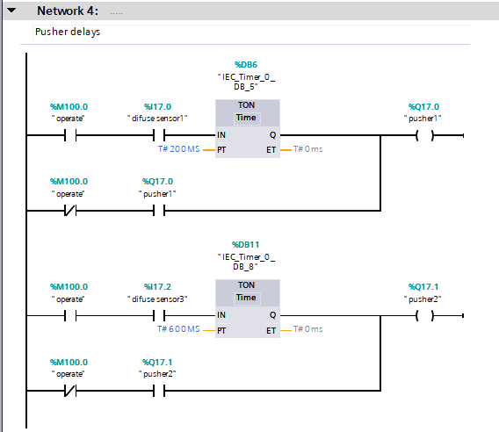
Network 4 shows how the pushers are timed to push the correct box down the correct conveyor. This is done by using the ‘operate’ tag to ensure the system is running and by the use of sensors. ‘Diffuse sensor 1’ is placed higher than ‘Diffuse sensor 3’ this is due to the larger box being triggered by ‘diffuse sensor 1’ and the small and medium box being triggered by ‘diffuse sensor 3’. This allows for the large box to be pushed out by pusher 1 and the small and medium boxes to go underneath the sensor and be pushed out by pusher 2. As shown, there is two TON timers in place as well this is for a time delay so once the sensors get triggered the pushers are timed to push the boxes on to the next conveyor at the right time. Network 4 also shows how the engineer can test the operation of both pushers through the PLC. As long as the conveyors are not running the engineer can press the test button on the engineers’ screen and operate the pushers.

Network 5
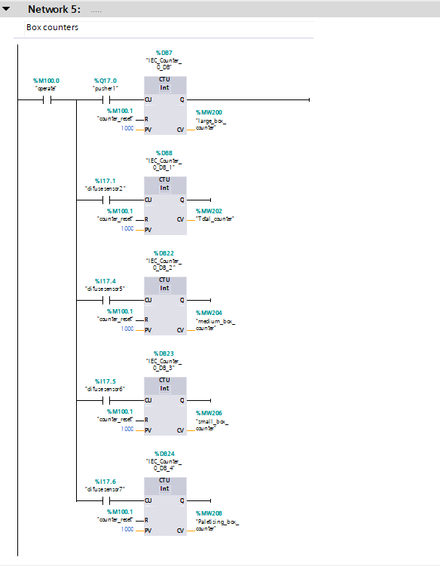

Network 5 shows how the amount of each box and the total amount of boxes that have been fed on to the conveyors is calculated. This is down by the use of sensors and pushers inputted in to a CTU, which is a count up function.

Network 6
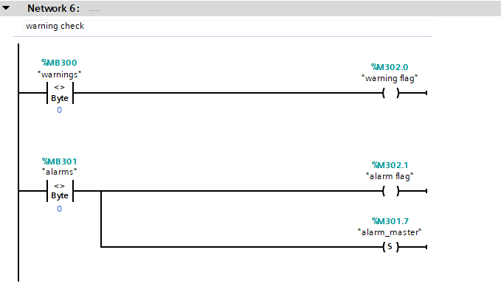
Network 6 shows how the warning and alarm flags are triggered. It also shows how the master alarm is set which will stop the factory if set.

Network 7
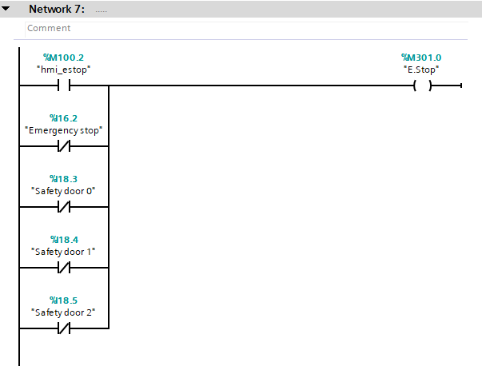
Network 7 shows how the E-stop is brought on. As shown the HMI is a normally open so will stop when it is pressed. However, the rest are all physical forms of E-stop so they are normally closed so they will break the circuit causing the Estop to come on when they are triggered. The safety doors have been added to the E-stop circuit as an extra safety measure so when the engineer opens the gate to fix a problem there is no moving parts.

Network 8
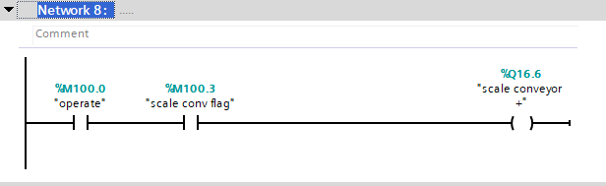
Network 8 shows how the scale conveyor weighs the boxes on top of it.

Network 9
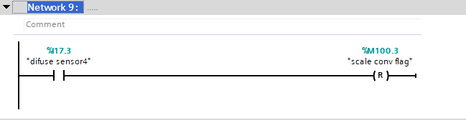
Network 9 shows how ‘diffuse sensor4’ resets the scale conveyor so it can weigh the next box.

Network 10
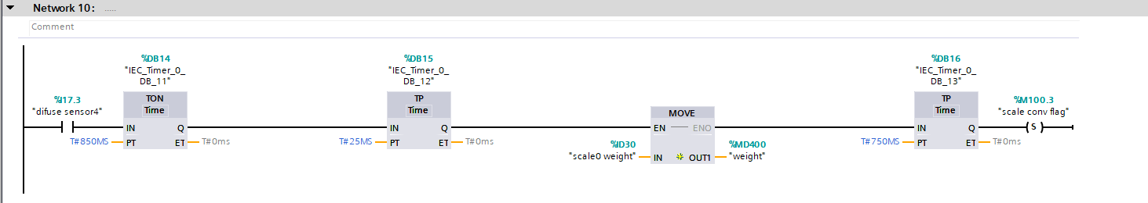
Network 10 shows how the weight for the scale conveyor is weighed and set. This is done using a sensor, a TON, two TP and a MOVE function block.

Network 11
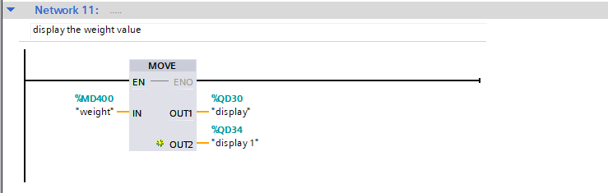
Network 11 shows how the weight is displayed on the physical screens on factory IO. This is done by using the move function in TIA to display hat the scale conveyor is reading when it weighs each individual box.

Network 12
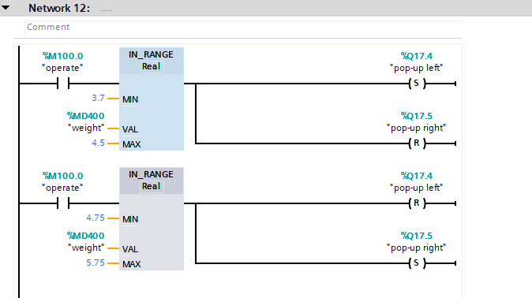
Network 12 shows how the scale conveyor tells the pop-up conveyor which way to send the box it has weighed. If the factory is running and an IN_RANGE function will assess the weight. If the value of the weight is between 3.7 and 4.5 then it is a small box and the pop-up conveyor will send the box left. If the value is between 4.75 and 5.75 then it is a medium box and it will send the box right.

Networks 13, 14, 15 and 16
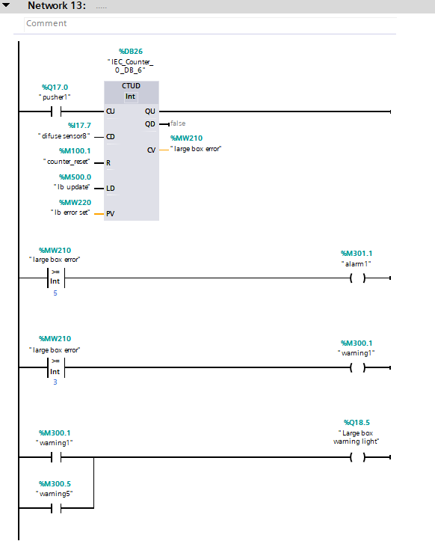
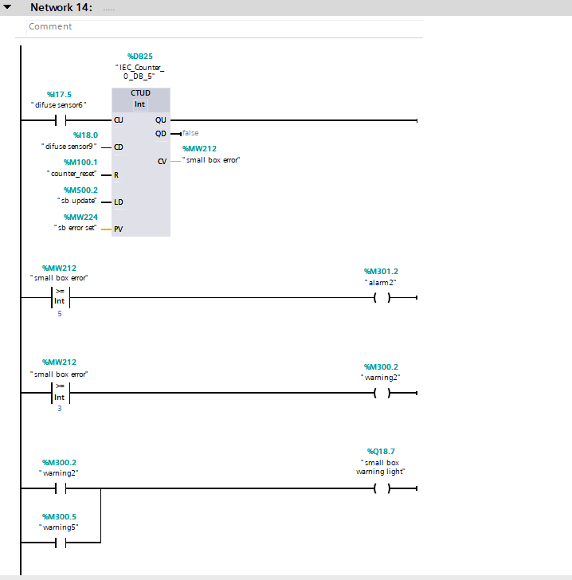
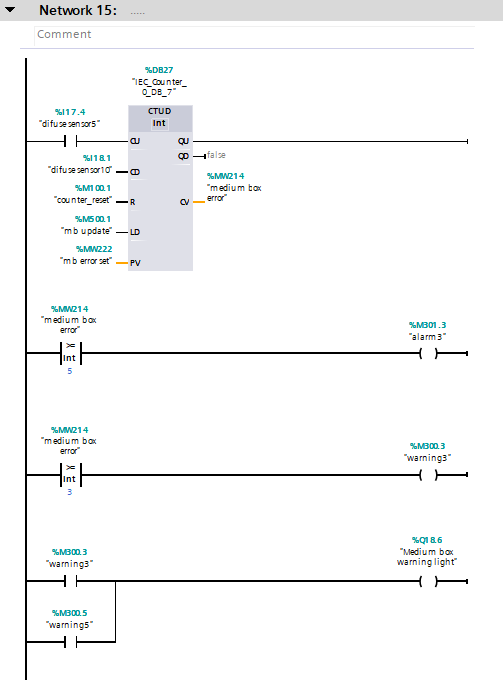
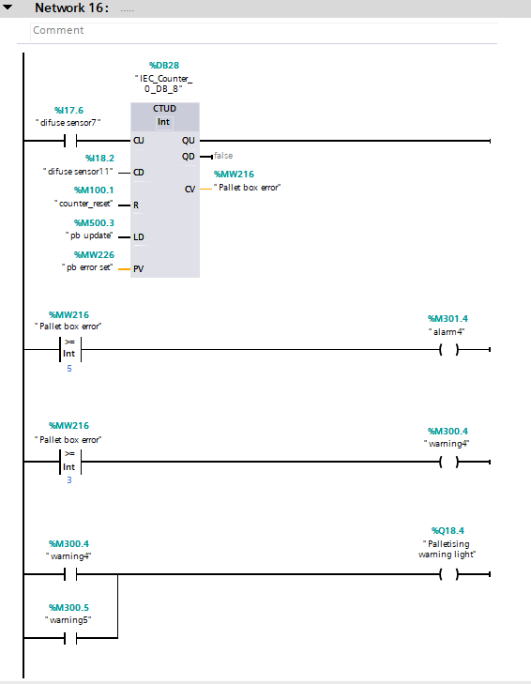
Network 14 shows how the error and warning for the small box is calculated and shown. This is done by using a CTUD function within TIA portal. A CTUD is a count up and count down function which I have triggered by using two sensors. ‘Diffuse sensor6’ is the count up part of the function and is at the start of the conveyor and ‘Diffuse sensor9’ is at the end of the line for the count down for the function. This ensures the box has reached the conveyor and has reached the end of the conveyor. If the box has fallen of the conveyor, then it will not count down. If the CTUD function is over a count of 3 then it will bring up the warning for the small box count. This will also trigger the ‘small box warning light’ showing the engineer where the boxes are falling off. If the CTUD count is equal to 5 or more then it will set of ’alarm 2’ stopping all conveyors. As shown in the screenshot above the CTUD function also has a ‘sb error set’ going to the PV slot and a ‘sb update’ going to the LD slot. This allows the engineer to enter an input to trigger the alarm and warnings to ensure everything is operating correctly. The count for the small box can be reset by using the counter reset button on the panel or the HMI as shown by the ‘counter reset’ tag going in to the R slot of the CTUD function. Network 14 also shows how the warning light triggers the warning light when ‘warning 5’ occurs which is a total box error meaning boxes are falling off more than one conveyor. This type of program is then repeated for networks 13, 15 and 16 for the Large, medium and palletizing box as shown above.

Network 17
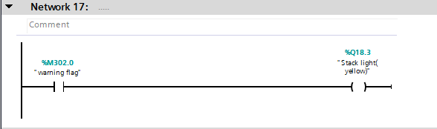
Network 17 shows the warning flag bringing on the yellow light on the stack light. This means if a warning has occurred then the yellow light will come on indicating so.

Network 18
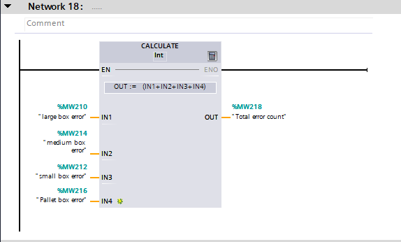
Network 18 shows how the total error count is calculated. The total error count is the total number of boxes that have not made it to the end of their respected conveyor. This is done by taking the individual error counts from networks 13, 14 15 and 16 and inputting them in to the calculate function block. The calculate function block Is set up to add all of these inputs and give the total as the output which is the total error count.

Network 19
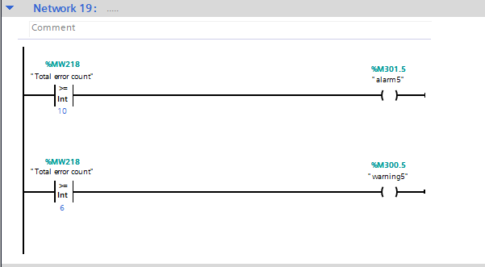
Network 19 shows how the total error count triggers the alarm and warning. As shown in the network above if the total error count is equal to 6 or above then it will trigger warning 5. If the total error count is greater or equal to 10 then the alarm will get triggered stop the factory.

Network 20
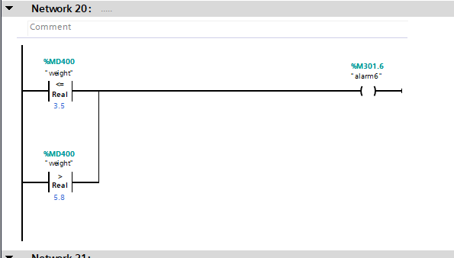
Network 20 shows how the alarm is triggered if a box is underweight or overweight. As shown from the screenshot of network 20 above the ‘weight’ tag is used with along with a less than or equal to for the underweight and a greater than for the overweight. If the weight is less than or equal to 3.5 or greater than 5.8 then it will trigger the alarm and the stopping the machine. This will then allow the engineer to identify what the issue is for example a wrong box has gone down the line.

Network 21
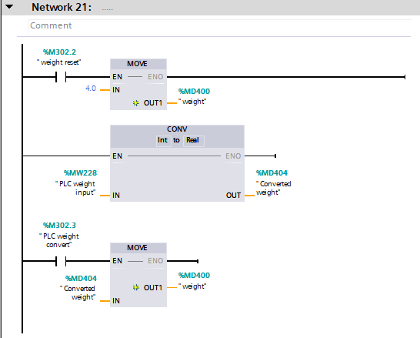
Network 21 shows how the engineer can reset the weight after the alarm for it has been triggered. This is done by the use of the weight reset button on the engineers’ screen on the HMI. When the weight reset button is pressed it will set the weight back to 4 which is in the acceptable range. The move function block which allows you to input a value and move it to a tag. After the weight has been reset to an acceptable range, the master alarm can be reset using the master alarm button on the HMI and the factory will be able to start up again. The second half of network 21 shows how the engineer can input a value for the weight to ensure everything connected to it such as the stack light and alarms are working as they should be. This is done by using a CONV function block which is set up to convert the int inputted on the HMI to a real data type. Once the weight has been converted the button can be pressed on the HMI which will close the ‘PLC weight convert’ contact allowing the MOVE function block to transfer the inputted on the HMI to the ‘weight’ tag.

Network 22
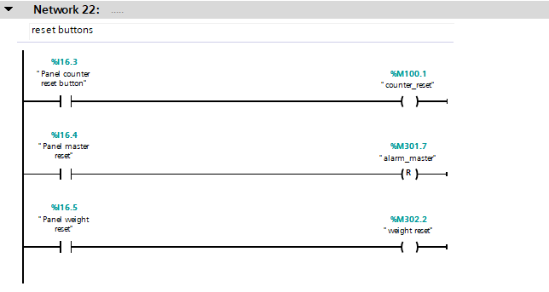
Network 22 shows how the engineer can reset the counters, alarm master and weight from the buttons on the main panel. When the buttons on the panel are pressed it will close the circuit for the and allow the signal to reset the respected output.

HMI

Root screen
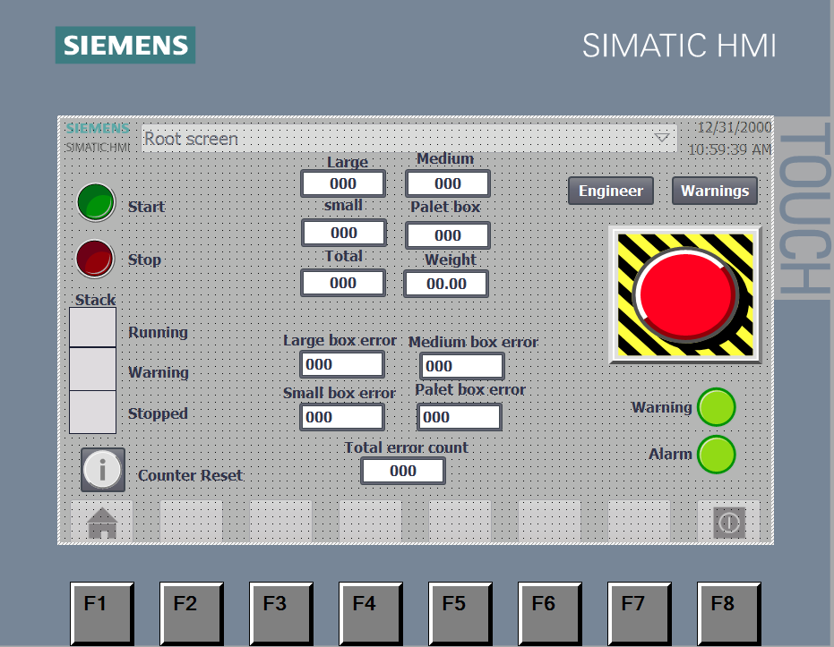
The root screen is shown above this is where the operator/engineer will run the machinery. There is a start and a stop button to run the machine, if the machine is running then the respected stack light will turn green indicating this. If there is a warning triggered in the factory the warning light on the HMI will illuminate yellow showing this. If the factory has got an alarm or the stop button has been pressed then the stopped light will illuminate red to show this. The root screen also has counters for each individual box and a total box counter to show the operator /engineer how many boxes and what size have been put on the start of the conveyor. The counter reset button on the bottom left of the screen which will reset the values of the counters and errors. There is also a weight display to show the operator/engineer the weight of each box that goes on the scale conveyor. The weight display has also been added as a fault-finding aid as it can show whether the alarm is due to an overweight and underweight box. There are also two buttons up the top which will take you to the respected screen. There is an E-stop button which when pressed will raise the E-stop alarm stop the machine. The warning and alarm lights on the HMI will illuminate red when there is a warning or alarm on the system.

Alarm screen
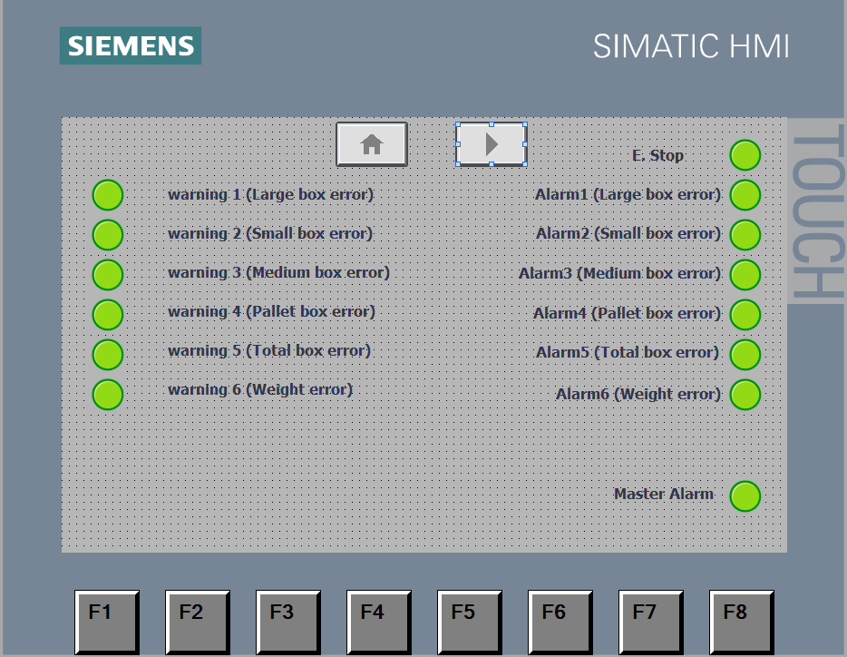

This is the alarm screen for the HMI, the green lights will turn red when the error or alarm has been raised. These can be reset on the engineers’ screen using the aster alarm reset. The screen also has navigation buttons on the top so you can access the root screen and engineers’ screen.

Engineers’ screen
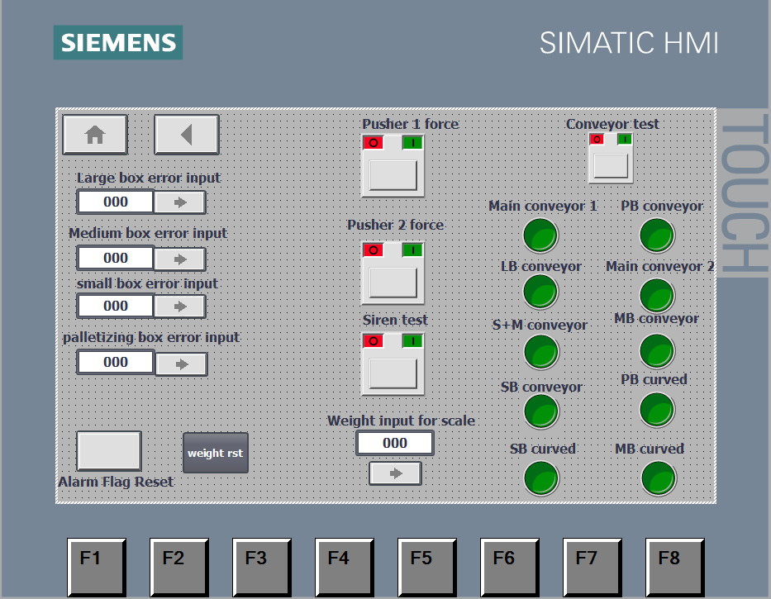
This is the engineers’ screen on the top left there is navigation buttons so the other screens can be accessed. There is an error input for each box which allows you to test the function of the alarms and warnings for each box. There is an alarm reset and weight reset button which will clear an alarm, warning and put the weight back in to an acceptable range if a problem occurs. There are buttons to force and test the operation of both pushers and the siren. The weight input for scale allows you to test the functions connected to the scale conveyor such as the display screens and alarms. The conveyor can also be individually turned on and tested using the conveyor test button and the individual conveyor button.

Factory I/O screenshots

Factory overview
The screen shots below show an overview of the complete build and layout of the factory. Guards have been placed around the for-safety purposes with safety doors to provide access for the engineers if an alarm was to go off. A small rail has been put in place Infront of the main panel so it can be easily accessed if needed.
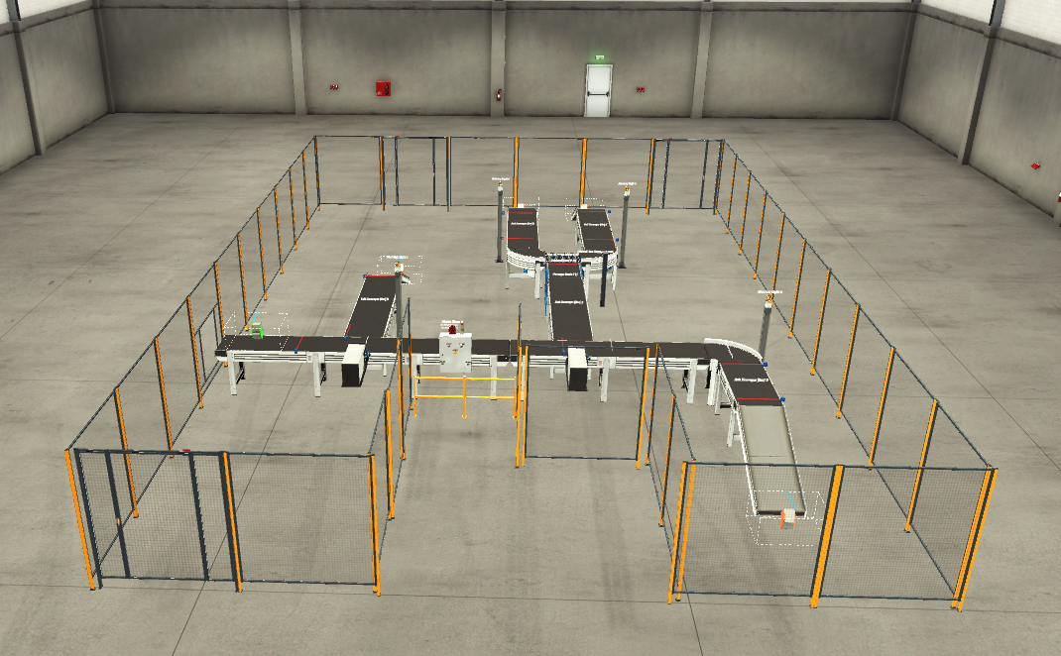

Main panel
The screenshot below shows the main panel for the factory. It has a siren which will alarms when the start button is pressed to indicate to the people in the factory the conveyors are starting. A stack light to indicate the state of the conveyor whether it is running stopped or has an alarm present. The panel also has stop, start and an E-stop button so the operator can access these functions from the panel. The reset buttons for the weight, master alarm and counter reset have also been added to this panel so they can be accessed from the panel. The panel also has a weight display to show the operator/engineer the weight of the boxes, this has mainly been put on the panel as a quick check for fault finding as it will give a clear indication if the machine has stopped due to a box being under or overweight. It will also show that the alarm has been reset correctly if the button is pressed to do so.
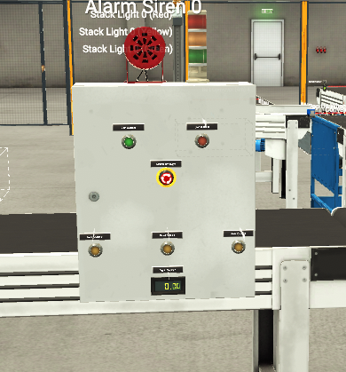

Large box line
The screenshot below shows the setup for how the large boxes are sent down the correct line. The sensor to the left of the pusher is the one that triggers the pusher to say it is a large box. It has been placed at a height where it is only triggered by large boxes. The pusher will then push the box down the line and the sensor on the end of the line will confirm the box has got the end of the line. The warning light will flash when there is a large box or total box error and alarm.
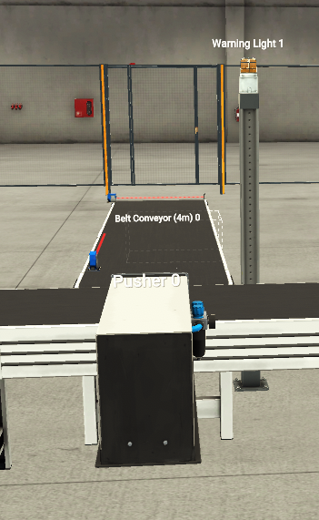

Small and medium box line
This is the medium and small box line the sensor will trigger the pusher when there is a small or medium box. The box will then be wayed by the scale conveyor to determine whether it is a small or large box and send it either right or left using the pop-up conveyor. the sensors will then let the program know that the boxes have made it to the end of the lines. the warning lights have been put in place to show if there is any alarms or warnings present on these lines.
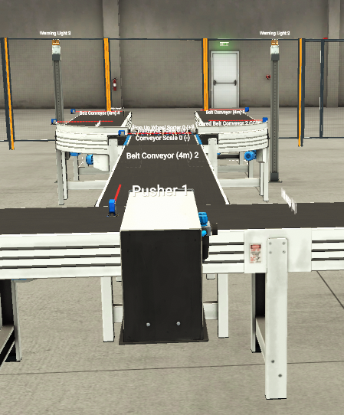

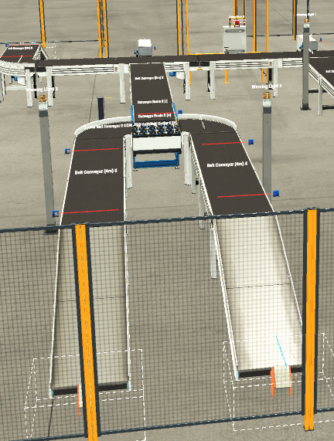

Scale conveyor
The screenshot below shoes the scale conveyor where the small and medium boxes are weighed. There is also a weight display to show a visual of the weight to the operator/engineer.
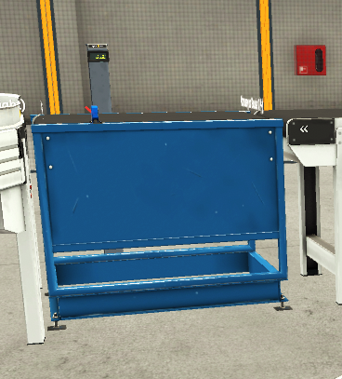

Pallet box line
This is the pallet box line there are two sensors present to ensure that the box makes it to the end of the line. There is a warning light present to show if there is any alarms or warnings present on this section of the factory.
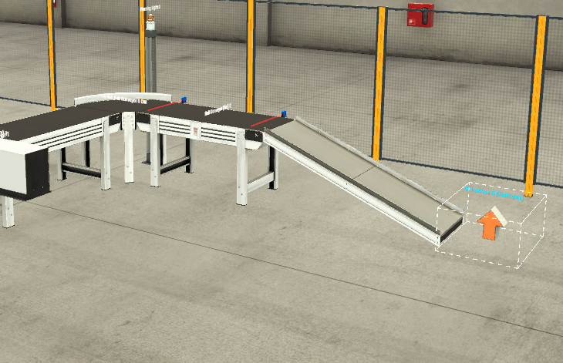

Tag table
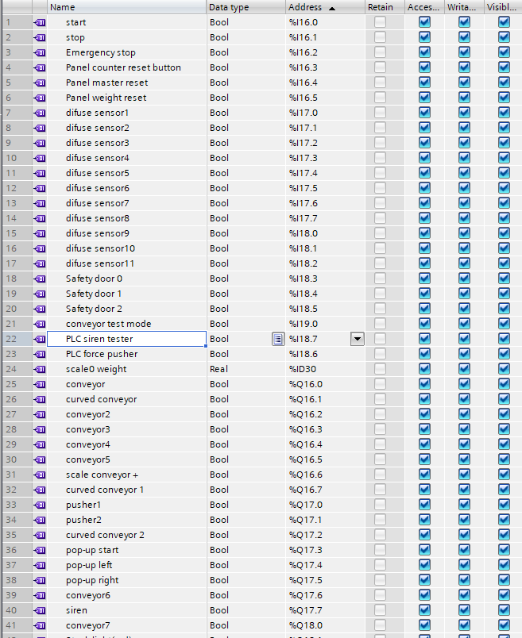
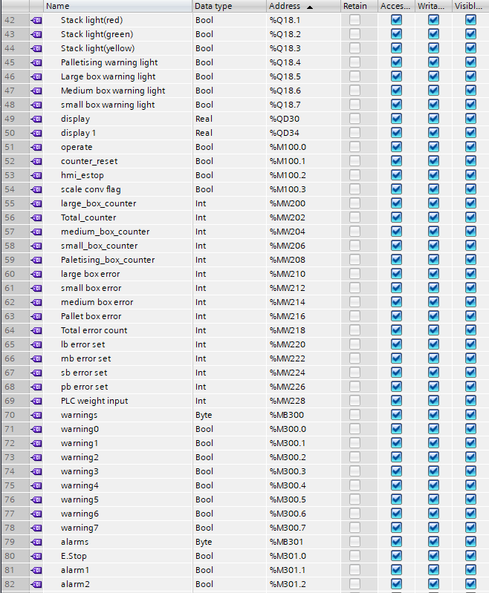
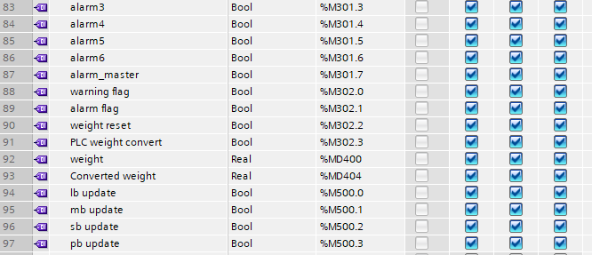

Flow charts

Large box flowchart
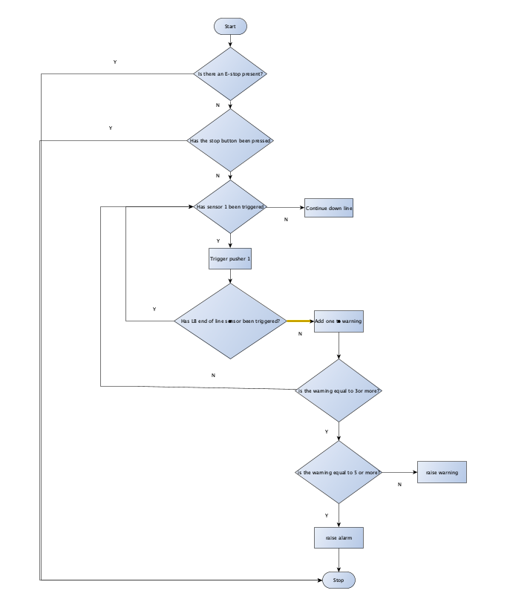

Small and medium box line
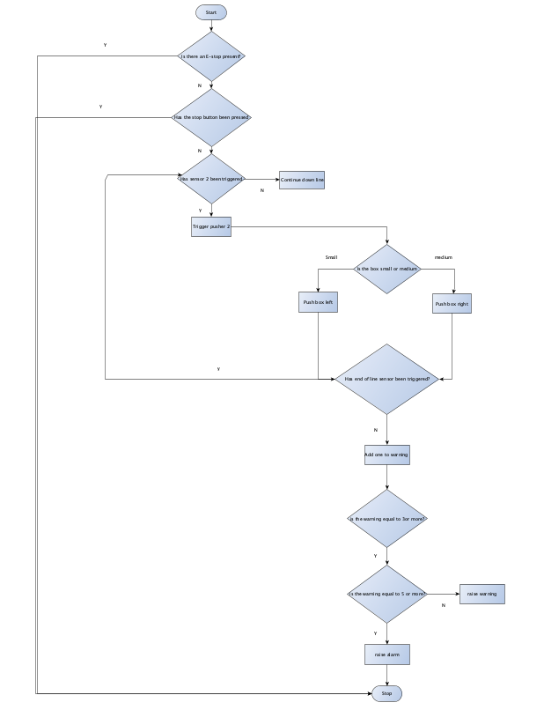

Pallet box line
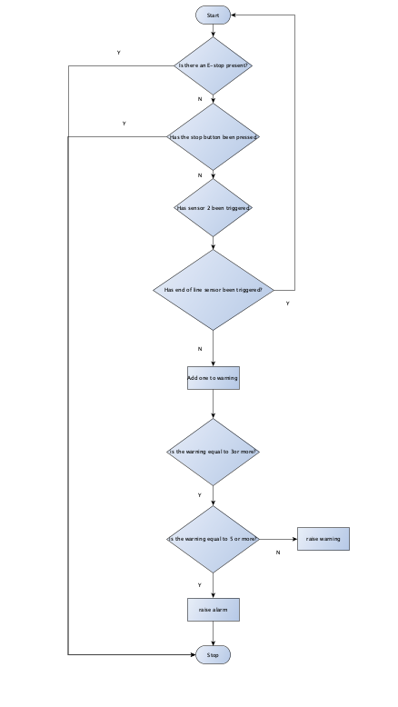

Conclusion
Overall, the factory built meets the specification and criteria needed however, there is still some improvements that could be made to the build and the program. The first one being another stack light could be added to the weight scale conveyor. This would be a good indication to the operator or engineer if there is an issue with the scale conveyor. The green light would illuminate when the weight is in an acceptable range and illuminate red when it is out of range. The yellow light could indicate that the conveyor is calculating the weight. Another addition that could be made to the build would be the introduction of guard rails to the conveyors this would reduce the possibility of boxes falling of the lines when they get pushed on to the lines by the pusher or scale conveyor. An improvement that could be made to the HMI would be the addition of password protection to the engineers’ screen this would introduce another element of safety to the program. Another improvement that could be made to the program would be the ability to adjust the range of the errors through the engineering screen, this would allow for more flexibility with in the system.

Bibliography

[1] | S. s. Michael, “Control automation,” 10 March 2022. [Online]. Available: https://control.com/technical-articles/what-is-a-plc-an-introduction-to-programmable-logic-controllers/ . [Accessed April 2024].
[2] | Plant automation, “An Overview of Programmable Logic Controllers (PLC),” [Online]. Available: https://www.plantautomation-technology.com/articles/an-overview-of-programmable-logic-controllers-plc .
[3] | R. Phillips, “What are the different types of PLC?,” 8 Novemeber 2022. [Online]. Available: https://basicplc.com/different-types-of-plc/.
[4] | G. Aggarwal, “6 Types of PLC And Their Outputs,” [Online]. Available: https://trainings.internshala.com/blog/different-types-of-plc/.

