

Student name: | Theresa DARZINS | Student ID number: | 1909721
Programme: | B.Sc HND Computing
Module: | Learning in the Digital Era
Module code: | ACCA4025
Lecturer: | James Williams
Assignment Title: | Assignment 2: Personal Development Plan
Submission deadline: | Thursday 7th January 2021

TABLE OF CONTENTS

 | Links and Screenshots | Page
 | link  https://youtu.be/NzlswT-2CxM | 3-12

Slide | Description | Speech
1 | 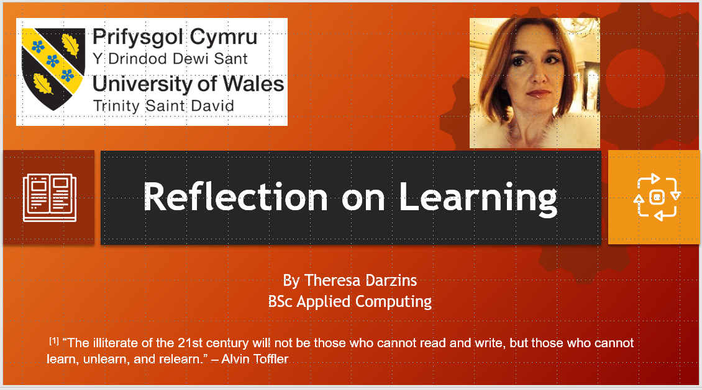
 | TITLE | Hello - my name is Theresa Darzins and I am a Computing Student at the University of Wales Trinity St. David.  Alvin Toffler stated:  “The illiterate of the 21st Century will not be those who cannot read and write, but those who cannot learn, unlearn, and relearn”.  This, I feel, is especially relevant when technology is changing at such a fast pace in this new Digital Era.

2 | 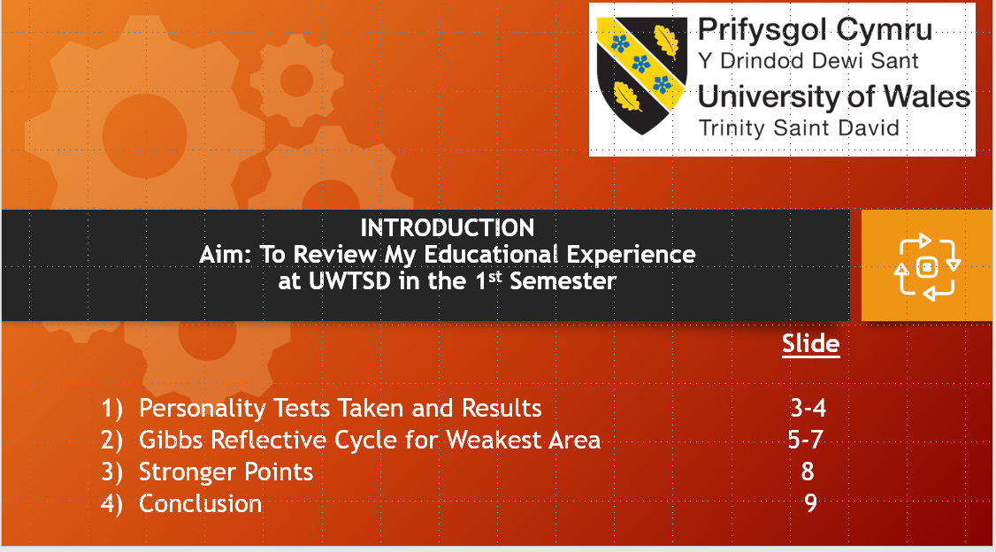
 | INTRO | My Aim is to analyse strengths and weaknesses that I have discovered about myself during the last four months whilst studying at University in the first semester  I have split this into 4 Sections:  - The tests taken and results 3-4  - Gibbs Reflective Cycle for my weakest area 5-7  - The Strengths I can capitalize on 8  - The Conclusion 9

3 | 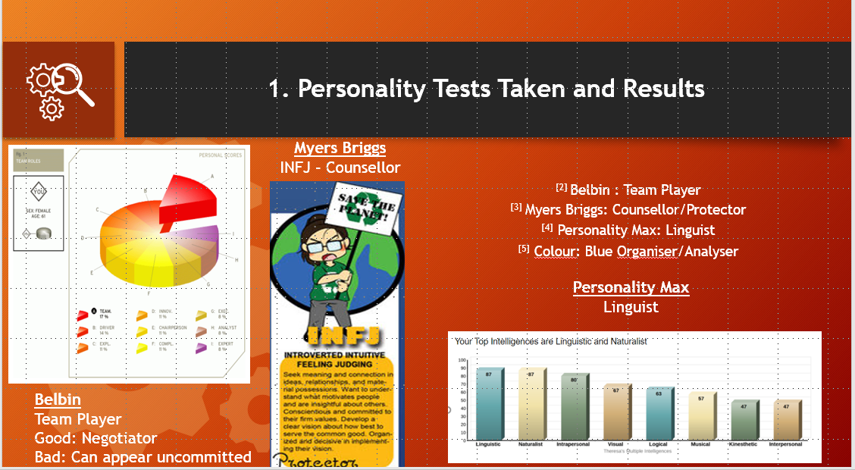
 | - TESTS TAKEN AND RESULTS | I did four tests:  - Belbin, said I am a good negotiator  - Myers Briggs, said I would make a good counselor as I’m empathetic  - Personality Max identified linguistic skills, and  - Colour Test pinpointed that I’m good at organisation and analysis

4 | 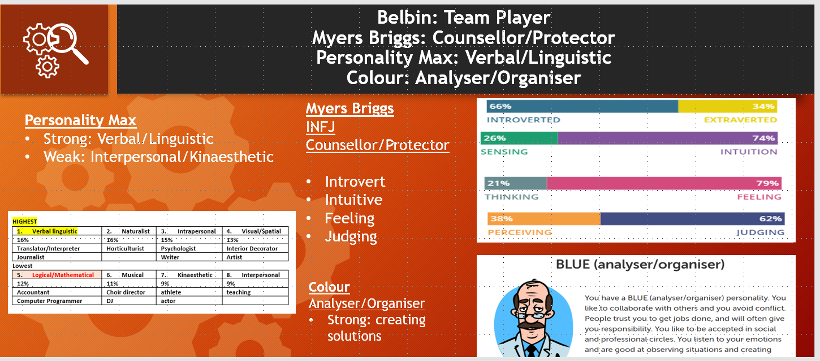
 | BELBIN: Team Player  MYERS BRIGGS: Counsellor/Protector  PERSONALITY MAX: Verbal/Linguistic COLOUR: Organiser/Analyser | The Belbin Test identified my mathematics concerns, but this was only ranked number 5 out of 8 categories.

5 | 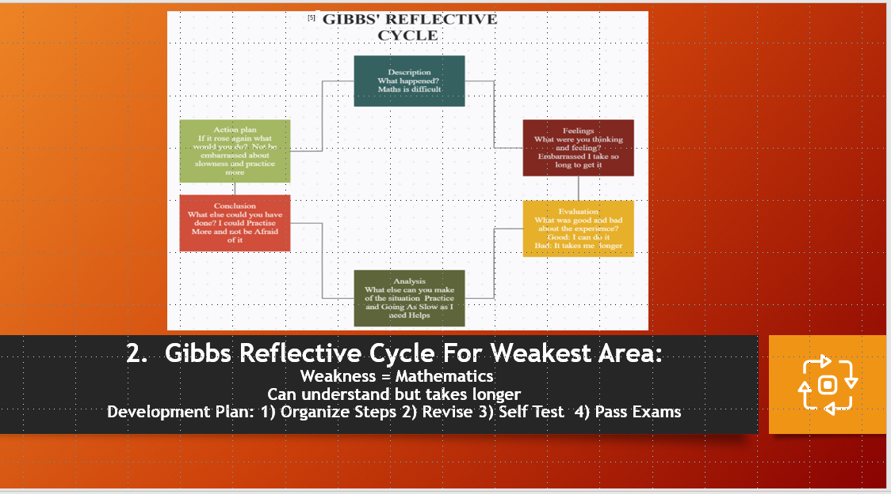
 | - GIBBS REFLECTIVE CYCLE | The Gibbs Reflective Cycle Identifies how I plan to remedy my weakest point of mathematics.  I have to get out of the way of myself and get over the embarrassment it takes me longer to understand, and:  - Organize Steps  - Revise  - Self-Test in order to commit the processes to long term memory

6 | 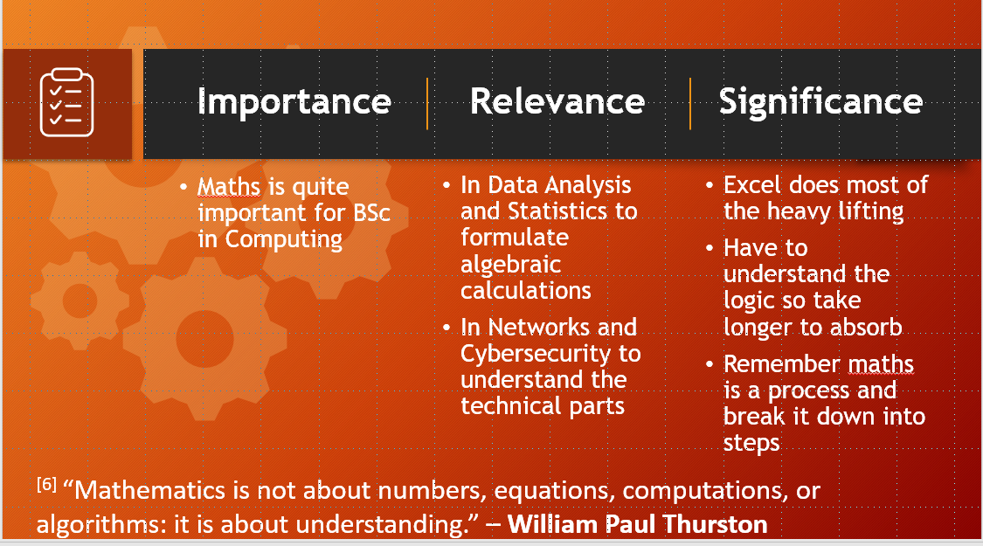
 | IMPORTANCE  RELEVANCE  SIGNIFICANCE | This is significant as mathematics is very important for both Data Analysis and Networks and Cybersecurity.  Manipulating Excel charts was enlightening – I just wish I was faster at it.  I take heart in the quote by William Paul Thurston that:  “Mathematics isn’t About numbers, equations, computations or algorithms – it is about understanding”.

7 | 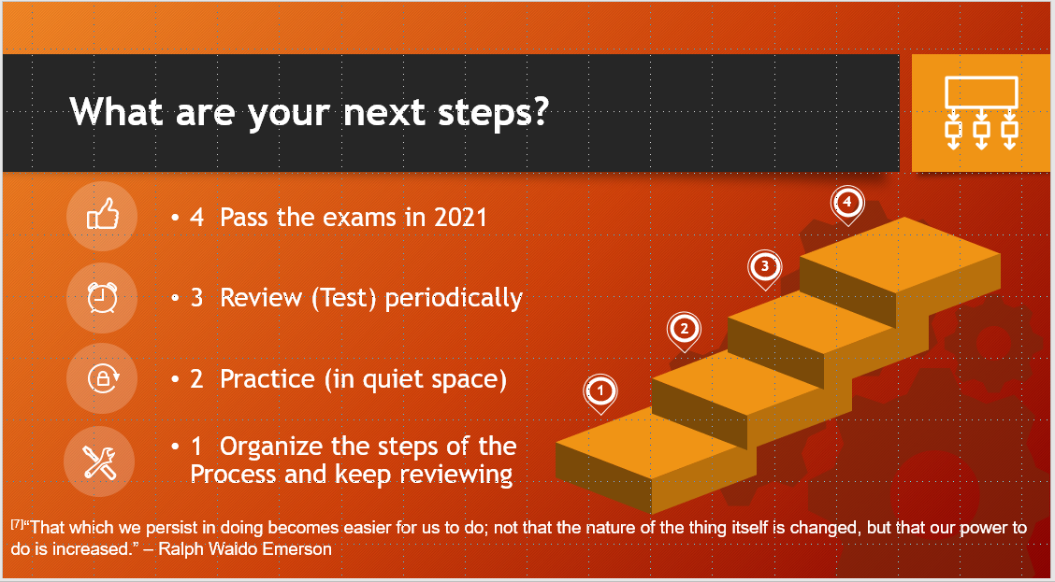
 | WHAT ARE YOUR NEXT STEPS? | The steps I am taking as a result of this learning experience are:  - To organize the steps of the process and keep reviewing them  - Practice them in a quiet space which I need to concentrate  - Test myself periodically to ensure the processes committed to long term memory  - And finally pass the exams in 2021  This quote by Ralph Waldo Emerson could be shortened to:  practice makes perfect

8 | 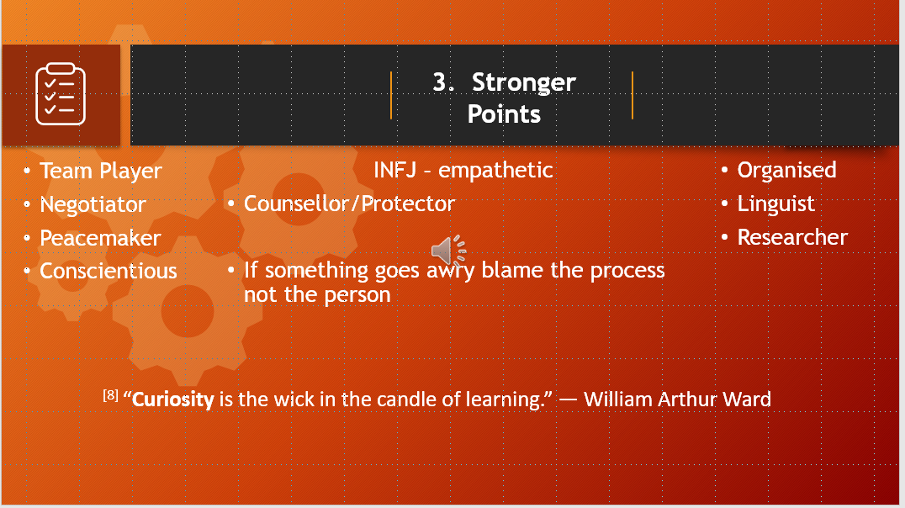
 | - STRENGTHS | Skills I can bring to the table are that:  - I am a Team Player and  - am empathetic;  - I will always try to improve the process (not blame the person) when things go wrong  - And I like to get a good idea of the big picture before I embark upon a subject so I can fully research it.  To quote William Arthur Ward:  “Curiosity is the wick in the candle of learning”.

9 | 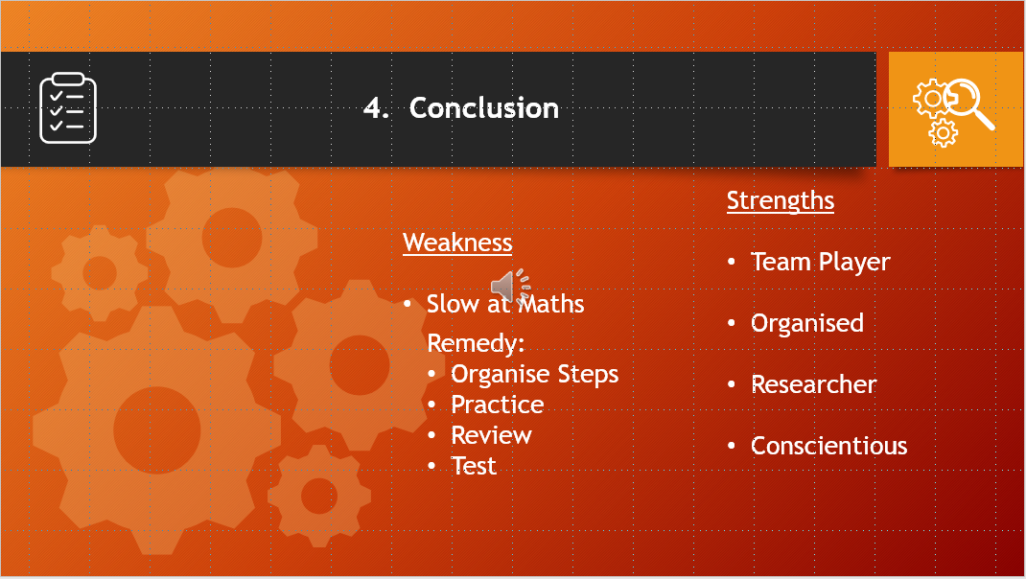
 | - CONCLUSION | The conclusion is that my weakness mathematics can be remedied with:  - organisation of the processes,  - Practicing, reviewing and testing.  Stronger points are that I am:  - a team player,  - organised,  - an avid researcher and  - conscientious.

10 | 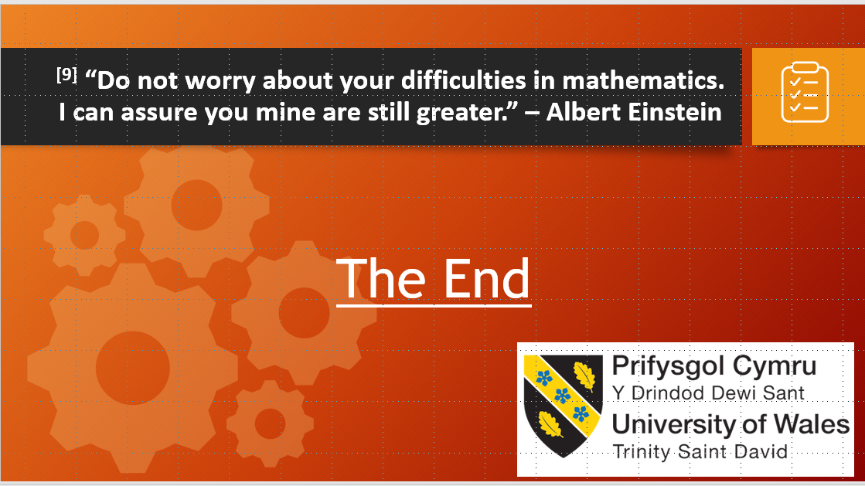
 | THE END |  | I feel have learnt a lot in this first Semester at the University of Wales, Trinity St. David, and I leave you with this quote –  “Do not worry about your difficulties in mathematics. I can assure you mine are still greater.” – Albert Einstein  Thank you for listening.
11 | 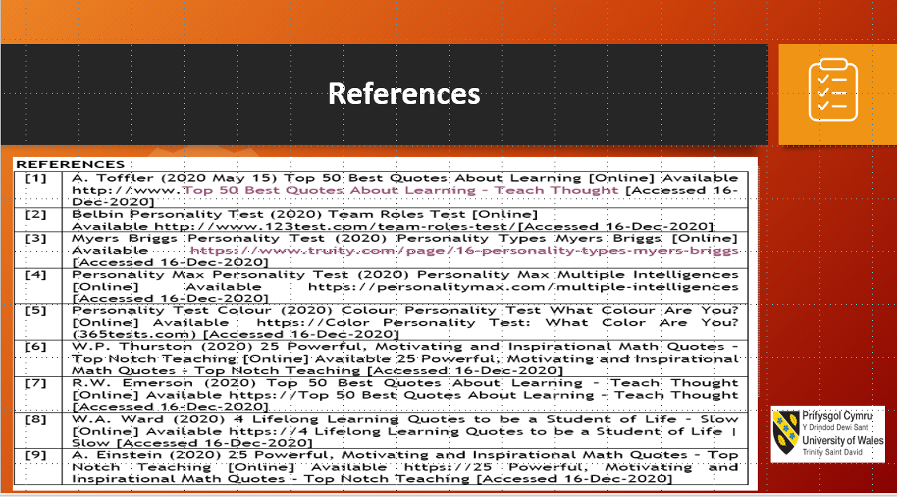
 | REFERENCES

