Question 1:1000 words - Understanding the role of Constable/Maintaining Professional Standards
Critically evaluate the concept of ‘the professionalisation of the police service’ considering how ‘Maintaining Professional Standards’ ‘ethical and inclusive’ and ‘Coaching and Mentoring’ approaches contribute to this.
In this answer I will evaluate the strategic drivers for professional policing and evidence successful strategies used in maintaining professional standards including elements that deal with ethics and inclusivity as well as coaching and mentoring.
The Policing Vision 2025 (NPCC 2016) outlines the National Police Chief’s Council and the Association of Police and Crime Commissioners role of policing over the next few years. Amongst the ideals listed include improving local policing so that it is tailored to societies complex and diverse needs. The strategy states the importance of creating a representative and professional workforce and that there is accountability in policing to maintain public confidence. This strategy has developed the historical concepts in the policing model within the UK since ‘Peelian Principles’ (Lentz 2007) were first introduced in 1829. A desire to develop professionalism within policing has developed over time due to societal changes and incidents which has seen the public perception of policing tarnished.
Recent incidents including the murder of Sarah Everard (Wright 2021) and officer misconduct involving the Nicole Smallman and Bibaa Henry killings (Dodd, 2021) highlight the deficiencies that currently exist within UK Policing. Some theorists (Beighton 2021) have argued that these types of incidents leave the public with a devastating lack of trust in the police which can have serious implications on those trying to enforce the law. Studies have developed this problem (Waters et al, 2007) explaining that there is a lack of public trust in policing, largely because a fully representative police service does not exist. This seems at odds with the Peelian principles and the code of ethics which lay at the heart of the UK Police Service.
Some academics have questioned whether Peelian principles are enough to drive the professionalism of policing. In a recent study (Loader, 2016) It was debated that Peelian principles needed to be recast to fit an aspirational style of ‘civic policing’. This model would entail principles in which the police service would actively listen to the demands of its citizens and there would be much stronger levels of public oversight. The Service would be compelled to tell their citizens ‘What they are doing as they govern us’ (Dunn 1999). Alternatively, it is debateable if we can discard these Peelian principles completed (Emsley 2013). The overriding principle of policing by consent and the notion that ‘the police are the public and the public are the police’ have been successfully transcribed to most modern, liberal, democratic state. However, as the Policing Vision for 2025 has shown, these Peelian principles alone are not sufficient to improve the professionalisation of the police force. A crucial step in maintain professionalism in the service is the maintenance of professional standards.
Studies have shown (Sunahara 2004) that police officers are susceptible to acting unethically. The study examines that a hostile working environment and a subculture in which loyalty is viewed as instrumental can lead to unethical behaviour. Other investigations (Chan, 1996) have identified shared values within the police have led to officers placing loyalty ahead of integrity which can perpetuate corruption. It may be argued however that the organisational culture within a modern police force has changed in recent years to deflect this issue of integrity. A more recent study (Biggs, Chataway and Barbour, 2016) suggests the organisational structure within policing has now adapted to reflect that there is more scrutiny and less social rituals thus reflecting the fact that policing professional standards are being abided by more prevalently. I would therefore argue that the structure of the modern service is more in line with professional standard requirements than ever.
Another feature of a professional service is how ethical and inclusive it is. The future strategy is to create a service that is representative to improve public confidence. In terms of ethnicity, Police services in England and Wales are below the representative population number as seen in the graph.
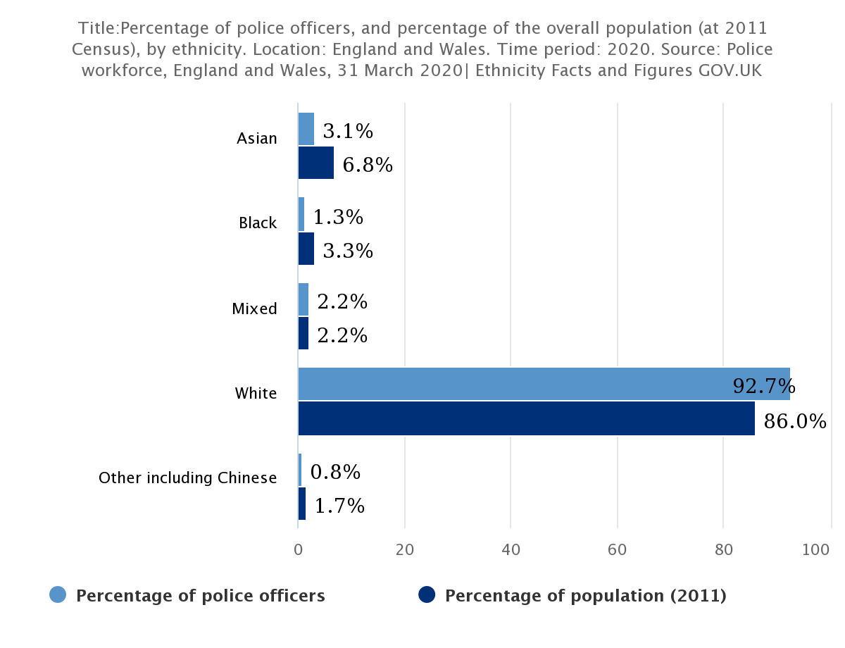(gov.uk 2021)
This under-representation adds to hostility that many ethnic groups feel toward the Police. Research (Waters et al, 2007) suggests a solution lies in not only improving recruitment campaigns to minorities but also improving the quality of service performed by police to these local communities. Furthermore, it has been commented (Jain, Singh and Agocs 2004) the legitimacy and effectiveness of the police rely on the acceptance of, and cooperation with, the community. Community policing is a vital part of making the police service more inclusive and tailoring its service to the local communities needs. This argument has developed (Bain et al, 2014) in the fact that it is a lack of communication between local police forces and the local community that results in poor perception of the police by the community.
Another development in the professionalism of the service is the emphasis placed on coaching and mentoring. Research (Goggin et al, 2015) has shown that further education and enterprise engagements as part of a career have the potential to deliver benefits for learners and institutions. The Policing Vision 2025 (NPCC 2016) concluded that the police service would look to support police education and professional development, so the service recruits a representative mix of people with the appropriate knowledge, skills, and experience. This decision has created the Policing Educational Qualifications Framework within the England and Wales Police Service. This program places tertiary education in the centre of all aspects of learning within the organization. Some authors (Wood, 2020) have argued the PEFQ will be a beneficial opportunity for the police service to engage with communities by employing knowledgeable officers who understand their professional role within society and respond to the demands faced by officers in appropriate ways. Others (Wood & Williams, 2016) have given a dissenting opinion on the adoption of the PEFQ method, particularly with the stipulation that every new officer is to be educated to degree level. At this early stage, it is difficult to ascertain if the PEFQ program will succeed in using coaching and mentoring to improve the professionalism of the police in the way that The Policing Vision 2025 stipulates. It is worth noting studies (Heslop 2013) that show there have been major changes to police training every 5 years so the certainty of the future of the PEFQ program is not concrete.
To conclude The Policing Vision 2025 has illuminated a path for a more professional police service by implementing changes to coaching and mentoring, with efforts being made to make policing more ethical and inclusive and strategies to maintain professional standards. However as recent studies have shown, together with high profile cases of police misconduct, there is still a long way for policing in the UK to go.
WORD COUNT 1100

Question 2: 1000 words - Community/Response Policing/Policing roads/Conducting Investigations /Digital Policing
Critically evaluate the role of the police in:
• Conducting Investigations (Volume, serious and complex)
In this answer I will critically evaluate the role of police in conducting investigations. I will examine and explain the differences between investigations involving volume crime and serious and complex crime.
There are many differences between volume crime and serious crime involving complex investigations. Volume crime is defined (College of Policing 2019) as crime which, through its sheer volume, has a significant impact on the community and the ability of local police to tackle it. Volume crime involves such acts as criminal damage, theft, and common assault. The remit for investigating volume crime is set by the local basic command unit in that area and usually local response officers that have received sufficient training would be expected to investigate. The training involves being trained in the Professionalising Investigation Programme to level 1 status. This level of training, introduced under the remit of the national policing crime business area (CBA) portfolio, maintains that officers conduct investigations professionally, to an agreed standard and ethically.
Serious and complex crime has been identified through legislation (Serious Crime Act 2007). In serious and complex crimes, officers are utilised with the higher PIP Level 2 or 3 level of training. The investigator is trained on using a variety of investigative approaches to gather material with a view of achieving an outcome. The victim is placed at the centre of all actions and decisions. The investigation of serious and complex crimes involves significantly more recourses. It may involve the deployment of a team of detectives and even specialist investigators and intelligence operatives.
Historically police officers have been criticised in the manner that they have conducted investigations which has led to several miscarriages of justice. These prominent cases such as the Lynette White case (BBC News 2001) have exposed critical flaws in the police investigation system which applied to complex and volume investigations alike. Increased media and public focusses on these miscarriages brought about extensive reform to legislation (Griffiths and Milne, 2018) which has significantly improved and professionalised the investigative process. Such legislation includes but is not limited to The Human Rights Act (1998), PACE (1984) and the Regulation of Investigatory Powers (2000). It has been debated by many however that despite improved legislation, there is still a failing within the police investigations which is still providing miscarriages of justice.
Research provided on miscarriages of justice (Huff and Killias, 2013) provide that most commonly it is the interview process in which most problems arise. The College of Policing has created some Principles of Investigation (College of Policing, 2019) amongst which is the principle that the exercise of legal powers should not be oppressive and should be proportionate to the crime under investigation. This principle is underlined by legislation that deals with the interview stage of the investigation, in particular, The Police and Criminal Evidence Act. (PACE 1984) Recent research (Poyser & Milne 2021) has suggested that the contribution of psychological research was vital in bringing about this reform to the investigative process. The article found psychological research revealed that investigators’ focus on getting a confession rather than conducting a neutral search for information was leading them to engage in overbearing questioning to manipulate suspects and exploit vulnerabilities (Hilgendorf and Irving, 1981)
It is also of interest however that even after legal reforms were introduced, The Police Service has been criticised for its handling of investigations. Following PACE, the number of criminal appeals featuring police impropriety has dropped significantly (Sanders et al, 2010) however it may be argued that the mindset of officers was difficult to change. Research completed after PACE was introduced found that some officers adopted methods that discouraged suspects from asking for a solicitor (McConville and Hodgson, 1993) and working around rules by framing ‘off the record’ interviews as welfare interviews (Bottomly et al., 1991). A reform in the way that officers where trained was viewed as a solution to changing this old mindset. Initially the PEACE model (below) was introduced which began a successful process of improving the ethical approach to interviewing (Walsh and Bull, 2010)
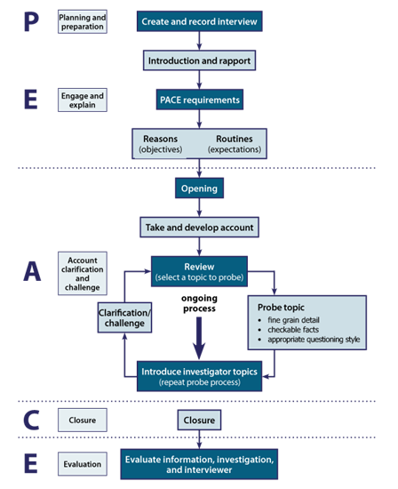(College of Policing,2019)
Later the Professional Investigation Programme (Centrix 2005) was created as a way of increasing the professionalism of all investigators. This five-tiered approach to training would benefit new recruits who would be responsible for investigating volume crime as well as specialist investigators responsible for examining serious and complex crime. It has been argued (Poyser & Milne 2021) that this approach has vastly improved the quality and ethical fairness of investigations as it improves care to those suffering vulnerabilities as well as improving accuracy in information gathering. Some have argued however (Milne et al, 2019) that despite being trained in all aspects of the PEACE mnemonic, some components of it are rarely used. It is hard to argue however with research (Milne 2019) which has shown a dramatic improvement in the professionalism of police investigations in both volume crime and complex investigations due to these reforms.
To conclude I have examined the differences between volume crime investigations and serious and complex criminal investigations. I have evaluated the problems that exist within police investigations and in particular the issues that have developed around police interviews which have led to so many miscarriages of justice. I have analysed that due to reform involving legislation and specialist training, the investigative process has slowly improved over time. These improvements, in particular the standardisation of improved interviewing training including PIP and the adoption of the PEACE mnemonic have led the way in this development, however there is still significant room for enhancement.
WORD COUNT: 920

Question 3: 1000 words - Information and Intelligence/Communication Skills
Critically evaluate the methods used by police in gathering information and intelligence, how information contributes to the ‘tasking and coordinating’ process and how information and intelligence is communicated.
There are many methods used by police forces to gather information & Intelligence. These methods are used in accordance with legislation including the Security Services Act (1989) and The Regulation of Investigatory Powers Act 2000 (RIPA). The methods range from Collection, which might include routine collection. This is information that the police would collect as part of an ongoing operational police activity. Tasked collection may also be utilised. This is when there is a prioritised collection of information this may take the form of the use of a Covert Human Intelligence Source (CHIS) or surveillance using open sources.
A CHIS is defined in legislation (s26(8) RIPA 2000) as a person who establishes a relationship with a person for the covert purpose of obtaining information or providing access to information to another person or disclosing information obtained by such a relationship. The uses and success of using CHIS informants has come into conflict recently. (Licate 2010) It was discussed that the use of a CHIS countered the legitimacy of a Police service in a democratic nation. It was argued that using such techniques that relied on deceit could undermine the ability to gain information and co-operation from the community. However, this argument is countered (Billingsley, 2009) by those that suggest that due to regulation under RIPA and the Human Rights Act 1998, the use and management of informers is much more transparent and is even monitored by the office of Surveillance Commissioners and the Audit Commission.
One critical element of the success of CHIS sources to gather intelligence is the relationship between the source and the handler. Research has provided (Henry et al 2020) that the selection, recruitment, and training of officers to become handlers is vital in managing the risk associated with human source work. The risks involved may be risk to the source if his identity became known (Rosenfeld et al 2003). There is also risk to the police service (Harfield, 2012) as they must not only assure the personal safety of the source and the handler but also avoid organisational corruption when adopting sources. Unfortunately, the training of source handlers is a new process. Research (Henry et al 2020) centred on examining CHIS handlers and found that many stated that attributes required for effective handling are dispositional and not amenable to training. This develops the historical idea that human source handling is an ‘art’ or ‘craft’ and cannot be trained. (Tong & Bowling 2006) This argument again throws into doubt the ethical suitability of using a Covert Human Intelligence Source. This practice encourages secrecy in the role and shows a lack of transparency. Until the nature of this training is clarified, the utilisation of a CHIS may be a useful but unethical method of gathering police intelligence and information.
Using Open Sources as a route of gaining information is a method of accessing publicly available information to gain knowledge and understanding in support of preventing crime. One of the biggest strengths of utilising open sources (Stainforth 2017) is that it adds value to police operations in the ability to obtain timely, dependable, and actionable intelligence related to the investigation or incident at hand. Critics of open sources have also stated that it is vitally important to determine the data’s source and reliability. Open-source data is therefore useful, however, as of all methods of intelligence gathering as a tool requires objectivity and open-mindedness on both the part of the analyst and the subsequent user (Harfield & Harfield, 2008) This is one of the factors that led the UK Government to create the National Intelligence Model which has acted to professionalise and standardise all manner of police intelligence-related activities.
A key part of the National Intelligence Model is the contributing to tasking & coordination process. This is often overseen by tasking and co-ordination groups as shown in the diagram below.
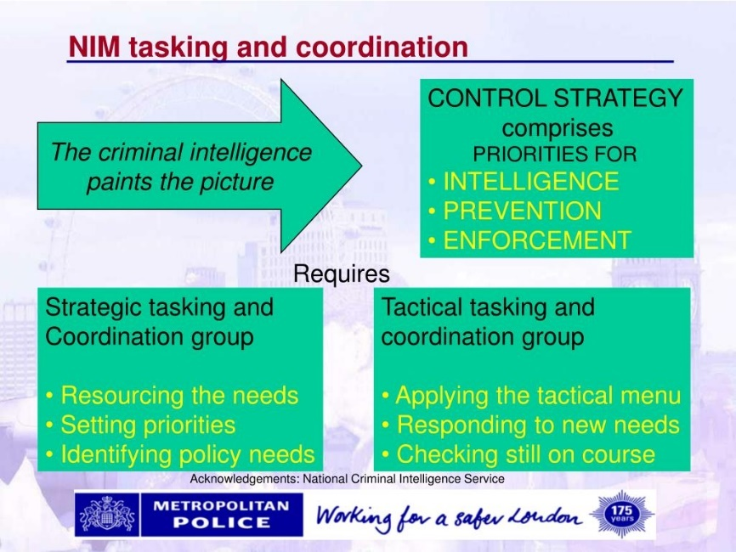
(National Criminal Intelligence Service, 2018)
Intelligence feeds into the tasking and co-ordination process which will then determine what further intelligence work will need to be done and where recourses should be deployed. Some critics have argued however (Gilmour & France, 2012) that the NIM is only as efficient at those at the top making the decisions. They argue that without effective management, the NIM can be process driven and leaders can be merely ‘turning the handle’ of the NIM without engaging with the problems that need to be addressed. They continue that this can be seen with that adoption of verification bias, where ineffective managers simply agree with previous decisions. Other critics argue (John & Maguire 2004) that the model is vulnerable due to its technical language only understood by those privileged with specialist knowledge. This could lead to the model being manipulated by those few at the top. It must be argued however that the model is successful in its ability to use intelligence and factor in resourcing across both a local and national level. A tool even more important to policing during this time of continued austerity. I will now investigate the way that Information is communicated by the police service.
There are many ways in which Police disseminate information. One of the main methods is the holding of a media briefing. The main reasons to hold such a briefing may be to provide information that is in the public interest or to support local or operational strategic directives. This briefing is mostly under the remit of a press officer who will offer a specialist role in providing specialist advice and support on media communications. There has been some debate however (Mawby, 2012) on whether the role of press officer is necessary or fit for purpose. The debate centres on recent reports (Filkin 2011) In the wake of the Levinson Enquiry where it was found that the leaking of information from police to the press presented problems of professionalism and accountability. One solution informed by this debate (Mawby, 2012) would be to remove the role of the press officer and instead provide training and guidance force wide for all officers at any level to be authorised to speak to the media. It is debatable however that the cost in training and developing a substantial number of police officers to become media savvy would outweigh the cost of retaining and training improved dedicated press officers to successfully disseminate information to the media and the public.
In conclusion, I have analysed two methods of gathering information as well as a method of communicating it and have found strengths and weaknesses in all. I have suggested that the NIM, despite some deficiencies is still an excellent model for UK policing.
Word Count: 1099

Question 4: 1000 words - Public Protection
Critically evaluate police strategies for dealing with public protection incidents considering the impact of abuse on victims, the impact personal attitudes and values on the investigative process and the association between Serious and Organised Crime groups and public protection issues.
In this answer I will seek to critically evaluate the strategies used for assessing public protection incidents. I will review the impact that serious and organised crime groups have and how public protections strategies seek to disrupt these activities. I will consider the long term and short-term impacts on victims. I will also analyse how personal values can affect the investigative process
Serious and organised crime groups within the United Kingdom are increasing in size and scope according to research (National Audit Office, 2019) which details there are over 4500 organised crime groups within the UK. These groups participate in the commitment of a multitude of crimes including anything from modern day slavery to child sexual exploitation. Policing in the UK has developed several strategies to limit the impact of these SOCG’s and their effect on public protection issues. Of particular importance for these strategies to work is to consider the effect of the impact of abuse on victims.
Recently there has been great development in re-centring victims of crime throughout the Criminal Justice System. This includes the introduction of a Victims Commissioner and a Victim strategy (Ministry of Justice, 2018) These mechanisms provide short term support for the victim often during the criminal investigation and following it immediately afterwards, however it is arguable that the most impact on the victim is the long-term effect of abuse. In a review of sexual abuse from members of the Catholic Clergy (Benkert & Doyle, 2009) it was found the effects of the damage of exposure only becomes clear to the victim after many years. These long-term effects can include psychological effects such as depression, anxiety, and post-traumatic stress. There are some schemes that exist to help combat these long-term stresses. One such scheme is the ‘Making Safe’ scheme trialled by many different council areas in the UK. This scheme enables victims of domestic abuse to stay in the family home while the perpetrator is forced to move elsewhere. Studies on the scheme (Clarke & Wydall, 2013) show that this enables increased opportunities for victims and their families to engage in recovery work whilst remaining in the family home. Unfortunately, these longer-term solutions are few and far between and there are few policing strategies to combat the long-term effect on victims. Other Strategies exist however that are successful in dealing with public protection incidents.
The Serious Organised Crime Strategy (Home Office, 2018) was formulated following the Strategic Defence and Security Review and the 2015 National Security strategy. The Strategy can be broken down into the ‘4 P’s’ as shown in the diagram below.
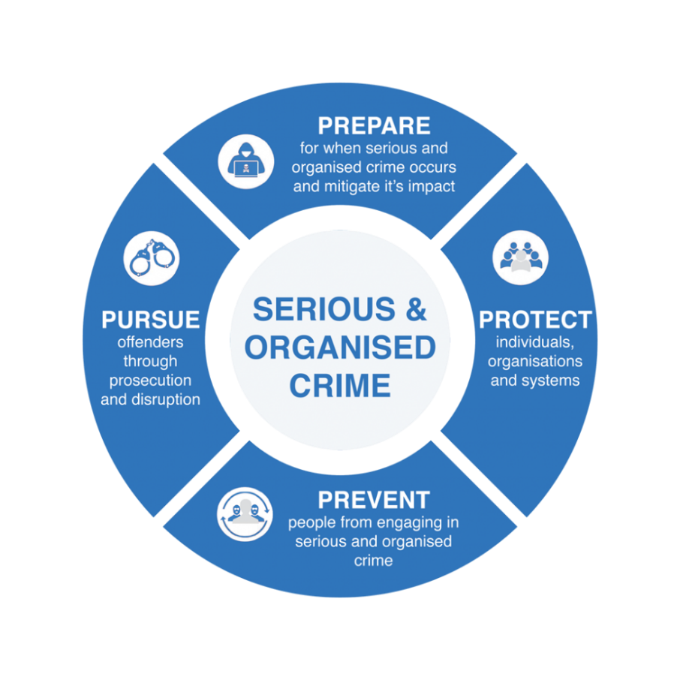
(West Midlands Regional Organised Crime Unit, 2022)
This strategy has been rolled out across UK policing; however, several critics have listed a number of problems.
One recent paper (Crocker et al, 2019) debates that the Government strategy of providing a diverse response to a multi faceted and complex problem of organised crime is a step in the right direction, however problems arise when the prevention strategies have struggled to take shape. The research in this study analysed crime groups in two individual cities and found that preventative strategies in those areas were struggling to have any effect. The main issue being that often there is a lack of support from supporting agencies and the police are left doing the brunt of the work. Unfortunately, the police service is not always the best institution to spearhead prevention strategies and the disengagement of other local partners may directly hinder this strategy. The paper does later argue however that some multi-agency responses in one of the cities was effective. In one case, the local housing authority were instrumental in intervening in shutting down the tenancy of one criminal group. Other research (Bjelland & Vestby, 2017) suggests that inter – organisational and multi-agency responses into organised crime networks can be successful due to their abilities to pool their powers and resources.
Significant research has been provided to examine the effect of personal attitudes and values on public protection strategies. In a 2008 paper (Sutherland & Jones, 2008) research revealed that those working in a culture of high-risk decision making within high priority public protection cases may normalise the risks that they frequently encounter. A term researchers dubbed ‘Risk Fatigue.’ This may be true when professionals in the public protection arena are faced with the same individuals and victims on a regular basis. It has been revealed that, particularly at MAPPA meetings, (Sutherland, 2009) that the continued presence of the same individuals at the meetings may lead practitioners dismissing some cases. It has been further argued (Nash, 2006) that increases in legislation that widen the net to which individuals are brought under the remit of public protection. increase the pressure on agencies to make these critical risk decisions and deepen this level of risk fatigue.
The final strategy I will examine is the Multi Agency Risk Assessment Conference. (MARAC) These meetings take place between representatives of local police, health, child protection, housing practitioners, probation and other specialists who review and share information involving high risk victims of domestic abuse. As discussed, despite personal attitudes being evidenced to creep into these decisions, these information sharing strategies are beneficial. Research has provided (Robinson, 2016) that following involvement by a MARAC up to 60% of domestic abuse victims report no further violence. However, the biggest problem facing public protection practitioners suggested by research (Stanley et al, 2011) is that they are overwhelmed with referrals, particularly when it concerns children exposed to domestic violence. Recent studies (Stanley & Humphries 2014) suggest that following several high-profile reviews into public protection (Munroe, 2011) the development of MARAC conferences and the utilisation of common risk assessment tools within this strategy help to provide a screening mechanism so that the conferences can triage approaches which aim to filter and direct domestic violence referrals.
To conclude the strategies employed by the police service to deal with public protection issues have many strengths and weaknesses. They have adapted to combat serious and organised crime groups but still have some way to go to assist the needs of victims.
Word Count 1012

Question 5: 1000 words - Evidence based policing/criminology and crime prevention/criminal Justice
Critically analyse the concept of evidence-based policing and ‘what works’ in policing evaluating crime prevention theories and strategies and considering the options open to reduce re offending.
In this answer I will critically evaluate the notion of evidence-based policing and understand the ‘what works’ theories. I will also look at recent crime prevention theories and opportunities that exits to reduce re offending.
Evidence based policing is a theory adapted from Criminologist Laurence Sherman (Sherman, 1998) in which he discussed that policing decisions should be informed by scientific evaluations. This theory has become instrumental in the development of UK Policing. So much so that its involvement is now a critical element in the training of new officers to the profession. (Pepper et al, 2020) There are problems with the adoption of this approach however which I will now discuss.
One problem in identifying evidence-based research is the concept that not all evidence is created equal. This concept was developed by Jerry Radcliffe (Radcliffe, 2017) in which he theorised that research fields have variable levels of methodological quality. He created a graph as an example to show the different hierarchy of these levels:
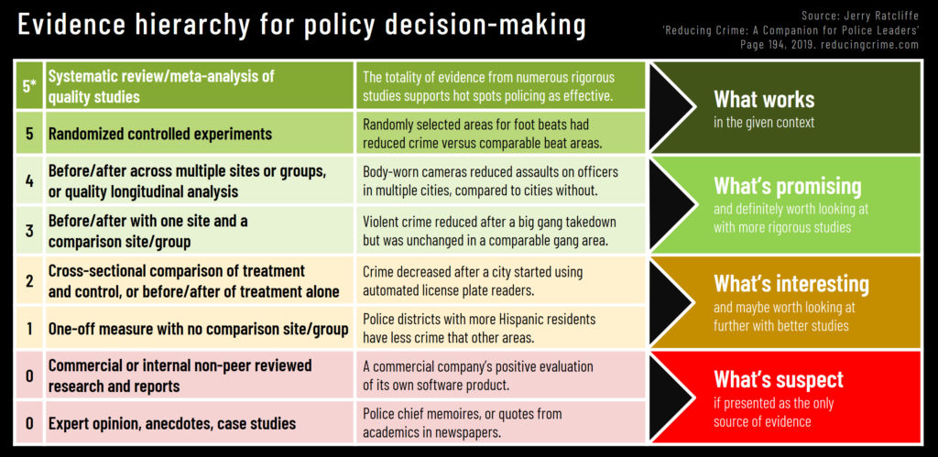
(Ratcliffe, 2019)
This diagram emphasis that the quality of evidence can range from the lower end of the scale including expert opinion and case studies which will often be filled with potential bias which would make it unreliable, to the top end of the scale which features randomised controlled experiments and systematic review of quality studies. This top level is defined as “what works” in the given context of evidence-based policing. There is debate however in putting too much consideration on ‘what works’ and the empirical nature of evidence-based policing in front of local culture and knowledge facing a particular police service. A term that some researchers have dubbed “What Matters” (van Dijk & Hoogewoning, 2015)
The research detailed above was committed by two advisers when performing a study comparing UK and Dutch Police Services. The study detailed that policing in the UK was being shifted from the traditional consent paradigm, built over decades of Peelian principal evolution, into a control paradigm. This control ethos, it was argued, had become more apparent due to the politicisation of the police with the introduction of Police and Crime Commissioners and the emphasis on cutting crime figures. The researchers also argued that policing should adopt a comprehensive paradigm which utilised not only evidential based policing research of ‘what works’ but also the focus should be on ‘what matters?’ This would consider the broader policing landscape and the challenges the leadership must face in coping with complexity and change. Others have argued (Dunham Et al 2021) it is dangerous to rely solely on the experience and discretion of local officers. It can impede change and learning and work against officers being receptive to outside knowledge which may benefit their local area. It is the delicate balance between empirical, statistical research which is vital to informing practice as well as a reliance on local understanding of the complex policing background which may provide the safest route in regarding evidence-based policing.
In examining evidence-based policing I will evaluate some crime prevention theories and strategies including options used to reduce reoffending. Crime prevention has been stated as a vital component of an overall strategy to reduce crime. (Welsh, 2011) It focuses on efforts to prevent crime and criminal offending in the first instance and before the act is committed. Most research agrees that there are many benefits to implementing crime prevention strategies, however research also elaborates (Welsh & Farrington, 2012) that crime prevention does not work for everyone and that there are significant gaps in knowledge on how crime prevention programs can be initiated.
One major theory of note is Crime Prevention Through Environmental Design (CPTED) first imagined by C. Ray Jeffery in the 1970’s. This theory introduces the concept of design as a means of reducing crime. This theory draws on opportunity theories such as the Routine Activity Theory (Cohen & Felson 1979) in which it states that for a crime to occur, all the three elements of a suitable target, a likely offender and an absence of a capable guardian must be present. Removing one of the elements effectively removes the crime. In CPTED theory, the target will be removed. This theory has been successfully implemented in all 43 police services in England & Wales, however some argue (Armitage, 2014) that problems exist with this theory, including a lack of flexibility which leads to the rigid application of standards as opposed to adapting the design to fit a particular context. Another critique of the theory is the failure of it to innovate and change. Research provided that the theory struggles to adapt to changing economic and social environment. In particular, during the 2008/9 financial crisis, only one of the 43 police services in England and Wales was able to adapt its model of delivery of CPTED to survive cutbacks. (Armitage, 2014) This theory therefore although effective may not be practical in an ever-changing local environment.
Another strategy to consider in crime prevention is one that deals with reducing reoffending. A recent paper (Welsh & Farrington, 2012) developed a new crime policy theory which utilised evidence-based policing to strike a balance between crime prevention and crime control. This policy was evidenced through work completed in Washington State, USA. Dating back to the mid 90’s, the state encouraged a series of research (Drake & Miller, 2009) to assess the effectiveness and economic efficiency of a large range of crime prevention and criminal justice programs. By 2006, the state had analysed 571 evaluations of crime prevention and criminal justice programs, estimated the benefits and costs of effective programs, and projected the amount to which alternative ‘portfolios’ of these programs could affect future prison construction needs, criminal justice costs, and crime rates. Some of these programs included prevention programs but also significant studies into adult and juvenile rehabilitation, both inside correctional facilities and outside of them. (Aos, Miller, & Drake, 2006,) The results of the research were staggering and in 2007 Washington State announced that it had abandoned plans to construct a new prison and would instead invest a further $48 million on evidence-based crime prevention and intervention programs. This success highlights the importance of utilising crime prevention together with crime control and engaging in the best available evidence. The research does admit however that the Washington State Strategy was only successful as it was backed by a political decision to utilise evidence-based research.
In conclusion, there are many crime prevention theories and strategies that have been trialled, both in the UK and abroad, however it seems evidence-based policing will only be successful if there is the political will to formulate the research into policy.
Word Count:1100

Bibliography

Armitage, Rachel (2014) Crime Prevention Through Environmental Design. In: Encyclopaedia of Criminology and Criminal Justice. Springer, London
Aos, S, Miller, M.G, Drake, E.K (2006) Evidence-based public policy options to reduce future prison construction, criminal justice costs, and crime rates Washington State Institute for Public Policy, Olympia, USA
BBC News Website, (2021) (online) Available at https://www.bbc.co.uk/news/uk-wales-58490038#:~:text=But%20Stephen%20Miller%2C%20Yusef%20Abdullahi%20and%20Tony%20Paris,a%20gross%20miscarriage%20of%20justice%20had%20taken%20place . (Accessed 23/01/22)
Bain, A., Robinson, B. K. and Conser, J. (2014) ‘Perceptions of Policing: Improving Communication in Local Communities’, International Journal of Police Science & Management, 16(4), pp. 267–276. doi: 10.1350/ijps.2014.16.4.345.
Baker, K, Sutherland, A, (2019) Multi-Agency Public Protection Arrangements and Youth Justice Policy Press, Chapter 3, 11 Feb 2009
Benkert, M & Doyle, T (2009) Clericalism, Religious Duress and its Psychological Impact on Victims of Clergy Sexual Abuse, Pastoral Psychol 14 January 2009 Springer Science + Business Media, 58:223–238,
Billingsley, R, (2009) Covert Human Intelligence Sources: The 'unlovely' Face of Police Work, Waterside Press, Hampshire, UK.
Bottomly, A, Coleman, C, Dixon, D, Gill, M, Wall, D (1991) The Impact of PACE: Policing in a Northern Force. Hull, UK: Centre for Criminality and Criminal Justice.
Bjelland, H Vsetby, A (2017) ‘It’s about using the full sanction catalogue’: on boundary negotiations in a multi-agency organised crime investigation, Policing and Society an International Journal of Research and Policy Volume 27, 2017 - Issue 6: Policing across organisational boundaries: Developments in theory and practice, P655-670
Brough, P, Biggs, A (2014) Comparing the impact of occupation-specific and generic work characteristics. In: Dollard, M, Shimazu, A, Bin Nordin, R, Brough, P, Tuckey, M (eds) Psychosocial Factors at Work in the Asia Pacific. London: Springer, 145–159.
Brough, P., Chataway, S. and Biggs, A. (2016) ‘‘You don’t want people knowing you’re a copper!’ A contemporary assessment of police organisational culture’, International Journal of Police Science & Management, 18(1), pp. 28–36. doi: 10.1177/1461355716638361.
Centrex (2005a) Professionalising Investigation Programme. London: National Centre for Policing Excellence.
Code of Ethics, College of Policing 2019 (online) Available at https://www.college.police.uk/ethics/code-of-ethics (Accessed 15/02/22)
Cohen, L., & Felson, M. (1979). Social change and crime rate trends: A routine activity approach. American Sociological Review, 44, 588–608.
College of Policing (2009) Practical advice on the management of priority and volume crime (online) Available at: https://library.college.police.uk/docs/acpo/VCMM-191109.pdf (Accessed on 23/01/22)
Chan, J (1996) Changing police culture. British Journal of Criminology 36: 109–134.
CLARKE, A. and WYDALL, S., 2013. 'Making Safe': A Coordinated Community Response to Empowering Victims and Tackling Perpetrators of Domestic Violence. Social Policy and Society, 12(3), pp. 393-406.
Crocker, R. et al. (2019) ‘Tackling local organised crime groups: lessons from research in two UK cities’, Trends in Organized Crime, 22(4), pp. 433–449. doi: 10.1007/s12117-018-9335-x
Crous, C (2011). Managing covert human intelligence sources: Lessons for police commanders. Australasian Policing 3(2): 12–15.
Criminal Justice Act (2003) S325-327B (online) available at https://www.legislation.gov.uk/ukpga/2003/44/contents (Accessed on 22/02/22)
Dodd V, 2021, Met police officers plead guilty over photos taken at scene of sisters’ deaths, The Guardian, (online) Available at https://www.theguardian.com/uk-news/2021/nov/02/met-police-officers-plead-guilty-over-photos-taken-at-scene-of-sisters-deaths (Accessed 15/02/21)
Drake, EK, Miller, S. Aos, M.G. (2009) Evidence-based public policy options to reduce crime and criminal justice costs: Implications in Washington state Victims and Offenders, 4 (2009), pp. 170-196
Dunn, J (1999) ‘Situating Democratic Political Accountability’, in A Przeworski, S Stokes and B Manin (eds) Democracy, Accountability and Representation (Cambridge: Cambridge University Press)
Dunham, R.G, Alpert, G.P, McLean, K.D.(2020) Critical Issues in Policing: Contemporary Readings, Eighth Edition, Waveland Press (online) Available at https://books.google.co.uk/books?id=l6LwDwAAQBAJ (Accessed 23/02/22)
Emsley, C (2013) ‘Peel’s Principles, Police Principles’, in J Brown (ed.) The Future of Policing (London: Routledge).
Fisher A., Phillips J. (2015) Quo Vadis: A New Direction for Police Leadership Through Community Engagement? In: Wankhade P., Weir D. (eds) Police Services. Springer, Cham.
Filkin E, (2011) The Ethical Issues Arising from the Relationship Between Police and Media. Advice to the Commissioner of Police of the Metropolis and his Management Board, London MPS
Goggin, D Cassidy, S, Sheridan, I, l O'Leary, P, (2017) Extensibility - Validation of Workplace Learning in Higher Education - Examples and Considerations Cork Institute of Technology SWORD - Southwest Open Research Deposit, Conference Papers Enterprise Engagement and Experiential Learning Group (E3L)
Gilmore, S, France, R, (2012) Local Policing and Transnational Organised Crime, Routledge Handbook of Transnational Organized Crime, Chapter 31, Routledge, London, P457-461
Harfield, C (2012) Police informers and professional ethics. Criminal Justice Ethics 31(2): 73–95.
Harfield C, Harfield K (2008) Intelligence: investigation, community and partnership. OUP Oxford, Oxford
Henry, P. et al. (2020) ‘Key attributes of an effective human source handler: Implications for handler selection and training’, The Police Journal, 93(4), pp. 290–309. doi: 10.1177/0032258X19862589.
Heslop R. (2013). A comparison of police pre‐employment training and education in the UK and USA. Paper at the 4th Annual Conference of the Higher Education Forum for Police Learning and Development (POLCON 4), Canterbury Christ Church University 3–4 September 2013.
Hilgendorf, EL, Irving, M (1981) A decision-making model of confessions. In Lloyd-Bostock, M. (Ed.), Psychology in legal contexts: Applications and limitations. London: MacMillan, pp. 67–84.
Huff, R, Killias, M (2013) Wrongful Convictions and Miscarriages of Justice: Causes and Remedies in North American and European Criminal Justice Systems. London: Routledge.
Jain, H. C., Singh, P. and Agocs, C. (2004), ‘Recruitment, Selection and Promotion of Visible-Minority and Aboriginal Police Officers in Selected Canadian Police Services’, in S. E. Nancoo (ed.), Contemporary Issues in Canadian Policing. Ontario: Canadian Educators’ Press.
Licate, D.A. (2010), "Covert Human Intelligence Sources: The “Unlovely” Face of Police Work", Policing: An International Journal, Vol. 33 No. 3.
Loader, I. In Search of Civic Policing: Recasting the ‘Peelian’ Principles. Criminal Law, Philosophy 10, 427–440 (2016).
Lentz, SA. & Chaires, RH. 2007 ‘The Invention of Peel’s principles: A study of policing ‘textbook’ history’ Journal of Criminal Justice, I, Jan-Feb., 69-79. 2007.
Mawby, R.C (2012) Crisis? What crisis? Some Research-Based Reflections on Police–Press Relations, Policing: A Journal of Policy and Practice, Volume 6, Issue 3, September 2012, Pages 272–280,
McConville, M, Hodgson, J (1993) Custodial Legal Advice and the Right to Silence. Research Study 61. London: Royal Commission on Criminal Justice
Milne, R, Griffiths, A, Clarke, C, Dando, C (2019) The cognitive interview: a tiered approach in the real-world. In: Dickinson, JJ, Schreiber Compo, N, Carol, R, Schwartz Bland McCauley, M (eds) Evidence-Based Investigative Interviewing: Applying Cognitive Principles. London: Routledge, 56–73.
Ministry of Justice (2019) Multi-Agency Public Protection Arrangements -Annual Report 2018/19 Ministry of Justice Statistics Bulletin 31 October 2019 (online) Available at https://assets.publishing.service.gov.uk/government/uploads/system/uploads/attachment_data/file/843057/mappa-annual-report-2018-19.pdf (accessed 22/02/22)
Ministry of Justice (2018) Victims of crime: Understanding the support you can expect (online) Available at https://www.cps.gov.uk/sites/default/files/documents/victims_witnesses/adult_victims_code_leaflet.pdf (accessed 23/02/22)
Munro, E. (2011) The Munro review of child protection: Final report. A child-centred system The Stationery Office, Norwich (2011) Department for Education
Nash, M, Walker, L (2009) Mappa—Is Closer Collaboration Really the Key to Effectiveness? Policing: A Journal of Policy and Practice, Volume 3, Issue 2, 2009, Pages 172–180
Nash, M (2006) Public Protection and the Criminal Justice Process, Oxford, Oxford University Press
National Audit Officer (2019) Tackling Serious and Organised crime HC 2219 SESSION 2017–2019 28 JUNE 2019 (online) Available at https://www.nao.org.uk/wp-content/uploads/2019/03/Tackling-serious-and-organised-crime-Summary.pdf#:~:text=7%20From%20what%20is%20known%2C%20the%20level%20of,ending%20December%202018%20%28paragraph%201.2%20and%20Figure%203%29. (Accessed 22/02/22)
NPCC Policing Vision 2025 (2016) (online) Available at https://www.npcc.police.uk/documents/Policing%20Vision.pdf (Accessed 15/02/22)
Pepper, I., Rogers, C. & Martin, H. 2020 ‘Evidence based policing: a view on its development within the police service’. Journal of Work Applied Management, Vol. 12 No. 1, pp. 91-96. (online) Available at: https://www.emerald.com/insight/content/doi/10.1108/JWAM-01-2020-0001/full/html (Accessed 23/02/22)
Poyser, S. and Milne, R. (2021) ‘The time in between a case of ‘wrongful’ and ‘rightful’ conviction in the UK: Miscarriages of justice and the contribution of psychology to reforming the police investigative process’, International Journal of Police Science & Management, 23(1), pp. 5–16. doi: 10.1177/14613557211006134.
Police Workforce facts and Figures, (2021) (online)Available at https://www.ethnicity-facts-figures.service.gov.uk/workforce-and-business/workforce-diversity/police-workforce/latest#main-facts-and-figures (Accessed 15/02/22)
Regulation of Investigatory Powers Act (2000) S26 (8) (online) available at https://www.legislation.gov.uk/ukpga/2000/23/section/26 (Accessed 24/02/22)
Ratcliffe, J. 2017 ‘Not all evidence is created equally’ (online) Available at: https://www.jratcliffe.net/post/not-all-evidence-is-created-equally (Accessed 23/02/22)
Robert Wright (2021) ‘Patel pledges “definitive” inquiry into Sarah Everard murder’, (online) Available at FT.com (accessed 23/02/22) [Preprint].
Robinson, A, Howarth, E (2016) Responding Effectively to Women Experiencing Severe Abuse: Identifying Key Components of a British Advocacy Intervention Los Angeles, CA: SAGE Publications Violence against women, 2016-01, Vol.22 (1), p.41-63
Rosenfeld, R, Jacobs, BA, Wright, R (2003) Snitching and the code of the street. British Journal of Criminology 43(2): 291–309.
Sanders, M, Young, R, Burton, M (2010) Criminal Justice. Oxford: Oxford University Press.
Serious Crime Act 2007 (online) Available at https://www.legislation.gov.uk/ukpga/2007/27/introduction (Accessed 08/12/21)
Serious Organised Crime Strategy 2018 (online) Available at https://www.gov.uk/government/publications/serious-and-organised-crime-strategy-2018 (Accessed 22/02/22)
Schneider, S. (1999). Overcoming barriers to communication between police and socially disadvantaged neighbourhoods: a critical theory of community policing. Crime, Law & Social Change, 30, 347–377.
Sherman, L. (1998), Evidence-based Policing: Ideas in American Policing, Police Foundation, Washington DC
Staniforth A. (2016) Police Use of Open-Source Intelligence: The Longer Arm of Law. In: Akhgar B., Bayerl P., Sampson F. (eds) Open-Source Intelligence Investigation. Advanced Sciences and Technologies for Security Applications. Springer, Cham
Stanley, N, P. Miller, H. Richardson Foster, G. Thomson (2011) Children's experiences of domestic violence: Developing an integrated response from police and child protection services Journal of Interpersonal Violence, 26 (12) (2011), pp. 2372-2391
Stanley, N, Humphreys, C, (2014) multi-agency risk assessment and management for children and families experiencing domestic violence, Children and Youth Services Review, Volume 47, Part 1, Pages 78-85, ISSN 0190-7409,
Sunahara, D (2004) ‘A Model of Unethical Police Behaviour’ The Canadian Review of Policing Research, Vol 1, 2004.
Sutherland A & Jones, S (2008) ‘MAPPA and Youth Justice, An Exploration of Youth Offending Team engagement with Multi-Agency Public Protection Arrangements’ London YJB, P30.
Tong, S, Bowling, B (2006) Art, craft and science of detective work. The Police Journal 79(4): 323–329.
van Dijk, A & Hoogewoning, F (2015), ‘What really matters in policing? And why “what works?” alone is simply not enough’ (online) Available at: https://www.cepol.europa.eu/sites/default/files/28-dijk-hoogewoning.pdf (Accessed 23/02/22)
Waters, I. et al. (2007) ‘Ethnic Minorities and the Challenge of Police Recruitment’, The Police Journal, 80(3), pp. 191–216. doi: 10.1350/pojo.2007.80.3.191.
Walsh, D, Bull, R (2010) What really is effective in interviews with suspects? A study comparing interviewing skills against interviewing outcomes. Legal and Criminal Psychology 15(2): 305–321
Welsh, B.C, Crime prevention M. Tonry (Ed.), The Oxford handbook of crime and criminal justice, Oxford University Press, New York (2011), pp. 126-155
Welsh, B.C, Farrington, D.P Science, politics, and crime prevention: Toward a new crime policy, Journal of Criminal Justice, Volume 40, Issue 2, 2012, Pages 128-133,
West Midlands Regional Organised Crime Unit (2022) (online) available at https://www.wmrocu.org.uk/serious-organised-crime-soc/ (Accessed 22/02/22)
Wood, D, (2020) Embedding Learning and Assessment Within Police Practice: The Opportunities and Challenges Arising from the Introduction of the PEQF in England and Wales, Policing: A Journal of Policy and Practice, Volume 14, Issue 2, June 2020, Pages 374–382,
Wood D. A., Williams E. (2016). The Politics of Establishing Reflexivity as a Core Component of Good Policing. In Armstrong Sarah, Blaustein Jarrett, Henry Alistair (eds), Reflexivity and Criminal Justice. Intersections of Policy, Practice and Research. London: Palgrave Macmillan, pp. 215–236.

