Health Assessment Report

Student Name: Soabia Rafiq
Student ID: 2015530
Module Code: BMHP5003_BIRM
Lecturer’s Name: Dr Mohammed Humza Saeed

TABLE OF CONTENTS

Introduction 3

Case Report - Muscular Skeletal System 4

Lo1 & Lo2 5

GDPR 6

Musculoskeletal System 7

Assessment – Leukodystrophy 9

Recommendations & Conclusion 12

References 13

appendix 17

Introduction

The purpose of this report is to address one of the ten systems of the body. The chosen system that will be discussed in this report is Muscular Skeletal System. In the case study I will speak about a patient x who suffered with Leukodystrophy. The care planning will be person centred care which is only catered only to patient x. In this report there will be a discussion about health assessments and findings of the patient x’s health with authorisation from them to follow GDPR rules. I will also speak about GDPR and how important this is to follow. There will also be a brief discussion about the function of the Muscular Skeletal System and the chosen disease. This will explain how to it affects the body and the abnormalities and normalities. Along with the plan of care there will be a topic on lifestyle changes.

Case Report

With this Healthcare Questionnaire Mr. Mohammed had given consent to add their details attached to this report. Mr. Mohammed led a very healthy lifestyle. He worked 2 jobs. One as an interpreter for the deaf as Mr. Mohammed was deaf but could lip read very accurately and at a fast pace. The other job he worked in an office, based on Hagley Road, Birmingham. He had never smoked as he saw 2 of his brother’s smoke and didn’t like the smell as he has heightened senses. He never drank as this was frowned upon due to his religious beliefs. Before being diagnosed of Leukodystrophy, Mr. Mohammed used to stay active but then he started to lose muscle strength. Mr. Mohammed’s older brother got him in a routine of using hand tool exercises things like:
- Stress balls
- Metal object of squeezing

This helped him for a short amount of time but then came to a point where he couldn’t cope anymore as he was in excruciating pain. He was then relocated into a care home as he was forgetting simple things. This eventually and he was put on a peg feed as he was nil by mouth and had a catheter put in as he lost all muscle response in his full body. This led to Paraplegia as well as Leukodystrophy.

LO1 – Structure and Functioning of the Human Body

According to Chen and Qiao (2020) The management of such a musculoskeletal by the individual central and peripheral nervous system (CNS) is indeed a lengthy issue in human motor control. First, research in neuroscience show that a musculoskeletal system's normal motor activity is built from a collection of time-varying muscle synergies. To describe the kinetics of muscle activation and force production. Each muscle acts as an actuator and is made up of muscle fibres and tendons. Neural stimulations stimulate muscle fibres, which then contract to create force. A tendon is a connective tissue that links muscle fibres to the bone (Chen & Qiao, 2020).

LO2 – Body Functioning and Anatomy and Physiology

According to Kirchgesner et al., (2018) they stated the ligamentous system is indeed a three-dimensional network of connective tissues that extends from the skull toward the feet even from the surface to the bone. This variable-thickness layer of connective tissue (stratum membranous) is connected to an epidermis (retinacula cutis superficialis) and the deeper components of the fascial system through fibrous tracts (retinacula cutis profondis). It is made up of interwoven collagen fibres that are loosely packed and blended with a lot of elastic fibres. Its size, thickness, and topography differ according on the body segment (Kirchgesner et al., 2018).

According to Zhang et al., (2021) stated Leukodystrophies are commonly thought to be children’s illnesses, but they can develop at any age, as well as the diverse clinical features of the adult-onset variety differ from the more well-known childhood forms. Regardless of the occurrence of other aggravating symptoms or neuroimaging abnormalities, individuals with delayed spastic paraplegia should be evaluated for underlying leukodystrophies (Zhang et al., 2021).

What is GDPR

According to Shu and Jahankhani (2017) stated that the NHS and added Healthcare systems struggled with the budgets and operative equipment with high strains of the patients. Due to the new technologies that have emerged and transformed the health care sector to minimise stress off the workers. The main new technology was patient records on tablet (iPad). This is where patients’ histories, previous health illnesses and medication is stored. With this the main thing was being able to protect the data and this is where Data Protection Act 1998 (DPA) comes into play. Data Protection Act covers all areas of confidential means like:

- Name
- Address
- Date of Birth
- Private and Confidential information
- Medical Histories

All hospitals and general practices by law follow DPA to gain the trust of patients and ensure that they can keep things confidential. There are 8 principles of what they must follow which is:

General Data Protection Regulations (GDPR) is designed for the patients to control their private and personal files (Shu & Jahankhani, 2017).


(Figure 1: GDPR)

(Paruch, 2019)

Musculoskeletal System

According to Jadvar et al., (2004) they stated that diagnostic imaging has helped a lot with trying to diagnose patients. These images have played a huge part in the medicine world as this has helped evaluate things like cancer in the bone/soft tissues. They have also stated that Positron Emission Tomography (PET) play a critical part as this helps with amputation stumps, detecting metastatic diseases, predictions of any type of therapy etc (Jadver et al., 2004).

Kosek et al., (2021) stated that Nociplastic pain was introduced in2017 and this consisted as a 3rd mechanistic pain describer. The Nociplastic pain had no actual indication whether this impaired or endangered any tissue that caused the peripherical nociceptors which seemed to cause the pain (Kosek et al., 2021).

Shraim et al., (2021) stated mediations are in place for musculoskeletal pain. The International Association for the Study of Pain (IASP) has identified three pain mechanism types (PMCs): nociceptive, neuropathic, and nociplastic pain. Discrimination between them is still difficult. The search approach turned up papers that discussed how to distinguish between different kinds of pain in the musculoskeletal system that are based on different mechanisms (Woolf et al., 1998). The findings of this review serve as a basis for improving techniques for differentiating the processes behind musculoskeletal pain (Shraim et al., 2021).

According to Arrigoni et al., (2020) Interactions between several tissue, including such muscular and neurons in neuromuscular illnesses, or numerous biological components of a tissue, such as bone cancers interacting with bone cells, characterise musculoskeletal tissues (Arrigoni et al., 2020).

According to Buckwalter (1997) Musculoskeletal function deterioration, including weakness, stiffness, and discomfort, causes gradual disability in many older people, restricting mobility and diminishing quality of life. Musculoskeletal soft tissue functioning reduces with age, as does susceptibility to degenerative illnesses and injuries, as does the opportunity to sustain from disease or injury; these changes raise the likelihood of a disability. Cell types, tissues, or organ systems' function, on the other hand, may stay steady or even improve momentarily with age (Buckwalter, 1997).

(Figure 2: Musculoskeletal Anatomy)

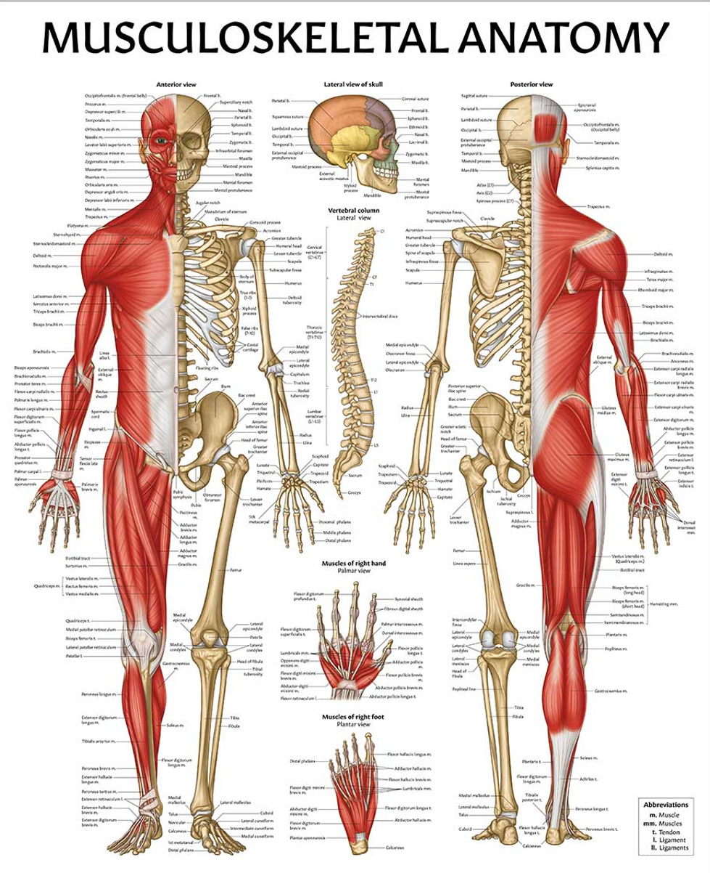

(AnatomyStuff, 2021)

Assessment – Leukodystrophy

According to Beerepoot et al., (2019) stated that Leukodystrophy absence causes increased urine excretion as well as intralysosomal build-up of these sulfatides in diverse organs (e.g. nervous tissue, gall bladder, kidneys and liver). The central and peripheral nerve systems' myelin sheaths are particularly impacted, leading in progressive demyelination, ataxia, first flaccid and subsequently spastic tetraparesis, mental regression, and other neurological symptoms (Beerepoot et al., 2019).

According to Van Der Knaap et al., (2019) Leukodystrophies are a huge set of unusual hereditary illnesses that mostly damage the white matter of the CNS. Historically, the analysis procedure was lengthy, and patient prognosis was poor since curative therapy was only accessible for a small number of leukodystrophies in their early stages. Whether MRI keeps its central place in diagnosis and what the role is of whole-exome sequencing are relevant questions for neurologists. Technological advance in molecular techniques and improved insight into the pathophysiology of individual leukodystrophies have led to therapeutic developments, including drug design and gene therapy (Van Der Knaap et al., 2019).

According to Shaimardanova et al., (2020) stated that Metachromatic leukodystrophy (MLD) is an autosomal recessive neurological illness that belongs to the lysosomal storage disorder category (LSDs). MLD is one of the most frequent leukodystrophies. MLD is substantially more common in certain isolated communities. Impairment to the myelin sheath that covers utmost nerve fibres in the central (CNS) and peripheral nervous systems (PNS) differentiates the illness, resulting in increasing motor and cognitive disfunction as clinical symptoms. Sulfatide accumulation causes neuronal degeneration, astrocyte dysfunction, and may trigger an inflammatory response. Numerous research has found that inflammation has a role in MLD. The cytokines described in this could be used as biomarkers to identify MLD in its initial stages and to monitor disease progression (Bentzen et al., 2010). There may be no correlation between demyelination and the presence of metachromatic material in MLD. Complement activation via an additional pathway therefore enhances myelin damage, inducing or enhancing the immune response to myelin (Shaimardanova et al., 2020).

According to Roosendaal et al., (2021) they stated that in the Amsterdam Leukodystrophy Centre’s database several anatomic structures were comprehensively evaluated using brain MR imaging. MR image processing characteristics evident of mitochondrial disease (Barkovich et al., 1993). Several illnesses or groups of ailments shared distinguishing characteristics. T2 hyperintensity inside the brain stem, mid cerebellum petiolate, and cell contains was linked to complex 2 impairment. Standard MR imaging abnormalities indicating of mitochondrial dysfunction were identified inside a broad sample of individuals with mitochondria leukodystrophy. In addition, we discovered various MR imaging patterns that corresponded to certain genotypes. Recognizing these trends aids in the diagnosis of future cases (Roosendaal et al., 2021).

According to Van Rappard, Boelens and Wolf (2015) they stated that a trigger of sulfatide build-up with in central and peripheral nervous systems, ultimately results to demyelination. Depending on the age of onset, the illness is categorised as late-infantile, juvenile, or adult onset, with each characterised by a range of neurological symptoms that lead to serious injury if left untreated. There is no cure for all forms and stages of malignancy (Atzmon et al.,, 2018). To reach a general conclusion and enhance treatment choices for metachromatic leukodystrophy, a thorough examination of the efficiency for bone marrow transplantation as well as a lengthier follow-up time for gene therapy are required (Van Rappard, Boelens & Wolf, 2015).

Whereas Kondo and Duncan (2016) stated that It is caused by a hereditary impairment in the activity of galactocerebrosidase (GALC), a lysosomal enzyme required for myelin maintenance. To date, the only successful therapy is autologous stem cell transplantation (HSCT), which includes umbilical stem cell transplantation. When conducted before illness start, HSCT greatly prolongs the lives of individuals with GLD, albeit that is not curable. Transplant of nerve cells in a few known paradigms of demyelinating and nerve damage illnesses reveals that such a method has the potential to restore counter - arguments conduction and protect neurons by supplying new healthy myelin (Kondo & Duncan, 2016).

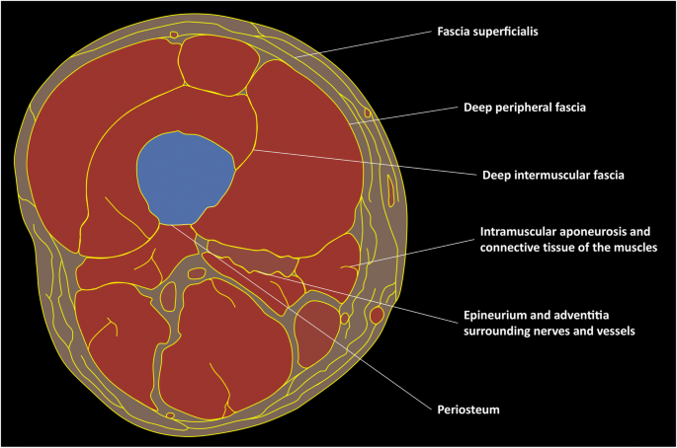
(Figure 3: Leukodystrophy tissue)
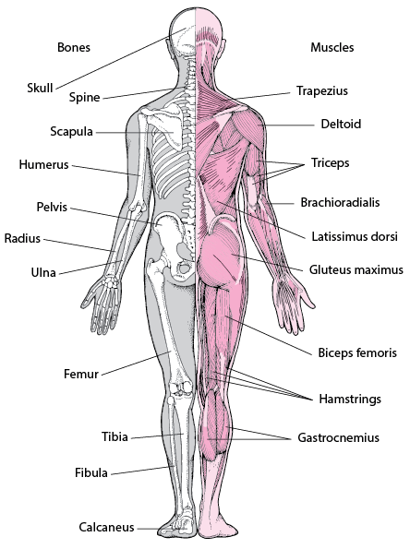
(Kirchgesner et al., 2018)

(Figure 4: Musculoskeletal)

(Villa-Forte, 2022)

Recommendation and Conclusion

My recommendation is to ensure that the lifestyle changes and plan of care are to be managed by Physicians, Qualified Doctors and Nurses. This is due to the fact that Mr. Mohammed has lost all muscle response and control which means that he cannot do this himself, due to some muscle spasms with his illness leukodystrophy (Axelsen et al., 2021). The Physicians should come out regularly to ensure Mr. Mohammed has some sort of exercise with full support to help due to him not being able to do it on his own like Swiss ball exercises (Lakshmanan & Rajalaxmi, 2020). Also ensure that he is turned every 2 hours to eradicate any pressure sores due to him being unable to move himself and ensure that there is some sort of soft pillows on each side to help elevate the pain. The mattress would be specialised air flow and checked daily to ensure its working correctly. Ensure that the peg feed is changed every 2 weeks and to ensure that the food that Mr. Mohammed is having is certified halal. Ensure that the catheter is not blocked by depositaries to be checked daily. Oximeter and blood pressure to be checked every day to see if there are any changes in his health. Ensure all staff are following his specialised care plan and know all the risk assessments for Mr. Mohammed. Ensure he is positioned ¾ upright, so he does not choke on saliver build-up. Ensure that they have a suction machine close to his bed just in case of any emergencies. Also ensure he has special mouth brush to keep his lips and mouth hydrated with minimal water. Ensure staff are fully trained and qualified to care for Mr. Mohammed.

The conclusion for this report is to understand Musculoskeletal System and ensure that the illness chosen (Leukodystrophy) is understood. This report to help understand the difficulties that Mr. Mohammed has suffered. The main point of this report is gaining authorisation from Mr. Mohammed by using sign language to communicate with him and ensuring that he has full capacity to understand that it has been shared into this report. Also, the meaning of GDPR needs to be understood as this can help keep things confidential.

References

AnatomyStuff (2021) Musculoskeletal Anatomy Chart / Poster – Laminated pp1

Arrigoni, C., Lopa, S., Candrian, C. and Moretti, M., 2020. Organs-on-a-chip as model systems for multifactorial musculoskeletal diseases. Current opinion in biotechnology, 63, pp.79-88.

Atzmon, A., Herrero, M., Sharet-Eshed, R., Gilad, Y., Senderowitz, H. and Elroy-Stein, O., 2018. Drug screening identifies sigma-1-receptor as a target for the therapy of VWM leukodystrophy. Frontiers in molecular neuroscience, 11, p.336.

Axelsen, T.M., Vammen, T.L., Bak, M., Pourhadi, N., Stenør, C.M. and Grønborg, S., 2021. Case report:‘AARS2 leukodystrophy’. Molecular Genetics and Metabolism Reports, 28, p.100782.

Barkovich, A.J., Good, W.V., Koch, T.K. and Berg, B.O., 1993. Mitochondrial disorders: analysis of their clinical and imaging characteristics. American Journal of Neuroradiology, 14(5), pp.1119-1137.

Beerepoot, S., Nierkens, S., Boelens, J.J., Lindemans, C., Bugiani, M. and Wolf, N.I., 2019. Peripheral neuropathy in metachromatic leukodystrophy: current status and future perspective. Orphanet journal of rare diseases, 14(1), pp.1-13.

Bentzen, S.M., Parliament, M., Deasy, J.O., Dicker, A., Curran, W.J., Williams, J.P. and Rosenstein, B.S., 2010. Biomarkers and surrogate endpoints for normal-tissue effects of radiation therapy: the importance of dose–volume effects. International Journal of Radiation Oncology* Biology* Physics, 76(3), pp.S145-S150.

Buckwalter, J.A., 1997. Maintaining and restoring mobility in middle and old age: the importance of the soft tissues. Instructional course lectures, 46, pp.459-469.

Chen, J. and Qiao, H., 2020. Muscle-synergies-based neuromuscular control for motion learning and generalization of a musculoskeletal system. IEEE Transactions on Systems, Man, and Cybernetics: Systems, 51(6), pp.3993-4006.

Face2FaceHR (2017) Five Ways To Protect Confidentiality In your Business pp1

Jadvar, H., Gamie, S., Ramanna, L. and Conti, P.S., 2004, October. Musculoskeletal system. In Seminars in nuclear medicine (Vol. 34, No. 4, pp. 254-261). WB Saunders.

Kirchgesner, T., Demondion, X., Stoenoiu, M., Durez, P., Nzeusseu Toukap, A., Houssiau, F., Galant, C., Acid, S., Lecouvet, F., Malghem, J. and Vande Berg, B., 2018. Fasciae of the musculoskeletal system: normal anatomy and MR patterns of involvement in autoimmune diseases. Insights into imaging, 9(5), pp.761-771.

Knilt., 2019, August, Unit 2: What is the Gibbs’ Cycle of Reflection, pp1.

Kondo, Y. and Duncan, I.D., 2016. Myelin repair by transplantation of myelin‐forming cells in globoid cell leukodystrophy. Journal of neuroscience research, 94(11), pp.1195-1202.

Kosek, E., Clauw, D., Nijs, J., Baron, R., Gilron, I., Harris, R.E., Mico, J.A., Rice, A.S. and Sterling, M., 2021. Chronic nociplastic pain affecting the musculoskeletal system: Clinical criteria and grading system. Pain, 162(11), pp.2629-2634.

Lakshmanan, R. and Rajalaxmi, V., 2020. A Comprehensive Physical Therapy Approach in Late Infantile Form of Metachromatic Leukodystrophy–A Case Study. Research Journal of Pharmacy and Technology, 13(5), pp.2214-2216.

Paruch, Z (2019) The General Data Protection Regulation – GDPR Compliance & Legal Requirements pp.1

Roosendaal, S.D., van de Brug, T., Alves, C.A.P.F., Blaser, S., Vanderver, A., Wolf, N.I. and van der Knaap, M.S., 2021. Imaging patterns characterizing mitochondrial leukodystrophies. American Journal of Neuroradiology, 42(7), pp.1334-1340.

Shaimardanova, A.A., Chulpanova, D.S., Solovyeva, V.V., Mullagulova, A.I., Kitaeva, K.V., Allegrucci, C. and Rizvanov, A.A., 2020. Metachromatic leukodystrophy: diagnosis, modeling, and treatment approaches. Frontiers in medicine, 7, p.576221.

Shraim, M.A., Masse-Alarie, H. and Hodges, P.W., 2021. Methods to discriminate between mechanism-based categories of pain experienced in the musculoskeletal system: a systematic review. Pain, 162(4), pp.1007-1037.

Shu, I.N. and Jahankhani, H., 2017, November. The Impact of the new European General Data Protection Regulation (GDPR) on the Information Governance Toolkit in Health and Social care with special reference to Primary care in England. In 2017 Cybersecurity and Cyberforensics Conference (CCC)(pp. 31-37). IEEE.

Van Der Knaap, M.S., Schiffmann, R., Mochel, F. and Wolf, N.I., 2019. Diagnosis, prognosis, and treatment of leukodystrophies. The Lancet Neurology, 18(10), pp.962-972.

Van Rappard, D.F., Boelens, J.J. and Wolf, N.I., 2015. Metachromatic leukodystrophy: disease spectrum and approaches for treatment. Best Practice & Research Clinical Endocrinology & Metabolism, 29(2), pp.261-273.

Villa – Forte, A., (2022) Bones. pp1.

Woolf, C.J., Bennett, G.J., Doherty, M., Dubner, R., Kidd, B., Koltzenburg, M., Lipton, R., Loeser, J.D., Payne, R. and Torebjork, E., 1998. Towards a mechanism-based classification of pain?. Pain, 77(3), pp.227-229.

Zhang, T., Yan, C., Liu, Y., Cao, L., Ji, K., Li, D., Chi, L. and Zhao, Y., 2021. Late-onset leukodystrophy mimicking hereditary spastic paraplegia without diffuse leukodystrophy on neuroimaging. Neuropsychiatric Disease and Treatment, 17, p.1451.

Appendix

Lifestyle Questionnaire

Introduction:

To help us focus our Health Promotion activities in the practice, we would be grateful if you could fill in this short questionnaire. If you have already completed one on a previous visit, please return this questionnaire to the receptionist.

Name Mr. Mohammed Date of Birth:23/03/1969

Do you smoke? |  | Yes | [ | ] No [ ]
If Yes, do you –
smoke less than 1 | cigarette/day |  | [ | ]
1 – 9 | cigarettes/day |  | [ | ]
10-19 | cigarettes/day |  | [ | ]
20-39 | cigarettes/day |  | [ | ]
more than 40 | cigarettes/day |  | [ | ]
smoke a pipe |  |  | [ | ]
smoke cigars |  |  | [ | ]

If No, have you –

never ever smoked  given up smoking in the last year not smoked for more than 1 year |  | [  [  [ | ]  ]  ]
Do you have high blood pressure? | Yes | [ | ] | No | [ | ]
Have you ever had a heart attack or suffered from angina? | Yes | [ | ] | No | [ | ]

Have you ever had a stroke, “shock”
or any weakness down one side? Yes [ ] No [ ] Have any of the following – mother, father,
(hyperlipidaemia)
brothers or sisters had –
a heart attack below the age of 60 | Yes | [ | ] | No | [ | ]
a heart attack above the age of 60 | Yes | [ | ] | No | [ | ]
a stroke | Yes | [ | ] | No | [ | ]
trouble with very high cholesterol | Yes | [ | ] | No | [ | ]

………………………………………………………………………………………

Practice Use Only
Health Education Smoking NO

BP 95 / 120

Height 6ft 6in

Weight 11st 7ibs

………………………………………………………………………………………

EXERCISE
Healthy exercise usually involves activity that lasts for at least 20 minutes, raises your pulse, and produces hard breathing. In younger people this might be running, cycling or sport, or brisk walking for older people.

Do you take this type of exercise –

daily [ ]
3 times weekly [ ]
once weekly [ ]
once monthly [ ]
seldom [ ]

I cannot take exercise because of disability [ ]

DIET
Please tick the one category which is closest to your usual eating pattern.

I eat no meat, fish, or dairy produce [ ]
I eat no meat [ ]
I eat a mixture including daily fruit and vegetables [ ]
I eat a mixture including regular chips and fries [ ]
I eat frozen meals (e.g. TV dinners) 3 or 4 times/week [ ]
I eat mainly snacks [ ]
I eat a special medical diet [ ]

Please specify – Puree (Peg Feed)

ALCOHOL
Please tick the statement which most closely describes your usual average alcohol intake. (1 unit is 1 glass wine, ½ pint beer or a single measure of spirit.)

I never drink alcohol [ ]
I drink less than 1 unit per day [ ]
I drink between 1 and 2 units a day [ ]
I drink between 3 and 6 units a day [ ]
I drink between 7 and 9 units a day [ ] I drink more than 9 units a day on average [ ]
……………………………………………………………………………………….

Practice Use Only

Health Education Alcohol NO
Alcohol Brief Intervention NO

……………………………………………………………………………………….

Authorisation Form

I Mr. Mohammed give Soabia Rafiq full authorisation to use my health-related illnesses in this report. Soabia Rafiq can discuss anything in relations to my health as well as any statistical means.

Name: Mr. Mohammed

Signature:

Date: 25th July 2022

Name: Soabia Rafiq

Signature:

Date: 25th July 2022

(Figure 5: Confidential)

(Face2FaceHR, 2017)

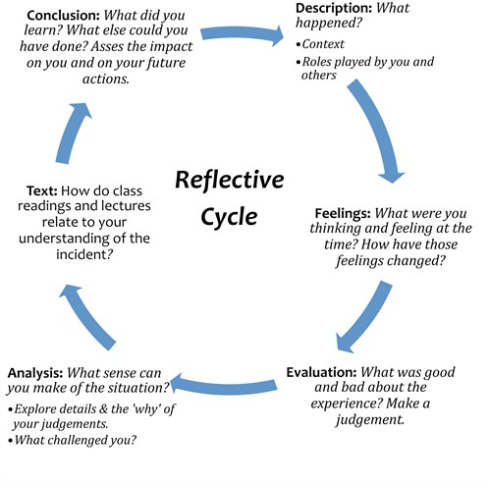
(Figure 6: Gibbs’ Reflective Cycle)
(Knilt, 2019)

