All About ABTA Training Certificates

All About ABTA

Certificate -
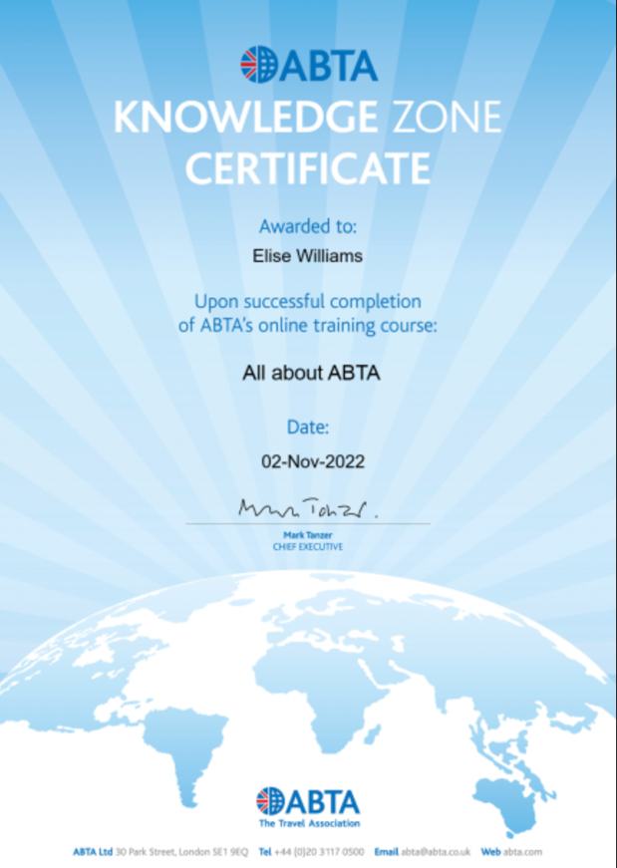

Score -

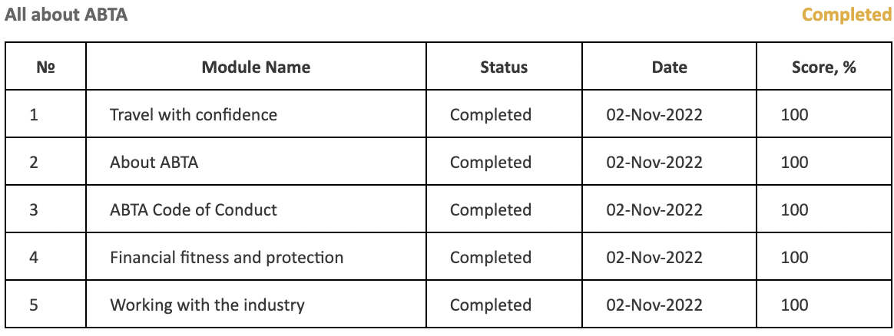

FCDO

Certificate -
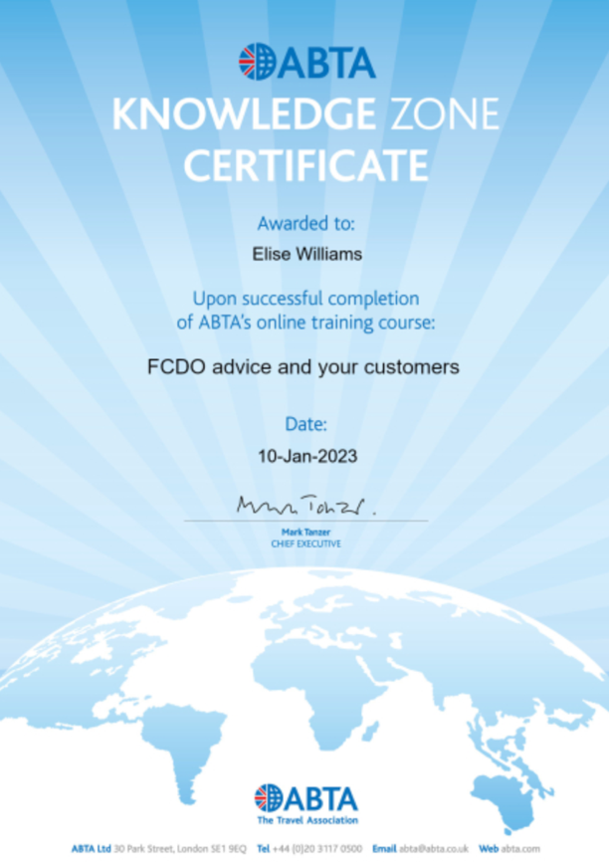

Score -

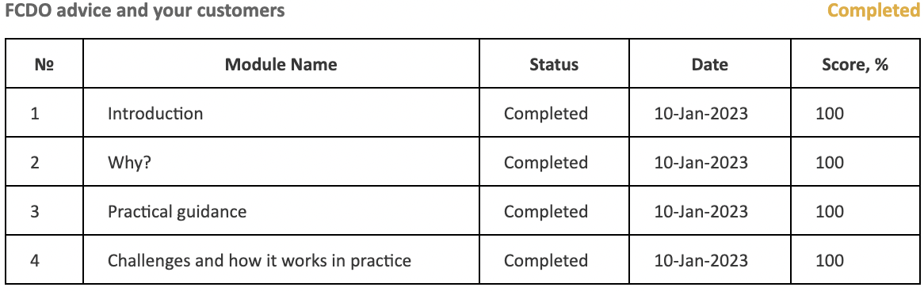

Inclusive travel: making business sense

Certificate -
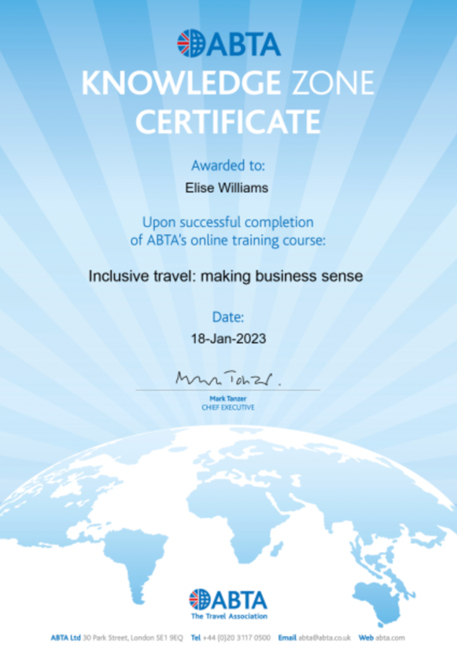

Score -

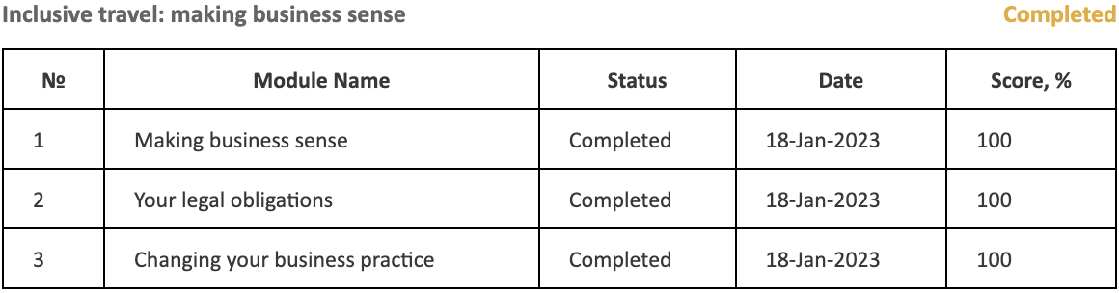

For everyone: demystifying accessibility

Certificate -
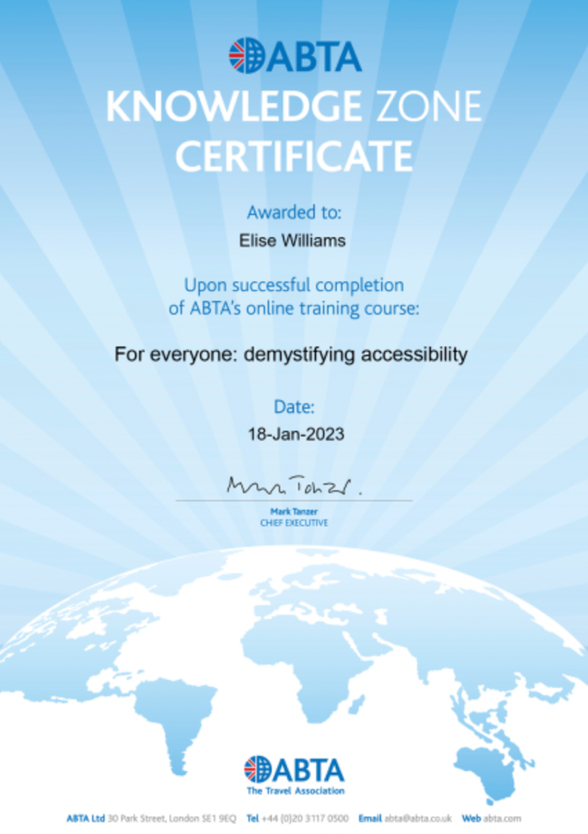

Score -

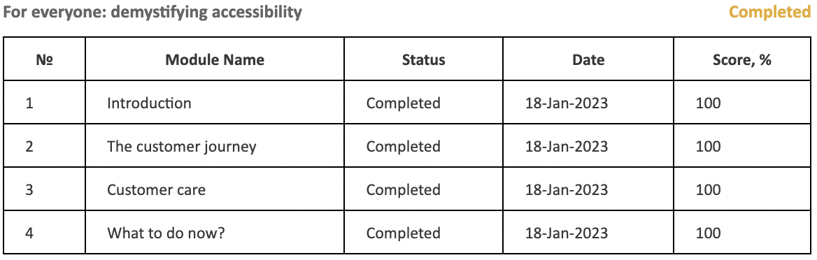

Sustainability

Certificate -
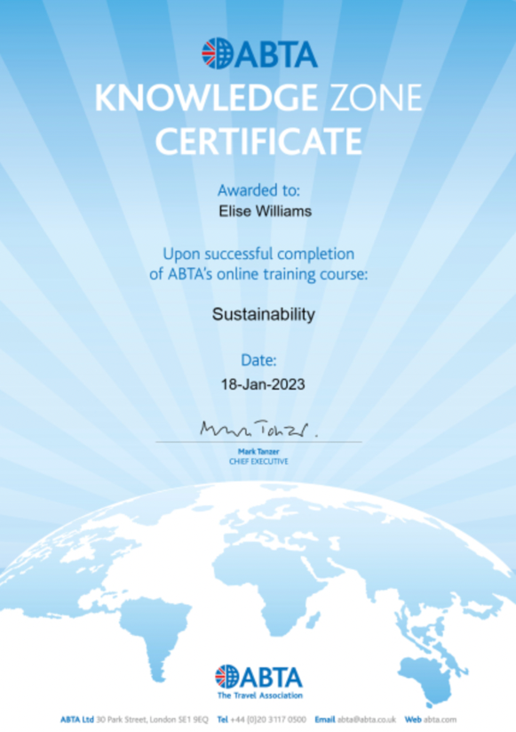

Score -



