Job advertisement
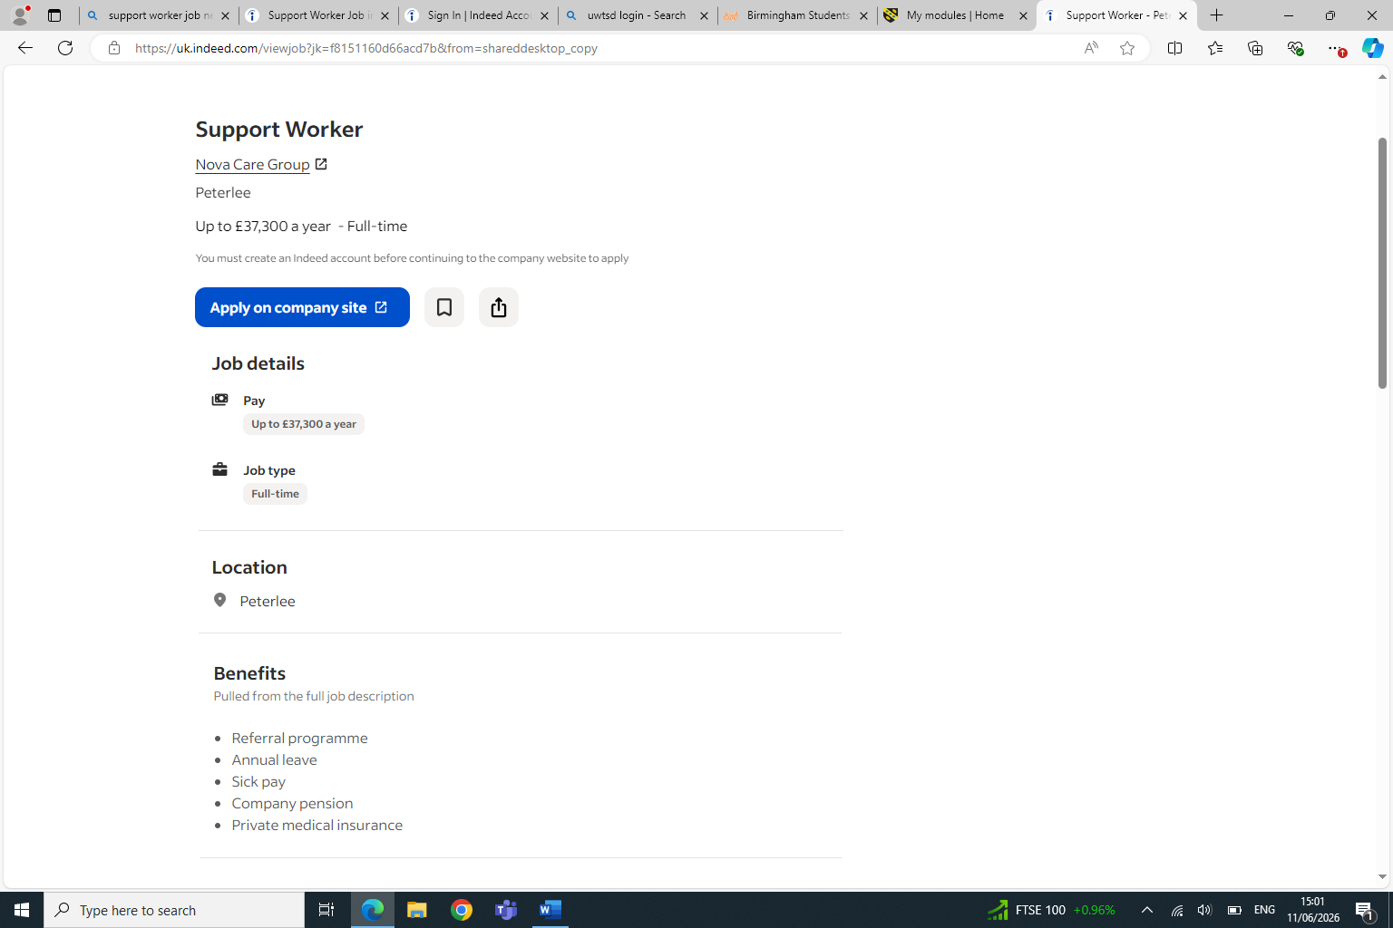
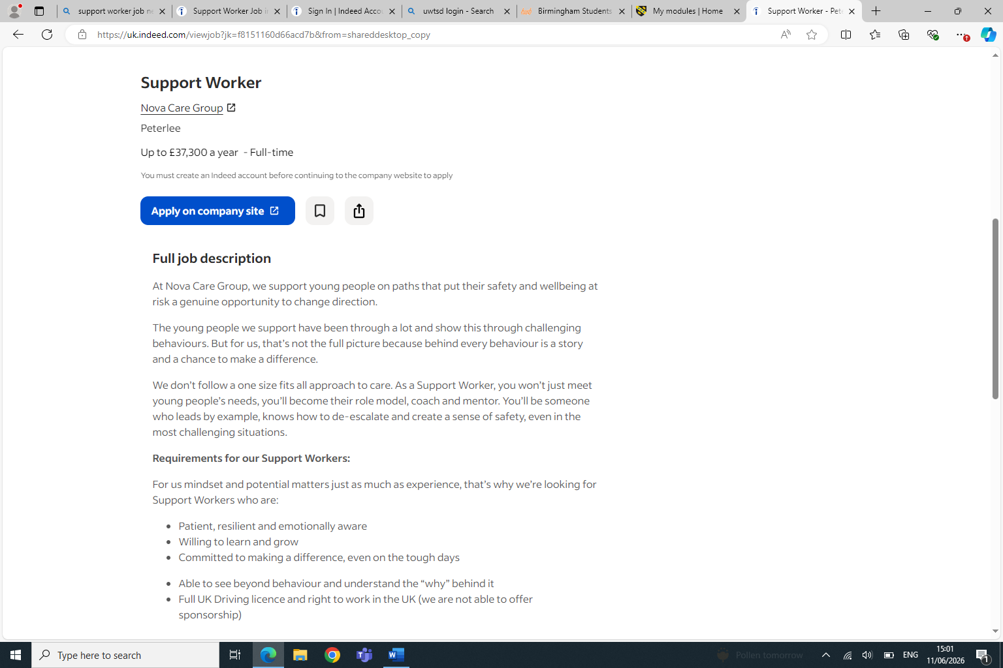
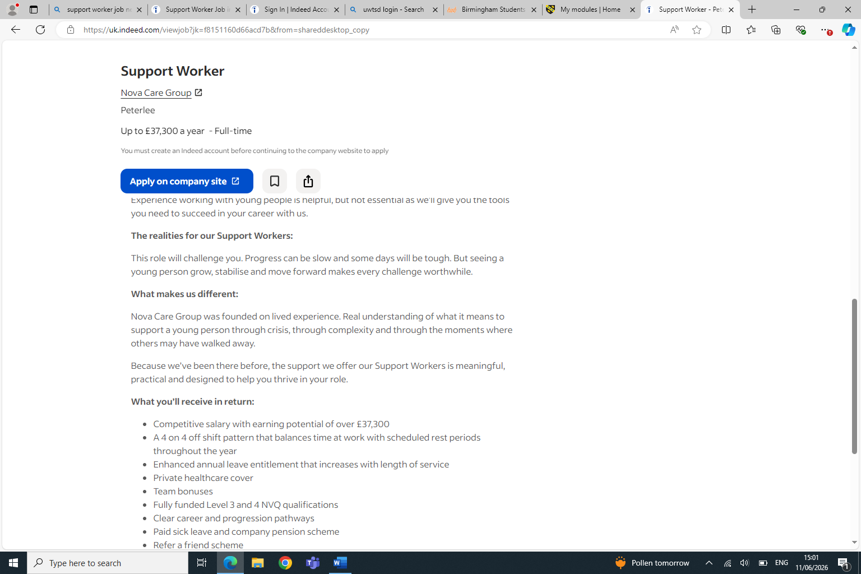
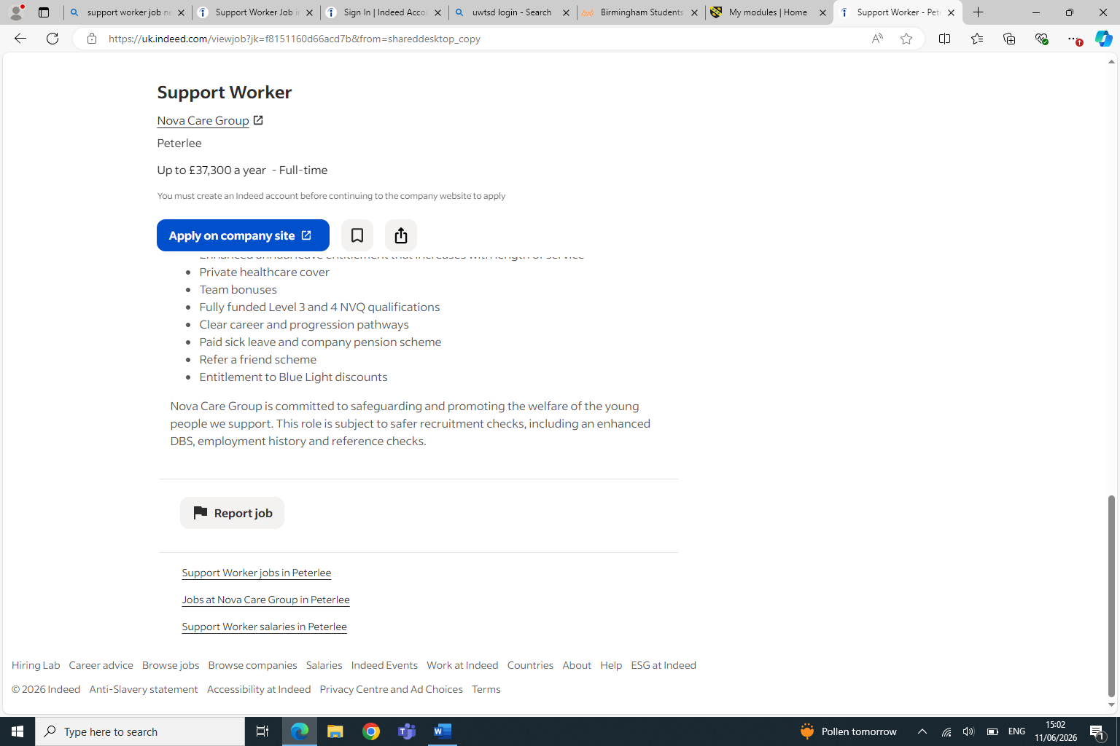

Curriculum vitae

Personal information
Chelsea Delaney
4 Duncan Edwards Close DY1 2DZ
07449624558
C.n.Delaney1@outlook.com
Personal statement
A compassionate,reliable and motivated individual with a strong interest in supporting andn helping young people and helping others overcome challenges. I am patient, emotionally aware and able to build positive relationships with people from different backgrounds. I understand the importance of looking beyond challenging behaviors and recognising the reasons behind someons actions. I am committed to learning, developing my skills and making a positive difference through a supportive and person centred approach.

Education
2021-2022, NHS Learning hub
- Mental Health Awareness Level 1 & Level 2
- Dementia Awareness Level 1 & Level 2
- Manual Handling
2019-2020, Bournville College
- Health&social care Level 2
- Maths

Work experience
2022-2026, JLKare support
- Provide support and assistance to individuals/service users
- Maintained patience and understanding in difficult situations
- Supported individuals tailored to there careplan
- Followed workplace policies and procedure
- Understanding of safeguarding and data protection

Additional Skills and Qualifications
- Strong communication and listening skills
- Patient, resilient and emotionally aware
- Ability to build trusting relationships with young people
- Understanding of safeguarding and preofessional boundries
- Calm approach when dealing with challenging situations
- Positive attitude and committed to making a difference
- Ability to support, encourage and motive others
- Full uk Driving License
- Right to work in the UK
- Available to work flexible hours
References
Jane Fearon
Jfearonjlk@gmail.com
07803547118

Trinh Nguyen
t.nguyen-thi-ngoc@uwtsd.ac.uk

Cover Letter

Chelsea Delaney
4 Duncan Edwards Close
07449624558
c.n.delaney1@outlook.com
11/07/2026
Dear Hiring Manager,
I am writing to express my interest in the Support Worker position at Nova Care Group. I am passionate about supporting young people and believe my caring attitude, patience, resilience and willingness to learn would allow me to make a positive contribution to your team.
I am particularly interested in this role because Nova Care Groups approach of looking beyond bahavior and understanding the reasons behind a young persons actions strongly reflects my own values. I believe that every individual deserves to be treated with respect, understanding and ecouragment, especially during challenges periods in their lives.
I understand that the role of a support worker involves being a posotive role model, helping young people feel safe and supported, and encouraging them to develop confidence and independence. I am committed to providing person-centred approach and would be willing to continue learning and developing my skills through training and experience.
I believe I am reliable and would be dedicated member to your team. I am motivated by the opportunity to make a meaningfull difference in young peoples lives and support them towards a more positive future.
Thankyou for considering my application. I would welcome the opportunity to discuss my suitability for the role further.
Yours sincerely,
Chelsea Delaney

