
MSc Public Health and Social Care in Practice
Module: Social Epidemiology and Public Health Development
Module code: LCHS7000

Assessment Title: The Gender Health Gap: A Social Epidemiological Analysis of Gender-Based Health Inequality in the UK

Student Name: Milon Mahmud
Student Number: 2433867
Word Count: 2506
Lecturer: Dr Itse Olaoye
Submission Deadline: 19th December 2025

Table of Contents
Part-1: Social Epidemiological Analysis 1
1. Title: 1
2. Introduction 1
3. Background and Underlying Facts 1
3.1 Increased rates of maternal mortality 1
3.2 Delays in Diagnosis of Cardiovascular Disease 2
3.3 Prevalence of Perinatal mental disorders 3
3.4 Gendered Cost-of-Living Crisis and Poverty 3
3.5 Domestic Abuse and Gender-Based Violence 3
3.6 The Imbalanced Cost of Unpaid Care 4
4. National Response to Lessen Health Inequalities 4
5. Organisations that Benefit the Chosen Group 4
6. Conclusion 5
Part 2: Epidemiological Analysis 6
1. Introduction 6
2. Main Body 6
2.1 Public Health Measures and the 3 P's 6
2.2 Key Determinants and Risk Factors 7
2.3 Health Needs Assessment (HNA) and Population at Risk 7
2.4 Monitoring and Surveillance Systems 8
2.5 Public Health Impact: Long- and Short-term Consequences 8
2.6 Health Intervention Programme: “The Tower Hamlets Digital lifestyle Hub” 8
2.7 Strengths and Weaknesses of the Epidemiological Approach 9
Reference 10

Contents of Figure
Figure 1: Blood pressure 1
Figure 2: Direct and Indirect maternal mortality rates per 100,000 maternities by discrete triennia, deaths 2
Figure 3: Public Health England 6
Figure 4: Tower Hamlets Mental Health 9

Part-1: Social Epidemiological Analysis
1. Title: The Gender Health Gap: A Social Epidemiological Analysis of Gender-Based Health Inequality in the UK
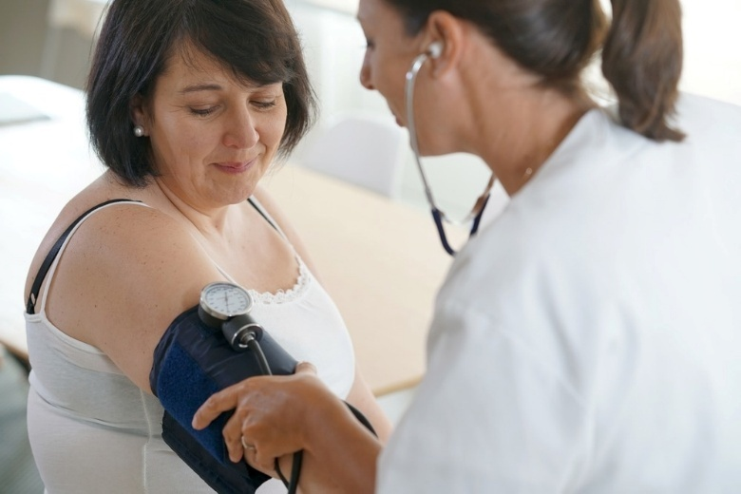
Figure 1: Blood pressure
Source: goodluz/Shutterstock.com

2. Introduction
The aim of the analysis is to target women in the United Kingdom. Gender-based health inequality can be defined as the systematic disparities in health outcomes and accessibility between men and women, usually enhanced by socio-economic and cultural factors. Although women in the UK live longer than men, they are in poor health or living with a disability for a considerably longer portion of their lives (Department of Health and Social Care [DHSC], 2022). A mix of clinical bias (the so-called male as default model of research), the unequal distribution of unpaid care, and the intersectional nature of ethnicity and regional deprivation make this group of people at risk of health inequities.

3. Background and Underlying Facts

3.1 Increased rates of maternal mortality
Maternal mortality is one of the health disparity indicators that are still time-sensitive. The latest surveillance on maternal deaths indicates that the maternal death rate in the UK in 2020-22 is the highest in almost 20 years, which is 13.41 per 100,000 maternities (MBRRACE-UK, 2024).
Statistical Disparities and Solutions: The major source of inequality is ethnicity; Black women are 3 times more likely to die during or after pregnancy than White women, and Asian women are 2 times more likely (MBRRACE-UK, 2025). These inequalities usually have their foundations in systematic racism and weathering the physiological effect of the sustained stress of discrimination. To address these issues, some of the solutions involve the adoption of the Maternal Medicine Networks and compulsory cultural competency training of all maternity NHS staff.
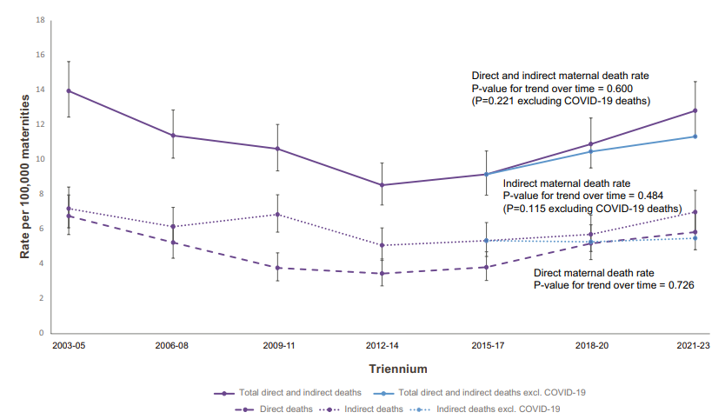
Figure 2: Direct and Indirect maternal mortality rates per 100,000 maternities by discrete triennia, deaths
Source: CMACE, MBRRACE-UK

3.2 Delays in Diagnosis of Cardiovascular Disease
Heart disease (CVD) can be wrongly assumed to be a male issue, which results in a grave disparity against women. It is argued that women have a 50% higher chance of misdiagnosis after a heart attack than men (British Heart Foundation [BHF], 2023).
Statistical Inequality and Interventions: The second-best practice for maternal death in the UK is heart disease, but only 11% of women who died of cardiac complications in 2021-2023 were diagnosed with heart problems beforehand (MBRRACE-UK, 2025). This disparity is due to the fact that women have always been under-represented in clinical trials. One of the solutions is the gendered diagnostic pathway that educates clinicians to understand that the symptoms experienced by women (e.g., nausea and back pain) are not usually similar to the typical male symptoms.

3.3 Prevalence of Perinatal mental disorders
Mental illnesses are one of the major causes of late maternal deaths (between six weeks and one year after delivery). About 34% of maternal deaths occurring in this time have psychiatric causes (MBRRACE-UK, 2025).
Statistical Disparities and Solutions: Here, inequalities are found due to the dismissal of mental health symptoms as baby blues. Perinatal mental illness is twice as much more common among women in the 20% of the UK most deprived than it is in the least deprived (DHSC, 2022). The possible solutions are the national implementation of special Perinatal Mental Health Services and the development of so-called Mother and Baby Units (MBUs) so that women would not have to decide between their health and their babies.

3.4 Gendered Cost-of-Living Crisis and Poverty
Women tend to live poorer than men, and this has been termed the feminisation of poverty. In the North of England, girls born between 2018 and 2020 may not get to live to 59.7, six years short of the girls in the South East (University of York, 2024).
Statistical Inequality and Remedies: Women become runners of the living costs of the cost-of-living crisis; women tend to forego meals to feed the kids (Women’s Budget Group, 2023). This economic disparity is realised because there is the gender pay gap and because of the low-paid work and part-time jobs undertaken by women. Options include structural reforms, e.g., changing Universal Credit to eliminate the two-child limit and raising the National Living Wage.

3.5 Domestic Abuse and Gender-Based Violence
Violence against women and girls (VAWG) is a significant health determinant of the social determinant. It was discovered in the 2025 MBRRACE-UK report that 22% of all women who died during or post-partum delivery had a known history of domestic abuse (MBRRACE-UK, 2025).
Statistical Disparities and Solutions: The difference in health is caused by the fact that victims experience direct physical injury and prolonged psychological trauma but are often hindered in their attempt to seek help. The domestic abuse rates are 19 per 1,000 people in the Northeast of England, as opposed to 11 per 1,000 in the rest of the country (University of York, 2024). These solutions are social prescribing and the implementation of domestic abuse specialists into primary care services.

3.6 The Imbalanced Cost of Unpaid Care
In the UK, women are the ones who offer the greatest volume of unpaid care. The contribution of unpaid care provided by women is an estimated £10 billion of the economy in the North of England alone annually (University of York, 2024).
Statistical Inequalities and Remedies: The implication of this burden is the one known as carer burnout, which impacts the physical health and mental wellbeing of women. In the North, one out of five women between 55 and 59 years old do some care for a family member (University of York, 2024). This disparity is due to the absence of low-cost social care facilities. The solutions need a national investment in a National Care Service which places social care on a par with the NHS in their priority.

4. National Response to Lessen Health Inequalities
In order to eliminate these social injustices, the UK government has initiated a number of national programmes:
- Women's Health Strategy of England (2022): It is the very first 10-year strategy specifically aimed at addressing the so-called gender health gap. It will help to make sure that the voices of women are heard by medical workers and increase access to care related to such diseases as endometriosis and menopause (DHSC, 2022).
- The Domestic Abuse Act 2021: This was a law that officially acknowledged the existence of domestic abuse in its many manifestations (including economic and emotional ones) and created a governmental body known as the Domestic Abuse Commissioner, who was meant to hold national and local government accountable on behalf of the support that they offered to the survivors.

5. Organisations that Benefit the Chosen Group
Wellbeing of Women is a well-known charity that helps women in the UK to obtain health services.
Wider Role and Goals: Wellbeing of Women is important in the awareness creation of health inequalities in its Health Collective programme. This organisation unites grassroots organisations to have women of marginalised communities represented in the national health policy, especially the Black and ethnic minority women (Wellbeing of Women, 2025).
How the Charity Helps: The charity funds critical research on gynaecological and reproductive health, which are traditionally underfunded. Their goals include:
- Research: Investment in research to ensure that there is enhancement in the early detection of gynaecological cancers and endometriosis.
- Education: Educating people to break the stigma about menstruation and menopause.
- Campaigning: Pressuring the Women's Health Strategy to make it cater to the needs of the most deprived women (Wellbeing of Women, 2025).

6. Conclusion
This discussion shows that the issue of gender-based health inequality in the UK is a complicated combination of clinical prejudice and social determinants. Women are more prone to chronic illnesses, high ethnic disparity in maternal mortality, and high social costs of poverty and unpaid care, although women have a higher survival rate. Such national initiatives as the 2022 Women’s Health Strategy are crucial steps in the right direction, but long-term change will only be possible when the underlying factors are considered: those economic inequalities in the region and the disenfranchisement of women in clinical practice.

Part 2: Epidemiological Analysis

1. Introduction
A noncommunicable disease (NCD) that is chronic and defined by insulin resistance and high blood sugar content is referred to as type 2 diabetes (T2D). Diabetes mellitus, if left untreated, may lead to potentially life-threatening complications, including cardiovascular disease, renal failure, amputation, and retinopathy. T2D imposes a significant burden on society and culture, which, in the majority of instances, results in a worse quality of life, a reduction in productivity, and increased costs associated with medical treatment.
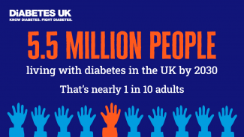
Figure 3: Public Health England
Source: (Diabetes UK, 2024)
Both the global and the national statistics are significantly impacted by type 2 diabetes. The International Diabetes Federation (IDF) (2021) projected that the number of individuals living with diabetes throughout the globe will increase to 783 million by the year 2045, in addition to the 537 million who were forecast to be living with diabetes in the year 2021. There are now more than 4.3 million people in the United Kingdom who have been diagnosed with diabetes (type 2 diabetes accounts for around 90 percent of all other patients) (Diabetes UK, 2024). This is an all-time high for the prevalence of diabetes in the country. It is especially prevalent in Tower Hamlets, where the high rate of its prevalence is conditioned by a diverse population and a high level of social-economic hardship, and the rates are much higher than in London. Tower Hamlets is a notable example of this phenomenon.

2. Main Body

2.1 Public Health Measures and the 3 P's
T2D management in Tower Hamlets is based on the 3 P concept:
- Prevention: The main primary prevention instrument is the NHS Diabetes Prevention Programme (DPP). It refers individuals with a prediabetes diagnosis by conducting blood glucose screenings and dispatching them to intensive lifestyle behavioural change programmes (NHS England, 2023).
- Protection: The second method is the secondary prevention by the National Health Check programme. Early detection of individuals at risk of developing complications helps the borough prevent the occurrence of the disease and other comorbidities, such as strokes or heart attacks.
- Promotion: Health promotion in Tower Hamlets is orientated to the cultural adaptation of communication. Physical activity and dietary campaigns are supported by promoting healthy lifestyles and targeting their members, namely the South Asian population, which has been recorded as the largest ethnic group in the borough, to tackle the dietary habits and sedentary lifestyles (Tower Hamlets Council, 2022).

2.2 Key Determinants and Risk Factors
In Tower Hamlets, the prevalence of type 2 diabetes is influenced by a complex network of factors that are important in determining the disease. An individual's ethnicity is one of the most significant biological risk factors; people of South Asian descent have a higher chance of developing type 2 diabetes at a lower Body Mass Index (BMI) and at a younger age than the White population (Diabetes UK, 2024). The most important social factor is socioeconomic deprivation, and Tower Hamlets is one of the boroughs in London that is considered to be among the most impoverished. For those living in poverty, the capacity to get low-cost and nutritious food (sometimes known as "food deserts") and safe locations for physical exercise is severely limited. A further factor that contributes to environmental problems and encourages sedentary lives is the excessive urbanisation that has occurred in recent decades.

2.3 Health Needs Assessment (HNA) and Population at Risk
For the purpose of conducting a Joint Strategic Needs Assessment (JSNA), epidemiologists have concluded that patients aged 40 and older, as well as males, have been at the greatest risk. However, in Tower Hamlets, the percentage of the population that is considered to be at risk is disproportionately represented in the most impoverished wards. Based on the findings of epidemiological study, it has been determined that the South Asian population of the borough is six times more likely to acquire type 2 diabetes compared to their White counterparts (Tower Hamlets Council, 2022). As the HNA indicates, the late identification of these particular populations is a result of a combination of factors, including language challenges and a lack of assistance that is culturally appropriate.

2.4 Monitoring and Surveillance Systems
T2D monitoring is conducted with the help of a multi-layered surveillance system:
- Quality and Outcomes Framework (QOF): This framework monitors the prevalence of T2D on the GP practice level to ensure that patients undergo frequent HbA1c testing and blood pressure monitoring.
- National Diabetes Audit (NDA): This is the main clinical audit that evaluates the quality of care given to individuals with diabetes in England and Wales. It helps to benchmark, i.e., compare the performance of Tower Hamlets to that of the other boroughs (NHS England, 2024).
- Passive Surveillance: The collection of data using primary care electronic health records (EHRs) is continuously needed, which helps epidemiologists monitor changes in the new diagnoses in real time.

2.5 Public Health Impact: Long- and Short-term Consequences
Worldwide Impact: T2D is the leading cause of death (6.7 million cases) every year (IDF, 2021). The economic effect in the long term is devastating, and the health spending on diabetes in the world is approximately equal to one trillion (IDF, 2021).
UK and Tower Hamlets Impact: Nationally, the acute complications of diabetes, such as diabetic ketoacidosis, will cause a short-term effect on primary care and emergency departments. In the long term the borough is in crisis of multimorbidity. The T2D patients are getting older and getting weaker and mentally unstable at a younger age, creating an unsustainable burden on the local NHS budget, of which 10 per cent of the total budget is spent on diabetes treatment (Diabetes UK, 2023).

2.6 Health Intervention Programme: “The Tower Hamlets Digital lifestyle Hub”
Design: I suggest an online-based, community-based intervention. It is a mobile app that offers real-time nutrition education in several languages (Bengali, Urdu, and Somali), which is complemented by the so-called Community Health Champions, who organise local walking group sessions.

Figure 4: Tower Hamlets Mental Health
Source: towerhamlets.gov.uk
Evaluation: The effect will be tested against a Randomised Controlled Trial (RCT) model in a number of GP clusters. The success will be determined by the mean change of the HbA1c level by 5 mmol/mol in 12 months and the number of active minutes per week (self-reported) (Public Health England, 2021).

2.7 Strengths and Weaknesses of the Epidemiological Approach
- Strengths: The National Diabetes Audit provides high-quality, standardised data that may be evaluated in significant patterns. This data can be obtained via the application of the audit. The localisation of interventions to the borough level makes the interventions appropriate to the population that is being targeted and makes them more tailored to the local environment.
- Weaknesses: Individuals that engage with digital treatments or even general practitioner examinations are often health-conscious, and it is not feasible to take into consideration the demographic that is traditionally considered to be difficult to reach. This is the first flaw that is connected to selection bias. It is also possible that the QOF data may not adequately represent the prevalence of the condition among the borough's temporary or migratory populations since it is based on patients who have a general practitioner registration.

Reference
British Heart Foundation [BHF] (2023) The Heart of the Matter: Women and Heart Disease. [online] Available at: https://www.bhf.org.uk/informationsupport/heart-matters-magazine/medical/women/misdiagnosis-in-women [Accessed 19 December 2025].
Department of Health and Social Care [DHSC] (2022) Women’s Health Strategy for England. [online] Available at: https://www.gov.uk/government/publications/womens-health-strategy-for-england [Accessed 19 December 2025].
MBRRACE-UK (2024) Saving Lives, Improving Mothers' Care: Surveillance 2020-22. [online] Available at: https://www.npeu.ox.ac.uk/mbrrace-uk/reports [Accessed 19 December 2025].
MBRRACE-UK (2025) Maternal Report 2025: Key Messages. [online] Available at: https://www.npeu.ox.ac.uk/assets/downloads/mbrrace-uk/reports/maternal-report-2025/MBRRACE-UK%20Maternal%20Report%202025%20-%20Main%20ONLINE%20v1.0.pdf [Accessed 19 December 2025].
University of York (2024) Report exposes vast inequalities faced by women in the North of England. [online] Available at: https://www.york.ac.uk/news-and-events/news/2024/research/women-inequality-report/ [Accessed 19 December 2025].
Wellbeing of Women (2025) The Health Collective: Driving equitable healthcare. [online] Available at: https://www.wellbeingofwomen.org.uk/what-we-do/campaigns/the-health-collective/ [Accessed 19 December 2025].
Women’s Budget Group (2023) Austerity is Gender-based Violence. [online] Available at: https://www.wbg.org.uk/article/austerity-is-gender-based-violence/ [Accessed 19 December 2025].
Diabetes UK (2023) Diabetes statistics and facts. [online] Available at: https://www.diabetes.org.uk/about-us/about-the-charity/facts-stats [Accessed 19 December 2025].
Diabetes UK (2024) Diabetes Prevalence 2024. [online] Available at: https://www.diabetes.org.uk/about-us/news-and-views/diabetes-prevalence-2024 [Accessed 19 December 2025].
International Diabetes Federation [IDF] (2021) IDF Diabetes Atlas 10th edition. [online] Available at: https://diabetesatlas.org/atlas/tenth-edition/ [Accessed 19 December 2025].
NHS England (2023) NHS Diabetes Prevention Programme (DPP). [online] Available at: https://www.england.nhs.uk/diabetes/diabetes-prevention/ [Accessed 19 December 2025].
NHS England (2024) National Diabetes Audit (NDA). [online] Available at: https://digital.nhs.uk/data-and-information/publications/statistical/national-diabetes-audit [Accessed 19 December 2025].
Public Health England (2021) Digital Health Intervention Evaluation. [online] Available at: https://www.gov.uk/government/publications/evaluating-digital-health-products [Accessed 19 December 2025].
Tower Hamlets Council (2022) Joint Strategic Needs Assessment (JSNA): Diabetes Profile. [online] Available at: https://www.towerhamlets.gov.uk/lgnl/health__social_care/joint_strategic_needs_assessmen/joint_strategic_needs_assessment.aspx [Accessed 19 December 2025].

