Name :ESTHER NWACHE

Student Number:2505633rtfolio
Module Course:LCHS4003
Introduction to Health and Social Care
Lecturer:Wafa Nasir
Assignment title Portfolio
Task One :Poster
Task two:Essay

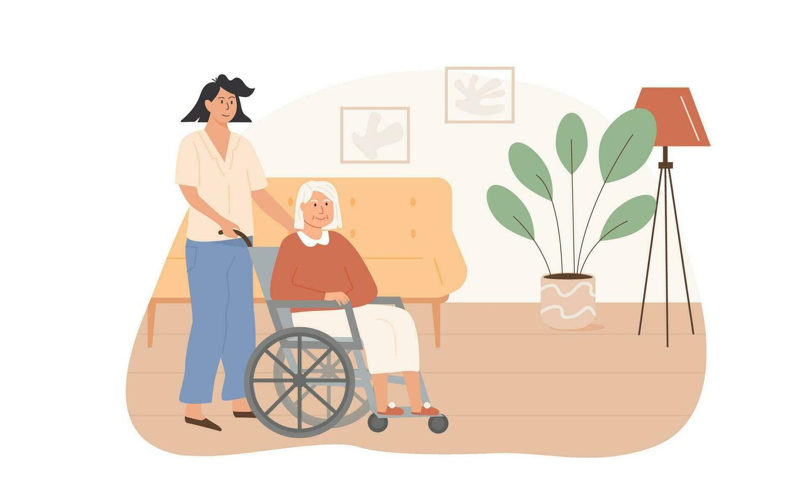
Part 1. Poster

Residential care homes
What the service is
- A residential care home is a regulated setting that provides 24- hour accommodation and personal care to individuals who cannot manage to live independently but do not require full time nursing care.
- Personal care includes washing, medication, toileting, meal and mobility.
- People live full time like their own home (NHS. Care Homes, 2019)
History of residential homes


- Different individuals who may need support due to their complex conditions, disability, age, illnesses, or loneliness (NHS, 2022).

- 10th century – Origins in alms houses in 936 ADS in York, funded by King Aethelstan
- 1601 – The Old Poor Law (Made each parish made to support responsible those unemployed, including the elderly and disabled.
- 18th–19th centuries – Workhouses care (older people worked long hours to get support.
- 1948 – NHS and welfare state transformation (hospitals and local authorities home provided support.
- 1980s – Private sector (private companies and voluntary organisations provided care.
- 2000s – Regulation and quality standards (CQC- monitoring standards of care)
- 2020s – COVID-19 and modern challenges (staffing, infection control and funding issues (D’Amen et al., 2021).



- Staffing- critical shortage of skilled and experienced staff. This is due to low pay, poor working conditions. For example, during COVID -19 staff shortages and many staff leaving jobs due to burn out- high staff turnover (Department of Health and Social Care, 2025).
- Vacancy rate is higher is an important indicator of providers’ capacity to deliver social care services CQC ( Staffing also affects quality: higher staff-to-bed ratios in care homes correlate with higher Care Quality Commission ratings.

Why this is a problem
Residential homes rely on agency staff -expensive and may not provide quality care as might not be familiar with patients. This can affect residents wellbeing and quality of life. For example even with minimum wage increase it was reported that in 2019-2020 one in four residential care workers lived or were in brink of poverty (Kings Fund, 2025).

Residential homes may fail to meet CQC standards and get poor ratings buy not meeting safe staffing levels.

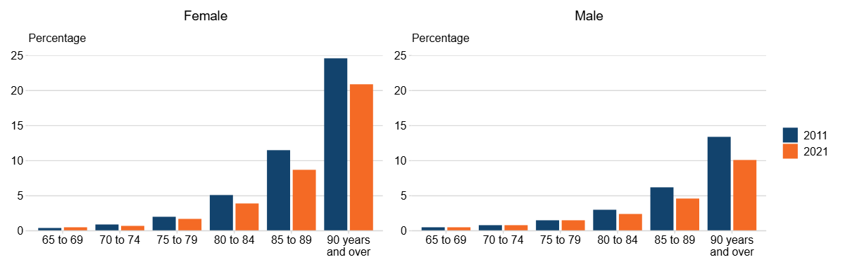
Figure. 1: population living in care homes



- Funding – adult social care is facing increasing costs

Why this is a problem.
- Some residential care homes are closing down as can not meet operational costs. People who need care may not receive it.
- Many care homes rely on government funding. The government is cutting costs, and this means the service providers are having to reduce staffing levels and other facilities that can affect the quality of life of residents.

- As Figure 1 shows the population of those living in care homes is increasing. This suggests a requirement for extra financial resources and higher staffing levels (Department of Health and Social Care, 2025).

- However, although spending on care has increased in real terms from 2015/16 to 2021/22, the Kings Fund (2025) noted as local authorities’ budgets still came under severe pressure and were forced to ration the care they provided. This yearly increase has impact on costs, fees and support (see Fig, 2) For example, between 2015/16 and 2021/22 the number of people receiving residential care dropped from 873,000 to 818,000.

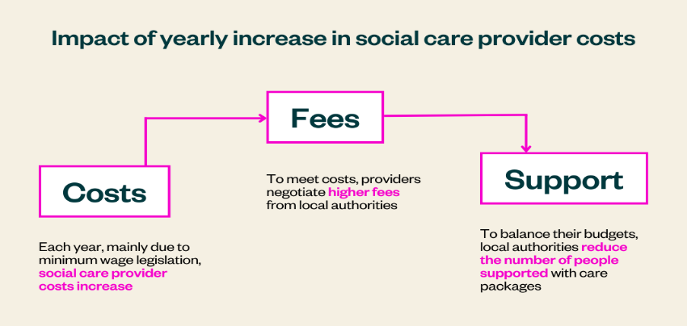 Source Kings Fund(2025).

Fig. 2. Impact of year on year increases in social care in UK.

Task 2. Essay.
Pharmacy Services
This essay investigates the origins of pharmacy services in the United Kingdom, exploring the historical context that shaped their development. It also evaluates how these services function today and discusses the significance of pharmacy services in enhancing the quality of life for service users.
The regulated activities of pharmacy services in the United Kingdom have undergone significant changes driven by legislative reforms that have expanded pharmacists’ prescription rights, increased collaboration with other professionals, and addressed the changing health needs of the ageing population (Gallagher, 2020).

The history of pharmaceutical services in the UK is complex, but evidence suggests it developed from the trading of spices and drugs. The early English traders formed groups of apothecaries under the guidance of the Grocers' Guild (Gallagher, 2020). This development later led to the establishment of the Society of Apothecaries in 1617, making apothecaries both prescribers and dispensers of medicines. However, during the same period, another group emerged that began manufacturing, selling, and dispensing medicines. According to John (2018), the emergence of this group raised concerns around standards and regulation, leading to the development of the Pharmaceutical Society of Great Britain in 1841 to provide formal training and professional oversight in the sector. The Pharmacy and Poisons Act of 1868 strengthened the sector by restricting the sale of medications and drugs to pharmacists, thus laying the foundation for modern pharmacy (Gallagher, 2020; John, 2018).
The creation of the National Health Service (NHS) in 1948, expanded the role of pharmacy services by introducing free prescriptions and increasing dispensing volumes. This period also saw the expansion of hospital pharmacy roles, with pharmacists becoming more involved in clinical decision-making, medicines management, and patient safety. The importance of pharmacists was recognized in the Linstead Report of 1953 and the Aitken Report of 1958 that further broadened the scope of pharmacists and their responsibilities while the Medicines Act of 1968 reinforced the professional regulations and clinical responsibilities of pharmacists (Degnan et al, 2018).

Currently, the service operates in primary care and public health across three key areas: community pharmacies, hospitals, and the pharmaceutical industry, with about 66,000 pharmacists currently registered in the UK. There are over 11,700 community pharmacies, employing approximately 71 per cent of pharmacy workers, with over one billion prescriptions dispensed each year (Gallagher, 2020). Community pharmacies now function as a key component of the NHS, acting as the first point of contact for people seeking advice and support regarding their health and well-being. They provide a range of services beyond dispensing medication, including vaccinations, weight management, and smoking cessation support (Gallagher, 2020). These expanded roles have improved access to care and reduced pressure on GPs and NHS hospitals.

However, Astbury and Gallagher (2020) noted the sector that with increasing legislation in pharmacy service, has led to criticism that the service is overly regulated. For example, Adams and Adams, (2021) suggest a medication error can be considered a criminal offence under the Medicines Act 1968. Further, Degnan, et al (2018) observed that the law governing pharmacy has a wide range of professional duties and obligations including removal from the registrar and loss of right to practice. Although this appears to be the case, Witt et al. (2024) argue the strict regulation is needed to improve public safety and people’s quality of life. As Degan et al. (2018) suggested, the legislation and reporting of medication errors is aimed at reducing preventable deaths.

The pharmacy sector faces a lot of challenges including financial pressure, staffing shortages and closure of community pharmacies (Witt et al, 2024). Further, although the skills and expertise of pharmacists are well recognized, their skills appear to be underutilized due to regulation and funding issues in public sector. Despite the various challenges facing industry, pharmacy services are often the most accessible healthcare setting, offering walk-in appointments and advice to vulnerable groups such as older people and those with mobility issues and some people from ethnic minorities.

References list

Adams, A.J. and Adams, J., 2021. Does increased state pharmacy regulatory burden lead to better public safety outcomes?. INNOVATIONS in pharmacy, 12(1), pp.10-24926.
Aminaho, F. and Onoshakpor, C., 2025. Analysis of CQC Ratings of Care Home Business Performance in England: Implications for Quality Improvement.
Cousins, C., Burrows, R., Cousins, G., Dunlop, E. and Mitchell, G., 2016. An overview of the challenges facing care homes in the UK. Nursing Older People, 28(9).
Degnan, D.D., Hertig, J.B., Peters, M.J. and Stevenson, J.G., 2018. Board of pharmacy practices related to medication errors and their potential impact on patient safety. Journal of Pharmacy Practice, 31(3), pp.312-321.
Department of Health and Social Care (2025). Health Trends and Variation in UK. Available at : https://www.gov.uk/government/publications/health-trends-and-variation-in-england-2025-a-chief-medical-officer-report/health-trends-and-variation-in-england ( accessed on 15 February 2026).
Gallagher, C.T., 2020. The changing landscape of UK pharmacy law in the early 21st century and its effect on the moral agency of pharmacists (Doctoral dissertation, University of East Anglia).
Gardiner, C., Laud, P., Heaton, T. and Gott, M., 2020. What is the prevalence of loneliness amongst older people living in residential and nursing care homes? A systematic review and meta-analysis. Age and ageing, 49(5), pp.748-757.
John, C., The changing role of the pharmacist in the 21st century. The Pharmaceutical Journal, 2018. 300(7909): p. online.
M. Astbury, J.L. and Gallagher, C.T. (2020). Moral distress among community pharmacists in the United Kingdom: causes and achievable remedies. Research in Social and Administrative Pharmacy: 16(3); 321-328.
NHS. Care Homes( 2019) .Available at : https://www.nhs.uk/conditions/social-care-and-support-guide/care-services-equipment-and-care-homes/care-homes/ (accessed 17 February 2026).

