

Student Name: Kiran Ali
Student ID: 2522876
Module Name: Software Solutions for Business
Module Code: ACCA-4026
Assignment Title: Component 1- Coursework: Portfolio
Lecturer Name: Osman Elgawi

Table of Contents
Introduction 3
Task 1: – E-Commerce Website Builders 3
Introduction to E-commerce Software 3
Shopify 3
Features 3
Wix 4
Features 4
Task 2: Mind Mapping 5
Introduction 5
Advantages of Mind Mapping in Business 6
Task 3 – Office Applications 8
Microsoft Word 8
Features 8
Example 9
Microsoft PowerPoint 10
Features 10
Example 11
Microsoft Excel 12
Features 12
Example 14
Example 16
Task 3b 16
Mail Merge 16
How does Mail Merge work? 16
VLOOKUP 19
Task 4: Communication & Collaboration Tools 20
Communication Tool- Microsoft Teams 20
How to use MS Teams? 23
Collaboration Tool- Google Docs 26
Features 26
Slack 28
Conclusion 29
References 31

Introduction
Software plays a vital role in today’s business environment. Today, businesses depend on different types of software to manage their business and daily activities. Software is used for communication, collaboration, data management, analysis, and much more [1]. This assignment describes various types of software and their usage in the business world.

Task 1: – E-Commerce Website Builders

Introduction to E-commerce Software
E-commerce platforms are online tools that help businesses sell and manage their products. These platforms provide the resources required to start an online business [2]. On these platforms, customers can view products, place orders, and make payments online.

Shopify

Features
Shopify is a popular e-commerce platform that helps businesses create and manage online stores. One of the important features of Shopify is the drag-and-drop store builder, which helps businesses create and design their website without needing technical skills.
The platform also offers payment integrations that allow businesses to accept online payments from customers using various methods. Another useful feature of Shopify is inventory tracking and management. By using Shopify, businesses can record their products and stock levels and automatically update availability.
Shopify also contains marketing tools that help businesses to promote their products. These tools allow businesses to create discount offers, run marketing campaigns, and connect their stores with social media platforms [3].
Pros | Cons
Easy to use  One major advantage of Shopify is that it is easy to use for beginners. People who lack strong technical knowledge can still create a professional online store or website. | Shopify has many advantages, but it also has some limitations.  Subscription fees  One disadvantage is that businesses must pay monthly subscription fees to Shopify to use the platform; if they do not pay, they cannot use it.
Scalability
Another advantage of Shopify is scalability. Businesses can start with a small store and, as they grow, expand further.

Transaction fee
Shopify may charge transaction fees depending on the payment system used.

Payment
Shopify also provides secure payment systems that protect customer information during online transactions, and customers can shop and pay from anywhere.

Wix

Features
Wix is also a popular website builder platform. Wix offers a wide range of templates, allowing users to create a website by selecting a template of their choice. Templates can be selected with a simple drag-and-drop tool; they are also customizable. Wix provides many tools for managing online stores, including product listing, order management, and payment processing. Wix also has a mobile-friendly design, ensuring websites work properly on mobile phones and tablets [4].
Pros | Cons
User-friendly interface  One of the main advantages of Wix is its simple, user-friendly interface. | Not suitable for large businesses  Wix is not suitable for large businesses and has some limitations regarding it. As the company grows, it requires more advanced features, so Wix does not offer the same level of scalability as many e-commerce platforms.
No technical skills required
Users or businesses can create a website without programming skills.

Affordable
Wix is also very affordable compared to other platforms, which makes it suitable for small businesses and start-ups.

Built-in templates
Another advantage is that Wix offers many templates, and users can customise them, allowing them to create any kind of website.

Task 2: Mind Mapping

Introduction
Mind mapping is a method used to organise ideas and information visually and in a structured way. It helps people understand complex ideas by showing the relationships among them. In a mind map, the main idea of the topic is placed in the centre of the diagram, and all the related ideas are connected through branches. Each branch represents a category or concept, and the smaller branches may contain more detailed information [5].
This technique is very popular in education and business. We can also use this technique for solving problems. Instead of writing a whole paragraph to explain a concept, a mind map presents information in a visual format, making it easier for people to read and understand. Because ideas are presented in a single word and relate to others.
Mind mapping also supports creative thinking. When people use Mind maps, they can quickly add new ideas and connect them to previous ones. When we want to generate new ideas, we can use Mind mapping, a useful tool for teams trying to generate new solutions or plan future projects.

Advantages of Mind Mapping in Business
- Idea generation
Mind Mapping has many advantages for businesses and organisations. The important benefit of mind mapping is idea generation. We can generate new ideas by using mind mapping. When organisations want to create new ideas, employees can brainstorm and connect each other’s ideas in a structured way. This way, organisations can explore different possibilities and develop creative solutions.
- Project planning
Another benefit of mind mapping is better project planning. Managers can use Mind maps to break large projects into smaller tasks. Each task can be placed on a branch of the mind map, making it easier for people to understand the project and the timeline.
- Improve communication
Mind maps also improve communication between employees [6]. When ideas are presented visually, employees can understand them more quickly, rather than a long paragraph, saving time. This decreases confusion and helps team members to understand ideas quickly and stay focused on their objectives.

- Problem-solving
Mind mapping is very helpful for problem-solving. Managers can analyse different aspects of a problem, consider possible solutions, and choose what is best for the organisation. Mind mapping helps businesses organise information clearly, support teamwork, and make better decisions.
Example of Mind Map
A simple mind map can be created to show different types of business software used in organisations. The central idea of the mind map is Business Software, and several branches represent different categories of tools used in business operations.
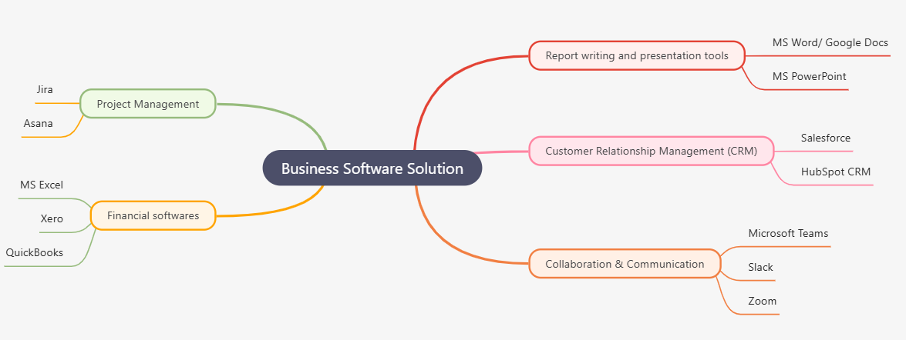
This mind map was created online at https://mindmapai.app/. This mind map explains some of the software solutions used by organisations today.

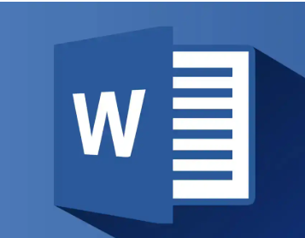
Task 3 – Office Applications

Microsoft Word

Features
Microsoft Word is a widely used word processing application in schools, colleges, and businesses. Using MS Word, users can create and edit any type of document professionally. Document creation is the main feature of Microsoft Word. Users can write reports, letters, essays, and many other types of documents using Word [7].
Another important feature of Word is the formatting tools. Word contains many options; users can change fonts, adjust text size, add headings, and organise paragraphs. This helps users to create a document that looks clean and professional.
Microsoft Word also includes a feature called Mail Merge. This feature allows users take information from a list or database to automatically create multiple documents. For example, users can create multiple documents by using the same document template.
Also, Word provides many built-in templates for resumes, reports, meeting agendas, and business letters. These templates help save time because we do not need to design the document from scratch.
Pros | Cons
- One important advantage of Word is that we can create professional documents quickly and easily. Employees can make reports, letters, and contracts in an organised format.  - Another benefit of Word is that we can easily edit any document. Word includes tools such as a spelling and grammar checker that help in correcting mistakes.  - The software also helps users to add comments and track changes, making it easier for teams to review and change documents together. | - Microsoft Word is very useful, but it has some disadvantages. It is designed for writing and creating documents, but it does not provide strong tools for complex data analysis, for example, calculations and large datasets are better handled in spreadsheet software.

Example
In business environments, Microsoft Word is used for many purposes, such as:
- Writing business reports
- Creating contracts and agreements
- Preparing official letters
- Recording meeting notes
Many organisations across the UK are using MS Word. One of the prominent organisations is the NHS Foundation Trust [8]. NHS uses MS Word to.
- Write patient reports and care plans
- Clinical letters and discharge summary
- Policy documents
- Training material

Microsoft PowerPoint

Features
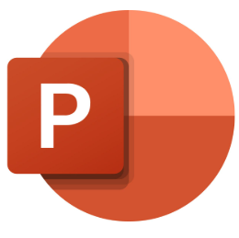
Microsoft PowerPoint is a presentation application used to write presentations or information through slides. Users can combine text, images, charts, and multimedia elements to explain ideas clearly [8].
Slide-based structure is an important feature of PowerPoint. Users can present information on different slides step by step, which helps organise it.
Another important feature of PowerPoint is the use of animations and transitions. With animation, users can move text and images using motion effects, while transitions control how one slide transitions to the next [8]. Users can use these features to make their presentation look interesting.
PowerPoint also includes tools for creating charts and diagrams. These tools help present complex data because the data is presented visually, making it very easy to understand. For example, a company can present sales data visually using graphs or charts.
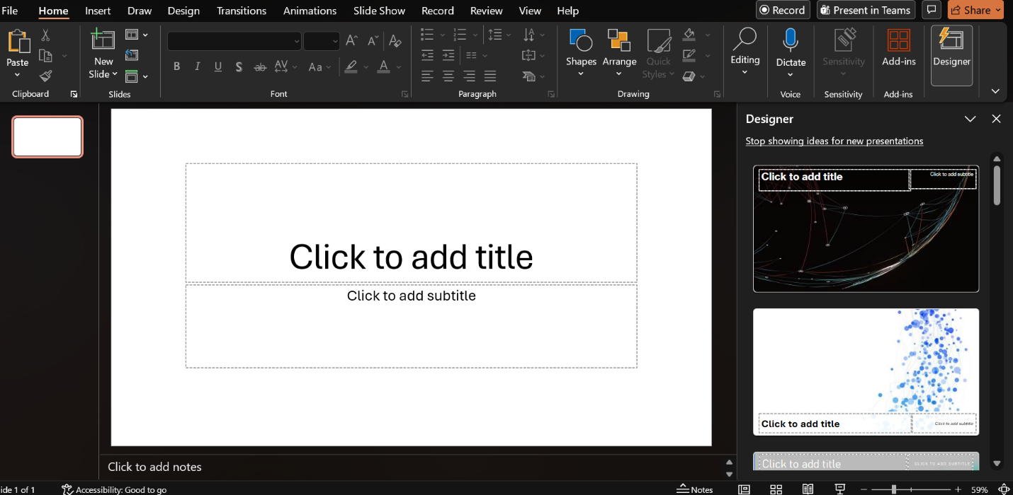
Figure 1: Home Page of MS PowerPoint
Pros | Cons
Communication  One of the main advantages of PowerPoint is its effectiveness in communication. Using this, the presenter can easily present their ideas to the audience. Visual elements such as images, diagrams, charts, and graphs make it easier for people to understand complex information.  Visual learning  Another advantage of PowerPoint is that it supports visual learning. Many people can easily understand information when it is presented visually, but it takes time to understand the whole paragraph of text it takes time. PowerPoint also allows businesses to present ideas professionally during meetings, training sessions, and conferences. | PowerPoint has some disadvantages too. Design skills are required for creating a presentation. If slides contain too much text or have a poor layout, the audience may find the difficulty to understand the presentation.

Example
Businesses use PowerPoint in many situations, including:
- Team meetings
- Project presentations
- Marketing proposals
- Employee training sessions
These presentations help companies share information and communicate ideas effectively.
Research conducted by Eyeful Presentations Ltd shows that
- Employees use MS PowerPoint to create appealing presentations
- PowerPoint is widely used in meetings, reporting, and internal communication.

Microsoft Excel

Features

Microsoft Excel is a popular spreadsheet application that is used for storing, organising, and analysing data [10]. In Excel, you can work with numbers and information in rows and columns. Excel is widely used in businesses for financial calculations and data management due to its powerful tools.
One of the most important features of Excel is spreadsheets [10]. In Excel, data is arranged in cells that are organised into rows and columns. Users can store large amounts of data in a clear format by using Excel.
Another important feature is the use of formulas and functions [10]. Excel includes many built-in formulas that allow users to perform calculations automatically. For example, users can calculate totals, averages, percentages, and other values using simple formulas.
Users can create charts and graphs by using Excel. With the help of graphs and charts, users can present data clearly and understandably. For example, a business can use charts to show sales growth over time.
Another useful feature of Excel is the data analysis tools. Excel includes options such as sorting, filtering, and conditional formatting. These tools help users analyse large datasets and identify important patterns or trends.
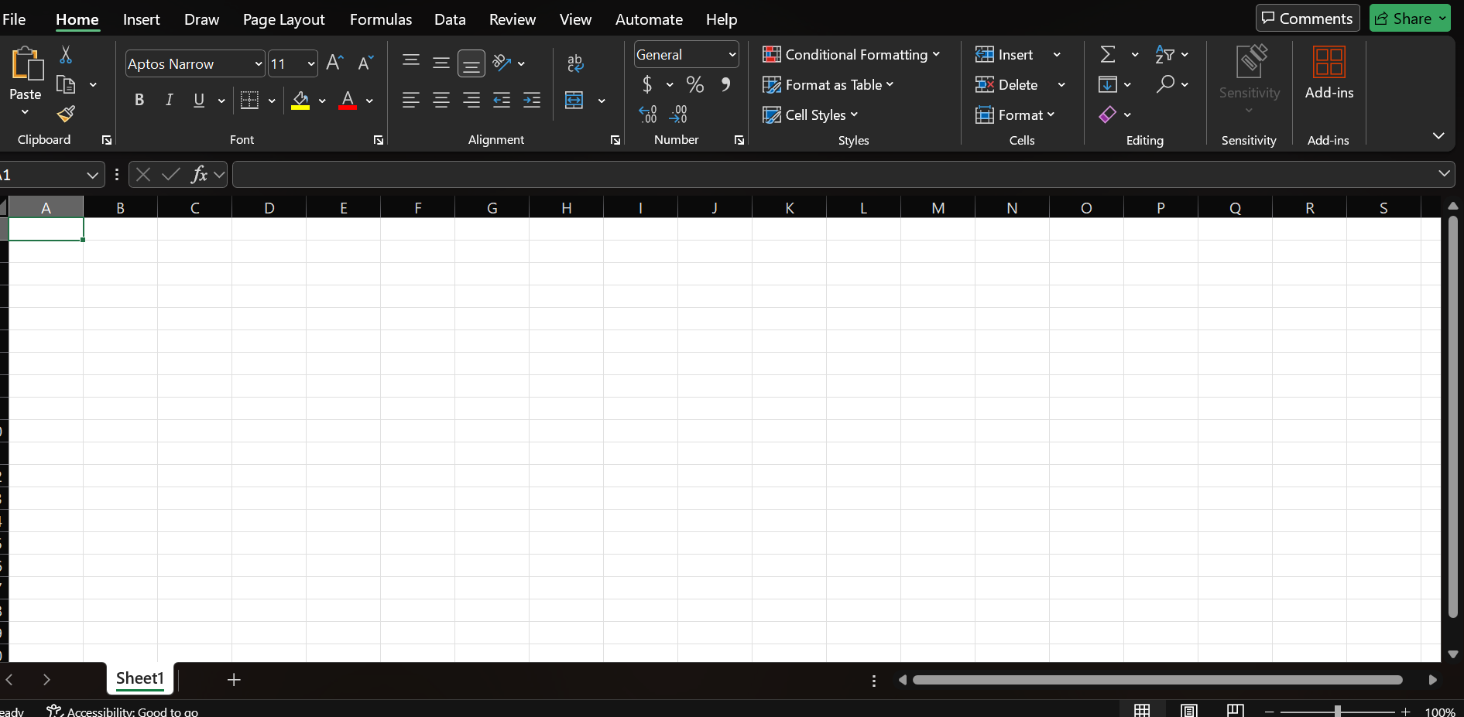
Figure 2: Spreadsheet of MS Excel

Pros | Cons
Microsoft Excel provides many advantages for businesses.  Helps with decision-making  Making decisions is one of the most practical features users can do with Excel. By analysing data, managers can identify patterns and make informed decisions.  Financial tracking  Another benefit of Microsoft Excel is its ability to track finances. Businesses usually use Excel to store data and manage budgets, calculate profits, and track expenses.  Easy calculations  Using Excel, users can calculate anything automatically. Instead of calculating numbers manually, Excel contains formulas to perform calculations automatically, which saves time and decreases errors [10]. | Excel is a very powerful tool, but it is difficult for beginners to use. Excel includes many advanced formulas and data analysis tools that can be difficult to use if you are new.

Example
In businesses, Excel is commonly used for:
- Budget planning
- Sales reports
- Financial calculations
- Business forecasting
These activities help companies manage their finances and analyse performance.
Microsoft Access
Features

Microsoft Access is a database management system that is used to organise large amounts of data. Access is also used to manage data structures. In spreadsheets, data is stored in rows and columns. Users can create relational databases that connect different types of information by using Access [11].
One important feature of Microsoft Access is the ability to create databases. Users can create databases containing multiple tables to store different categories of data.
Another important feature of Access is data storage and organisation. Information is stored in tables as rows and columns. These tables can be connected through relationships, which helps to organise data efficiently [11].
Microsoft Access also contains queries as an important feature. By using queries, users can search for specific information in the database. For example, a company can search for any customer records or product information using queries.
Another useful feature of Access is forms and reports. In the Forms, users can enter and edit data, which provides a simple interface, while users can generate organised summaries of stored information using reports.
Pros | Cons
Data management  One of the most useful advantages of Microsoft Access is organised data management. Businesses can store large amounts of information and data in a structured way by using Access.  Database creation  Another advantage of Microsoft Access is the ability to create relational databases. With relational databases, users can connect different types of information. This decreases duplication and improves data accuracy. | Microsoft Access is not as widely used today as cloud-based database systems. Many organisations use online database solutions because they can access them from different locations.

Example
Motorworks is a retail and e-commerce store in the UK. They use MS Access for;
- Managing the inventory database of motorbike parts
- Generate product catalogues for marketing purposes
- Store and organise stock and product data

Task 3b

Mail Merge
Mail Merge allows you to create multiple personalised documents at once. In simple terms, instead of using the same letter for different people, mail merge allows you to.
- To create a document once
- Send it to multiple addresses

How does Mail Merge work?
In MS Word, go to the Mailings tab and select Start Mail Merge.
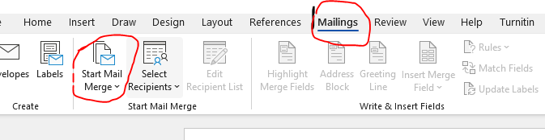
In the drop-down menu, I have chosen Step by Step Wizard to make things easier for me. The step-by-step wizard will take you through each step of the Mail Merge process. A step-by-step wizard appears in the right corner of the document.
Step 1:
Select the document yoi wish to create. I have chose letters.
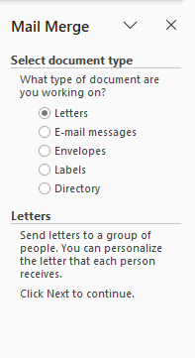
Step 2:
You can write your own letter, or you can also select from the templates. I choose to write my own letter.
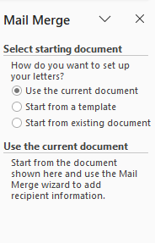
Step 3:
Choose recipients. You can create a new list or choose from the existing ones. I have chosen the existing file from the module course.
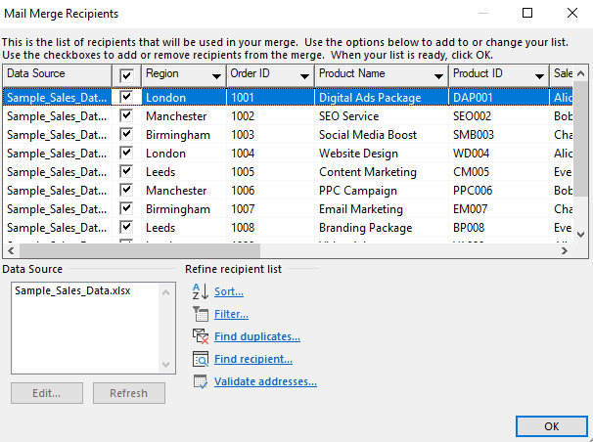
Step 4: Write a letter.
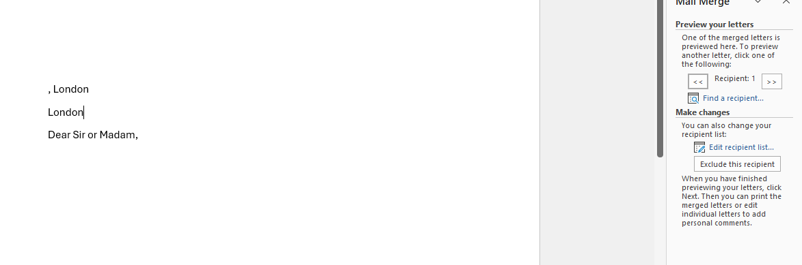
The final step is to complete the merge.

VLOOKUP
VLOOKUP helps to find information quickly. To practice the VLOOKUP function, I have explored the files from the module and selected the following;
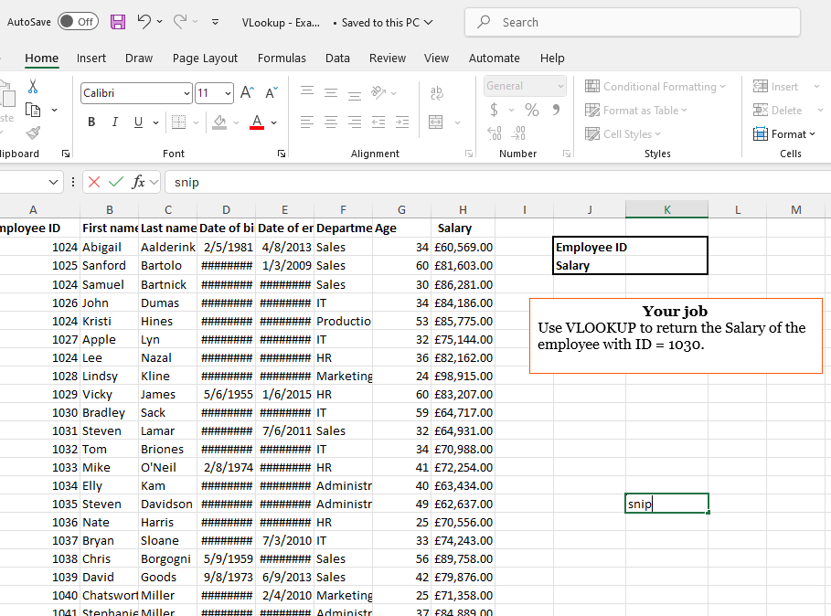
To perform the VLOOKUP function, we must enter the syntax:
=VLOOKUP(lookup_value, table_array, col_index_num, range_lookup)
Where,
- Lookup_value: value that you want to find
- Table_array: The table where data is located
- Col_index_num: column number to return data from
- Range_lookup: false= exact match
True: approximate match
From the above data, the syntax values are;
=VLOOKUP(1030, A2:H20, 8, FALSE)
Where;
- 1030: employee if
- A2:H20: the table range containing employee data
- 8: Salary column number
- FALSE: ensures an exact match
Using this formula, the result was 64717.
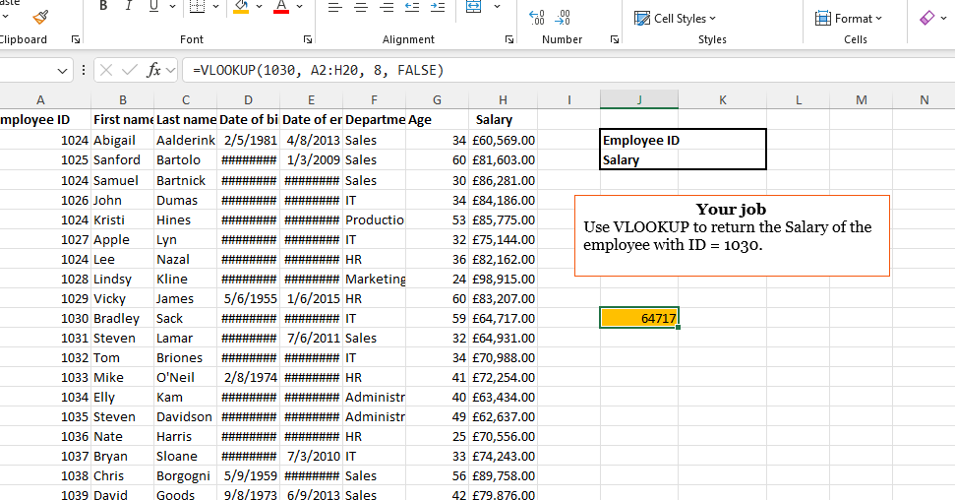

Task 4: Communication & Collaboration Tools


Communication Tool- Microsoft Teams
Features
Microsoft Teams is a platform that helps users communicate and is developed by Microsoft. Employees work in an organisation, so they must communicate, and they need software and a platform to do so. Microsoft Teams contains messaging, video meetings, and file sharing in one place [12]. Many companies use Microsoft Teams to connect their employees and improve teamwork. Microsoft Teams is a useful tool for the organisation, particularly when employees work from different locations.
Fast communication is very important in today’s business. By using Teams, employees can share information quickly, discuss ideas, and organise meetings without sending many emails. It has become a commonly used communication tool in businesses and educational institutions because of these features [13].
One of the important features of Microsoft Teams is instant messaging. Employees can send messages to other team members through private and group chats. These employees can communicate and solve problems quickly. This also saves time.
Video meeting is another important feature of Teams. Users can schedule online meetings, and team members can join them from any location. During video meetings, users can use video, audio, and screen sharing. This is a very useful feature for presentations and discussions.
We can also share files with Microsoft Teams. Employees can upload and share documents. Employees can share files with other team members, and any team member can edit them.
Pros | Cons
Microsoft Teams provides many advantages for businesses, schools, and organisations.  Communication tool  One of the main advantages is communication. Employees can arrange video meetings to discuss everything with other team members, rather than having them tell each employee about the task separately. They can arrange meetings to discuss the projects and tasks, and everyone shares their suggestions. This saves time and effort.  It also supports remote. Employees who are not physically in the meeting and are working online can still join, and if they are working from different cities, they can also share their ideas and collaborate with other team members.  Microsoft Teams improves collaboration by enabling employees to share documents, discuss project-related tasks, and manage them on the same platform. | Microsoft Teams is a very powerful tool for business, but it has some limitations. New users feel it is difficult to use this platform. It takes a lot of memory. Microsoft Teams sends many notifications, and it is difficult to manage and view them all. Teams usually overlap with Outlook, SharePoint and Yammer, leading to confusion about which tool to use for specific tasks.

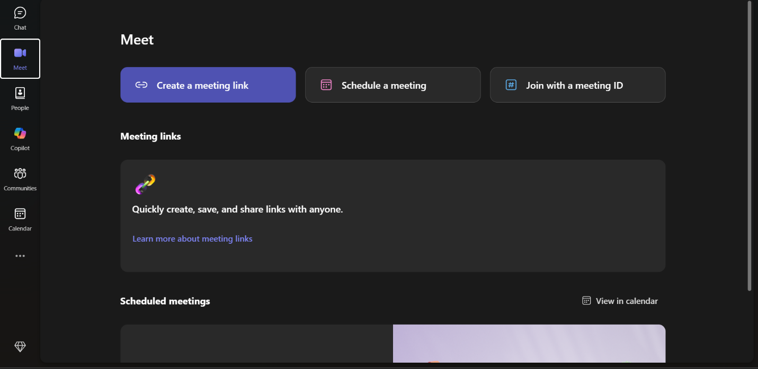
Figure 3: Home page MS Teams

How to use MS Teams?
Sign in to your Microsoft account. After signing in, the interface looks like this;
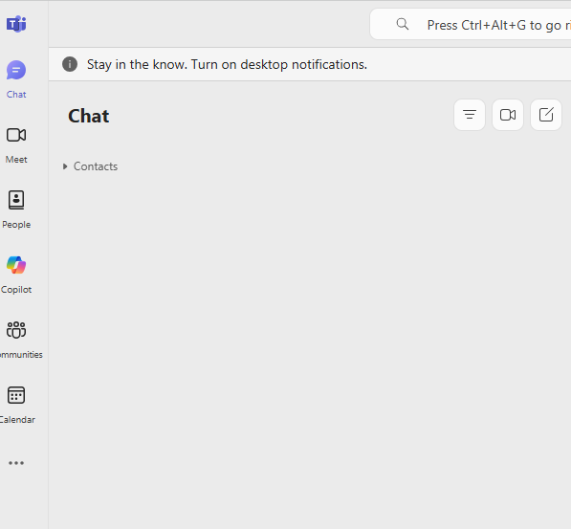
All the options are presented on the left side. You can choose the function you desire. For example, if you have to start a video call, just click on the video icon.
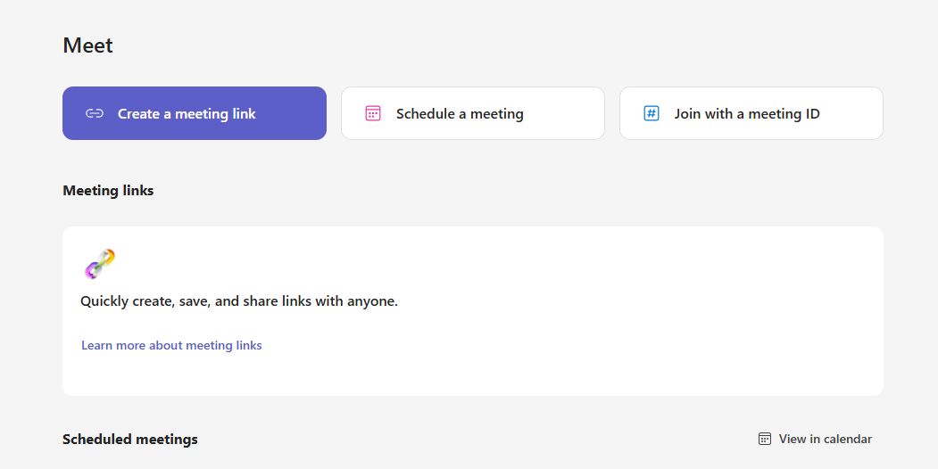
Now, you can create a meeting link, schedule a meeting, and join a meeting using a meeting ID. Here, I am creating a video call link.
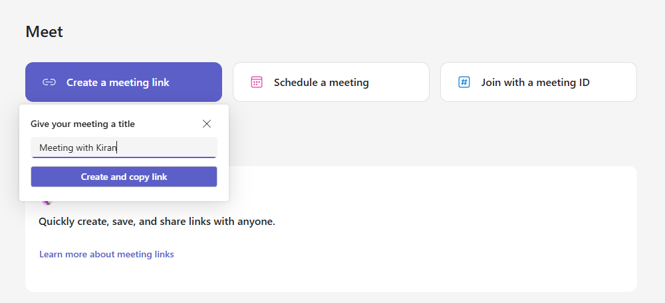
Share the link with others so they can join.


Collaboration Tool- Google Docs

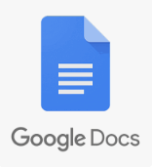
Features
Google Docs is a cloud-based document application developed by Google. It is used to edit the document. By using this platform, users can create, share, and edit documents online. Google Docs saves documents in the cloud, so they are not saved on your PC. You can access them from anywhere by opening your Google account [13].
Google Docs is also used in education and business. Organisations and students use Google Docs because multiple users can work on the same document simultaneously. This makes it an excellent tool for teamwork and collaboration.
One of the most important features of Google Docs is real-time editing. Multiple users can work and edit the same document at the same time. When one person makes changes, other users can see the updates quickly.
Another important feature of Google Docs is cloud storage. Documents are automatically saved to Google Drive, so users do not need to save them manually, and they can be accessed from anywhere on the internet.
Another useful feature of Google Docs is document sharing. Users can share a document by sending a link or an email invitation. You can control the permission, such as view, comment, or edit access.
Pros | Cons
- Google Docs has many advantages. It supports teamwork. Multiple users can edit the same document, which speeds up work and saves time.  - Users can easily share documents by using Google Docs. You don’t need to share all the files; users share a link to the document [13].  - Google Docs keeps the history. Users can view all changes made to the document, and if they want something from a previous version, it is easily retrieved.  - Google Docs allows exporting files into multiple formats, including .docx, .pdf, .rtf, and .txt.  - Google Docs includes features like voice typing, translation tools, and easy integration with other Google Apps (Sheets, Gmail). | - Google Docs has many advantages, but it also has some disadvantages. Documents exceeding 80,000–100,000 words can slow down Google Docs.  - Another disadvantage is that exporting documents to Word or PDF formats can result in broken layout or inconsistent formatting.  - Because Google Docs is cloud-based, data privacy is a concern for sensitive documents, and sharing settings can sometimes be overly broad. Offline access is not as good when files are saved locally; users must enable offline mode in advance, which is less convenient and sometimes problematic.  - Another limitation of Google Docs is that it may not provide all the advanced formatting features available in some desktop word processors.

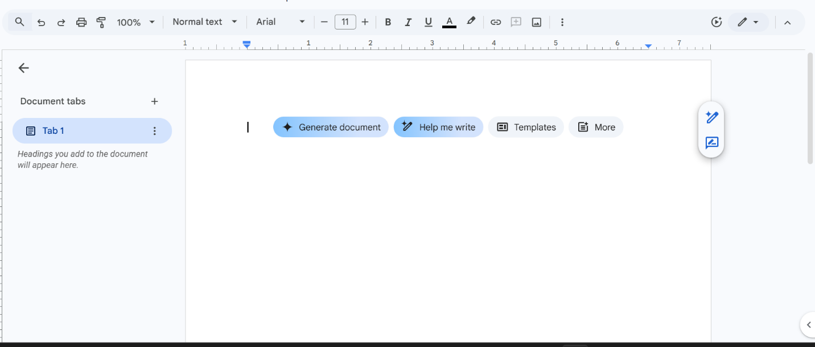
Figure 4: Google Docs home page

Slack
Slack is a cloud-based collaboration tool that enables teams to share files and manage work in one place.
To use Slack, sign in to your Slack account. You can create a Slack ID, or you can also use an Apple or Gmail ID.
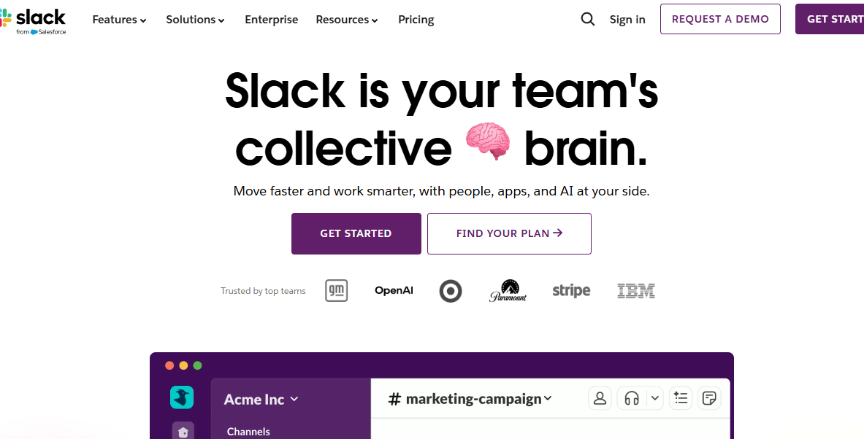
Here, I am creating a new workplace. You have to choose how you plan to use Slack.

Pick a name for the group and add other members by using their email IDs.
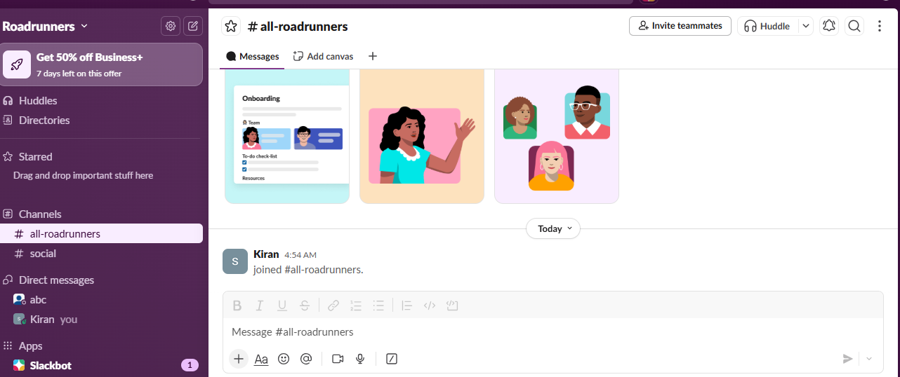
Now, here you and other team members can send messages, share files and more.

Conclusion
Software plays an important role in modern business. Digital tools help businesses perform tasks faster and more efficiently, enabling better decision-making and growth.
This assignment discussed many different types of business software used in organisations. E-commerce platforms help companies sell their products online, allowing customers to buy from anywhere. Mind mapping is a useful technique for organising ideas and improving planning visually. This assignment also covers important office applications, including Microsoft Word, Microsoft Excel, Microsoft PowerPoint, and Microsoft Access. These applications support document creation, data analysis, presentations, and database management in businesses.
The assignment also discusses communication and collaboration tools such as Microsoft Teams and Google Docs. These tools help employees communicate easily and work together on projects, which is very important in modern workplaces.

References
[1] P. Schubert, “Business Software as a Facilitator for Business Process Excellence: Experiences from Case Studies,” Electronic Markets, vol. 17, no. 3, pp. 187–198, Aug. 2007, doi: https://doi.org/10.1080/10196780701503088.
[2] “E-commerce,” Google Books, 2026. https://books.google.com.pk/books?hl=en&lr=&id=MwEB8LuK0P0C&oi=fnd&pg=PA2&dq=e+commerce&ots=faAya6y2iy&sig=6m1p7_-OxW7LIKCzcLvX7rZ7iz8&redir_esc=y#v=onepage&q=e%20commerce&f=false (accessed Mar. 19, 2026).
‌[3] J. Sophy. "Small Business Trends: What is Shopify and How Does it Work." Newstex Entrepreneurship Blogs. [Online]. Available: https://www.proquest.com/docview/2796680142
[4] “What is the Wix eCommerce platform?” Wix.com, 2026. https://dev.wix.com/docs/api-reference/business-solutions/e-commerce/what-is-the-wix-e-commerce-platform (accessed Mar. 19, 2026).
‌[5] “Mind Mapping For Dummies,” Google Books, 2026. https://books.google.com.pk/books?hl=en&lr=&id=Carhx4QuxxwC&oi=fnd&pg=PR17&dq=mindmap&ots=BOb3gF4pog&sig=9Cv9tkeBrTxP_TnoxSLtToaKsg4&redir_esc=y#v=onepage&q=mindmap&f=false (accessed Mar. 19, 2026).
[6] T. Grant and A. Archer, “Multimodal mapping: Using mind maps to negotiate emerging professional communication practices and identity in higher education,” South African Journal of Higher Education, vol. 33, no. 1, Apr. 2019, doi: https://doi.org/10.20853/33-1-2758.
[6] U. Schick and H. Haupt,MS-WORD 6.0, 1. Aufl. Ed. Darmstadt: Winklers Verl. Gebr. Grimm, 1994.
[7] O. Kruse and C. Rapp, “Word Processing Software: The Rise of MS Word,” Springer eBooks, pp. 15–32, Jan. 2023, doi: https://doi.org/10.1007/978-3-031-36033-6_2.‌[8] “The 10 best-read Microsoft UK stories of 2016,” Microsoft UK Stories, Apr. 23, 2024. https://ukstories.microsoft.com/features/the-10-best-read-microsoft-uk-stories-of-2016/
[8] H. H. Peterson and R. M. Horton, “Powerful Presentations with Microsoft® PowerPoint®,” BioTechniques, vol. 24, no. 1, pp. 78–80, Jan. 1998, doi: https://doi.org/10.2144/98241ir01
[9] "UK company explores the true cost of presentations in business today," M2 Presswire Jun 18 2019. [Online]. Available: https://www.proquest.com/docview/2242226104
‌[10] G. Harvey, Excel 2010 Workbook for Dummies, 1st Ed. Hoboken: John Wiley & Sons, Incorporated, 2010. [Online]. Available: https://ebookcentral.proquest.com/lib/[SITE_ID]/detail.action?docID=589088
[11] J. Eckstein and B. R. Schultz,Introductory relational database design for business, with Microsoft Access, 1st Ed. Hoboken, N.J: Wiley, 2018. doi: 10.1002/9781119430087[Online]. Available: https://cir.nii.ac.jp/crid/1130282271670256768
[12] J. L. Christina Wheeler, Mastering Microsoft Teams, 1st Ed. Newark: Wiley, 2022. doi: 10.1002/9781119698012[Online]. Available: https://www.perlego.com/book/3557098/mastering-microsoft-teams-creating-a-hub-for-successful-teamwork-in-office-365-pdf
[13] V. Ireddy, D. Tripathy and B. N. Ilag, "Microsoft Teams Overview," in Understanding Microsoft Teams Administration, United States: Apress L. P, 2023, pp. 1–43. doi: 10.1007/979-8-8688-0014-6_1Available: http://ebookcentral.proquest.com/lib/SITE_ID/reader.action?docID=31027932&ppg=27&c=UERG
[14] A. Z. Mansor, "Google Docs as a Collaborating Tool for Academicians," vol. 59, pp.411–419, Oct 2012, doi: 10.1016/j.sbspro.2012.09.295. Available at: https://doi.org/10.1016/j.sbspro.2012.09.295.
[15] R. Attebury, J. George, C. Judd and B. Marcum, "Google Docs: A Review," vol. 20, no. 2, pp.38–42, Apr 1 2008, doi: 10.7771/2380-176X.2736. Available at: https://www.proquest.com/docview/57628579.

‌

‌

