
Skills for the Workplace
Module Assignment Submission
Student Name: | Gregory Hudgell
Student Number: | 1918315
Module No: | BMSK4006
Module Title: | Part 1 Business Plan

Statement of Confirmation of Authenticity
By the act of making this submission, the student declares that this is the work of the student named above. The work has not, in whole or in part, been knowingly presented elsewhere for assessment, or where assessment has been built on a previous assessment, this has been identified. Where materials have been used from other sources it has been properly acknowledged. If this statement is untrue, the student acknowledges that an assessment offence has been committed.
Attention is drawn to the plagiarism and unfair practice policies of both the University and of ILM.

Table of Contents
Title Page 3
Executive Summary 4
Business/Industry Overview 7
Market Analysis and Competition 9
Sales and Marketing Plan 11
Product or Service Offerings 11
Pricing Strategy 11
Sales and Distribution 12
Advertising and Promotion 12
Ownership and Management Plan 15
Operating Plan 16
Financial Plan 17
Appendices 19

Title Page

HERCULEAN ELECTRICAL
A BUSINESS PLAN

Date: to be confirmed
Business Address: 3 Bryn Mount
Bryn Close
Swansea
SA4 4FW
Phone Number: 07710178795
Email address: gdh@herculeanelectrical.co.uk
Web address: www.herculeanelectrical.co.uk

Executive Summary

Herculean Electrical would be a fully licensed and regulated electrical contractor services company with a difference. The lead individual of the company is not only a fully qualified electrician but also has many years of building, labouring and construction experience under their belt. Specialising in modern and new technology installation around the home and workplace, creating media walls and creating a wireless home.

In a growing modern and technologically advanced world, there is always need for electricians and the services that they can provide. Electricity and power pay a key part in all day to day life, in both industrial and residential settings. Not only is it a key part of the construction industry but electrical contractors are there to ensure the safety and repair of electrical goods as well as helping to modernise and upgrade outdated fixtures and fittings.

The vision for this company is to provide a service that goes beyond the generic electrical contractor. That can provide a more personal and bespoke quality service to the general public. In short, the modern electrician.

The company would consist of one individual who would be the front face of the company, who would then, depending on the size of the job, would hire in the necessary additional labourers to help complete the job at hand. Ensuring that those hired to fulfil the required work have a reputable business or evidence of quality work before hire.

The locale of the company would be based in the Swansea area, with the address being Gorseinon. However the company can reach as far west as Carmarthen and East as Bridgend in the beginning stages, which opportunity and possibility of branching out further when developed into a substantial company.

The company would be run and managed under a sole proprietary management, meaning the company ownership and management would fall to one individual. This means that all profits, after tax, are kept by this individual and also does not hold anyone else liable for any losses.

The main product for the company would be the electrical services that are provided. Advertising as an electrical contractor with building and labouring experience that can offer services from a new/old build rewire to modern upgrades such as new fixtures, fittings, wireless technology and constructing media walls. All regulations and guidelines set out by the governing body would be met and all work completed to a high standard. Safety checks completed and work signed off only when safe to do so.

Customer base for the company would be very diverse, offering services to domestic and commercial dwellings and even industrial businesses. Free no obligation quotes would take place where advise can be given as to the best options within that customers budget. Larger jobs would most likely require additional labourers, which would be discussed with the customer and pricing of this provided in the quotes. All quotations would be completely transparent with a break-down of labouring and material costs giving the customer an open and honest look into how the services are priced.

With the need of electrical companies across the UK the competition for this business is vast. However with this company specialising in bespoke modernisation and upgrading of properties it will set apart from the competition. The company will take pride in quoting for any job, big or small. 76% of those included in the IBIS World market research report saw the positive opportunity that wireless technology is bringing the current climate, and so shows the increased demand and want for the latest, modern technology. A further plus to upgrading to this technology throughout the home and the workplace is that rewires are not as time consuming or messy, as there is little need to chase cables into walls or through trunking but rather just cables under floorboards to wireless receivers, which then wirelessly connect to light switches.

Financial projections for the first few years
First year profits: £20,000+
Second year profits: £25000+
Third year profits: £30000+

Start up costs;
- £525+ NICEIC application fee (annual)
- £475+ NICEIC registration fee (annual)
- £100-£1000 Cost of materials for first job

Start-up finances would be minimal due to the tools and equipment required are already purchased from previous employment and experiences. However the cost of becoming an approved contractor by the NICEIC would be required in order to safely sign off and pass work completed. To begin with a small commercial van with suffice for the work load, however this would be upgraded to a larger vehicle once the company becomes more established and gains more customers. The jobs will cover the cost of materials required, which would be needed to paid upfront by the company, the cost of materials would then be included in the total cost for the job. Due to the variety of services available the cost of materials would vary depending on the job at hand. Appendix B shows the average costing of a full house rewire depending on size, with the lower amounts being in rural areas and higher amounts relating to inner city prices. These costs outlined include the labouring costs for the work as well as the materials. Materials for a rewire can vary in cost depending on the specification the customer wants to meet, and averages out at around £800 for a 2-3 bedroom home. The fine details and prices of course would be agreed with the customer on a job to job basis.

Business/Industry Overview

The general nature of the electrical industry is to provide power and electricity across the board to its customers. It is an industry that is in great need and is not at risk of going anywhere in the near future due to the ever expanding technology and electrical upgrades that are available.

The industry itself has taken a hit in the recent COVID-19 pandemic following lockdown rules. The lockdowns enforced by the government when COVID hit the UK caused a great lull in the electrical business as it was deemed that only emergency works could take place. All non-essential work, big and small, were not allowed to go ahead during the heavy lockdowns within 2020, this included upgrading of properties and modern electrical installations. However with the lockdown rules being lifted and easing off, more work can now take place, albeit under the restrictions that are still in place such as face masks being required and social distancing being adhered to. Not only this but also thanks to COVID raw material costs have increased and so creating a more expensive material requirement.

Over recent decades the electrical business has seen more work in the development and construction of new build properties due to the expanding developments of these new build estates. However in recent years the focus has shifted and according to the NICEIC and ECA Vision Report 2021 (Appendix A) more work and money is being focused repair, maintenance and improvement of existing properties. Showing the financial shift towards the modernisation and upgrading of property electrics.

Economic influences within the industry show that more and more people are swayed towards eco friendly and energy saving electrics. 94% of those surveyed by NICEIC and ECA Vision Report see the opportunity and benefits in increasing local renewable energy sources and network grids, which in turn could see the increased demand for solar panel installation and other renewable energy sources based at home. At present there is no specific grant or funding available for solar panel installation within Wales, but there is a feed-in-tariff enabling you to be reimbursed by the energy company for energy you may create but not use. There has also been a shift towards the use of lower energy bulbs in the form of LED lighting, which offer lighting without using as much energy in the long term, saving on the energy footprint and also on bills. Further governmental influences within the industry refer to the guidelines and regulations in terms of safety within electrical installations. The government requires electrical contractors to be registered with a governing body for electrical works, in order for works to be safely signed off and proving they meet current health and safety standards.

This business fits into the industry as it covers a wide range of services provided across the board by electrical contractors and more. Specialising in upgrading properties to the latest and technologically advanced fittings, something that existing competitors may not have experience with. Already established companies, albeit update their training each year, may not be familiar with wireless electronics and so give this company the edge in that field.

Market Analysis and Competition

Competition within this industry is vast. It is a growing industry with needs increasing with the advancement of technology. In the IBIS world market research report it estimates that there are over 44000 businesses in the electrical contracting industry, with over 180000 individuals employed within these businesses. It also highlights how many workers within the industry went without work through the COVID-19 pandemic, thus creating a lull in the progress of the industry, which in turn needs more individuals to catch up with outstanding work that could not be completed during that time.

As seen in Appendix C, the Swansea area is a large geographical area with 36 different regions within it, with a population in the region of 246,217 (2019). It is a densely populated area with many areas having dense residential settings, approximately 109,500 residential dwellings (2019). This, as well as commercial and industrial dwellings would be the target market for the company. In addition to this, the company can stretch further to areas such as Carmarthen, Ammanford and Bridgend, with a contribution to the cost of travel factored into the quotes.

There is ongoing need for electricians within the Swansea area. A threat to this is that during the COVID lockdowns of 2020, with many people losing their jobs or being placed on the furlough scheme, they had time to learn new skills and may have completed works on their own homes in this time. However this company, being regulated by the NICEIC would be required to sign off the work carried out and ensuring that it has been done safely and meets current government regulations. This would be another service that this company can provide for a charge, plus any corrective works that need to be carried out can also be charged to the customer.

In an industry such as this, the repeat purchase rate would be low, as once a rewire has been completed, there would be little to no need to do additional works for a period of time following. However word of mouth is just as important as quality of work within this industry and so by completing all and any job, big or small, to a high standard can in turn create a return for expansions and further upgrades in the future. As well as this the company would then be recommended by customers to their family and peers, creating more work following a good reputation.

Economic changed can increase the purchase rate for the company as the need for the newest and most energy efficient electrics would increase over time. This would increase sales for this company in particular as it will be specialised in the installation of the most modern and energy efficient fixtures and fittings.

Sales and Marketing Plan

Product or Service Offerings
In an industry with so much competition is it important to remember to stand out from the rest. This can be done in a number of ways. Advertisement needs to be memorable and attractive to the services that are provided. As detailed above the services and product provided would vary from customer to customer, and as a company there is pride in being able to meet and accommodate different tasks that may be required.

The name of the company is unique and memorable “Herculean Electrical” and has strong connotations, thus giving a good impression to passers-by and possible customers. The logo would again be simple but effective in catching the eye of the public and give a professional insight into the company and it’s vision.

Pricing and sales would be handled on a job to job basis with clarity and openness on behalf of the company lead, a referral discount of 10% can be offered to those who refer new customers such as family or friends to the companies services that results in a completed purchase of services. An important part of any business such as this is post sales support. It is important to remember that the job does not end with the payment of services, the company strives to make a lasting impression which causes no doubt in the customers mind on who to contact should there be any issues or need for follow up.

Pricing Strategy
As an electrician employed by another company, when working on a rewire for example services are charged at £200 a day based on a 10 hour working day, with the additional costs of materials and further labourers if required. Being a start up company with a reputation to build, the day rate would begin at £170 until the company has built up a customer base and reputable business. All costs such as this are outlined in the quotes provided to the customer and so full transparency is given with regards to what they are paying for. An average rewire timescale is detailed in Appendix B, with approximately 60% that time spent on the first fix and 40% of time spent on the second fix.

That being said, other services will cost differently to this, and costing is subject to job size and time needed to complete. If work is completed by another company or individual who is not licensed or regulated and requires this companies services to sign off the work, then there would be a fixed price for that plus any additional charges for any changes that are required to meet health and safety regulations.

Sales and Distribution
Due to being a service rather than a product, the companies distribution will be the services delivered by the lead individual in a professional van, clearly displaying the company name and information. The individual would present themselves in appropriate work clothing with branded t-shirts and jumpers to maintain the professional outlook. Punctuality would be key to this in that it gives a good impression of the company and the individual carrying out the works.

Company headed quotes would be drawn up with the customer, with the customer going over this before confirming sale of services. Invoice would then be drawn up detailing the works to be completed with a payment schedule, again agreed with the customer. In the instance of a rewire, half the total payment would be required following the completion of the first fix, with the remaining half paid on the completion of the second fix. Invoices and quotes will be kept with the company for their records and tax purposes. Payments accepted via cash or secure bank transfer with company headed invoice receipt following payment for security for both company and customer.

Advertising and Promotion
Advertisement and promotion of the company will mainly take place within the social media platforms such as Facebook and Twitter. There is no cost to setting up these pages and through the power of social media the work and ethics can be shared with followers and to the public. The website will also detail the companies vision and services with links to the social media platforms where evidence can be shown of completed work and the high standard that it is completed to.

Further advertising can be made through business card distribution. Ordering business cards in bulk can cost between £10-£15 for 250 cards. The more ordered, the cheaper it would be for the cards. These cards can be given to customers who requested services as well as being left on the tills and desks within trade shops such as TLC, B&Q and Screwfix. A discounted price of 10% could then be offered to first time customers with the business card.

Ownership and Management Plan

The ownership structure of the company falls to one individual, this individual will be the management of the company as well as the owner and deliverer of services. This is due to the company being managed under a sole proprietorship.

Being managed under a sole proprietorship means that all profits are that of the companies after income tax, however any losses or debts are also liable to the company and thus in turn a loss to the individual.

Operating Plan

Operations development will run from the business address which is a home based office to save on costs. Being a sole proprietary business this provides more than enough space for the needs of business. The equipment source is already existent due to previous jobs and experience, materials however will be agreed with the customer on a job to job basis depending on their needs. Should equipment need replacing or upgrading this will be done as and when required without hesitation to ensure the best work is being carried out at all times.

Production of services will again vary from job to job, each time completed to a high standard and fulfilling the quotation of the job required. The facilities of the company would not incur extra charges or funding due to being a home address, and also the addresses of where the work is being carried out.

Staffing levels will be kept to a minimum, being a modern electrician and skilled labourer the need for additional staffing would be very rare. However should it be required, whether that be due to job size and or timescale required for the job then extra staffing will be included in quotes and thus covered in the expense charge for the jobs.

Financial Plan

Expenses would be job dependent as materials would be required for purchase beforehand without having to charge the customer upfront, this could be an option in the future when a steady reputation has been established.

Profit would be the total job cost minus the expenses of materials and cost of running the van.

Anticipated cash flow and revenue would be as follows;
Time frame | Rewires minus material costs | Additional job revenue | Total profit before tax and expenses
0-6 months | £8400 | £2400 | £10800
7-12 months | £8400 | £4800 | £13200
Year 2 | £16800 | £9600 | £26400
Year 3 | £19200 | £12000 | £31200

Within the first six months of the business there would be one rewire per month at £175 per day based on 8 days, with extra smaller jobs also contributing to additional profits (approximately £400 a month).

The second 6 month time frame will still see one rewire per month at £175 per day based on 8 days, however extra jobs will have increased to approximately £800 per month.

Year 2 will continue to see 2 rewires per month, based on £175 per day for 8 days, with additional jobs totally more than £800 extra per month.

Year 3 will see the increase of job load to 3 rewires per month and in pay rate to £200 per day based on 8 days, with additional £1000 coming from additional smaller jobs.

As reputation builds, as will work load thus creating more revenue for the business and higher profit margins. An increase such as this also allows for an increase in cost of services due to the proven record of the established business and high quality work it turns out.

A business account will be created in order to manage the cash flow from jobs and cost of materials for the business. This account will hold the majority of the money, with a little being released each month in order for the sole proprietor to use at their discretion for personal payments and use. This is so that initial costs for jobs, such as materials are covered by the business account and funds are always available, and also should any equipment require replacing or the van need MOT/service etc, it would then be charged to the business account as this classes as expenses.

It is apparent from the predictions that the cash flow creates profit from the first 6 months once the initial start up finances are covered. This in turn shows a successful business plan and business to proceed with.

Appendices

Appendix A
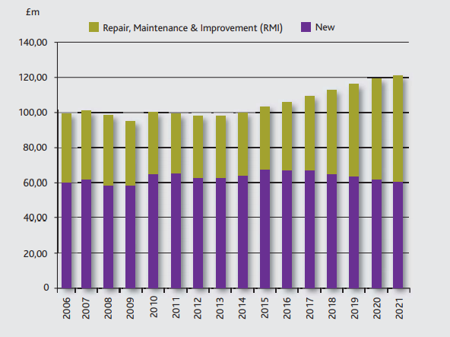

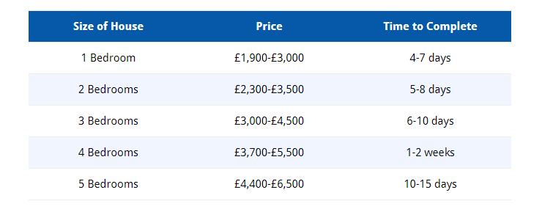
Appendix B

Appendix C
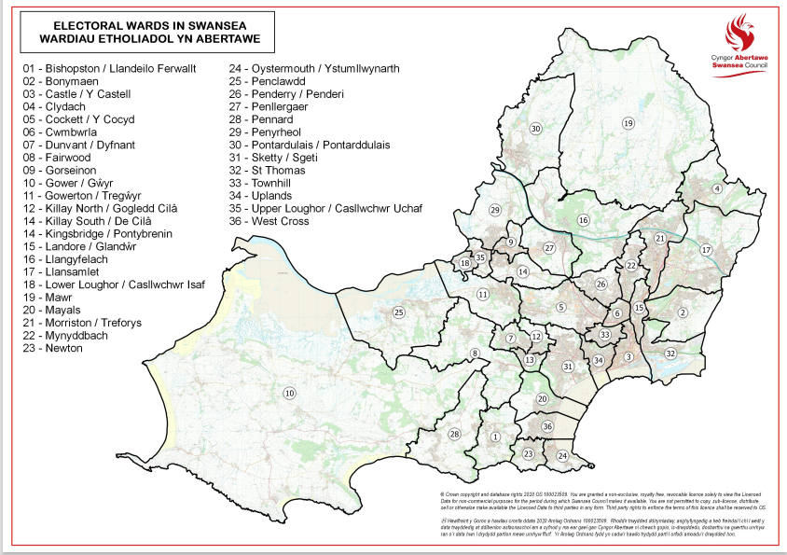

Online sources for market research;
- https://www.greenmatch.co.uk/solar-energy/solar-panels/solar-panels-in-wales
- https://householdquotes.co.uk/how-much-does-rewiring-cost/
- https://www.ibisworld.com/united-kingdom/market-research-reports/electricians-industry/
- https://www.niceic.com/join-us/approved-contractor-scheme-(1)/eas-entry-requirements-april-21.aspx
- https://www.niceic.com/Niceic.com/media/Press-Photos/NICEIC-and-ECA-2021-Vision-Report.pdf
- https://www.swansea.gov.uk/householdestimates#:~:text=The%20latest%20official%20mid%2Dyear,1.369%20million%20households%20in%20Wales.

